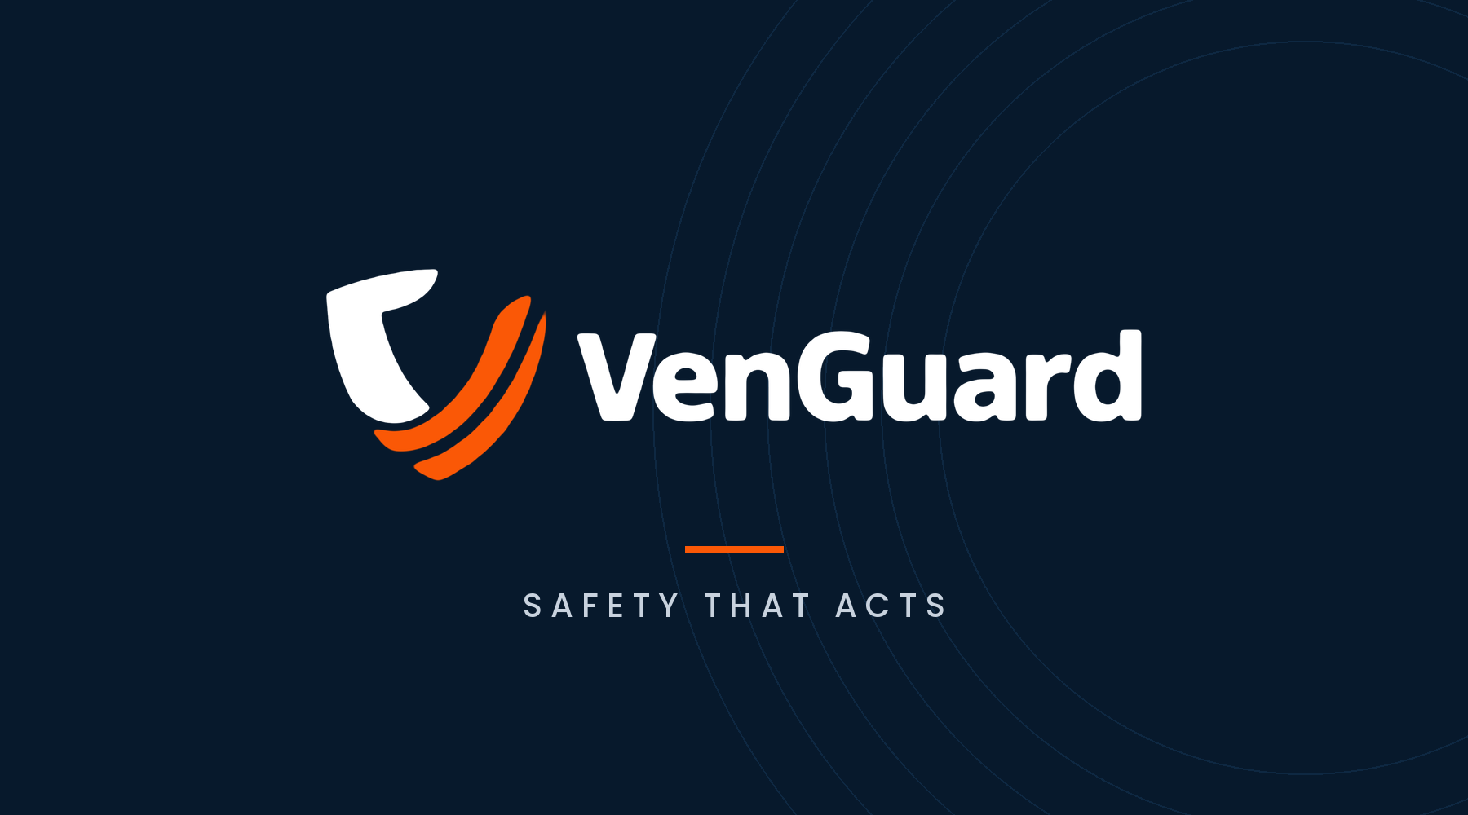
Brand Identity Guidelines
Logo Usage Standards
Version 1.0 · October 2026
VenGuard by OASIS Next · Dhaka, Bangladesh
For internal teams, designers, printers, dealers and partners
Contents

01 Introduction Purpose of this guide and the brand idea
02 Logo Anatomy What each part of the logo means
03 Logo Versions Approved versions and when to use each
04 Construction and Proportions The x-unit system that holds the logo together
05 Clear Space The protected zone around the logo
06 Minimum Size Smallest sizes for print and screen
07 Colour Brand palette, values, ratios and accessibility
08 Typography Typefaces that accompany the logo
09 Backgrounds and Themes Which version goes on which background
10 Placement and Proportion Where the logo sits and how large it is
11 Applications Digital, print, presentations, product and packaging
12 Co-branding Using the logo with partner logos
13 Incorrect Usage What never to do
14 Logo Files and Naming Master files, formats and file names
15 Approval and Contact How to get artwork checked

01 Introduction

A consistent logo builds recognition and trust. This guide sets one clear standard for how the VenGuard logo appears everywhere, in Bangladesh and internationally.

Our brand in one line
VenGuard is an automatic gas shut-off system for kitchens. When it senses a leak, it is designed to close the cylinder valve and start the exhaust fan by itself. Our promise is captured in three words: Safety that acts.
The logo must therefore always look calm, dependable and precise. It should never look playful, distorted or improvised, because people trust it with the safety of their homes.

Who should use this guide
- Internal teams creating marketing, sales and product materials
- Designers, agencies and printers producing VenGuard artwork
- Dealers, installers and retail partners displaying the brand
- Event, competition and media partners featuring VenGuard

How to use it
Every rule in this guide is based on one simple measuring unit, called x (explained in Section 04). Start with the right logo version (Section 03), check the background (Section 09), then follow the placement and size table for your item (Sections 10 and 11). When in doubt, use the primary full-colour logo on white, with generous space around it.

Golden rule
Always use the official master artwork files. Never redraw, retype, recolour or rearrange the logo. If something you need is not covered here, ask the brand team before publishing.

02 Logo Anatomy

The VenGuard logo has two parts that always appear together in the primary lockup: the symbol and the wordmark.
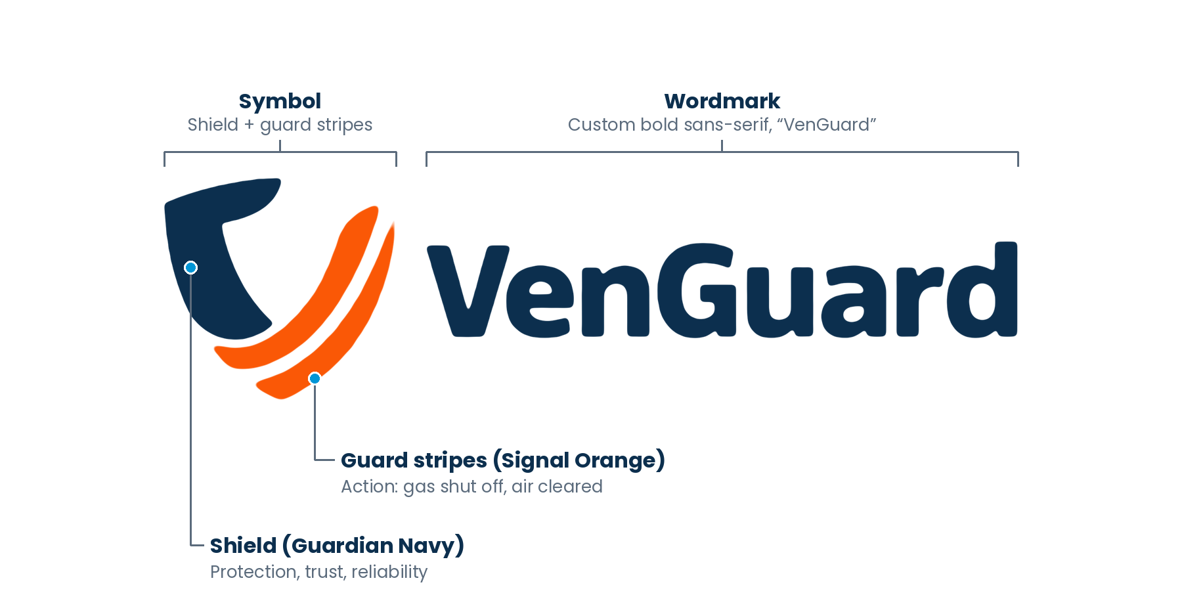
Figure 2.1 The parts of the VenGuard logo
Element | Description | Meaning
Shield | The solid Guardian Navy form on the left | Protection, trust and reliability
Guard stripes | Two parallel Signal Orange sweeps that complete the shield | Action: the valve closing and the air being cleared, the two things VenGuard does by itself
Symbol | Shield and guard stripes together, forming a “V” | The “V” of VenGuard and a sign of a protected home
Wordmark | “VenGuard” in a custom bold sans-serif, capital V and G | A modern, confident and readable name, in Latin script in every market

The symbol and wordmark have a fixed relationship. Their size, spacing and alignment must never be changed. The only approved ways to separate them are the stacked lockup and the symbol-only version in Section 03.

03 Logo Versions

Use the primary logo whenever possible. Order of preference: A primary › B reversed › C/H stacked › D symbol › E/F/G one colour. Move down the list only when the version above cannot work.
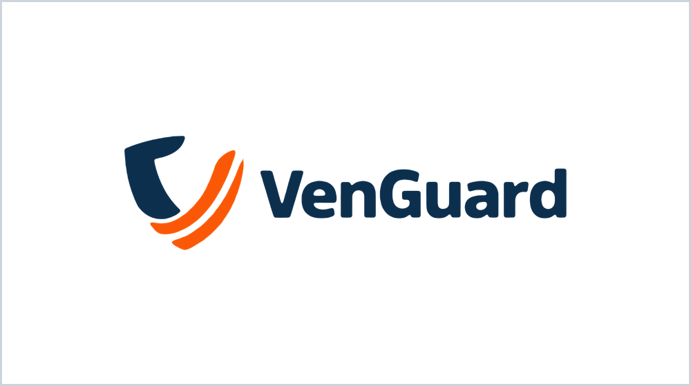  A Primary logo (full colour)  The preferred version. Use on white and light backgrounds whenever space allows. | 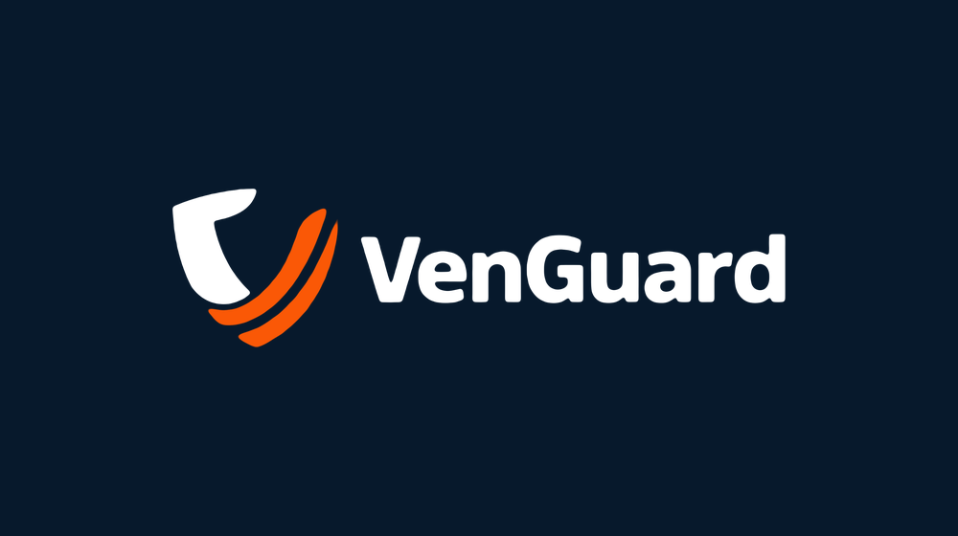  B Reversed logo  Shield and wordmark in white, stripes stay Signal Orange. For Deep Navy, Guardian Navy, black and dark photos.
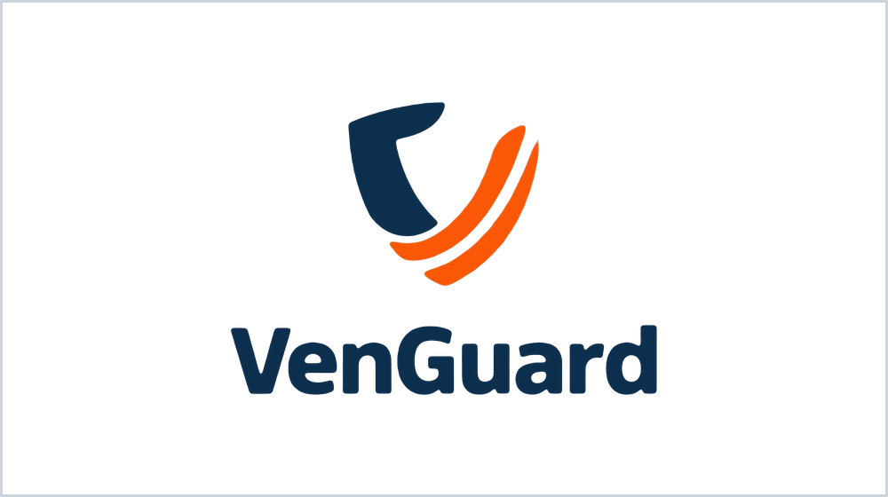  C Stacked lockup  For square or narrow spaces such as posters, signage panels, stickers and merchandise. |   D Symbol only  For app icons, favicons, social avatars, product housings and patterns. Use only where the brand name is already visible or well known.
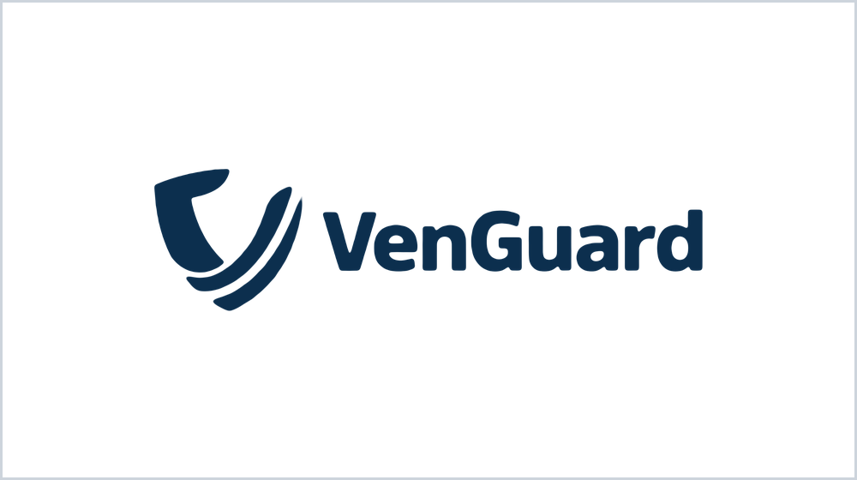  E One colour, Guardian Navy  For single-colour print, embossing, laser etching, stamps and official forms. | 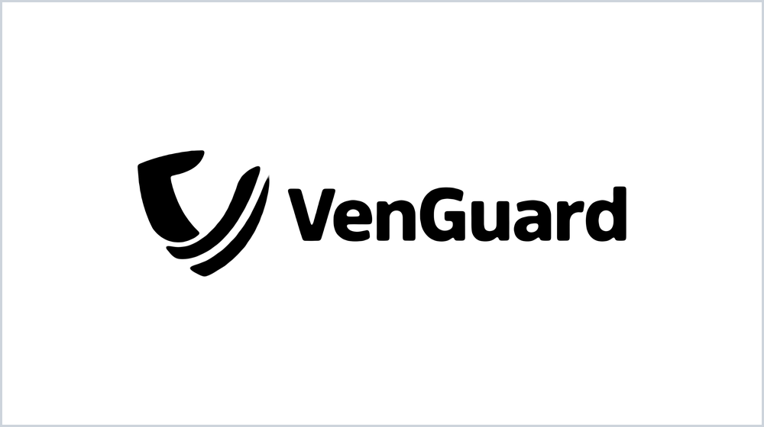  F One colour, black  Only for newspaper ads, fax and black-only printing where colour is impossible.
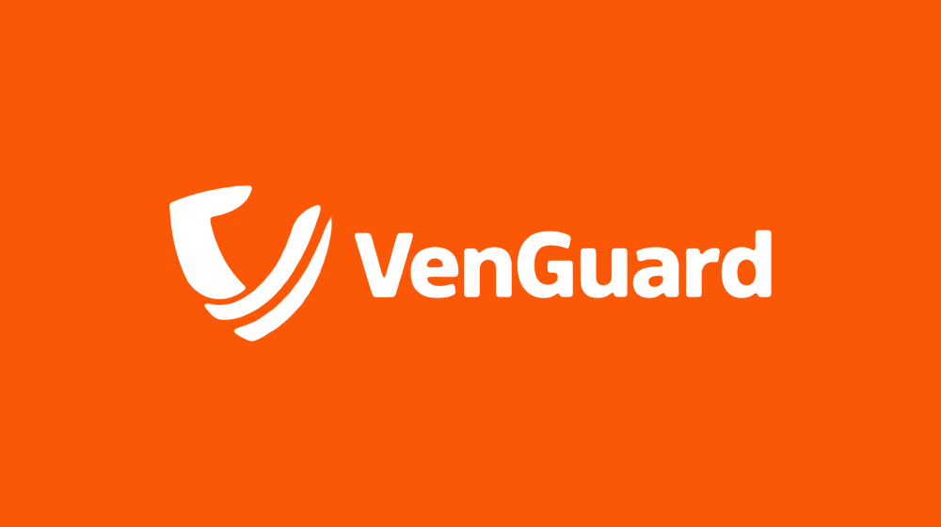  G One colour, white  For Signal Orange backgrounds, coloured surfaces and engraving on dark materials. | 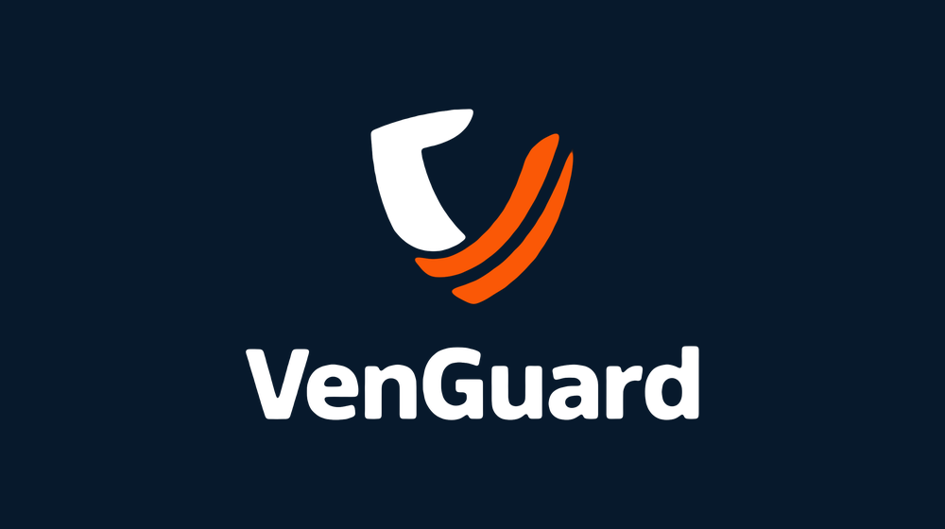  H Stacked, reversed  The stacked lockup for dark backgrounds, with the same rules as version B.

04 Construction and Proportions

The logo is built on a single unit, x. Using x keeps spacing and proportion correct at any size, from a favicon to a billboard.
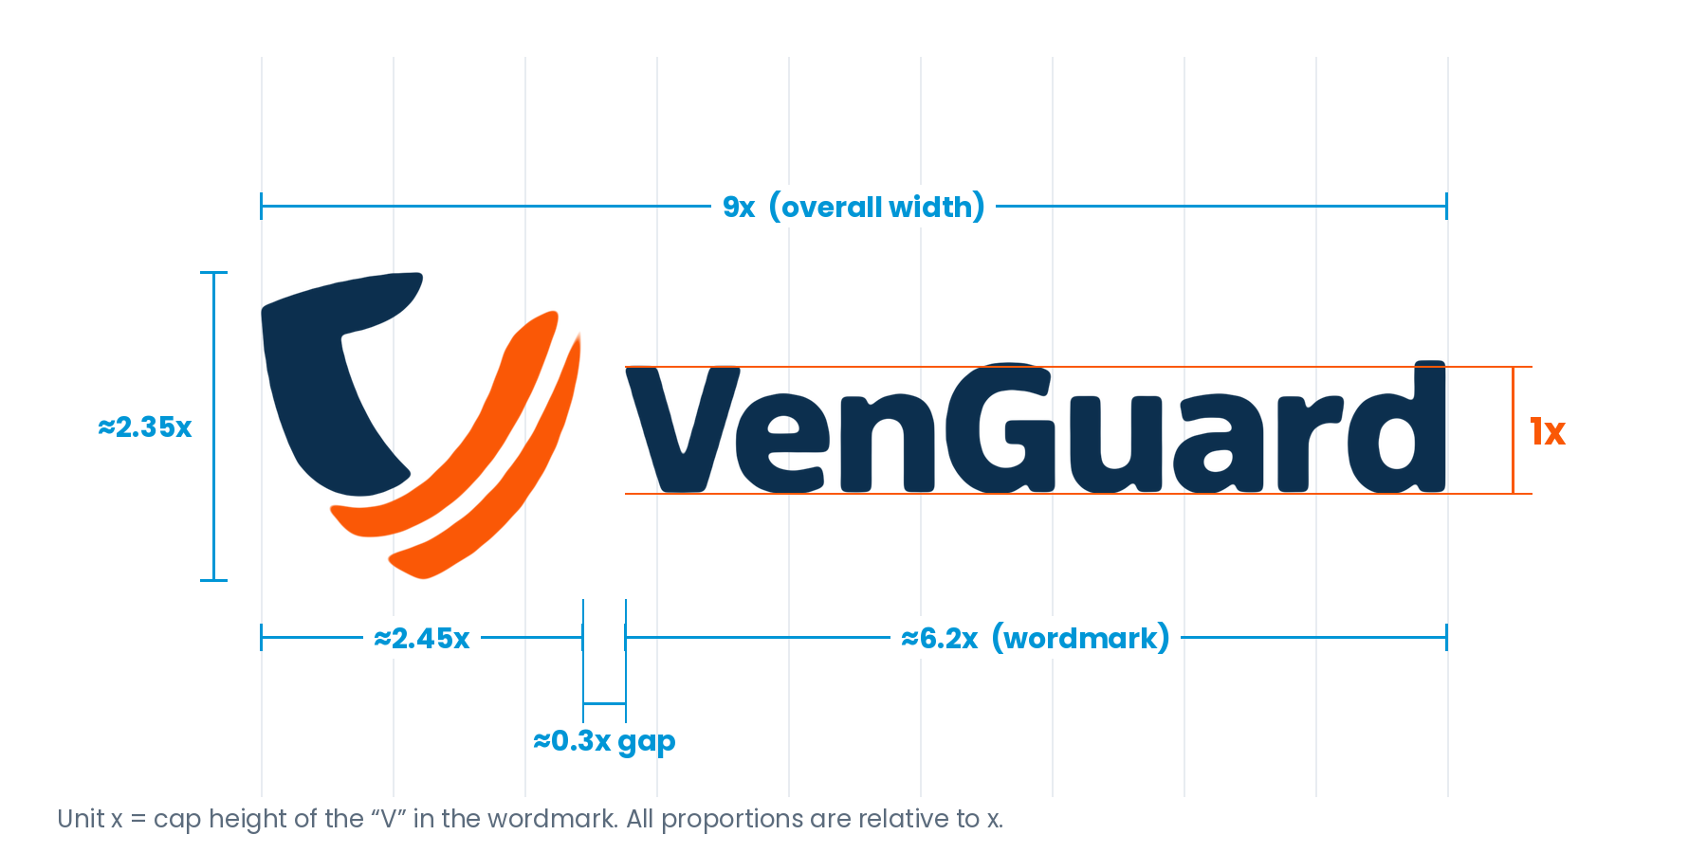
Figure 4.1 Construction grid. One grid column equals 1x.
Measurement | Value | Notes
Unit x | Cap height of the “V” | The base measuring unit for the whole system
Overall lockup width | 9x | Symbol + gap + wordmark
Overall lockup height | ≈2.35x | Set by the height of the symbol
Aspect ratio (primary) | ≈3.85 : 1 | Always scale proportionally; lock the ratio
Symbol width | ≈2.45x | Symbol height ≈2.35x
Gap, symbol to wordmark | ≈0.3x | Fixed; never widen or tighten
Wordmark width | ≈6.2x | Optically centred on the symbol’s vertical middle
Stacked lockup | ≈6.2x wide × 4.3x tall | Symbol centred above the wordmark, gap ≈0.55x

Quick check: for a primary logo 90 mm wide, x = 10 mm. For a logo 180 px wide on screen, x = 20 px. Divide the logo width by 9 to find x.

05 Clear Space

Clear space protects the logo from other elements so it stays visible and recognisable.
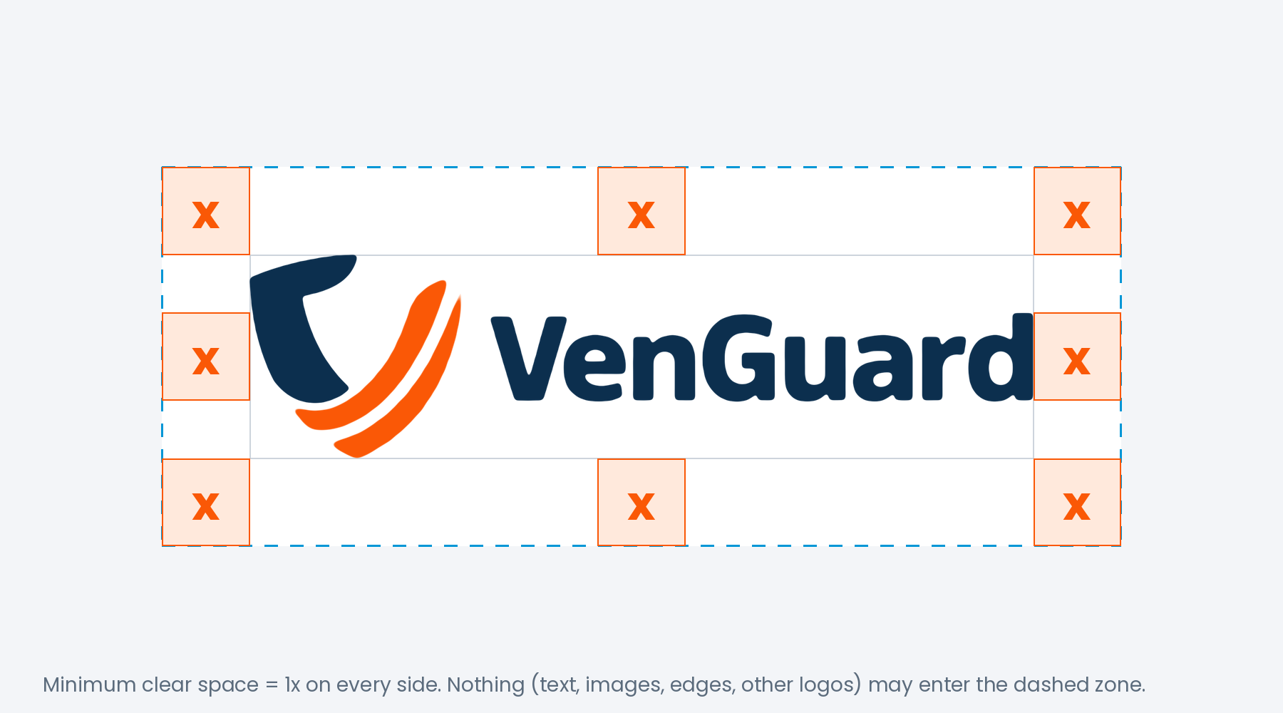
Figure 5.1 Minimum clear space of 1x on every side
- Keep a minimum of 1x clear space on all four sides of the logo.
- For the symbol alone, the clear space is also 1x, measured from the outer edges of the shield and stripes.
- No text, image, graphic, page edge, fold, crop mark or other logo may enter this zone.
- 1x is the minimum. Where possible, give the logo 2x or more; more space always looks more premium.
- On product housings and very small items, clear space may reduce to 0.5x only when 1x is physically impossible.

06 Minimum Size

Below these sizes the guard stripes merge and the wordmark becomes hard to read. Never reproduce the logo smaller than this.
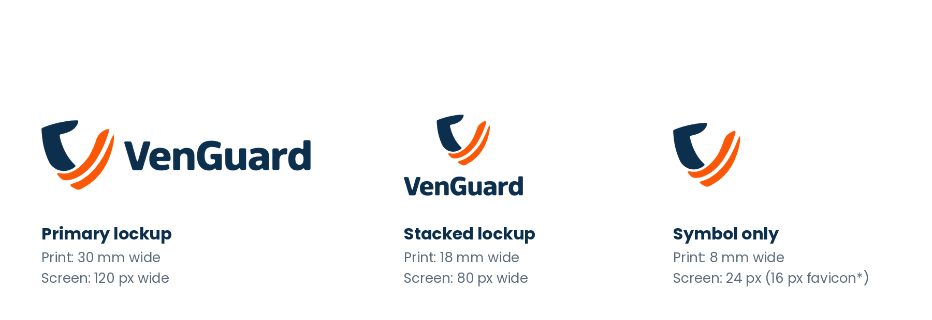
Figure 6.1 Minimum reproduction sizes (illustration, not to scale)
Version | Print (minimum width) | Screen (minimum width)
Primary lockup | 30 mm | 120 px
Stacked lockup | 18 mm | 80 px
Symbol only | 8 mm | 24 px (16 px allowed for favicon only)
Embroidery / engraving | Primary 40 mm, symbol 12 mm | —

If the space available is smaller than the minimum for the primary lockup, switch to the stacked lockup or the symbol. Never squeeze the primary logo.

07 Colour

The palette is built from the two logo colours, supported by a deep navy taken from our website theme and calm neutrals.
Colour | HEX | RGB | CMYK (approx.) | Pantone (nearest)
Guardian Navy  Primary · shield, wordmark | #0C2F4E | 12 · 47 · 78 | 95 · 75 · 40 · 35 | PMS 540 C
Signal Orange  Primary · guard stripes, accents | #FA5806 | 250 · 88 · 6 | 0 · 78 · 100 · 0 | PMS Orange 021 C
Deep Navy  Secondary · dark backgrounds | #07192C | 7 · 25 · 44 | 90 · 75 · 45 · 65 | PMS 5395 C
White  Base · backgrounds | #FFFFFF | 255 · 255 · 255 | 0 · 0 · 0 · 0 | —
Cloud Grey  Neutral · panels, sections | #F3F5F8 | 243 · 245 · 248 | 3 · 2 · 1 · 0 | PMS 663 C
Slate Grey  Neutral · body text, captions | #5B6B7C | 91 · 107 · 124 | 65 · 50 · 37 · 15 | PMS 7545 C
CMYK and Pantone values are starting points. Always approve a printed proof against a physical Pantone swatch before a production run, because results vary with paper and press.

Colour balance: the 60 · 30 · 10 rule
Keep layouts calm and let orange do the signalling. Use about 60% White or Cloud Grey, 30% Guardian Navy or Deep Navy, and 10% Signal Orange. Orange is for calls to action, highlights and the logo stripes, never for large blocks of body text.

Accessibility (WCAG 2.2)
Combination | Contrast ratio | Use
Guardian Navy on White | 13.7 : 1 | Pass AAA. Best for text and logo
White on Deep Navy | 17.7 : 1 | Pass AAA. Dark theme text and logo
Signal Orange on Deep Navy | 5.5 : 1 | Pass AA. Stripes, accents, buttons
Signal Orange on White | 3.3 : 1 | Large text, icons and logo stripes only, not for small text
White on Signal Orange | 3.3 : 1 | Large bold text, buttons and one-colour white logo only

08 Typography

The wordmark is custom artwork and must never be typed. These typefaces are used for all text that appears alongside the logo.
Role | Typeface | Weights | Use
Headlines (English) | Poppins | Bold, Medium | Titles, campaign lines, packaging names
Body (English) | Poppins | Regular, Medium | Paragraphs, captions, UI text
Bangla text | Hind Siliguri | Regular, SemiBold, Bold | All Bangla content; pairs naturally with Poppins
Office fallback | Arial / Nirmala UI | Regular, Bold | Word, PowerPoint and email when brand fonts are not installed

- Poppins and Hind Siliguri are free Google Fonts under the Open Font License, so they can be used anywhere without licence fees.
- Set the tagline “Safety that acts.” in Poppins Medium or Bold, in Guardian Navy, White or Signal Orange.
- The logo wordmark always stays in English. On Bangla materials, keep the logo unchanged and write the surrounding text in Bangla.
- Never place a Bangla translation inside or attached to the logo lockup.

09 Backgrounds and Themes

Choose the logo version by the background. The aim is always strong contrast and a clean, calm surface.
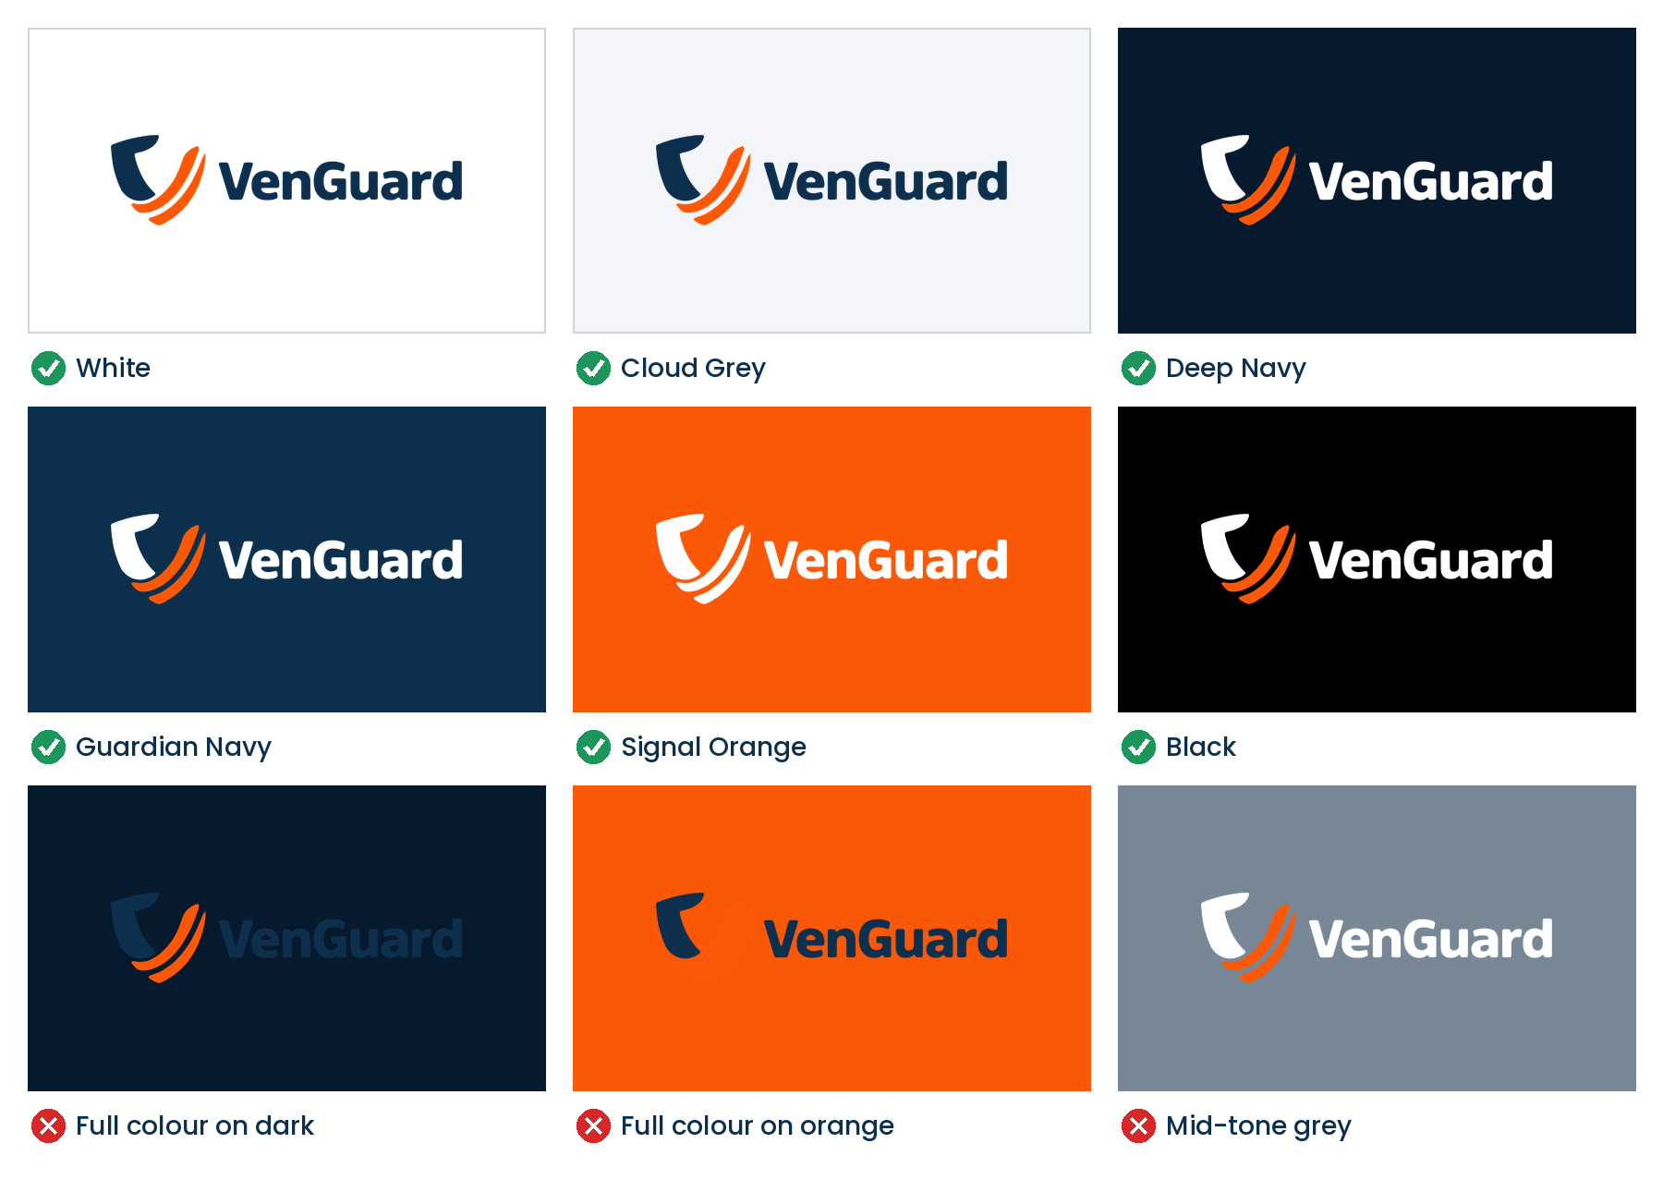
Figure 9.1 Approved and incorrect background combinations
Background / theme | Logo version to use | Notes
White, Cloud Grey, light tints | A Primary (full colour) | Default for documents, website header, packaging
Deep Navy #07192C (website theme) | B Reversed | Website footer, app dark mode, business card front, slides
Guardian Navy, black, very dark colours | B Reversed | Signage, event backdrops, merchandise
Signal Orange | G One colour, white | Never full colour on orange; the stripes disappear
Mid-tone colours or greys | Avoid | Move the logo to a white or dark area, or use a container
Light mode (web and app) | A Primary | Header logo on white
Dark mode (web and app) | B Reversed | Header logo on Deep Navy

On photography
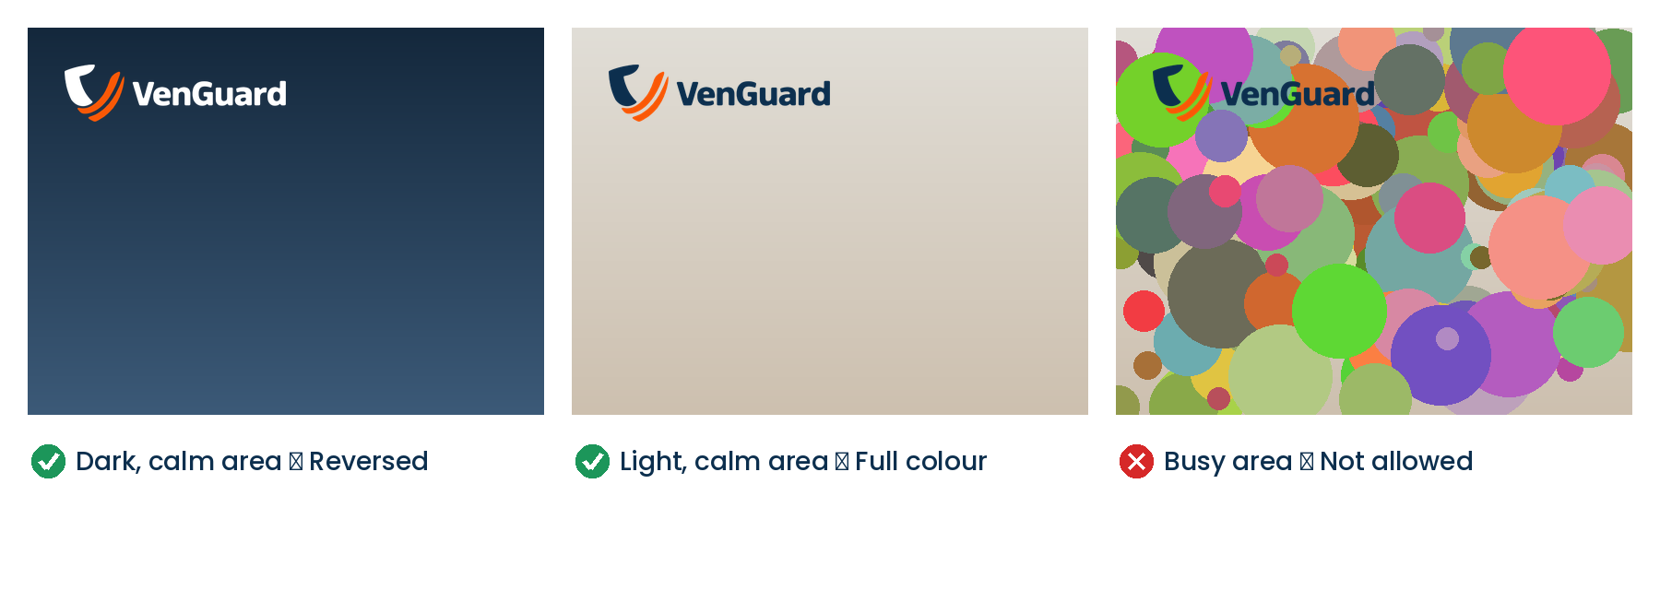
Figure 9.2 Place the logo only on calm, even areas of a photo
Place the logo over the calmest, most even part of an image. Use the reversed logo on dark areas and the primary logo on light areas. If no area is calm enough, add a solid White or Deep Navy panel behind the logo, keeping 1x clear space inside the panel. Never add a drop shadow to improve contrast.

10 Placement and Proportion

Consistent placement makes every VenGuard item feel like part of one family.

Preferred positions
Position | When to use
Top-left (first choice) | Websites, letterheads, documents, packaging, social posts. Matches the left-to-right reading order of English and Bangla.
Centred | Covers, business card fronts, title slides, app splash screens, event backdrops and stories.
Bottom-right (sign-off) | Content slides, social posts led by an image or headline, videos, adverts where the message comes first.

Never place the logo at top-right, bottom-left or floating in the middle of text. Margin from the edge of any format: use whichever is larger, 1x or 5% of the shortest side of the format.

Logo size as a proportion of the format
Format | Version | Position | Logo width
A4 / Letter document | Primary | Top-left | 45 mm (about 21% of page width)
A4 report cover | Primary or reversed | Top-left or centred | 60–80 mm
Business card 90 × 55 mm | Reversed (front) / primary (back) | Centred / top-left | 50 mm / 32 mm
Website header | Primary | Top-left | 36–40 px tall desktop, 28–32 px mobile
Square social post 1080 px | Primary or reversed | Top-left or bottom-right | 22% of width (≈240 px)
Story / reel 1080 × 1920 | Reversed or primary | Centred, below top 14% | 40% of width
Presentation 16:9 | Reversed / primary | Centred / bottom-right | 38% (title) / 12% (content)
Poster A3 / A2 | Primary or stacked | Top-left or bottom-centre | 20–25% of width
Roll-up banner 85 × 200 cm | Stacked or primary | Top, centred | 60–70% of width
Packaging front panel | Primary | Top-left | 40% of panel width
Product housing | Symbol or wordmark, one colour | Front, lower centre | ≈15–40% of face, minimum 10 mm
Video end card | Reversed or primary | Centred | 35–40% of frame width

11 Applications

These examples show how the rules come together. Dimensions in blue are the standard; follow them unless a format cannot physically accommodate them.

11.1 Website
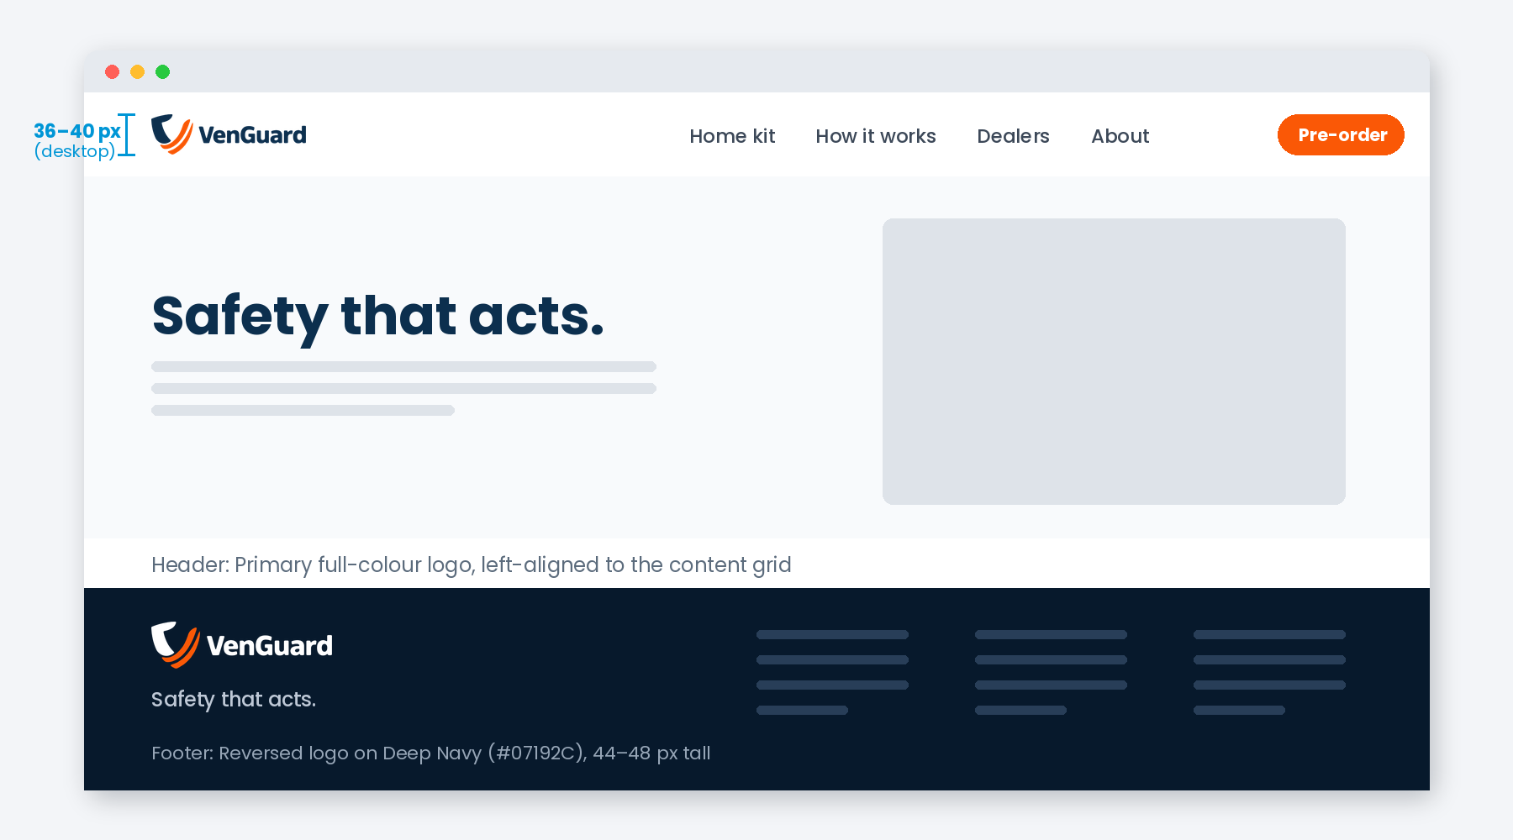
Figure 11.1 Website header (light) and footer (Deep Navy theme)
The header logo links to the home page and sits left-aligned on the content grid. The footer uses the reversed logo on Deep Navy #07192C, matching the site’s theme colour. Keep the logo in an SVG file so it stays sharp on every screen.

11.2 Mobile, app icon, favicon and social avatar
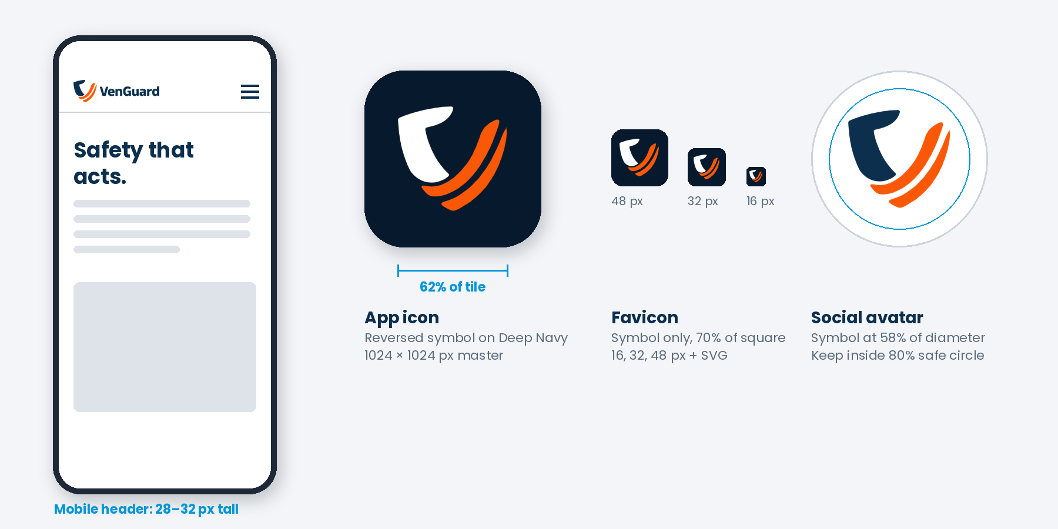
Figure 11.2 Symbol-based applications
Use the reversed symbol on Deep Navy for the VenGuard app icon and favicon so it is recognisable at small sizes. For social profile pictures, centre the full-colour symbol on white at 58% of the circle’s diameter, inside the 80% safe area, because platforms crop avatars to a circle.

11.3 Social media
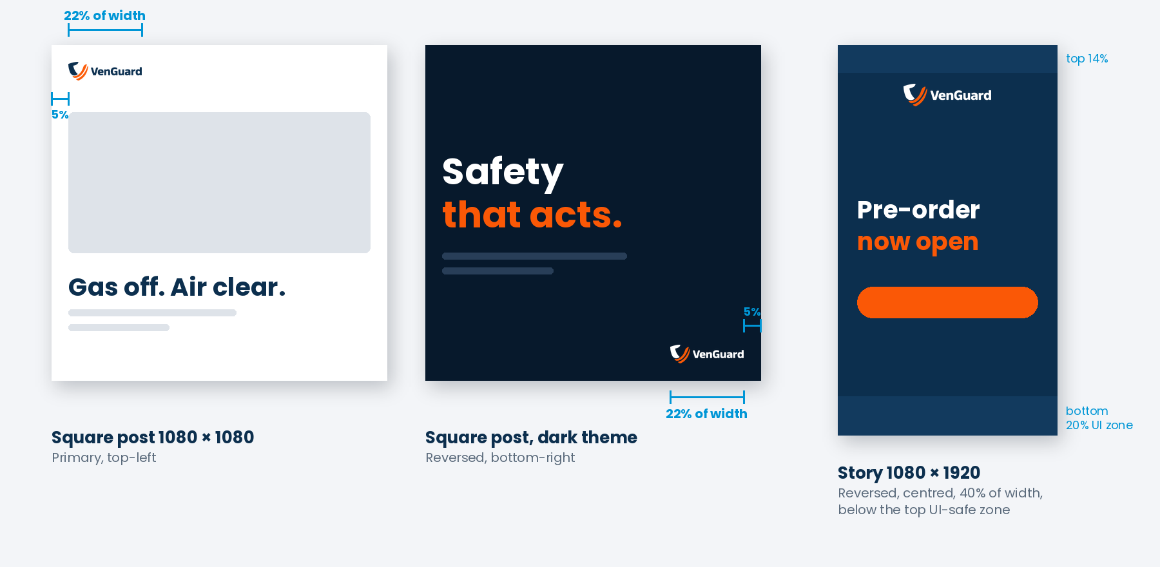
Figure 11.3 Social media placement
Pick one position per campaign and keep it the same across every post. In stories and reels, keep the logo and key text out of the top 14% and bottom 20%, where the platform interface covers the content.

11.4 Business cards and email signature
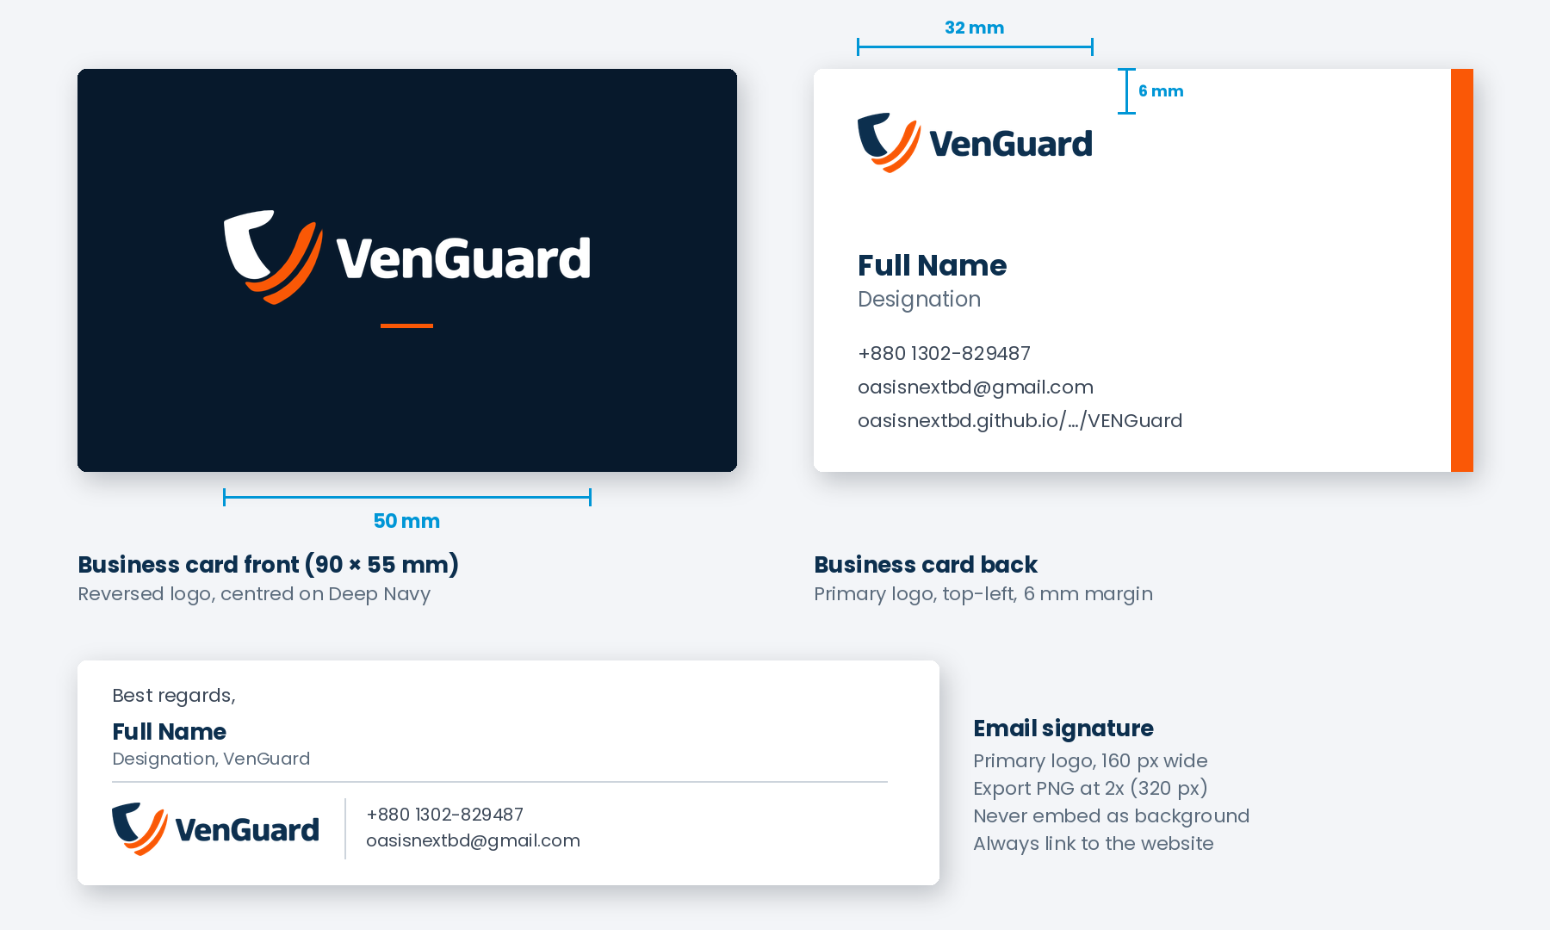
Figure 11.4 Business card (90 × 55 mm) and email signature

11.5 Letterhead and envelope
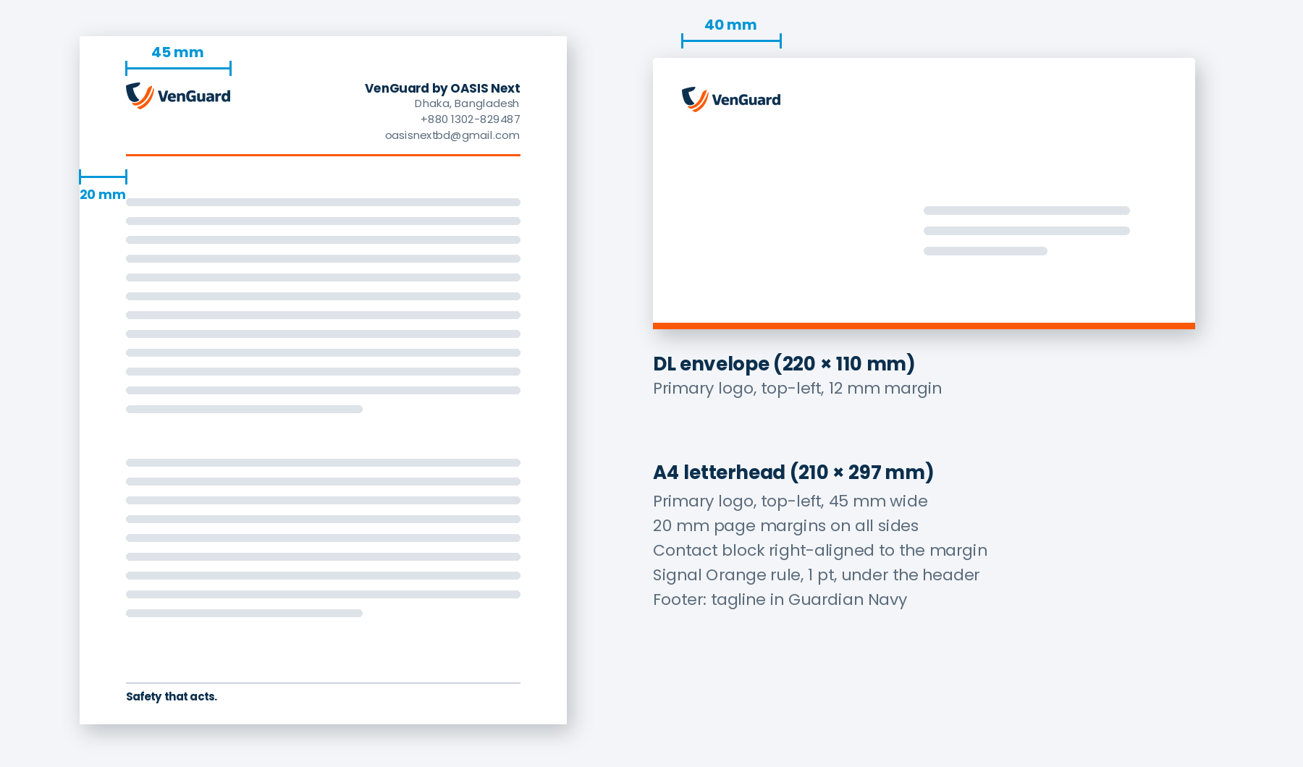
Figure 11.5 A4 letterhead and DL envelope

11.6 Presentations
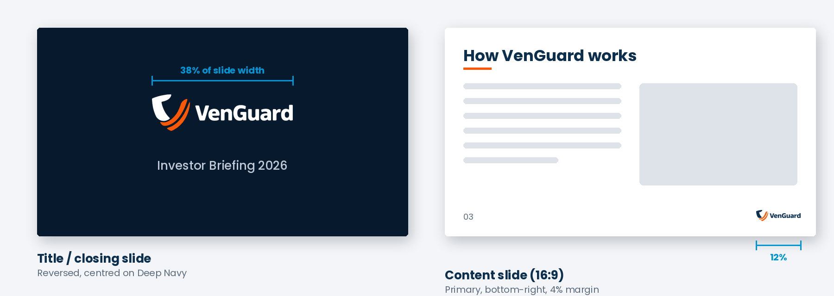
Figure 11.6 Title slide and content slide
Open and close every deck with the reversed logo, centred on Deep Navy. On content slides, place a small primary logo at bottom-right on every slide, or remove it completely; never move it around between slides.

11.7 Product and packaging
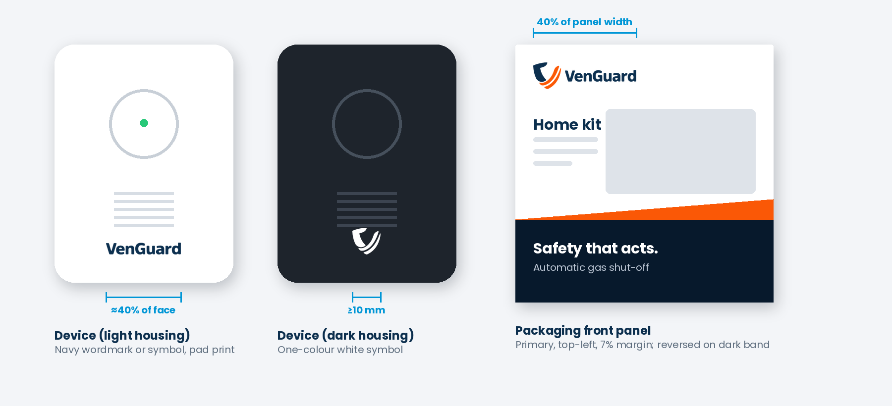
Figure 11.7 Device marking and packaging
On the device, use a single colour (Guardian Navy on light housings, white on dark housings) by pad printing, laser etching or moulding. On packaging, the primary logo leads the front panel at top-left, and the reversed logo may repeat on side panels and dark bands. Safety, certification and regulatory marks must keep their own clear space and never touch the logo.

11.8 Merchandise, signage and vehicles
Item | Version | Position and size
T-shirt / polo | Primary or reversed, embroidered or printed | Left chest, 80–90 mm wide
Cap | Symbol or stacked | Front centre, 50–60 mm wide
Installer uniform | Reversed on navy fabric | Left chest 90 mm; back stacked 250 mm
Dealer shop sign | Primary on white or reversed on Deep Navy | Left or centre, 1x clear space inside sign frame
Vehicle | Primary on white bodywork | Side doors, 40–50% of door width
Event backdrop | Repeat pattern of primary logo | Grid with 2x spacing; one large logo at eye level
Stickers / installation labels | Primary or symbol | Minimum 30 mm wide; durable, non-reflective stock

12 Co-branding

VenGuard often appears with partners, competitions, universities and funders. These rules keep both brands respected.
- Place partner logos side by side in a horizontal row, separated by a thin vertical line in Slate Grey or Cloud Grey.
- Give the two logos equal visual weight; match them by apparent size, not by width.
- Leave at least 2x between the VenGuard logo and the divider, and the same distance on the other side.
- Align logos on a shared horizontal centre line.
- When VenGuard is the host, our logo comes first (left). When VenGuard is the guest, follow the host’s brand guidelines.
- Never merge the VenGuard symbol with another brand’s mark or create a combined logo.
- For “Powered by” or “In partnership with” labels, set the label in Poppins Regular, Slate Grey, above or to the left of the logos.

13 Incorrect Usage

The strength of the logo comes from consistency. These are the most common mistakes. Do not make them.
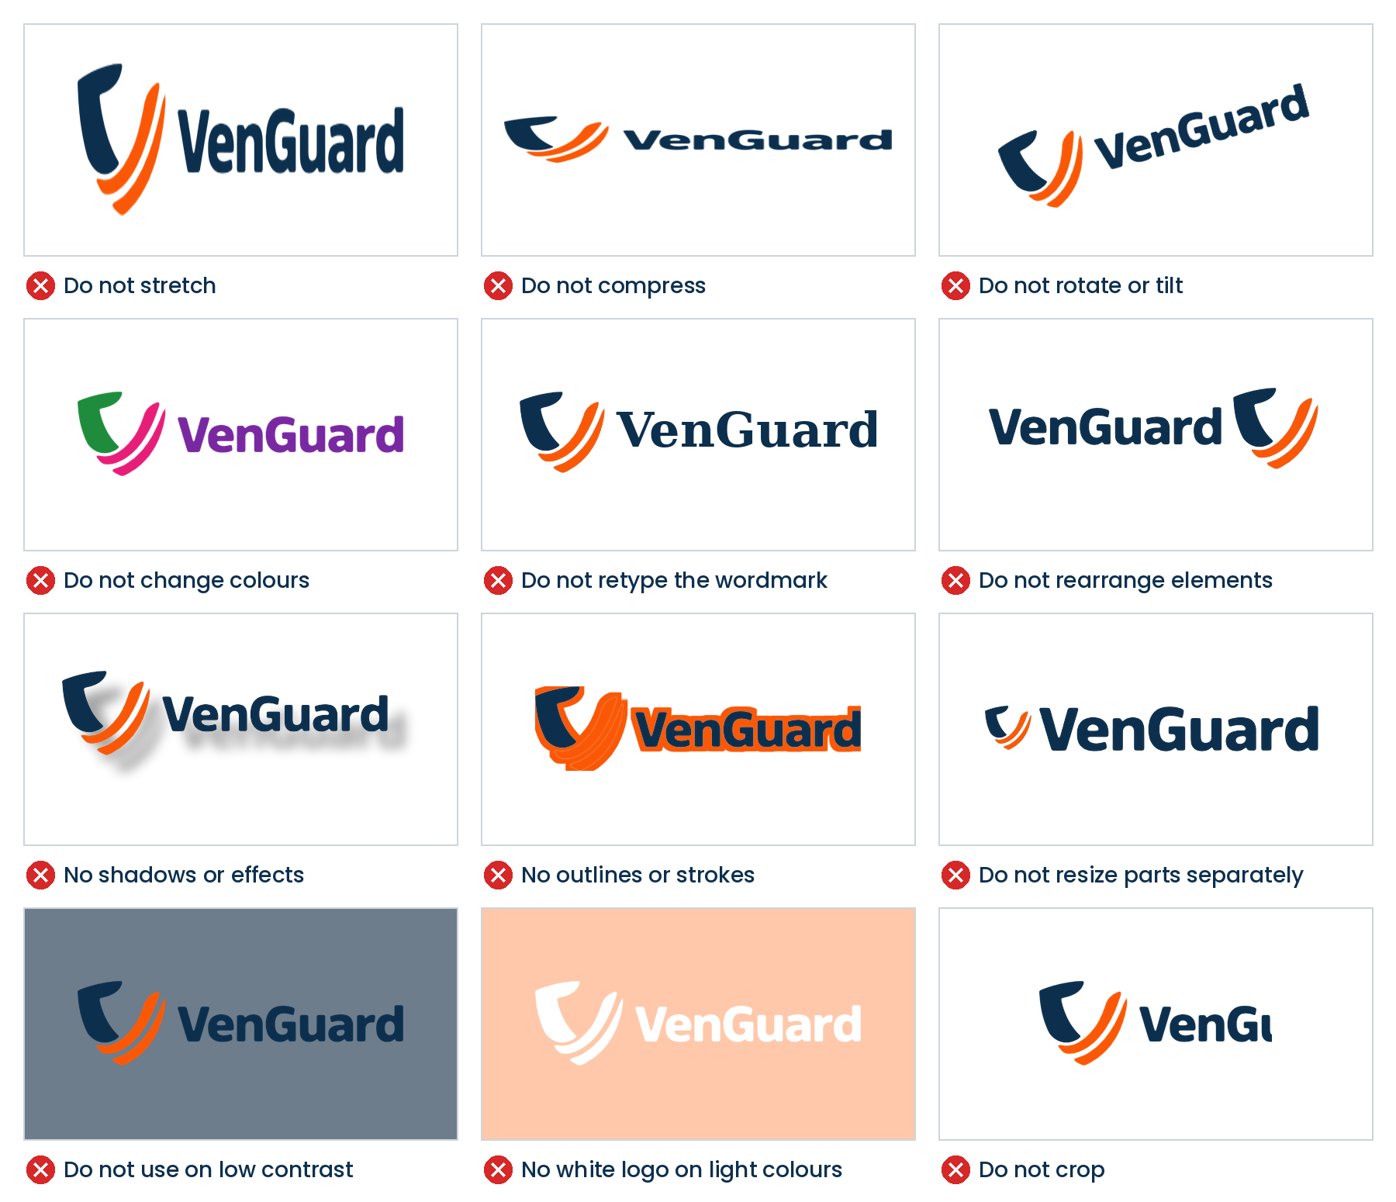
Figure 13.1 Examples of incorrect use
- Do not use a screenshot, a low-resolution copy or a logo from a website or social post.
- Do not animate the logo by bending, spinning or separating its parts unless an approved animation file is supplied.
- Do not use the logo inside a sentence as a replacement for the word “VenGuard”.
- Do not add the tagline, a slogan or any other words to the lockup.

14 Logo Files and Naming

Always pick the right file for the job. Vector files work at any size; PNG is for screens only.
Format | Use for | Colour mode
SVG | Websites, apps, digital documents | RGB
PDF / EPS / AI (vector) | Professional print, signage, packaging, merchandise | CMYK and Pantone
PNG (transparent background) | Office documents, presentations, social media, email | RGB
ICO / PNG 16–512 px | Favicons and app icons | RGB
JPG | Not recommended; only where transparency is not supported | RGB

File naming
Use this pattern so everyone finds the right file: VenGuard_Logo_[Version]_[Colour]_[Mode].[ext]
- VenGuard_Logo_Primary_FullColour_RGB.svg
- VenGuard_Logo_Primary_Reversed_CMYK.pdf
- VenGuard_Logo_Stacked_FullColour_RGB.png
- VenGuard_Symbol_Reversed_RGB_1024.png
- VenGuard_Logo_Primary_OneColour-White_CMYK.eps

Important: create a vector master
The current logo exists as a small JPG image (512 × 286 px). Before any print, packaging, signage or merchandise production, have a designer redraw it as a precise vector master (AI/SVG) using the exact proportions and colours in this guide. All other files should be exported from that single master.

15 Approval and Contact

To protect the brand, any new or unusual use of the logo should be reviewed before it goes public.

Before you publish, check
- Is this an official master file, not a copy or screenshot?
- Is it the right version for the background (Section 09)?
- Does it have at least 1x clear space on every side?
- Is it above the minimum size?
- Is it in the right position and at the right proportion for the format (Sections 10 and 11)?
- Are the colours exact, with no effects added?

Brand contact
Item | Details
Organisation | VenGuard by OASIS Next, Dhaka, Bangladesh
Email | oasisnextbd@gmail.com
Phone / WhatsApp | +880 1302-829487
Website | oasisnextbd.github.io/OASIS_official_website/VENGuard/en/


Safety that acts.

