# Introduction

In this project, our goal was to investigate whether and how transformer language models can aid with problem formulation by suggesting abstractions for problem statements.

We created a computational pipeline using the GPT-Neo transformer language model to <what is the high level intuition of what the model does?>, and evaluated model performance against human judgments. We also investigated how model performance varies by <what were the main things we investigated? Temperature? Model size?>

# System

## Task formulation (formal)

Input?

Instructions?

Output?

Temperature <how did we decide on 0.9>

## Implementation

Libraries to be installed – numpy, pandas, random, string, datetime.datetime, time, transformers.pipeline

# Experiment methods

## Models tested:

* GPT Neo with 125M Parameters
* GPT Neo with 1.3B Parameters
* GPT Neo with 2.7B Parameters

## Coding approach <how did you decide what was good or bad?>

The results of the models were manually coded based on the results.

# Results

Show overall, and describe what you conclude from the graph.

And then by subproblem; also describe what you conclude from the graphs. Any variation by subproblem?

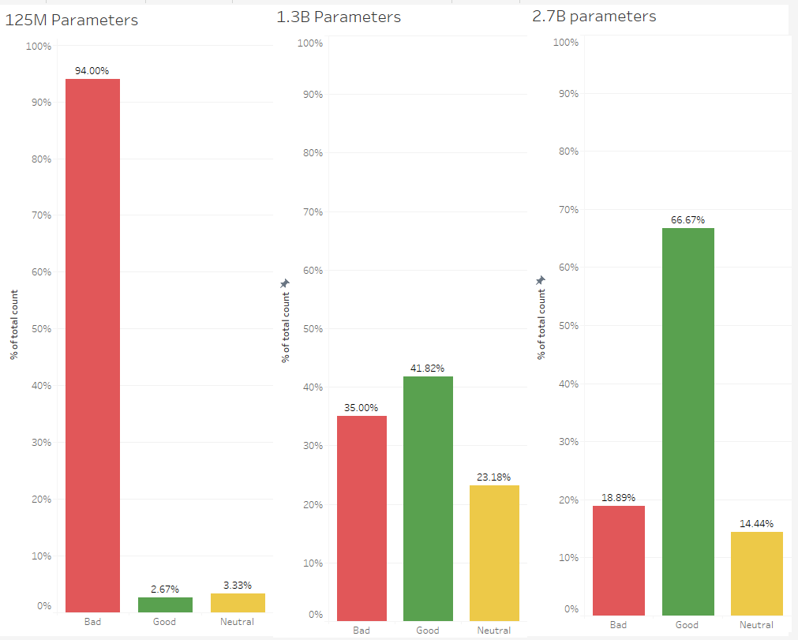

Comparison of average processing times per iteration for all the three models on CPU, GPU and TPU.

