Setup

Libraries to be installed – numpy, pandas, random, string, datetime.datetime, time, transformers.pipeline

Models tested:

* GPT Neo with 125M Parameters
* GPT Neo with 1.3B Parameters
* GPT Neo with 2.7B Parameters

The results of the models were manually coded based on the results.

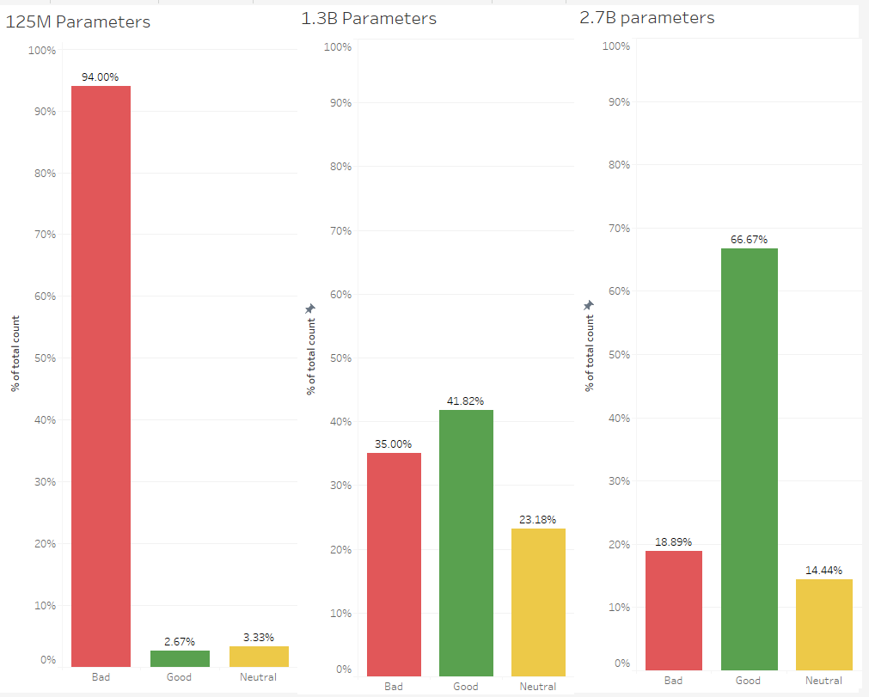

Comparison of average processing times per iteration for all the three models on CPU, GPU and TPU.

