Homework4
Question 9.1

For the crime dataset I apply the principal component analysis (PCA) and then use the resulting components for regression. The resulting components provide the ability to do dimensionality reduction followed by a transformation back to the original feature space.

- PCA Model – Factors and Coefficients:

Implementing PCA, the 15 original correlated variables are transformed into 15 orthogonal (independent) principal components. For this model, I selected the first 6 components, which explain approximately 90% of the total variance in the data. This can be seen by looking at the below table. PC1 alone explains over 40% of the variability, capturing the most significant trend within the crime data predictors. By utilizing the first 6 components in a regression model (as can be seen in the R implementation), we effectively reduce the problem from 15 dimensions to 6 while retaining most of the “signal” and minimizing random “noise”.

After the determination of the 6 components, the linear regression is performed using “lm” and the regression summary table below shows that the adjusted R-squared is 0.6074 (which means that the model explains about 60.7% of the data variance after adjusting for the number of predictors) and the p-value is $4.869*{10}^{-8}$ which means the model is highly statistically significant.

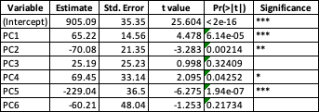

After getting the coefficients from the regression model on the PCA components, we use these values to transform the principal component coefficients back into the context of the original variables.

- Regression Coefficients (PCA space) : Shown in the above table these values represent the “slopes” of the model in the coordinate system of the first 6 principal components.
- Rotation Matrix (V): This matrix (often called the loadings) shows the contribution of each original variable to the first 6 principal components. It is the “map” used to translate between the original 15 variables to the PC space.

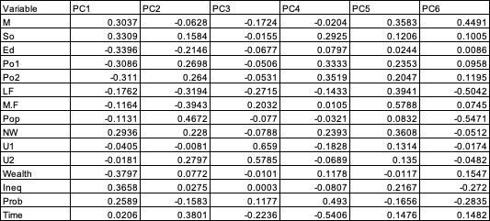

- Scaling and Centering factors: To revert to original units, we must account for the mean (m) and standard deviation (s) used during the initial scaling of the data.

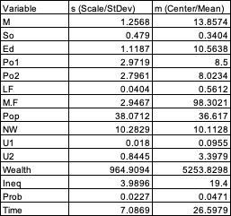
Rescaling Mathematically:

The final coefficients in terms of original variables ($β_{orig}$) are calculated by multiplying the rotation matrix by the PC coefficients and then dividing by the standard deviation of each feature:
$β_{orig}=( V. β_{pca })$ / s
The intercept is adjusted to account for the shifted means:

$$∝_{orig}= ∝_{pca}- \sum_{1}^{15}{\left(β_{orig} . m\right)}$$

Using the above PCA model, the predicted crime rate for the new city is 1248.43.

- Strategy, Analysis, and Judgement:
I used PCA to solve the multicollinearity problem seen in Question 8.2. Variables like Po1 and Po2 are nearly identical; in a standard regression, they “compete” and ruin the model’s stability. PCA combines these correlated variables into single components, capturing the essence of the data without the redundancy.

Analysis: Selecting Components
A ‘Scree Plot’ analysis shows a distinct ‘elbow’ around 5 or 6 components. By using 6 components (k = 6), we capture 90% of the information while discarding the remaining 10% which is likely random noise.

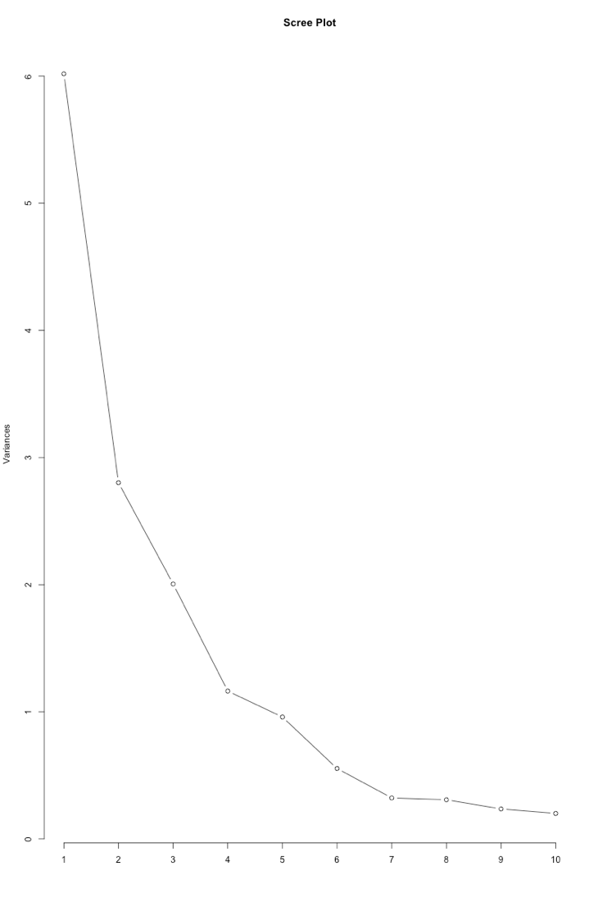

Comparison – Quality/Judgement:

- vs. Full Model: The PCA model is significantly better. The full model overfit the data so badly that it predicated a crime rate of 155, which is unrealistically low. The PCA prediction of 1248 is much more aligned with the dataset’s reality.
- vs. Reduced Model: The reduced model from 8.2 had a higher $R^{2}\left(0.76 vs 0.66\right).$However, PCA is often more robust. While the reduced model simply threw away 9 variables, the PCA kept the information from all 15 but condensed it.
- Final Verdict: Use the PCA model if stability and handling of correlated data are the priority. Use the reduced model if you need to explain exactly which specific real-world factors (like Education) are driving the result.

