Homework4
Question 11.1

- Stepwise Regression (Linear Regression):
Implementation: The implementation uses a bidirectional approach (both forward and backward) to minimize the Akaike information criterion (AIC).
- Initial State: The implementation starts with a full linear model ( lm(Crime ~ ., data = data)) containing all 15 predictor variables.
- Iterative Process: The step() function evaluates adding or removing variables one ata time. The script captures this “path” by parsing the step_log to extract AIC values and the specific variable changes at each iteration.
- Optimization: The process stops when no further additions or removals can lower the AIC, identifying the most statistically significant subset of predictors.
Results and Analysis:
- Model Fit: The final model achieved an Adjusted R-squared of 0.7444, explaining approximately 74.4% of the variance in crime rates.
- Residuals: The Residual Standard Error is 195.5 on 38 degrees of freedom.
- Significant Predictors: The summary output highlights several key variables with high significance (p < 0.01) such as M (percentage of males), Ed (mean years of schooling), Ineq (income inequality), and Prob (probability of imprisonment).
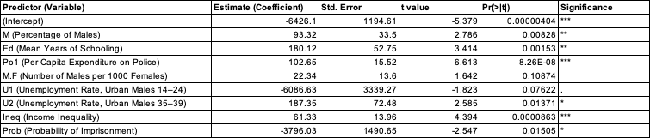

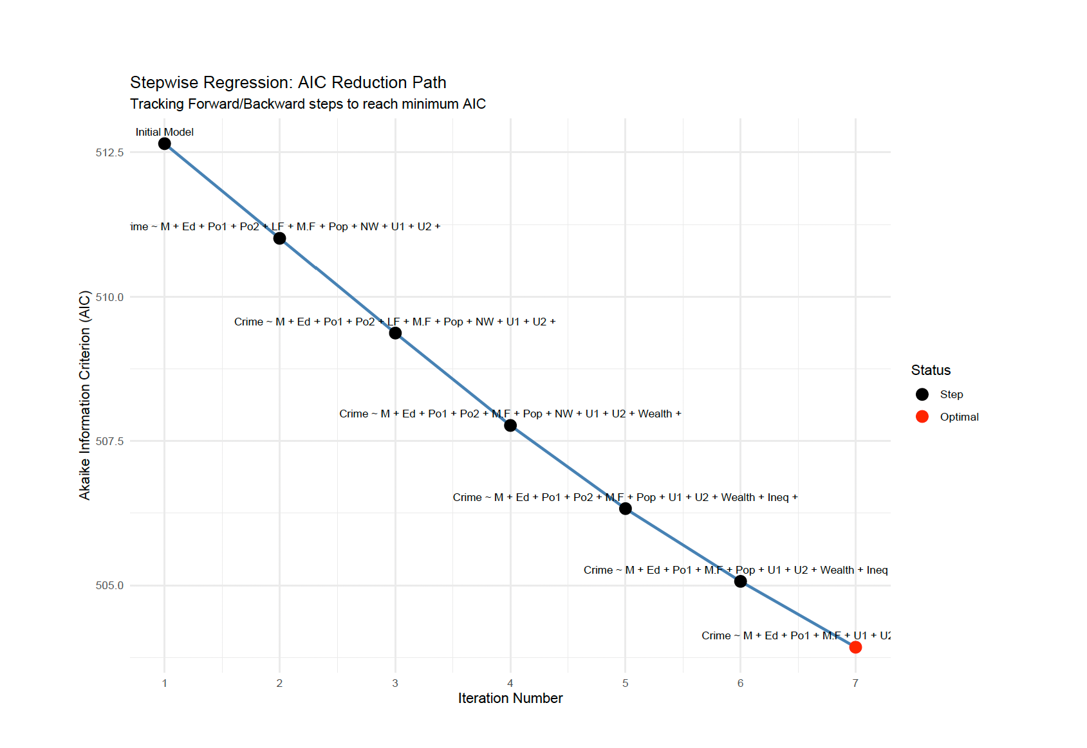

- Lasso Regression ($∝ =1)$:

Implementation: Lasso (Least Absolute Shrinkage and Selection Operator) is implemented via the glmnet package, which adds an L1 penalty to the loss function.
- Standardization: Predictors are scaled (scale(x)) before fitting to ensure the penalty is applied uniformly across different units.
- Tuning: 5-fold cross validation (cv.glmnet) is used to find the optimal $⋋\left(penalty strength\right)$.
- Visualization: The script generates a four-panel diagnostic dashboard:
  - CV Error curve: Shows the mean squared error (MSE) across different log($⋋)$ values.
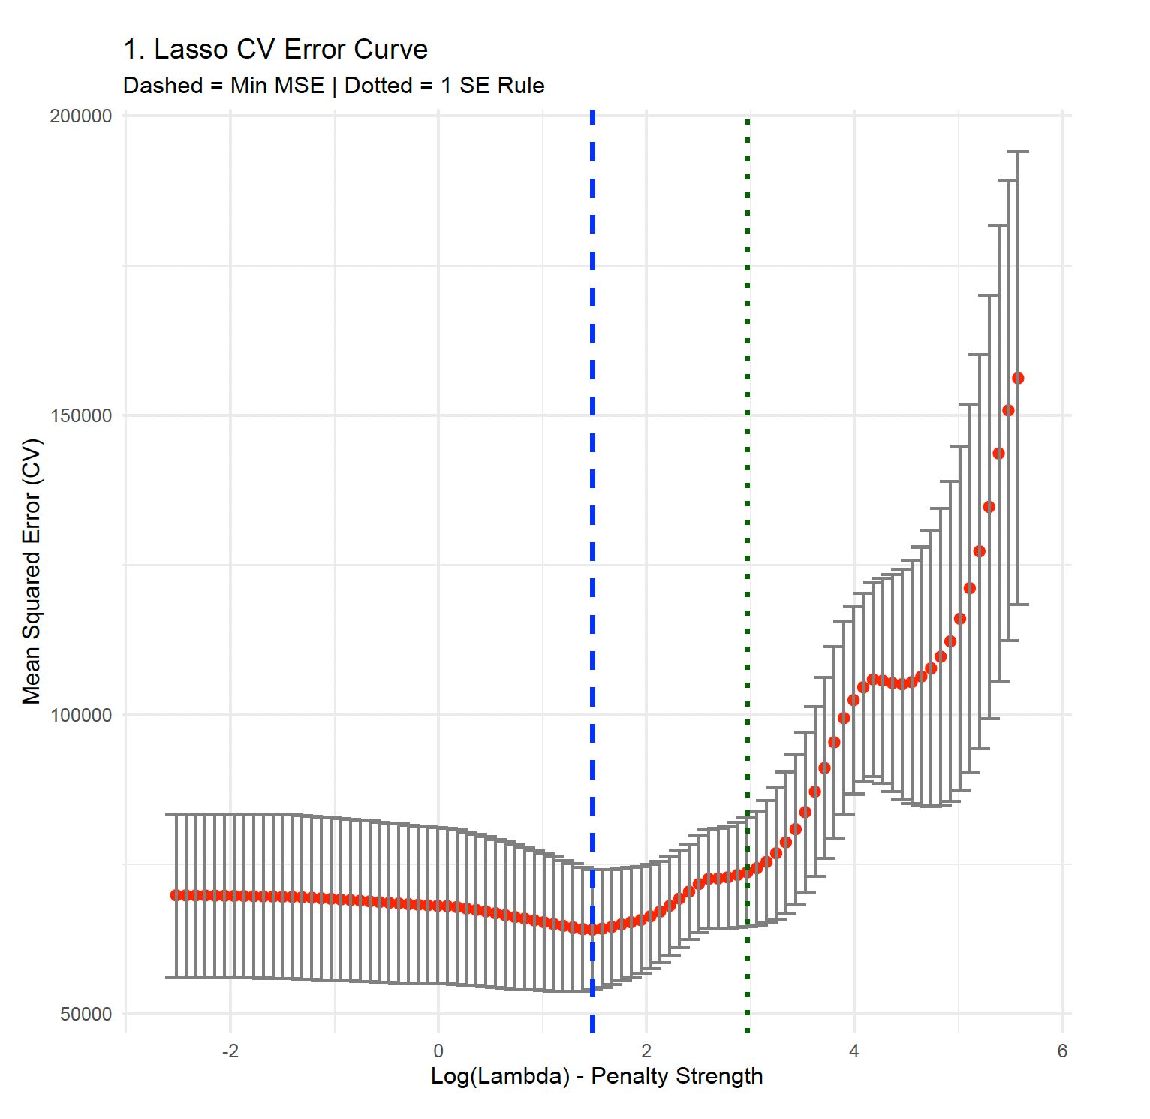
  - R-Squared curve: Tracks the proportion of deviation explained as the penalty increases.
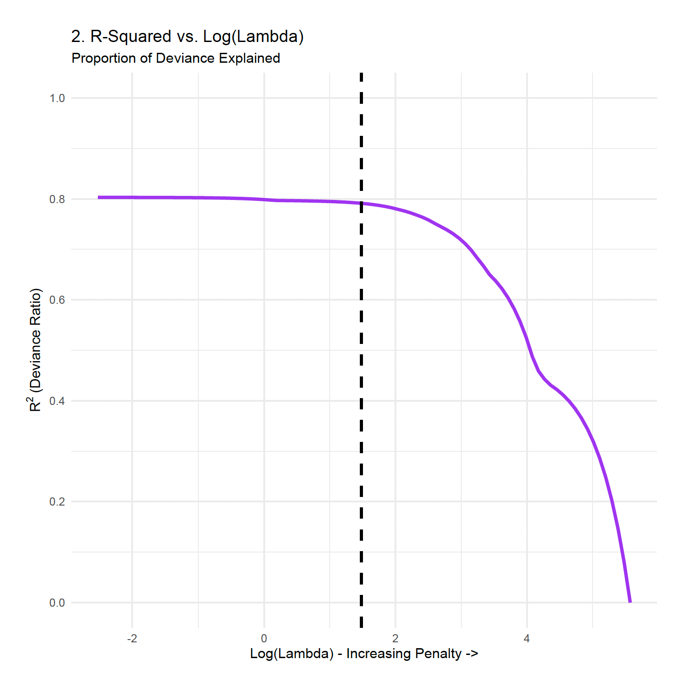
  - Coefficient Path (Lambda): Shows coefficients being “squeeze” to exactly zero.
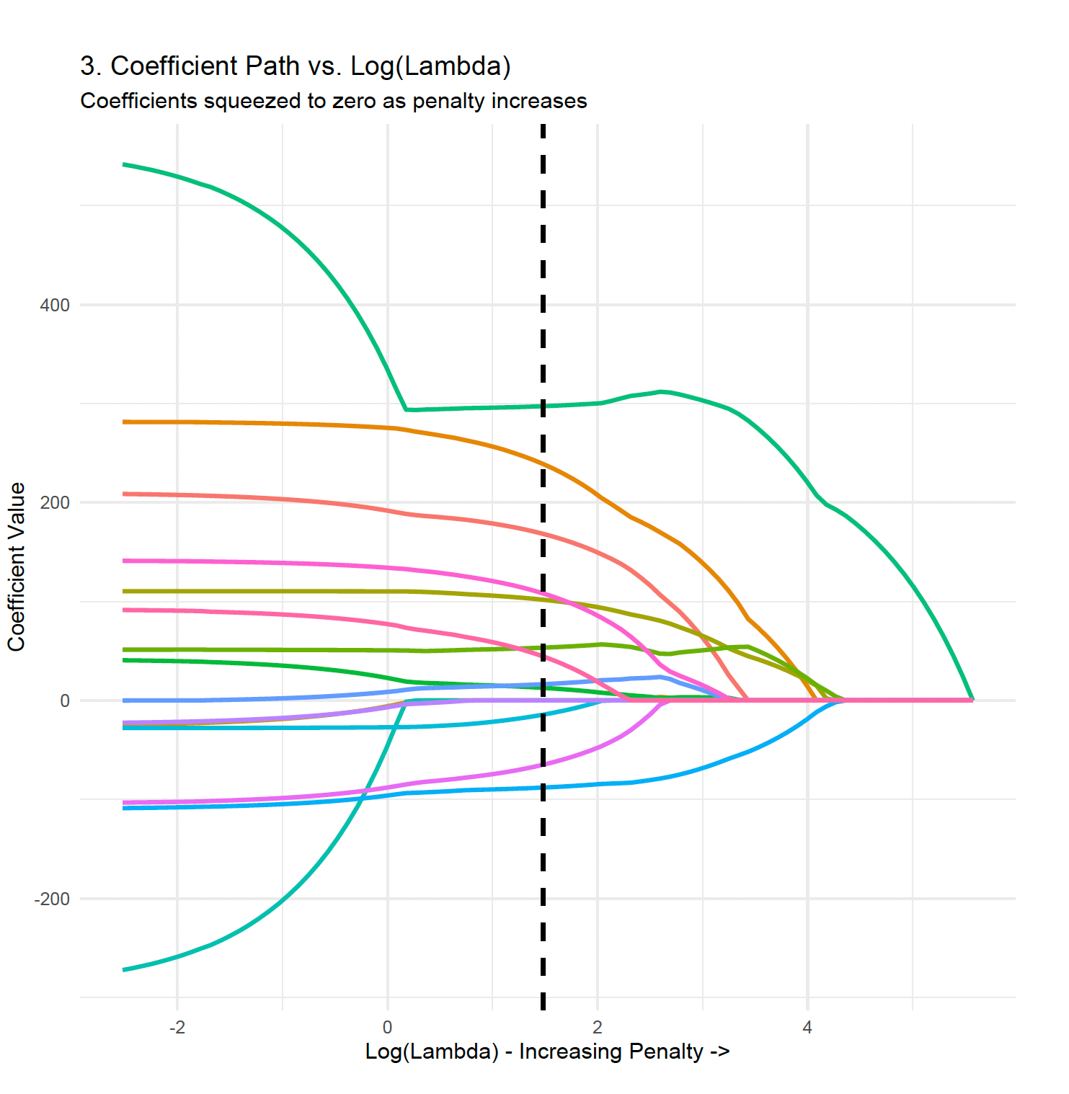
  - Coefficient Path (L1 Norm): Visualizes variable entry as the “budget” (T) for coefficients relaxes.
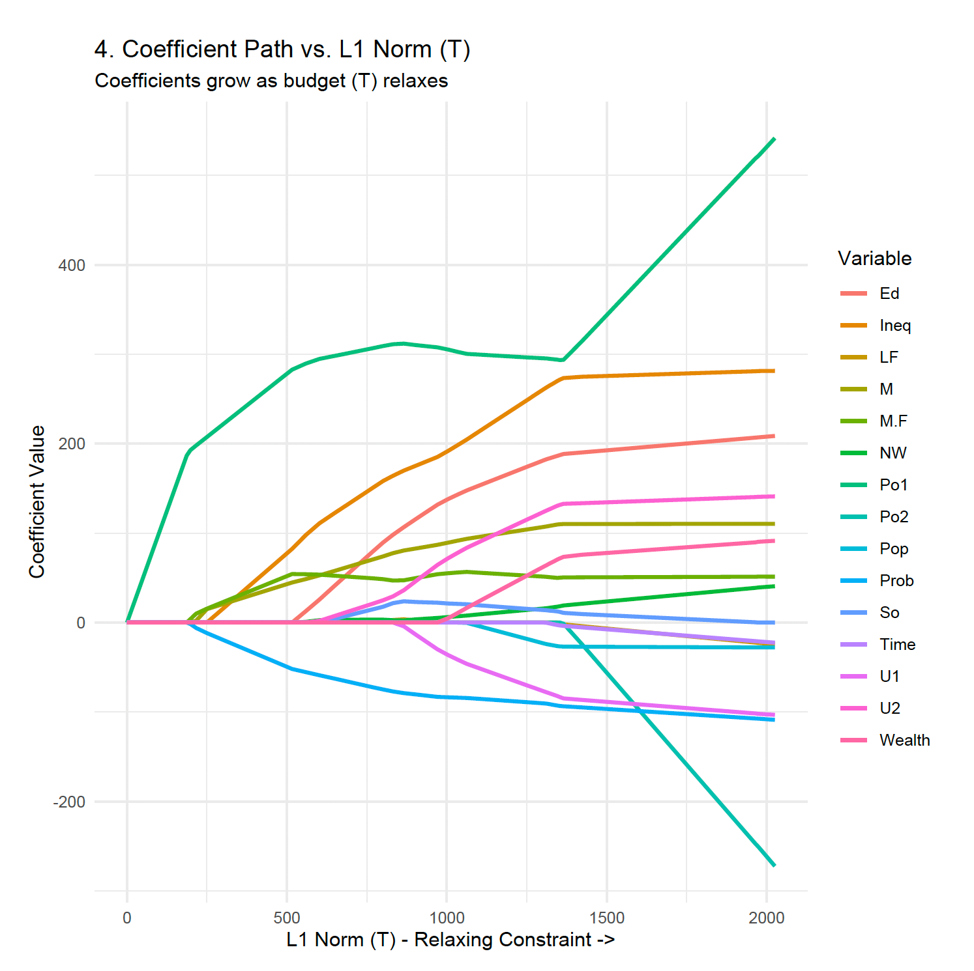
Results and Analysis:
- Variable Sparsity: Lasso successfully performs variable selection by zeroing out less impactful predictors, such as So, Time, and Wealth, as seen in the coefficient paths.
- Optimal Penalty: The “Dashed” line in the diagnostic plots indicated “lambda.min”, while the “Dotted” line shows the simpler “lambda.lse” model.

- Elastic Net Regression ($∝ =0.7)$:

Implementation: Elastic Net combines L1 (Lasso) and L2 (Ridge) penalties. The implementation includes an automated hyperparameter search.
- Alpha Search: The code loops$∝$ values from 0.0 to 1.0 (step 0.1) and selects the one with the lowest CV MSE.
- Selection: The search identified $∝ =0.7$ as the optimal mixing parameter.
- Final Model: A final cv.glmnet is performed at $∝ =0.7$ to select the best $⋋$.
  - CV Error curve: Shows the mean squared error (MSE) across different log($⋋)$ values.
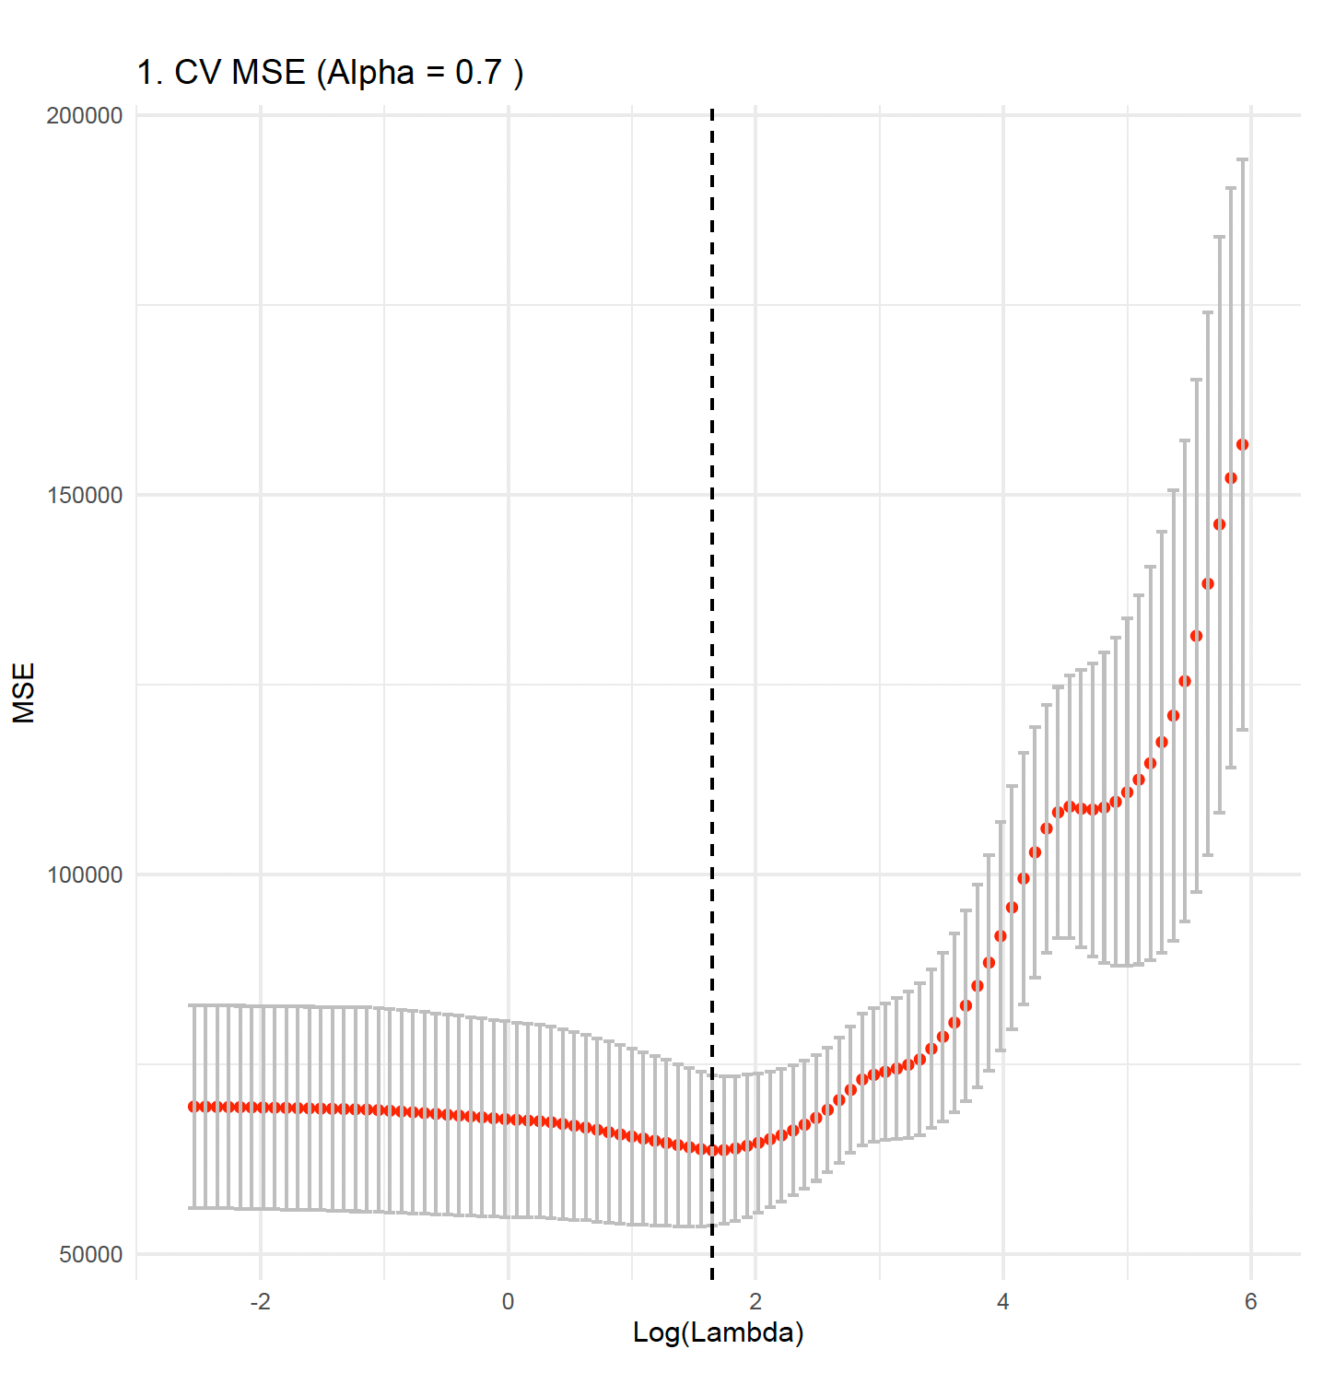
  - R-Squared curve: Tracks the proportion of deviation explained as the penalty increases.
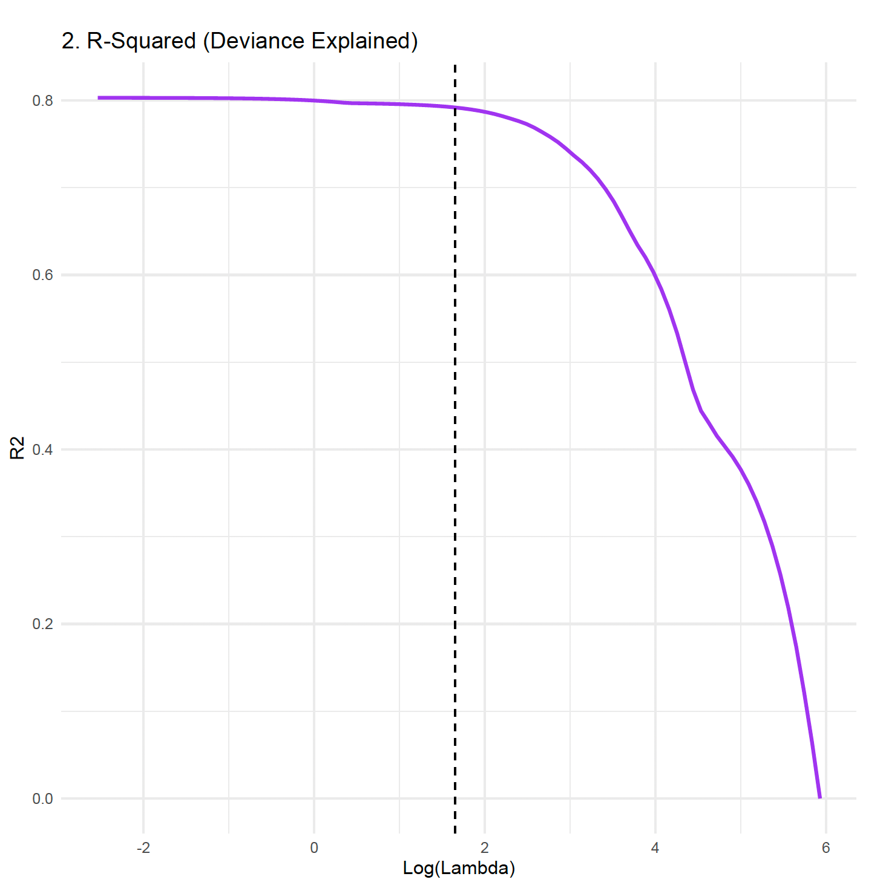
  - Coefficient Path (Lambda): Shows coefficients being “squeeze” to exactly zero.
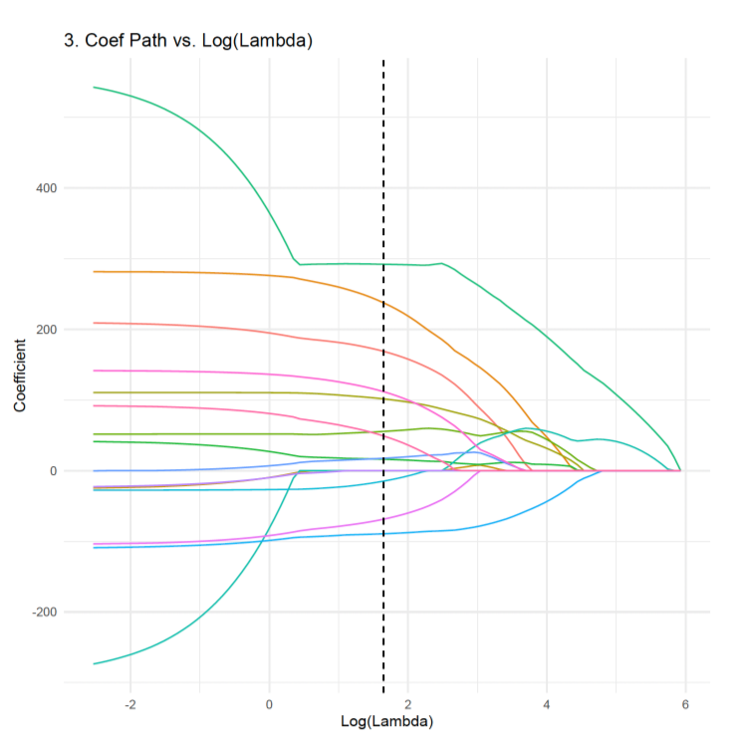
  - Coefficient Path (L1 Norm): Visualizes variable entry as the “budget” (T) for coefficients relaxes.
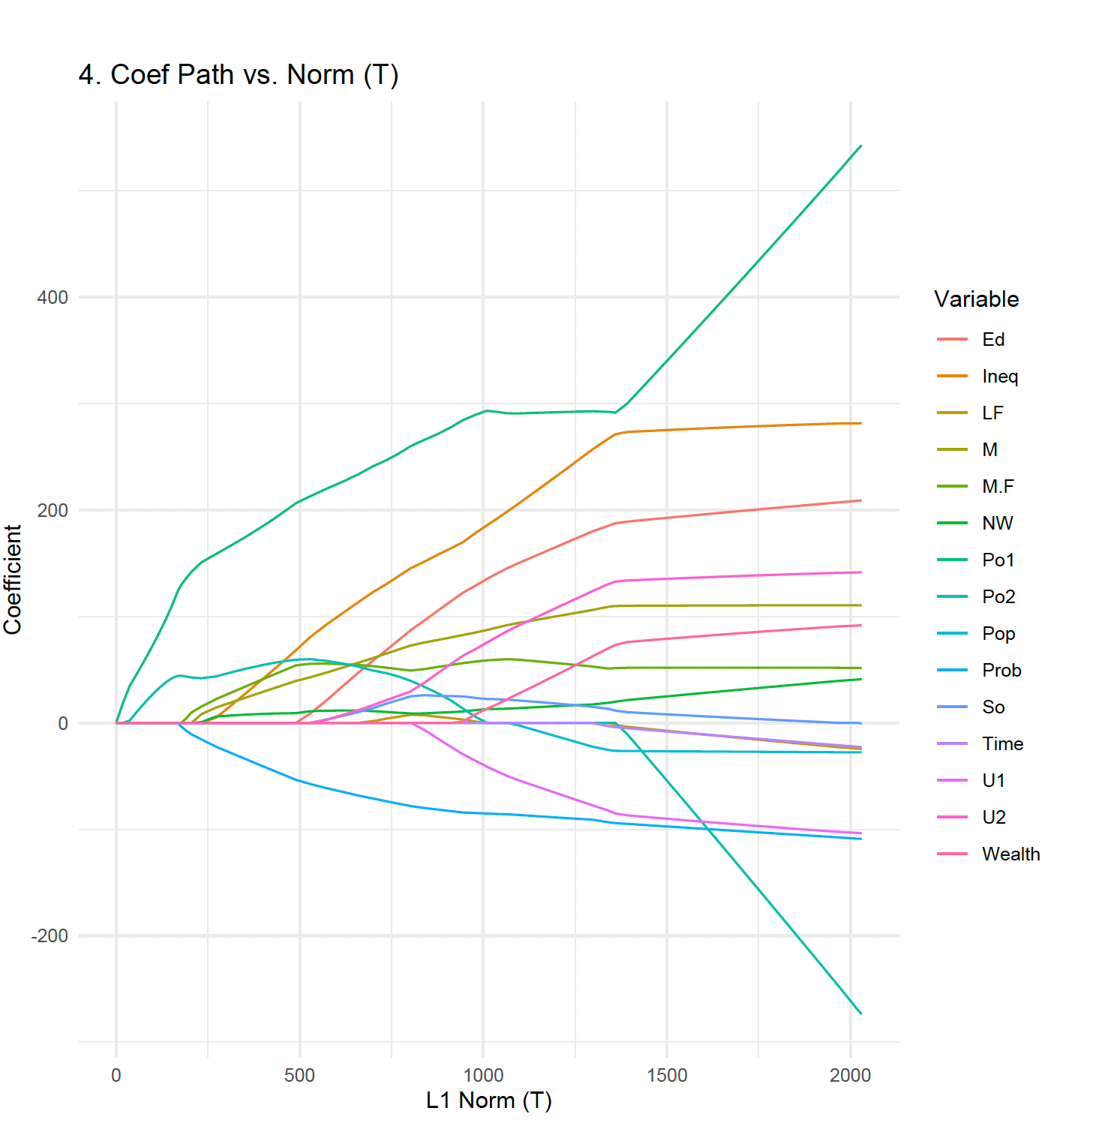
Results and Analysis:
- Hybrid Behavior: With $∝ =0.7$, the model behaves more like Lasso than Ridge but retains enough influence to handle potential multicollinearity between variables like Po1 and Po2.
- Predictive Power: The R-squared plot for the Elastic Net shows a high peak deviance ratio (approx. 0.7-0.8) before the penalty becomes too severe.
- MSE Performance: The CV MSE curve for $∝ =0.7$ shows a clear “U-shape”, identifying a precise $⋋$ that balances bias and variance better than a standard linear model.
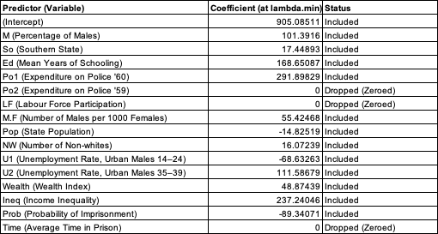

- Detailed Comparison:
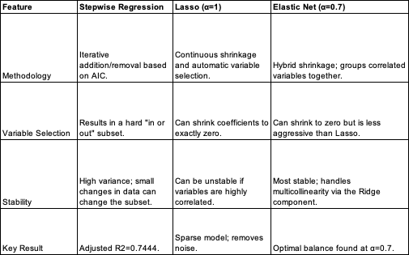

The stepwise model provides the most interpretable list of predictions but risks overfitting. Lasso is effective for automated feature selection but may arbitrarily pick one variable from a correlated group. Elastic Net ($∝ =0.7$) is the superior implementation for this dataset as it provides the predictive benefits of Lasso while using a hybrid penalty to maintain model stability across the 15 crime-related predictors, effectively handling potential multicollinearity between related variables like Po1 and Po2. It also performed variable selection by shrinking the coefficients of Po2, LF and Time to exactly zero. It also showed variables with largest positive impact are Po1 (291.90), Ineq(237.24), and Ed(168.65), indicating they are strong positive predictors of crime in this model.

