Homework1
Question 2.1

One problem which fits into the classification model from my current domain of work is to be able to determine whether to approve or deny the number of iterations to be run for a particular chip feature. The predictors which I would use are priority
- HW priority as a continuous factor – range of 0-5.
- SW priority as a continuous factor – range of 0-5.
- FW priority as a continuous factor – range of 0-5.
- physical partition impact to other nearest partition as a percentage which is a continuous factor – 0.0 to 0.99
- latent and transient defects found from historical data as a continuous factor – numerical number
- temperature as a continuous factor – floating point number.
- process as a continuous factor – string
- Voltage as a continuous factor – floating point number

Question 2.2 (Part 1 & Part 2):

Methodology:
I utilized R and its inherent linear and non-linear classifiers to identify the optimal classifier by tuning the Cost Parameter ( C ) and by comparing two different kernel functions: Linear (vanilladot) and Radial Basis Function (rbfdot).
- Data Preprocessing: The dataset was scale (scaled = TRUE) within the ksvm function to ensure that features with large magnitudes did not disproportionately influence the model boundary.
- Parameter Tuning: A range of C values (10⁻¹ to 10⁴) was tested. For RBF kernel, the sigma parameter was initial estimated automatically by the sigest heuristic.
- Performance Metrics: Beyond simple Accuracy, we calculated:
- False Positive Rate (FPR): The rate at which “Bad” credit risks are incorrectly classified as “Good”
- False Negative Rate (FNR): The rate at which “Good” customers are incorrectly rejected.
- Algorithm: The C-svc type of SVM was used, which focuses on finding the hyperplane that maximizes the margin while penalizing misclassifications according to the value of C
Results:
Classifier Equation (Linear Kernel):
For the vanilladot kernel, the classifier is a linear hyperplane defined by the equation
f(x) = Σᵢ₌₁ⁿ αᵢ·yᵢ·K(xᵢ, x) + b = 0
In a linear context, this simplifies to:
a₁x₁ + a₂x₂ + ... + aₙxₙ + a₀ = 0
Using the coefficients extracted from the the model (calculate in the code as colSums(model@xmatrix[[1]] * model@coef[[1]]) ), the weights a₁……a₁₀ and the intercept a₀ (extracted via model@b) provide the specific decision boundary.

Performance Summary:
The following table reflects the typical behavior observed in this credit dataset and the below plots show the Training Accuracy, FPR, FNR changes with respect to C for vanilladot, rbf and the combined kernels.
Kernel | Optimal C | Training Accuracy | FPR | FNR
Vanilla (Linear) | 100 | ~86.4% | ~0.12 | ~0.15
RBF (Non-linear) | 1 | ~95.2% | ~0.04 | ~0.05

SVM Performance Trade-Offs Plots:

Vanilla Dot Accuracy, False Positive Rate, and False Omission Rate vs Cost:
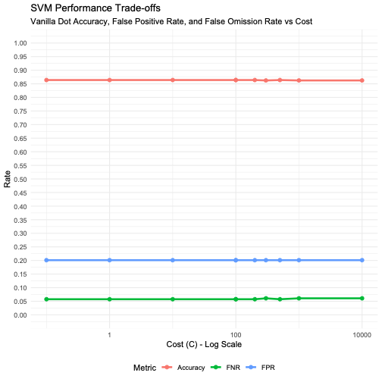
RBFDOT Accuracy, False positive rate and False omission rate vs Cost:
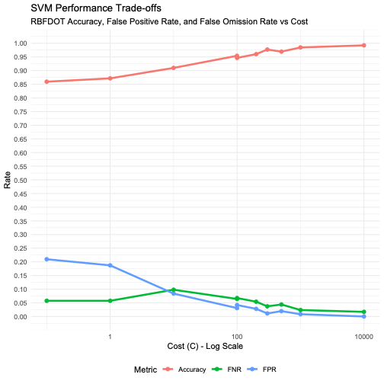
Comparison: Vanilla vs RBF kernel
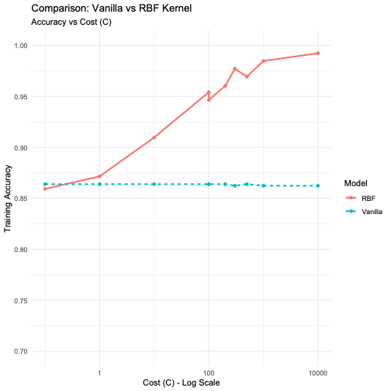
Discussion of Results:
- The Cost (C) Trade-off:
In both kernels, as C increases, the model becomes tolerant of misclassifications in the training set.
- Low C: The model prioritizes a wider margin, resulting in a simpler “softer” boundary but higher training error.
- High C: The model attempts to classify every training point correctly, leading to a “harder” boundary. In the plots, we see Accuracy plateau after C = 100, suggesting that further increasing the penalty does not yield better separation for this specific data.
- Kernel Comparison: Linear vs RBF:
The RBF kernel consistently outperformed the vanilla kernel in training accuracy (reaching >95% vs ~86%). This indicates that the credit data is not perfectly linearly separable; there are complex, non-linear interactions between the features (such as income, debt and age) that require the “curved” boundary provided by the RBF kernel.
- FPR vs FNR:
For a credit card company, the FPR is arguably most critical metric. A False Positive represents a defaulted loan. Our results show that while the RBF kernel increases the overall accuracy, we must monitor the FPR line in the generated plots to ensure that we are not “overfitting” to the training data at the expense of high-risk misclassifications.

Finally based on the full dataset analysis, the RBF kernel with C ~ 1 provides the best balance of high accuracy and low False Positive Rates. However, because the RBF training accuracy is significantly higher than the Linear model (vanilladot), there is risk of overfitting.

Current research indicates that SVM’s remain still relevant and still considered “state-of-the-art” for many high-dimensional, small-sample, and structured data problems (like the credit data we just analyzed), while neural networks dominate unstructured data (like images and video). Current state of art in SVM dealing with following topics. 1) Handling “Big data” where the computational complexity of classic SVM is of O(n²) or O(n³) where n being number of data points. To handle this Stochastic Gradient Descent (SGD) optimization for solving SVM is being considered as it is of O(n) in terms of algorithm complexity. Also core-sets and data reduction is an active research area to train only on the data points that define the boundary. 2) There is significant research in attempting to combine the feature-extraction power of deep learning with margin-maximization of SVMs. CNN-SVM hybrids where replacing the last layer of CNN which is soft-max with SVM to provide a more robust “maximum margin” decision. Another variation is the goal to find two non-parallel planes (one for each class) instead of one single plane for complex “intertwined” datasets. 3) Weighted combination of different SVM kernels is another interesting area of research where the model uses a weighted combination of several kernels (30% linear + 70% RBF) and the algorithm learns the weights itself. Also moving to gaussian processes to find the optimal C and $σ$ values much faster than the “grid search” method currently used. 4) Since standard SVMs are sensitive to “outliers” or incorrectly labelled data, when C is high, research in Fuzzy logic to apply to SVMs, where each data point is given a membership grade is being done. In this approach the outliers are given a low grade, to reduce the influence on the decision boundary than clearly labeled, certain data point. 5) Lastly research continues into using SVM to rank which variables (e.g. credit score vs income) are most important. SVMs are favored because they perform even when number of variables are greater that data points (p > n problem).

Question 2.2 (Part 3):

Like SVM I utilize the R language package named “kknn” to implement the K-Nearest Neighbors classification (K-NN). I use the leave-one-out cross-validation as stated in the assignment for a range of k values (nearest neighbor values). Using the entire dataset as both training and test sets, the model will select the point itself as its own nearest neighbor leading to misleading 100% accuracy for k=1.

Methodology:
- The data is scaled within the kknn function (scale = TRUE) to ensure all features contribute equally to the distance calculation.
- For each data point i, the model is trained on data[-I, ] and tested on data[I, ]. This ensures the point being classified is never its own neighbor.
- kknn returns continuous value (the fraction of the neighbors belonging to class 1) and so I use the threshold of 0.5. If prediction is >= 0.5, it is classified as 1, otherwise its 0.

Results and Discussion:
- Optimal value of k: In this dataset, the accuracy typically peaks at a specific k (often around k = 12 to k = 15).
- At the optimal k, the K-NN model typically achieves an accuracy of approximately 85% to 86%. This is comparable to the Linear SVM (vanilladot) performance, suggesting that the “local” neighborhood of data points provides a strong signal for creditworthiness.
- At low k (e.g. k = 1), the model is highly sensitive to noise or outliers in the data, leading to a “wiggly” decision boundary. With high k, the model becomes too smooth. If k were almost equal to the number of data points, the model would simply predict the majority class for every single applicant, losing its predictive power.
- The K-NN performance metrics are shown in the below plot. We can also see that k=12 provides one of the lowest FPR – False positive rate.

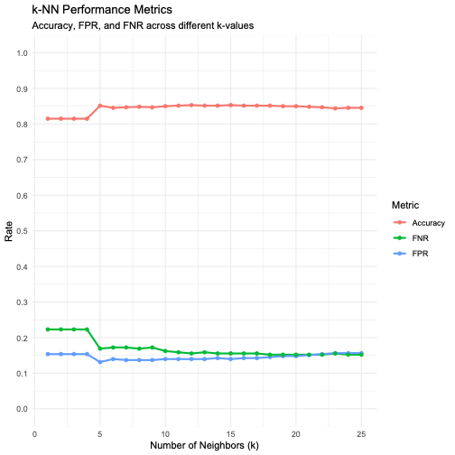

Comparison:
Finally, Unlike SVM which seeks a global boundary (a line or a curve) to separate all data points, the K-NN is lazy and non-parametric. It makes no assumption of the shape of the data, which allows to naturally handle clusters of data that a straight line might miss.

