Question 3.1

Using the same data set (credit_card_data.txt or credit_card_data-headers.txt) as in Question 2.2, use the ksvm or kknn function to find a good classifier:
- using cross-validation (do this for the k-nearest-neighbors model; SVM is optional); and
- splitting the data into training, validation, and test data sets (pick either KNN or SVM; the other is optional).

(a) The approach I made was using cross-validation with train.kknn function. This function utilizes the leave one out cross validation method on the dataset and therefore running a 10-fold cross validation. I chose a random number of 20 neighbors to test and based on the results the optimal k value is equal to 20 with an accuracy of 87.8% and 10% mean squared error.
(b) The first approach to make is to split the data to a training, validation, and test data set. I chose to split it 60/20/20. Using the kknn model fit the best value using the train dataset and using that optimal k value ran the test data set. Based on my results I found the optimal k value to be 8 with an accuracy of 87.8% and using k = 8, the test model showed an accuracy of 87.8%.

Question 4.1

Describe a situation or problem from your job, everyday life, current events, etc., for which a clustering model would be appropriate. List some (up to 5) predictors that you might use.
We could apply a clustering model for school. Based on predictors such as hours of studying per week, overall GPA, exam scores, class attendance, extracurricular activity participation, we could see a bigger picture of how students perform and behave. From this we could cluster these groups and identify unique patterns and see what makes some groups perform better while others struggle.

Question 4.2

The iris data set iris.txt contains 150 data points, each with four predictor variables and one categorical response. The predictors are the width and length of the sepal and petal of flowers and the response is the type of flower. The data is available from the R library datasets and can be accessed with iris once the library is loaded. It is also available at the UCI Machine Learning Repository (https://archive.ics.uci.edu/ml/datasets/Iris ). The response values are only given to see how well a specific method performed and should not be used to build the model.

Use the R function kmeans to cluster the points as well as possible. Report the best combination of predictors, your suggested value of k, and how well your best clustering predicts flower type.

From the data set we can expect to see three clusters based on the number of distinct species, but I also plotted by the elbow method to visually confirm this.

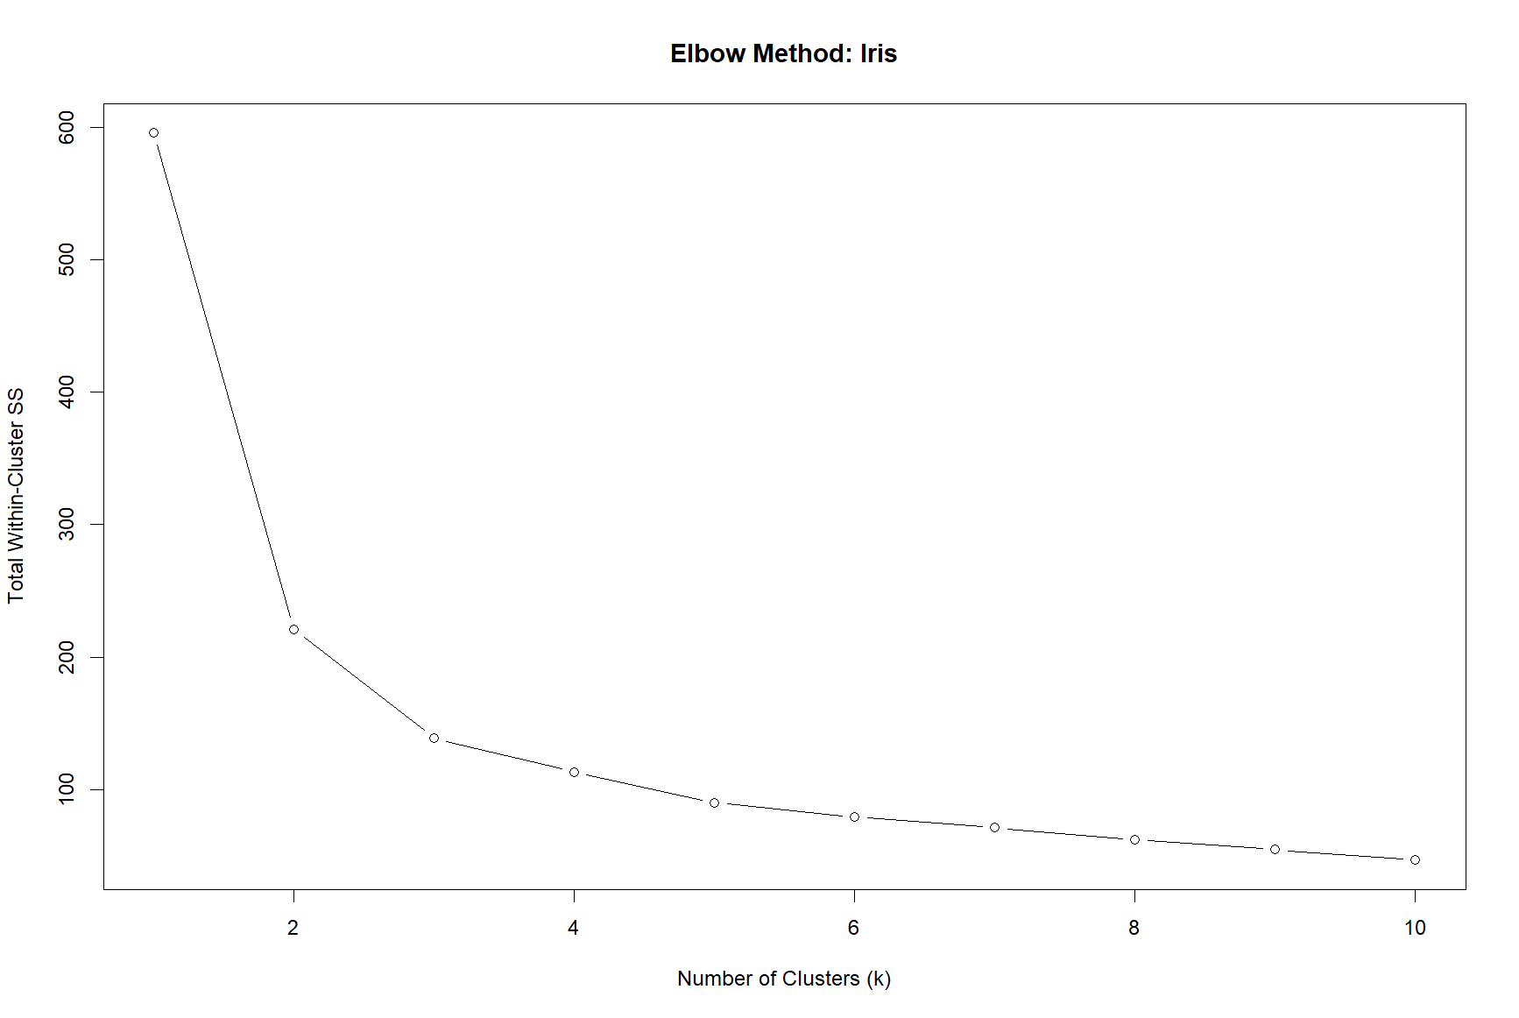
From the plot we see at k = 3 the graph starts to level off indicating that there are 3 clusters for the iris dataset. Using k = 3, I ran the model in a loop to test all different combinations of vectors using combn() and found that petal length, petal width gave the highest accuracy of 96%. When plotting the best predictor pair we could clearly see similarly to what is shown in the contingency table that one cluster clearly shows the Setosa group and overlap between Versicolor and Virginica. It is known that it is difficult to differentiate versicolor and virginica and this is also shown from the graph, therefore, the model does indeed predict the flower types well.

Petal.Length + Petal.Width

Accuracy: 0.96

setosa versicolor virginica

1 50 0 0

2 0 48 4

3 0 2 46

