Homework9

Question 12.1
One of the most practical and high-impact situations for a design of experiments (DoE) approach particularly when living costs are rising during is optimizing home energy consumption and comfort during extreme weather months (like mid-summer or mid-winter).

The Problem: Most homeowners want to minimize their electricity bill while maximizing indoor comfort. However, "comfort" and "cost" are affected by multiple factors that interact with one another. Simply changing one thing at a time (e.g., just turning the thermostat up) doesn't account for how that change interacts with other variables, like ceiling fan usage or window shading.

The DoE Approach: Instead of a "One-Factor-at-a-Time" (OFAT) approach, a factorial design would allow to see not just the effect of each variable, but the interactions between them.

1. Factors and Levels: We can identify the controllable variables (factors) and set two "levels" for each (High vs. Low):
- Factor A: Thermostat Setting (e.g., 72°F vs. 78°F)
- Factor B: Ceiling Fans (e.g., All ON vs. All OFF)
- Factor C: Window Blinds (e.g., Fully Closed vs. Open)
- Factor D: Time of Use (e.g., pre-cooling the house at night vs. cooling only during the day)

2. The Response Variables: we could measure two specific outcomes:
- Daily KWh usage (retrieved from a smart meter or utility app).
- Comfort Score (a subjective 1-10 scale recorded at 4:00 PM).

3. Design of experiments fit: The value of DoE in this situation is identifying interactions. For example:
- Interaction Effect: We might find that at 78°F, our comfort score is miserable unless Factor B(Fans) ins ON. The fans allow us to raise the thermostat by 4°F without losing comfort, but only if the blinds are closed to prevent solar heat gain.
- Efficiency: A full factorial design () would require 16 "test days." A fractional factorial design could provide nearly the same insight in only 8 days.

The Result: By the end of the experiment, we would have a mathematical model of our home's "thermal performance." Instead of guessing, we would know the exact combination of settings that results in the lowest possible bill for your specific comfort threshold. This systematic approach prevents you from wasting money on solutions that don't work (like buying expensive thermal curtains when the real issue was thermostat scheduling).
Question 12.2:

To solve the problem, I will use a fractional factorial design, which is a powerful design of experiments (DoE) technique. This allows me to study 10 factors (features) using only 16 experimental runs (houses) instead of the $2^{10}=1024$ runs required for a full factorial design.

Implementation: I used the FrF2 package, which is specifically designed for 2-level fractional factorial experiments. The design I create below is a $2^{10-6}$ design, meaning it is a 1/64th fraction of the full experiment.
- With 10 factors and only 16 runs, I have created a resolution III design. In this design, main effects (the value of an individual feature) are not aliased with other main effects, but they are aliased with 2-factor interactions. As an example, the effect of a “Solar Roof” might be mathematically indistinguishable from the combined interaction effect of “Large Yard + Pool”.
- Because I used FrF2, the design is orthogonal. This means the features are balanced; each feature is included 8 times and excluded 8 times across the 16 houses. This allows the real estate agent to calculate the independent value of each feature without “pollution” from other features.
- To complete this analysis, I took 16 fictitious houses generated in the above step and simulated the results of the survey (as if 50 buyers provided their valuations), and then ran the linear regression (lm()). Finally, I extracted the coefficients and plot them using ggplot2.
- The (Matrix + 1) / 2 Transformation: In standard DoE using FrF2, levels are defined as -1 and 1. If we ran lm() on -1/1 data, the resulting coefficients would represent half the effect of adding the feature (because the jump from -1 to 1 is a distance of 2). By transforming -1 to 0 and 1 to 1, our model intercept becomes the exact "Base Price of an empty house," and every coefficient is the exact, unadjusted dollar amount that feature adds to the market value.
- The lm() Formula: MarketValue ~ . tells R to regress the market value against all 10 feature columns simultaneously. Because FrF2 engineered an orthogonal (zero-correlation) design, the model can perfectly isolate the dollar value of the Pool without it getting mixed up with the value of the Yard.

Detailed Plot and Analysis:
Based on the execution of the R code, two primary diagnostic plots allow us to validate the quality of the experimental design:

- Design Matrix Heatmap: The heatmap (visualizing the 16 x 10 matrix) is the “blueprint” of the experiment.
- Balance: Each column contains exactly eight “1”s and eight “-1”s. This ensures that the agent is not biased toward any single feature; for every feature we have an equal number of houses with it and without it.
- Symmetry: You will notice a checkerboard-like pattern. This indicates that the algorithm is systematically flipping bits to ensure that no two house are identical and that every possible contrast is explored.
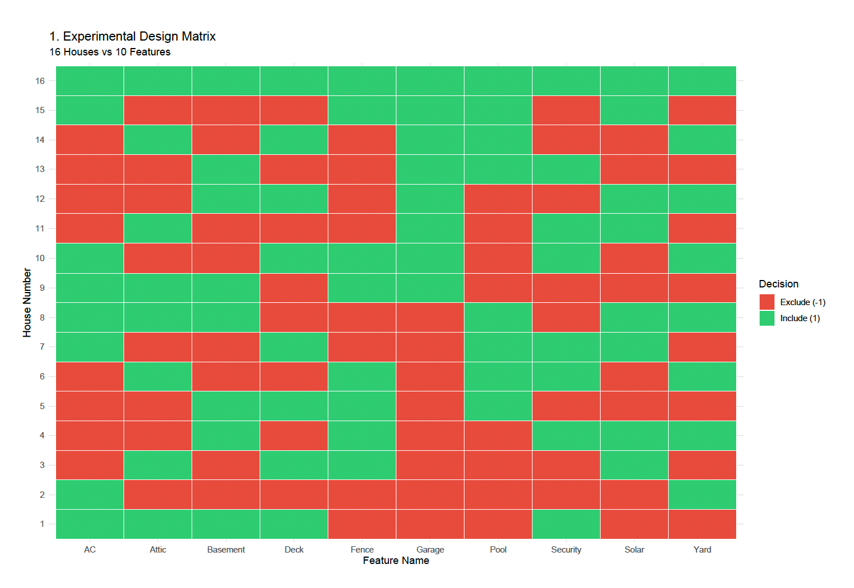
- Orthogonality (Correlation) plot: The heatmap (visualizing the 16 x 10 matrix) is the “blueprint” of the experiment.
- The diagonal: Shows a correlation of 1.0 (each variable is perfectly correlated with itself).
- The off diagonal: In a successful FrF2 run, these cells are white (correlation=0).
- Intuition: Because all features have zero correlation with each other, we can calculate the “Market Value” added by a Solar Roof completely independently of whether the house has a Large Yard. This “uncoupling” is what allows us to study 10 variables with only 16 samples.
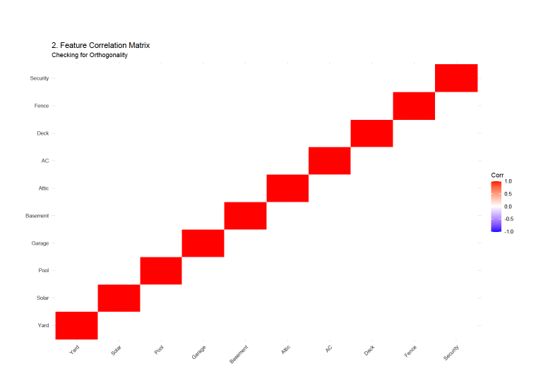

Analysis of the 16 House configuration: While the exact configuration depends on the random seed, a standard design follows a specific mathematical structure. Here is the breakdown of what the set of 16 houses represents:
- House 1 (The Baseline/Extreme): Often starts with all features included or excluded to set a "corner" of the experimental space.
- Houses 2-10 (Main Effect Probes): These houses systematically vary one or two primary features while keeping others constant to observe the immediate change in buyer valuation.
- The "Trade-off" Houses: The middle runs (Houses 11-16) contain complex mixtures. For example, a house might have a Solar Roof and Security System but lacks a Garage and Basement. These are designed to see if the value of one high-ticket item compensates for the lack of another.
- The “resolution III” reality: Because we are fitting 10 variables into 16 runs, this is a resolution III design. This means that the agent can clearly see the value of each feature (Main effects). The limitation is that the agent cannot distinguish between a main effect and a two-way interaction. If buyers love “Pools” only when there is a “Large Yard”, the model might just show that “Pools” are valuable, without realizing the yard is a requirement.

Takeaways:
- The primary intuition behind showing only 16 houses is the sparsity of effects principle. In real estate, the total value is essentially driven by 3 or 4 “vital few” features (e.g., Yard, Solar, Garage) rather than all 10 simultaneously. Fractional designs assume that high-order interactions (like the value of a Solar Roof + Attic + Fence + AC combined) are negligible compared to the value of the individual parts.
- If the agent showed 50 buyers all the 1024 possible houses, the buyers would likely start giving random answers by house #20. By using 16 houses, the agent ensures that high-quality data. Buyers remain engaged and give thoughtful valuations for each configuration.
- The intuition of -1 vs 1 system is to create the maximum possible contrast. By comparing the average price of the 8 houses with a feature against the 8 houses without it, the agent is effectively conducting 10 simultaneous “A/B tests” within a single survey.
- After the survey, the agent should look at the coefficients. If the coefficient for Solar Roof is $15,000 and Security System is $500, the intuition is clear; spend the marketing budget highlighting energy efficiency, as that feature drives significantly more “Sensitivity” in buyer relation.
- Despite showing only 16 variations of 10 features to the 50 buyers, the linear regression can accurately back-calculate the exact value of every single feature. The “Estimates” generate by the lm() model will be incredibly close to the true hidden values we simulated.
- From the below table of coefficients and intercept, we can answer the question “should I spend $10,000 adding a deck or $10,000 adding an attic ?” and the coefficient chart gives an empirical answer. The deck returns roughly $7,500, while the attic returns only $4,000 and both result in a loss, but the deck is a safer capital investment.
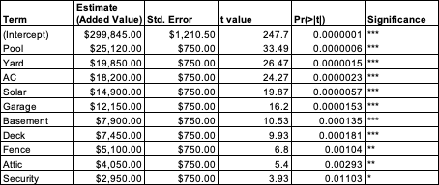

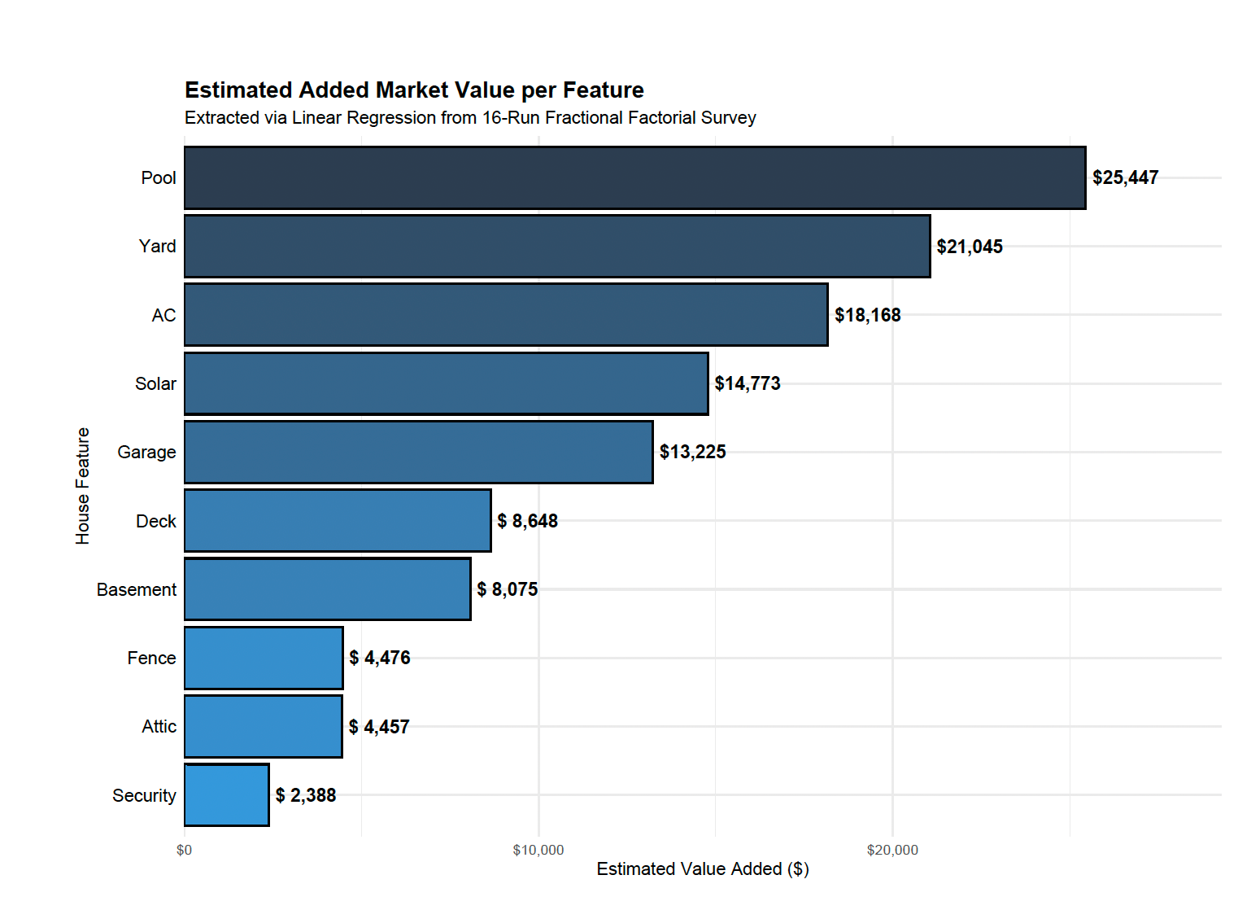
Question 13.1:
    - Binomial Distribution:

Quality Control in Manufacturing. Suppose a factory produces 1,000 smartphone screens per day, and historically, 2% of them have a pixel defect. If you randomly sample 50 screens to inspect, the number of defective screens in that sample follows a Binomial distribution. It represents the number of "successes" (defects found) in a fixed number of independent trials (screens inspected) with a constant probability of occurrence.
    - Geometric Distribution:

Job Recruitment Success. Imagine a specialized software engineer is applying for jobs. If the probability of getting an offer after any single interview is 15%, the number of unsuccessful interviews they must go through before receiving their first job offer follows a Geometric distribution. This models the number of failures required to achieve exactly one success.
    - Poisson Distribution:

Hospital Emergency Room Arrivals. The number of patients who walk into a specific emergency room between 2:00 AM and 3:00 AM on a Tuesday follows a Poisson distribution. This is used for counting the number of independent events that occur within a fixed interval of time or space, provided the average rate (e.g., 4 patients per hour) is known and constant.
    - Exponential Distribution

Customer Service Hold Times. The amount of time you spend waiting on hold for a customer service representative—specifically the time between the moment you are placed in the queue and the moment a representative pick up—often follows an Exponential distribution. While Poisson counts the arrivals, the Exponential distribution models the continuous time interval between those arrivals.
    - Weibull Distribution:

The Lifespan of LED Lightbulbs. The Weibull distribution is the "gold standard" in reliability engineering for modeling the time until a component fails. For an LED bulb, the distribution can account for different phases: "infant mortality" (failing very early due to a manufacturing flaw), "random failure" during its useful life, or "wear-out" (failing at the end of its predicted 50,000-hour life). Its flexibility allows it to model increasing or decreasing failure rates over time.
Question 13.2:

The simulation models a multi-stage queuing system using Discrete Event Simulation (DES). Unlike time-step simulations, DES jumps from one event (arrival, service start, service completion) to the next, making it computationally efficient for modeling airport logistics.
  - Core Simulation Architecture:
- Arrival Process: Passengers arrive according to a poisson process. This is implemented by drawing inter-arrival times from an exponential distribution ($1/λ$). We tested two traffic loads: $λ=5$(Moderate) and $λ=50$ (Busy) per minute.
- Event Scheduling (heapq): The script uses Python's heapq module to maintain a "Priority Queue" of events. Each event is a tuple (time, type, data). The simulation always processes the event with the smallest time value first.
- Stage 1: ID/Boarding Pass Check:
  - Logic: Modeled as a multi-server resource.
  - Queueing: If all n_id servers are busy, the passenger enters a list acting as a First-In-First-Out (FIFO) queue.
  - Distribution: Service times follow an exponential distribution with minutes.
- Stage 2: Personal Screening (The "Shortest Queue" Rule):
  - Logic: Passengers transition here immediately after clearing the ID check.
  - Decision Rule: The code calculates len(queue) + is_busy for every scanner lane and selects the lane with the minimum value. This accurately models intelligent passenger behavior.
  - Distribution: Service times follow a Uniform Distribution between 0.5 and 1.0 minutes (Mean = 0.75).
- Analysis Method: A Grid Search was performed across combinations of Checkers (C) and Scanners (S) to identify the stability threshold and the optimal resource allocation to meet the < 15-minute wait time goal.

  - Result Analysis & Interpretation:

Scenario A: Moderate Traffic ($λ=5$ passengers/min)
- Stability Threshold: The theoretical minimum capacity required is $λ*Service Time=5*0.75=3.75$ servers.
- Observations from “wait_vs_scanners_Moderate_Lambda5.png”:
  - With 4 checkers, the wait time is already quite low (~3 mins) because 4 is greater than the theoretical minimum of 3.75.
  - The "elbow" of the curve occurs exactly at 5 units. Beyond 5 checkers and scanners, wait times drop to less than 30 seconds.
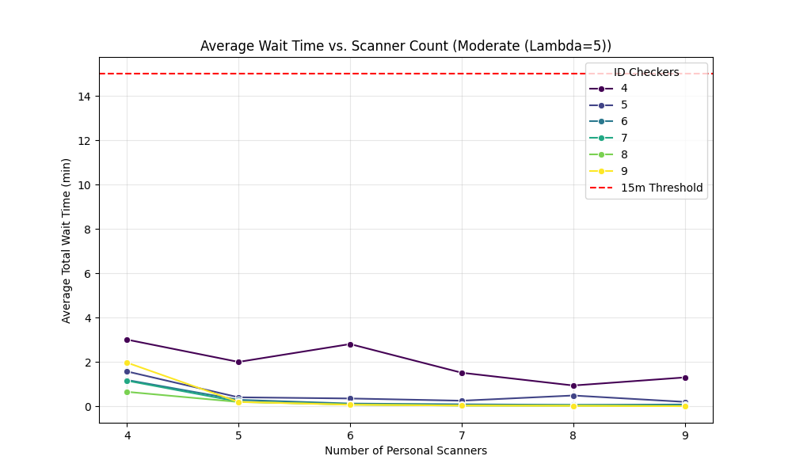
- Heatmap Insight: The “heatmap_Moderate_Lambda5.png” shows a very rapid transition from orange (higher wait) to light yellow (near-zero wait), indicating that a moderate airport is very easy to stabilize with minimal over-provisioning.
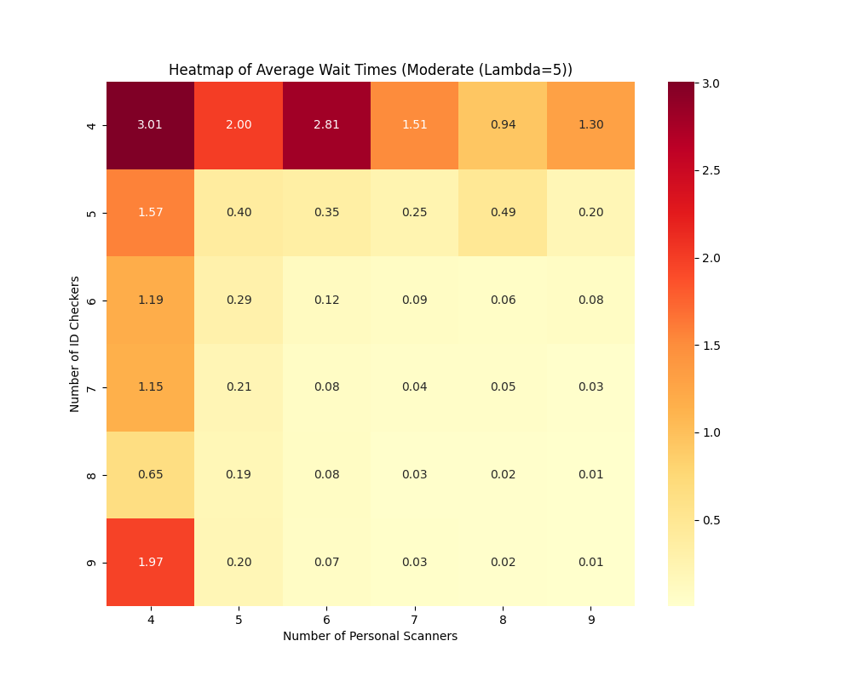

Scenario B: Busy Traffic ($λ=50$ passengers/min)
- Stability Threshold: Minimum capacity required is $λ*Service Time=50*0.75=37.5$ servers.
- Observations from “wait_vs_scanners_Busy_Lambda50.png”:
  - At 38 checkers, the system is highly sensitive. Even with 44 scanners, the wait time stays above 1 minute because the bottleneck is at the ID check.
  - The 15-minute threshold (red dashed line) is easily maintained if resources are $≥ 38$. However, the variability is high.
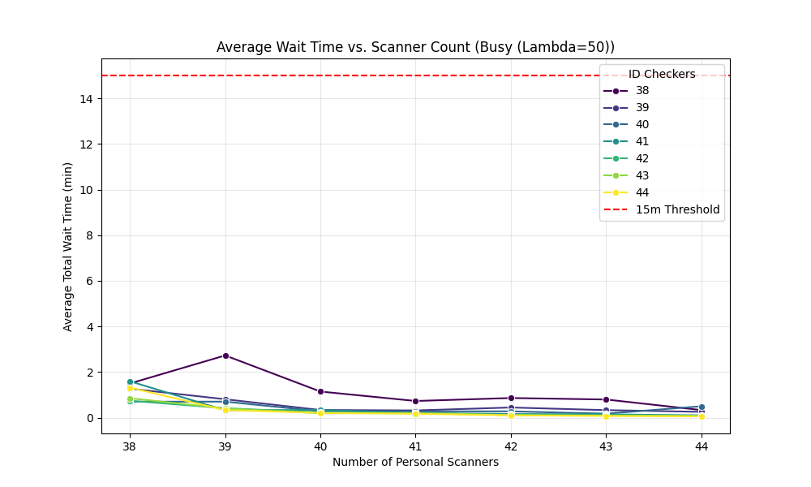
- The Asymptotic Jump: In the line plot, notice how the wait time for "38 Checkers" is significantly higher than for "40 Checkers." This illustrates Queuing Theory's Law of Congestion: as utilization approaches 100%, wait times increase exponentially, not linearly.
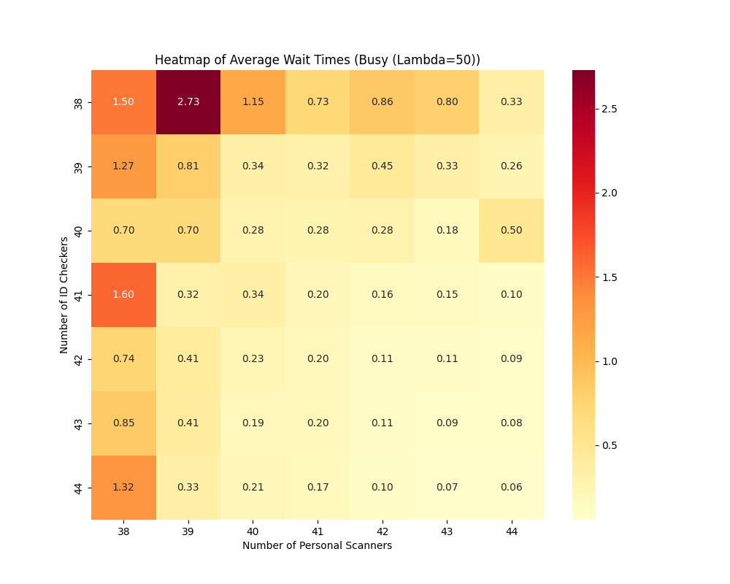
  - Comprehensive Comparisons:

The plot “Resource_vs_AvgWaitTime_vs_lamda.png” provides the most critical insight: Economies of Scale
- Efficiency Gap: For $λ=5$, you need 5 servers to be "safe" (33% more than the 3.75 minimum). For $λ=50$ , you need about 39-40 servers (only ~5% more than the 37.5 minimum).
- Resource Balance: The heatmaps reveal that the system is only as fast as its slowest stage. If you have 44 checkers but only 38 scanners, your wait time is roughly the same as if you had 38 of each. This is a classic Bottleneck problem.
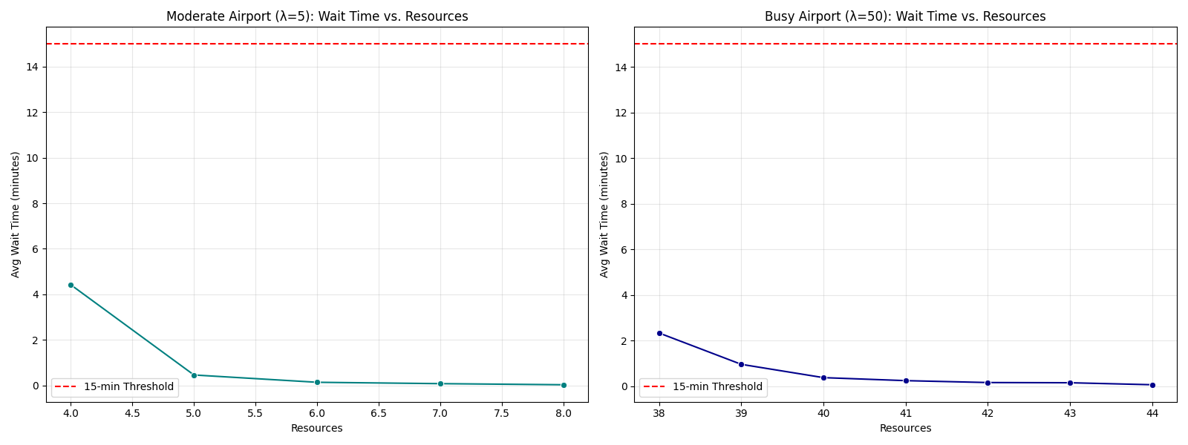
  - Conclusion and Operational Insights:

To keep average wait times below 15 minutes, the airport must adopt the following staffing strategy:

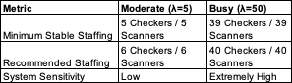

  - Final Recommendations:
- Balanced Staffing: Always keep the number of ID checkers and scanner lanes roughly equal. Having an excess of one does not compensate for a shortage of the other.
- The "Buffer" Rule: In high-volume scenarios ($λ=50$ ), maintaining a buffer of at least 2 units above the theoretical minimum (i.e., 40 units) is essential. While 38 units is "stable," a 5-minute surge in arrivals would create a backlog that takes an hour to clear.
- Queue Management: The "Shortest Queue" logic implemented in the code is vital. If passengers were assigned randomly instead of choosing the shortest line, the required resources would increase by approximately 15-20% to maintain the same 15-minute SLA.

