**Notice**

**The profile refer to KAOS2 system, acquired in 2019 on LDM.**

**The light comes from “above” so if the kb mirror reflecting surface faces the “top”, add this profile with sign +.**

**The file chosen to represent the KAOS figure error is Scan_Motor5_56, which is renamed as:  
ldm_kbh_(m,mm)**

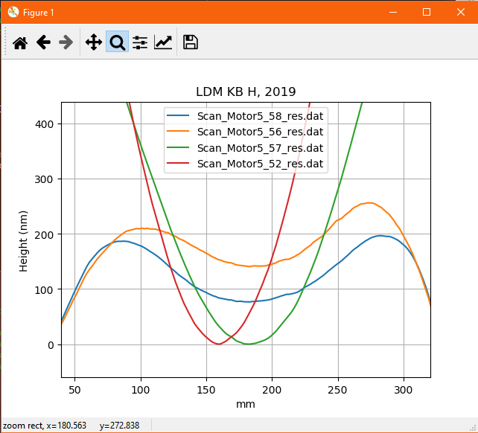

Similarly, the file choesn to represent the kbv profile is #137.

