Computer simulations and ray-tracing for hard X-ray optics

TUTORIALS on SHADOWOUI (EXERCISES AND ANSWERS)

Manuel Sanchez del Rio, ESRF, BP 220, F-38043 Grenoble Cedex

Ray-tracing of synchrotron sources and beamline optics (Exercises to be done with SHADOWVUI)
- 11 - Geometrical source. Learning reference frames
- 12 - Synchrotron sources: Bending magnets
- 13 - Insertion devices
- 14 - Beam propagation (phase space (z,z’) ellipses)
- 15 - Focusing with grazing incidence mirrors: effect of aberrations
- 16 - Kirkpatrick-Baez system
- 17 - Double crystal monochromator
- 18 - Sagittal focusing - python script
- 19 - Simulation of a complete beamline
- 20 - Slope errors
- 21 - Thermal bump
- 22 - Curved crystal monochromators: Rowland and off-Rowland configurations
- 23 - Crystals in Laue geometry
- 24 - Transfocators
- 25 - Fresnel propagator
- 26 - Two slits experimnt - python scripts
- 27 - More examples

Appendix – The very basics of SHADOW
- 1 - SHADOW Introduction
- 2 - SHADOW files
- 3 - SHADOW frame
- 4 - Effect of optical element orientation in SHADOW frame
- 5 - Macro programming (IDL): Survival guide

Resources
(c) srio@esrf.eu 2001-2013

Learning reference frames in SHADOW using a geometrical source.

You will:
- learn to define geometrical sources
- understand the use of a python script for modifying an existing source
- understand reference frames

- Create a collimated (i.e., zero divergence) geometric source with elliptical shape with vertical semi axis twice the horizontal semi axis (e.g., 0.2 cm and 0.1 cm in Z and X, respectively). Visualize it
- Apply the following macro, that reads the source file begin.dat, keeps only the rays with positive values of X and Z (i.e., sets the flag as “lost” for rays with negative values of X and Z), and rewrites the source file begin.dat with the modified source. Visualize the new result.
a=ReadSh('begin.dat')
x = GetShCol(a,1)
z = GetShCol(a,3)
f = GetShCol(a,10)
bad1 = Where(x LE 0)
bad2 = Where(z LE 0)
f[bad1]=-100
f[bad2]=-1100
a.ray[9,*]=f
putrays,a,'begin.dat'
- Create a mirror optical element, with incident angle 45 degrees, and p=q=1m. Trace the system in two cases, with Mirror orientation angle 0 and 90 degrees. Verify the results with the pictures shown before.

Hints: you may load the workspace ex11_referenceframe.ows.

Answer
Pay attention to make plots using “Rays: Good Only” and same aspect ratio (click the blue octogone in )

Source (x,z) plane before and after applying the script that select only “positive” rays

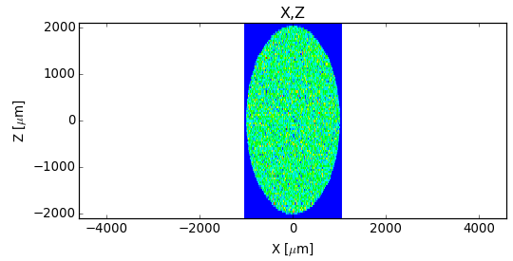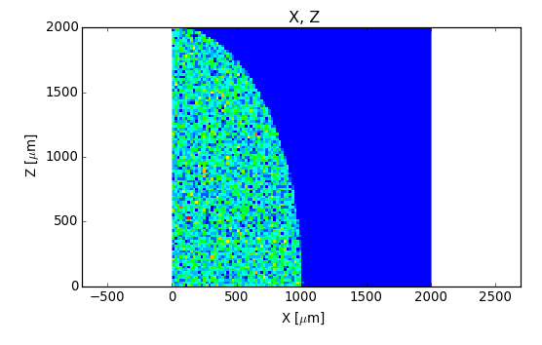

a) Mirror orientation angle = 0
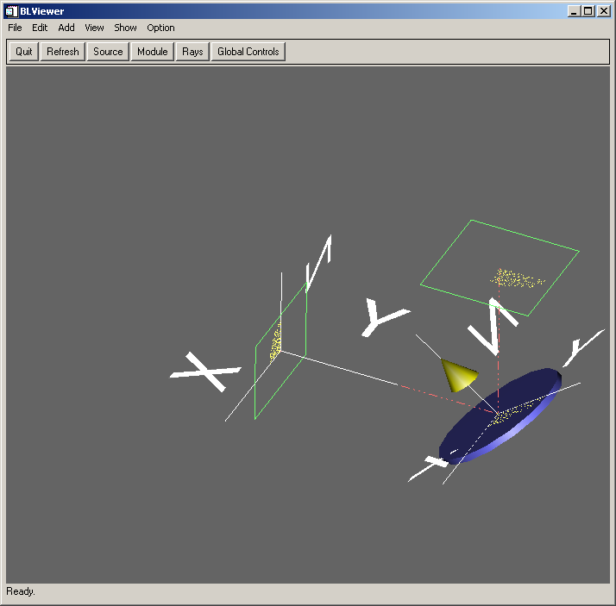

Left: footprint (Y,X) plane. Right: image (X,Z) plane
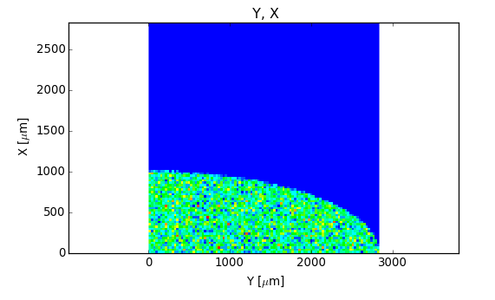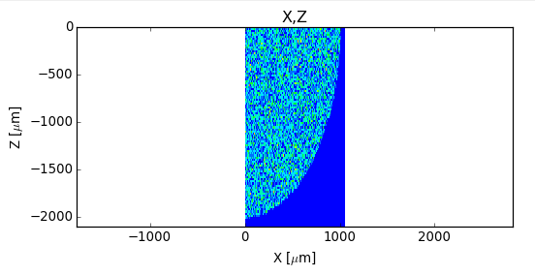

b) Mirror orientation angle = 90 deg

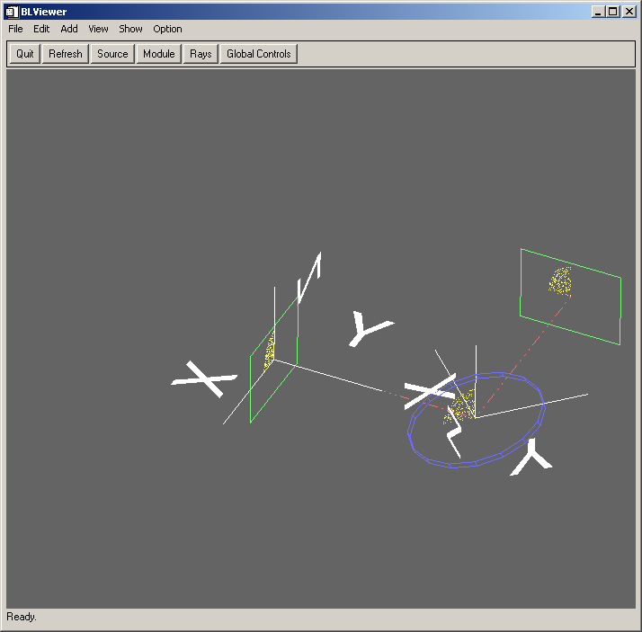

Left: footprint (Y,X) plane. Right: image (X,Z) plane:
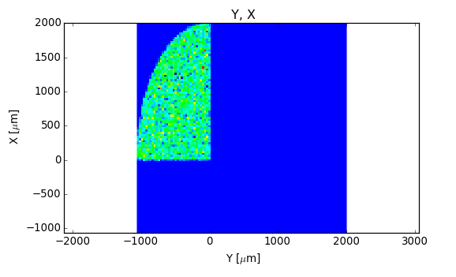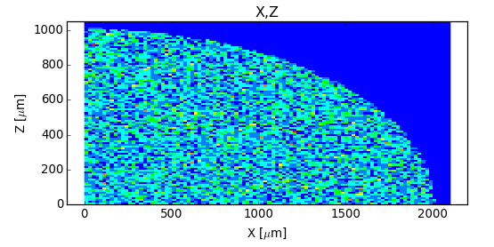

Synchrotron sources: Bending magnets.

You will learn to
- simulate bending magnets

i) Simulate the source for the ESRF bending magnet (full emission) at a fixed energy (e.g.,. 8 keV). Use one mrad of horizontal divergence. Visualize the cross section (x,z), the divergence space (x’,z’), the phase spaces (x,x') and (z,z’). Visualize the top view (y,x). Make histograms of intensity (total, σ-polarized and π-polarized) as a function of the vertical divergence. Plot also the degree of circular polarization (S3 component of the Stokes vector).

ii) Change the source energy to 18 keV and compare the plot f intensity versus vertical divergence with the result at 8 keV. Verify that the radiation is more collimated. Simulate the same source but on a limited vertical divergence (e.g., +/- 50 μrad).

Hints: you may load the workspace ex12_bendingmagnet.ows, where this system is defined, for full vertical emission.

Notes:
By default one can use Calculation Mode = Precomputed, and select an “infinite” Max vertical half-divergence (we set to 1 rad which contains everything that is radiated). Shadow will calculate rays following the full emission. In case that one wants to work very far from the critical energy (like for infrared beamlines), one should use “Exact Calculation”. In this case, the Max vertical half-divergence should be larger than the natural full divergence but not much larger. For example, in this case one can set 0.001: 1 mrad is still much larger than the full vertical emission (~200 μrad).

Answer

i)
Open the “Bending Magnet” widget, click “Run Shadow/Source” and display in the right panel using “Detailed Plot” the cross section (x,z), the divergence space (x’,z’), and phase spaces (x,x'), (z,z’):

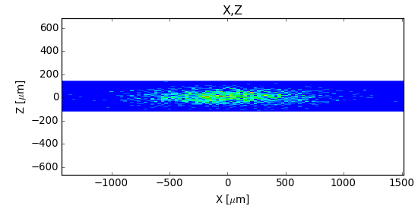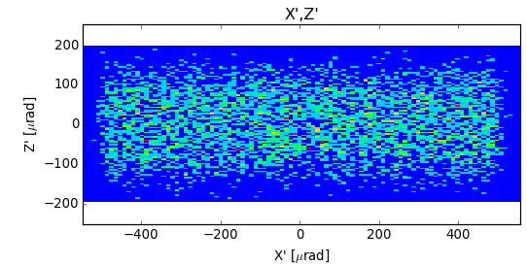

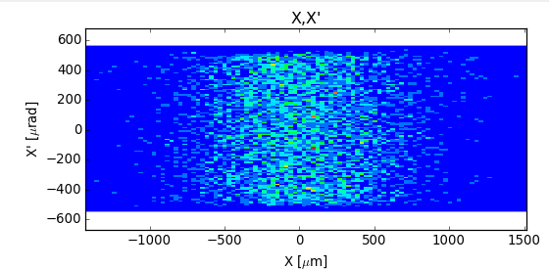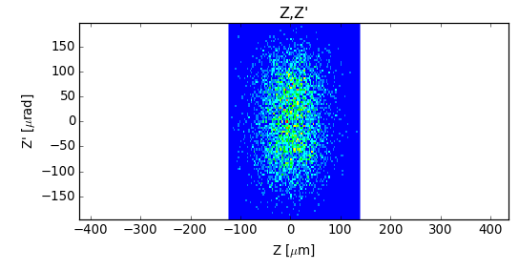

Another way is to plug a “Plot XY” widget and select the wanted coordinates for the plot. This can also be used to display the “top view” (y,x).

Plug the “Histogram” widget to display histograms of intensity weighted by 23:Total Intensity, 24:σ-polarized, 24: π-polarized, S3-Stokes or circular polarization). Although it is not possible to combine histograms in a single plot, it is always possible to prepare a simple script that performs customized plots, like the one included in the workspace that produces:

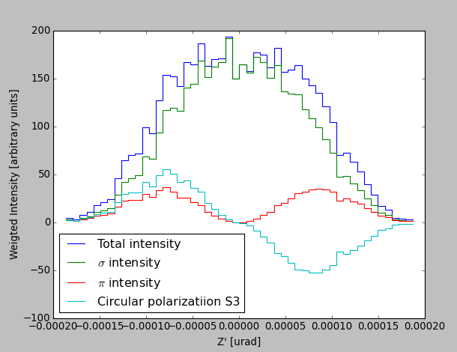

Insertion devices

You will learn to
- Simulate wigglers and undulators

a) Simulate the old wiggler for the ESRF ID17 (medical beamline) the energy interval 10000±10 eV . Calculate the total horizontal divergence (width of the x’ histogram) and visualize a top view of the emission (y,x) with finite emittance and source size, and without emittances (i.e., setting emittances and sigma’s to zero).

b) Simulate the ESRF U46 undulator with gap tunned to have its third harmonic at 7833.5 eV. Use Gaussian approximation and understand the parameters.

Hint: you may use the workspace file ex13_insertiondevices.ows

Answer

a)

E [keV] | x’[μrad] | z’[μrad]
10 | 3056 | 179

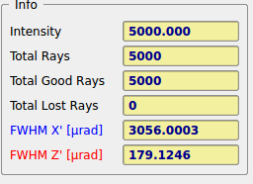

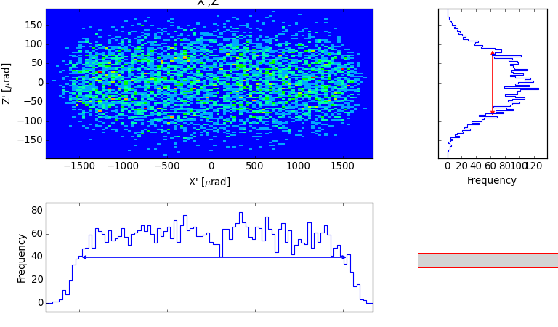

Plot of X versus Y for the wiggler with (left) and without (right) emittances

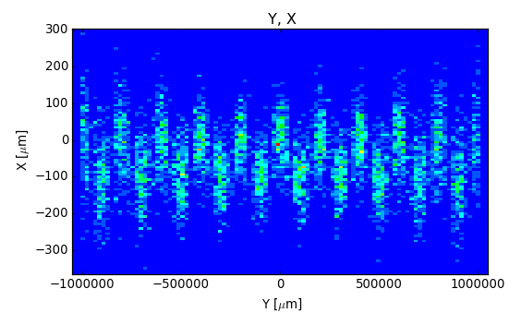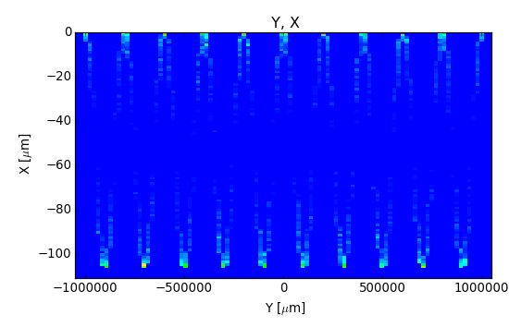

b)
Use the “Undulator Gaussian” widget and input the corresponding parameters for the electron beam and photon energy. This application will create a source using the Shadow Geometrical source with divergences and sizes corresponding to the photon beam. These values or the photon beam (Σ,Σ') comes from a convolution (sum in quadrature) of the values for the electron beam (σ_{e} σ_{e}' ) with the values corresponding to the photon emission of a single electron beam ( σ_{γ}, σ_{γ}') and wavelength λ=1.58274326 A (7833.5 eV), and undulator length L=1.65 m .

The formulas used are (Onuki & Elleaume: Undulators, Wigglers and their applications, CRC press, 2002):

In our case:
 | σ_{e} | σ_{e}' | σ_{γ} | σ_{γ}' | Σ | Σ'
X | 57 μm | 68.4 μrad | 3.52μm | 6.758μrad | 57.11μm | 68.73μrad
Y | 10.3μm | 3.78μrad | 3.52μm | 6.758μrad | 10.887μm | 7.74μrad

These values can be checked in the “Source Info” available using the “Info” widget.

Plot of the divergence space (X’,Z’) for the undulator.
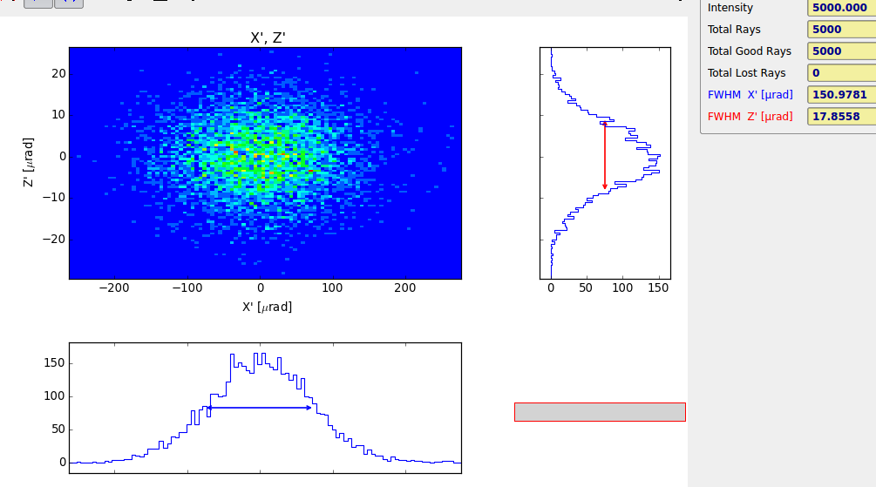

Beam propagation (phase space (z,z’) ellipses)

You will learn to
- Define screens and slits associated to optical elements
- Learn about the phase space changes when the beam propagates
- “Optimize the source” in the sense shadow will only store rays that enter in a defined aperture

a) Using the created bending magnet source (example 12) add several screens at 0 (source position), 50, 75 and 100 cm from the source. See the tilt of the (z,z’) diagram.

b) Define an aperture (20 μm×20 μm) in the first screen and see its effect in screens #2 and #3. Use

Hints: You may use the workspace files ex14a_beampropagation.ows. It also, contains the system with slit, but using an optimised source in order to avoid losing most of the rays at the slit.

Answer
a)

0cm 50cm
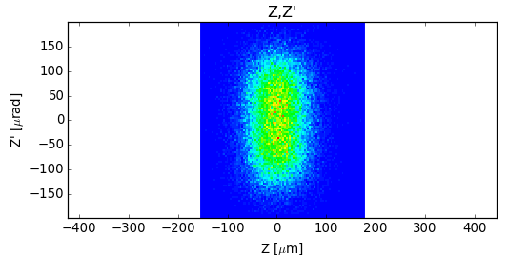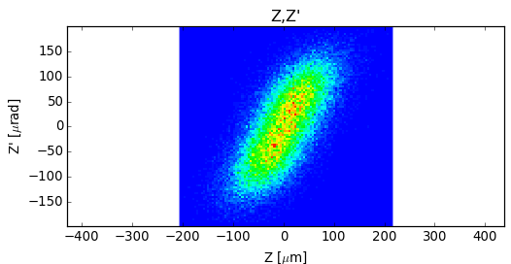

75cm 100cm
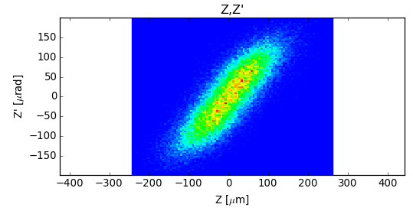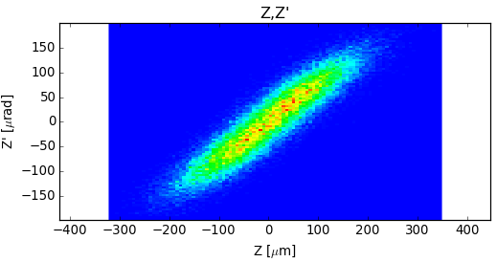

Note that instead of defining the different screens, one can directly plug a “Plot XY” to the source and widget and use “Position of the image” = Retraced and play with the distances.

b)
75cm 100cm

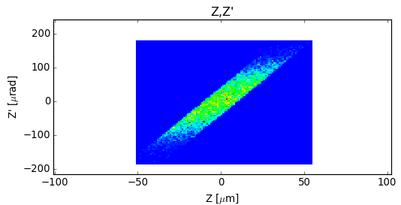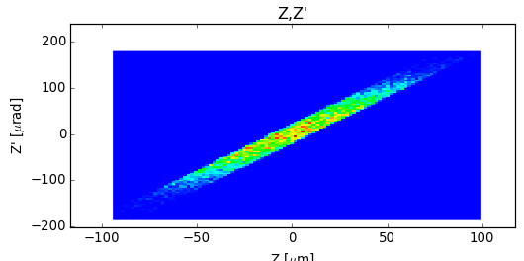

Focusing with grazing incidence mirrors: effect of aberrations.

You will learn to
- Use different mirror shapes in SHADOW
- Experience with the automatic calculation of the mirror parameters.
- Include mirror reflectivity by using the “prerefl” preprocessor
- Visualize results using contour curves.

Create a geometrical source with Gaussian shape (σ_{x}=57 μm, σ_{z}=10.4 μm) and Gaussian divergence (σ_{x’}=88.5 μrad and σ_{z’}=7.2 μrad) to simulate the emission of an ESRF 1.65 m undulator at 10 keV in a Low beta section.

a) Study the case of different mirror shapes (spherical, toroidal and ellipsoidal) for focusing the source with distances (p,q)=(30m,10m) (magnification 1/3) and (30m,1m) (magnification 1/30). Set the grazing angle to 2 mrad. Study the effect of the spherical aberrations and its influence depending on the magnification factor.
Study the dependence on mirror dimensions and incident angle.

b) Enter the effect of mirror reflectivity. Consider a Rh (ρ=12.4 g/cm³) coating and a source with energy distribution in 5-45 keV (box-distribution). Visualize the results. Plot also the intensity versus energy.

Hints. For the different mirrors, Shadow can calculate the surface parameters (curvature radii, ellipse axes, etc). by selecting the parameters in Basic Settings → Surface Shape → Type = “internal/calculated” . The resulting mirror parameters can be seen using the “MirInfo” tab from the “Info” widget. For including reflectivity, the preprocessor PreRefl must be used. The workspace file ex15a_aberrations.ows contains this exercise.

Answer
a) The aberrations effect increases if
    - one goes to more grazing angle
    - one reduces the magnification factor (i.e., mode demagnification of the source)
    - one uses larger mirrors. Small mirrors reduce aberration because cut rays which arrive far from the mirror center. Obviously, this effect reduces also the intensity. For analysing that, use the Basic Settings->Dimensions->Limits Check entry.

M=1/3 Toroidal: 43 μm x 26 μm FWHM, Ellipsoidal 40 μm x 9 μm
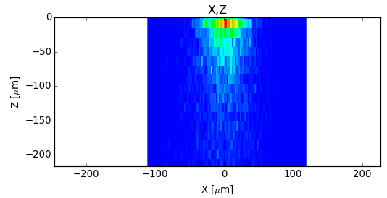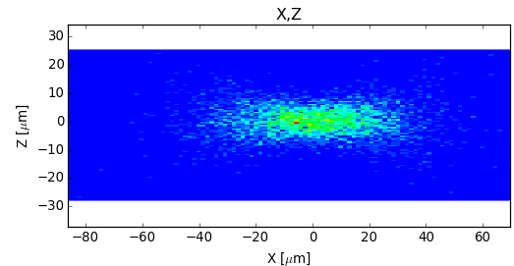

M=1/30 Toroidal: ? μm x 39 μm FWHM, Ellipsoidal 2.4 μm x 1.6 μm. Note that a graph type “preview” has bee used to better observe the aberration tails produced by the toroidal mirror.
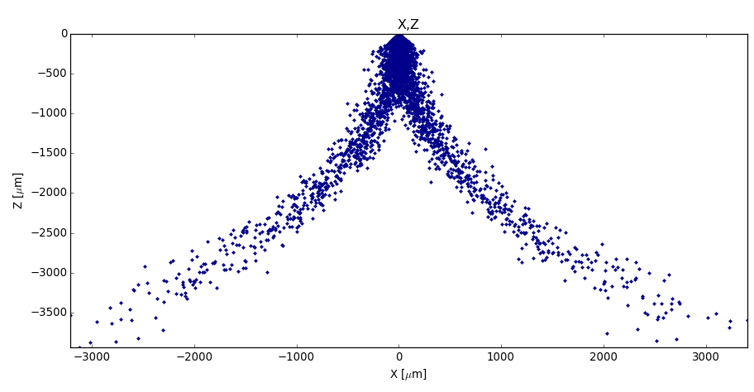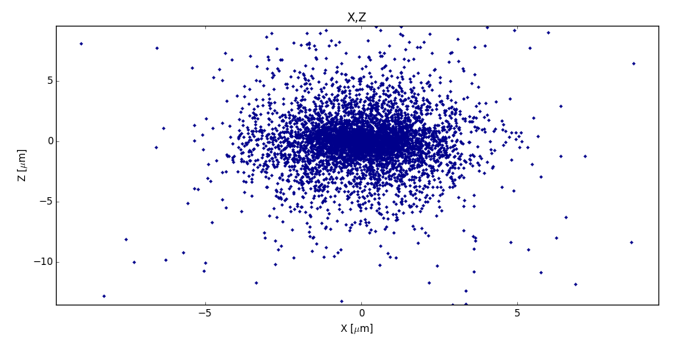

b) I(E) plot.

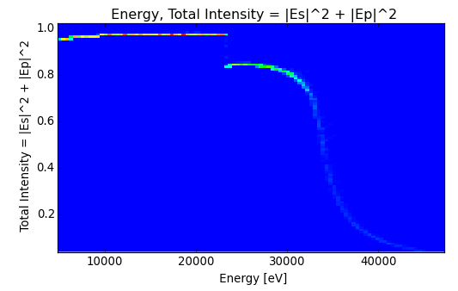

Kirkpatrick-Baez system
You will learn to
- define an optical system with two mirrors
- define a cylindrical mirror with circular or elliptical section
- tell SHADOW to calculate automatically the mirror parameters in the case that focal planes not coincident with continuations planes
- exercise with the mirror orientation angle.
- define mirror dimensions

Study the case of the previous exercise (M=1/30) with a Kirkpatrick-Baez system with cylindrical (and later with elliptical) mirrors of length=40 cm and width=4 cm. Distance source-M1=29.5m; Distance M1-M2=1m; Distance M2-spot=9.5m. Use 25000 rays. Do not include the mirror reflectivity.
Hint: you may use the workspace file ex16a_kb.ows, which contains this case with cylindrical mirrors, and automatic (internal) calculation of the mirror parameters given the distances of the focal planes. The workspace file ex16b_kb.ows contains the same system, but the mirror parameters (i.e., radii) are external parameters.

Answer
Spot with cylindrical mirrors in the plane (Z,X), corresponding to the horizontal (Z) and vertical (X) directions. Note that these directions are swapped respect to the source because the mirror orientation angle for the second mirror is 90 degrees. The resulting mirror parameters are (check them using MirInfo) R(M1)=739455.7 cm and R(M2)=691710.4 cm.
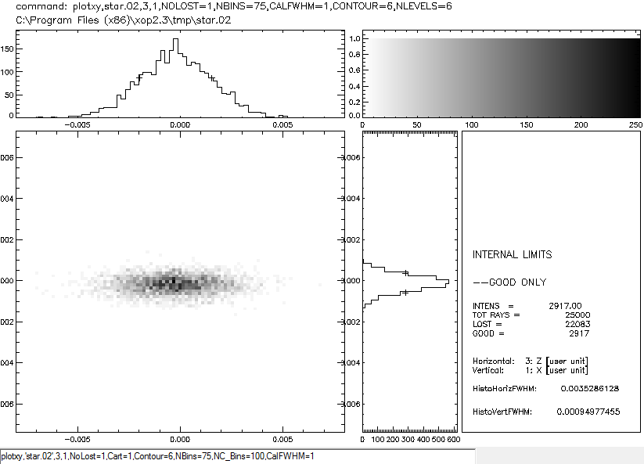

Double crystal monochromator.

You will learn to
- create crystal reflectivity data using the “bragg” preprocessor
- use the “autotunning” facility to align the crystal
- calculate the energy resolution for a crystal and a combination of systems
- optimise the source bandwidth
- play with the mirror orientation angle. Relate its values to the crystal dispersion ( (+,-) and (+,+) crystal combination)

Create a bending magnet source (starting from exercise 12) at 8000±25 eV with 3 mrad horizontal divergence. Verify its energy dependence and horizontal and vertical divergence values.
a) Implement a flat Si 111 crystal at 30 m from the source. Verify the energy dependence and calculate resolution. Redefine the source energy bandwidth to optimize the calculation in order to obtain the energy dependence with the highest signal.
b) Add a second crystal 10 cm downstream from the first one in (+,-) and (+,+) configurations (play with the mirror orientation angle). Explain the obtained differences in energy resolution.

Hint: you may use the workspace file ex17_crystalmonoa.ows for (+,-) and ex17b_crystalmono.ows for (+,+). Notice that the workspace file does not contain the file with the reflectivity for the crystal, so you will need to run the bragg preprocessor. Use the Bragg preprocessor to create the reflectivity data for a Si 111 crystal. You can create the output file for a large range of energy (e.g., from 5000 to 15000 eV). Pay attention to the file name when you run bragg, because it also appears in the o.e. crystal menus. In this case, the file is called si5_15.111.

Answer

a) The optimized energy range selected is 8000±10 eV. The histogram of the energy (including reflectivity) after the first crystal (i.e., file star.01) is:
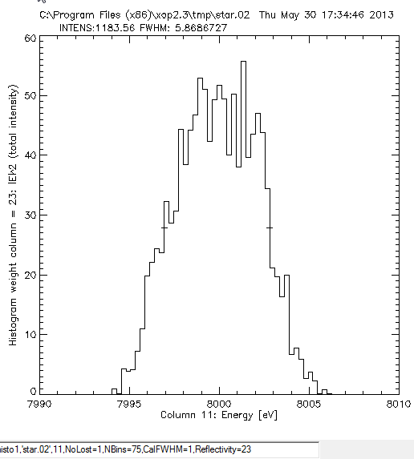

b) Left: resolution function for (+,-) (non-dispersive configuration). Here the mirror orientation angles are 0 and 180 deg for the first and second crystals, respectively. Right: resolution function for (+,+) (dispersive configuration). The mirror orientation angle is 0 for both crystals.
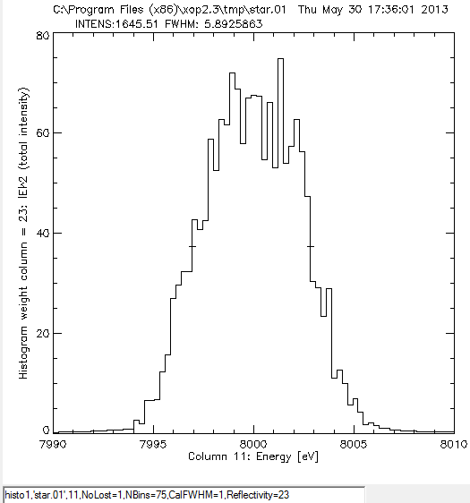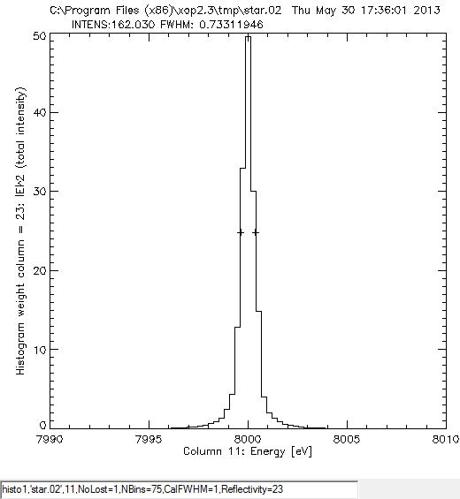

Sagittal focusing - python script
You will learn to
- define a cylindrical mirror for sagittal focusing
- define “externally” the optical element radius of curvature
- optimize the focal spot

a) Using the (+,-) system defined in the last exercise, bend sagittally the second crystal to focus in the horizontal plane at the sample position, placed 1000 cm downstream from the monochromator (monochromator at 3000 cm from the source). Calculate horizontal spot size.

Use ShadowVUI|Results|ray_prop to find the position of the best focus. Calculate its size.

b) Study the effect of the ratio between the distances mono-sample and source-mono in the transmitted intensity. Study the case of M=1/30. See the effects in energy resolution and system transmitivity. Explain these differences. Verify that ratio 1/3 is the optimum.

Hints: Use the program ShadowVUI|Utils|Optical|Tang and sag radii (rcil) to calculate the curvature radius: Rs(8keV,M=1/3)=371 cm. You may use the workspace files ex18a_sagittalfocusing.ows corresponding to M=1/3. The workspace ex18b_sagittalfocusing.ows contains two macros (the first on in IDL and the second one in PYTHON in thefile ex18b.py ) that scans the magnification. One can see that the intensity peaks at about 1/3.

Answer

a) Focusing system: Spot width=0.033 cm, I/I₀=1183/25000, ΔE=5.9 eV
Non-focusing system: Spot width=11.4 cm, I/I₀=1184/25000, ΔE=5.9 eV
Best focus very close to the focal position. The spot size does not change appreciably.
b) p=30m, q=1m, R_{s}=47.8 cm, Spot width=0.012 cm, I/I₀=168/25000, ΔE=5.8 eV
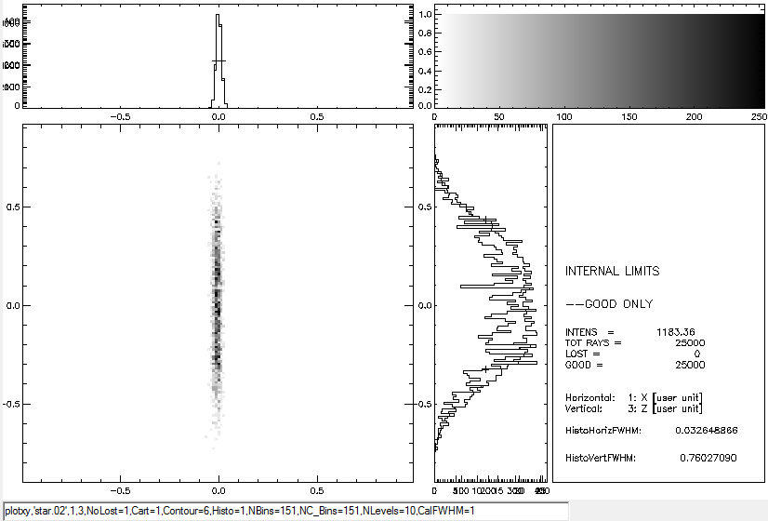

The study of the variation of the intensity as a function of the magnifications needs to run shadow for many points of M. It can be done with a macro. The result should show an optimum magnification of M=1/3 for large divergence values. Its effect can be seen in the following figure (M. Sanchez del Rio "Ray tracing simulations for crystal optics" SPIE proceedings, vol. 3448, 230-245, 1998). The macro ex18b_sagittalfocusing.ows will reproduce this this figure (5 mrad, but with less points)

Intensity (in arbitrary units) versus magnification factor M for a point and monochromatic (E= 20 keV) source placed at 30 m from the sagittaly bent crystals. Three beam divergences are considered: 1 mrad (dotted), 2.5 mrad (dashed) and 5 mrad (continuous). We clearly observe the maximum of the transmission at M=0.33 when focusing the 5 mrad beam, as predicted by the theory

Simulation of a complete beamline.
You will learn to:
- Combine several optical elements
- Obtain final results for a beamline in terms of flux, resolution and spot size.

Define the following elements in SHADOW:
Geometrical Gaussian source at 10000±10 keV (box distribution) (like in exercise 15 b, but changing the energy interval)
M1: Cylindrically collimating mirror in the vertical plane at 25 m. Grazing angle 0.12 degrees. Rh coating (density=12.4 g/cc). Infinite dimensions.
MONO: Double crystal monochromator, Si 111, with second crystal sagittally bent (focusing the source into the sample position in the horizontal plane), at 30 m from the source (Rs=296.6 cm)
M2: Re-focusing mirror at 35m from the source, focusing at the sample position. Same angle as M1
Sample at 40 m

Calculate:
- Beam geometry at the sample position
- Energy resolution
- Transmitivity of the whole beamline. Number of photons at the sample position supposing that at the source we have, at 10 keV, a flux of 5 10¹³ ph/sec/0.1%bw
b) How are these results modified using a focusing first mirror and a flat second mirror?

Hint: you may use the workspace file ex19_beamline.ows

Answer

ΔΕ_{source}=4 eV (optimized source bandwidth); ΔΕ=1.3eV; I/I₀=1441/5000
Transmitivity in one eV=T=(I/ΔΕ) /(I₀/ΔΕ_{source})(1441/1.3)/(5000/4)
Number of photons at the source in one eV bandwidth =N= 5 10¹²
Total number of photons = N×T×ΔE

Intensity distribution in the (X,Z) plane at the image position
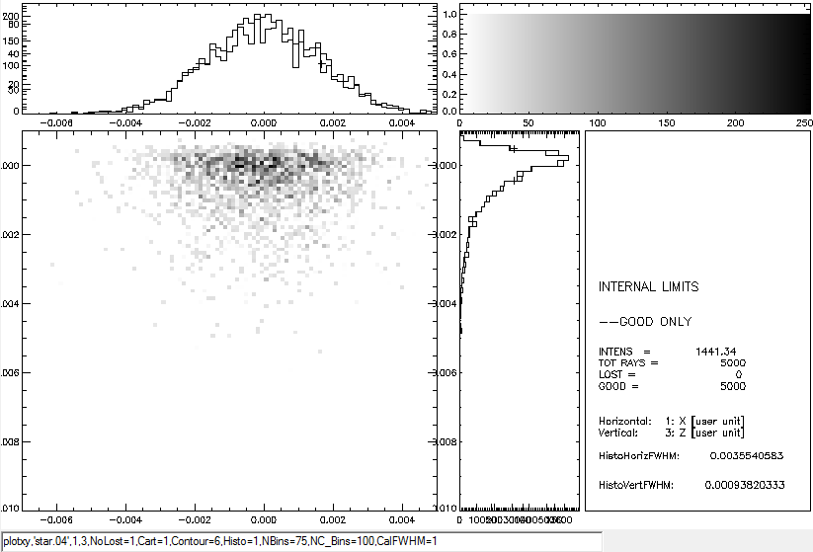

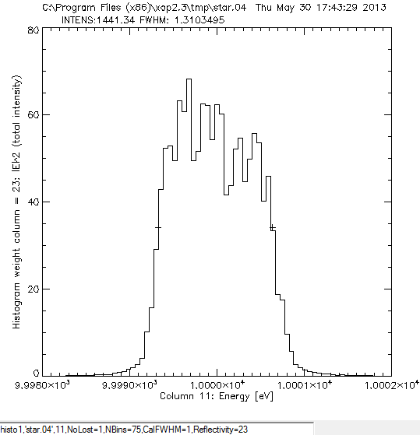

Slope errors.
You will learn to:
- Use Waviness preprocessor to create a file sampling slope errors
- Use presurface to inject it in SHADOW
- See the important effect of slope errors in the focal size

a) Load the Kirkpatrick-Baez system of exercise 16. Set mirror surface to be elliptical. Check that mirror dimensions are 40×4 cm². Calculate spot sizes without slope errors.

b) use the preprocessor Waviness to create maps of slope errors:
- i) In the Input tab at the Waviness window, load the input file wav_test1.inp to create a slope of 0.5 arcsec. Go to the "Create Outputs" tab and run sequentially options 1, 2 and 3.
- ii) Do the same with wav_test2.dat to obtain a rippled surface.
- iii) Use now the file wav1opt.inp. Modify the value of the initial Y slope error in order to get a value close to the desired tangential slope error of 0.5 arcsec rms. Then modify the number of points in X in order to adjust the sagittal slope error to 1 arcsec rms. Create another file wav2opt.inp with the same inputs but changed the seed. Then visualize the resulting surfaces and run SHADOW for both surfaces.
- iv) in SHADOWVUI oe menu, select modified surface: surface error…, and use then external spline with the corresponding *.sha file, one different file for each mirror to avoid coupled unphysical effects. Calculate then the spot size.

Hints: use the workspace ex20_slopeerrors.ows for part b). The macro modifies the inputs to run also part a).

Answer
a) 9.6 (V)×40 (H) μm²
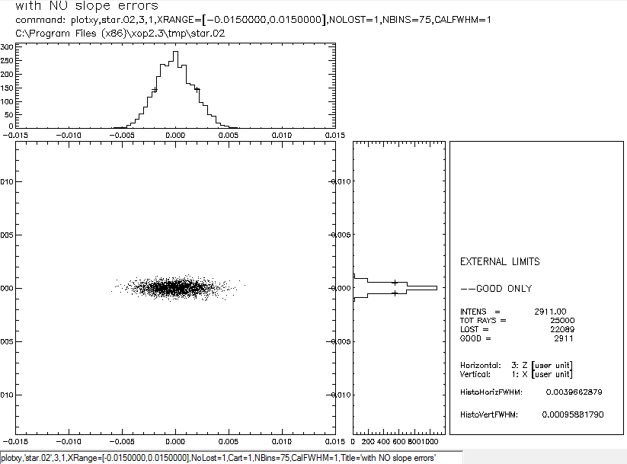

b)
i) and ii)
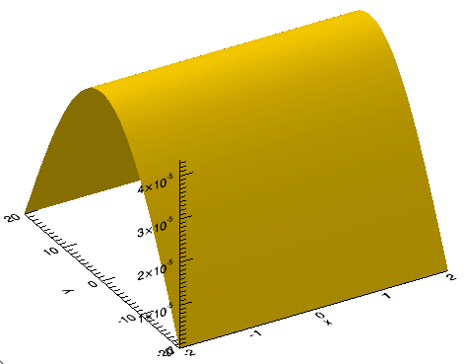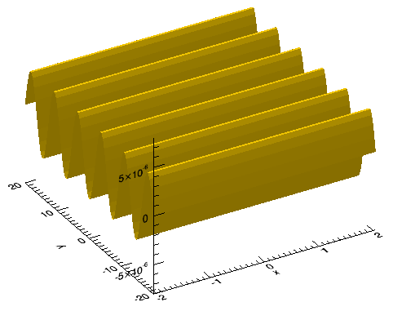
iii)
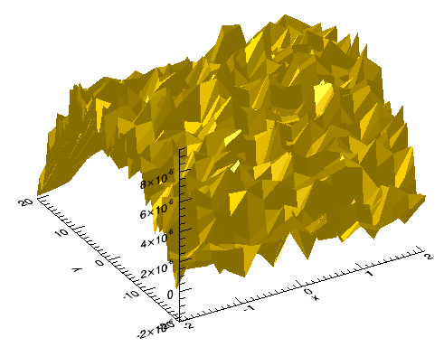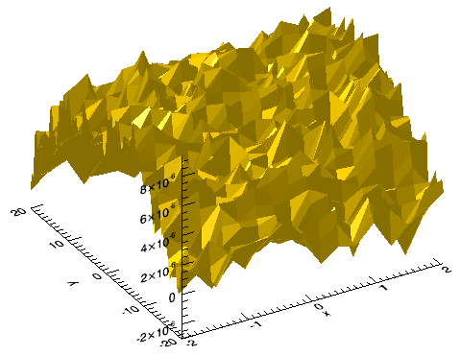

v) 101 (H) × 113 (V) μm²

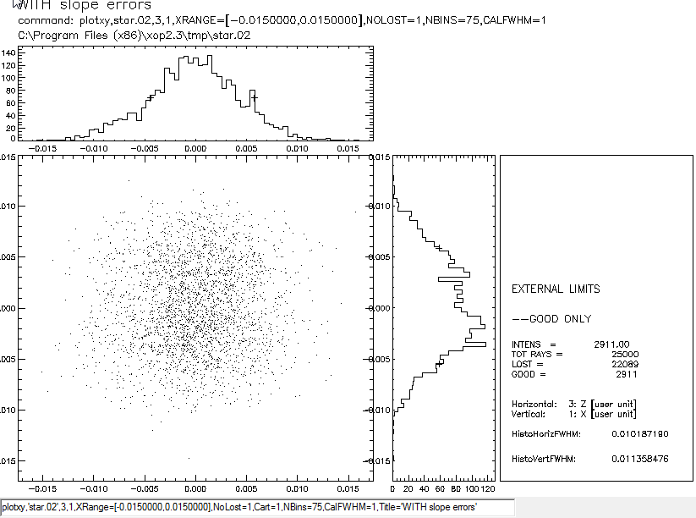

Thermal bump.
You will learn to:
- use a macro to create a file sampling a thermal bump
- use presurface to inject it in SHADOW
- see the effect of the bump in energy resolution.

Load the ex21_thermalbump.ows workspace. Create the source. Run the macro to create a Gaussian bump bump.dat and run SHADOW’s presurface. Run the system (a single Si111 crystal) without and with thermal bump. See the changes in the energy resolution.

Answer
With bump:
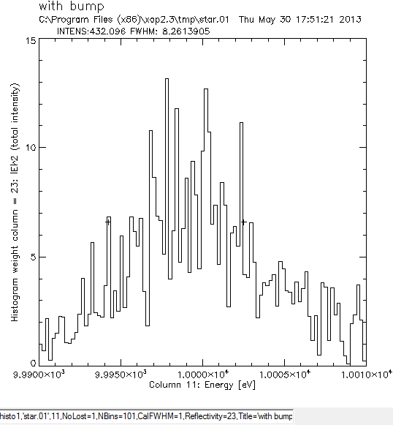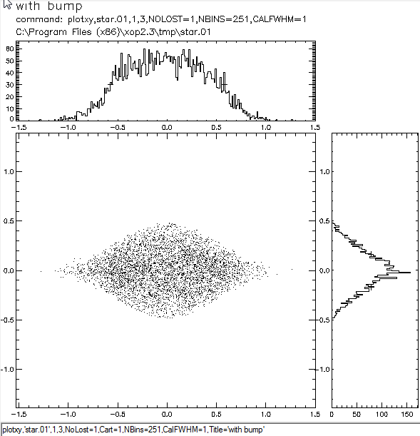

Without bump

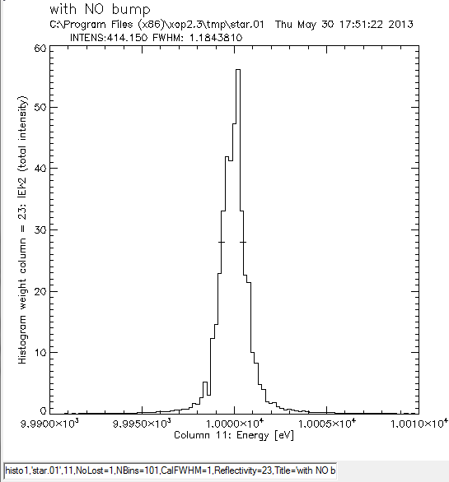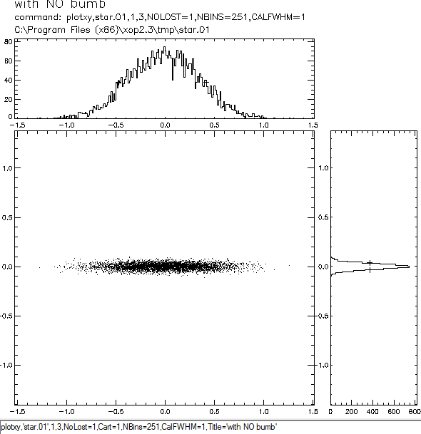

Curved crystal monochromators: Rowland and off-Rowland configurations
You will learn to:
- understand the effect of crystal radius in energy resolution and focusing conditions
- calculate the focusing conditions in and out Rowland configuration
- understand the importance of using contour curves with PlotXY
- simulate an asymmetric crystal

a) Using the same Gaussian source as in exercise 21, verify the focusing conditions for a symmetrical Si111 Bragg crystal at 10 keV, with p=30m. Calculate ΔE. Calculate ΔE for R_{t}=5000 cm and R_{t}=2500 cm. Explain the differences.
b) Calculate the Rowland conditions for 10 keV, Si111, p=30m and asymmetry angle α=5º. Calculate energy resolution and spot size.

Answer
a)
For the focusing conditions, we have R_{t}=15172 cm and ΔE=1.40 eV (use ex22a_rowland.ows)

For R_{t}=5000 we then have ΔE=2.07 eV (use ex22b_rowland.ows)
For R_{t}=2500 cm we then have ΔE=3.6 eV (use ex22c_rowland.ows)

b) Use the file ex22d_rowland.ows.
R_{t}=10622 cm, q=1185 cm; .ΔE=0.89 eV; spot size = 0.88×0.032 cm².
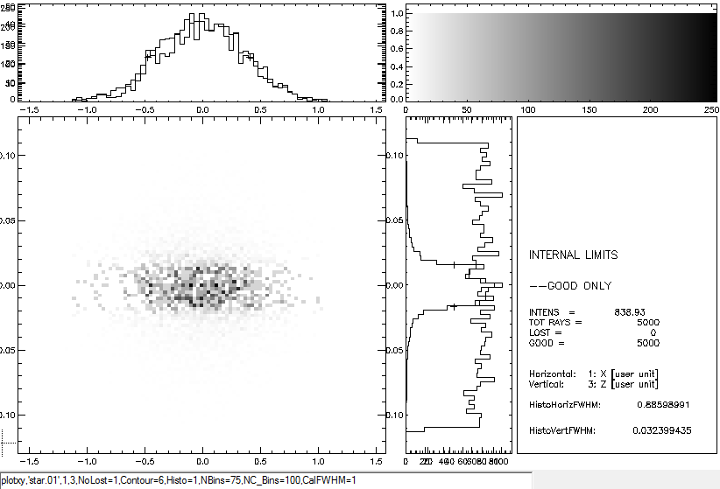
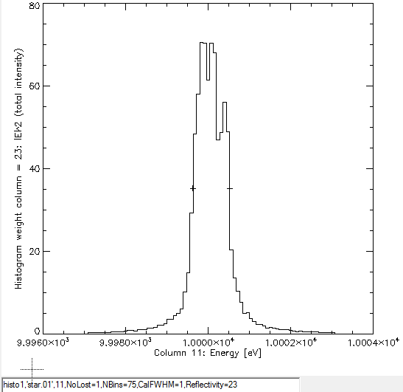

Crystals in Laue geometry
You will learn to:
- Set Laue crystals in SHADOW
- See the transformation in the phase space
- Apply a macro to copy intensity from one file to another.

Implement the system in file ex23_laue.ows, consisting in an asymmetric Laue diamond (111) crystal (a=3.55 Å) and a symmetric Bragg germanium (220) crystal (a=5.66 Å) in non-dispersive configuration. Notice that the diamond crystal has two associated screens, one before and another after it. Run the system, and then the macro that copies the electric vectors (i.e., intensities) from screen 2 to screen 1. Make histograms for these two screens and verify the changes in width for the z and z’ coordinates. Relate these changes to the Liouville theorem.

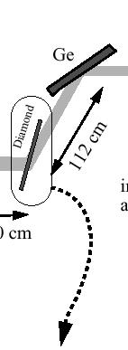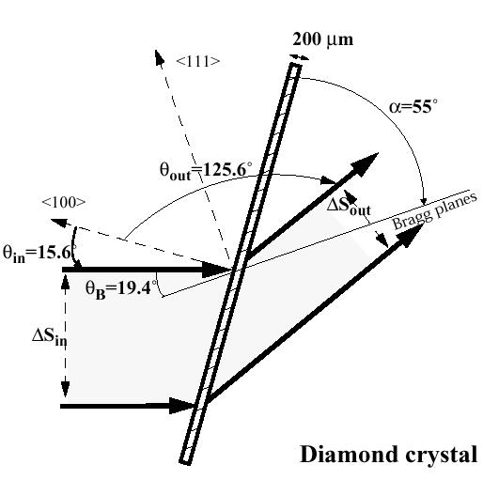

Answer
Phase space (Z,Z’) before the crystal
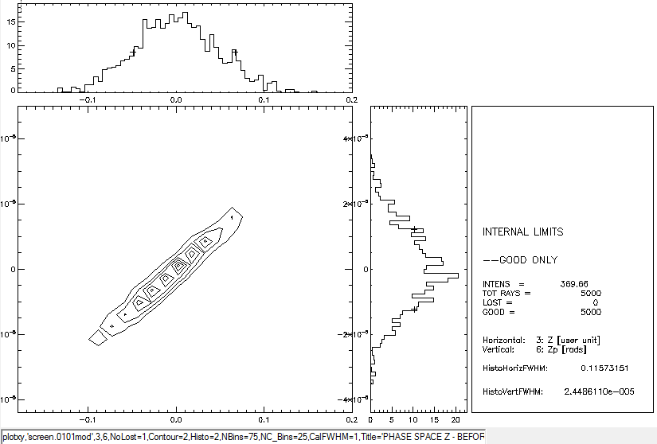

Phase space (Z,Z’) after the crystal
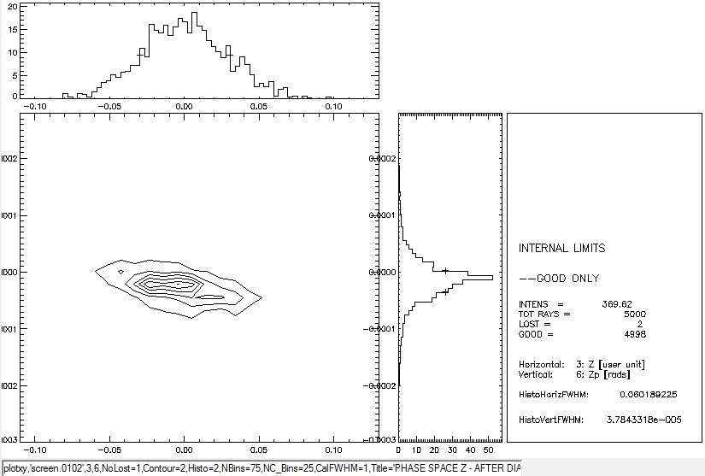

Transfocators
You will learn to:
- Use an approximated method to reduce a transfocator made by two CRLs to 2 single lense
- Use the precrl preprocessor to create the group of o.e. that constiture a CRL or a transfocator
- Run the exact transfocator using the SHADOW command runcrl
- Find the position of the best focus
- Study the changes due to the source energy (chromatic aberrations)

Implement a monochromatoc (E=37500 eV) Gaussian source of 48.2 (H) x 9.5 (V) μm RMS size and 100 (H) x 4.3 (V) μrad RMS divergence. Implement a transfocator consisting of two CRLs, 2D-focusing (in both H and V), the first made in Be (16 lenses of radius 200 μm, separated 50μm), and the second in Al (21 lenses of radius 200 μm, separated 50μm). The focal distances are p=3150 cm and q=1000 cm. This setup is discussen in Baltser et al. http://dx.doi.org/10.1117/12.893343
It is asked to:
- Approximate the transfocator by two single lenses, but a "fake" density (ρ=32* ρ _{Be}=59.04 g/cc and for Al: ρ =42*ρ_{Al}=113.4 g/cc) to account of the multiple lenses.
- Run the exact system using precrl with the input file mytransfocator.dat

Compare the results using plotxy. Study the beam evolution close to the focal plane using ray_prop: you will find a small astigmatism, i.e., the H and V foci are at slightly different position (you will find that the astigmatism disappears when using a point source, so it is the result of the final dimensions of the source). Change the energy of the source from 35700 eV to 35500 eV and see the effect in focal poition and intensity.

Hint: use the system in file ex24_transfocator.ows. The comparison gives similar focal size, but different intensity, as the approximated method does not calculate correctly the absorption. Note that the result of running crlrun gives final.01 (exact calculation) as output file, to be compared with star.02 (approximated).

Answer
For E=35700 eV we find a focus of 35 x 7.2 μm (FWHM) with I= 14384
For E=35200 eV we find a focus of 35 x 10.4 μm (FWHM) with I= 14176, best H focus at about -40 cm.

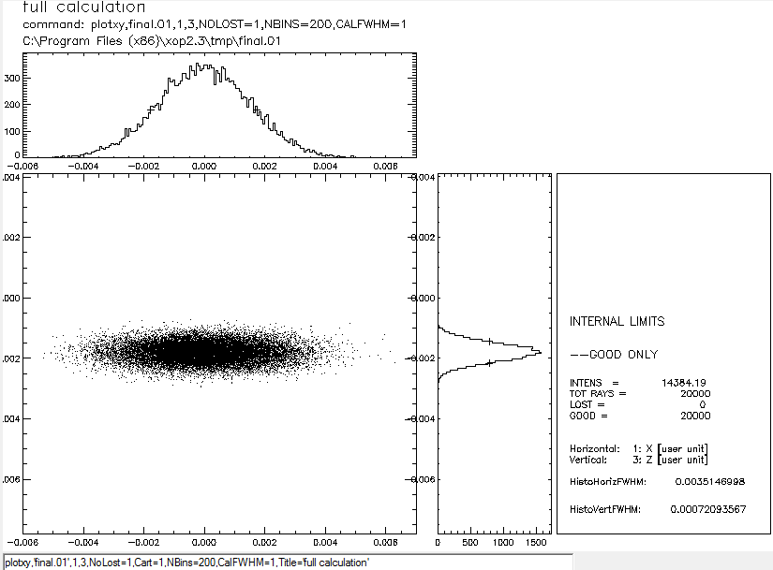

Fresnel propagator
You will learn to:
- Use the ffresnel wave optica propagator to compute the diffraction pattern (1D) by a slit.

Implement a monochromatoc (E=11000 eV) , collimated in H and with enough divergence in V to illuminate a 100 μm slit placed at 3760 cm from the source. Use the ffresnel postprocesor to compute the diffraction pattern at 550 cm from the slit.

Hints: Use the ex25_fresnel.ows workspace.

Answer

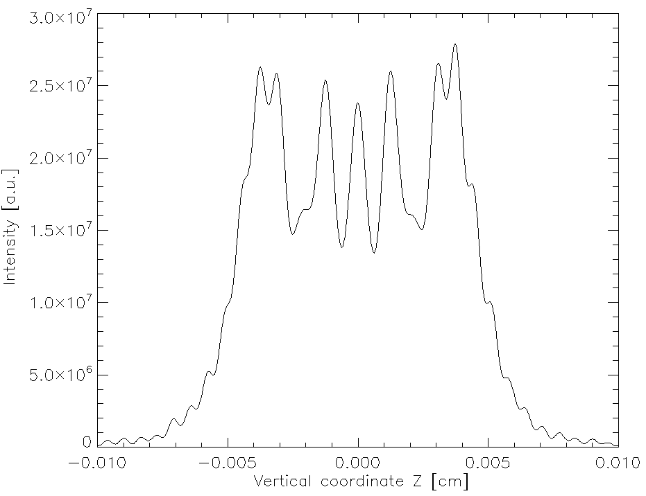

Two slits experiment - python scripts

You will learn to:
- Reproduce experimental results of a diffraction from a double-slit Leitenberg et al. Physica B 336 (2003) 63-67 http://dx.doi.org/10.1016/S0921-4526(03)00270-9
- Define a doube-slit in SHADOW using a screen/slit with external file definition
- Define a source optimised to illuminate into a reduced acceptance.
- Use ffresnel postprocessor to compute the diffraction patter produced by two slits
- Use a python script to make wave-optics propagation
- Find the position of the best focus
- Study the changes due to the source energy (chromatic aberrations)

Implement a monochromatic (E=14000 eV) rectangular source of 0 (H) x 140 (V) μm RMS size and 0 (H) x 2500 (V) μrad RMS divergence optimised to illuminate a square of 100 μm at 3090 cm (defined in file acceptance.dat). Trace the source into a screen containing the double slit, defined in a file twolits.pol. Trace make the ffresnel propagation to oa plane at 500 cm from the slits plane (fully coherent illumination). Run the python script that implements an ensemble of sources with different phases, and combine the results (partial coherence).

Tips:
Use a source of 140 microns vertical, with enough divergence to fully
illuminate the slits plane (15.4 microns) at 30.9m, so the divergence is
(70+7.7)*1e-3/30.9 rads.
Use variance reduction at the source to improve efficiency, with acceptance file: acceptance.dat
The oe includes the double slit from external files twoslits.pol
After source creation, and trace, macro 3 runs the python script
twoslitsLeitenberger.py that performs the propagation in vacuum and the
ensemble average. Please note that there are parameters hard-coded in this
script.

Answer

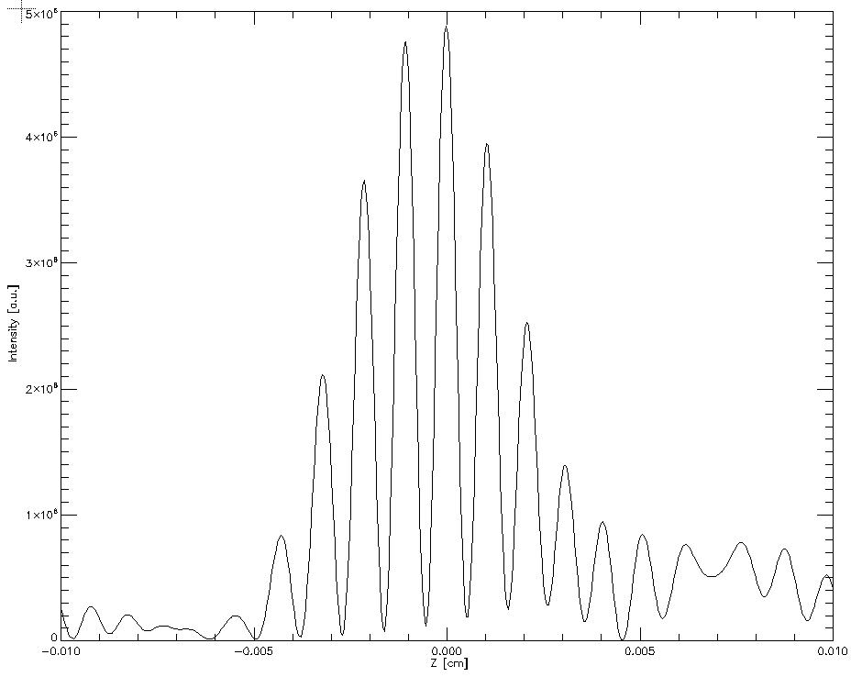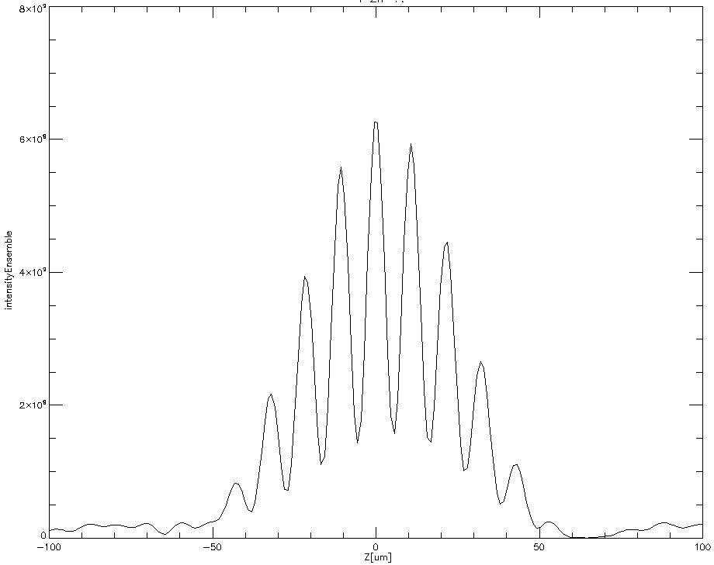

Other examples

Study the example SHADOWVUI->Load Example Workspace->From Example Dir...
- crl_snigirev1996.ows shows how to run CRL and transfocators in shadow3.
- crystal_mosaic.ows: an example of a crystal mosaic.
- ellipses_in_phase_s.ows: shows how to create a grid source whare rays follow ellipses in phase space.
- example_ffresnel.ows: an example of using ffresnel, the SHADOW wave-optics propagator.
- example_respower.ows: an example of using the postprocess application respower, that calculates the resolving power by a grating monochromator.
- example_roughness.ows: an example to include surface roughness in shadow, using a Gaussian PSD function.
- lens_chromatic_aberrations.ows: illustrates the chromatic aberrations in lenses.
- macro_collimator.ows: an example of programming a collimator.
- macro_conicsurface.ows: an example of programming a conic mirror from scratch in a macro.
- macro_crystal_with_external_diffraction_profile.ows: an example of how to post-process shadow results to include crystal reflectivity from an external diffractoin profile.
- macro_fresnelzoneplate.ows: an example of programming a macro for tracing a Fresnel Zone Plate.
- macro_gridpattern.ows: an example of programming a macro inserting a grid pattern in the beam.
- macro_kb_variancereduction.ows: an example of setting a KB mirror from inputs in a separate file and coding an algorithm of variance reduction for dealing with transmission by small apertures.
- macro_knifeedgescal.ows: an example of scanning a knife edge
- macro_lens.ows: setting a simple lens in SHADOW.
- macro_metrology_hfm_slope.ows: an example of applying mirror errors from experimental (slope) metrology data .
- macro_metrology_mirror_profile.ows: an example of applying mirror errors from experimental (profile) metrology data .
- macro_scanvariable.ows: an example demonstrating several ways of scanning SHADOW variables.
- macro_source_spectrum.ows: an example of post-processing a SHADOW source file to redefine the energy spectrum.
- screen_pattern.ows: an example of defining a patterned screen in SHADOW.
- screen_polygon.ows: an example of defining a polygonal slit in SHADOW.
- Shadow3_test.ows: an example of an IDL macro using the SHADIW3-API (i.e., not interacting via files).

Appendix - The very basics of SHADOW

SHADOW introduction

SHADOW is a ray-tracing program specially optimized for the design of the synchrotron radiation beamline optics.

SHADOW generates and traces a beam along the optical system. The beam is a collection of rays in a given point of the beamline which are stored in a disk file. The optical system is a collection of optical elements (o.e.) (mirrors, multilayers, slits, screens, etc.) placed in a sequential order.

Each ray is an array of 18 (or 12) variables or columns. Each variable of column has an special physical meaning. The first six defines the geometry: spatial coordinates (Col. 1,2,3 or x, y and z, respectively) and the direction of the ray (cols. 4,5,6, or x’,y’ and z’, respectively). The rest of the columns defines the history of the ray traversing the optical system (electric vector for s-polarization (cols. 7,8,9) and p-polarization (cols. 16-18), flag for lost ray (10), wavelength (11) etc.).

The source is the beam at the starting point. It is generated by SHADOW by sampling the spatial, angular, energy and other qualities of the synchrotron radiations sources (i.e., bending magnets, wigglers and undulators) into a finite number of rays, using a Monte Carlo method. At the source position the intensity of each ray (or better, its probability of observation) is set to 1. This intensity will decrease along the beamline because of the interaction of the ray with the optical elements. The source generated by SHADOW samples linearly the real source, which allows scaling the intensity with the number of photons.

SHADOW traces the source sequentially thought each individual optical element of the optical system. SHADOW solves the intercept of each ray at a given o.e., calculates the output direction and the decrease in intensity. This decrease is calculated for each ray using a physical model (i.e. Fresnel equations for mirrors, Dynamical Theory of the Diffraction for perfect crystals, etc.)

SHADOW files

Important input files (written by ShadowVUI):
- start.xx an ASCII file with the list of variables for the source or optical elements (start.00 for the source, start.01 for the first o.e, start.02 for the second, and so on)
- systemfile.dat a small file listing the start.xx files to be traced.

After running SHADOW, either in command mode or using the interface (via the the command shadow3 < shadow3.inp ), the binary files containing the rays at different points are:
- begin.dat binary file containing the beam at the source position
- mirr.xx binary file containing the beam on each o.e. (i.e. mirr.02 is the beam on the second o.e)
- star.xx binary files with the beam at the image created by each o.e. The image of a given o.e. is the source for the following o.e.
- screen.xxyy SHADOW can (optionally) create the image file in a different points of the beamline, or screens. Screens are associated to a given o.e., and can allow to define apertures (slits or beam stoppers) and absorbers (filters). xx refers to the o.e. and yy refers to the screen order (i.e. screen.0204 means the fourth slit associated to the 2nd o.e.)

SHADOW frame
The coordinate system of SHADOW is (schematic, ):

Note that:
- The y(2) coordinate is along the beam direction
- The frame is rotated if one o.e. is rotated
- The position, orientation, etc. of any o.e. is always referred to the previous one

Effect of o.e. orientation in SHADOW frame

Macro programming (IDL): survival guide

Changing values and running the interface

Change variable in the interface for source (use source=0 for geometrical source, 1 for BM, 2 for Wiggler and 3 for Undulator):
shadow_setIfcPar,'NPOINT',npoint,source=0

Change variable in the interface for o.e's (use trace=0 for o.e. 1, 1 for o.e. 2, etc.):
Shadow_SetIfcPar,'T_SOURCE',3000.0,Trace=0
Shadow_SetIfcPar,'T_IMAGE',1000.0,Trace=1

Run source:
Shadow_RunSource,/Only_Run or
Shadow_Run,/Source

Run Trace:
Shadow_RunTrace or
Shadow_Run,/Trace

Changing values from files and injecting SHADOW commands

Read start.xx file, change a value, and re-write the file:
g0 = read_gfile('start.00')
g0.NPOINT = 10000
write_gfile,g0,'start.00'

Write input file:
openw,unit,'shadow3.inp',/get_lun
printf,unit,'version'
printf,unit,'exit'
free_lun,unit

Run shadow3 with an input file:
xsh_run,SHADOW3_BINARY()+'< shadow3.inp'

Access binary SHADOW files

Reads one or several columns in a binary file (column indices start by one):
x = GetShCol('begin.dat',1)
xyz = GetShCol('begin.dat',[1,2,3])

Reads binary file (and change a value) (column indices start by zero in ray):
a=ReadSh('begin.dat')
a.ray[0,100]=33

Write binary file:
putrays,a,'begin.dat'

Visualizing results

Start graphics (plotxy, histo1, ray_prop):
xsh_plotxy,.... xsh_histo1, ..., xsh_ray_prop,....

Programming

DO loop:
FOR iii=0,n DO BEGIN
Print,iii
ENDFOR

IF loop:
IF (a EQ 0) THEN BEGIN
print,a
ENDIF

RESOURCES

XOP:
- M. Sanchez del Rio and R. J. Dejus "XOP v2.4: recent developments of the x-ray optics software toolkit Proc. SPIE 8141, 814115 (2011) http://dx.doi.org/10.1117/12.893911.

SHADOW:

- F. Cerrina and M. Sanchez del Rio "Ray Tracing of X-Ray Optical Systems" Ch. 35 in Handbook of Optics (volume V, 3rd edition), edited by M. Bass, Mc Graw Hill, New York, 2009. ISBN: 0071633138 / 9780071633130 http://www.mhprofessional.com/handbookofoptics/vol5.php
- M. Sanchez del Rio, N. Canestrari, F. Jiang and F. Cerrina "SHADOW3: a new version of the synchrotron X-ray optics modelling package" J. Synchrotron Rad. (2011). 18, 708-716
http://dx.doi.org/10.1107/S0909049511026306

Web resources:

- XOP Web site: http://www.esrf.fr/Instrumentation/software/data-analysis/xop2.3/Main
- XOP ftp http://ftp.esrf.eu/pub/scisoft/xop2.3/
- SHADOW3 repository https://forge.epn-campus.eu/projects/shadow3/
- Command to retrieve shadow3 sources: git clone git://git.epn-campus.eu/repositories/shadow3

