FirstName Sahachan Last name Tippimwong SID 62215039

Tutorial 1 (1-dimension array tutorial)

•Create an one dimension array of type integer that has a size of 999.

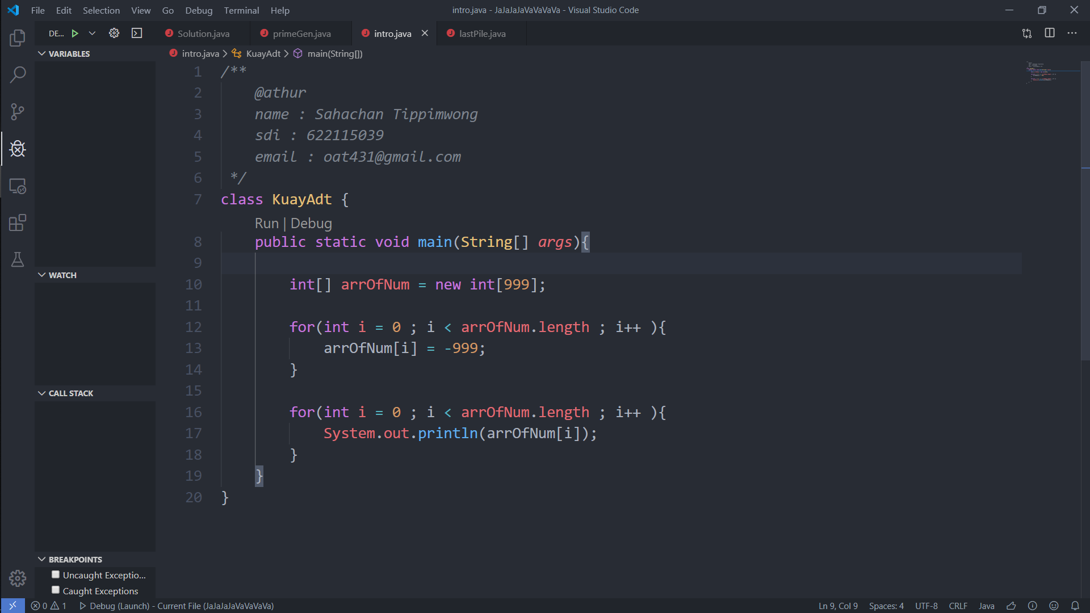

•Initiate all the element in the array to -999;



•Display all the element inside the array using for loop

Full program

