Write a pseudocode to solve the following problem

Define: newline mean output will goes to nextline

Define: Read() mean read input from user

Define: name = new DataType[size] mean declare array and this array start first   
 element at 0

Define print_bit(arr:Array_Integer) :

For Let i in arr Then

Display i “ “

Endfor

Display (newline)

Define: gen_bit(n:Integer, arr:Array_Integer, i:Integer):

If n == i :

print_bit(arr)

return

EndIf

arr[i] = 0

gen_bit(n,arr,i+1)

arr[i] = 1

gen_bit(n,arr,i+1)

Start

Let t <- input()

arr <- new Integer[t]

gen_bit(t,arr,0)

End

Show that your code is correct

the code that I wrote is a recursion approach it mean if the function called itself the previous function won’t end until the current function is ended

if I show in static visual representation I will show you something like this

this code flow called gen_bit() after arr[i] = 0

this code flow called gen_bit() after arr[i] = 1

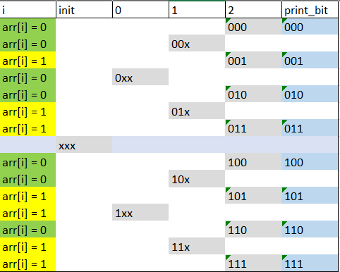

Find all possible cases of the input

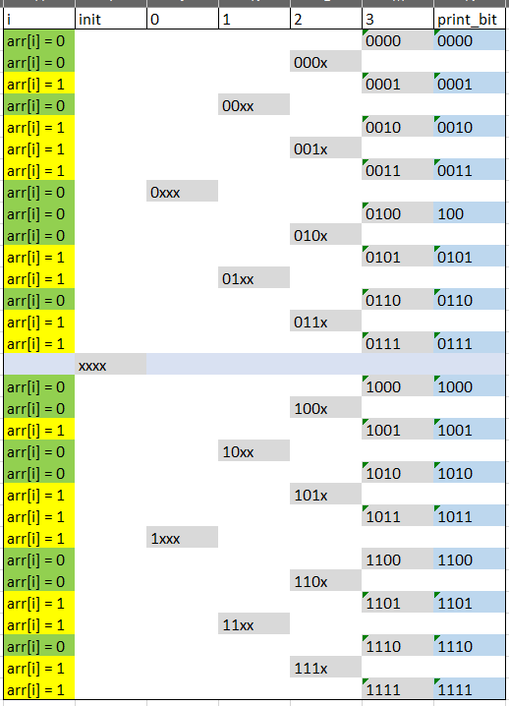

Implementing your code and show the solution

Programming language : python 3.8

Text editor : visual studio code with python extension

