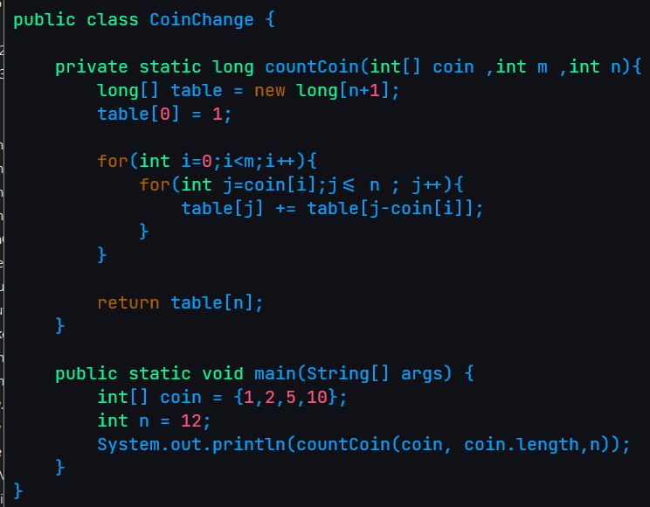My code on Dynamic programing

I use overlapping approach to do this problem by

1 table is just like a note that remember all the value that exchange the coin

2 given all the default value to table and the default value is 1 with is only 1 way to exchange the coin

3 the loop run though all coin and it sum up the default value and update value

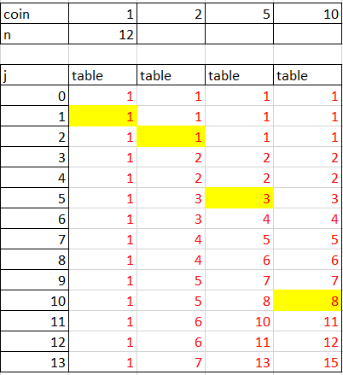The visualize for this problem will be right this

Select coin “1”   
 table 1 will be   
 [1,1,1,1,1,1,1,1,1,1,1,1,1]

Select coin “2”   
 table 1 will be   
 [1,1,2,2,3,3,4,4,5,5,6,6,7]

Select coin “5”   
 table 1 will be   
 [1,1,1,2,2,3,4,5,6,7,8,10,11,13] Select coin “10”   
 table 1 will be   
 [1,1,1,2,2,3,4,5,6,7,8,11,12,15]