Rotate array  
  
1.Write a pseudocode to solve the following two problems, as the picture attached.

Define: input() for get input from user and it will automate cut input at ‘]’ and detect the newline of the input in the other hand it can turn input from user to matrix

Define: length() for knowing a size of the array

Start

matrix <- input()

Let row <- length(matrix)

Let col <- length(matrix[0])

For Let i <- 0 To row-1 Step i By 1 Then

For Let j <- 0 To col/2 Step j By 1 Then

Let t = matrix[i][j]

Matrix[i][j] = matrix[i][col-j-1]

Matrix[i][col-j-1] = t

Endfor

Endfor

End

2.List the characteristic of the possible input and output and show some examples.

Input: characteristic  
 it need to be an String that begin with [ and end with ] between those square it need to have list of number and there has 2 delimiter first delimiter is a space between number and another is a newline delimiter   
  
example  
[ 1 2 3

4 5 6

7 8 9 ]

Output: characteristic : The output show the flip matrix( each row in matrix will show reverse order)

Example

[ 3 2 1

6 5 4

9 8 7 ]

3. Do programming according to your algorithm designed, submit code in an implementable file (define program and its version that you use) and capture the screen of the running code result.

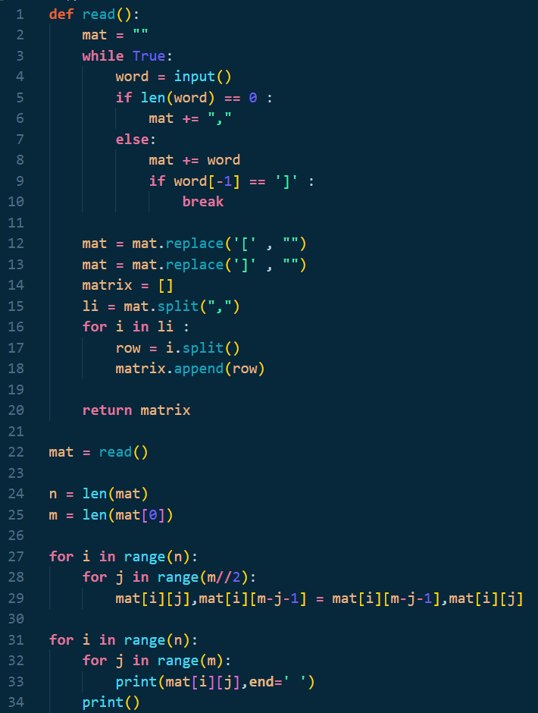Program that develop this code: VSCode with python extension   
Python version 3.8  
  
code : output:

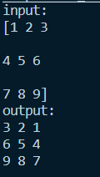

Sequence Sum

1.Write a pseudocode to solve the following two problems, as the picture attached.

Define : input_array() for input array

Define: input() for getting input from user

Define: length() for knowing a size of the array

Start

Let s <- input()

Let n <- input()

Let arr <- input_array()

Let cnt <- 0

For Let i<- 0 to length(arr)-1 Step i By 1 Then

If i + n – 1 == length(arr) then

EndFor

Endif

Let sum <- 0

For let j to i + n – 1 Step j By 1 Then

sum += arr[j]

Endfor

If sum == s then

cnt = cnt + 1

Endif

Endfor

Display cnt

End

2.List the characteristic of the possible input and output and show some examples.

input: characteristic

there are 3 input

first is a list of the number that separate with “,”

second is a expect result of the problem from first input

third is a require number of sequences that can produce the second input

Example:

1,2,3,4,3,2,1   
6 3

Output: characteristic

There is only one output

The output tells us how many sequences that can produce a expect result from list of number

Example:

2

From Example in input characteristic:

Expect result 6

Require 3 sequence

List of number {1 2 3 4 3 2 1}

{[1 2 3] 4 3 2 1} tell us that 1 + 2 + 3 is 6

{1 [2 3 4] 3 2 1} tell us that 2 + 3 + 4 is 9

{1 2[ 3 4 3] 2 1} tell us that 3 + 4 + 3 is 10

{1 2 3 [4 3 2] 1} tell us that 4 + 3 + 2 is 9

{1 2 3 4 [3 2 1]} tell us that 3 + 2 + 1 is 6

From above there are 2 sequence that produce the expect result  
  
 so output is 2

3. Do programming according to your algorithm designed, submit code in an implementable file (define program and its version that you use) and capture the screen of the running code result.

Program that develop this code: VSCode with python extension   
Python version 3.8  
  
code : output:

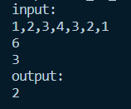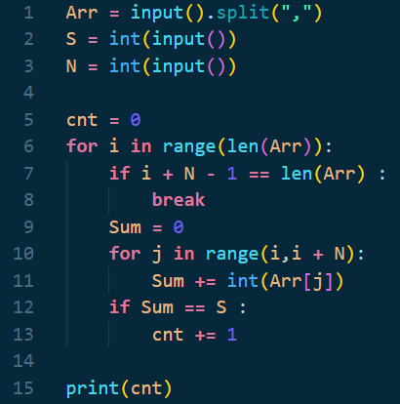

Sahachan Tippimwong 622115039