**Lab 2**

**Install the JAVA editor**

**Name-Surname**………………………………......**Student No**........................................**Section (LAB)**……………

**Lab instruction**

1. Open VS code or JAVA IDE in your computer.
2. Create a new java class name Countdown.java, then write the following code.

public class Countdown  
{  
 //-----------------------------------------------------------------  
 // Program By ..(Your name and Student no.)  
 //-----------------------------------------------------------------  
 public static void main (String[] args)  
 {  
 System.out.print ("Three... ");  
 System.out.print ("Two... ");  
 System.out.print ("One... ");  
 System.out.print ("Zero... ");  
  
 System.out.println(2010);

System.out.println ("This is My First JAVA program :");  
 }  
}

1. Share VS code screen and run the program to the teacher assistant (TA) to get the score.

**Checkpoint 1 For teacher or TA**

󠇀 Run “Countdown” Program.

Question 1

What is difference between print and println statement?

Answer

1. Create number.java then write the following statements then record the results
   1. System.out.println(3 + 15 / 5 – 2 + 2 * 3); _______________________
   2. System.out.println(3 * 3 + 3 % 2 – 5 + ( 3 / 2)); _______________________
   3. System.out.println(3 + 20 / 5 + -2 * 4); _______________________
   4. System.out.println(2 * ( 1 + -(24/4) / 2) * (2 – 6 % 3)) _______________________
2. Share VS code screen and run the program to the teacher assistant (TA) to get the score.

**Checkpoint 2 For teacher or TA**

󠇀 Run “Number” Program.

1. Write a program that display you nickname by using * symbol.

Example

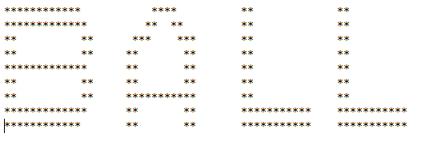

**Checkpoint 3 For teacher or TA**

󠇀 Run Nickname Program.

--------------------------------------------End of Lab-----------------------------------------------