SE212 Database System and design

Lab 9 Basic DML

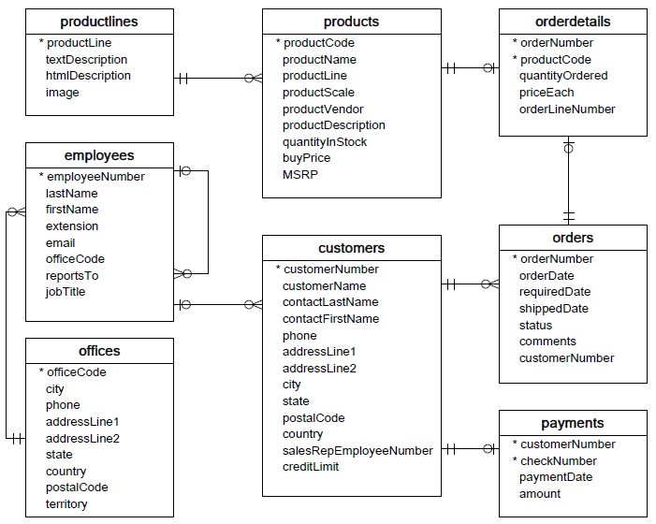

Write a SQL statement to retrieve the data from the given database to answer the question.   
1. How many orders for each status?

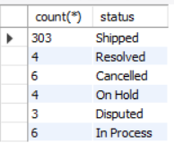



1. List customers whose orders are in “Disputed” status?

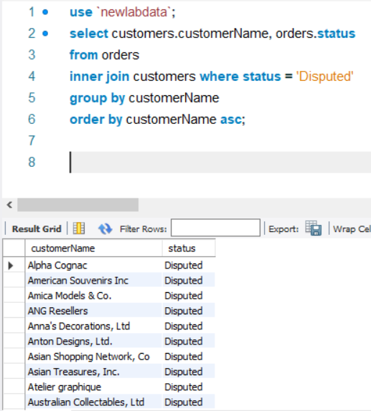

1. List the customer who cancel the order. Hint: The order that is canceled has “Cancelled” status.

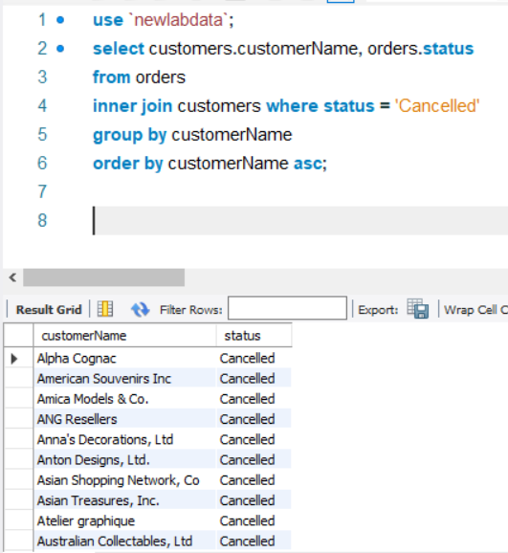

1. Identify the order where required date is later than 30 days after their orders.

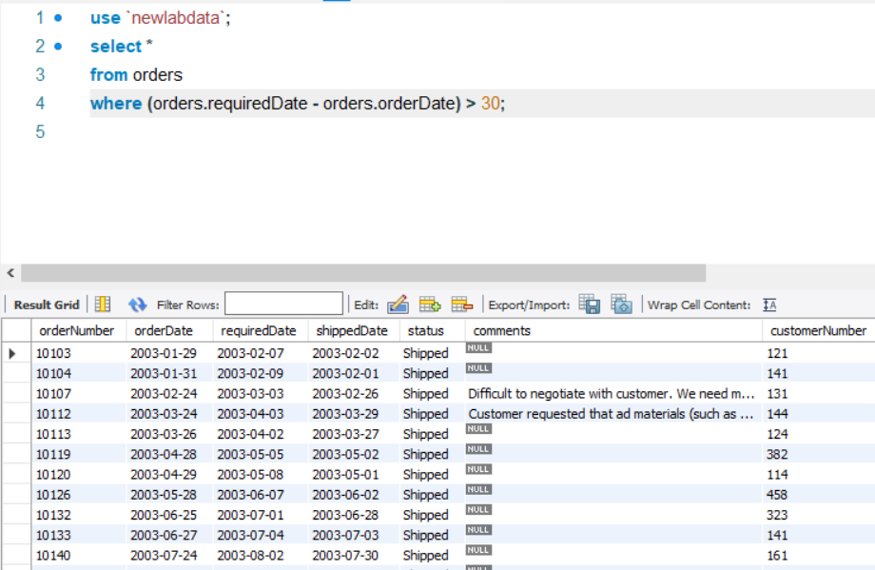

1. Identify the order where shipment date is within 15 days after the order.

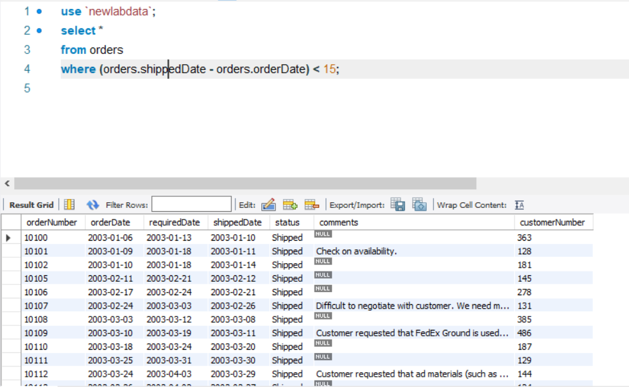

1. List the customer and their total number of order. You need to sort the result by descending order of number of order.

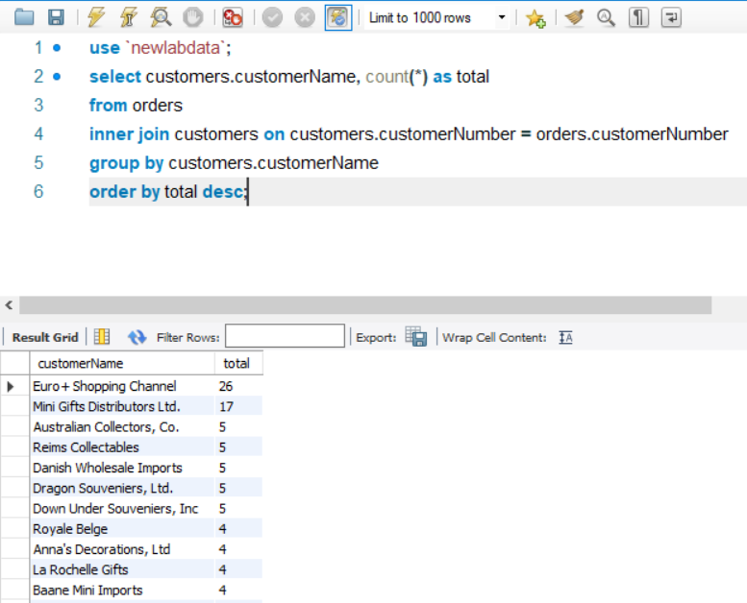

1. Which product has the highest sales?

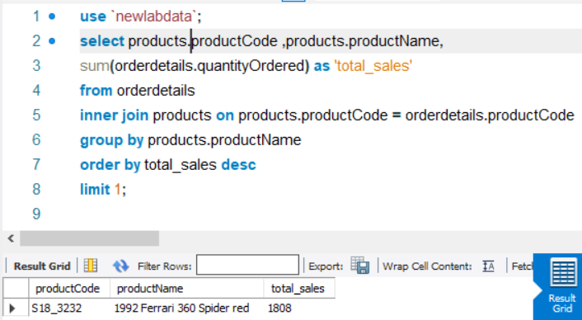

1. Display the product by name and its total sales.

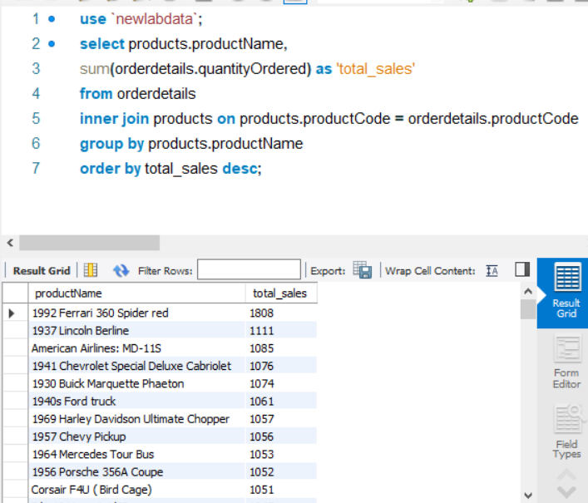

1. Display the total payments of each days.

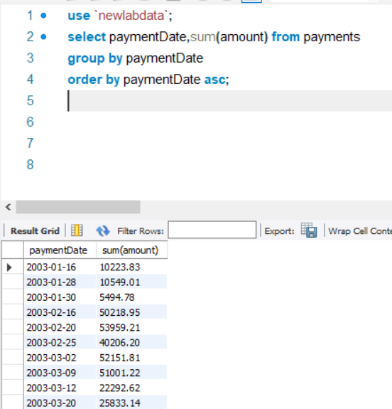

1. Display the average of each payments.

