Creating “Hello World”

Methods to create programs
- Type in the program
- Cut and paste elements from an existing program
- Use the code template

Use Code Template
For this example, use the Code Template to create the following program:
task main()
{
eraseDisplay(); // clear the NXT display
// display "Hello World"
nxtDisplayCenteredBigTextLine(2, "Hello");
nxtDisplayCenteredBigTextLine(4, "World!");
while (true) // loop until program is terminated so
; // that we can read the display
}

To use the Code Template, go to the code template area, select and drag items from the template to Code Window then edit as appropriate.
- _C Constructs à Tasks/Subroutines à task taskname …
  - Change taskname to main
  - Select and delete body
- Display à Intrinsics à eraseDisplay()
- Display à Intrinsics à nxtDisplayCenteredBigTextLine ()
- Display à Intrinsics à nxtDisplayCenteredBigTextLine ()
- Edit arguments for last two commands
  - Change nLineNumber to 2 and 4 respectively
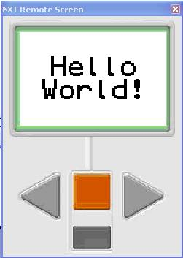
  - Change sString to “Hello” and “World!” respectively
- _C Constructs à Control Structure à while
  - Change conditional to true
  - Change { body } to ;
- Add comments to describe what is happening (optional)
- File àSave AsàHello World.c

Run program using debugger
- Robot à Compile and Download Program
- Note: Pops up debugger
- Insure remote display is up
- While observing the remote display, Select step into, step over, …, stop
- Close Debug window to end session

For additional information in using the debugger, see Help→ROBOTC Help, then select ROBOTC Debugger.

