**Instructions to Guide Users Through the Installation and Setup of Tools Required in the PythonInDigitalAg repository**

To complete this module, you need a means to obtain code from the course repository. GitHub is the largest and most popular website to host repositories for codes and projects. It is where we have stored the codes from this learning module. You may make your code available (if you choose) in your own GitHub repository. Even if you don't make your code available, GitHub offers the benefits of free cloud storage and access from anywhere, on the internet. The first section of this document guides you through an introduction of GitHub and the process of setting up a profile. It will also guide you through forking and publishing features.

To use Python in general, an integrated developer environment (IDE) is used. Section 2 describes the Instructions and steps that should be followed sequentially to install and configure the VS Code IDE for Python programming. VS Code is highly recommended and great for those new to Python (or other languages). There are alternatives, but this one will serve you well.

## Set up a Git hub profile:

Use the video links below to set up a GitHub Profile:

1. Profile Setup: <https://www.youtube.com/watch?v=ZhHDfZ-l7ZU>
2. Creating a repository by forking an existing repo from a different user: <https://www.youtube.com/watch?v=ZB9VgHFqqXU>
3. Download the [PythonInDigitalAg](https://github.com/oats-center/PythonInDigitalAg) course repository from the Oats-center page on GitHub. It looks like this:

1. Committing one-time changes to GitHub: [https://github.blog/2016-02-18-upload-files-to-your-repositories/](https://github.blog/2016-02-18-upload-files-to-your-repositories/%20) . Please remember GitHub is different from Git and this process is not version control. This will only help you publish your work on GitHub.
2. For this course module
   1. Create a new folder for example, create a folder with the name” your name”. (Note: Insert your name instead of “your name”.)
   2. Download the zip file for the PythonInDigitalAg repo in this” your name” folder.

## VS Code user installation and configurations for a windows computer:

**Step 1:** To get started, you'll need to download the installer for Visual Studio Code. You can download it from the official website: <https://code.visualstudio.com/download>.

Once you're on the download page, you should see a button that says, "User Installer”. Select the x64 version for your computers. If you want to know more about the difference between the user and system installer you could visit the [VS Code page](https://code.visualstudio.com/docs/setup/windows#:~:text=VS%20Code%20provides%20both%20Windows,a%20smoother%20background%20update%20experience.) .

**Step 2:** Save the “VSCodeUserSetup-x64-1.77.1.exe” file. If it does not prompt for a location it will save the file in the download folder of the computer. Saving it in download folder is fine.

**Step 3:** Run the installer file by double-clicking on it.

1. Accept terms. Next
2. Next.
3. Next.
4. Next.
5. Install.
6. Finish.

It is now installed on your system. You are the admin of the system. So, it will not need any password anymore. Cancel any prompt that asks you for a password.

**Step 4:** Search for VS Code in your search bar at the bottom of your screen. You should be able to see this screen for VS Code.(Note: the VS Code can be dark or light mode, don’t worry about the background color). Here is a ~7 min video on the [user interface](https://youtu.be/B-s71n0dHUk?si=tOtqDNyGZBmd0dSM&t=20) of the VS Code, check out the UI tour, Save/Autosave, create Python file, and Add Python Extensions parts of the video.

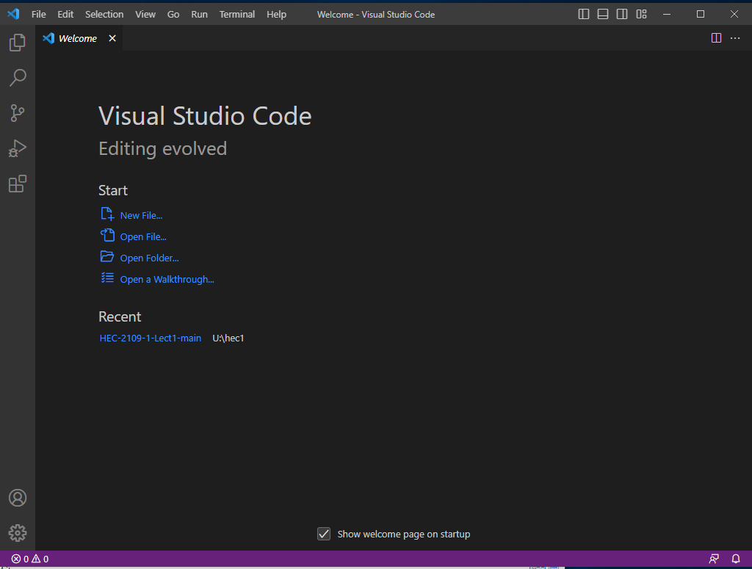

**Step5:** Select Open Folder... and navigate to the “your name” folder and select it. The folder structure should look like this.

**Step 6:** Install Python interpreter when prompted by VS Code. It will show up in the bottom right of the window. It will install the newest version of Python to your VS Code.

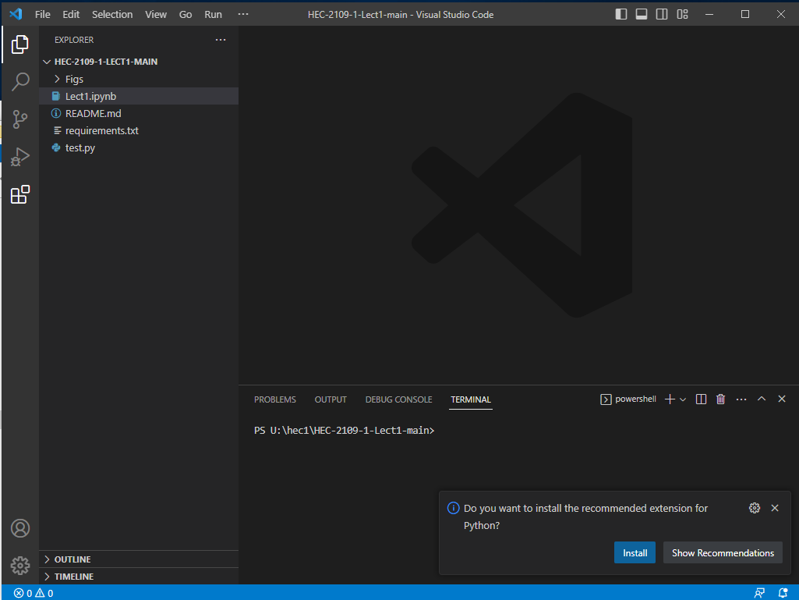

**Step 7**: If this Alert pops up, **Cancel** it. You do not need this.

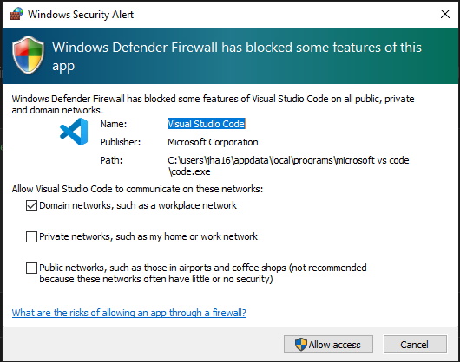

**Step 8**: Select your Python Interpreter. It’s best to select the recommended one.

**Step 9**: Install the IPython kerned when prompted by IDE. This will enable the python interactive window. <https://code.visualstudio.com/docs/python/jupyter-support-py>

**Step10**: As we are using Python 3 we should use pip3 to install the packages in the VS Code terminal.

1. Open the terminal from the tool bar in VS Code. From Terminal open a New Terminal.

|  |
| --- |
|  |
|  |

1. Select the terminal command prompt.

|  |
| --- |
|  |
| The folder address of the author is redacted. Users should see their own folder address instead. |

1. Install the Python packages using pip3 and the command from the PyPI webpage. We write the command “pip3 install NumPy” in the opened terminal in VS Code. On entering the command pip will download and install NumPy. It will also print the downloading and installation outputs. The output in the author’s terminal reads “Requirement already satisfied NumPy in c:\tools\manim\lib\site-packages (1.24.2)”. This would be different for each user based on the structure of their home directory. The package has been installed correctly when the terminal displays installation is successful. (Note: Install pip if VS Code prompts you for it)

|  |
| --- |
|  |
|  |
|  |

**NOTE**: We will not be using Python environments, but creating virtual environments for different Python projects is good practice. To learn more about why? and how? you can read “[Using Python Environments in VS Code](https://code.visualstudio.com/docs/python/environments)” on VS Code’s official website.

**Step 10**: Some background on the VS Code layout is available on its official [User Interface webpage](https://code.visualstudio.com/docs/getstarted/userinterface).

