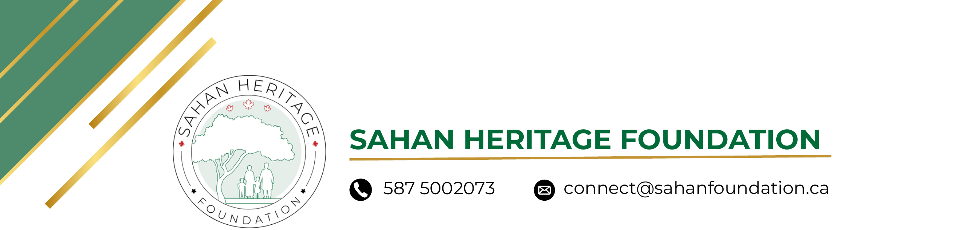
WELCOMING PARTY FOR SAHRA HALGAN
OFFICIAL CONTRIBUTION RECORD

If you are attending, please send your contribution to: yycsomaliland@gmail.com
CONTRIBUTOR NAME | AMOUNT | STATUS
Hebaq Mahmoud Handoli | $50
  PAID
Deeqa Bare | $200
  PAID
Obaid Obsiye | $150
  PAID
Abdirahman Awaleh | $100
  PAID
Ayaan Yusuf Hassan | $50
  PAID
Ahmed M | $100
  PLEDGED
Rooda Yousuf | $100
  PAID
Suldaan Abdillahi | $100
  PAID

Total Collected: | $750
Total Pledged: | $100
Grand Total (Known): | $850
Thank you for your generous support of the Sahan Heritage Foundation.

