

​​
Data Structures & Algorithms
40201201
T/618/7430
Section (6)

Data Structures & Algorithms

Submitted to
Ahmed Bataineh
Submitted by
Obada Al-Halaybeh

Spring –2025

Question 1
In this system, I used different Abstract Data Types (ADTs) for each feature depending on what the feature needed. Each ADT is implemented using appropriate Java classes, and I made sure each one supports the valid operations needed for that part of the system. Below is the explanation for each feature and the ADT used.
- Feature 1 lost and found tracking
I used the generic LinkedList ADT for this feature since the lost items can’t be a fixed size and this allow me to do easy add and removal since I do not worry about the size.
This feature had 3 classes first one is LostFoundItem that hold description, date, and location. The second one is LostFoundManager that controls the operations using the Linked list. And the last one is the main for this feature it work as inside menu for the operations here. The operation are add, view, and remove
the valid operations
Method | Description
add(T data) | Adds a new element to the end of the list (same as calling addAt(size, data)).
addFirst(T data) | Adds a new element to the beginning of the list. Updates the head pointer.
addAt(int index, T data) | Inserts a new element at the specified index (supports adding at head, tail, or middle). Throws IndexOutOfBoundsException if index is invalid.
get(int index) | Returns the element at the given index. Traverses the list from head. Throws IndexOutOfBoundsException if index is invalid.
remove(int index) | Removes the element at the specified index. Updates pointers accordingly. Throws IndexOutOfBoundsException if index is invalid.
size() | Returns the current number of elements in the list.

- Feature Room Booking
I used generic queueLinkedlist for this feature I also used sorting algorithm the merge sort the booking request are sorted based on priority high, mid and low I used the queue for its FIFO principle as after sorting the request the high priority will be inserted first on that queue so he will be processed first. This feature had 3 classes a BookingRequest contains student info and priority, a RoomBookingManager to manage and sort the requests and a main for this feature the micro control the operation inside this feature. The operations are add request, sort & queue request, process request, view unsorted request and view queue (sorted reuqests)
valid operations (here I have array list for the mereg sort and linkedqueue for the processing )
Method | Description
add(T element) | Adds an element at the end of the array (same as addAt(size, element)).
addFirst(T element) | Inserts an element at the start (index 0), shifting others forward.
addAt(int index, T element) | Inserts an element at a specific index. Shifts elements to the right. Resizes array if full.
get(int index) | Returns the element at the specified index. Throws exception if out of bounds.
remove(int index) | Removes the element at the specified index, shifting elements to the left.
size() | Returns the number of elements currently stored in the array.
resize() | (Private) Doubles the capacity of the array when full.

Method | Description
enqueue(T item) | Adds an element to the end of the queue (using linked list .add() method).
dequeue() | Removes and returns the element at the front of the queue (index 0). Throws error if empty.
isEmpty() | Checks if the queue is currently empty.
peek() | Returns (but doesn’t remove) the front element.

- Feature 3 student orientation help
I used the graph for this feature since its purpose is to help students find shortest path around the campus I used undirected graph as this is the reasonable way of people can go forward and backward and I used Dijkstra’s algorithm since its great at finding shortest path, I had 2 classes a graph that create the adjacency matrix and do the Dijkstra operation and I have main the micro controls this feature operations. The operation here can one and it is find shortest path.
valid operations
Method | Description
Graph(int numberOfNodes) | Constructor that initializes the cost adjacency matrix for a graph of fixed size. All edges start as INF (infinite/unreachable) except self-loops which are zero. Predefined edges are added for specific campus locations.
addEdge(int from, int to, int cost) | Adds a bidirectional (undirected) edge between two nodes with a given cost (distance).
isNeighbor(int i, int j) | Checks whether two nodes are directly connected (i.e., cost is not INF).
dijkstra(int start, int end) | Runs Dijkstra's algorithm to find the shortest path and cost from the start node to the end node.
printPath(int[] prev, int node) | Recursively prints the full shortest path from start to end using the prev[] array from Dijkstra.
getName(int index) | Converts a node index to its corresponding campus building name.
printBuildings() | Displays all building names with their node indexes, helpful for the user interface.

- Feature 4 undo/redo system
I used generic stack for this feature since we are talking on reverting the last action or redo it the push pop logic I used 2 classes here an Action class that has the type and the data we will work on , and a undoRedomanager that handle that logic with creating 2 stacks one for each operation pop from the undo then pushing it to the redo. This feature do not have main since I implemented it on each feature that can do redo undo that mean all of them except the shortest path feature.
valid operations
Method | Description
ArrayStack(int length) | Constructor that initializes the stack with a specified capacity using a custom ArrayList<T>.
push(T item) | Adds an item to the top of the stack.
pop() | Removes and returns the item at the top of the stack. Throws an exception if the stack is empty.
peek() | Returns the item at the top without removing it. Throws an exception if empty.
isEmpty() | Checks whether the stack contains any elements.
clear() | Removes all elements from the stack by continuously popping.
size() | Returns the current number of items in the stack.

- Feature 5 Event Participation Registration
I used array queue to process the registration since the queue use the FIFO principle so that will cover the tracking like the order received and the use of the array is justified to the limited seats the event could have. I have 3 classes for this feature first one is the students where the information of the student is stored the second one is the event manager that manage all the operations and last is the main that micro control that feature. The operation I have there are register student, View All Registrations and Process Next Student.
valid operations
Method | Description
ArrayQueue(int length) | Initializes the queue with a fixed capacity array, using circular indexing.
enqueue(T item) | Adds an item to the rear of the queue. Resizes array if full.
dequeue() | Removes and returns the item at the front of the queue. Handles circular wrap and empty state.
peek() | Returns the front element without removing it. Throws exception if the queue is empty.
isEmpty() | Checks if the queue has no elements (front == -1 && rear == -1).
size() | Returns the number of elements currently in the queue.
resize() | (Private) Doubles the internal array size and realigns elements from front to rear.
printAll() | Prints all elements in the queue in order, considering circular indexing.

- Feature 6 Student Locker Allocation
I used BST for this feature as it offer easy way to manga lockers by students id and quick lookups and insertion. I have 3 classes for this feature first one is the locker that store the data of the locker and student, second is the locker manager where is handle all the operation like adding or removing or searching for lockers, last one is the main for that feature that micro control that feature. The operation that I have here are Register Locker, Remove Locker, Lookup Locker.
valid operations
Method | Description
insert(T data) | Inserts a new node into the binary search tree, maintaining BST ordering. Duplicates are not added.
delete(T data) | Deletes a node from the tree. Handles all 3 cases: leaf node, one child, and two children (by replacing with in-order successor).
search(T data) | Searches for a node containing the given value. Returns true if found, false otherwise.

here is the diagram 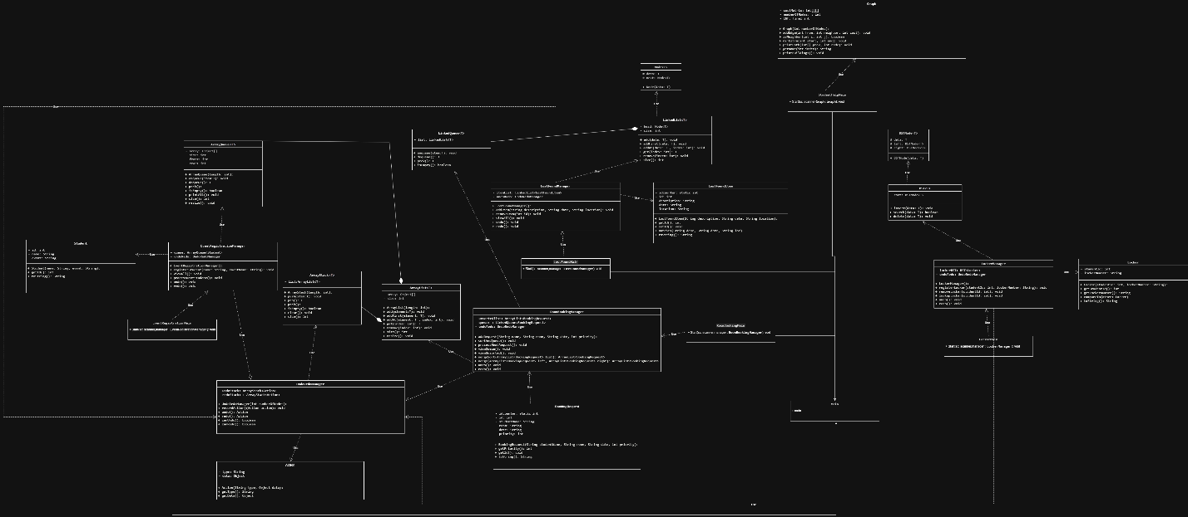

question 2
- Feature 1: Lost & Found Tracking
First the ADT used is LinkedList, the why is LinkedList works well because the number of lost/found items is unknown and can change often and it allows dynamic memory use, fast insertions/removals, and doesn’t require resizing.
On how it will meet the user needs, the user can quickly add or remove items from the list and see all current lost/found records in real time.
For the benefits, first it has a dynamic size so there is no fixed capacity unlike the arrays, second it has efficient insertions since it adds at the start of the list, and lastly it has efficient memory use as it allocate memory when needed to avoid wasted space.
Use Case:
A student reports a lost wallet:
manager.addItem("Wallet", "2025-06-10", "Library");
Staff removes it when claimed:
manager.removeItem(1, "Wallet", "2025-06-10", "Library");
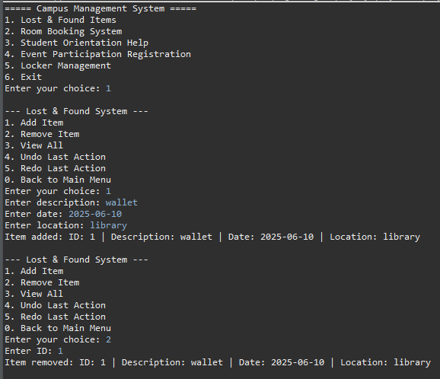
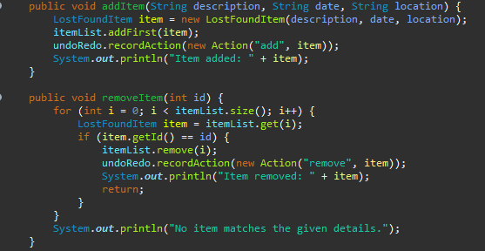
- Feature 2 Room Booking (Priority-Based)
First I used merge sort on array of the rooms then I use LinkedList Queue, the why that is I want first to sort the requests based on the priority then add them to the Queue so it can then be processed in FIFO also the time complexity for merge sort is the fastest so that help the over all system to be faster at doing the operation.
On how it will meet the user needs, it gives priority to certain student types automatically, improving fairness in room allocation.
For the benefits, first the queue ensure a fair processing with the FIFO, second having it on a linked list made it easier to store more requests as the request number is not known, last thing the queue has a constant time for enqueuing and dequeue that help build an efficient system.
Use Case:
High-priority request:
manager.addRequest("Ali", 1,"Room101", "2025-06-15");
Process requests in priority order:
manager.sortAndQueue();
manager.processNextRequest();
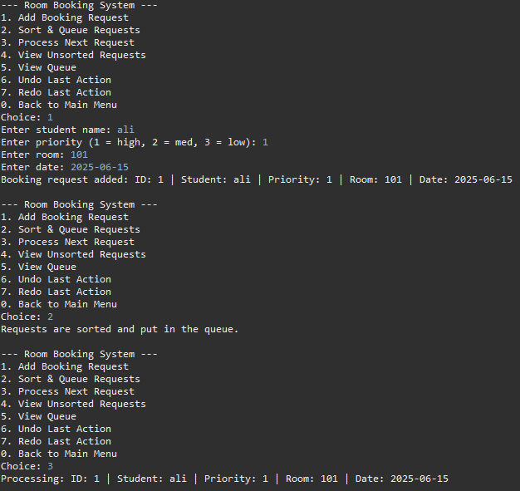
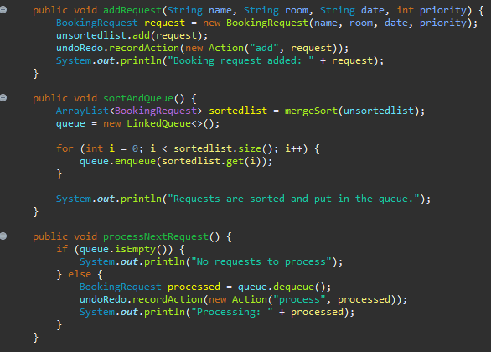
- Feature 3 Orientation Help
First I used Graph Dijkstra algorithm, the why is that the campus buildings and pathways form a natural graph. Using an adjacency matrix and Dijkstra’s algorithm made it simple to model distances and calculate the shortest path.
On how it will meet the user needs, new students can find the fastest route between any two buildings, reducing confusion during their first weeks.
For the benefits, first the graph naturally fit the building network structure giving aureate modeling for the buildings, second Dijkstra give efficient shortest path calculations, lastly it is scalable since I can add more nodes (building) without changing the core logic.
Use Case:
student asks for the shortest path from Library (1) to Dorm (5):
graph.dijkstra(1, 5);
// Output: Path: Library -> Cafeteria -> Engineering -> Dorm (Cost: 7)
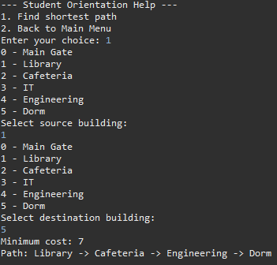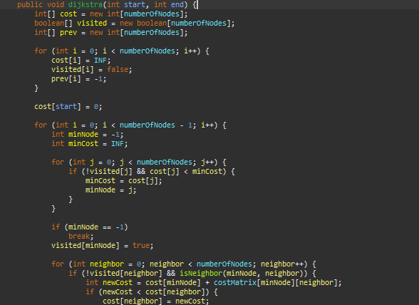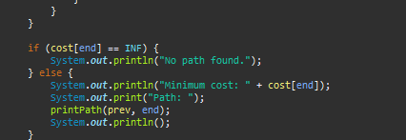
- Feature 4 Undo/Redo
First the ADT used is the ArrayStack, the why because the stack follow the LIFO order which is perfect for undoing the last action and then redoing it as each action is recorded and reversed step by step.
On how it will meet the user needs, users can undo accidental actions (like deleting a lost item) or redo them if they change their mind.
For the benefits the stack ADT support the redo and undo behavior naturally because of the LIFO order, second thing pushing and popping actions takes constant time, which keeps the system responsive even if many actions are recorded, lastly Stack keeps the undo/redo logic isolated and reusable.
Use Case:
Undo accidental lost item deletion:
manager.undo(); // Restores the last deleted item
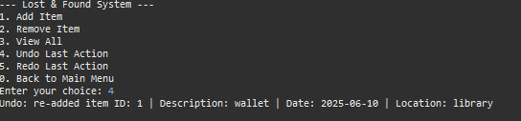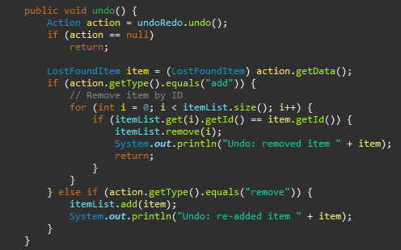
- Feature 5 Event Registration
First the ADT used is ArrayQueue, the why because registrations happen in a first-come, first-served manner, a fixed-capacity array queue gives fast enqueue/dequeue operations and reflects limited event slots.
On how it will meet the user needs, it ensures fair registration by maintaining order and preventing overbooking.
The benefits first using this ADT give a sense of fairness as it enforce the FIFO logic, second it is fast and easy to manage when the numbers are known, lastly this ADT has a circular array and this prevents overflowing.
Use Case:
Student registers for an event:
manager.registerStudent("Fatima", "Robotics Workshop");

Staff processes registrations in order:
manager.processNextStudent();
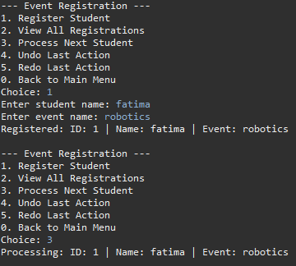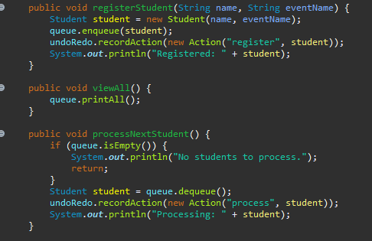
- Feature 6 Locker Assignment
First the ADT used is the BST, the why is because locker lookups, insertions, and deletions should be fast, a BST provides efficient O(log n) average time for these operations, which is better than scanning a list.
On how it will meet the user needs, quickly find, assign, or remove a locker using student ID, saving time for both staff and students.
The benefits first this ADT has efficient search the lookup is faster than the linear search, second BST handles changing data without reordering the entire structure so it has flexible deletion and insertion, lastly lockers are naturally ordered by student ID so it has a sorted structure.
Use Case:
Assign a locker to student ID 2001:
manager.registerLocker(2001, "A42");
Lookup locker by ID:
manager.lookupLocker(2001);
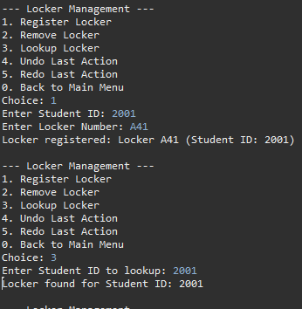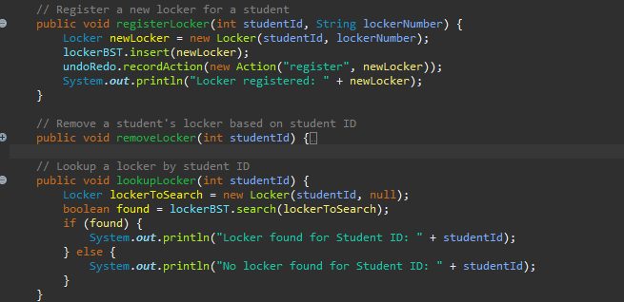

Question 3
Operation | Time Complexity | Space Complexity | Justification
addItem() | O(1) | O(1) | Add the item to the front of the list
removeItem() | O(n) | O(1) | Must traverse the list to find the item
viewAll() | O(n) | O(1) | Iterates through all nodes
undo()/redo() | O(n)/O(1) (for the stack operation) | O(1) per operation | Searches for the item to remove/re-add (there is loop)
Since insertions usually take place in constant time (O(1)), one of the primary benefits of using a LinkedList is its speedy handling of insertions, particularly when adding items to the front of the list. A LinkedList's dynamic size is another important advantage; in contrast to arrays or fixed-capacity structures, it can expand as needed without needing to be resized. But there are drawbacks as well. The main disadvantage is that removal processes can be slow, particularly if they are based on looking for a particular value. This is due to the removal time complexity being O(n), which requires a linear traversal of the list in order to find the matching node.
Operation | Time Complexity | Space Complexity | Justification
addRequest() | O(1)/worst case O(n) to resize | O(n) | Appends to ArrayList (resizing costs O(n) occasionally)
mergeSort() | O(n log n) | O(n) | Recursive divide-and-conquer sorting
processNextRequest() | O(1) | O(1) | LinkedQueue dequeues in constant time
Adding to the queue | O(1) | O(n) | Appends elements to the tail

One of the main advantages of using a sorted list for room booking is the ability to define custom priority rules, such as always placing VIP(1) students ahead of others. Once the list is sorted, processing the next request becomes very fast (O(1)), since it's always at the front. However, there are a couple of drawbacks. Merge Sort, which I used to sort the list, needs extra memory (O(n)) because it's not done in-place. Also, the sorting isn’t incremental — every time a new request is added, I have to re-sort the entire list. This can become inefficient if the number of bookings keeps growing.
Operation | Time Complexity | Space Complexity | Justification
addEdge() | O(1) | O(1) | Updates matrix cell
dijkstra () | O(V²) | O(v) | Uses nested loops over all vertices (V)

Using an adjacency matrix made sense for a small campus. Dijkstra’s algorithm worked fine here, but with a larger graph (like 100+ nodes) is not going to be good with that.
Operation | Time Complexity | Space Complexity | Justification
recordAction() | O(1) | O(n) | Stack push operation
Redo/undo () | O(1) | O(1) | Stack pop operation
Stack was perfect here. All operations were fast, predictable, and easy to implement. The structure matches the problem exactly (LIFO), and performance doesn’t degrade no matter how many actions are stored.
Operation | Time Complexity | Space Complexity | Justification
registerStudent () | O(1) | O(n) | Enqueues to circular array
processNextStudent () | O(1) | O(1) | Dequeues from front
queue was the best option here since it has a constant time, also I use circular array since the seats will be fixed for the event the array play a good part for that.
Operation | Time Complexity | Space Complexity | Justification
registerLocker () | O(log n) | O(1) | Balanced BST insertion
lookupLocker() | O(log n) | O(1) | Binary search traversal
removeLocker() | O(log n) | O(1) | BST deletion

Using a Binary Search Tree (BST) for locker allocation worked well because it gave me efficient performance for searching, inserting, and deleting lockers based on student ID. In the average case, these operations run in logarithmic time (O(log n)), which is much faster than scanning through a list. Another benefit is that the data stays automatically sorted by student ID, so I don’t need extra sorting logic. However, one downside is that if the tree becomes unbalanced — like if IDs are added in sorted order — the performance can drop to O(n), which is no better than a regular list. To avoid this in larger systems, a self-balancing BST would be more reliable.

Question 4
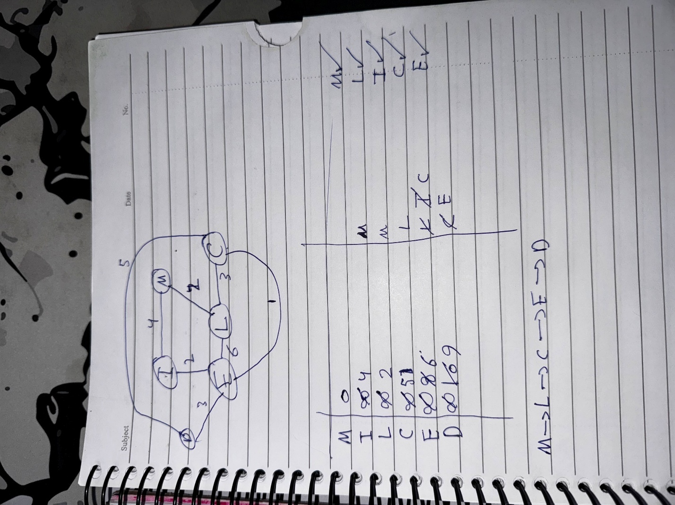
(since I to E same as C to E I took C to E in the drawing)
This feature allows the user to find the shortest walking path between two campus buildings using Dijkstra’s algorithm. The buildings are represented as nodes in a weighted undirected graph, where each edge represents a direct walking path with an associated distance (cost). Below is a detailed step-by-step explanation of the implemented algorithm.
Table 1: Graph Representation (Cost Matrix)
This table represents the campus graph, where the cost between buildings (nodes) is stored. The diagonal is 0, and other cells contain the distance between connected buildings (infinite distance for disconnected buildings).
Building | Main Gate | Library | Cafeteria | IT | Engineering | Dorm
Main Gate | 0 | 2 | INF | 4 | INF | INF
Library | 2 | 0 | 3 | INF | 6 | INF
Cafeteria | INF | 3 | 0 | INF | 1 | 5
IT | 4 | INF | INF | 0 | 2 | INF
Engineering | INF | 6 | 1 | 2 | 0 | 3
Dorm | INF | INF | 5 | INF | 3 | 0

Table 2: Initialization of Dijkstra’s Algorithm
This table shows the initial state of the cost[], visited[], and prev[] arrays before the algorithm starts.
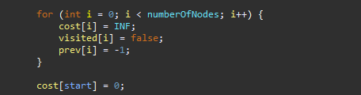
Node | Cost (cost[]) | Visited (visited[]) | Previous Node (prev[])
Main Gate | 0 | TRUE | -1
Library | INF | FALSE | -1
Cafeteria | INF | FALSE | -1
IT | INF | FALSE | -1
Engineering | INF | FALSE | -1
Dorm | INF | FALSE | -1
Table 3: Example of Path Updates After Iteration
This table shows how the cost[] and prev[] arrays are updated after each iteration.
The algorithm runs a loop numberOfNodes - 1 times to find the shortest paths. For each iteration, the following steps are performed:
1. Find the unvisited node with the smallest cost[] value and mark it as visited.
2. Explore its unvisited neighbors, and for each neighbor:
- Check if there is a direct edge.
- Calculate the new cost.
- If the new cost is lower, update cost[] and prev[].
3. Repeat until all nodes are visited or their shortest paths are finalized.
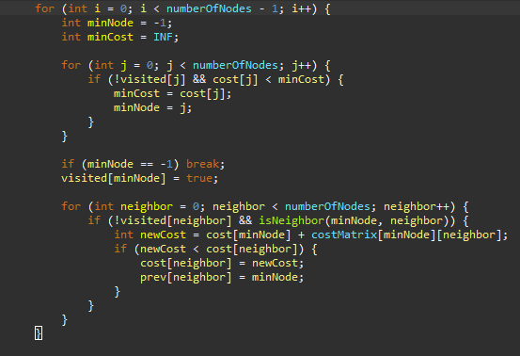

Iteration | Node Visited | Min Node | Updated Node | Cost Updated | Previous Node Updated
1 | Main Gate | 0 | Library | 2 | 0
2 | Library | 1 | Cafeteria | 5 | 1
3 | IT | 3 | Engineering | 6 | 3
4 | Cafeteria | 2 | Dorm | 10 | 2
5 | Engineering | 4 | Dorm | 9 | 4

Table 4: Final Path Output
This table summarizes the shortest path from the Main Gate to Dorm, using the `prev[]` array to track the path backward.
Node | Previous Node (prev[]) | Path Traced
Dorm | 4 | Dorm
Engineering | 3 | Engineering → Dorm
IT | 0 | IT → Engineering → Dorm
Library | 0 | Library → IT → Engineering → Dorm
Main Gate | -1 | Main Gate → Library → IT → Engineering → Dorm

Final Output
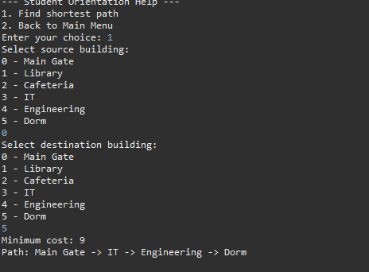
about bellman ford
It has one advantage over Dijkstra that it can deal with the negative edges, so if Dijkstra had a one negative edge cost it will be wrong answer meanwhile with bellman ford it will give a correct answer similar to the start of Dijkstra we set every thing to infinity and the source for the same destination to 0 then we start relaxation process the loop will be the vertices – 1 since the first one is 0 (same node) we check if the sum of [u] and w is less than v we update it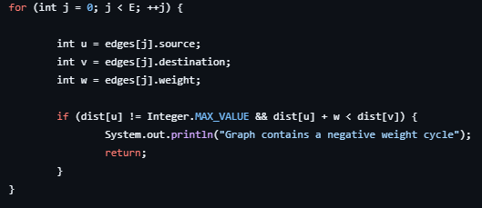
Then we check for the negative weights here
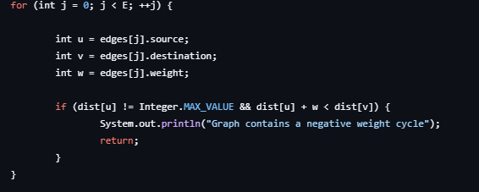
Aspect | Dijkstra | Bellman-Ford
Negative Weights | Not allowed | Allowed
Negative Cycles | Can't detect | Detects
Time Complexity | O(V²) | O(V × E) wors case could be O(v³)
Algorithm Type | Greedy | Dynamic Programming
Use Case | Fast with non-negative weights | Works with negative weights

Question 5
The encapsulation and information hiding are used to ensure that the ADTs are handled safely and efficiently.
Lets start from the original ADTs the array and linked list, both of these ADTs has a private attributes that can’t be accessed directly unless a getter and setter are initialized, and they are used inside the methods but this methods are public so we only expose the necessary part only and this apply to the other ADTs since they are constructed from the 2 original ADTs, for encapsulation in my system we can look at the redo undo stacks as in the system and there is the encapsulation in the ADTs like stack using private arraylist also I have a private methods like the resize method that the user do not need and it happen automatically also the merge sort on feature 2 is private so the user do not have access to it directly and only call the function that uses it.
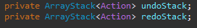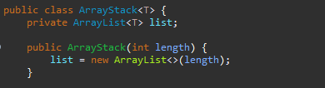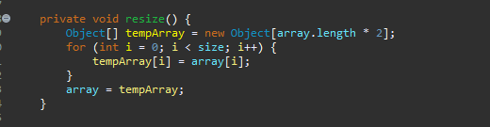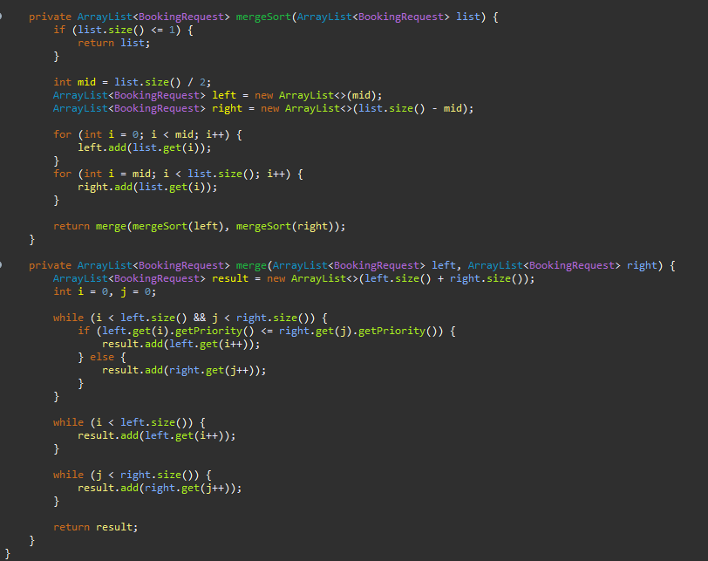
For the stack they can't be accessed directly by external classes, external classes can interact with the stacks only through the provided methods (push(), pop()), ensuring LIFO behavior is maintained, the encapsulation help here by ensuring the stack operate according to the LIFO principle.
By preventing external interference from accessing the internal state of data structures, information hiding makes sure that data is only altered in safe, controlled ways.
ADTs as base for OOP
Abstract Data Types (ADTs) are a fundamental idea in object-oriented programming (OOP) that help structure and arrange data according to OOP's principles of modularity, abstraction, and encapsulation.
- Encapsulation and Information Hiding:
ADTs make it possible to hide data and define a clear interface for working with the data. With these internals abstracted away and only relevant operations visible to the user, ADTs make sure that the complexity of data-structures are shied away from the user. This leads to a modular design in which an implementation can be changed without changing other parts of the program. In OOP this is done by defining a class with private members (data) and public methods (operations) which is a direct application of information hiding.
- Abstraction
ADTs provide a high level of abstraction and developers can make use of data structures such as stacks, queues and lists without having to know how they are implemented. This is consistent with the OOP principle of abstraction, which emphasizes what the operation is, as opposed to how it is implemented.
- Modularity
With ADTs, you can create modular pieces of code which can be used in various programs or systems. ADTs serve as a component, or a class, that creates a natural separation between system functionalities. In the world of OOP, classes can also be likened to packages of functionalities that organizes and represents a data and methods related to a particular type of things in a way that allows these parts to be both reused and maintainable over time.
advantages of using ADTs to serve as the foundation for OOP a number of advantages are afforded by the use of ADTs to support the OOP. Improved Maintainability: The data manipulation logic are abstracted behind a well defined interface and we have flexibility to make changes to the underlying data structure without affecting the other parts of the codebase. Second, Reusability is enhanced because ADTs allow a common interface to data, so it is easier to reuse components in other systems or projects. Finally , Separation of Concerns is facilitated as ADTs help separate the logic of data manipulation from the logic of application behavior, leading to cleaner, more understandable code.

Question 6
Feature 1 – Lost & Found Tracking
Selected ADT: LinkedList
Alternative ADTs: ArrayList
Time complexity
- Insert
  - LinkedList: O(1) if adding at the end, O(n) for adding at a specific position (linear search)
  - ArrayList: O(1) for adding at the end, O(n) for adding at a specific position due to shifting elements, but if there is a resize then it will take O(n) anyway
- Remove
  - LinkedList: O(n) for searching and removing an item
  - ArrayList: O(n) for searching and removing an item because of shifting
- Search
  - LinkedList: O(n) for a linear search
  - ArrayList: O(1) it has constant time if we look by index if not its o(n)
Space Complexity
- LinkedList: O(n)
- ArrayList: O(n)
Trade-off
- LinkedList is better for dynamic data where elements are frequently inserted and removed, especially from the beginning or middle, since insertion/removal is fast (O(1)) when not requiring traversal.
- ArrayList is better for fast access to elements via indexing (O(1)), but not as efficient when it comes to adding/removing from the middle or beginning.
Since we anticipate frequent additions and deletions (such as items entering and exiting the Lost/Found list) and don't need quick random access or indexing, LinkedList was selected in this instance. Here, the insertion/removal time complexity of an array list might be an advantage.
Feature 2 – Room Booking

Selected ADT: ArrayList + LinkedQueue

Alternative ADTs: PriorityQueue

Time complexity
- Insert (Booking Request)
  - ArrayList + Queue: O(1) (arraylist is o(1) if we are adding to the last)
  - PriorityQueue: O(log n)
- Sort
  - ArrayList + Queue: O(n log n)
  - PriorityQueue: //
- Process Next(Remove)
  - ArrayList + Queue: O(1)
  - PriorityQueue: O(log n)
Space Complexity
- ArrayList + Queue: O(n) the merge sort has O(n) not in place
- PriorityQueue: O(n)
Trade-off
- Although a Sorted LinkedList is simpler to implement and offers greater flexibility in the case that the priority scheme changes, a PriorityQueue would be faster for insertion since there is no sorting requirement on it.

Feature 3 – Student Orientation Help
Selected ADT: Graph (Adjacency Matrix)
Alternative ADTs: Adjacency List
Time complexity
- Insert
  - Adjacency Matrix: O(1) for inserting an edge because it’s just a cell update
  - Adjacency List: O(1) for adding a neighbor to a node’s list.
- Find Shortest Path (Dijkstra)
  - Adjacency Matrix: O(V²) since it checks all nodes
  - Adjacency List: O(V + E), much better for sparse graphs (fewer edges)
Space Complexity
- Adjacency Matrix: O(V²) because we store a value for every pair of nodes.
- Adjacency List: O(V + E), efficient for sparse graphs (fewer edges).
Trade-off
- The Adjacency Matrix is space-inefficient for large, sparse graphs, but for a small campus map (with fewer buildings and edges), it’s a simple and quick solution.
- Adjacency List would have been more efficient in terms of space, especially if the campus had a larger number of buildings, but the matrix is simple to use for the relatively small number of nodes (6 buildings).
Feature 4 – Undo/Redo (Stack ADT)
Selected ADT: Stack
Alternative ADTs: ArrayList
Time complexity
- Push/Pop
  - Stack: O(1) for both push and pop
  - ArrayList: O(1) for adding to the end, but would require shifting elements if modifying anywhere else
- Access Last Item
  - Stack: O(1) to access the top item (last added)
  - ArrayList: O(1) for direct access, but not the best for undo/redo behavior
Space Complexity
- Stack: O(n), stores each action in the stack
- ArrayList: O(n), and could be used, but the shift on removal doesn’t work well for undo/redo
Trade-off
Stack is perfect for the undo/redo functionality because of its LIFO behavior. Other alternatives like ArrayList doesn’t maintain the last-in, first-out order needed for the operations.(no trade-off)

Feature 5 – Event Registration
Selected ADT: ArrayQueue
Alternative ADTs: LinkedList
Time complexity
- Enqueue
  - ArrayQueue: O(1) if there’s space
  - LinkedList: O(1) for insertion at the end
- Dequeue
  - ArrayQueue: O(1) if not empty
  - LinkedList: O(1) for removal from the front
Space Complexity
- ArrayQueue: O(n), fixed array size
- LinkedList: O(n), each element requires a reference to the next
Trade-off
ArrayQueue was chosen for simplicity because we don’t need priority in this feature. LinkedList could have been an alternative for a dynamic structure, but ArrayQueue offers constant time complexity for enqueue and dequeue operations with a fixed size. This makes it efficient for the use case where the size of the queue is predictable and doesn’t require the overhead of dynamic resizing.
Feature 6 – Student Locker Allocation
Selected ADT: Binary Search Tree (BST)
Alternative ADTs: LinkedList
Time complexity
- Insert
  - BST: O(log n) in the average case (balanced tree), O(n) in the worst case (unbalanced)
  - LinkedList: O(n) since we must traverse the list to find the correct position
- Search
  - BST: O(log n) in the average case, O(n) in the worst case
  - LinkedList: O(n) for linear search
- Delete
  - BST: O(log n) in the average case, O(n) in the worst case
  - LinkedList: O(n) for finding and removing the node
Space Complexity
- BST: O(n) for storing n nodes, but no extra space for resizing
- LinkedList: O(n) for storing n nodes
Trade-off
- BST is a good choice for student locker allocation because it keeps the lockers sorted by student ID, providing efficient search and insertion in the average case (O(log n)).
- LinkedList could be an alternative, but it would have worse performance for searching and insertion (O(n)), as we'd have to traverse the list to find or insert a locker.

Reference
GeeksforGeeks (2017). Abstract Data Types - GeeksforGeeks. [online] GeeksforGeeks. Available at: https://www.geeksforgeeks.org/abstract-data-types/.
Shaffer, C.A. (2012). Data Structures and Algorithm Analysis in Java, Third Edition. Courier Corporation.
Al-Louzi, M. (2021). Tree (BST) [PDF]. School of Computing and Informatics – Al Hussein Technical University.
Al-Louzi, M. (2021). Big O Notation and Time Complexity [PDF]. School of Computing and Informatics – Al Hussein Technical University.
Al-Louzi, M. (2022). Shortest Path Algorithms [PDF]. School of Computing and Informatics – Al Hussein Technical University.
Al-Louzi, M. (2021). List [PDF]. School of Computing and Informatics – Al Hussein Technical University.
Al-Louzi, M. (2021). Queue [PDF]. School of Computing and Informatics – Al Hussein Technical University.
Al-Louzi, M. (2021). Graph [PDF]. School of Computing and Informatics – Al Hussein Technical University.
Al-Louzi, M. (2021). Linked List [PDF]. School of Computing and Informatics – Al Hussein Technical University.

