

​​
Discrete Maths40303221
F/618/7429
Section (8)

Discrete Maths Take home

Submitted to
Rola Musleh
Submitted by
Obada Al-Halaybeh

Spring –2025

Part 1

Task 1
In mathematics and computer science, a graph is a way of representing pairs of objects' relationships. It consists of edges and vertices (or nodes) which connect pairs of vertices. Graphs are used in many areas like mapping, networking, scheduling, and data structures. Planar graph is one special case that can be sketched on a plane surface with no intersecting edges. To be able to color these graphs — i.e., to color vertices so that the adjacent ones are colored differently — is helpful when solving problems like map coloring, circuit designing, and resource allocation planning. This leads us to an important result in graph theory: the Five Color Theorem.
any planer graph can be colored using five or less colors
Case 1 deg(v) <= 4
V (short for vertex)
in the first case v has 4 or less neighbors
we can see that we used all the 5 colors since V has 4 neighbors that mean we are left with the last color to be added to V its self
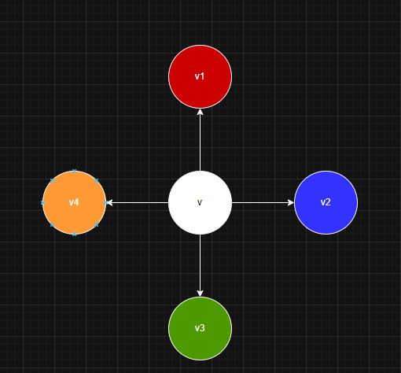

Case 2 deg(v) = 5
sub class1
when there is 5 neighbors to v each one can have its color but when we also can say that A and C are not adjacent so they can have the same color and the last color go to V (color of A)
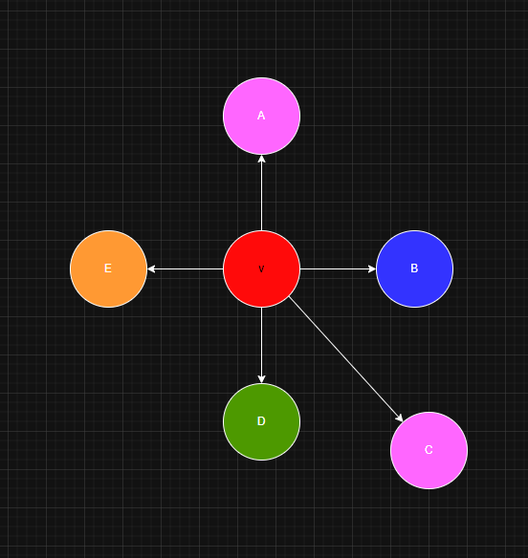
sub class 2
when we assume that A and C are connected via path we can notice that this path will keep B inside and D out side so it is impossible for them to be adjacent so the V will take the B color (the blue ) and B will be green .
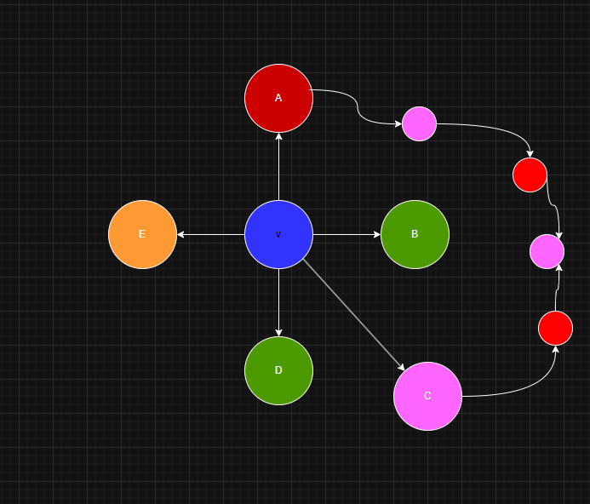

Reference
5-color Theorem proof (2017). 5-color Theorem proof. [online] Mathematics Stack Exchange. Available at: https://math.stackexchange.com/questions/2418524/5-color-theorem-proof.
Mathematics with Naveed (2024). Five Color Theorem. [online] YouTube. Available at: https://www.youtube.com/watch?v=IhtYgEEtGs8.
‌

