**Dos report**

By Obada Qasrawi

& Adam siksik

Supervisor :

**D.Samer Arandi**

Introduction

In this part, we want to scale up the simple server that made it before and balance the load in the new nodes all over this system

# First :

Duplication and scaling up this microservice

we duplicate every server as and run it in another port in the same docker-compose

So we have 2 category servers,2 order servers, and the frontend server

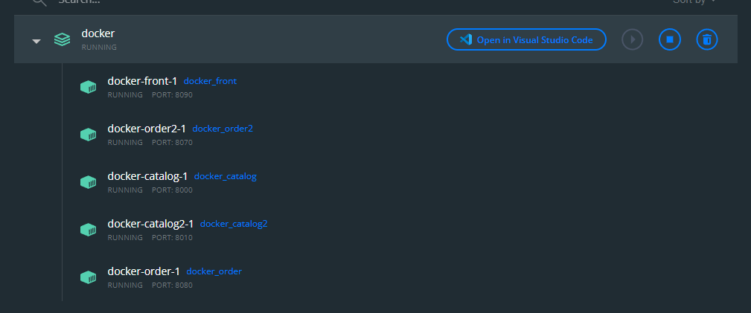

# Second :

Load balancing

We used Round-robin load balancing to distribute client requests across a group of servers. A client request is forwarded to each server in turn. The algorithm instructs the load balancer to go back to the top list and repeat it again.

There is a problem with this system how can configure order servers to talk to category server

So we used variables environment and passed it to order servers to determine which order server connected with which category server

