How to create the SC-200 Sentinel lab environment from scratch
1. Create a Resource Group
Go to: Azure Portal → Resource groups → Create
Use:
Resource group name: rg-sc200-lab-sea-2
Region: Southeast Asia
Click: Review + create → Create
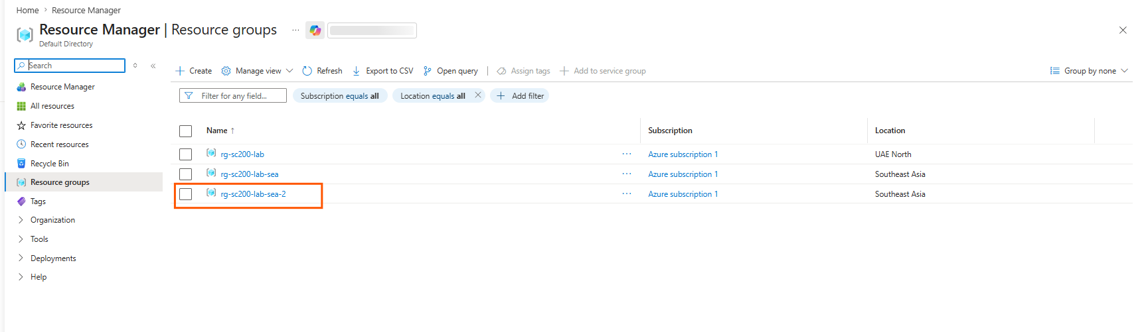
2. Create Log Analytics Workspace
Go to: Azure Portal → Log Analytics workspaces → Create
Use:
Resource group: rg-sc200-lab-sea-2
Workspace name: law-sc200-lab-sea-2
Region: Southeast Asia
Click: Review + create → Create
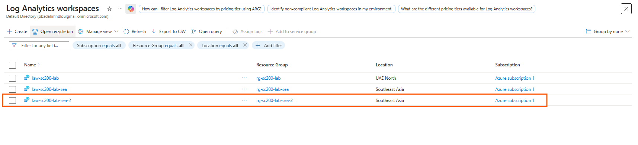
3. Enable Microsoft Sentinel
Go to: Azure Portal → Microsoft Sentinel
Click: Create
Select your workspace: law-sc200-lab-sea-2
Click: Add
Now Microsoft Sentinel is enabled on the workspace.
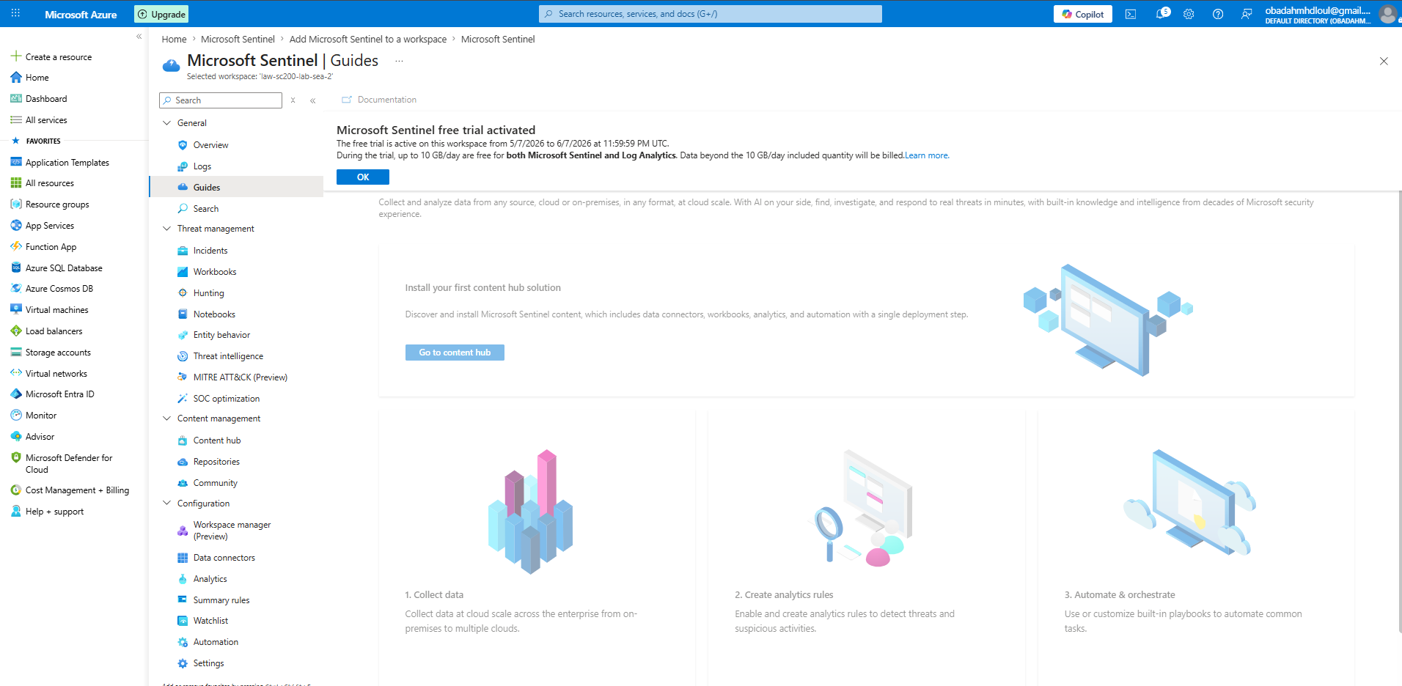
4. Install Sentinel Content / Solution
Go to: Microsoft Sentinel → Content hub
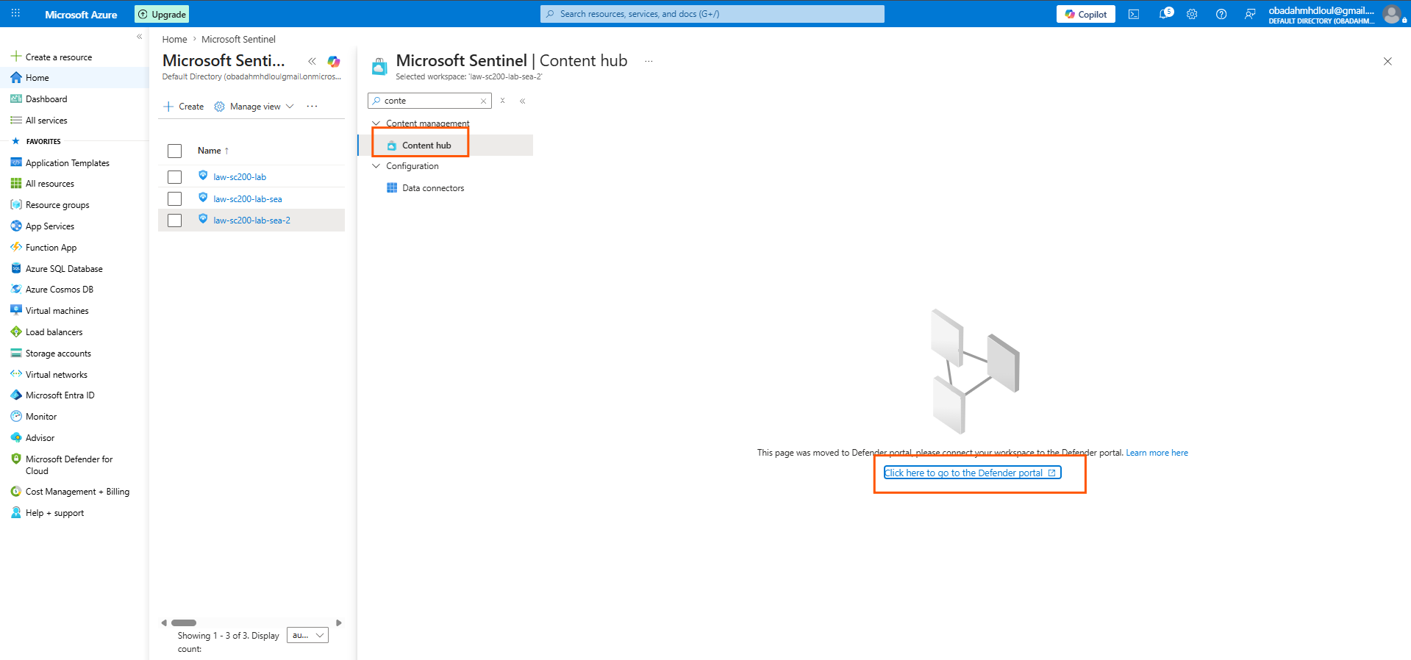
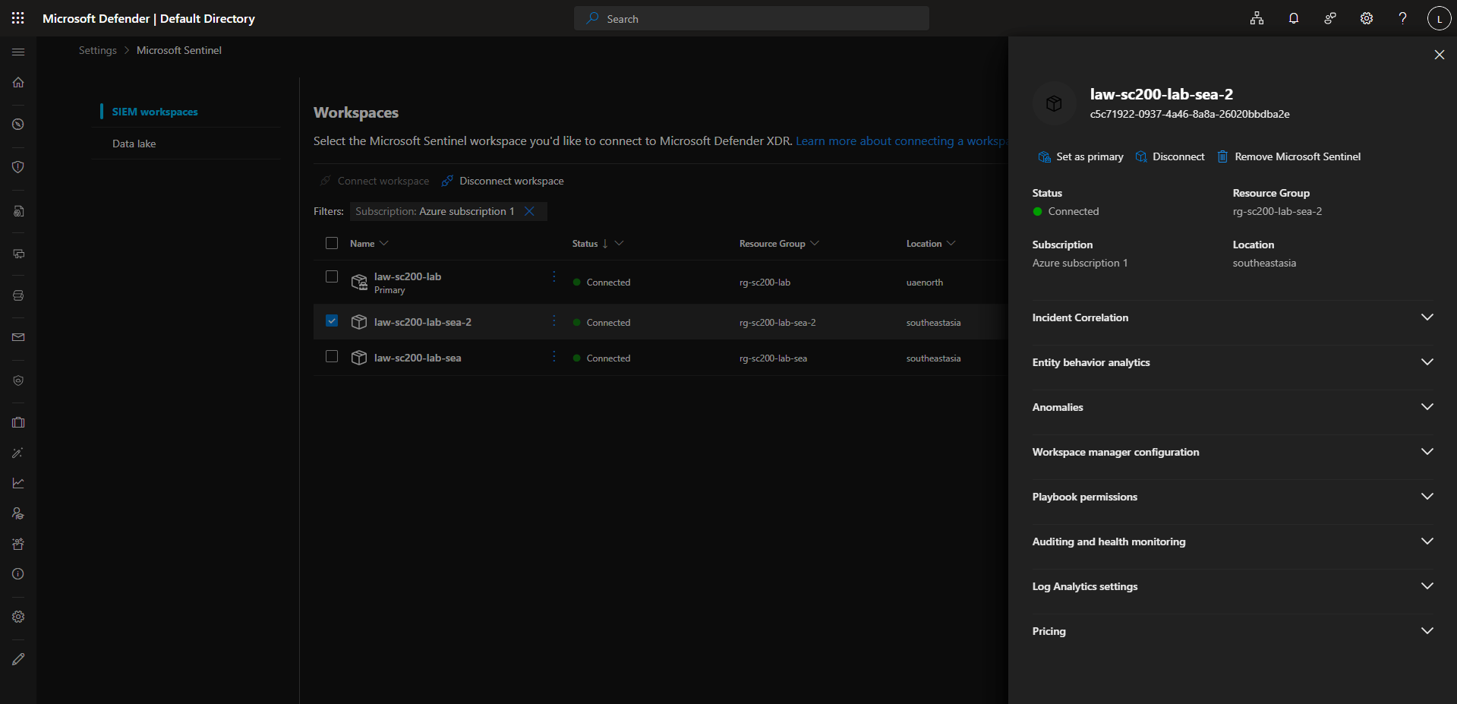
Do not change anything here.
From the left menu, click: Microsoft Sentinel
If it expands, look for: Content hub
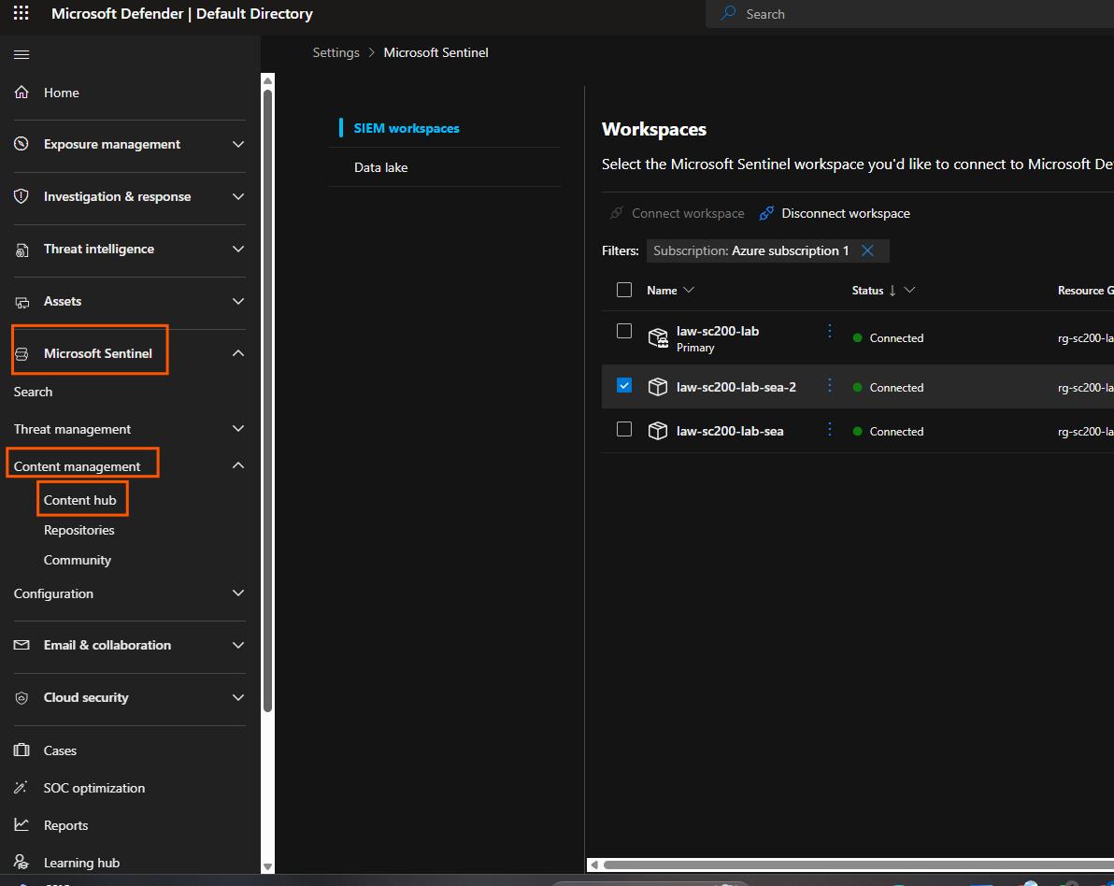
Click: Content hub
This is where Sentinel content packs/solutions are installed.
Step 5
At the top, make sure the selected workspace is: law-sc200-lab-sea-2
Use this workspace because it is already connected.
Step 6
In the Content hub search bar, search: Windows Security Events
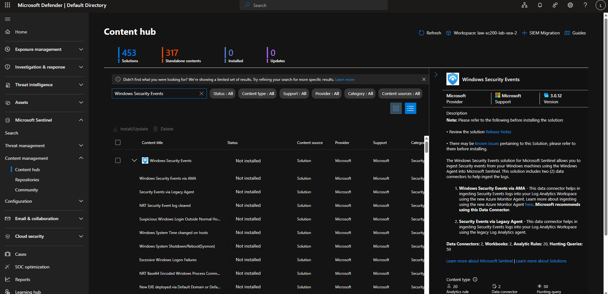
Then do this now
Step a
Select the checkbox next to: Windows Security Events
Not the sub-items. Select the main one.
Step b
Click: Install/Update
Top-left above the list.
Step c
Wait until installation finishes.
Step d
After it finishes, check the status. It should change from: Not installed
to something like: Installed
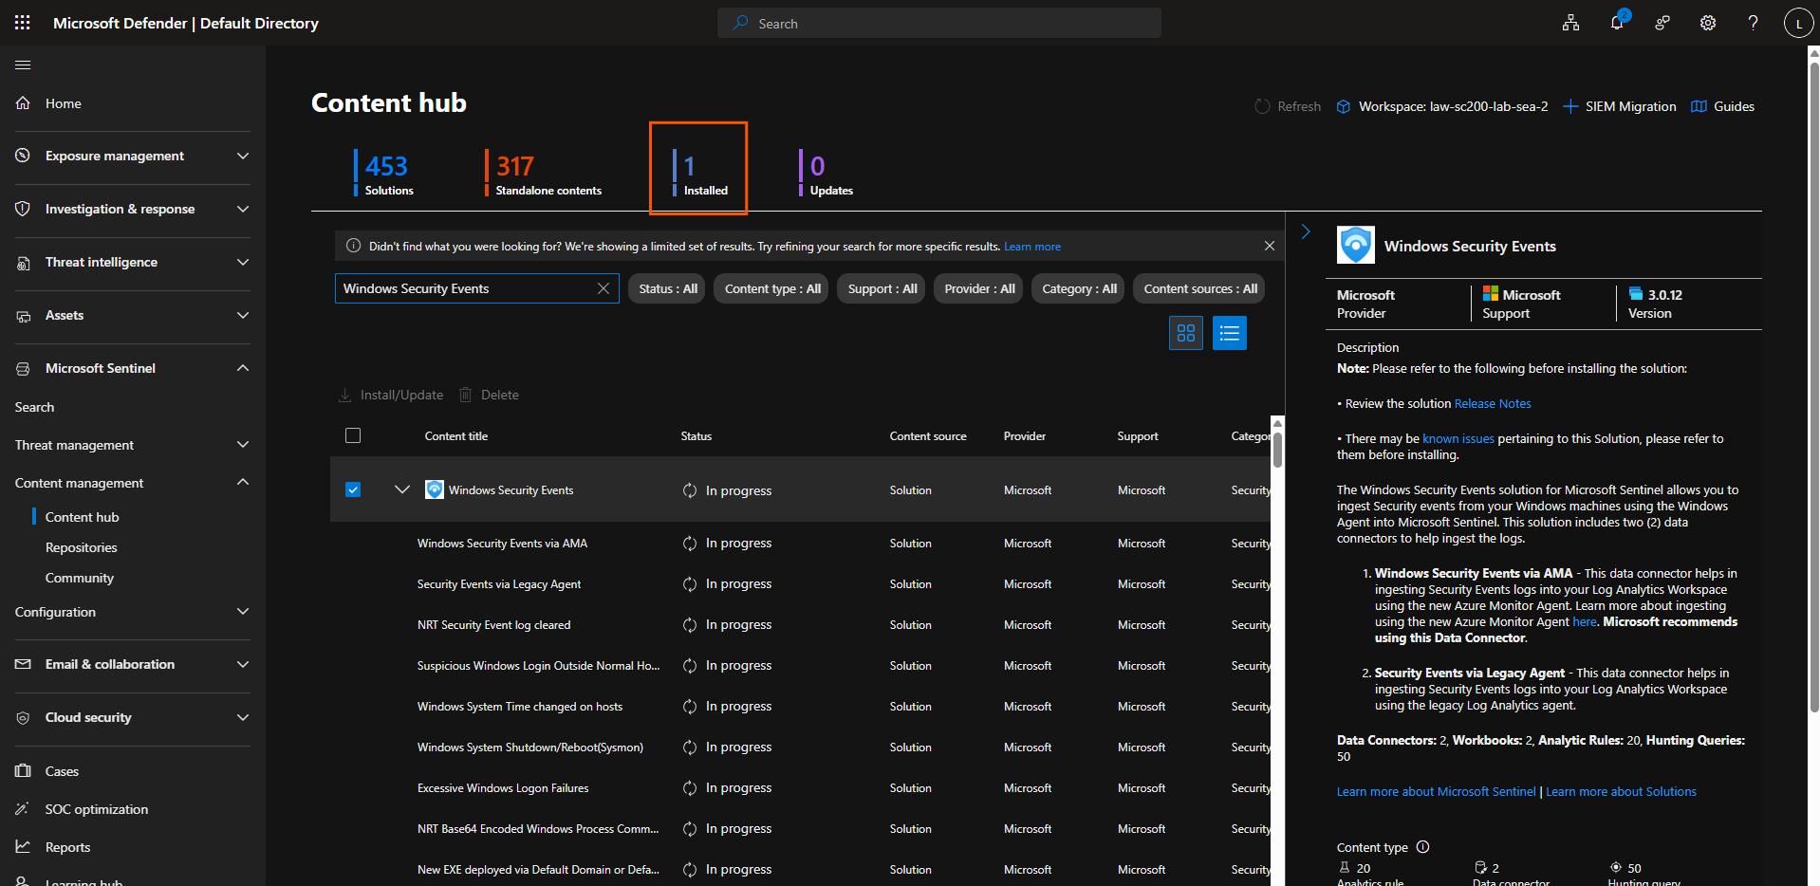
Current status
Windows Security Events content is installed.
That means Sentinel now has:
- Windows Security Events connector
- Analytics rule templates
- Hunting queries
- Workbooks
Next step
Now we need to connect a Windows machine so Sentinel receives real logs.
Step 7
In Defender portal left menu, go to:
Microsoft Sentinel → Configuration → Data connectors
Search: Windows Security Events
Open: Windows Security Events via AMA
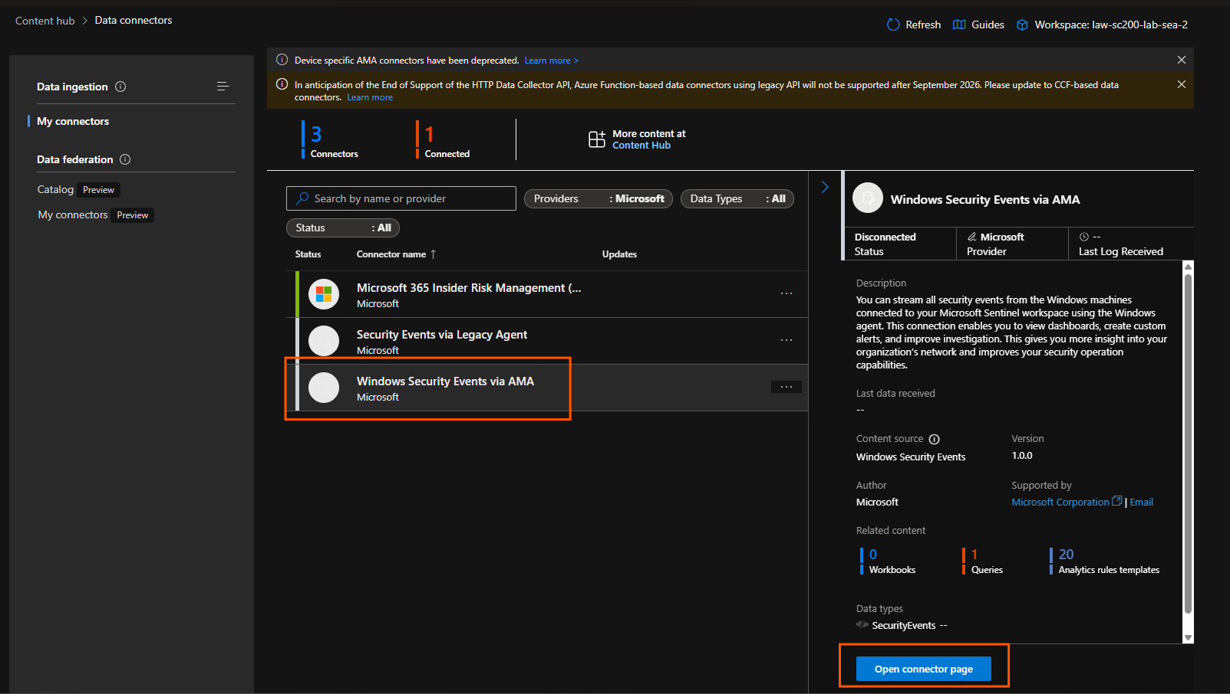
Click: Open connector page
On the connector page, look for a section like:
Configuration
or
Data collection rule
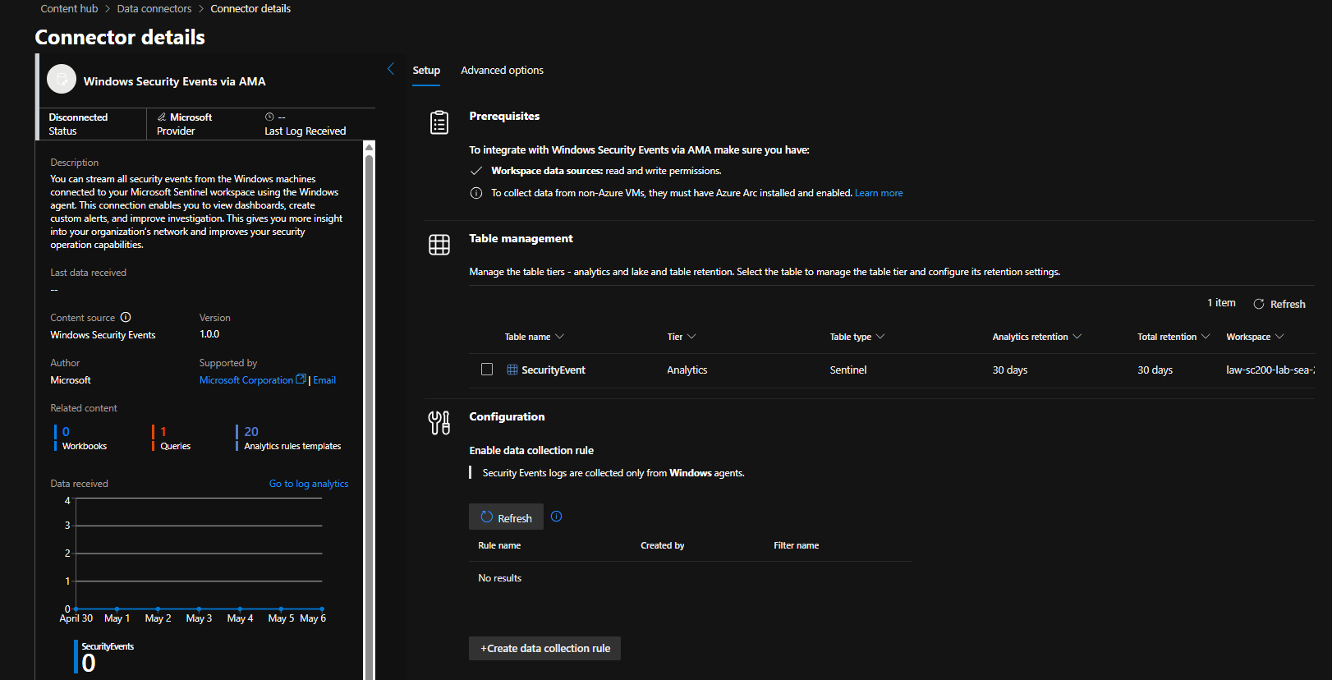
Do not click Create data collection rule yet.
Step 8
Open Azure portal in another tab.
Go to: Microsoft Sentinel Data connectors
Open: Windows Security Events via AMA
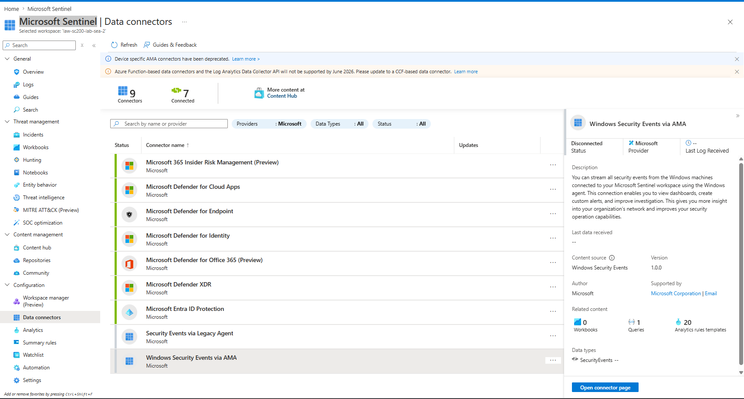
But since we don’t have an Azure VM, we will connect your own Windows laptop using Azure Arc.
Do this now
Step 9
Open a new Azure tab.
In the top search bar, type: Azure Arc
Open: Azure Arc
From the left side, click: Infrastructure Machines
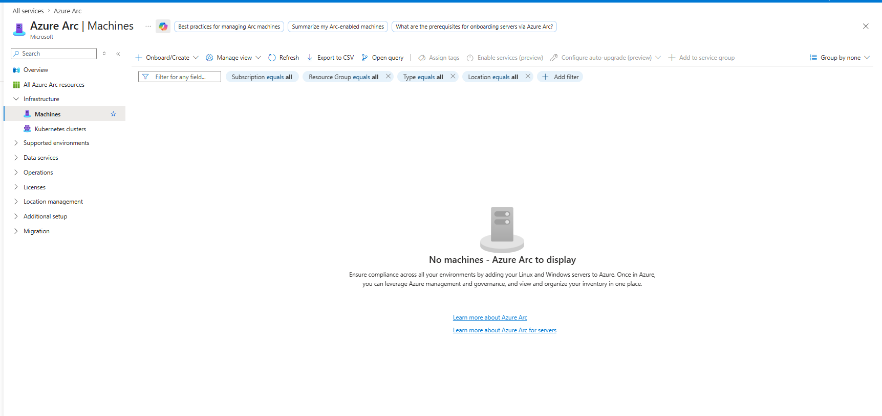
Click: Onboard/Create Top left.
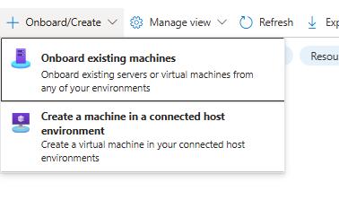
Click: Onboard existing machines
Fill the setup like this:
Subscription: Azure subscription 1
Resource group: rg-sc200-lab-sea-2
Region: (Asia Pacific) Southeast Asia
Operating system: Windows
Connectivity method: Public endpoint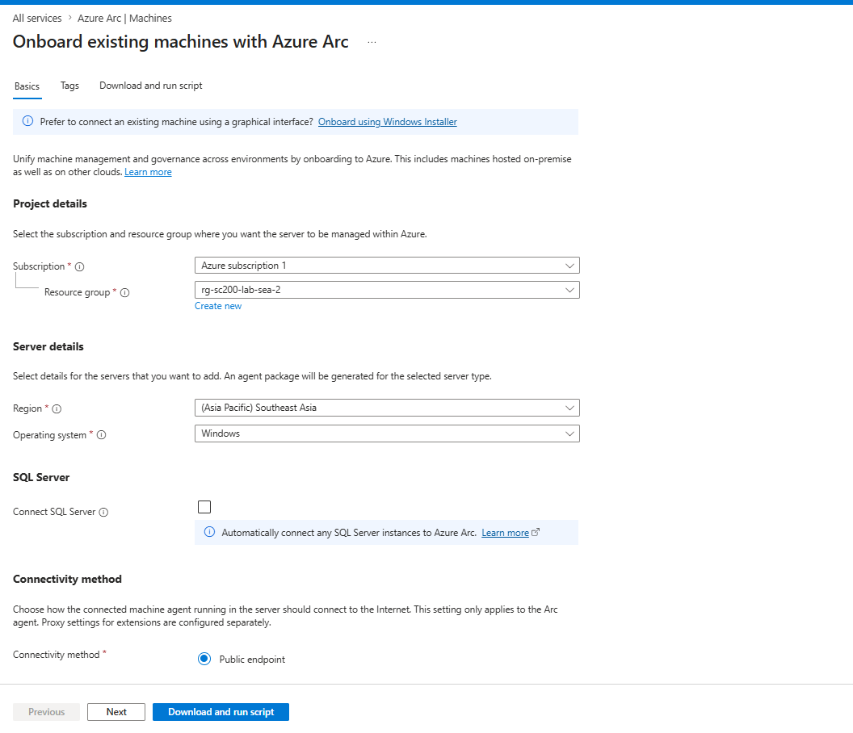
Then: Download and run script then Download
Step a — Open PowerShell as admin
Search: PowerShell
Right-click: Run as administrator
Step b — Go to Downloads
Run: cd $env:USERPROFILE\Downloads
Step c — Temporarily allow this script only
Run: Set-ExecutionPolicy -Scope Process -ExecutionPolicy Bypass
Type: Y
This only affects the current PowerShell window, not your whole system.
Step d — Run the script
Run: .\OnboardingScript.ps1
Step e
If it asks you to sign in, sign in with your Azure account.
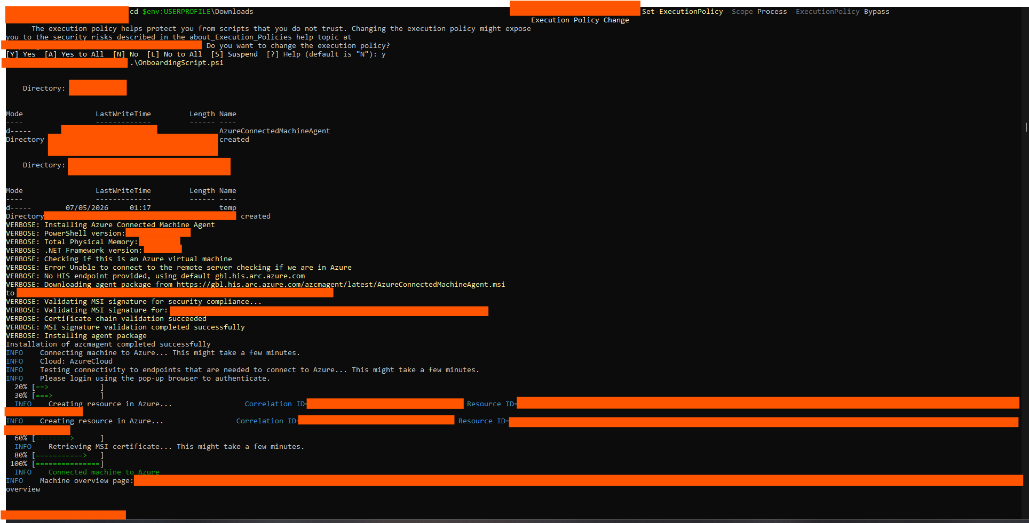
Wait until PowerShell finishes completely.
After it finishes, go back to: Azure Arc → Machines → Refresh
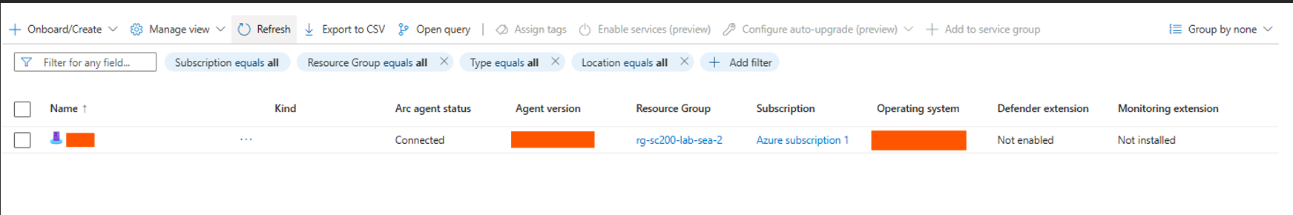

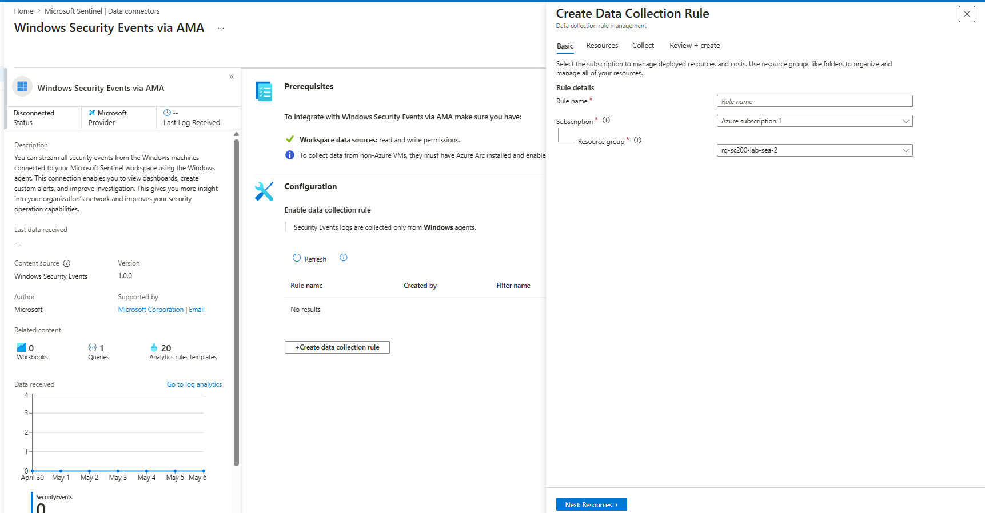
Current status
- Machine name: **
- Arc agent status: Connected
- OS: Windows ** Home
- Monitoring extension: Not installed
Next step
Now we connect this machine to Sentinel logging.
Step 10
Go back to: Microsoft Sentinel → Data connectors → Windows Security Events via AMA
Open the connector page.
Click: Create data collection rule
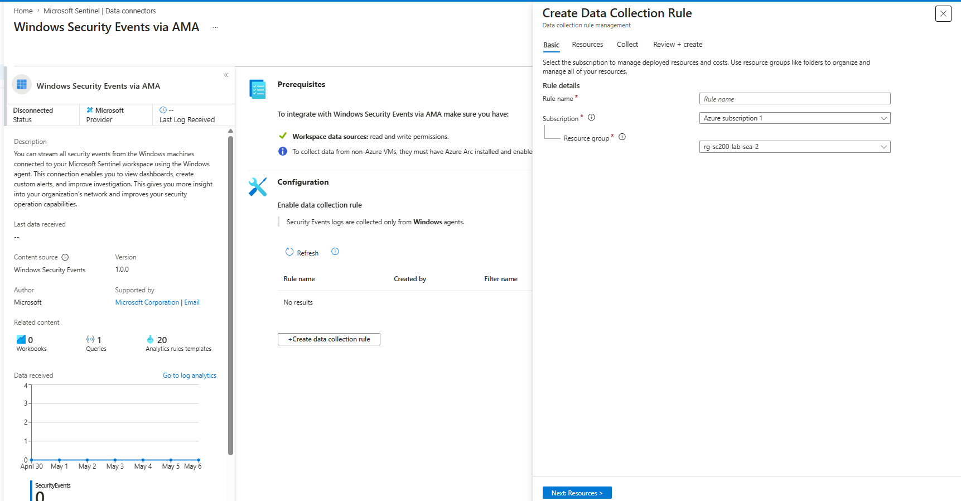
In Rule name, write: dcr-sc200-windows-security-events
Keep:
Subscription: Azure subscription 1
Resource group: rg-sc200-lab-sea-2
Click: Next: Resources
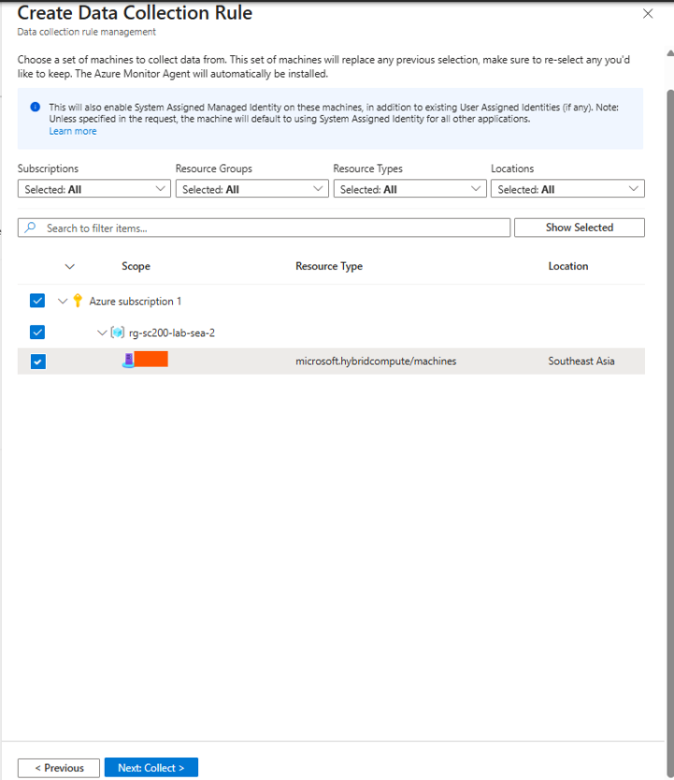
Click the arrow beside: rg-sc200-lab-sea-2
Then you should see the machine: **
Check the box next to ** only.
Then click: Next: Collect
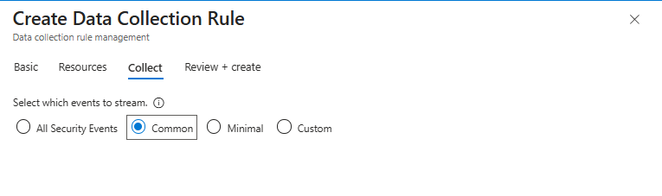
Do not use All Security Events because it can collect too many logs and waste credits.
Select: Common
Then click: Next: Review + create
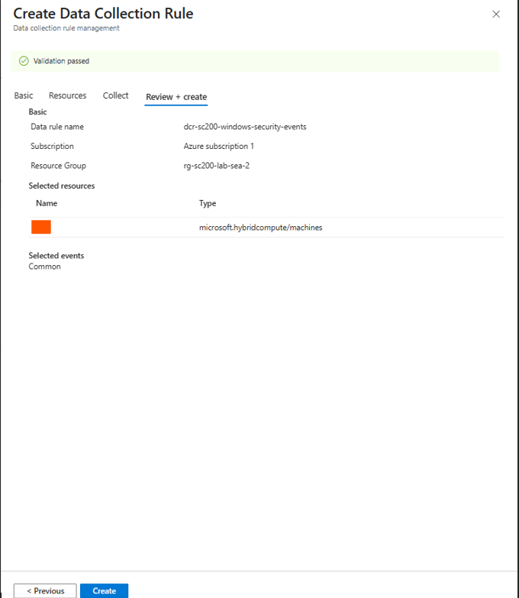
Click: Create
Then wait until deployment finishes.
After it finishes, go back to: Windows Security Events via AMA connector page
Click: Refresh
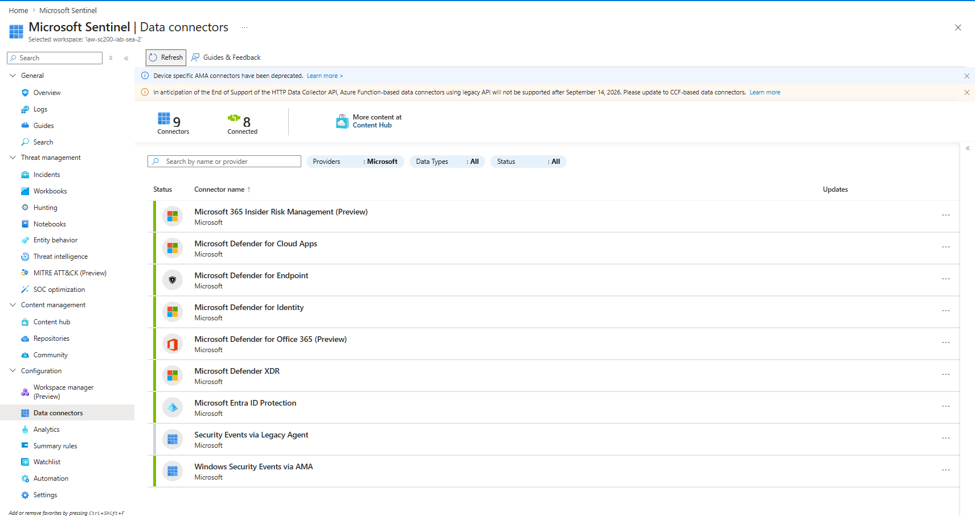
Click: Windows Security Events via AMA
Click: Open connector page
Check if you see the rule: dcr-sc200-windows-security-events
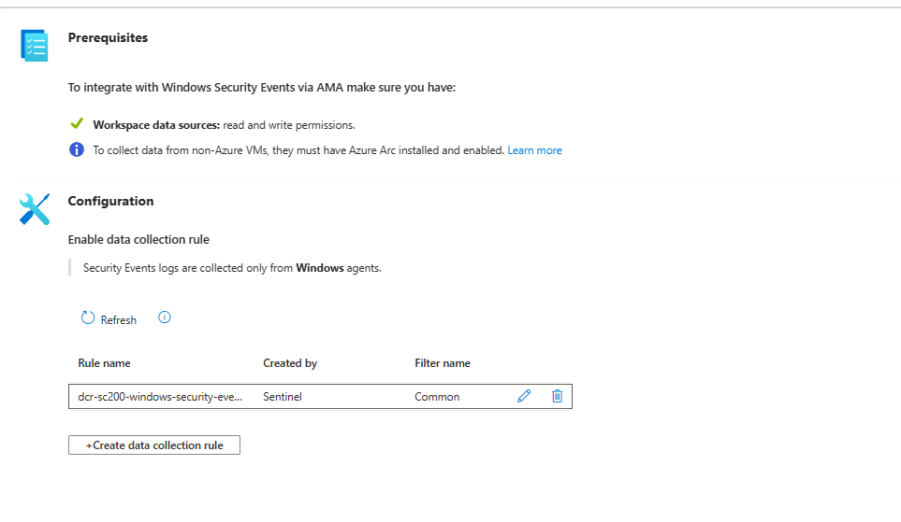

Next step: check if logs arrive
Wait 5–10 minutes, then go to:
Microsoft Sentinel → Logs
Run this query:
SecurityEvent
| take 10
If no results, run:
SecurityEvent
| count
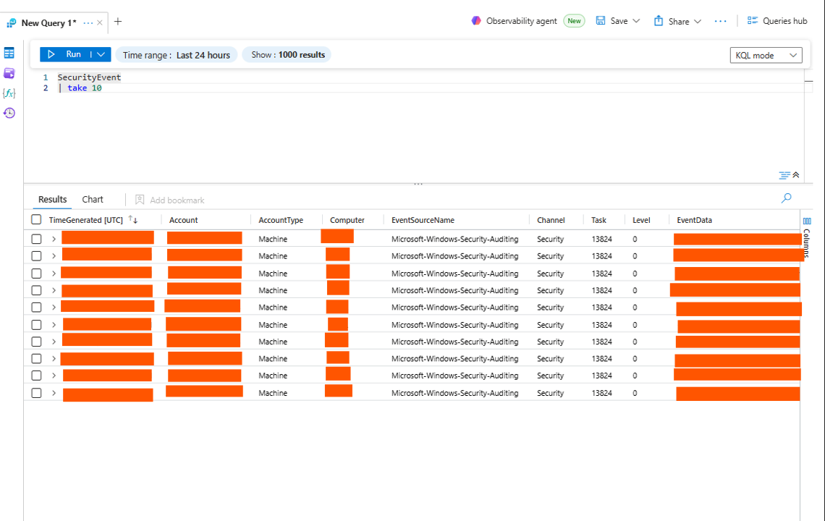
Current status
You successfully connected your Windows laptop to Sentinel.
Confirmed:
- SecurityEvent table has logs
- Computer name: **
- Account: WORKGROUP\**$
- Source: Microsoft-Windows-Security-Auditing
- Channel: Security

