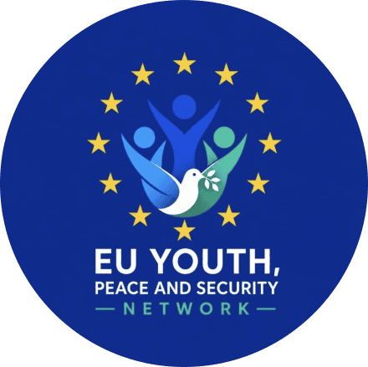
Draft programme – Conflict Minerals Conference
Hybrid event
Thursday, 12 November 2026

*** The event will take stock of the closed-door session on 10 November, the outcomes of which will be shared with you on 11 November***

15:30 – 15:35 Introduction
- Ms Katariina Leinonen, Head of Division, PCM.1, European External Action Service

15:35 – 16:10 Situation and legal framework
- INTPA Unit E2 (speaker tbc), European Commission
- Ms Kylea Shropshire, Unit G5, European Commission
- Mr Salvatore Berger, MD Multilateral 5, European External Action Service

16:10 – 16:40 Needs on the ground
- Mr Bertin Cituli or Mr Jospin Habimana, EU Youth, Peace and Security network
- Activist from Central African Republic (speaker tbc), EU Youth, Peace and Security network
16:40 – 16:55 Questions and answers
16:55 – 17:00 Conclusions
- Mr Bernardo Mariani, Conflict Management Center, Vienna

***

