**Global Distributed Software Development**

**Summer 2021**

**Milestone 2 - Project Team A**

**Under the guidance**

**Rainer Todtenhoefer, CTO and CEO**

**Team Members**

|  |  |
| --- | --- |
| Team Member Name | Role |
| Jagadesh Devan | Team Lead & Frontend Developer |
| Ahmad Yar Khan | Frontend Lead & GitHub Master |
| Taha Bin Aziz | Backend lead |
| Obada Altnawi | Frontend / Backend Developer |
| Rabia Hafeez | Frontend Developer |

**Revision History**

|  |  |  |  |  |
| --- | --- | --- | --- | --- |
| Name | Date Submitted | Date Revised | Revision Summary | Version |
| Jagadesh Devan | 24.05.2021 | NA | NA | 1.0 |

Contents

1. Personae and main Use Cases 3

1.1. Personae 3

1.2. Use Cases 4

1.2.1. List of use cases 4

1.2.2. Main use cases 5

1.3. Application Story 5

2. Functional requirements 6

3. List of main data items and entities – data glossary/description 8

4. UI Mockups and Storyboards (high level only) 9

4.1. Website Tree 9

4.2. UI Mockups and Storyboards for Main Use Cases 10

5. High level Architecture, Database Organization 19

5.1. Database Architecture Diagram 19

5.2. TABLES 19

5.3. ERD-DIAGRAM 20

6. High Level UML Diagrams 22

7. Actual Key Risks 22

8. Project Management 24

# Personae and main Use Cases

Following summarizes the two main types of personae and describe the main use cases of HomeForMe system.

## Personae

**Ali - A Student**

Ali is a new student in Fulda University and coming to Fulda within 15 days from Pakistan. Unfortunately, he couldn’t get any room in student hostel and he has to find a room outside of student dormitories. He doesn’t know too much about Fulda city so he’s looking for an online real estate site where he can search for a room near to his university which is not so costly and available him within 10 days so that he can reserve his accommodation before arrival.

What Ali loves:

1. Search through categories and find what he needs quickly.
2. Suggestions for related items based on his searches.
3. Simple and quick authorization methods without complex verifications.

**Peter - A Real Estate Agent**

Peter is a real estate agent in a well-known real estate company. He has a good understanding and knowledge on web applications and how to use them. He loves online buying and selling properties because it saves a lot of time and resources. Peter is a creative guy who likes to have everything in standards. He hates when users upload some unnecessary images and descriptions to their ads. He likes to see decent and professional colors on the website too. When he feels the website is not so professional, he tries to find better alternatives.

What Peter loves:

1. To have clear images and descriptive information on advertisements.
2. To see other user’s reviews on properties.

**Christina-A Buyer**

Christina is an old lady. She wants to gift a little apartment to her granddaughter on her wedding. She is looking for a website where she can find the desired apartment. As she is too old and it’s very difficult to go outside and see all the properties by visiting personally so she decides to search it online. She likes to have a simple user interface and a simple navigation method. She hates it when there are so many small text descriptions, and all the website's font is small. She prefers to have a high contrast version of a website or ability to have bigger images and texts.

What Christina love:

1. Read comments and reviews on a property.
2. Have a chat with the property owner for specific information. (she prefers a real time chat with them)
3. She loves to have nice and clear information about property images.

## Use Cases

### List of use cases

1. Register
2. Login
3. Chose profile type
4. Search catalogue
5. View property details
6. Browse catalogue
7. Get average price
8. Change data to see price effect
9. Manage properties
10. Add property
11. Edit property
12. Delete property
13. Agent dashboard
14. View sales
15. Cancel sales
16. Massaging
17. Create contract
18. Buyer dashboard
19. Cancel contract
20. Approval
21. Agent profile
22. Sales cancel by agent
23. Property operations
24. Admin dashboard
25. Property and sales reporting

### Main use cases

1. **Manage Contracts (1):**buyers sign up to be able to make contracts, and agent also to be able to be listed as an agent under their company and add new property and manage their sales. Admin also require to login to accessing to the website for approvals.
2. **Search Catalogue (4):** The user who is interested to buy, sell or get tenant can search the property on the website where he/she can filter the records based on categories which include location, city, pricing range, property type (home, flat, studio, penthouse, room).
3. **Get Average Price (7):** User will be able to enter the data of the property he is interested in for example (rooms, size, city, balcony, backyard) and the system will be able to give the use an average price of the property available on the website.
4. **Manage Properties (9):** The agent will be able to add, edit and delete his property on the website but they will not be able to go live on the w ebsite without admin approval.
5. **Massaging (16):** Buyers can massage the Agents on the platform and ask them any question they want about the property and agent can see notification of the massage and replay to the buyers.
6. **Approvals (20):** Admin will have to review the new property that is created if it complies with the website policy before it goes live on the website and approve now agent profile and if he is requested to be listed on the correct company.

## Application Story

**Motivation & Importance**

The real estate market is one of the most complex markets in the entire world since it is in a continuous change, thus making it a very dynamic market. The internet has a lot to offer consumers regarding real estate and as a result it is a great place to start shopping. The buyer and seller have direct access to information about the property in question. This makes other forms of communication between the buyer and the seller obsolete. The internet is easy in comparison to the old-fashioned method of answering dozens of phones calls or setting up numerous meetings.

There is no better, safe, and easier way to search for a home or to sell one than online as the internet has a lot to offer in the real estate market and it is rapidly developing, gaining more and more consumers every day and thus improving your chances for a profitable buy/sell.

**Target Audience:**

The target of our applications is the customers who cannot spend more time for buying and selling the housing property.

Online real estate has become popular and is consuming are looking to the internet more each day as an easy place to get good information. As a matter of fact, more than 5 million people use the internet for real estate issues every month. With numbers like this it is easy to see how the internet can improve your chances for selling or buying a home.   
   
Another major advantage of real estate moving to the internet is that you won't need a real estate agent to start your search. This is very important because we all know that real estate agents are of value but sometimes you just want to look.

**Reasons to use our HomeForMe application:**

Using our HomeForMe application for real estate will make you your own real estate agent without having to pay a great sum of money to an agent and you will have full control. If you are a home buyer or seller, it is very easy to search for the perfect house as the online offers are endless.

**Unique Selling Point:**

There are several applications available in the market for real estate. But our HomeForMe application will allow users to calculate an avg price of a property by adding in their preferences like area, rooms beforehand so it makes the user and provide specific results which will reduces the time for the users.  Also, we have made our application user friendly so that you need is very basic computer usage skill.

# Functional requirements

**New user:**

* **View Properties:**

1. User can go the properties page and see all the properties available.
2. Use can navigate properties pages and can go to first last page.
3. User can click on a property and view full details for that property

* **Searching:**

1. User can enter any text in the search box in the properties page and click search.
2. User can see the result of the search text and click on any property to access it.

* **Advance Search:**

1. Implementing Approximate string matching so user can find correct result in spite of any spelling mistakes.

* **Filter/Browse Properties:**

1. User can chose different parameters that can filter the properties results based on different values such as (price range, location, city, property type, number of rooms, etc.)
2. User can select any property from the filtered list and show the property details

* **Get Average Price:**

1. User can access the average price calculation page and enter the needed parameter for example(house size, rooms , balcony, garden, distance to bus station, floor, garage).
2. User will press the “Get Average Price” button and the price will be displayed.
3. User will be able to change the entered parameter and see the price effect.

* **Compare:**

1. Use can chose two property and select added to compare list.
2. Once there is at least two property the button “Compare Now” will be clickable
3. Properties will be displayed side by side in a table that show the differences and similarities.

* **Registration:**

1. User will be able to access registration page to create an account on the website.
2. User can enter his/her information and chose profile type buyer/Agent.
3. User will click on register now and the profile will be created.

**Buyers**:

* **Messaging:**

1. User will be able to go to any property and click on chat with agent.
2. User will be taken to the massaging page and can type massages for the agent,

* **Dashboard:**

1. Buyers should have a dashboard to manage their contacts, properties they have applied to, and massages they have.

* **Make a Contract:**

1. User can click on create a contract from any property page.
2. Contract will be added to buyer contracts in the dashboard.

* **Edit Profile:**

1. User can access his profile and change his/her details
2. User can delete his profile.

* **Rating:**

1. User can rate any property they made a contract with.

**Agent/Sellers:**

* **Mange Properties:**

1. Agent can post any new property to the website.
2. Agent can Edit and delete any property the added.

* **Dashboard:**

1. Agent should be able to view a dashboard to be able to manage their sales, mark properties available, sold, reserved etc.

* **Messaging:**

1. Agent should be able to see the massages of the users and be able to replay to the massages.

**Admin:**

* **Approvals:**

1. Admin should be able to review before publishing property going live on the website.
2. Admin can approve or reject any property according to the website policy.

* **Dashboard:**

1. Admin should have a reporting of selling and buying property.

|  |  |  |
| --- | --- | --- |
| **Actor** | **Requirement** | **Priority** |
| **Priority 1** | | |
| **New User** | View Properties | 1 |
| **New User** | Searching | 1 |
| **New User** | Filter/Browse Properties | 1 |
| **New User** | Registration | 1 |
| **Buyers** | Messaging | 1 |
| **Buyers** | Dashboard | 1 |
| **Buyers** | Make a Contract | 1 |
| **Agent** | Mange Properties | 1 |
| **Agent** | Dashboard | 1 |
| **Agent** | Messaging | 1 |
| **Admin** | Approvals | 1 |
| **Priority 2** | | |
| **New User** | Advance Search | 2 |
| **New User** | Get Average Price | 2 |
| **Buyers** | Edit Profile | 2 |
| **Priority 3** | | |
| **New User** | Compare | 3 |
| **Buyers** | Rating | 3 |
| **Admin** | Dashboard | 3 |

# List of main data items and entities – data glossary/description

1. **Administrator**

A system administrator, or sysadmin, is a person who is responsible to manage user access for sellers and manages the dashboard for customers.

2. **Authentication**

The process of verifying the legitimacy of a user on a platform.

3. **Approval**

Confirm the inclusion of a post/content which is relevant for the application, product, service category, or the overall expectation of the platform.

4. **Buyer**

A buyer is a person or entity who is potential player to acquire or view the property.

5**.** **Seller**

A Seller is a person or entity who owns the existing property.

6. **Categories**

Distribution of product items or services into different groups based on their properties or attributes.

7. **Database**

A database is a collection of information that is organized so that it can be easily accessed, managed, and updated. Computer databases typically contain aggregations of data records or files, containing information about transactions or interactions of specific customers.

8. **In-app message**

In-app messages are messages delivered to the application users within the platform. This type of messaging does not include any other platform.

9. **Object**

Software objects are conceptually like real-world objects: they too consist of state and related behavior. An object stores its state in fields and exposes its behavior through methods or procedures.

10. **Profile**

A description of an individuals’ social characteristics that identify him/her on media platforms.

11. **Record**

A record is simply a set of data stored in a table, for example, a customer or property record. A record in a database is an object that can contain one or more values.

12. **Service**

A service is an intangible process. This means it does not have physical dimensions to it; it cannot be measured or weighed. Services usually provide tangible product in the end. For example, a tutor providing language lectures on the internet.

# UI Mockups and Storyboards (high level only)

## Website Tree



## UI Mockups and Storyboards for Main Use Cases

**Home Page**

**Main Use Cases**

* 1. **Search Catalog:**

1. User Can brows any property by navigating the pages
2. User Can search for any property name.
3. User can select filters from the left bar
4. User Can click for any product to access the full product details

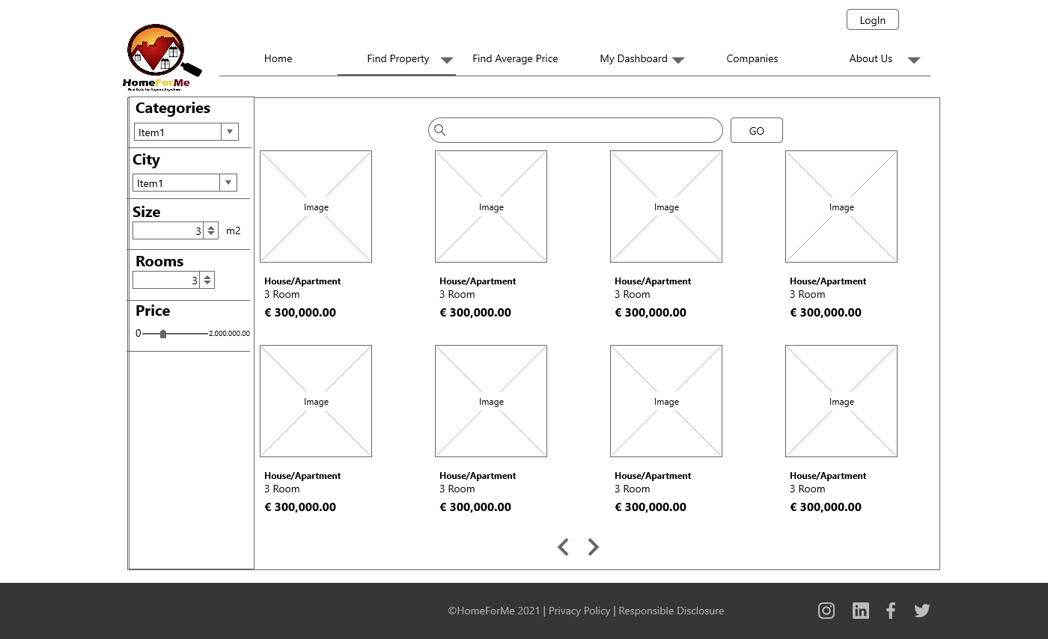

* 1. **Manage Contracts:**

1. Buyers can enter a property detail and make a contract
2. Contract will show in his dashboard and in the agent dashboard
3. Buyers and sellers can see their contracts and terminate them.
4. Buyer can navigate between different contracts types (Active, Completed, Canceled,All Contracts)

* 1. **Get Average Price:**

1. User Can Enter his/her prefer data by using the fields in the page
2. Users click on the “Get Average Price” button and see the average price that will be calculated based on the property available at the website which have that information.
3. Use can change the data and see the price impact.

* 1. **Messaging**

1. Buyer can massage any agent from the product details page.
2. User and agent can access their massage page and select any conversation and type their enquires/replies in the chat.
3. A notification in the Dashboard for the agent and buyer will appear when there is a new unread message.

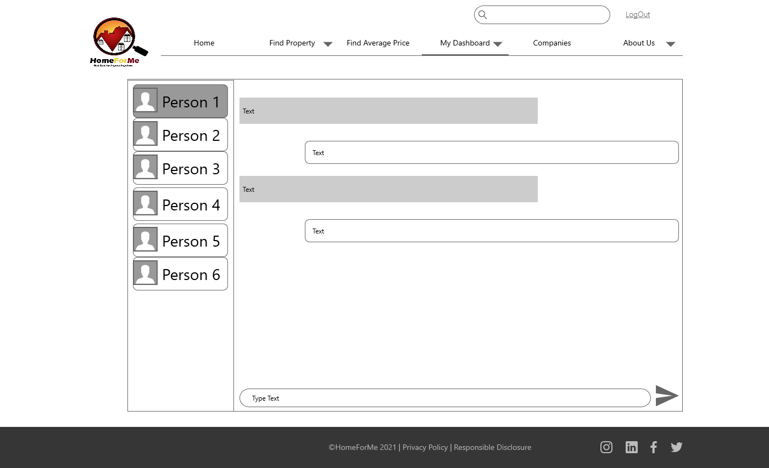

* 1. **Approvals**

1. Admin will be able to check the his dashboard to see the pending approvals
2. Admin can approve any new property posted and new agent profiles

# High level Architecture, Database Organization

## Database Architecture Diagram

Above diagram shows the high-level architecture of application, in which Application would run on Amazon EC2 instance and we would be using file system for the Storage for our images, in addition as per the diagram Client/Browser would interact with Front end application build on REACT type and Bootstrap, back-end services and logics would be the in Node.JS which would get data from MySQL database.

## TABLES

1. Admin
2. Categories
3. Companies
4. Users(buyer/agent)
5. Property Details
6. Property Images
7. Create Contract
8. Contract Details
9. Agent Msg
10. Buyer Msg

## ERD-DIAGRAM

**Media Storage**

For Media storage, file system would be our choice as its less complex to implement and read/write to a DB is always slower than filesystem

**Filtration Architecture**

As describe in our functional requirements users can use filtration on the bases of many properties such as category, price, property posted date etc. For the search, we will be using MySQL ‘%LIKE’ feature on the property title to fetch the any property which contain searched text.

**APIS**

Design REST API for the retrieval of data. The main purpose of API is to request a server and get response from it.

**Non-Trivial Algorithm**

For the sake of simplicity, we will not use any fancy algorithm for rating, ranking or prioritization of property or user. But will store user (agent) rating and review in database for future analyses and for future admin approval of property.

# High Level UML Diagrams

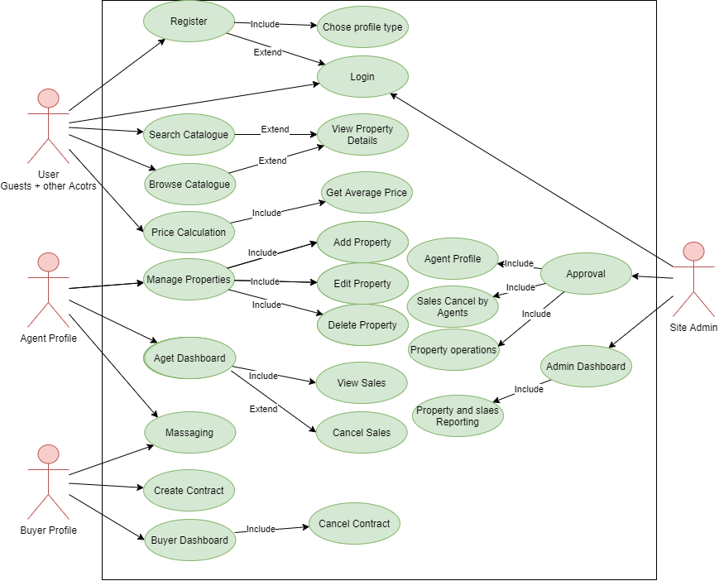

# Actual Key Risks

|  |  |  |
| --- | --- | --- |
| **S.No** | **Risk** | **Mitigation** |
| 1 | Schedule risk, the risk that activities will take longer than expected. Slippages in schedule typically increase costs and, also, delay the receipt of project benefits, with a possible loss of competitive advantage. | To overcome we have prioritized out requirements into Priority 1, 2 and 3. We have a plan to finish priority 1 and 2 on or before schedule. Depending on the time availability priority 3 will be implemented. |
| 2 | Performance risk, the risk that the project will fail to produce results consistent with project specifications. We have divided the frontend and backend team based on the skills set. | We have divided the frontend and backend team based on the skills set. Also, members with less knowledge are investing time in learning the technologies so we do not see this as a major risk. We agreed upon to have a proper knowledge sharing session within the project teams. |
| 3 | Cost risk. This is the risk that the project costs more than budgeted. Cost risk may lead to performance risk if cost overruns lead to reductions in scope or quality to try to stay within the baseline budget. | In our HomeForYou project we use the available free software technologies. So cost is not major risk in our project. |
| 4 | Technology risk**, Using software and other utilities inadequately, could lead to a decrease in your productivity.** If there are technological problems, this will delay or hinder the delivery of your projects. | To avoid such issue we held a team meeting to decide the software technology. At this point of time we do not have any issue related to technology. If it happens in the future we are going to adapt. |

As a team we believe that proper communication can avoid any kind of risks. So, we always get into a meeting if we wanted to discuss about any process. As of this moment we do not have any risks in our HomeforYou moment.

# Project Management

Project management has become a key aspect in our team, everyone tends to follow the process in place. So, we have 2 channels for communication. We use Microsoft teams for tasks allocation and regular discussion on team activities, knowledge sharing and internal team training. And we use WhatsApp application for a quick and routine discussions.

After a milestone has been set, we make a meeting then the team leader will divide and create tasks as we agreed, we are using “Microsoft Planner” to assign and set due date for each task. then Backend and Frontend teams work in parallel with an always open channel of communication and there will be meeting created when needed. Before and after every submission we access our team performances based on the review by the CTO and CEO.

