Sentiment Based Model for Recommender Systems

Now-a-days all application will be using some kind of recommendation system to entice their customers with offers based on their past browsing or collaborative filtering. Existing techniques often suffer from Cold Start issue which will give inaccurate recommendation when matrix size goes smaller or higher. This issue occur because of single entity usage called RATINGS

To overcome from above issue author of this paper employing Comments Sentiments along with ratings. Comments often express user sentiments which can help in getting accurate recommendation. Comments help in predicting accurate sentiment which will help in accurate prediction of Recommendation.

To predict sentiments and recommendation we are employing CNN2D (convolution neural networks) advance algorithm which will get trained on YouTube comments and this comments we have divided into 5 different sentiments from 1 to 5 where 1 refers to Negative, 2 refers to Neutral, 3 refers to Positive, 4 refers to happy and 5 refers to extremely happy.

CNN algorithm performance is evaluated in terms of RMSE (root mean square error) which refers to different between original and predicted values so the lower the difference the better is the algorithm. CNN get tested on dynamic split of train and test data so RMSE score always vary for each run.

To train CNN we are using below YouTube comments dataset

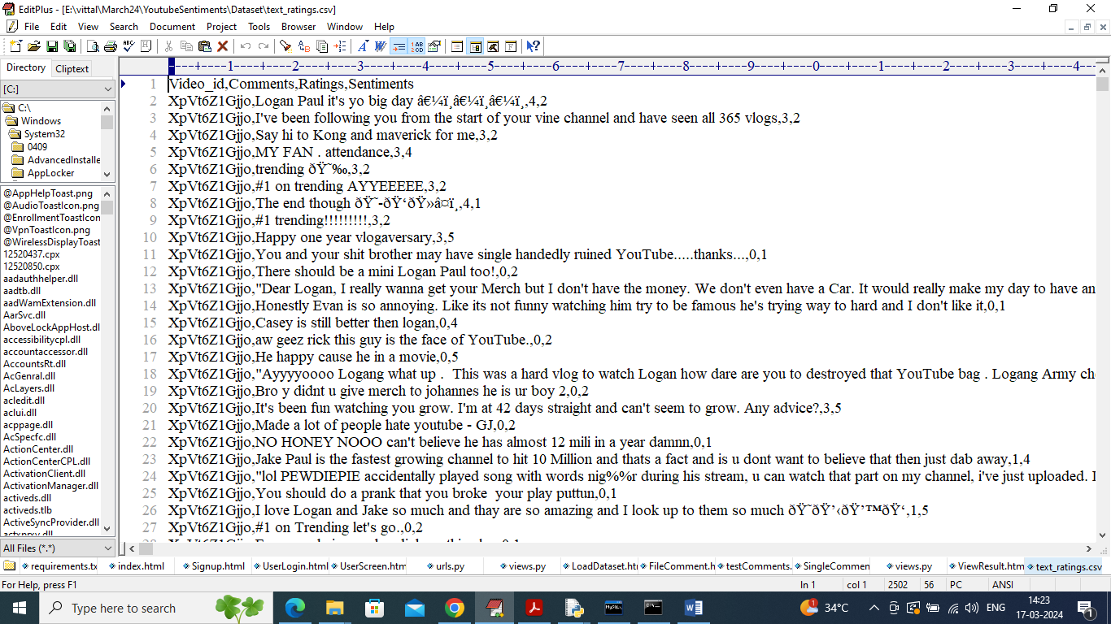

In above dataset screen first row contains dataset column names and remaining rows contains dataset values. So by using above dataset will train and test CNN algorithm.

To implement this project we have designed following modules

1. User Sign up: user can sign up with the application
2. User Login: after sign up user can login to application
3. Load Dataset: using this module user can upload and pre-process dataset values
4. Train CNN: using this module user can train CNN algorithm and then get RMSE error as output
5. File Comments Analysis: using this module user can upload test comments file and then CNN will predict sentiments and based on sentiment will predict recommended movies
6. Single comment: user can enter comment text to predict sentiments and movie recommendation

Install python 3.7 and then install all packages given in requirements.txt file and then install MYSQL dataset and then copy content from DB.txt file and paste in MYSQL console to create database

SCREEN SHOTS

To run project double click on run.bat file to get below screen

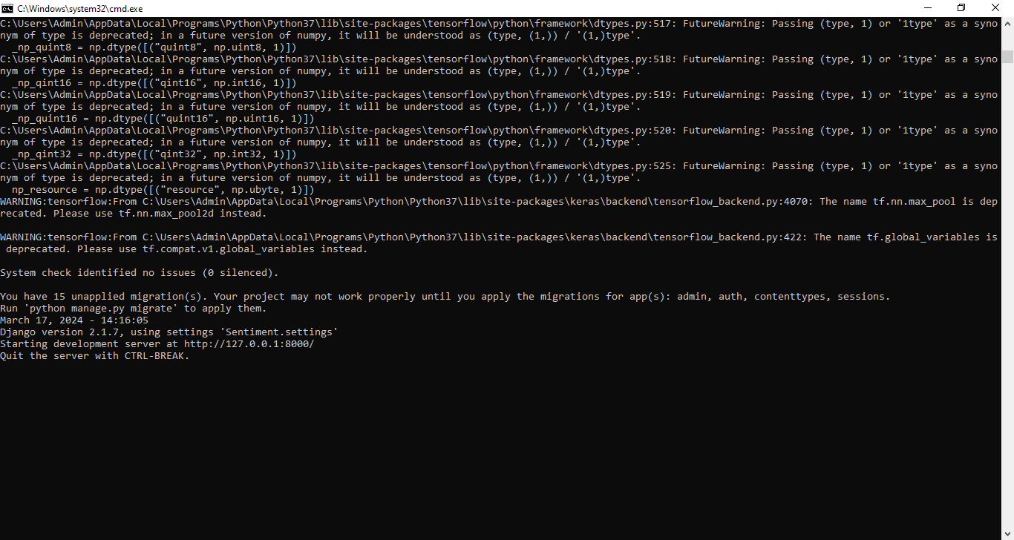

In above screen server started and now open browser and enter URL as <http://127.0.0.1:8000/index.html> and press enter key to get below page

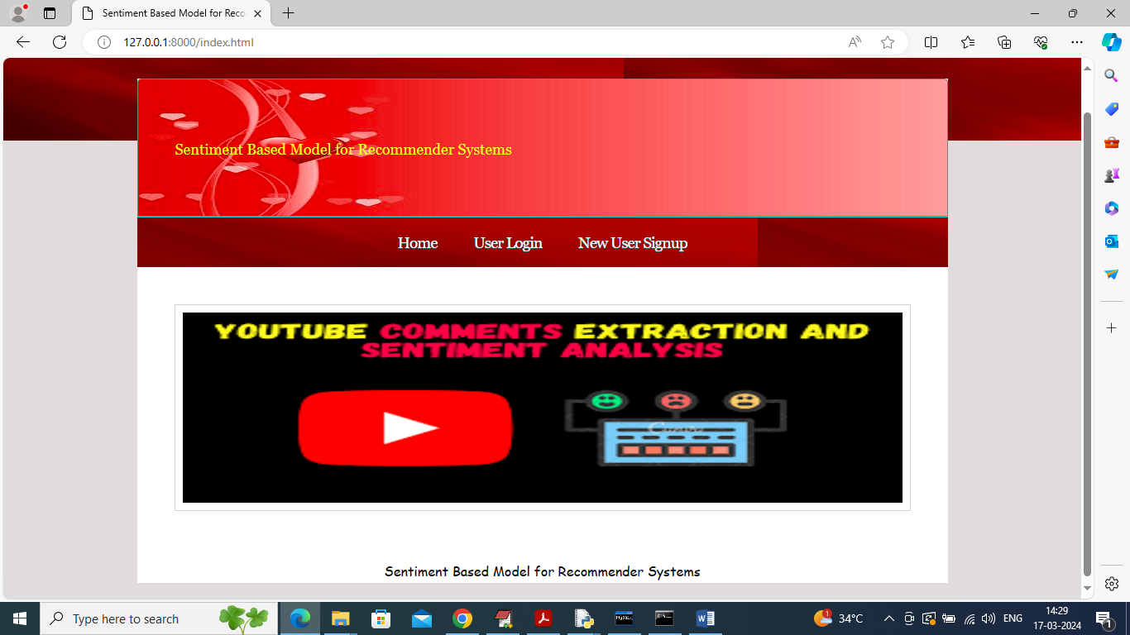

In above screen click on ‘User Sign up’ link to get below page

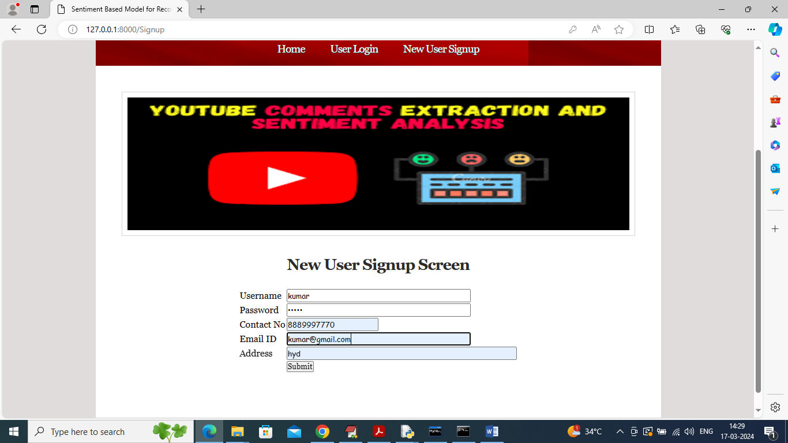

In above screen user is entering sign up details and then press button to get below page

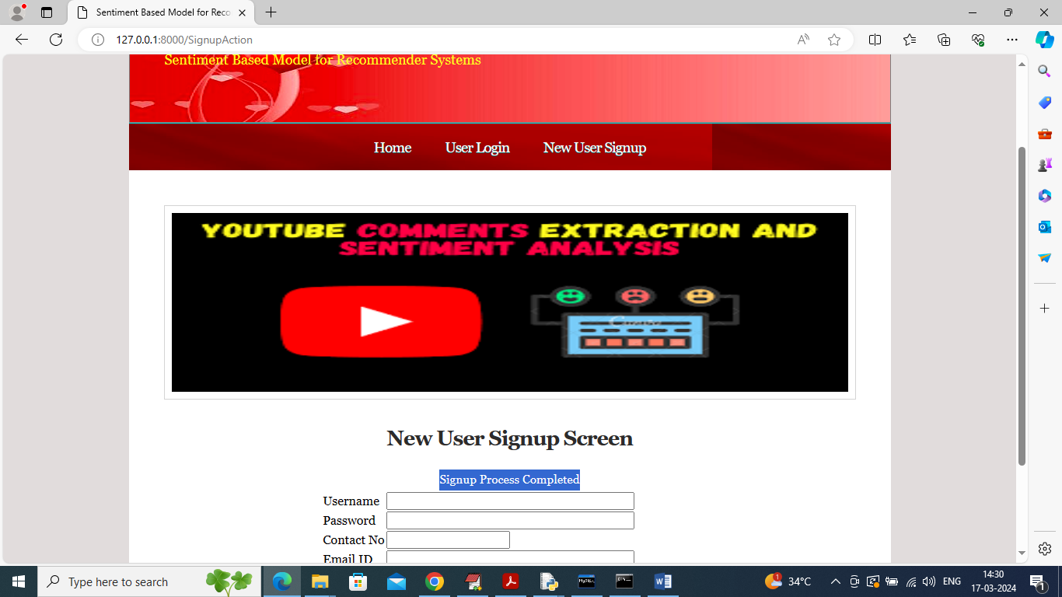

In above screen user sign up completed and now click on ‘User Login’ link to get below page

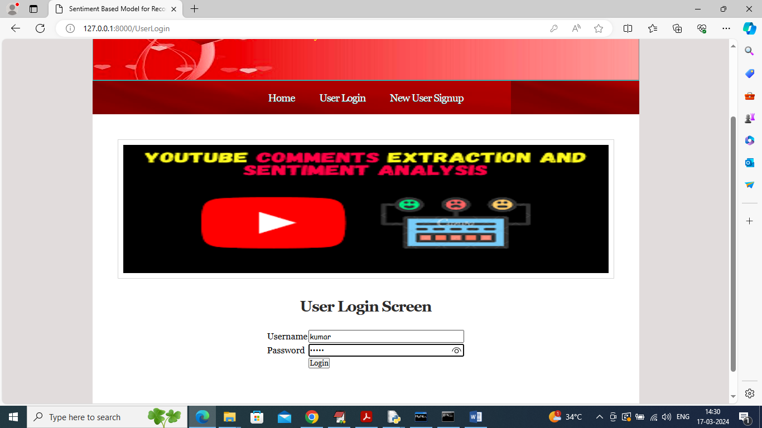

In above screen user is login and after login will get below page

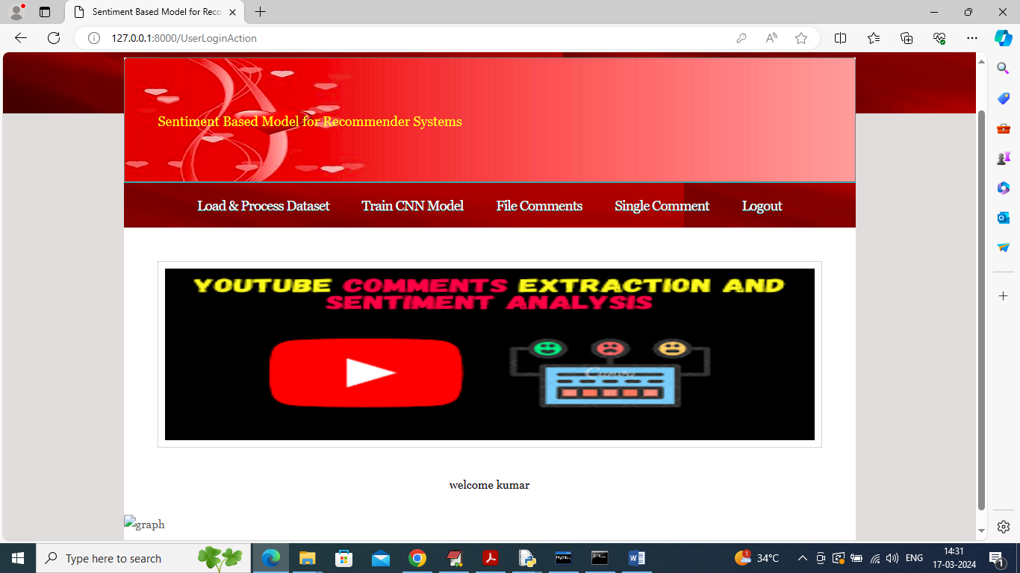

In above screen click on ‘Load & Process Dataset’ link to get below page

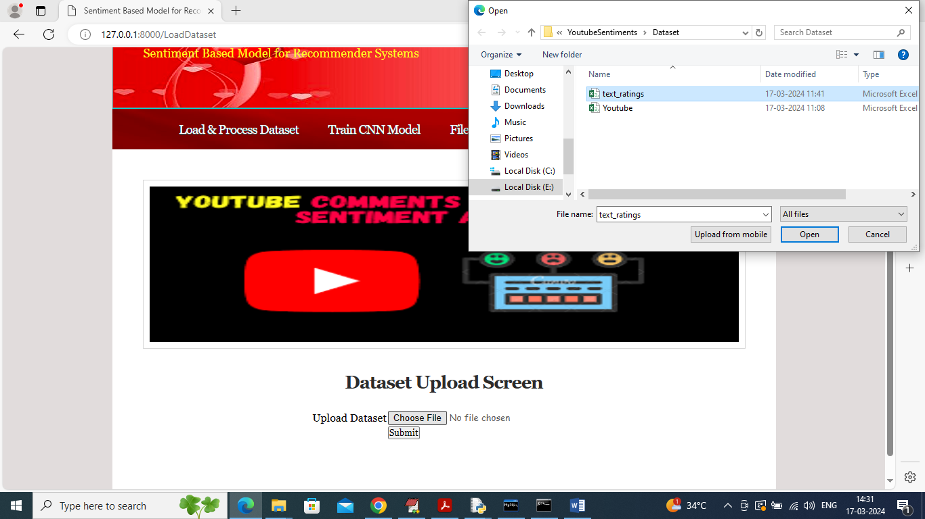

In above screen selecting and uploading ‘text_ratings.csv’ file and then click on ‘Open’ button to load dataset and get below page

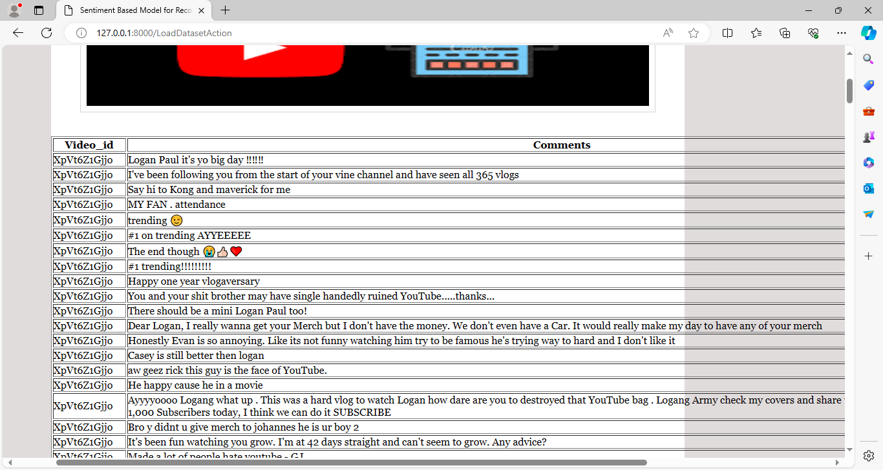

In above screen dataset loaded and now click on ‘Train CNN’ link to train algorithm and get below page

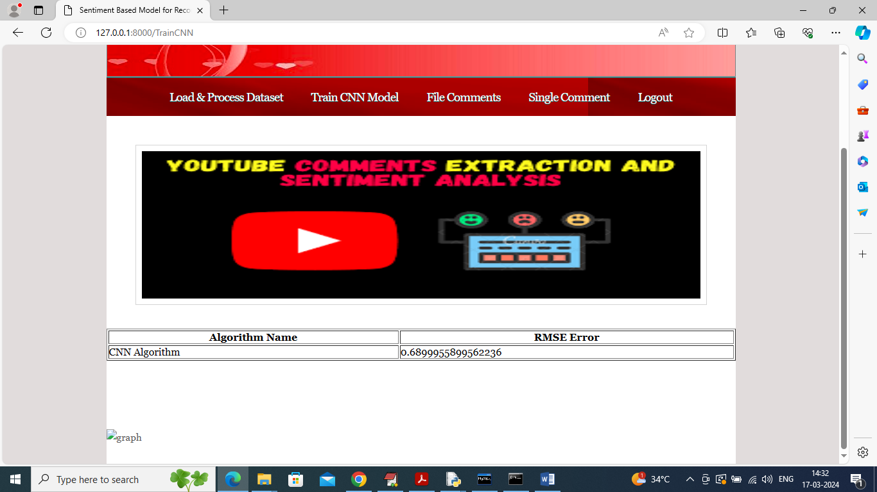

In above screen CNN training completed and got RMSE error as 0.68% and now click on ‘File Comments’ link to get below page

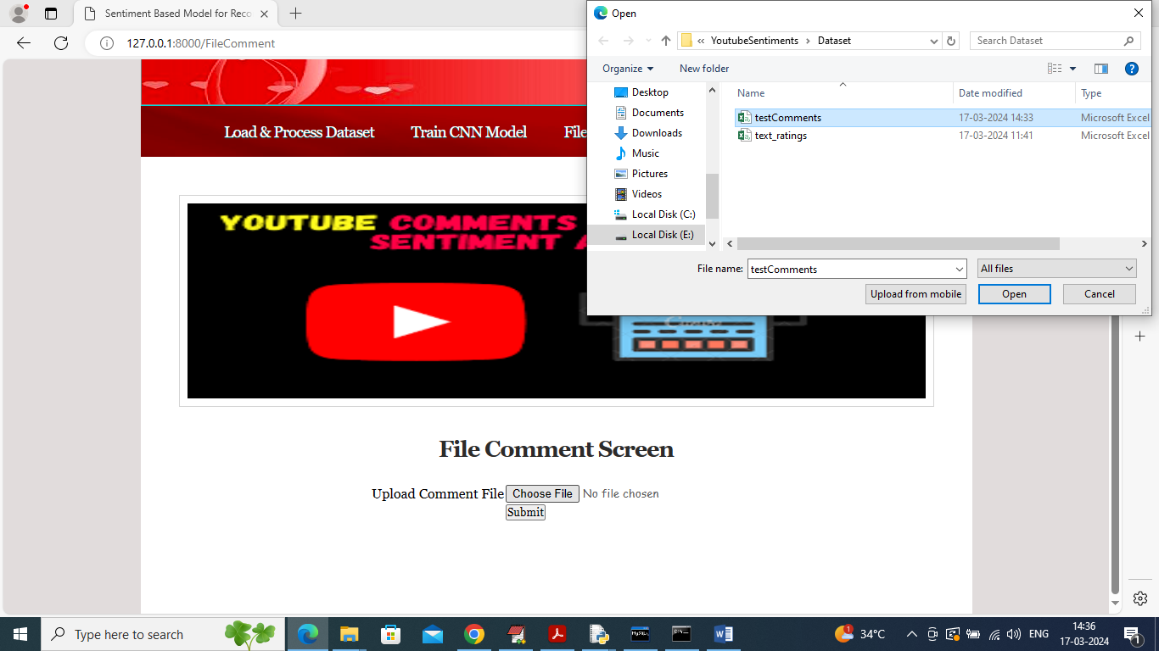

In above screen selecting and uploading ‘test comment.csv’ file and then click on ‘Open’ and ‘Submit’ button to get below page

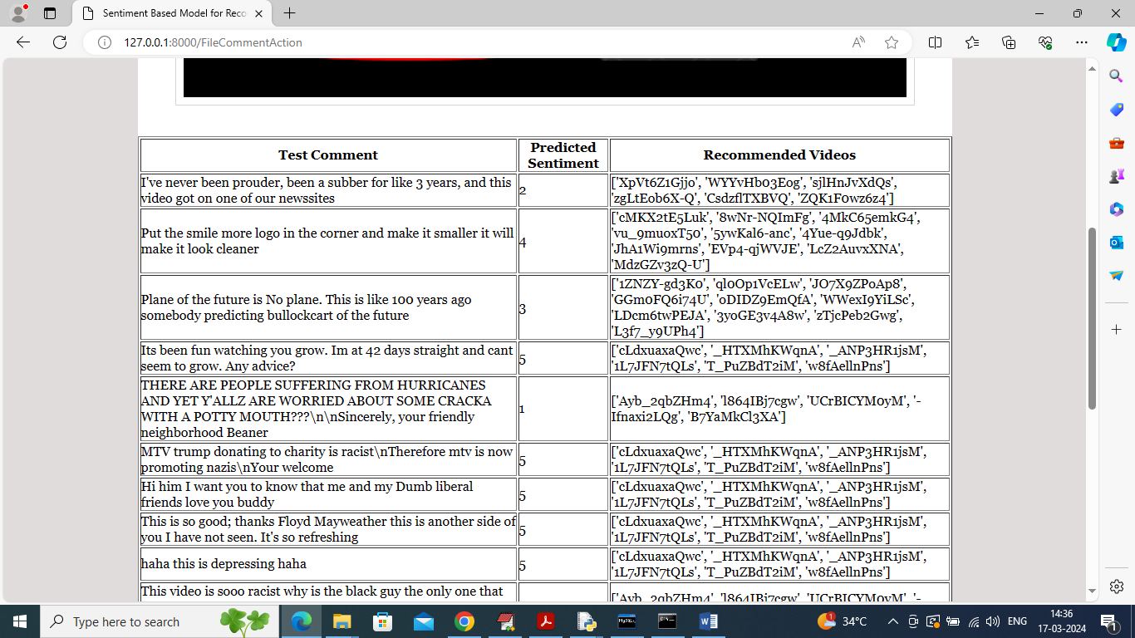

In above screen in first column can see Test Comment Text and in second column can see predicted sentiments from range 1 to 5 and then based on predicted sentiments displaying top 10 recommended videos and in below is predicted sentiments graph

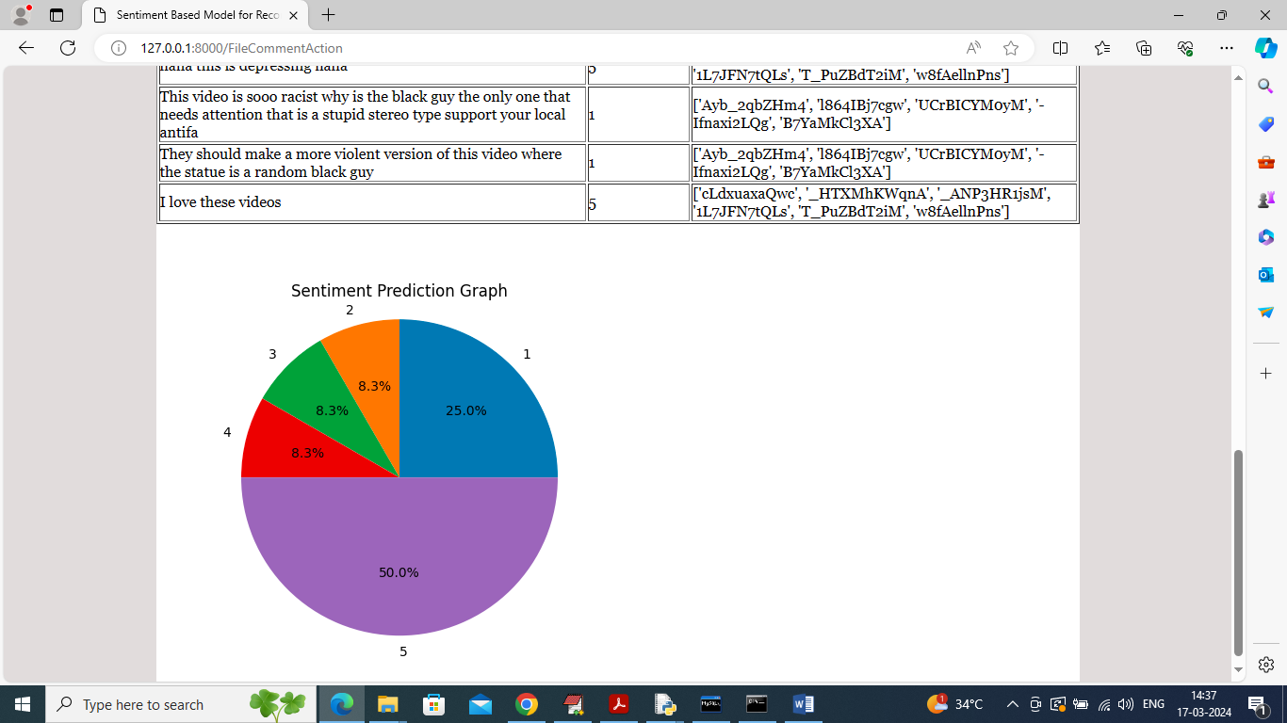

In above graph can see percentage of different sentiments and now click on ‘Single Comment Analysis’ link to get below page

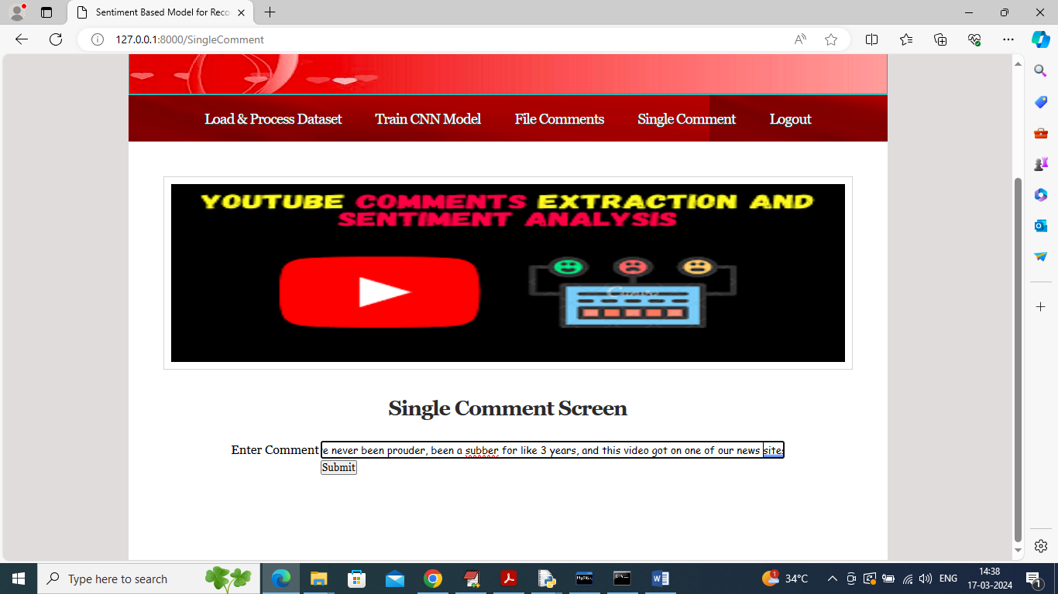

In above screen entered single comments and then press button to get below output

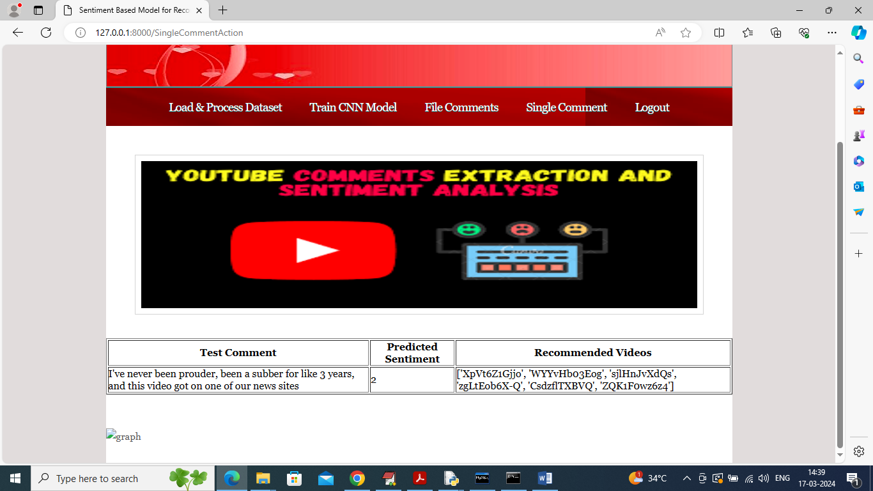

In above screen can see test single comment text and then can see predicted sentiment and list of recommended videos.

Similarly by following above screens you can run entire application