KICKSTARTER CAMPAIGNS

The kickstarter campaign is more than 10 years old and raise about 2 billion dollar fund. Today we are trying to dig out some fact and figure about the success of this campaign project. Let’s go over few statistical figures which were captured after extensive search from kickstart database by Analytic team. The team uses a reliable computer with Microsoft XL and knowledge as analysis tools. This analysis counted more than random 4000 project out of 300000 kickstarter project and try to narrow down any hidden trend.

Graphical figure shows the state of more than 4000 project as per parent category. It

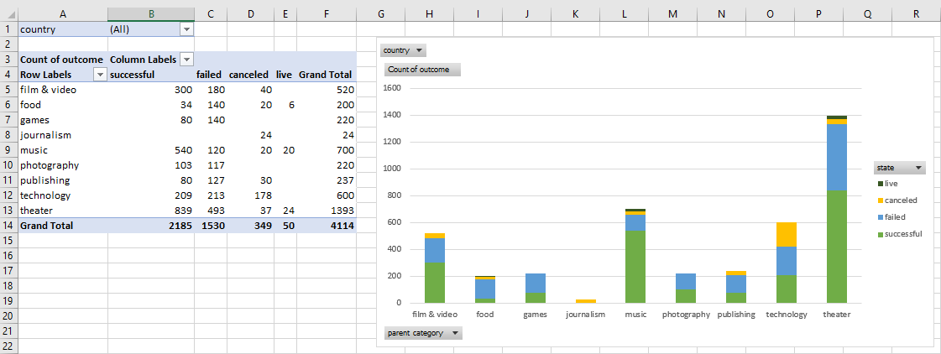

Is visible the most and least successful project by category. Similar way the most or least no of project has been canceled or failed and live by category. The theater category has most no of success and failure. All the project under journalism category are canceled and food category became the least successful among all category. Let’s go over the next figure by sub category.

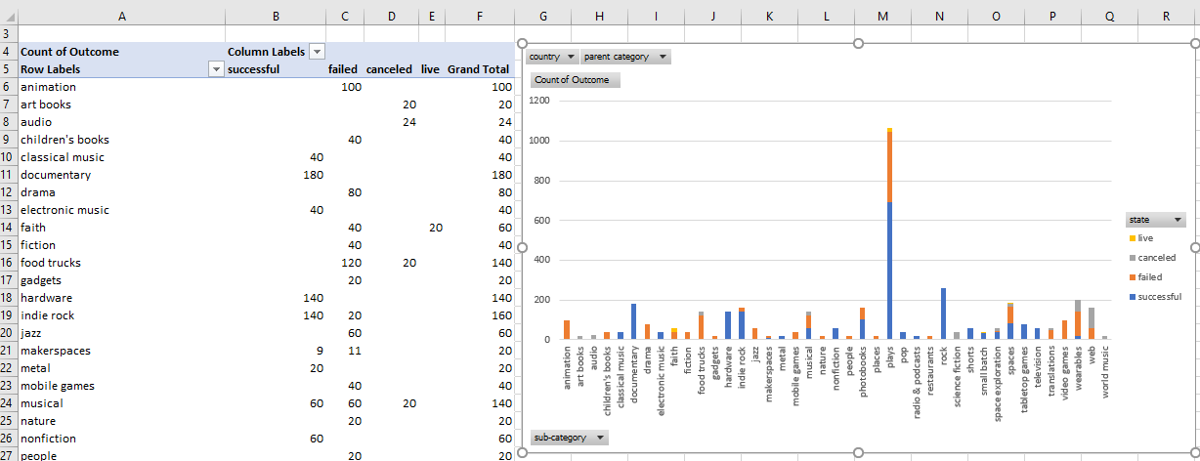

The plays sub-category project got the most success and most failure. Rock, Television, tabletop games, hardware and documentary sub category all the project got full success without any failure, but their individual magnitude is not a large. The video games and animation sub category project did not see any kind of success.

Let’s have a look a launched timebound state of each parent category project at various time of the year.

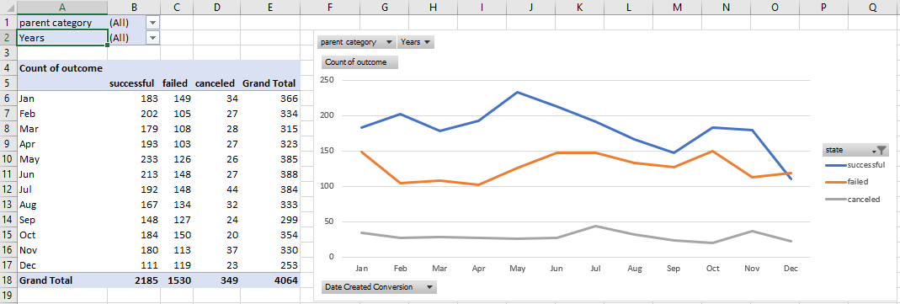

A prominent no of project launch at April to June got more success than November or December time.

Team concluded following:

1. Theater, music and flim/video categories are most success as quantity counted. The visual graph of music category indicate the less failure rate in compare with other two category.
2. On the sub category analysis shows the most successful sub categories are plays, rock, documentary, hardware, indie rock, classical music, shorts, pop and nonfiction etc. The plays sub category has most no of success as well as failed. The rock, documentary and hardware sub category have got 100% success rate over the period.
3. Third analysis shows the summer time dominate the success rate of project over winter time. The rock music arrangement at summer time is much easier and less expensive to organize.

Music is the most successful category.

Limitation:

The ratio of sample rate is 4:300 and accuracy is directly proportional to the ratio of sample rate.

The analysis could be extend on following:

Analysis could do the ascending or descending order on success state to narrow down quickly.

Which category or sub category project got more percent fund and became successful.

Is the project duration a factor to success or failure of a project, If so, Which categories are counted as success?

What category project received higher no of average donation and became successful?

1. What are three conclusions we can make about Kickstarter campaigns given the provided data?
2. What are some of the limitations of this dataset?
3. What are some other possible tables/graphs that we could create?