PROJECT FEATURE REPORT
Finance Manager
Personal Finance Management Platform
A complete, feature-by-feature walkthrough of the platform — architecture, data model, every user and admin capability, the analytics and reporting engines, and the security model.

◆ Dashboard ◆ Transactions ◆ Budgets ◆ Goals ◆ Investments ◆ Analytics ◆ Reports ◆ Admin
Document | Feature & Architecture Report
Platform | Next.js 15 · TypeScript · Prisma · PostgreSQL (Neon)
Version | 1.0 · Application v0.1.0
Date | 3 July 2026

Table of Contents

1 Executive Summary
2 Technology Stack
3 System Architecture
4 Data Model
5 Feature Deep-Dive
5.1 Authentication & Access Control (RBAC)
5.2 Dashboard & Financial Health Score
5.3 Accounts
5.4 Transactions & Transfers
5.5 Categories
5.6 Budgets
5.7 Recurring Bills
5.8 Savings Goals
5.9 Investments
5.10 Quick Spending Tracker
5.11 Analytics
5.12 Reports & Data Export
5.13 Notifications
5.14 Admin Panel
5.15 Profile & Settings
6 API Surface
7 Security Model
8 Feature Summary Matrix
9 Appendix — Setup & Operations

1 ◆ Executive Summary

Finance Manager is a modern, full-stack personal-finance platform that lets a user bring their entire financial life into one place — bank and card accounts, every transaction, category budgets, recurring bills, savings goals, and an investment portfolio — and then understand it through an auto-refreshing dashboard, rich analytics, and exportable reports. A separate, fully-guarded admin console adds user management, platform analytics, an audit trail, and system-wide settings.
The application is built on Next.js 15 (App Router) with a strict TypeScript codebase, a Prisma-modelled PostgreSQL database hosted on Neon, and Auth.js v5 for authentication. Every mutating request is validated with Zod, ownership-checked, and protected by an origin-based CSRF guard, giving the platform a security posture appropriate for real financial data.
▸ At a glance
15  user & admin feature modules | 14  database models | 40  REST route handlers
24  application pages | 4-signal  financial-health score | 3  export formats (CSV · Excel · PDF)

◆ Who it is for
Individuals who want a single, self-hosted or Vercel-deployed dashboard for budgeting and net-worth tracking — plus an operator/admin who manages the user base and monitors platform health.
2 ⚙ Technology Stack

The platform is composed of six cooperating layers. Each was chosen for type-safety, developer velocity, and a smooth path to production on Vercel.

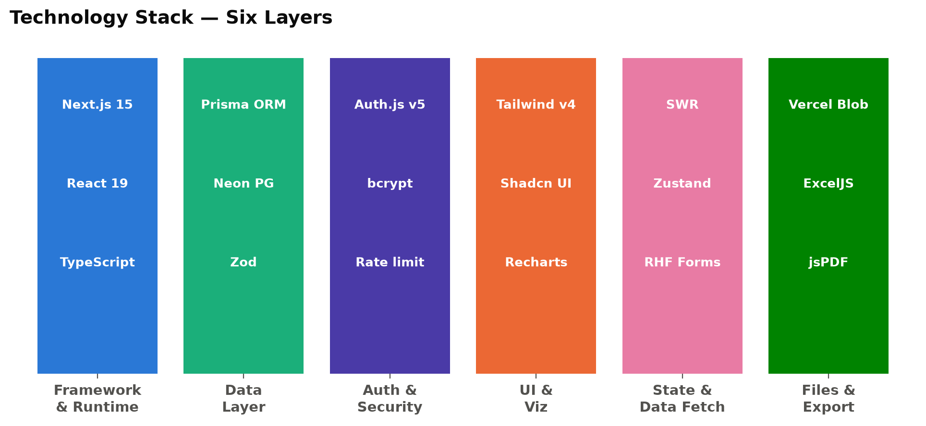
Figure — The six layers of the technology stack and their primary libraries.
Layer | Technologies | Role in the platform
Framework & Runtime | Next.js 15 (App Router, Turbopack), React 19, TypeScript | Server components, route handlers, and a strictly-typed UI.
Data Layer | Prisma ORM 6, Neon serverless PostgreSQL, Zod | Typed schema & queries; runtime validation of every input.
Auth & Security | Auth.js v5, bcrypt (cost 12), in-memory rate limiting | Credentials + OAuth sign-in, hashed passwords, brute-force defence.
UI & Visualisation | Tailwind CSS v4, Shadcn UI, Recharts, lucide-react | Design system, accessible components, and interactive charts.
State & Data-fetching | SWR, Zustand, React Hook Form | Auto-refreshing server data, UI state, and typed forms.
Files & Export | Vercel Blob, ExcelJS, jsPDF + autotable, PapaParse | Receipt uploads and CSV / Excel / PDF report generation.
3 ▤ System Architecture

Finance Manager follows the Next.js App-Router model: server components render pages, browser components fetch live data through SWR, and all writes flow through REST route handlers that share a single security pipeline before they ever touch the database.
▸ Request lifecycle (a mutating API call)
1. Middleware — middleware.ts protects every route — unauthenticated users are redirected, and admin pages require the ADMIN role.
2. Origin / CSRF check — auth.config.ts compares the request Origin against the host on every POST/PUT/PATCH/DELETE.
3. Authentication — The Auth.js session is resolved; the handler obtains the current user id.
4. Validation — The JSON body is parsed by a Zod schema; malformed input is rejected with 400.
5. Ownership check — The target row is confirmed to belong to the requesting user (or requireAdmin() passes).
6. Persistence — Prisma writes to Neon PostgreSQL; side-effects (notifications, audit log) are recorded.

▸ Route groups
● (auth) — Login, register, and forgot / reset-password screens with their own minimal layout.
● (dashboard) — The authenticated shell: a persistent sidebar, header, notification bell, and every user-facing and admin page.
● api — REST route handlers grouped by resource, each self-guarding.
✔ Why route handlers, not a separate backend
Co-locating the API with the app keeps a single type-safe codebase: the same Zod schemas validate forms on the client and payloads on the server, and Prisma types flow end-to-end with no duplication.
4 ▦ Data Model

The schema contains 14 Prisma models: four support Auth.js, and ten model the finance domain. Every domain row is owned by a user and cascades on delete, so removing an account cleanly removes its dependent data.

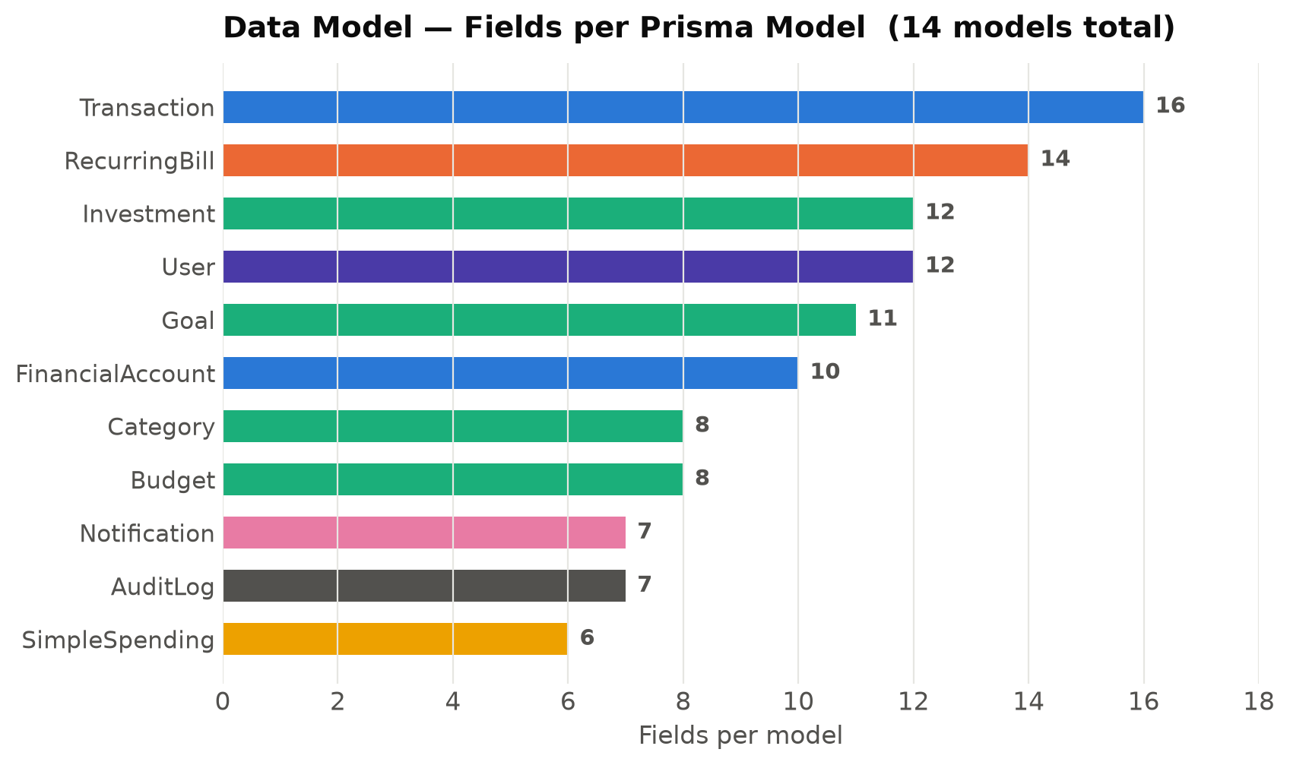
Figure — Relative size (field count) of each Prisma model in the schema.
Model | Purpose | Key fields / enums
User | Account holder & identity | role (ADMIN/USER), status (ACTIVE/SUSPENDED), baseCurrency
FinancialAccount | A bank / card / cash / loan account | type (7 kinds), balance, currency, color, isArchived
Category | Income / expense classification | type, parentId (hierarchy), isSystem, color, icon
Transaction | A money movement | type (INCOME/EXPENSE/TRANSFER), amount, receiptUrl, tags[]
Budget | A spend limit per category | amount, period (WEEKLY/MONTHLY/YEARLY), rollover
RecurringBill | A repeating obligation | frequency (6 kinds), nextDueDate, autoPay, reminderDays
Goal | A savings target | targetAmount, currentAmount, targetDate, status
Investment | A portfolio holding | type (7 kinds), quantity, purchasePrice, currentPrice
SimpleSpending | Quick expense jotting | description, amount, date
Notification | In-app alert | type (INFO/SUCCESS/WARNING/ERROR), isRead, link
AuditLog | Admin action trail | action, entity, entityId, metadata (JSON), ipAddress
SystemSetting | Platform-wide config | key → JSON value (maintenance mode, registration, …)
◆ Enumerated types keep data clean
Account types, transaction types, budget periods, bill frequencies, goal and user statuses, investment kinds, and notification severities are all Postgres enums — invalid states are impossible at the database level.
5 ★ Feature Deep-Dive

This section documents every capability of the platform, module by module. Each module lists what the user can do, the notable rules that govern it, and how it connects to the rest of the system.
5.1 Authentication & Access Control (RBAC)
Secure sign-in with role-based access. Two roles — ADMIN and USER — are enforced in middleware and again inside every API handler, so the UI guard can never be bypassed by calling the API directly.
▸ Capabilities
✔ Email / password sign-in (Credentials) with bcrypt-hashed passwords (cost 12).
✔ Optional “Continue with Google” and “Continue with GitHub” OAuth.
✔ Self-service registration (can be toggled off platform-wide by an admin).
✔ Forgot-password → email reset link, with a secure single-use token.
✔ Rate limiting on login, registration, and password-reset endpoints.
✔ Account suspension: a SUSPENDED user is blocked from signing in.
⚠ Defence in depth
Admin routes are gated in middleware (page redirect) AND by requireAdmin() in each API handler. Password hashes are never selected into any API response.
5.2 Dashboard & Financial Health Score
The landing screen after sign-in. It aggregates the user’s whole financial picture in a single server query and refreshes automatically via SWR, so the numbers stay current without a manual reload.
▸ What the dashboard shows
● Total balance across all non-archived accounts, plus monthly income, expenses, and net cash flow.
● Savings balance and total investment value with unrealised gain / loss and percentage.
● A 6-month cash-flow trend (income vs. expenses vs. net).
● Per-category budget progress bars with over-budget highlighting.
● The eight most recent transactions.
● A computed Financial Health Score (0–100) with an Excellent / Good / Fair / Needs-attention label.
▸ How the Financial Health Score works
The score is a deterministic 0–100 blend of four signals that investors commonly track. The weights sum to 1:

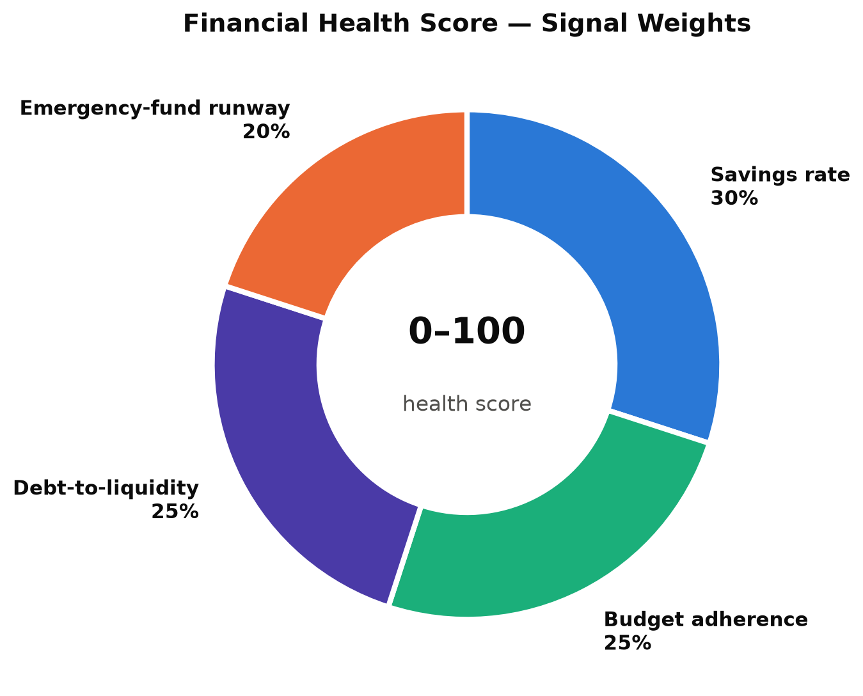
Figure — The four weighted signals that make up the 0–100 financial-health score.
Signal | Weight | Measures | Full marks at
Savings rate | 30% | (income − expenses) / income | ≥ 20% saved
Budget adherence | 25% | share of budgets kept within limit | no budgets over
Debt-to-liquidity | 25% | debt / (debt + liquid assets) | no net debt
Emergency-fund runway | 20% | savings / monthly expenses | ≥ 6 months
◆ Cash-flow trend (illustrative)
The dashboard renders a live 6-month income / expense / net chart like the one below, bucketed by calendar month from the user’s transactions.

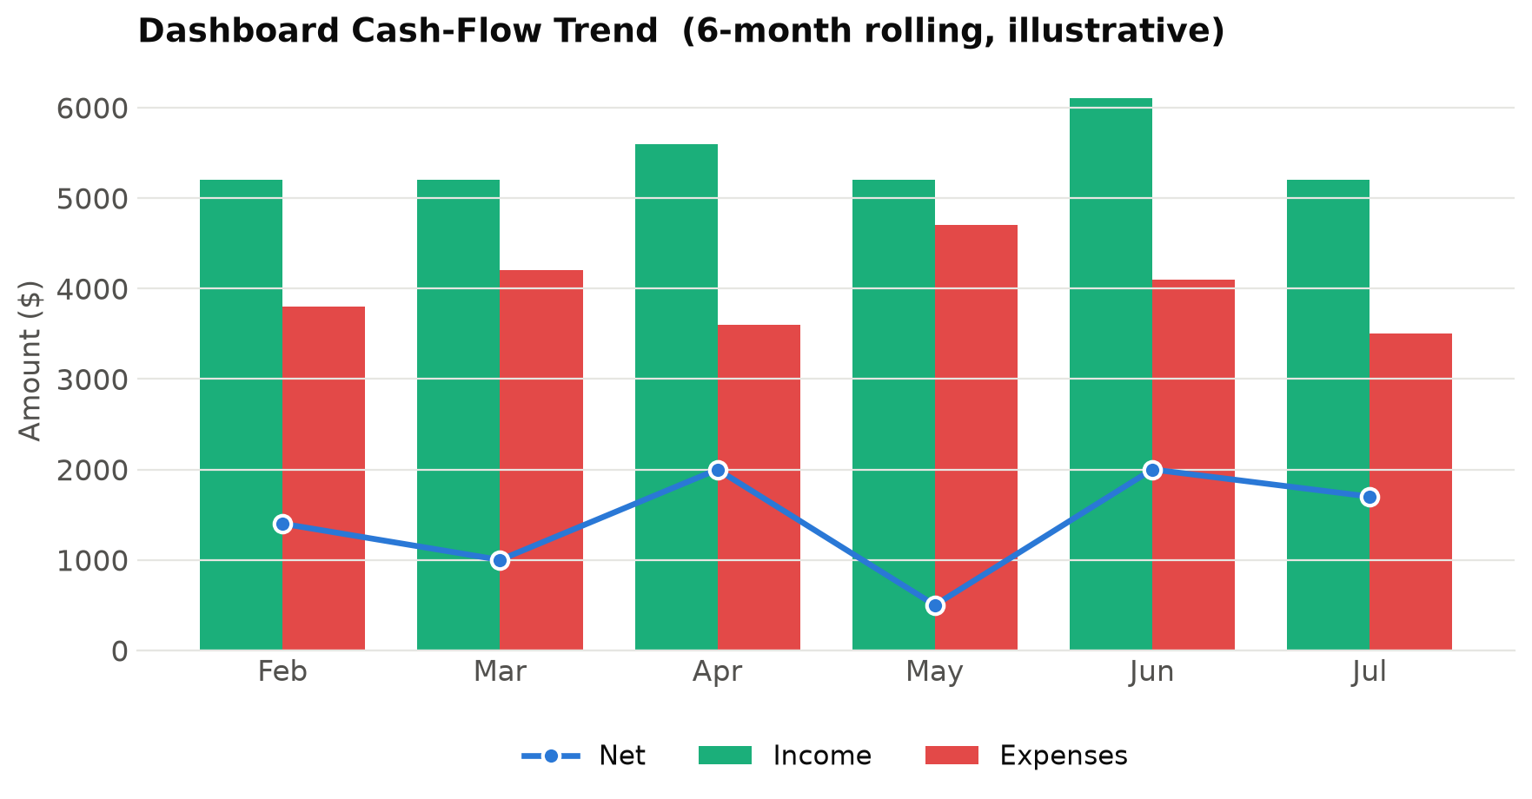
Figure — Example dashboard cash-flow trend — income vs. expenses with the net line.
5.3 Accounts
Users manage every place their money lives. Each account has a type, currency, running balance, and a colour + icon used consistently across the app.
● Seven account types: Checking, Savings, Credit Card, Cash, Investment, Loan, Other.
● Create, edit, and archive accounts (archiving hides them without losing history).
● Custom colour and icon per account for fast visual recognition.
● Liquid types (Checking, Savings, Cash) and debt types (Credit Card, Loan) feed the health score.
5.4 Transactions & Transfers
The core ledger. Every income, expense, and inter-account transfer is recorded here, with a powerful table for finding anything.
▸ Capabilities
✔ Record income, expense, or transfer transactions with amount, date, description, notes, and tags.
✔ Attach a receipt image (uploaded to Vercel Blob) to any transaction.
✔ Transfers move money between two of the user’s accounts in one action.
✔ Full-featured data table: search, sort, multi-filter, and pagination.
✔ Link a transaction to the recurring bill it paid.
✔ Server-side power
Search, sort, filter, and pagination are all executed on the server against indexed columns (userId + date, accountId, categoryId), so the table stays fast even with a large history.
5.5 Categories
Transactions and budgets are organised by category. Categories are typed as income or expense and can be nested into a parent/child hierarchy.
● Income and expense categories, each with a colour and icon.
● Optional parent/child hierarchy for sub-categories.
● System categories are seeded for every user; custom categories can be added.
5.6 Budgets
A spend limit attached to a category over a period. The dashboard and budget page show live progress and flag anything over its limit.
● Weekly, monthly, or yearly budget periods.
● One budget per category + period (enforced by a unique constraint).
● Optional rollover of unused budget into the next period.
● Progress bars turn red when spending exceeds the limit; over-budget count feeds the health score.
5.7 Recurring Bills
Repeating obligations — rent, subscriptions, utilities — tracked with a due date and reminders so nothing is missed.
▸ Capabilities
✔ Six frequencies: Daily, Weekly, Bi-weekly, Monthly, Quarterly, Yearly.
✔ Each bill has an account, optional category, amount, next-due date, and reminder-days lead time.
✔ “Mark as paid” creates the matching expense transaction and advances the next-due date.
✔ Optional auto-pay flag and active/inactive toggle.
✔ A daily cron job generates due / overdue reminder notifications.
5.8 Savings Goals
Named savings targets with progress tracking and an optional deadline.
● Set a target amount, starting/current amount, target date, colour, and icon.
● Track progress toward the target; goals move through Active → Completed → Archived.
● Milestone alerts notify the user as they approach or hit a goal.
5.9 Investments
A lightweight portfolio tracker for holdings across asset classes, with live gain/loss based on current vs. purchase price.
● Seven asset types: Stock, Crypto, Bond, Mutual Fund, ETF, Real Estate, Other.
● Record symbol, quantity (6-decimal precision), purchase price, and current price.
● Portfolio value, cost basis, and unrealised gain/loss (absolute and %) surface on the dashboard.
● Optionally tie a holding to a financial account.
5.10 Quick Spending Tracker
A friction-free way to jot a quick expense — just a description, amount, and date — without opening the full transaction form. Ideal for cash spends on the go.
● One-line capture of description, amount, and date.
● Stored separately from the main ledger for lightweight day-to-day logging.
5.11 Analytics
A dedicated analytics workspace with interactive charts over any date range, letting users see where money goes and how income and spending trend over time.
● Line, area, bar, and pie charts (Recharts).
● Custom date-range selection.
● Spending broken down by category, and income vs. expense trends.

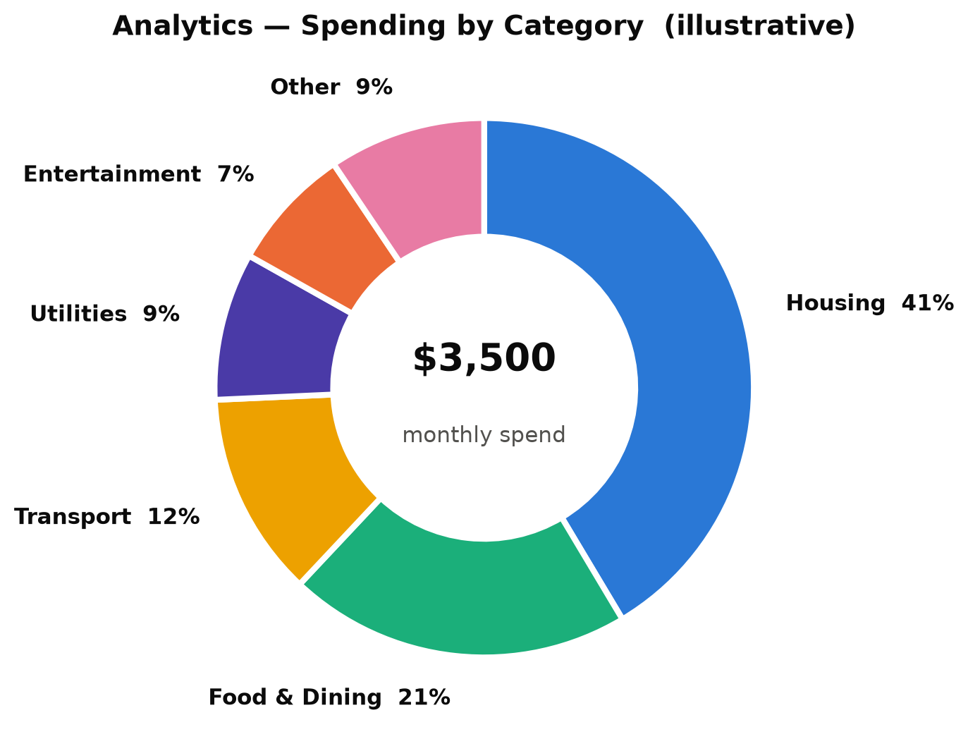
Figure — Example analytics output — monthly spending broken down by category.
5.12 Reports & Data Export
Users can export their data for taxes, sharing, or offline analysis in three formats, choosing between a raw transaction list and a summarised report.
Export | Format | Library | Contents
Transactions | CSV | PapaParse | Every transaction row for the selected range.
Transactions | Excel | ExcelJS | Formatted spreadsheet with typed columns.
Financial summary | PDF | jsPDF + autotable | Totals, category breakdown, and tables.
5.13 Notifications
An in-app notification centre plus a bell in the header keep the user informed of anything that needs attention.
● Budget-threshold alerts when spending nears or passes a limit.
● Goal-milestone alerts as savings targets are approached or met.
● Recurring-bill reminders for due and overdue bills (generated by a daily cron job).
● Four severities (Info, Success, Warning, Error); mark one or all as read; deep-link to the source.
5.14 Admin Panel
A separate, ADMIN-only console for operating the platform. Every admin page and API route is double-guarded.
▸ Capabilities
✔ User management — search users, change roles, and suspend / reactivate accounts.
✔ Platform analytics — user growth, activity, and aggregate platform metrics.
✔ Audit log — a searchable trail of admin actions (action, entity, IP address, metadata).
✔ System settings — maintenance mode, registration toggle, and other platform flags.
⚠ Every admin action is recorded
Sensitive operations write an AuditLog entry capturing who did what, to which entity, from which IP — providing accountability and an investigation trail.
5.15 Profile & Settings
Each user controls their own identity and app preferences.
● Edit profile name, image, and base currency.
● Change password (current-password verified; re-hashed with bcrypt).
● Light / dark theme toggle and an adjustable app-wide text size.
6 ⇄ API Surface

The platform exposes 40 REST route handlers, grouped by resource. Every mutating route runs the full security pipeline described in Section 3.

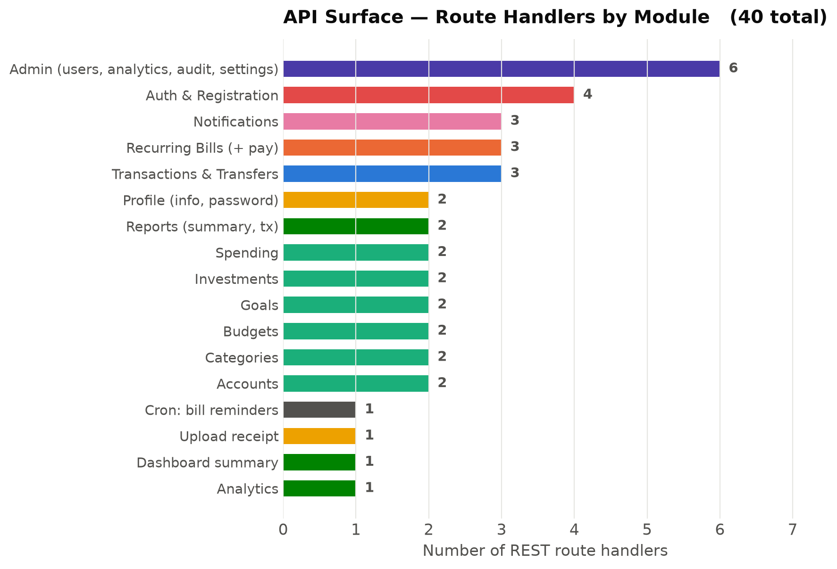
Figure — REST route handlers grouped by functional module (40 total).
Area | Representative endpoints | Methods
Auth | /api/register, /api/auth/forgot-password, /api/auth/reset-password | POST
Accounts | /api/accounts, /api/accounts/[id] | GET POST PATCH DELETE
Transactions | /api/transactions, /api/transactions/[id], /api/transfers | GET POST PATCH DELETE
Categories | /api/categories, /api/categories/[id] | GET POST PATCH DELETE
Budgets | /api/budgets, /api/budgets/[id] | GET POST PATCH DELETE
Recurring bills | /api/recurring-bills, /api/recurring-bills/[id]/pay | GET POST PATCH DELETE
Goals | /api/goals, /api/goals/[id] | GET POST PATCH DELETE
Investments | /api/investments, /api/investments/[id] | GET POST PATCH DELETE
Spending | /api/spending, /api/spending/[id] | GET POST PATCH DELETE
Dashboard / Analytics | /api/dashboard/summary, /api/analytics | GET
Reports | /api/reports/summary, /api/reports/transactions | GET
Notifications | /api/notifications, /api/notifications/read-all | GET PATCH
Profile | /api/profile, /api/profile/password | PATCH
Upload | /api/upload/receipt | POST
Admin | /api/admin/users, /api/admin/analytics, /api/admin/audit-log, /api/admin/settings | GET PATCH
Cron | /api/cron/bill-reminders | GET (secured)
7 🔒 Security Model

Because the platform holds financial data, security is layered rather than bolted on. The controls below apply across the whole application.
Control | How it is enforced
Input validation | Zod schema on every mutating request; invalid payloads rejected with 400.
Ownership checks | Every resource read/write confirms the row belongs to the requesting user.
Role gating | middleware.ts redirects, plus requireAdmin() inside each admin API handler.
Password security | bcrypt hashing at cost factor 12; hashes never returned in any response.
CSRF protection | SameSite=Lax session cookie + an Origin-header check on all mutations.
Rate limiting | Login, registration, and password-reset endpoints are throttled.
Security headers | A locked-down Content-Security-Policy and hardened header set.
Cron protection | CRON_SECRET guards the scheduled bill-reminder endpoint in production.
Audit trail | Admin actions are logged with actor, entity, IP address, and metadata.
🔒 Single security pipeline
Validation → authentication → ownership → persistence runs the same way for every mutating route, so no endpoint can accidentally skip a check.
8 ▦ Feature Summary Matrix

A one-glance map of every module, who uses it, and its core operations.
Module | Audience | Core operations | Ties into
Authentication | All | Sign in/up, reset, OAuth | Every route
Dashboard | User | Aggregate & health score | All finance data
Accounts | User | CRUD + archive | Transactions, health
Transactions | User | CRUD, transfer, receipts | Accounts, categories
Categories | User | CRUD + hierarchy | Transactions, budgets
Budgets | User | CRUD + progress | Categories, health
Recurring bills | User | CRUD, mark-paid, remind | Transactions, cron
Goals | User | CRUD + milestones | Notifications
Investments | User | CRUD + gain/loss | Dashboard
Quick spending | User | One-line capture | —
Analytics | User | Charts + date ranges | Transactions
Reports | User | Export CSV/Excel/PDF | Transactions
Notifications | User | Alerts, read state | Budgets, bills, goals
Profile | User | Edit, password, theme | Auth
Admin panel | Admin | Users, analytics, audit, settings | Audit log
9 ⚙ Appendix — Setup & Operations

▸ Getting started
● Install dependencies with pnpm install.
● Copy .env.example to .env and provide DATABASE_URL, DIRECT_URL, AUTH_SECRET, and NEXTAUTH_URL.
● Sync the schema with pnpm db:push, then seed sample data with pnpm db:seed.
● Start the dev server with pnpm dev and open http://localhost:3000.
▸ Key scripts
Script | Purpose
pnpm dev | Start the dev server (Turbopack).
pnpm build | Generate the Prisma client and build for production.
pnpm db:push / db:seed | Sync the schema / seed admin + demo + sample data.
pnpm test / test:e2e | Run the Vitest unit suite / Playwright end-to-end suite.
▸ Optional integrations
● Google / GitHub OAuth via AUTH_GOOGLE_* / AUTH_GITHUB_* credentials.
● Receipt uploads via a Vercel Blob store (BLOB_READ_WRITE_TOKEN).
● Real password-reset emails via SMTP_* / EMAIL_FROM (falls back to console logging).
● A daily Vercel Cron job hits /api/cron/bill-reminders (protected by CRON_SECRET).

— End of report —

