**Project 2. Web-based questionnaires for interviewing tinnitus patients.**

Enter and store data from patients’ interview questionnaires: Initial and Follow-up questionnaires (the templates of the paper form are available).

Implement requirements: 1.4, 1.4.1, 3.5, 1.11.3, 3.13.3.

Sample tables: Visit, Interview, Reference table: Problem.

**Requirement 1.4 - Interview Screen**

**Requirement 1.4.1 - Initial / Follow-up Interview Screen**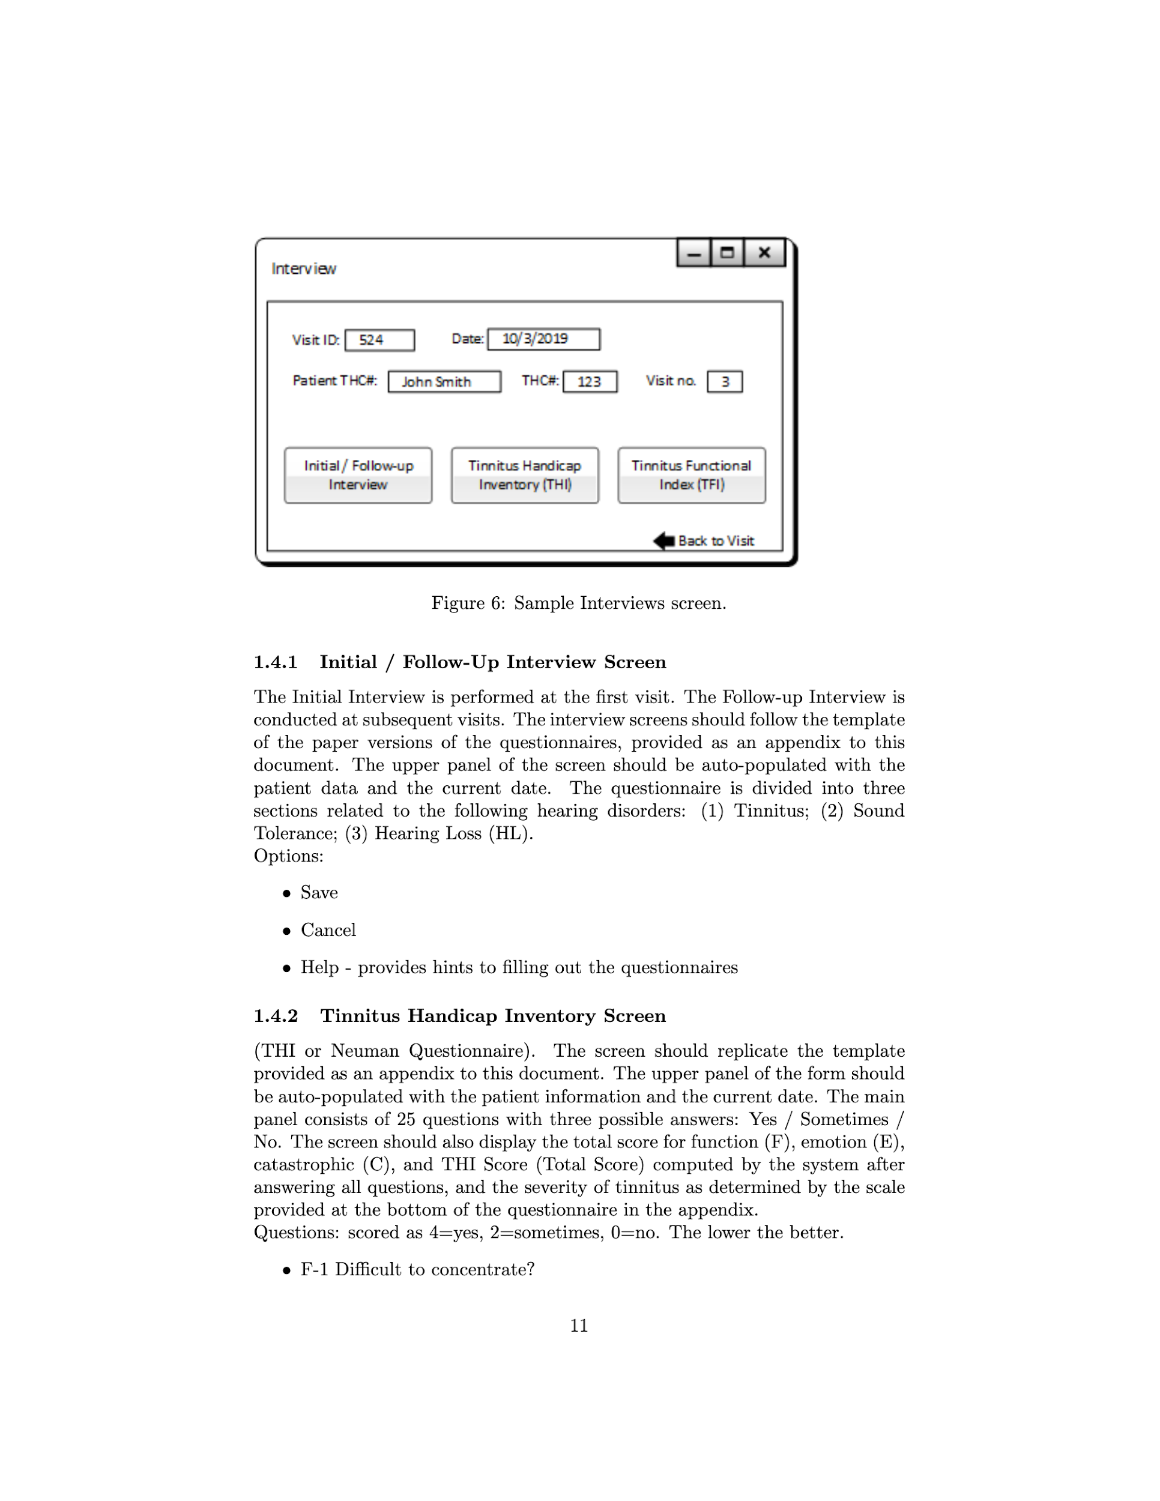

* Interview screen should follow the template of paper versions of the questionnaires (provided as an appendix to the professor’s document)
* Upper panel o screen should be auto-populated with patient data and current date
* Questionnaire is divided into three sections:
  + Tinnitus
  + Sound Tolerance
  + Hearing Loss
* Options:
  + Save
  + Cancel
  + Help - provides hints to filling out questionnaires

**Requirement 3.5 - Fill out Interview Form**

* The user performs Add New Visit
* The user chooses the option Add Interview
* The system opens the Interview screen
* The user chooses the option Initial / Follow-up Interview
* The user fills out the required information
* The user chooses option Save
* The system adds the interview data

**Requirement 1.11.3 - Medical Data**

* Add / Edit hearing problem:
  + Code (id)
  + Full name (ex. Tinnitus, hyperacusis, hearing loss)
  + Abbreviation (ex. T, H, L)
  + Description

**Requirement 3.13.3 - Add / Edit Medical Data**

* The user enters the Main Screen
* The user chooses option Other
* The system opens the Other screen
* The user chooses option Dictionary data
* The system opens the Dictionary data screen
* The user chooses the option Medical data
* The system opens the Medical data screen
* The user chooses the data item to add/edit and fills out/modifies the required information about the medical item
* The user chooses the Save option
* The user closes the screen

Variation #1: The user adds a new data item from the Interview screen.

1. The user performs Fill out Interview Form

2. Go to step 6.