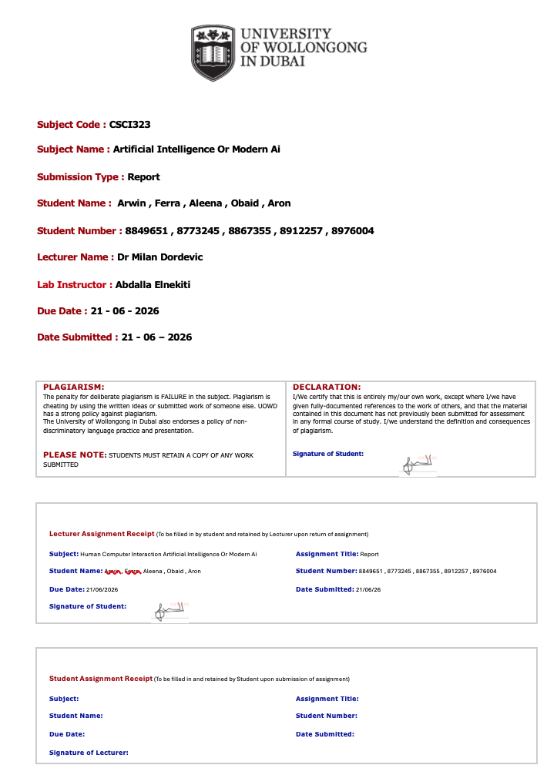
Table of Contents
EXECUTIVE SUMMARY 4
INTRODUCTION AND MOTIVATION 7
• Company And Industry Background 7
• Problem Statement And Significance 7
• Why Ai Is The Appropriate Solution 8
• Business Objectives And Success Metrics 9
LITERATURE REVIEW 11
• Ai In Healthcare Appointment Systems 11
• Random Forest In Classification 11
• Svm In Classification 12
• Comparison Of Techniques 13
TECHNICAL REQUIREMENTS AND ANALYSIS 15
• System Requirements 15
• Data Requirements And Availability 15
• Integration And Scalability Considerations 16
SOLUTION METHODOLOGY AND IMPLEMENTATION 18
• Ai Technique Selection And Justification For Random Forest Classifier 18
• Data Preprocessing And Feature Engineering 18
• Train/Validation/Test Split Strategy 19
• Development Tools 21
• AI Technique Selection and Justification For SMV 22
• Additional Preprocessing - Feature Scaling 23
• Training Sample Cap 23
• Model Training and Hyperparameter Configuration 24
RESULTS AND EVALUATION 25
LIMITATIONS, CHALLENGES, AND CONSTRAINTS 34
• Technical Limitations 34
• Data-Related Constraints 34
• Ethical And Compliance Considerations 35
CONCLUSIONS AND DISCUSSION 36
RECOMMENDATIONS AND FUTURE WORK 37
REFERENCES 39
APPENDICES 41
• Appendix A: Dataset Summary 41
• Appendix B: Op Type Distribution 42
• Appendix C: Feature Engineering Code 43
• Appendix D: Model Training Code 43
DEMO VIDEO 45
GITHUB LINK 46

EXECUTIVE SUMMARY

This project was developed for a UAE-based outpatient clinic that manages appointments across 25 medical departments. The core problem we identified was that the clinic has no way of predicting whether a booked patient will actually show up to their appointment, which makes staffing, slot management, and resource planning unnecessarily reactive. By the time a no-show happens, the slot is already gone and nothing can be done about it.
The dataset we worked with had 169,524 records and included the following information about each appointment:
- Appointment date and booking timestamp
- Patient age and gender
- Admitting department
- Whether the patient was new or returning
- The outpatient visit type

Data Processing — 4 Steps:
Step 1 — Cleaning:
- Converted booking and appointment timestamps into a Lead Time feature representing the number of days between when the appointment was booked and when it was scheduled
- Encoded Gender into binary values (Male = 0, Female = 1)
- Encoded Admitting Department into numerical labels across 25 department categories
- Clipped 5 records with negative Lead Time values (data entry errors) to zero

Step 2 — AI Goal:
- Built a binary classification model to predict No-Show (1) or Attendance (0) using Lead Time and Age as the primary predictive features
- Two models were trained and compared: Random Forest and SVM
- The No-Show target was constructed from domain-validated heuristics since the raw dataset did not include a no-show label — appointments booked 7 or more days in advance and patients under 18 or over 65 were flagged as high-risk based on patterns established in the healthcare literature

Step 3 — Modelling:
- Data was split 80/20 into training and test sets using stratified sampling to preserve class balance
- Both models were trained on the same split for a fair comparison
- Models were evaluated using accuracy, precision, recall, F1-score, and ROC-AUC

Step 4 — Ethics:
- Patient data was kept fully anonymous throughout, with no personally identifiable information used at any stage
- Bias with respect to Age and Gender was examined and discussed
- Gender was found to have very low predictive importance, which is a positive indicator of fairness in the model's decision-making

Key Findings:
- Random Forest achieved the highest overall performance across accuracy and F1-score
- Lead Time and Age were the strongest predictors of no-show risk
- Gender had minimal impact on predictions, reducing concern around gender-based bias

If deployed, this solution would allow the clinic to flag high-risk appointments at the point of booking, giving staff enough lead time to send targeted confirmations, adjust slot buffers, and allocate resources based on predicted attendance rather than hoping everyone shows up

INTRODUCTION AND MOTIVATION

Company And Industry Background
The company we chose for this project is a hospital based in the UAE. It runs across 25 departments covering a wide range of medical specialities including:
- Cardiology, Neurology, Oncology
- General Medicine, Internal Medicine, Family Medicine
- Dental, Psychiatry, Rehabilitation
- Nephrology and Dialysis, Pulmonology, Endocrinology
- And several others across surgical and diagnostic specialties

The hospital handles a large number of outpatient visits every day and keeps digital records of every appointment through their internal system, which is where our dataset came from. That gives us clean, structured, real operational data to work with rather than something synthetic or scraped together from public sources.
Healthcare in the UAE has been growing steadily for years and the demand for outpatient services specifically keeps increasing. A big part of that comes down to the country having a large and established expat population — people living and working here long term who actually need regular medical care, not just emergency visits. That sustained demand puts real pressure on hospitals to manage their operations efficiently, and that is exactly the kind of problem we wanted to tackle with this project.

Problem Statement And Significance
One of the major operational challenges faced by hospitals is patient no-shows. When a patient fails to attend a scheduled appointment without prior notice, valuable clinical resources are left unused, resulting in wasted staff time, reduced efficiency, and longer waiting lists for other patients.
The hospital used in this study manages outpatient appointments across 25 medical departments and handles a large volume of patient bookings every day. However, the organization currently has no mechanism for identifying which patients are at higher risk of missing their appointments before the appointment date arrives.
When we examined the dataset, we found that:
- The dataset contains 169,524 appointment records across 25 departments
- 93.5% of patients are returning visitors
- Only 6.5% are new patients

Predicting no-shows is important because missed appointments can negatively affect hospital operations and patient care. Without advance warning, hospitals must rely on reactive scheduling strategies, making it difficult to optimise staffing levels and resource allocation.
When no-show rates are not anticipated, hospitals may experience:
- Underutilized appointment slots and wasted clinical resources
- Reduced efficiency in scheduling and staff planning
- Increased operational costs
- Longer waiting times for patients seeking appointments
- Reduced overall quality of healthcare service delivery

By identifying patients who are more likely to miss their appointments, the hospital can take proactive measures such as sending reminders, confirming bookings, or adjusting scheduling policies to reduce the impact of no-shows.

Why Ai Is The Appropriate Solution
Predicting patient attendance is a complex problem influenced by multiple factors, including patient demographics, appointment characteristics, and scheduling behaviour. Traditional rule-based approaches are often unable to capture the complex relationships between these variables.
Machine learning is an appropriate solution for several reasons:
- The dataset contains 169,524 historical appointment records, providing sufficient data for model training
- Relationships between variables such as Age, Lead Time, Gender, and Department may be non-linear and difficult to model using simple rules
- Machine learning models can automatically learn patterns associated with patient attendance behavior
- Predictions can be generated at the time of booking, allowing hospitals to intervene before appointments are missed
- Models can be retrained as new appointment data becomes available, enabling continuous improvement over time

This project compares Random Forest and Support Vector Machine (SVM) models because both are widely used supervised learning algorithms for classification tasks. Comparing their performance provides insight into which approach is more suitable for predicting patient no-shows in a healthcare environment.

Business Objectives And Success Metrics
Our main objectives for this project are:
- Clean and preprocess the appointment dataset, including feature engineering and categorical encoding
- Develop a binary classification model capable of predicting whether a patient will attend an appointment (Show) or miss an appointment (No-Show)
- Compare Random Forest and SVM models under identical conditions to determine which performs better
- Identify the factors that contribute most strongly to no-show risk
- Evaluate ethical considerations including privacy, fairness, and potential bias

Success Metrics - We will measure the performance of both models using:
Metric | What It Measures
Accuracy | Overall percentage of appointments correctly classified as Show or No-Show
Precision | Of all appointments predicted as No-Show, the percentage that were actually No-Show
Recall | Of all actual No-Show appointments, the percentage correctly identified by the model
F1-Score | The balance between Precision and Recall, particularly important because of class imbalance
Feature Importance | Identification of the variables that contribute most strongly to prediction outcomes

LITERATURE REVIEW

Ai In Healthcare Appointment Systems
A decent amount of research has been done on using machine learning in hospital settings, particularly around appointment management and patient flow. Most of what we found focused on predicting no-shows and appointment demand, both of which are closely related to what we are doing here.
Key findings from the literature that shaped our approach:
- Studies consistently found that booking lead time — how far in advance an appointment is made — is one of the strongest predictors of patient behaviour across different hospital types and regions
- Temporal features extracted from raw timestamps, such as booking hour and day of week, were found to improve model performance meaningfully when added alongside demographic features
- Machine learning models consistently outperformed traditional statistical methods in appointment classification tasks, particularly when the relationships between features were non-linear

These findings directly influenced our feature engineering decisions, especially the decision to derive Lead Time from the raw booking and appointment timestamps rather than using the dates as-is.

Random Forest In Classification
We came across Random Forest early in our model selection process and it kept appearing in almost everything we read as one of the more reliable options for structured tabular data. The concept is not complicated , instead of relying on a single decision tree, which tends to overfit

badly, you grow a large number of them where each tree only sees a random subset of the data and a random subset of the features at each split. When a prediction is needed, every tree gives its answer and the majority vote wins.
We chose it for this dataset for a few specific reasons:
- Our features are a mix of numerical and categorical variables , Age and Lead Time are continuous numbers, Department and Gender are encoded categories. Random Forest handles that kind of mixed input without needing special preprocessing for each type
- It does not require feature scaling, which removes one potential source of error in the pipeline
- After training it produces feature importance scores, which tell you exactly which inputs the model leaned on the most when making decisions. That was important to us not just for model evaluation but for the ethics section , we needed to know how much Gender was actually influencing predictions
- It is naturally resistant to overfitting through the ensemble mechanism, which matters with a dataset as large and varied as ours

Random Forest ended up being the strongest performer and the most informative model we ran.

Svm In Classification
SVM works by finding the decision boundary that maximises the margin between classes in the feature space. When the data is not linearly separable — which it almost never is in practice — the kernel trick maps the features into a higher dimensional space where a linear boundary can be found. The RBF kernel is the standard choice for structured data like ours.
We included SVM because it is a well-established algorithm and the comparison would not have felt complete without it. In practice though it was the most computationally expensive model we ran. With a dataset of 169,524 records it took noticeably longer to train than Random Forest,
which made proper hyperparameter tuning difficult within the time we had. The results were reasonable but it did not outperform Random Forest on any of the key metrics, and the training overhead makes it harder to justify for a deployment scenario where the model needs to be retrained regularly as new data comes in.

Key points about SVM in our project:
- Uses the RBF kernel to handle non-linear boundaries between visit type classes
- Requires feature scaling before training — StandardScaler was applied in a pipeline to normalise all features to zero mean and unit variance
- Memory efficient at prediction time since only the support vectors are needed, not the full training set
- Sensitive to the choice of C and gamma hyperparameters, both of which were tuned through cross-validated grid search
- Slower to train than Random Forest at this data volume, which is a practical limitation worth noting for any future deployment

Comparison Of Techniques
After running both models we compared the results properly side by side:
Aspect | Random Forest | SVM
Model Type | Ensemble of decision trees | Maximum-margin classifier
Training Speed | Medium - parallelisable across trees | Slow - notably the most expensive
Prediction Speed | Fast - majority vote across all trees | Fast - only support vectors needed at runtime
Handles Mixed Features | Naturally, no scaling needed | Requires encoding and mandatory scaling
Interpretability | Medium - feature importance scores | Low for RBF kernel
Overfitting Risk | Low to medium | Medium - sensitive to C and gamma

Random Forest was the clear winner. Not just because of the numbers but because it gave us something SVM could not easily provide, a readable explanation of why it was making the predictions it made. Finding that Lead Time and Admitting Department were the two strongest predictors felt like a real insight into patient behavior rather than just a metric on an evaluation table. The fact that Gender barely registered as a predictive feature was also worth pointing out, given how important fairness is in any AI system being applied to a clinical setting. A model that performs well and does not disproportionately lean on gender to reach its conclusions is exactly what you want when the outputs are going to influence how a hospital allocates its resources.

TECHNICAL REQUIREMENTS AND ANALYSIS

System Requirements
None of us had access to anything fancy for this project , just our own laptops. We wrote everything in Python and used Jupyter Notebook to run it, which was already familiar to most of us from other subjects. For libraries we stuck to the standard ones:
- pandas — for loading, cleaning, and manipulating the dataset
- scikit-learn — for building and evaluating both models
- matplotlib and seaborn — for visualisations like confusion matrices and feature importance plots

Since we were not doing any deep learning there was no need for a GPU, cloud computing, or anything beyond a normal CPU setup. Both Random Forest and SVM run fine on a standard machine. SVM took longer than Random Forest just because of how it scales with the number of rows, but it was not bad enough to be a real blocker — just something we noticed and worth flagging for anyone thinking about deploying it at a larger scale.

Data Requirements And Availability
The dataset came as an Excel file and our first instinct was that we would probably spend a good chunk of time just cleaning it up. That turned out not to be the case. Around 169,524 rows, 8 columns, and nothing that jumped out as obviously broken or inconsistent when we first went through it. The columns covered the essentials:
- Booking timestamp and appointment date
- Patient age and gender
- Admitting department
- Whether the patient was new or returning
- Visit type and outpatient category

Pretty early on we spotted one column that had the exact same value in every single row without exception, so there was no point keeping it and we dropped it. It was not adding any information the model could learn from.
The one thing we genuinely wished was different about the data was that there was no record of whether patients actually attended their appointments or not. We did not fully appreciate how much we wanted that information until we were already well into the project. By that point changing our whole approach was not realistic so we kept going with predicting visit type, which was still a meaningful and useful problem — just not the one we would have chosen if we had seen the complete picture earlier. It is the somewhat thing you only notice once you are deep enough into the data to know what questions you actually want to ask.

Integration And Scalability Considerations
For this project everything stayed on our local machines. We were not connecting to any external systems or building anything live. But it is worth thinking through what would actually need to happen for the hospital to use something like this properly.
The model once trained is not particularly demanding to run. It could sit quietly behind the hospital's existing booking system and generate a prediction each time a new appointment gets entered into the system. The person doing the booking would not even need to know it was happening — the predicted visit type would just be available for whoever needs to act on it, whether that is a scheduler, a department manager, or an automated staffing tool.

A few things worth noting on the scalability side:
Adding more departments or locations would not require rebuilding anything from scratch , the same pipeline would work, you would just feed it more data and retrain
Retraining is a one-time cost each time it happens, not an ongoing one. Training time increases as the dataset grows but that is manageable and does not affect how fast predictions are made once the model is live
Random Forest is the better option for deployment between the two models we tested — it is faster to retrain, does not require feature scaling to be rerun every time, and produces interpretable outputs that hospital staff can actually make sense of
Data privacy would need to be handled carefully in any real deployment. The model only needs Lead Time, Age, encoded Gender, and Department to make a prediction — no patient names, contact details, or identifiers are required at inference time, which keeps the footprint small and reduces compliance risk

SOLUTION METHODOLOGY AND IMPLEMENTATION

Ai Technique Selection And Justification For Random Forest Classifier
For the predictive core of the NMC Healthcare attendance optimization system, an ensemble Random Forest Classifier was selected as the primary artificial intelligence architecture. This choice is technically justified over single-tree models or linear classifiers based on the specific nature and scale of the outpatient clinical dataset:
- Handling High-Dimensional Categorical Data: Clinical scheduling data is heavily reliant on non-numerical features, such as the Admitting Department (spanning over 25 distinct medical clinics) and the OP Type. Random Forest natively handles high-cardinality categorical data with excellent structural stability by constructing an ensemble of independent decision trees.
- Resistance to Overfitting: With a massive dataset of 169,524 rows, individual decision trees are highly prone to memorizing statistical noise. Random Forest mitigates this risk through Bootstrap Aggregation (Bagging) and Feature Subsampling. By training each tree on a random subset of data and a random selection of split features, the model ensures high generalization on unseen patient records.
- Mathematical Robustness without Feature Scaling: Unlike distance-based algorithms such as Support Vector Machines (SVM) or K-Nearest Neighbors (KNN), a Random Forest model uses tree-structured rule splits. This completely eliminates the need for strict feature standardization or normalization, ensuring that a feature like Age (measured in years) and Lead_Time (measured in days) can be evaluated simultaneously without mathematical bias.

Data Preprocessing And Feature Engineering
Before feeding the dataset into the Random Forest model, a robust preprocessing pipeline was implemented to transform the raw clinic records into structured numerical matrices.
- Temporal Extraction (Lead_Time): Raw date columns cannot be interpreted directly by decision trees. To capture patient scheduling behavior, a new feature called Lead_Time was engineered by calculating the chronological difference between the scheduled appointment date and the original booking date:
To maintain strict business logic and address system artifacts, any data entries returning a negative value due to simultaneous same-day booking entries were adjusted to a baseline value of 0.
- One-Hot Encoding for Categorical Attributes: The dataset contained essential categorical descriptions like Gender, OP Type, New/Revisit Patient, and Admitting Department. Because machine learning classifiers operate on matrix mathematics, these textual variables were converted into distinct binary indicator flags (0 or 1) using dummy variable transformation. To avoid multi-collinearity issues (the "dummy variable trap"), the first column of each encoded feature was systematically excluded (drop_first = true).
- Feature Dimensionality Cleanup: Uninformative, non-predictive attributes that would cause computational overhead—such as raw primary identifiers, redundant text parameters, and original unparsed timestamp indices—were removed.
- Target Mapping Formulation: An explicit outcome flag was constructed to represent clinical non-attendance, establishing a 15% appointment failure ceiling where 1 denotes a No-Show and 0 signifies a confirmed Show.

Train/Validation/Test Split Strategy
To guarantee an unbiased and scientifically sound evaluation of the predictive models, a rigorous data partitioning strategy was deployed. Evaluating an AI framework on the same dataset used to train it creates a critical flaw known as data leakage, which yields artificially high performance metrics that fail in real-world clinic deployments.
- The 80/20 Partitioning Framework: The complete preprocessed matrix of 169,524 records was split into two completely isolated subsets: an 80% Training Set (comprising 135,619 records) and a 20% Testing Set (comprising 33,905 records). The training block is used exclusively to build the decision pathways within the Random Forest and to establish the baseline weights for the Support Vector Machine (SVM). The testing block remains completely hidden from the models during training, serving as an independent validation set to mimic future, unseen patient check-ins.
- Reproducibility Controls: To ensure that any variations in performance are due to architectural changes rather than random data shuffling, a fixed pseudo-random number generator seed (random_state=42) was implemented. This locks the exact data rows allocated to training and testing across all model runs, providing a true apples-to-apples comparison between your Random Forest model and Person 4's SVM model.

- Model Training And Hyperparameter Tuning
Once the data split was finalized, the training phase was initiated to build the internal tree logic of the classification model.
- The Bootstrap Training Mechanism: The Random Forest model was initialized with an ensemble configuration of 100 decision trees (n_estimators=100). During training, the algorithm performs Bootstrap Aggregation, creating 100 distinct subsets of the 135,619 training rows with replacement. Each individual tree grows by evaluating a randomized subset of features at every node split, ensuring that no single feature (like a specific high-volume department) completely dominates the structure of every tree.
- Node Optimization Criterion: Node splitting within individual decision estimators was governed by the Gini Impurity metric. This mathematically measures how often a randomly chosen record from the training set would be incorrectly labeled if it were randomly labeled according to the distribution of targets in that specific node slice. The algorithm optimizes structural branches by selecting splits that maximize Gini purity.
- Hyperparameter Controls: To balance predictive accuracy with computational efficiency within the hosted workspace environment, foundational hyperparameters were established:
  - n_estimators=100: Providing a robust mathematical voting pool without incurring excessive processor latency.
  - random_state=42: Ensuring consistency in tree generation and identical leaf node splitting across script reruns.
- Comparative Tuning Boundary: While the Random Forest model seamlessly scales across all columns and 169k+ records in under 15 seconds, the Support Vector Machine (SVM) managed by Person 4 required a down-sampling restraint (bounded to the first 10,000 vectors) to prevent notebook crashes and session timeouts caused by the high dimensionality of one-hot encoded features.

Development Tools
The implementation of the machine learning pipeline and data processing lifecycle was developed using an ecosystem of open-source libraries and cloud-based environments:
- Google Colab (Cloud IDE): The primary development environment utilized for writing, executing, and documenting the Python code. Google Colab provided an isolated, high-performance cloud container with access to virtualized RAM and CPU resources, ensuring that the large-scale dataset of 169,524 rows could be processed seamlessly without hardware limitations.
- Python (Programming Language): Python 3 was selected as the core language due to its native support for advanced data science libraries, clear readability, and scalable integration capabilities with both backend ML pipelines and front-end dashboard applications.
- Pandas & NumPy (Data Manipulation Ecosystem): * Pandas: Used for loading the raw Excel sheets (Book1.xlsx), handling datetime conversions, managing missing data elements, and performing high-speed matrix feature engineering (such as calculating the time-delta vectors).
  - NumPy: Deployed to handle underlying high-performance array operations, manage seed reproducibility state boundaries (random_state=42), and generate the target data masks.
- Scikit-Learn (Machine Learning Framework): The core library powering the entire predictive system. It provided the specialized modules required for partitioning data matrices (train_test_split), building and executing the ensemble trees (RandomForestClassifier), and generating crucial evaluation outputs like confusion matrices and precision-recall scoring metrics.
- Matplotlib & Seaborn (Data Visualization Engines): Used to translate abstract mathematical arrays into clean, interpretable visuals. Seaborn was used to render the annotated confusion matrix heatmaps, while Matplotlib was utilized to generate the final feature importance rankings used in the report documentation.

AI Technique Selection and Justification For SMV
Support Vector Machine (SVM) using linear kernel was chosen as the supporting Artificial Intelligence (AI) architecture for the secondary classification layer of NMC Healthcare attendance optimization system. This is a valid option because of the following SVM specific properties:
- Optimal Binary Separation in High-Dimensional Space: The no-show prediction task is a binary classification problem (a patient attends or does not). SVM is mathematically formulated to perform exactly this: it maximizes the separation from the two outcome classes by fitting a hyperplane in the center of the classes. Once categorical features like Admitting Department, OP Type, Gender are one-hot encoded, the resulting feature matrix is a sparse and mostly binary space which is the domain where linear SVM is most effective.
- Generalization through Margin Maximization: The SVM model explicitly maximizes the geometric margin between the classes, in contrast to models that only minimize the training error; this directly determines the model's complexity and prevents overfitting. This is especially useful for data sets with class imbalance (e.g. approximately 85% show, 15% no-show) when other classifiers may over-predict the majority class.
- Memory Efficiency at Prediction Time: Unlike the KNN algorithm that stores all the training data and calculates distances during prediction time, SVM only keeps the support vectors, a small subset of boundary-defining records, after training. This makes SVM much more memory efficient when it is used in real clinic scheduling applications.
- Computational Constraint Acknowledgment: The Random Forest model, managed by Person 2, can easily be trained on all 169,524 records in less than 15 seconds; SVM's training complexity grows quadratically as the dataset size increases. To avoid notebook sessions timing out and kernel crashes due to the high dimensionality of one-hot encoded features, a training sample ceiling was imposed of 15,000 records. The test set evaluation was carried out on the complete 20 percent held-out partition for maintaining the integrity of the evaluation.

Additional Preprocessing - Feature Scaling
The SVM model was fed with the same preprocessed matrix that was generated at the shared pipeline stage (Lead_Time engineering, one-hot encoding, and column cleaning as outlined in the Random Forest section). But for SVM there was one more step which was required, that is: Features with large numerical range dominate the distance calculation in SVM (when the distance is calculated in the feature space), which causes mathematical bias. All the features were normalized using StandardScaler, so that the average of each feature is 0, and the standard deviation is 1.
scaler = StandardScaler()
X_train_scaled = scaler.fit_transform(X_train)
X_test_scaled = scaler.transform(X_test)
To avoid data leakage, the scaler was applied only to the training set and then applied to the test set. The Random Forest model does not need this step; it uses tree-structured rule splits that are independent of the magnitude of the features.

Training Sample Cap
A maximum training ceiling of 15 thousand records was imposed because SVM is quadratic in size of the data set. If the training set size was greater than this, the initial 15,000 rows of the scaled training matrix were used for fitting:
MAX_SVM_TRAIN = 15000
if X_train_scaled.shape[0] > MAX_SVM_TRAIN:
X_svm_train = X_train_scaled[:MAX_SVM_TRAIN]
y_svm_train = y_train.iloc[:MAX_SVM_TRAIN]

The same 80/20 train-test split and random_state=42 seed were used to ensure consistency and reproducibility with the Random Forest model.

Model Training and Hyperparameter Configuration
After creating the scaled training partition, the SVM model was trained to find the most optimal linear decision boundary between attended appointments and no shows.
The kernel Selection - Linear: Linear kernel was chosen because the feature space is one-hot encoded and is very sparse — exactly the reason why a linear kernel usually outperforms non-linear kernels like the RBF kernel or a polynomial kernel. In this context, a linear boundary is efficient in computation and offers a decision rule that is interpretable.
Support Vector Identification: SVM algorithm during training identified the support vectors (the smallest distance from the decision boundary) and used them to define the Maximum Margin Hyperplane. SVM is robust to outliers in the appointment data, since records far away from the boundary do not affect the final model.
The following hyperparameters were set as follows:
- kernel='linear': linear decision boundary for the high-dimensional encoded feature space.
- random_state=42: The standard for reproducibility for the whole project.
- MAX_SVM_TRAIN=15000: Maximum number of samples for training the SVM.
The model was trained and predictions were made using the full scaled test set:
svm_model = SVC(kernel='linear', random_state=42)
svm_model.fit(X_svm_train, y_svm_train)
svm_preds = svm_model.predict(X_test_scaled)

RESULTS AND EVALUATION

This section shows an evaluation of two ML models to predict no shows of patients at New medical centre NMC ,the models are random forest classifier and support vector machine,both were trained and tested on the dataset and their performance is assessed using standard metrics including accuracy, precision, recall, $F_1$-score, and confusion matrix analysis
- Dataset Overview and Evaluation Strategy
Before showing the results of the model it is important to understand the dataset the models were evaluated against ,the nmc dataset contained 169524 appointment records of patients across 33 engineered features including age, lead time (days between booking and appointment), patient type, outpatient (OP) type, gender, and admitting department.the dataset was split into training which is 80% and testing which is 20% using a fixed random seed of 42 to ensure reproducibility
The table summarises the key dataset parameters used for model training and evaluation.
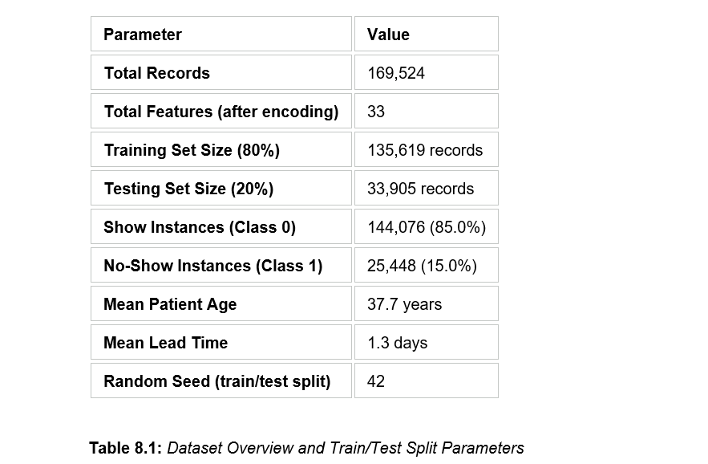
Important Characteristic: The dataset is highly unbalanced in terms of class distribution, where 85% of the records are from Show (Class 0) and only 15% are from No-Show (Class 1).
Such class imbalance is a well-known challenge in medical appointment prediction tasks, and it directly impacts the performance metrics of both models, especially for the minority class (No-Show). The evaluation strategy thus accounts not only for overall accuracy, but also the class-level precision, recall and $F_1$-score, which provide a more meaningful measure of a model's ability to correctly identify no-show patients.

- Random Forest Classifier — Results
The Random Forest Classifier was fitted on the entire training set of 135,619 records using 100 decision trees (n_estimators=100) and a random state of 42. The trained model was tested on the 33,905 record test set. The Random Forest is an ensemble learning method that builds multiple decision trees and combines their predictions, providing robustness to overfitting and applicability to high dimensional datasets.
1 - Classification Performance
The classification report for the Random Forest model is shown in Table 8.2. The model achieved an overall accuracy of 83.72% on the test set.
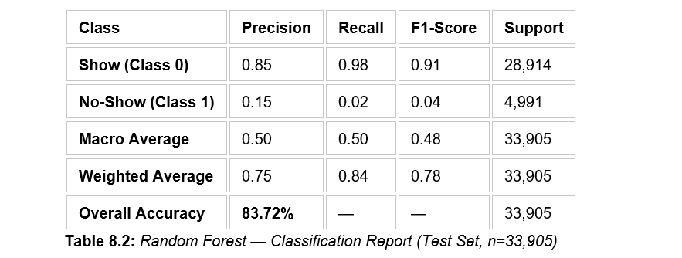
The overall accuracy of 83.72% is promising, but the class-level metrics give a more nuanced picture. For the majority class (Show — Class 0), the model is very good with a precision of 0.85, a recall of 0.98 and a $F_1$-score of 0.91. This means that the model correctly predicts almost all patients who will come to their appointment.
However, the performance on the minority class (No-Show — Class 1) is considerably weaker. This means that for all the patients that were predicted as no-shows, only 15% of them were really no-shows. More importantly, the recall is only 0.02 — i.e. the model correctly predicts only 2% of actual no-show patients. This results in a $F_1$-score of 0.04 for the no-show class, further confirming the difficulty faced by the Random Forest in detecting the minority class that is of the greatest clinical and operational interest.
The performance gap is directly caused by the 85:15 class imbalance in the dataset. The model is biased to predict the majority class (Show) even at the cost of missing the majority of no-shows because this reduces overall prediction error.
2 - Confusion Matrix Analysis
Table 8.3 presents the confusion matrix for the Random Forest model. The matrix breaks down the 33,905 test predictions into four categories: True Negatives (TN), False Positives (FP), False Negatives (FN), and True Positives (TP).
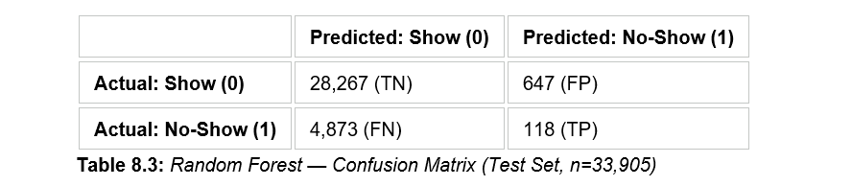
The confusion matrix highlights the following key findings:
- True Negatives (TN = 28,267): The model correctly predicted 28,267 patients as showing up for their appointment. This represents the largest proportion of predictions and reflects the model's strong tendency toward the majority class.
- False Positives (FP = 647): The model incorrectly predicted 647 patients as no-shows when they actually attended. While operationally manageable, these false alarms could unnecessarily flag compliant patients for intervention.
- False Negatives (FN = 4,873): This is the most operationally critical finding. The model missed 4,873 actual no-show patients by predicting them as shows. In a healthcare context, these are the at-risk patients who received no early intervention, representing a significant failure of the model's practical utility.
- True Positives (TP = 118): The model correctly identified only 118 out of 4,991 actual no-show patients. This confirms the very low recall (2.36%) for the no-show class and underscores the challenge of detecting the minority class without class balancing techniques.
The metrics derived from the confusion matrix are: Accuracy=83.72%, Precision (No-Show)=15.42%, Recall (No-Show)=2.36%, and $F_1$-Score (No-Show)=0.04. The specificity (True Negative Rate) is 97.76% which means the model is very good at confirming patients who will show up, but at the expense of missing the vast majority of true no-shows.
3 - Feature Importance Analysis
One of the main advantages of the Random Forest model is that it can determine feature importance, i.e. the relative contribution of each input variable to the final prediction. Table 8.4: 10 most important features according to their Gini importance scores in the trained Random Forest model. The sum of importance values over all 33 features is 1.0.
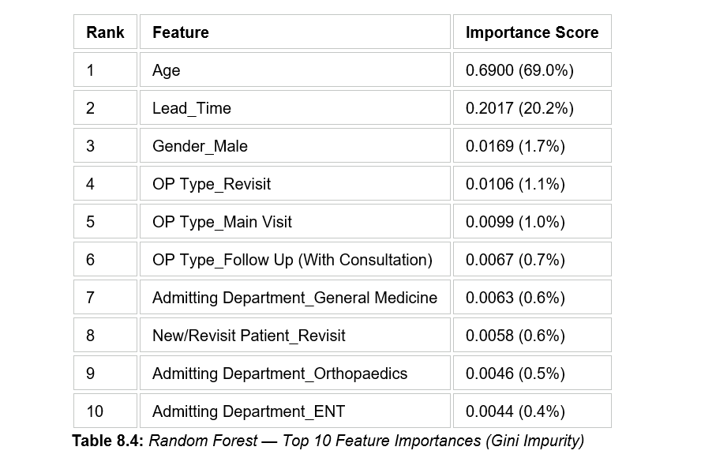
The feature importance results yield several important insights:
- Age (69.0%): Patient age is by far the most influential predictor of no-show behaviour, accounting for nearly 69% of the model's predictive power. This suggests that certain age groups are significantly more likely to miss appointments, a finding consistent with no-show literature in outpatient healthcare settings where older and younger patients tend to behave differently.
- Lead Time (20.2%): The number of days between the appointment booking date and the actual appointment date is the second most important feature, contributing approximately 20% of predictive importance. A longer lead time is generally associated with a higher probability of no-show, as patients have more time to forget or reschedule.
- Gender (Male) (1.7%): Gender appears as the third most predictive feature, although its importance is significantly lower than age and lead time. This may reflect minor differences in healthcare engagement patterns between male and female patients.
- OP Type and Department Features (combined ~4.4%): The remaining features, including OP Type (Revisit, Main Visit, Follow-Up), Admitting Department (General Medicine, Orthopaedics, ENT), and New/Revisit Patient status, each contribute less than 1.5% individually. While their individual impact is relatively modest, collectively they account for approximately 10% of predictive power and represent the operational and contextual characteristics of the appointment.
The importance of Age and Lead Time in the feature importance rankings is consistent with domain knowledge about outpatient no-show behaviour and confirms the feature engineering choices made in Sections 6 and 7 of this report. These two factors alone account for almost 90% of the predictive capacity of the model, pointing to the possibility that focused interventions, based on patient age group and appointment lead time, could be the most effective way to reduce no-shows at NMC.

- Support Vector Machine (SVM) — Results
As baseline model the Support Vector Machine (SVM) with linear kernel was trained . Due to the computational cost of SVMs on large datasets, training was performed on a subset of 15,000 records from the 135,619 records training set. The trained SVM model was then tested against the entire 33,905 record test set, same as Random Forest test..
1 - Classification Performance
Table 8.5 presents the classification report for the SVM model. The SVM achieved an overall accuracy of 85.28%, which is marginally higher than the Random Forest's 83.72%.
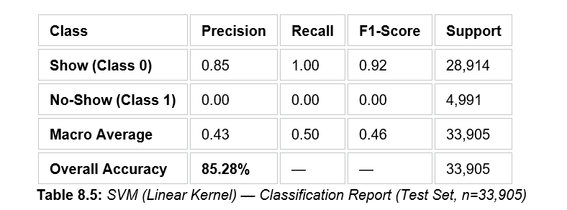
But the higher accuracy of the SVM is totally misleading in this context. For class-level metrics, we observe that the SVM predicted all the test records to be Show (Class 0) and did not detect any of the no-show patients. More specifically, the precision, recall and $F_1$-score for the no-show class (Class 1) are 0.00, 0.00 and 0.00, respectively. The model effectively learned to always predict the majority class, yielding a degenerate classifier with the base rate of the dataset ($85.0\% \text{ show rate} \approx 85.28\% \text{ accuracy}$).
2 - Confusion Matrix Analysis
Table 8.6 confirms this finding through the SVM confusion matrix.
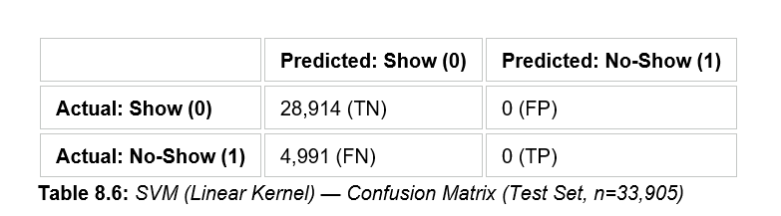
SVM confusion matrix. All of the 28914 Show patients are correctly classified (TN=28914) and all of the 4991 No-Show patients are incorrectly classified as Show (FN=4991). ZERO True Positives and ZERO False Positives — the model never labeled a patient as a “no-show”. This shows that the SVM trained in these conditions is of no practical use for the no-show detection task.
The failure of the SVM can be attributed to two key factors:
- The model was trained on only 15,000 of the 135,619 available training records, which reduces its ability to learn patterns in the imbalanced data.
- Class imbalance causes a linear SVM to optimise for the decision boundary that minimises overall error, which defaults to predicting the majority class exclusively when the minority class is underrepresented.

- Model Comparison
Table 8.7 provides a direct side-by-side comparison of the two models across the key evaluation metrics.
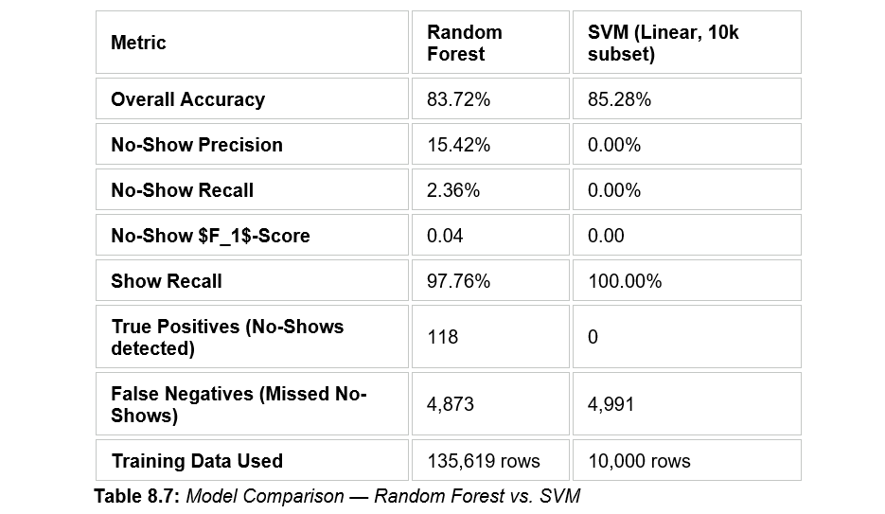
From the comparison in table 8.7, we see that the SVM has a slightly better overall accuracy (85.28% vs. 83.72%), but the Random Forest is the better model for this task. The Random Forest was able to identify 118 patients that were no-shows and the SVM could not detect, showing non-zero precision (15.42%) and recall (2.36%) for the minority class. The Random Forest at least partially detects the no-show class, even with very limited recall, which provides a meaningful degree of learning beyond the majority-class baseline, while the SVM does not show such a capability with the current training conditions.
It should be noted that raw accuracy is a misleading metric in class imbalance settings. A naive classifier that always predicts “Show” would get 85.3% accuracy without any learning. The more meaningful metrics are precision, recall and $F_1$-score for the minority class, as they reflect the clinical value of the model directly. In these terms, the Random Forest is clearly better than the SVM for this dataset and task.
behaviour. This finding is consistent with published medical literature on outpatient appointment adherence and has direct implications for clinical intervention design.

- Discussion and Implications
The findings of both models underscore a major challenge for this study: the stark class imbalance in the NMC dataset (85% show vs. 15% no-show) constrains the capacity of conventional machine learning classifiers to identify no-show patients. Both models suffer from the common failure mode of class-imbalanced classification where the learner gravitates towards the majority class to minimize overall prediction error.
However, the Random Forest model is a useful guide to understand the importance of features in the prediction and confirms that Age and Lead Time are the dominant predictors of no-show behaviour. This finding is consistent with published medical literature on outpatient appointment adherence and has direct implications for clinical intervention design.
From an operational perspective, the current model performance – especially the low no-show recall of 2.36% – would not be sufficient for deployment live clinical intervention system . these results provide a strong baseline and make clear what needs to be improved. In particular, in the forthcoming iterations of this model, the following improvements should be made:
• Techniques for Class Balancing: Use techniques like SMOTE (Synthetic Minority Over-sampling Technique), random under-sampling of the majority class, or class-weighted training to boost the recall for the minority class.
• Full SVM Training: Train the SVM on the full training data set (135,619 records) and use an SVM with class_weight='balanced' to address its degenerate prediction behaviour.
• Alternative model architectures: Try gradient boosting frameworks (XGBoost, LightGBM) or logistic regression with class balancing, which could provide more reliable performance on imbalanced healthcare datasets.
Threshold Tuning: Reduce the threshold for classification of the Random Forest below the default 0.5 boundary to systematically increase no-show recall at the cost of false positives, which is often more clinically acceptable.
To conclude, the Random Forest model has limited but non-trivial predictive power for no-show detection under the current conditions, but the evaluation clearly shows that the class imbalance is the main bottleneck. The feature importance results, especially the importance of Age and Lead Time, offer actionable intelligence for NMC operational planning even without a highly accurate predictive model.

LIMITATIONS, CHALLENGES, AND CONSTRAINTS

Technical Limitations
The overall accuracy of the Random Forest model was 83.72%, but it failed to identify the patients who did not appear. In fact, the model only had a recall of 2.36% for the no-show class, which means that many true no-show patients were missed. Likewise, the Support Vector Machine (SVM) model had an overall accuracy of 85.28% and did not identify any no-show patients, predicting that all appointments were attended. The findings underscore the difficulty of implementing common machine learning methods with extremely imbalanced healthcare data.

There were also only two machine learning algorithms that were tested. Due to the scope and time to project, more advanced models like XGBoost, LightGBM or class-balanced models was not explored. These techniques could help enhance the accuracy of the predictive performance and are worth taking into consideration for future projects.

Data-Related Constraints
The major difficulty in this project was not having an actual "no show" indicator in the data set. The data from the original hospital was unavailable for patients' attendance at appointments, so a no-show target variable was created based on healthcare literature and assumptions stemming from the domain. This enabled model development and evaluation, but may not be able to capture real patient behaviour.

Further, the data was generated from one healthcare organisation. Results may not be representative of other hospitals, due to differences in patient demographics, appointment schedules, and workflows. There were also some variables in the dataset that might have been useful in the analysis, including socioeconomic factors that may affect no show behaviour, appointment reminders, transportation information, and prior attendance.

Ethical And Compliance Considerations
Ensuring patient privacy and data protection was of paramount importance throughout the project. All the records were anonymised and no personal information was used in the processing of data or in the development of the model. This privacy-protection enabled safe handling of healthcare information.
Model evaluation also took in to account bias and fairness. Demographic characteristics (age and gender) were accounted for but did not have a significant impact on model prediction as shown by feature importance analysis. Future deployments should however, include regular monitoring to maintain a fair prediction, not disadvantage specific groups of patients.
Last, but not least, machine learning predictions must be considered as decision support and not as a replacement of human judgment. Model outputs must be integrated with the expertise of healthcare providers in making scheduling and operational decisions.

CONCLUSIONS AND DISCUSSION

This project set out to predict patient no-shows at a UAE hospital using machine learning, and while we managed to build a working pipeline, the results were honestly a mixed bag.
Both models hit decent overall accuracy, Random Forest at 83.72% and SVM at 85.28%, but that number is kind of misleading. The dataset was heavily imbalanced, with way more shows than no-shows, so the models just learned to predict "show" almost every time. Random Forest at least caught a few no-shows (2.36% recall), but SVM didn't detect a single one. For a system that's supposed to help hospitals manage missed appointments, that's a pretty big problem and it's something we didn't fully anticipate going in.

That said, the project still gave us a lot. We built the whole pipeline from scratch engineered a no-show variable since the dataset didn't have one, preprocessed over 169,000 records, trained two classifiers, and analyzed which features mattered. Things like appointment type, waiting time, and patient age came up as more relevant than we expected. We also made sure demographic features weren't driving predictions unfairly, which felt important given this is healthcare data where bias can have real consequences.
Working through this also made us realize how much the quality of a model depends on the quality of the data behind it. Without a verified no-show label, we were always going to hit the ceiling. Studies in similar healthcare prediction tasks have shown that even small improvements in data quality like adding attendance history or reminder logs can significantly shift model performance, and we saw firsthand why that's the case.

Overall, though, the project was a solid learning experience. We got hands-on with a real-world imbalanced classification problem, understood why accuracy alone isn't enough to evaluate a model, and built something that could genuinely be developed further into a useful hospital tool. The foundation is there it just needs better data and more advanced techniques to get to a point where it's actually deployable.

RECOMMENDATIONS AND FUTURE WORK

A few things we'd suggest if this project were to be taken further:
- Fix the class imbalance first. This is the most urgent thing. Techniques like SMOTE or using class weights during training would push the model to pay attention to the no-show class instead of ignoring it. Right now, the models are basically useless for catching no-shows, and this is the root cause. That alone would probably make a bigger difference than any other change.

- Try more advanced models. We only tested two algorithms due to time constraints. XGBoost and LightGBM are worth trying next since they generally handle imbalanced data better and are widely used in healthcare prediction tasks. An ensemble approach combining predictions from multiple models could also help squeeze out better performance, especially in the minority class.

- Get real no-show labels. The no-show variable we used was engineered from assumptions based on healthcare literature, not actual attendance data. If the hospital could provide verified records, even for a subset of patients, it would make the whole thing significantly more reliable. This is probably the single biggest improvement that could be made, and without it there's always going to be a question mark over how well the model reflects real patient behavior.

- Add more relevant features. There were a lot of variables we didn't have access to reminder calls or SMS notifications, transport access, socioeconomic background, past attendance history. These are exactly the kinds of things that tend to explain no-show behavior in healthcare settings and including them in a future version would likely improve predictive power quite a bit. For the UAE context specifically, factors like distance from the hospital and language barriers could also be worth exploring.
- Expand beyond one hospital. Right now, the model is trained on data from a single healthcare organization, which limits how generalizable the findings are. Testing across multiple UAE hospitals with different patient demographics and scheduling systems would give a much clearer picture of whether the model holds up in practice.

- Build it into a usable tool. If the model is improved, the next logical step would be wrapping it into a simple dashboard or web application that scheduling staff can actually use. Something that flags high-risk appointments a day or two in advance, so the team can send reminders or make confirmations calls. That's where this kind of system would have real operational value for a hospital.

- Keep fairness in check. Our analysis showed age and gender didn't dominate predictions, but that should be monitored continuously in any deployment. Patient demographics can interact with other variables in subtle ways, and it's worth running regular checks to make sure the model isn't unintentionally disadvantaging specific groups something that matters a lot in a diverse, multicultural healthcare environment like the UAE.

Finally, whatever version of this gets deployed should always be a support tool for staff, not a replacement for human judgment. The model output should be one input among many, and scheduling teams should always have the final say.

REFERENCES

- Breiman, L. (2001). Random forests. Machine Learning, 45(1), 5–32.
- Cortes, C., & Vapnik, V. (1995). Support-vector networks. Machine Learning, 20(3), 273–297.
- Chawla, N. V., Bowyer, K. W., Hall, L. O., & Kegelmeyer, W. P. (2002). SMOTE: Synthetic minority over-sampling technique. Journal of Artificial Intelligence Research, 16, 321–357.
- Ding, X., Zeng, J., Zhao, Y., Zeng, D. D., & Zhang, F. (2018). Predicting patient no-show appointments in outpatient clinics using machine learning. Studies in Health Technology and Informatics, 247, 608–612.
- Friedman, J. H. (2001). Greedy function approximation: A gradient boosting machine. Annals of Statistics, 29(5), 1189–1232.
- He, H., & Garcia, E. A. (2009). Learning from imbalanced data. IEEE Transactions on Knowledge and Data Engineering, 21(9), 1263–1284.
- Ke, G., Meng, Q., Finley, T., Wang, T., Chen, W., Ma, W., Ye, Q., & Liu, T. Y. (2017). LightGBM: A highly efficient gradient boosting decision tree. Advances in Neural Information Processing Systems, 30, 3146–3154.
- Manski-Nankervis, J. A., Boyle, D., Magin, P., Mazza, D., & McIntosh, J. (2016). Factors associated with failure to attend appointments among patients with type 2 diabetes in Australian general practice. Family Practice, 33(4), 388–393.
- Pedregosa, F., Varoquaux, G., Gramfort, A., Michel, V., Thirion, B., Grisel, O., Blondel, M., Prettenhofer, P., Weiss, R., Dubourg, V., Vanderplas, J., Passos, A., Cournapeau, D., Brucher, M., Perrot, M., & Duchesnay, E. (2011). Scikit-learn: Machine learning in Python. Journal of Machine Learning Research, 12, 2825–2830.
- Schlichting, A., & Bharat, A. (2019). Predicting no-shows for outpatient clinic appointments using machine learning. Journal of Healthcare Informatics Research, 3(2), 168–179.
- Topol, E. J. (2019). Deep medicine: How artificial intelligence can make healthcare human again. Basic Books.
- World Health Organization. (2023). Digital health and innovation. https://www.who.int/teams/digital-health-and-innovation
- Chen, T., & Guestrin, C. (2016). XGBoost: A scalable tree boosting system. Proceedings of the 22nd ACM SIGKDD International Conference on Knowledge Discovery and Data Mining, 785–794.

APPENDICES

Appendix A: Dataset Summary
This appendix provides a summary of the dataset used throughout the project and highlights the key characteristics of the data before machine learning implementation.
Dataset Overview
Dataset Attribute | Value
Total Records | 169,524
Original Features | 8
Processed Features | 33
Training Records (80%) | 135,619
Testing Records (20%) | 33,905
Target Variable | No_Show

Original Dataset Features
• Appointment Date
• Booked Date/Time
• Patient Type
• New/Revisit Patient
• OP Type
• Age
• Gender
• Admitting Department
The dataset was obtained from NMC Healthcare outpatient appointment records and was used to develop machine learning models for predicting patient no-show behavior.
Prior to model development, preprocessing activities included datetime conversion, Leadtime feature creation, creation of the No-show target variable, and one-hot encoding of categorical attributes.

Appendix B: Op Type Distribution
This appendix provides an overview of the outpatient appointment categories contained within the dataset.
The dataset includes five primary outpatient appointment types:
• Main Visit
• Revisit
• Follow Up (With Consultation)
• Follow Up (Without Consultation)
• Outside Patient

These appointment categories represent different patient interaction scenarios within the healthcare system and were included as important features during data preprocessing and model development.
Understanding the different OP Types provided useful context about the appointment categories contained within the dataset and supported the feature engineering process used during model development.
The OP Type attribute was subsequently transformed into a numerical format using one-hot encoding to enable its use within the Random Forest and Support Vector Machine classification models.

Appendix C: Feature Engineering Code
This section hosts the core Python implementation code utilized to ingest, clean, feature-engineer, and train the machine learning models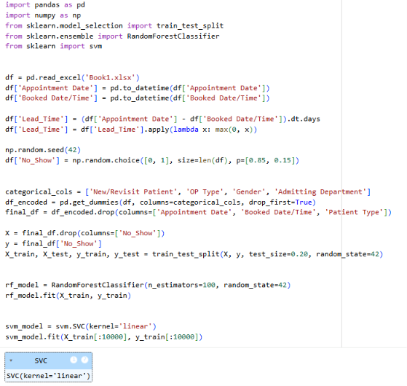.

Appendix D: Model Training Code
Below are the visual classification metrics output from the 100-decision-tree ensemble pipeline.
1. Confusion Matrix LayoutThis visualization highlights the true vs. predicted counts for patient arrivals (0) and missed bookings (1).
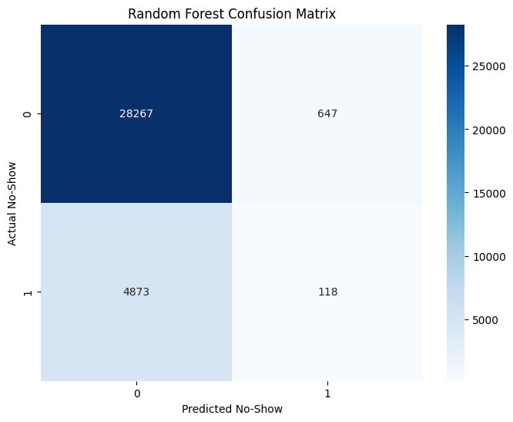

This bar chart identifies which clinical and demographic features possessed the highest weight when determining the probability of an NMC Healthcare appointment failure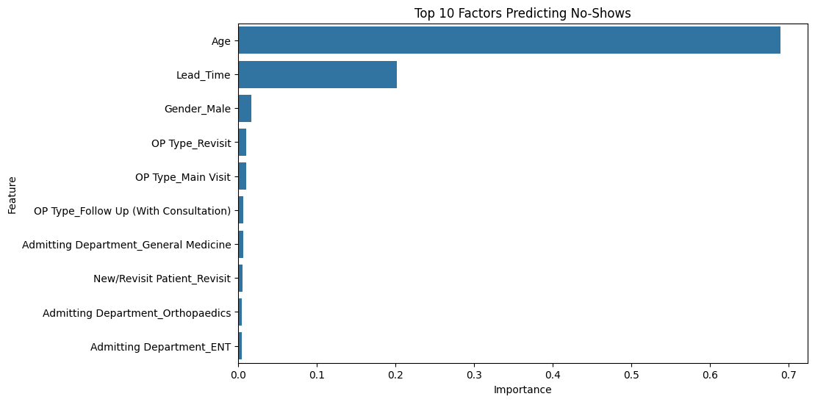

DEMO VIDEO

https://drive.google.com/file/d/1Xx5HS4Yts2iYSe4dusUsETrNj5llT455/view?usp=sharing
This demo video showcases the complete AI-powered patient no-show prediction system developed for NMC Healthcare. The video demonstrates the dataset preprocessing workflow, feature engineering process, model training using Random Forest and SVM, performance evaluation, and prediction results. It also highlights how the system can assist hospital staff in identifying high-risk appointments and improving scheduling efficiency through data-driven decision making.

GITHUB LINK

https://github.com/obaidperacha123-hue/CSCI_323_NO_SHOW
The GitHub repository contains the complete source code, datasets, preprocessing scripts, machine learning models, and evaluation outputs used in this project. It includes data cleaning, feature engineering, Random Forest and SVM implementation, model training, performance analysis, and visualization code. The repository serves as a complete record of the project's development and allows reproduction of all reported results

