* **Assignment No.1** ->

**Python Code**-> import cv2

import numpy as np

def grey(im):

h,w,c=im.shape

gim=np.zeros([h,w])

gim=gim.astype(np.uint8)

for i in range(h):

for j in range(w):

gim[i][j]=((int(im[i][j][0])+int (im[i][j][1])+int(im[i][j][2]))//3)

return gim

im=cv2.imread('2.jpg')

cv2.imshow('imagedisplay',im)

ans=grey(im)

cv2.imshow('imagedisplay',ans)

**Output ->** 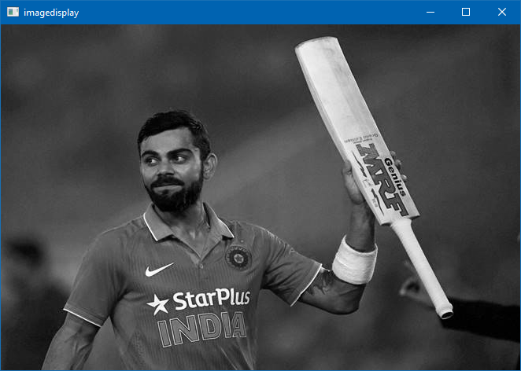

* **Assignment No.2** ->

**Python Code**-> import cv2

import numpy as np

def grey(im):

h,w,c=im.shape

gim=np.zeros([h,w])

gim=gim.astype(np.uint8)

for i in range(h):

for j in range(w):

gim[i][j]=0.3*im[i][j][2]

+0.59*im[i][j][1]+0.1*im[i][j][0]

return gim

im=cv2.imread('2.jpg')

cv2.imshow('imagedisplay',im)

ans=grey(im)

cv2.imshow('imagedisplay',ans)

**Output ->** 