**Assignment No. 2** Date: 12.09.2022

**Problem Statement:** Write a program to read a color image as RGB image and gray scale image. Also, convert the color image into gray scale image using i) average of R, G, and B components and ii) luminosity form.

**Assignment No. 1** Date: 12.09.2022

**Problem Statement:** Write a program to show all the channels of an input Color Image.

**Problem Analysis:**

**Code**:

import cv2

import numpy as np

def grey(im):

h,w,c=im.shape

gim=np.zeros([h,w])

gim=gim.astype(np.uint8)

for i in range(h):

for j in range(w):

gim[i][j]=((int(im[i][j][0])+int (im[i][j][1])+int(im[i][j][2]))//3)

return gim

im=cv2.imread('2.jpg')

cv2.imshow('imagedisplay',im)

ans=grey(im)

cv2.imshow('imagedisplay',ans)

**Output:**

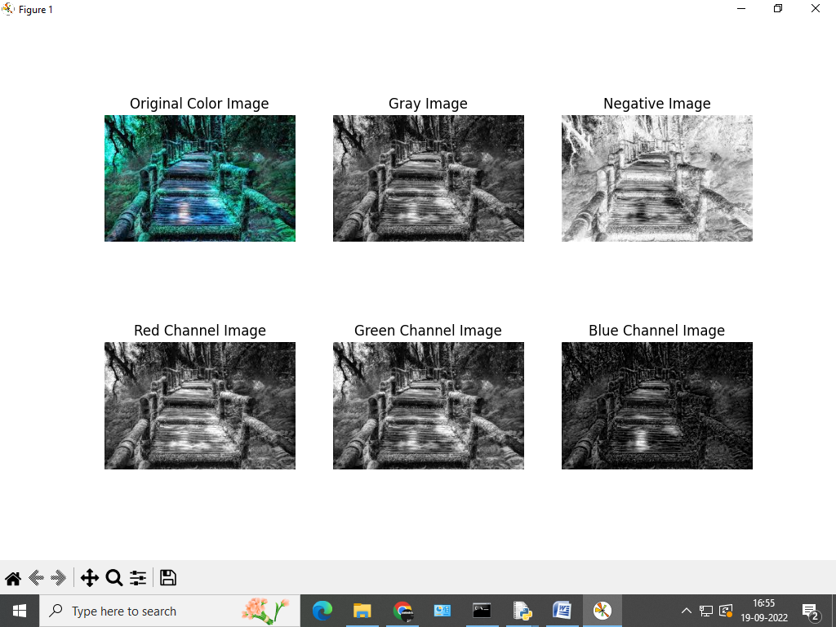

* **Assignment No.2** ->

**Python Code**->import cv2

import numpy as np

def grey(im):

h,w,c=im.shape

gim=np.zeros([h,w])

gim=gim.astype(np.uint8)

for i in range(h):

for j in range(w):

gim[i][j]=0.3*im[i][j][2]

+0.59*im[i][j][1]+0.1*im[i][j][0]

return gim

im=cv2.imread('2.jpg')

cv2.imshow('imagedisplay',im)

ans=grey(im)

cv2.imshow('imagedisplay',ans)

**Output ->**