WPL Problem-Based Learning (PBL)
Name: Obaidullah Arif
ID: IU04-0122-0120
Problem:
Q. create crud operations and include prepared statement to prevent sql injection.

Code:

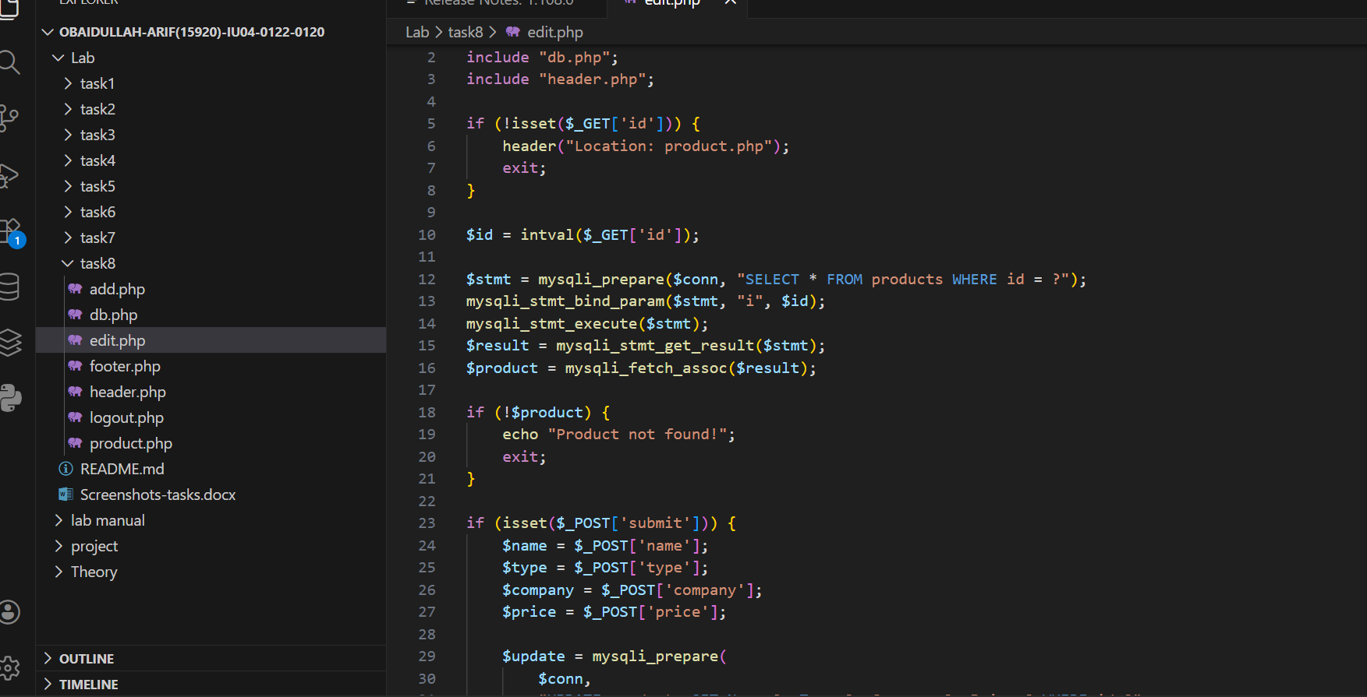
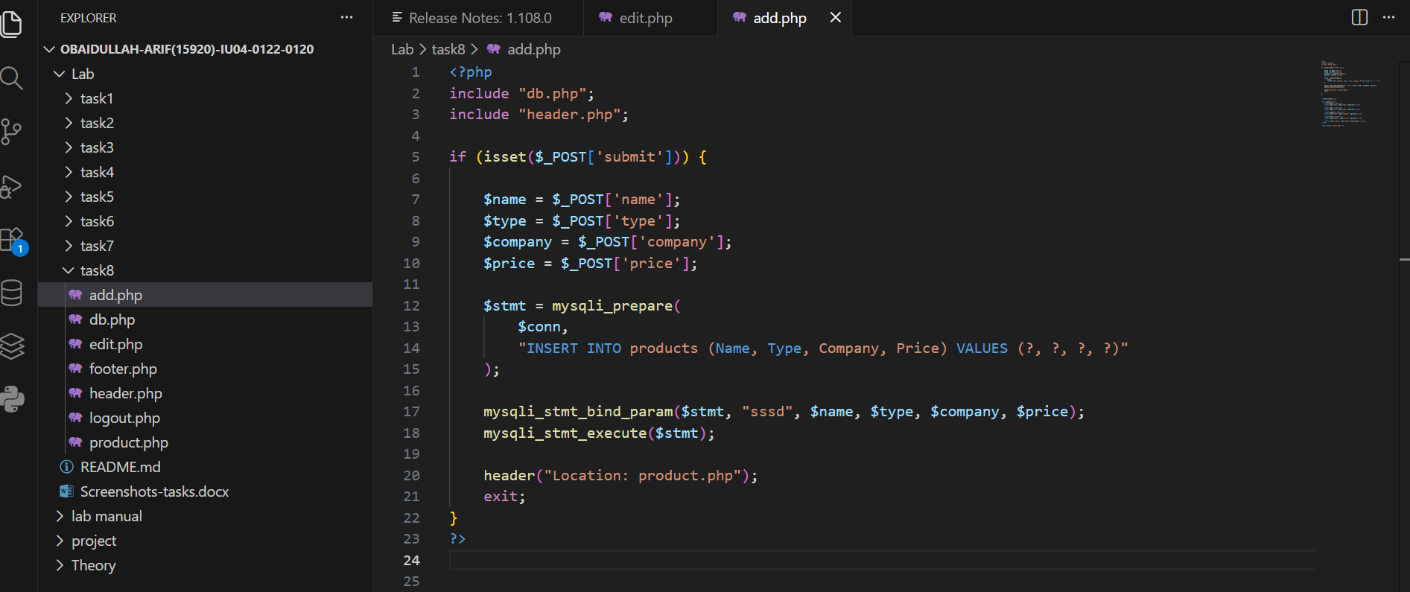
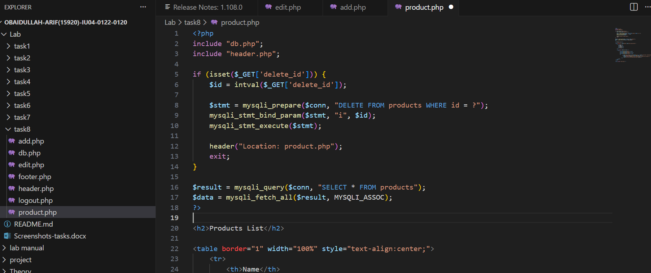

Screenshot:

