AHSANULLAH UNIVERSITY OF SCIENCE AND TECHNOLOGY (AUST)
& 142, Love Road, Tejgaon Industrial Area, Dhaka-1208.



Department of Computer Science and Engineering
Program: Bachelor of Science in Computer Science and Engineering

Project Final Report
Course No: CSE-1200
Course Title: Software Development – I
Project Title: DEATH PIT – The Cyber Dungeon
Date of Submission: 28/09/2026

Submitted to
Saha Reno — Assistant Professor, Department of CSE, AUST.
Md. Zahid Hossain — Lecturer, Department of CSE, AUST.

Submitted by
Name: Muhaiminul Islam Mazid | Student ID: 00725105101101
Name: Obaidur Rahman | Student ID: 00725105101088
Name: Mohammed Abir Hossen | Student ID: 00725105101110
Name: Md. Shishir Ahmed | Student ID: 00725105101095

INTRODUCTION
1.1 Project Overview
Death Pit – The Cyber Dungeon is a 2D top-view action shooter developed with iGraphics in C/C++ for Windows. The player progresses through three levels, fights enemies, solves puzzles, uses weapons and pickups, and faces the Warden boss.
1.2 Objective
• Develop an interactive 2D top-view shooter using the iGraphics graphics library.
• Implement movement, shooting, enemies, collision detection, pickups, and game-state transitions.
• Create different gameplay mechanics across multiple levels.
• Implement a puzzle-driven Level 1, four-room Level 2, and Warden boss encounter in Level 3.
• Maintain run scores through file handling and a scoreboard.
Game Development
2.1 Tools and Technologies Used
• Programming Language: C/C++
• Graphics Library: iGraphics
• IDE/Platform: Visual Studio on Windows PC
• File Handling: Plain-text scores.txt for persistent run scores
• Audio: Background music and sound-effect files integrated through the game code
• Project Organization: iMain.cpp with separate modules for Level 1, Level 2, Level 3, and scoreboard
2.2 Core Features
• Player Movement: W/A/S/D or arrow keys move the player during gameplay.
• Shooting: Space bar fires projectiles.
• Mouse Crosshair: The operating-system cursor is replaced by an in-game aiming crosshair.
• Level 1 Puzzle: Cyber Genie clue leads to a three-switch sequence that unlocks the exit.
• Level 1 Hazards: Laser, bombs/mines, walls, enemies, projectiles, and health pickup.
• Level 2 Challenge: Four rooms with switches, enemies, laser gates, mine, shield, and timer.
• Level 3 Warden Arena: Vanguard wave followed by the Warden boss.
• Warden Boss: 3000 max health, multiple attack patterns, phases, animations, reinforcements, and defeat sequence.
• Clone Ability: Up to two clones assist for a limited duration.
• Checkpoint System: Progress is saved at major level milestones.
• Persistent Scoring: Scores are saved to scores.txt and shown in the scoreboard.
Implementation Details
3.1 Code Structures
• iMain.cpp: Application initialization, menu, input, crosshair, update loop, and game-state transitions.
• level1.h: Room, health pickup, laser, Genie, switch puzzle, bombs, enemies, collisions, completion, and restart.
• level2.h: Four-room map, switches, enemies/elites, laser gates, mine, shield, timer, UI, completion, and restart.
• level3.h: Warden arena, vanguard, boss AI, attacks, reinforcements, animations, health bar, clones, and checkpoint restart.
• scoreboard.h: Score calculation, scores.txt read/write, run recording, highest/lowest score, and rendering.

3.2 Challenges Faced & Solutions
CHALLENGES | SOLUTION
Keeping gameplay code manageable | Group major systems into level1.h, level2.h, level3.h, and scoreboard.h.
Reliable enemy collision and targeting | Use rectangular overlap checks and mouse-to-world coordinate conversion.
Room-based enemy behavior | Use detection ranges and keep enemies inside assigned Level 2 rooms.
Multi-stage boss encounter | Separate vanguard, boss entrance, attacks, phases, summons, animations, and defeat sequence.
Preserving scores between runs | Append finished runs to scores.txt and read them back at startup.
Preventing repeated score writes | Use a runScoreRecorded guard so a run is saved once.
Screenshots
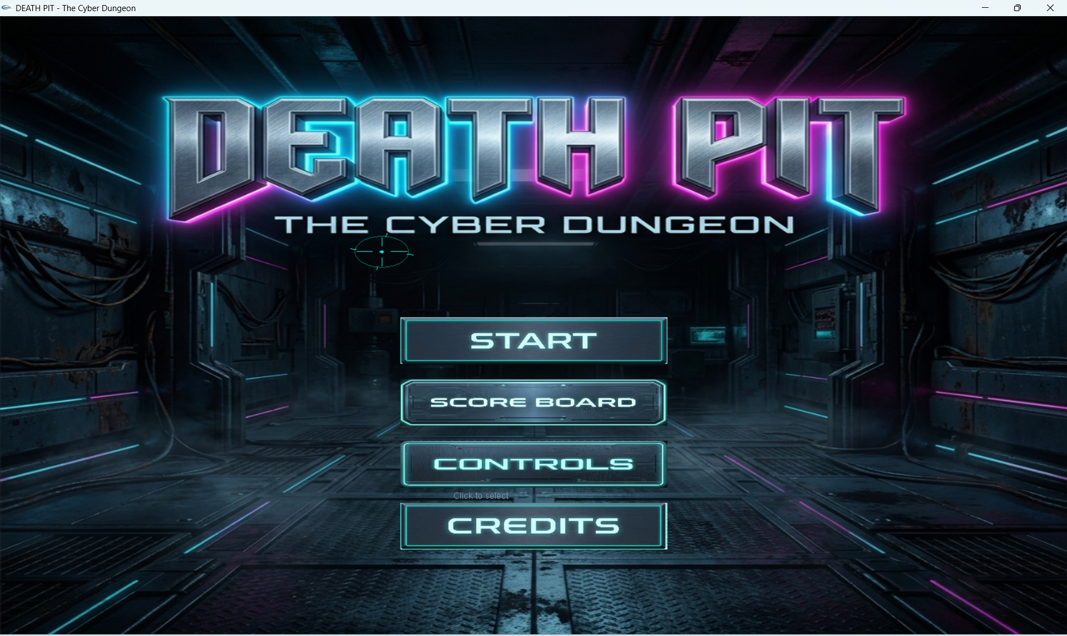  Figure 1: Main Menu / Start Screen | 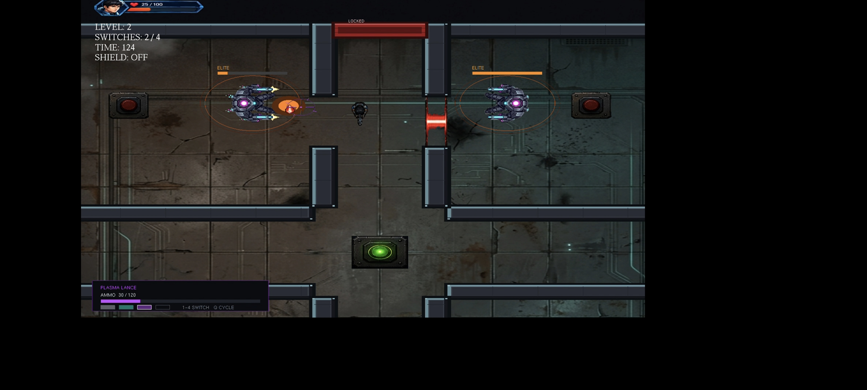  Figure 2: Level 2 Four-Room Challenge
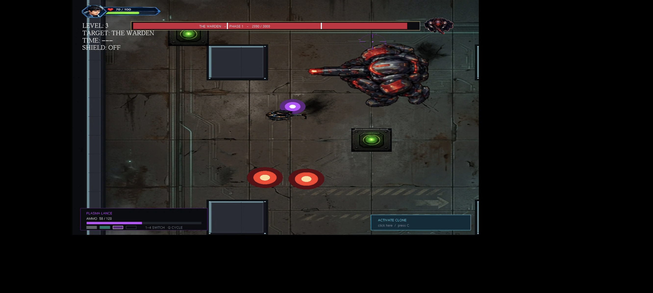  Figure 3: Warden Boss Fight | 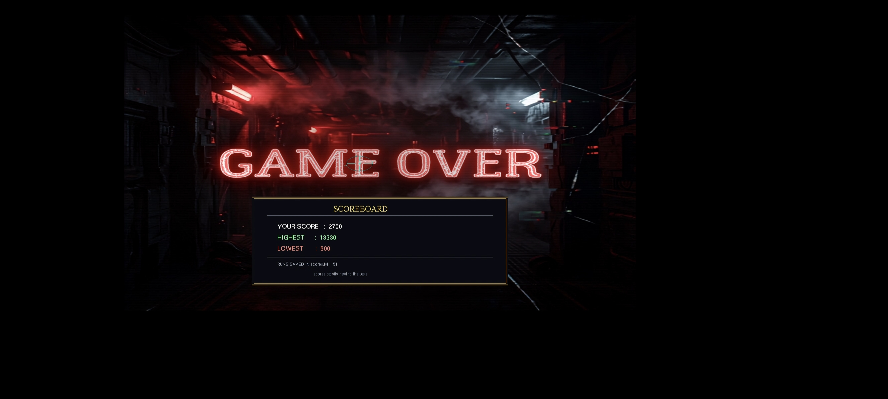  Figure 4: Scoreboard / Game-Over Screen

4. GitHub Collaboration

4.1 Repository Management
The report states that repository management should document commits, branches, pull requests, merges, and conflict resolution; the supplied game source does not include GitHub history, so specific repository evidence must come from the team's actual repository.

4.2 Contribution Workflow
Repository initialized → assigned feature/module work → changes committed → branches/pull requests used if applicable → reviewed changes merged into the main project.

4.3 Individual Contributions
Member | Main Contribution Area
Member 1 | Player and Enemy Shooting Mechanics, Boss Logic
Member 3 | Map Design, Collision Detection, Clone Logic
Member 3 | Scoring System and Game State Management
Member 4 | Player and Enemy Movement, Mine Logic
4.4 Contribution Evidence
GitHub contribution graph or repository commit-history screenshot should be attached here; the supplied report does not contain that evidence.
5.Challenges and Limitations
• Managing multiple gameplay states and transitions across Level 1, Level 2, and Level 3.
• Synchronizing Warden movement, attack cooldowns, animation frames, hurt states, and phase changes.
• Handling collisions among the player, walls, lasers, mines, enemies, projectiles, and pickups.
• Keeping Level 2 enemy behavior inside intended rooms.
• Preventing duplicate score entries when game-over remains active across frames.
• Maintaining consistent Warden sprite alignment with a shared sprite canvas and anchor position.

5.1 Limitations

• The game uses an 800×800 iGraphics window, so presentation is tied to a fixed rendering size.
• The supplied source files do not include a complete asset list or full GitHub history.
• Exact team-member responsibilities and submission metadata are not present in the source code.
• AI-tool usage is not documented in the supplied source files.

6. Conclusion

6.1 Summary
Death Pit – The Cyber Dungeon implements a three-level top-view shooter using iGraphics, combining combat, puzzle solving, hazards, room-based enemies, pickups, checkpoints, a multi-stage Warden boss, temporary clones, and persistent scoring. The code is organized into separate level and scoreboard modules while iMain manages central application flow.

6.2 Scoring System
100 points per enemy + 250 per elite + 500 per level reached + 5 per remaining health point + 2000 for defeating the Warden + 1500 for finishing the game.

7.Future Enhancements

• Improve visual assets and animation quality for the player, enemies, and Warden.
• Add more enemy types and additional boss attack patterns.
• Expand the number and variety of levels and environmental puzzles.
• Improve the visual design of walls, rooms, effects, and HUD elements.
• Add more detailed sound design and stage-specific background music.
• Add persistent statistics such as total kills, fastest completion time, and weapon-specific performance.
• Further modularize shared gameplay systems as the project grows.

Appendix: Source Files Analyzed

• iMain.cpp
• level1.h
• level2.h
• level3.h
• scoreboard.h

