E-Commerce Sales Analysis - EDA Report
This report presents an Exploratory Data Analysis (EDA) of the E-Commerce Sales dataset. The goal is to identify trends, business insights, customer behavior, and profitability patterns.

1. Dataset Overview
Total Records: 5000
Total Columns: 16
Column | Description
order_id | Unique order identifier
order_date | Date of order
ship_date | Shipping date
customer_name | Customer name
segment | Customer segment
country | Country
city | City
state | State
region | Region
category | Product category
sub_category | Product sub-category
product_name | Product name
sales | Sales amount
quantity | Quantity sold
discount | Discount applied
profit | Profit earned

2. Summary Statistics
Metric | sales | quantity | discount | profit
count | 5000.0 | 5000.0 | 5000.0 | 5000.0
mean | 2542.74 | 5.56 | 0.15 | 317.6
std | 1429.89 | 2.86 | 0.09 | 419.86
min | 50.97 | 1.0 | 0.0 | -475.99
25% | 1313.96 | 3.0 | 0.07 | 15.14
50% | 2535.42 | 6.0 | 0.15 | 199.14
75% | 3772.36 | 8.0 | 0.22 | 562.99
max | 4999.94 | 10.0 | 0.3 | 1730.28

3. Key Insights
- Total sales generated: 12713724.57
- Total profit earned: 1588005.07
- Average discount offered: 14.79%
- Highest sales category: Furniture
- Most profitable region: North
- Some products show negative profit due to high discounts.
- Sales fluctuate across months, indicating seasonal demand patterns.

4. Visual Analysis

Sales by Category
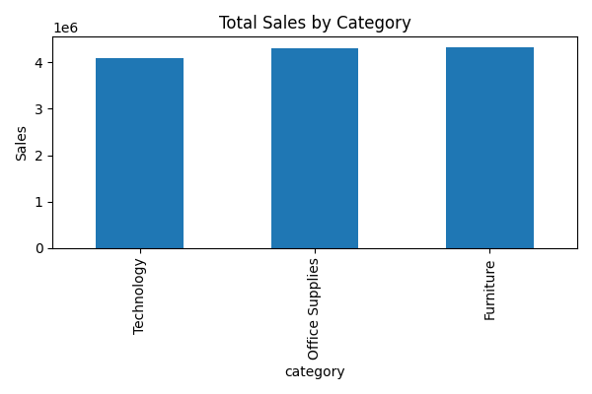

Profit by Region
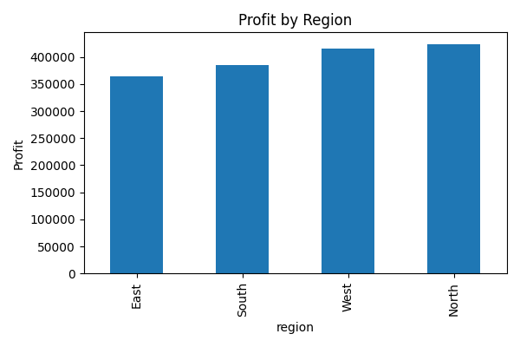

Monthly Sales Trend
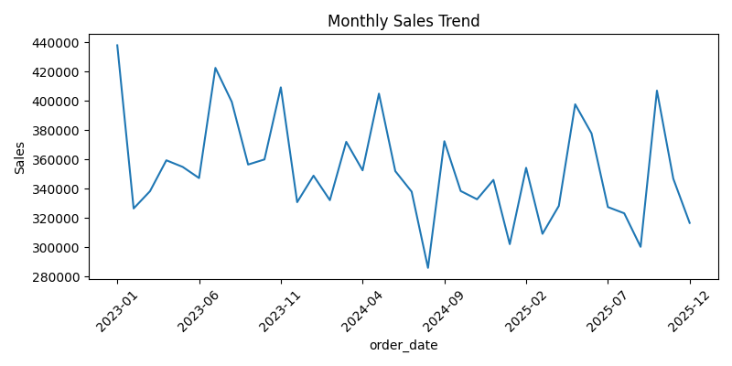

Top 10 Products by Sales
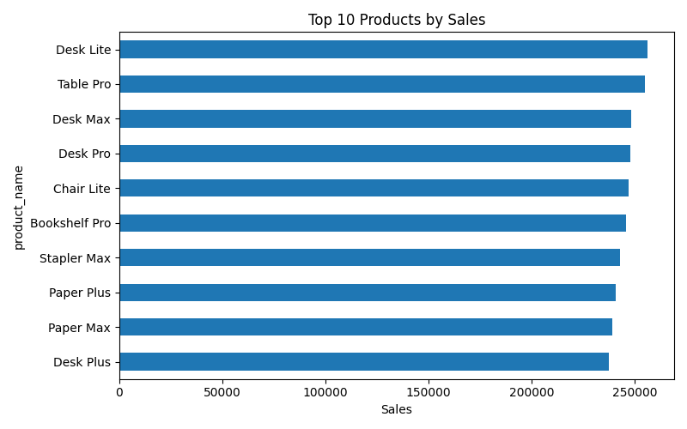

5. Recommendations
- Focus marketing efforts on high-performing categories.
- Reduce excessive discounts on low-margin products.
- Improve inventory planning for seasonal sales peaks.
- Promote top-selling products using targeted campaigns.
- Analyze underperforming regions for operational improvements.

