HR Analytics Project Report: Employee Attrition Analysis
Prepared By: Obaid Vadaliwala
Tools Used: Python (Pandas, Matplotlib, Seaborn)
Dataset Size: 200 Records
Date:24/02/2026

1. Business Problem Statement
I am a data analyst TechNova Analytics Pvt Ltd (Mid-sized IT Services Company) The organization is experiencing employee attrition and seeks to understand the key drivers behind employee turnover. The objective of this analysis is to identify patterns, risk factors, and actionable insights to reduce attrition.

2. Dataset Description
The dataset contains the following attributes:
- EmployeeID – Unique employee identifier
- Age – Age of employee
- Gender – Male/Female
- Department – Business unit (HR, Sales, IT, Finance, Marketing)
- Salary – Monthly salary
- Experience – Years of experience
- PerformanceScore – Rating (1–5)
- Overtime – Whether employee works overtime (Yes/No)
- Attrition – Whether employee left the company (Yes/No)

3. Data Cleaning Process
- Removed duplicate records using Pandas drop_duplicates().
- Handled missing Salary and Experience values using median imputation.
- Replaced missing PerformanceScore values using mode imputation.
- Converted Attrition column into numeric flag (Attrition_Flag: Yes=1, No=0).
- Validated data types and ensured numerical consistency.

4. Key Performance Indicators (KPIs)
- Total Employees - 180
- Total Employees Left - 82
- Attrition Rate (%) - 43.15

- Department-wise Attrition Rate

Finance 59.52%
HR 43.58%
IT 47.61%
Marketing 34.37%
Sales 25.71%

- Overtime-based Attrition Rate
Overtime Attrition is – 64%
- Average Salary Comparison (Left vs Stayed)
Stayed - 72503.85
Left - 66292.53
- Experience Comparison (Left vs Stayed)
Stayed - 7.435185
Left - 7.256098

5. Exploratory Data Analysis (EDA)
- Overall attrition distribution visualization.
Stayed – 108
Left - 82

- Department-wise attrition percentage comparison.

Finance 59.52%
HR 43.58%
IT 47.61%
Marketing 34.37%
Sales 25.71%

- Salary distribution analysis using boxplots.

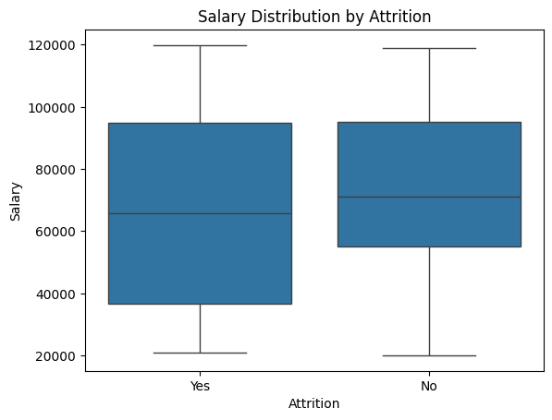

- Overtime impact analysis showing significantly higher attrition among overtime employees.

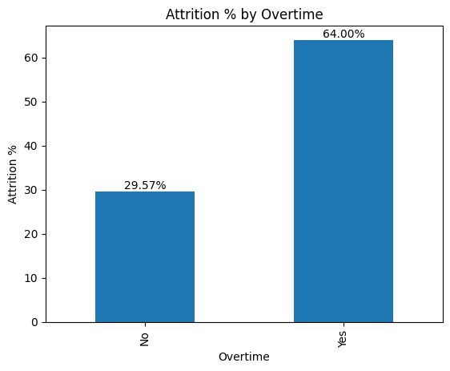

- Experience and performance relationship analysis.

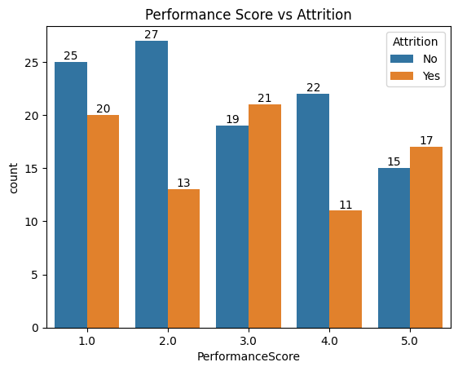

- Correlation heatmap for numeric variables.

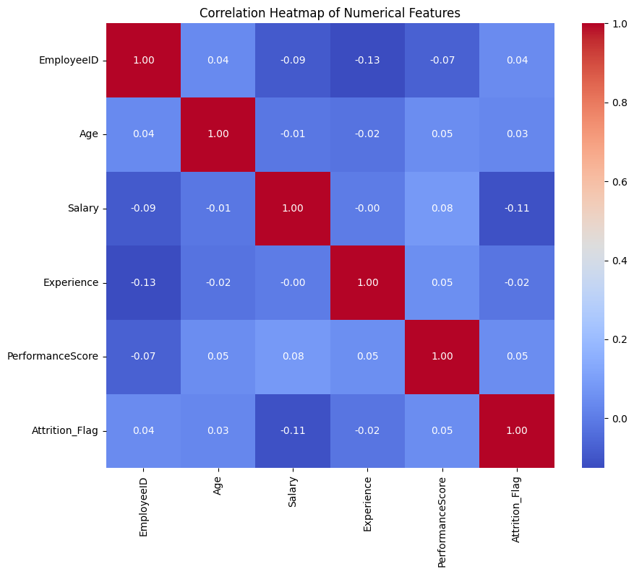

6. Key Insights
- Employees working overtime show significantly higher attrition rates compared to non-overtime employees.
- Salary demonstrates a weak negative correlation with attrition, indicating slightly higher turnover among lower salary employees.
- No strong linear relationship was observed between age and attrition.
- Department-wise analysis reveals certain departments experience higher turnover than others.
- Attrition appears to be influenced more by workload and categorical factors rather than individual numeric variables.

7. Business Recommendations
- Reduce excessive overtime through better workforce planning.
- Review compensation structure for lower salary bands.
- Implement employee engagement and retention programs in high-risk departments.
- Introduce workload monitoring and employee wellness initiatives.
- Conduct exit interviews to further validate analytical findings.

8. Conclusion
This project demonstrates strong data cleaning, analytical reasoning, and visualization skills using Python and Pandas. The analysis highlights workload and compensation as potential drivers of attrition. The findings can assist management in making data-driven retention strategies.

