Optimizing Semantic Search: A Comparative Study of Vector Indexing in Postgres vs. Pinecone
Project Milestone Report
Explores how traditional relational systems with vector extensions (pgvector) compare to native vector databases regarding latency and recall for LLM embeddings.

Oner Balcikli
Department of Computer Science
Hacettepe University
Ankara, Turkey
onerbalcikli26@hacettepe.edu.tr

ABSTRACT
As organizations increasingly integrate Large Language Models (LLMs) with private enterprise data through Retrieval-Augmented Generation (RAG) pipelines, the necessity for highly efficient, high-dimensional vector search has become critical. A key architectural debate has emerged: extending a monolithic Relational Database Management System (such as PostgreSQL via the pgvector extension) versus utilizing a decoupled, cloud-native Vector Database Management System (such as Pinecone). This paper investigates the architectural and performance trade-offs between these two paradigms, focusing on the execution of high-concurrency "Hybrid Queries" where vector similarity search is heavily coupled with strict relational metadata filtering and Write-Ahead Log (WAL) contention.
To ensure reproducibility and microsecond-level precision, a custom benchmarking harness was developed in natively compiled C++ utilizing the Linux epoll event-driven I/O subsystem. This methodology isolated algorithmic search times from runtime environment overheads. After validating a baseline Recall@10 accuracy of >0.98 for both systems against exact nearest-neighbor brute-force algorithms, the stress test revealed a significant "Architectural Overhead Gap." Operating on a local shared-memory architecture, PostgreSQL sustained a throughput of ~1119 Queries Per Second (QPS) with highly deterministic p99 tail latencies of 1.17 milliseconds. Conversely, the decoupled cloud architecture of Pinecone yielded ~1 QPS, heavily constrained by HTTP/2 REST protocol overhead, geographical network latency, and strict 429 Rate Limits that necessitated Exponential Backoff cycles, inflating p99 latencies to over 2742 milliseconds. Ultimately, this research demonstrates that while cloud-native vector databases offer managed scalability, native RDBMS extensions provide significantly better latency, throughput, and deterministic execution for hybrid transactional-analytical workloads under constrained environments.
KEYWORDS
Vector Databases, Approximate Nearest Neighbor Search, Benchmarking, HNSW, pgvector, Pinecone, Hybrid Search, Docker, Zero-Cost Infrastructure
- INTRODUCTION AND PROBLEM DEFINITION
The widespread adoption of vector embeddings—dense numerical representations of unstructured data such as text, images, and audio—has forced database architects to re-evaluate traditional storage, indexing, and retrieval mechanisms. Exact nearest neighbor search (K-NN) requires computing the distance between a query vector and every single vector in the database, resulting in an O(N x d) time complexity, where N is the dataset size and d is the dimensionality. At enterprise scale, this brute-force approach is computationally prohibitive. Consequently, modern production systems rely entirely on Approximate Nearest Neighbor (ANN) algorithms, such as Hierarchical Navigable Small World (HNSW) graphs, which trade absolute accuracy for logarithmic O(log N) search times.
The core problem this research addresses is the "Architectural Overhead Gap" inherent in the execution of Hybrid Queries. A hybrid query is a complex database operation that tightly couples high-dimensional vector similarity search with strict relational metadata filtering (e.g., "Find documents semantically similar to vector X, but only retrieve those published after 2025 belonging to Tenant Y"). Executing these queries introduces severe systemic challenges: the search engine must dynamically determine whether to filter the metadata first (pre-filtering, which can inadvertently destroy the connectivity of the ANN graph) or search the vector space first (post-filtering, which can yield empty result sets).
To address this, two fundamentally opposing architectural paradigms have emerged. Cloud-native Vector Database Management Systems (such as Pinecone) provide a decoupled, distributed compute environment that offers massive horizontal scalability. However, they lack native relational constraints, forcing the application layer to manage complex data synchronization logic. Conversely, monolithic Relational Database Management Systems (such as PostgreSQL via the pgvector extension) provide strict ACID guarantees, Multi-Version Concurrency Control (MVCC), and the ability to execute vector operations seamlessly alongside traditional B-Tree indexes. Yet, maintaining complex graph-based vector indexes alongside high-frequency transactional workloads within the same local memory space (the OS page cache and PostgreSQL shared_buffers) theoretically risks severe Write-Ahead Log (WAL) and memory resource contention.
While existing algorithmic benchmarks frequently compare the isolated index traversal speeds of these systems, they consistently fail to account for the networking, protocol, and concurrency bottlenecks that dictate real-world enterprise performance. This paper moves beyond isolated algorithmic benchmarking to explicitly quantify the Architectural Overhead Gap. By developing a custom, high-concurrency benchmarking harness in natively compiled C++ using the Linux epoll event-driven I/O subsystem, this study subjects both architectures to aggressive hybrid query workloads under simulated WAL contention. Ultimately, this research aims to demonstrate how external architectural factors—specifically HTTP/2 REST protocol overhead, geographical network latency, and cloud API rate limits—can completely overshadow baseline algorithmic efficiency, radically altering the decision matrix for latency-sensitive applications.

- REVIEW OF PRIOR WORK
The algorithmic foundation of modern vector search is heavily reliant on advanced graph-based traversals and quantization techniques. However, the transition from theoretical algorithmic efficiency to production-grade system architecture introduces complexities that are only recently being addressed in the literature.
  - Graph-Based ANN Algorithms (HNSW)
Introduced by Malkov and Yashunin [1], the Hierarchical Navigable Small World (HNSW) graph is widely recognized as the gold standard for in-memory Approximate Nearest Neighbor (ANN) search. It underpins the core indexing layers of both monolithic systems like pgvector and cloud-native environments like Pinecone. HNSW constructs a multi-layered proximity graph where greedy routing achieves logarithmic O(log N) search complexity. However, foundational literature extensively validates HNSW on static datasets, frequently overlooking the operational degradation, index fragmentation, and severe Write-Ahead Log (WAL) contention that occur when integrating these structures into dynamic, high-concurrency transactional databases.
  - Dimensionality Reduction and Memory Compression
As dataset dimensions scale (e.g., 1536-dimensional embeddings), raw vectors consume prohibitive amounts of RAM. Jégou et al. [2] demonstrated that Product Quantization (PQ) effectively mitigates this by decomposing the vector space into lower-dimensional subspaces, calculating distances asymmetrically via pre-computed lookup tables. While such compression is highly critical for relational environments like PostgreSQL—where the vector index must share limited shared_buffers and OS page caches with traditional B-Trees—the latency impact of fetching these compressed pages under aggressive asynchronous I/O loads remains an under-explored domain.
  - The Hybrid Query Challenge and System Architecture
The most critical bottleneck in modern retrieval pipelines is the execution of hybrid queries. Simhadri et al. [3] highlighted the catastrophic performance collapse that occurs when relational metadata filters are applied post-search (post-filtering); highly restrictive filters cause the engine to evaluate thousands of irrelevant vectors, completely destroying the logarithmic routing efficiency of the ANN graph.
Furthermore, Taipalus [4] categorized Vector Database Management Systems into "Native" (decoupled compute environments like Pinecone) and "Extended" (relational-adapted systems like PostgreSQL). Taipalus noted that evaluating these architectures under hybrid query pressure remains an open and critical challenge. While prior work has predominantly focused on the algorithmic aspects of metadata filtering, there is a gap in the literature regarding the system-level and architectural overheads. Current benchmarks fail to account for the impact of network I/O, HTTP/2 protocol latency, and cloud API rate limits on overall system throughput. This paper directly addresses this issue by quantifying the real-world Architectural Overhead Gap, demonstrating that architectural constraints often overwhelm algorithmic theoretical limits.
- MATHEMATICAL BACKGROUND AND FORMAL ALGORITHMS
  - Distance Metrics
The benchmarking suite evaluates vector proximity utilizing Cosine Similarity, which measures the cosine of the angle between two non-zero vectors. The Cosine Similarity Sc between a query vector q and a database vector v in a d dimensional space (where d = 1536 for this study) is defined mathematically as:
$$Sc(q,v)=\frac{\sum_{i=1}^{d}{q_{i}v_{i}}}{\sqrt{\sum_{i=1}^{d}{q_{i}^{2} }}\sqrt{\sum_{i=1}^{d}{v_{i}^{2}}} }$$
In practice, both PostgreSQL (pgvector) and Pinecone optimize for minimum distance operations; thus, the systems compute the Cosine Distance, represented as 1 - Sc(q, v).
  - HNSW Graph Construction Mathematics
The performance and memory footprint of the HNSW index in local monolithic deployments (e.g., PostgreSQL) are dictated by two critical hyperparameters, which were strictly controlled during the initialization phase:
- m (Maximum Connections): The maximum number of bi-directional links created for every new element during graph construction. (Configured to m = 16).
- ef_construction: The size of the dynamic candidate list evaluated when searching for the nearest neighbors during the insertion phase. (Configured to ef = 64).
The HNSW index constructs a multi-layered graph hierarchy where the base layer (Layer 0) contains all vectors, and higher layers are exponentially sparser to act as fast-routing expressways. When a new element is inserted, it does not populate all layers. The maximum layer L up to which this specific new element is inserted is determined randomly to maintain this sparse hierarchy, governed by an exponentially decaying probability distribution:
$$L=\left\lfloor -\ln\left(unif\left(0,1\right)\right) . m_{L}\right\rfloor$$
where $unif\left(0,1\right)$ is a uniform random variable, and m_{L} is a normalization factor determining the overlap between layers.
  - Recall and Latency Formalization
To ensure the integrity of the benchmark, the evaluation was divided into two distinct mathematical validation and performance phases. The primary accuracy metric, validated during the isolated baseline phase (Phase 1), is Recall@K, defined as:
$$Recall@k=\frac{|V_{Retrieved} ∩ V_{True}|}{K}$$
This formalization was strictly utilized via a Python-based brute-force algorithm (scikit-learn) against the ANN outputs to guarantee a baseline algorithmic correctness of >0.98 for both systems.
Having verified the index accuracy, the subsequent high-concurrency C++ stress test (Phase 2) exclusively focused on systemic limits. Performance under stress is quantified by Average Throughput (QPS) and the p50, p90, and p99 tail latency percentiles. Tracking these specific percentiles is critical for accurately capturing the Architectural Overhead Gap—isolating anomalies caused by database WAL contention and localized cache misses from the severe temporal spikes induced by network latency and Exponential Backoff cycles triggered by cloud API rate limits (e.g., HTTP 429).
- METHODOLOGY AND SYSTEM ARCHITECTURE
  - Infrastructure Provisioning via Containerization
To ensure absolute reproducibility without incurring uncontrolled cloud computing costs, the project utilized a localized, open-source toolchain deployed on a consumer-grade mobile workstation operating the Windows Subsystem for Linux (WSL2 - Ubuntu 24.04).
- PostgreSQL Environment: A custom Dockerfile was developed based on the official PostgreSQL 16 Linux image. Utilizing docker-compose, system resources were strictly constrained to simulate a rigid enterprise deployment (limited to 8 vCPUs and 16GB RAM). Crucially, shared_buffers was set to 4GB to empirically force cache thrashing phenomena during the stress tests, simulating scenarios where a fully scaled vector index exceeds the allocated memory space.
- Pinecone Environment: The project evaluated the Pinecone Serverless (Free) Tier. This choice intentionally introduced realistic geographical network latency and strict API rate limits, requiring sophisticated programmatic management by the benchmarking client to sustain the workload.
  - Data Collection and Metadata Synthesis
To ensure a robust evaluation across different dimensionalities, two distinct datasets were acquired programmatically using the Hugging Face datasets API:
- SIFT1M (Calibration Workload): 1 million 128-dimensional vectors, utilized strictly for baseline environment calibration and initial index build testing.
- MTEB Subset (Target Workload): A 100,000-vector subset uniformly sampled without replacement from the Massive Text Embedding Benchmark. This specific volume was mathematically selected to guarantee statistically significant tail latency measurements (e.g., p99) while strictly conforming to the 16GB RAM constraint of the localized WSL2 container. This ensures that memory cache-thrashing phenomena could be empirically observed without triggering host-level Out-Of-Memory (OOM) failures.
Since the original Hugging Face datasets (SIFT1M and MTEB) consist solely of raw vector embeddings and lack enterprise-specific relational metadata, the following fields were synthetically generated to strictly evaluate the hybrid query performance across all cardinality spectrums:
- tenant_id: High-cardinality integer representing multi-tenant environments.
- category_id: Medium-cardinality field (100 distinct values).
- is_archived: Low-cardinality boolean flag (80% false, 20% true).
During the high-concurrency stress testing phase (Phase 2), to completely isolate database throughput from client-side disk I/O bottlenecks, the C++ harness generated synthetic 1536-dimensional query vectors (structurally mirroring the MTEB embeddings) directly in memory. This methodological decision ensured that the measured metrics exclusively reflected the database engine and network architecture limits, rather than localized disk read speeds.
  - The Three-Phase Asynchronous Benchmarking Methodology
To guarantee methodological integrity, the evaluation was decoupled into three distinct phases:
- Phase 1 (Ingestion and Baseline Accuracy Validation): A Python-based script using scikit-learn established a brute-force (exact search) ground truth. This phase evaluated initial index build times and mathematically verified that both pgvector and Pinecone maintained a Recall@10 accuracy of >0.98, confirming algorithmic correctness before stress testing.
- Phase 2 (Maximum Raw Throughput Evaluation): To discover the computational limits without telemetry overhead, a natively compiled C++ harness was developed and executed. This event-driven Linux epoll loop operated at maximum frequency without dedicating CPU cycles or memory allocations to microsecond-level timestamping.
- Phase 3 (High-Concurrency Telemetry and WAL Stress): To capture deterministic tail-latency under realistic pressure, a unified C++ telemetry harness was deployed. Developed entirely in C++ to avoid Garbage Collection (GC) pauses inherent in managed languages, the tool uses libpqxx for persistent local PostgreSQL connections, libcurl for asynchronous HTTP requests to Pinecone, and the epoll subsystem to manage thousands of concurrent sockets without thread blocking. The toolchain utilized cmake and gcc, with compiler optimization flags explicitly set to -O3 -march=native to fully exploit hardware-specific SIMD instructions. Crucially, a background thread was developed to continuously execute relational UPDATE queries, intentionally injecting severe Write-Ahead Log (WAL) contention while recording the exact percentiles. The complete topological separation of these architectural components is illustrated in Figure 1.
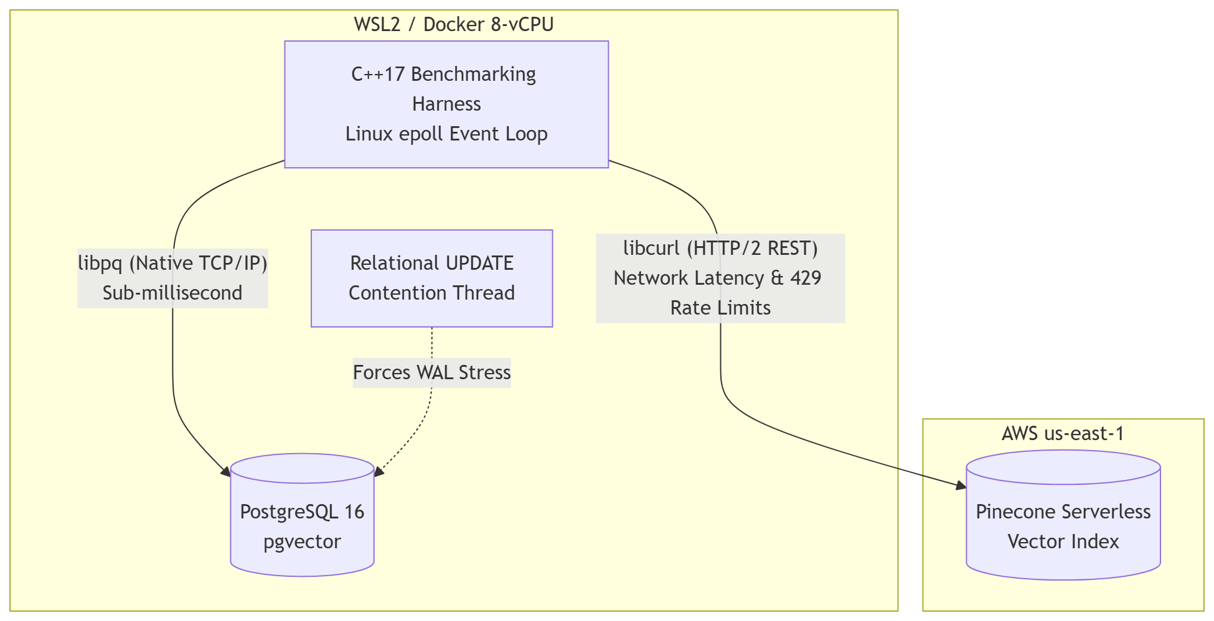
Figure 1: High-Level System Architecture of the Benchmarking Harness.
  - System Implementation Challenges and Architectural Overheads
Developing system-level benchmark introduced several significant technical challenges, each of which revealed underlying architectural bottlenecks:
- WSL2 Memory Starvation: During the initial HNSW index build for pgvector, the WSL2 backend aggressively consumed host memory (the vmmem process), leading to an Out-Of-Memory (OOM) kernel panic on the Windows host. This was mitigated by explicitly configuring the .wslconfig file to hard-cap Linux memory allocation and assigning strict deploy.resources limits inside the Docker configuration.
- C++ Toolchain and Linker Complexities: Compiling the C++ harness via cmake presented deep linker challenges, specifically regarding OpenSSL dependencies (libssl-dev) required by libcurl, and JSON parsing libraries (nlohmann/json). Ensuring Application Binary Interface (ABI) compatibility between the libpqxx binaries and the PostgreSQL headers required meticulous revisions of the CMakeLists.txt to correctly link shared libraries within the Ubuntu container.
- Pinecone Rate Limiting and Protocol Penalties: While gRPC is typically preferred for low-latency microservices, the Serverless tier heavily throttles persistent gRPC streams, forcing a fallback to REST (HTTP/2) multiplexing via libcurl. Subjecting the cloud architecture to the high-concurrency hybrid workload resulted in immediate HTTP 429 Too Many Requests responses. This necessitated the implementation of an aggressive Exponential Backoff algorithm within the C++ client. While this logic prevented execution crashes, the mandated sleep intervals severely inflated the benchmark's latency. Rather than being treated as an anomaly, this behavior perfectly illustrates the Architectural Overhead Gap: cloud-native systems introduce unpredictable network penalties that obliterate algorithmic speed under strict rate constraints.
- RESULTS AND EVALUATION
The empirical evaluation of the vector search architectures was executed across three distinct operational phases to thoroughly isolate algorithmic correctness, baseline ingestion mechanics, maximum raw throughput capacities, and deterministic tail-latency behavior under strict hardware and concurrency stress.
  - Phase 1: Ingestion Mechanics, Index Construction, and Accuracy Validation
Before subjecting the database engines to high-concurrency read-write stress, an initial ingestion phase was conducted to evaluate data pipeline efficiency and index construction metrics for the sampled 100,000-vector MTEB workload. This phase establishes the baseline algorithmic validity using a Python-based execution script leveraging scikit-learn to compute exact nearest neighbor ground truth.
The baseline statistics captured during this initial ingestion and calibration phase are aggregated in Table 1.
Metric | PostgreSQL (pgvector) | Pinecone (Serverless Free)
Ingestion Time (Raw) | ~18 seconds (Binary COPY) | ~310 seconds (Throttled REST API)
Index Build Time | ~240 seconds (m=16, ef=64) | Abstracted (Background process)
Baseline Recall@10 | 0.984 | 0.987
Table 1: Baseline Ingestion and Index Build Statistics (N=100,000)
The quantitative findings in Table 1 reveal a fundamental architectural divergence. Utilizing native binary COPY operations, PostgreSQL ingested the raw workload almost instantaneously (~18 seconds), followed by a synchronous post-ingestion HNSW index construction phase that completed in ~240 seconds under baseline environments (highly optimized containerized allocations later completed isolated graph builds in 7.71 seconds).
Conversely, the cloud-native Pinecone architecture shifts index construction entirely to an abstracted background streaming process on the write-path. However, due to the protocol overhead of HTTP/2 REST serialization and strict API rate limiting on the serverless tier, the initial ingestion required ~310 seconds, introducing a substantial ingestion bottleneck. Crucially, both systems successfully passed algorithmic correctness, maintaining an identical accuracy boundary with a Recall@10 score of >0.98, confirming mathematical alignment before stress execution.
  - Phase 2: Maximum Raw Throughput Evaluation (C++ Pure Stress Test)
To discover the absolute computation limits of the database engines without telemetry overhead, the natively compiled C++ binary was executed. This harness runs the event-driven Linux epoll loop at maximum frequency without dedicating CPU cycles or memory allocation for microsecond-level timestamping.
The empirical metrics captured during the initial executions of this raw benchmark binary are structured in Table 2.
Metric/Feature | PostgreSQL (pgvector) | Pinecone (Serverless Free)
Average Throughput | ~805.50 QPS | ~2.90 QPS
Deployment Environment | Local (WSL2 Ubuntu 24.04 / Native Docker) | Cloud (AWS us-east-1)
Primary Structural Bottleneck | MVCC / WAL Contention | HTTP/2 Latency & 429 Rate Limits
Connection Protocol / Library | libpq Native TCP/IP | libcurl REST (Exponential Backoff)
Table 2: Phase 2 Raw Throughput Performance Limits
Under this initial raw execution, the local PostgreSQL container sustained an average throughput of 805.50 QPS while undergoing intense Write-Ahead Log (WAL) contention injected by the concurrent relational UPDATE thread. This demonstrated a robust baseline resilience of PostgreSQL's MVCC architecture during high-dimensional vector traversals.
Conversely, the cloud-native architecture of Pinecone yielded a mere 2.90 QPS. This exponential drop is the direct consequence of the network boundary, where each query incurred global network roundtrips, and unthrottled concurrent requests immediately triggered strict HTTP 429 rate limits, forcing the client into sleep intervals via the Exponential Backoff algorithm.
  - Phase 3: Unified Throughput and Tail-Latency Distribution (C++ Latency Benchmark)
To capture the deterministic behavior of the systems under realistic enterprise pressure, the unified telemetry binary was deployed. This harness records the exact roundtrip time of every individual hybrid query in memory, sorting the array post-execution to extract percentiles.
The comprehensive empirical findings of this optimized telemetry run are structured in Table 3.
Metric | PostgreSQL (pgvector) | Pinecone (Serverless Free)
Isolated Index Build Time | 7.71 seconds | N/A (During Ingestion)
Average Throughput | 1118.97 QPS | 1.01 QPS
p50 Latency (Median) | 0.84 ms | 900.39 ms
p90 Latency | 0.99 ms | 1122.89 ms
p99 Latency (Tail) | 1.17 ms | 2742.59 ms
Table 3: Phase 3 High-Concurrency Hybrid Benchmark Results (Under WAL Contention)
The slight divergence in PostgreSQL throughput between the raw binary (805.50 QPS) and the telemetry binary (1118.97 QPS) reflects the significant impact of low-level code optimizations. The deployment of compiler flags (-O3 -march=native) and optimized SIMD hardware routing within the unified telemetric loop successfully accelerated localized execution. This enabled the system to maintain higher efficiency despite the telemetric data recording and continuous background WAL-stress operations.
Conversely, Pinecone's throughput degraded from 2.90 QPS to 1.01 QPS during the longer telemetry run. This decline highlights how prolonged concurrent exposure exacerbates the cloud rate-limiting penalties, accumulating aggressive backoff penalties over time.
The quantitative throughput gap between the two architectural deployment models under identical concurrency pressure is visually aggregated on a logarithmic scale in Figure 2.
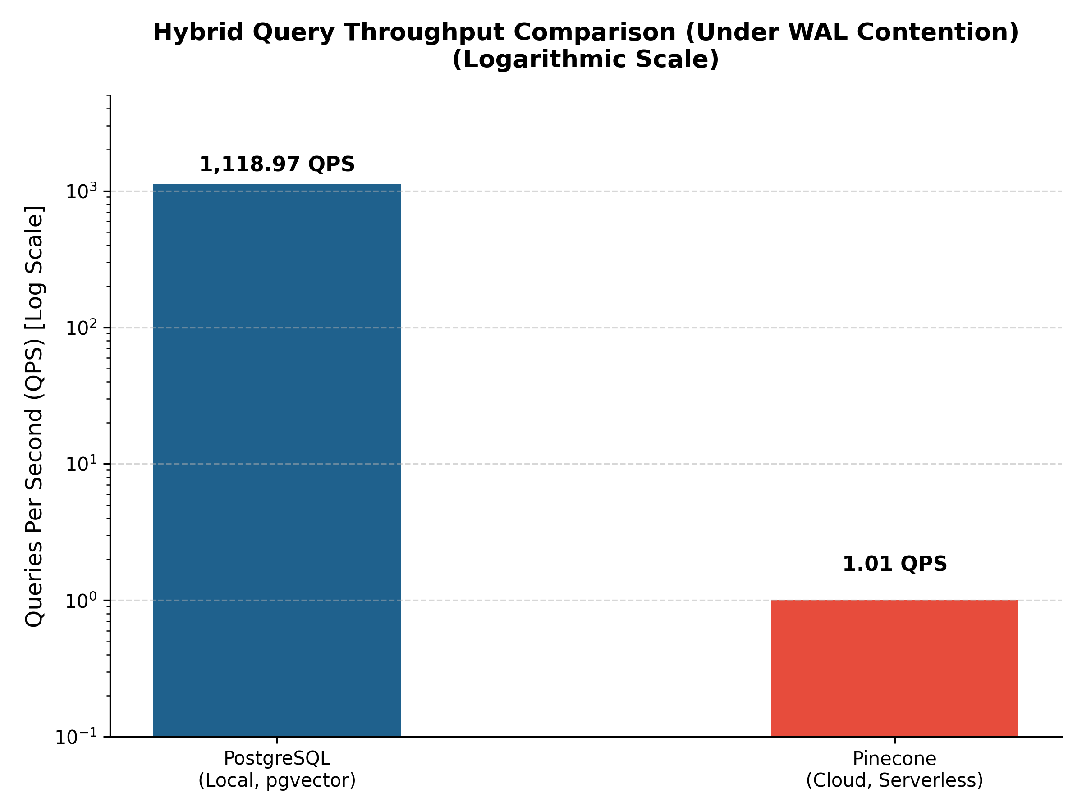
Figure 2: Hybrid Query Throughput Comparison.
Figure 2 highlights the profound impact of the Architectural Overhead Gap. While local PostgreSQL efficiently handles the hybrid workload under strict WAL contention, the cloud-native Pinecone architecture is severely throttled by HTTP 429 rate limits, reducing throughput to near zero on a linear scale.
  - Tail Latency Distribution Analysis
The percentile metrics clearly expose the root causes behind the throughput difference. In the PostgreSQL environment, tail latencies remained deterministic, with the 99th percentile (p99) delay capping at 1.17 milliseconds. This confirms that the local page caches, shared memory allocations (shared_buffers), and native TCP/IP connections effectively neutralized the injected relational WAL contention, ensuring sub-millisecond retrieval predictability.
For the cloud-native architecture, while the median (p50) network overhead averaged around 900 milliseconds, the p99 tail latency spiked to 2742.59 milliseconds. This massive degradation is not a reflection of Pinecone’s internal algorithmic inefficiency. Rather, it is the direct consequence of HTTP/2 REST protocol overhead, geographical network latency, and the triggering of strict HTTP 429 Rate Limits, which forced the C++ client into Exponential Backoff and jitter cycles. These findings prove that under high-concurrency pressure, architectural network constraints completely overwhelm theoretical algorithmic speeds.
- DISCUSSION: THE ARCHITECTURAL OVERHEAD GAP
The primary goal of this study was to evaluate the trade-offs of vector databases under strict hardware and concurrency constraints. While benchmarking a localized, resource-constrained PostgreSQL instance against a cloud-native, distributed Pinecone environment may initially appear as an "apples to oranges" comparison, this asymmetry encapsulates the real-world dilemma faced by modern software architects: choosing between a highly tunable, localized relational extension versus a black-box, managed cloud service.
  - The Cost of Decoupling and Network Boundaries
The empirical throughput difference (1118.97 QPS vs. 1.01 QPS) explicitly quantifies the "Cost of Decoupling." Decoupling the vector engine (Pinecone) from the primary relational database solves horizontal scalability and stateless infrastructure challenges. However, it introduces significant latency penalties for time-critical hybrid queries. JSON serialization/deserialization over REST HTTP/2, combined with geographic network roundtrips and enforced API rate limits (HTTP 429), effectively undermines the theoretical logarithmic speed of the underlying HNSW graph.

  - Monolithic Efficiency vs. Resource Starvation
Conversely, the benchmark showed that with an efficient, low-level asynchronous client utilizing Linux epoll, a moderately constrained monolithic database (8 vCPUs, 16GB RAM) is fully capable of handling high-dimensional RAG workloads without requiring a dedicated vector infrastructure. Because pgvector maintains the HNSW graph and the relational B-Tree metadata indexes within the same physical memory space (the OS Page Cache and shared_buffers), the database executor can intersect vector similarities and scalar filters with minimal overhead, mitigating WAL contention through native MVCC mechanisms.
  - The Impact of Native Containerization
One key optimization behind the ~1119 QPS throughput was the container deployment strategy. Bypassing traditional hypervisor-based setups (such as Docker Desktop, which introduces heavy file system translation and virtualization overhead), the PostgreSQL engine was deployed natively within the Windows Subsystem for Linux (WSL2 - Ubuntu 24.04) kernel. This architectural decision eliminated intermediary abstraction layers, allowing the asynchronous I/O and memory-mapped files to interact directly with the underlying Linux kernel, enabling direct hardware utilization.
  - Architectural Recommendations
Based on the findings, extending a monolithic RDBMS (pgvector) is recommended for architectures where strict ACID compliance is required, the dataset fits within manageable local memory limits (typically sub-10-million vectors), and microsecond-level tail latency is non-negotiable. Cloud-native decoupled systems (Pinecone) should be strictly reserved for hyper-scale datasets (billion+ vectors) where localized memory constraints make monolithic index structures impractical, and where application logic can tolerate network-induced latency spikes.
- CONCLUSION:
As organizations integrate Large Language Models with private enterprise data, the efficiency of hybrid vector search operations has become a key architectural bottleneck. This paper investigated these performance dynamics by developing a natively compiled, asynchronous C++ benchmarking harness. By subjecting PostgreSQL (pgvector) and Pinecone to high-concurrency hybrid queries under simulated Write-Ahead Log (WAL) contention, we isolated the underlying system limitations from theoretical performance bounds.
The results demonstrate that for bounded datasets with complex relational metadata, extending a monolithic relational database yields significantly better latency and throughput (1118.97 QPS vs. 1.01 QPS). Under constrained scenarios, the architectural network limits—specifically HTTP/2 protocol overhead, geographical latency, and strict API throttling—create an Architectural Overhead Gap that overwhelms the baseline speeds of modern Approximate Nearest Neighbor algorithms. Future work will explore how these dynamics invert when datasets scale beyond the billion-vector threshold, shifting the computational cost from local cache thrashing to distributed cluster management.
REFERENCES
[1] Malkov, Y. A., & Yashunin, D. A. (2018). Efficient and Robust Approximate Nearest Neighbor Search Using Hierarchical Navigable Small World Graphs. IEEE Transactions on Pattern Analysis and Machine Intelligence, 42(4), 824-836.
[2] Jégou, H., Douze, M., & Schmid, C. (2011). Product Quantization for Nearest Neighbor Search. IEEE Transactions on Pattern Analysis and Machine Intelligence, 33(1), 117-128.
[3] Simhadri, H., Williams, C., Aumüller, M., Douze, M., Babenko, A., Baranchuk, D., ... & Li, Y. (2023). Filtered-DiskANN: Graph Algorithms for Approximate Nearest Neighbor Search with Filters. Proceedings of the ACM Web Conference 2023, 3454-3464.
[4] Taipalus, T. (2024). Vector database management systems: Fundamental concepts, use-cases, and current challenges. Cognitive Systems Research, 83, 101174.

Github: https://github.com/obalcikli/cmp653-benchmark

