**Department of Engineering**

**University of Ottawa**

**CSI4142**

**Introduction to Data Science**

Muhammad Owais Bawany - 7993647

Matteo Colombi - 8238926

Patrick Langis - 8196917

Felix Singerman - 7970742

Table of Contents

Background 2

Data Staging -- Preprocessing 2

High-Level Schematic 3

Physical Design -- Data Mart 3

OLAP Queries 3

Business Intelligence Dashboard 4

Machine Learning 4

**Appendix** **23**

**References** **30**

## 

## Background

We designed, built and implemented a data mart using data on all disasters that have affected Canadians worldwide5. We did data staging, designed and implemented OLAP queries, had a user interface to interact and visualize the queries and finally applied several machine learning algorithms to the data.

## Data Staging -- Preprocessing

We decided to do the data staging in python. We have one large python script norm.py that does all the preprocessing. We used the library pandas in order to help with the dataframes.

We used an external data source for population statistics. The data source used was retrieved from Stats Canada 2011 census3. We removed the columns that were of no concern to us. We parsed out location column to extract the province and put it in its own column using regex. This data set has information on the population statistics of every city in Canada. This includes whether a city is an Indian Reserve, the population rank, land area etc. The resulting file is cleanedPop.csv.

Using the CanadianDisaster dataset we convert the rows with no values to be set as ‘unknown’ as described in the instruction manual. We then got rid of the rows with NaN values in several of the columns where it wouldn't make sense to have NaN such as location or event_category. We also looked for anomalies in the first column and found many of the to begin with ‘note’ so we removed those rows as well. We had many issues with the encoding of french-canadian names such as occurrences of accents. We solved this by using latin1 encoding.

We created new columns for city, province, country and ID which links the same disaster that took place in multiple cities. We then wrote several regex for each province and its corresponding geographical name (ie: prairie provinces) and wrote regex for typical city data splitting the city and province. It then uses the regex to get the city and province data and write out to a new row. If it has multiple locations it writes out to multiple rows. If the location was not in Canada we set the city, province and country to OTHER. We then wrote the csv out to ‘Disaster_clean_final.csv’

The script can be run by using `python norm.py --icsv 'CanadianDisasterDatabase.csv' --ocsv 'Disaster_clean_final.csv' --population 'canadianstats.csv' --stopwords 'stopwords.txt'

`

The cleaned canadianstats.csv will be found as cleanedPop.csv

We planned on using a list of stop words that we found on NLTK common stop word list in order to have an easier time at parsing out the summary column and create a keyword column4. However, we decided against doing so as we did not see the use of having a keyword column.

During this process, we considered using an external data set for meteorological history in Canada. After searching, we found a free public data set offered by the Canadian Government. However, after discussing, we decided not to implement a weather dimension since the data set did not offer, what we considered to be relevant data1. We also attempted to first do a fuzzy match to the population statistics we found, however, there would be too much data loss.

## High-Level Schematic

See Figure 1 for the full example. The Canadian Disaster Database was supplied to us by Professor Viktor5. We used a public data set from Statistics Canada to get an accurate representation of population in Canadian cities3. Pgadmin was used as our postgresql database management system throughout the project. We used Amazon Web Services (AWS) to host our sql server. It was simple to connect to it in our pgadmin interface. The Tableau desktop application was used for all data visualization purposes. We made use of weka to test various machine learning algorithms on our data set. In the end, we had six label targets: Locations, Dates, Costs, Populations, Disasters and Facts.

## Physical Design -- Data Mart

Our data mart was created in Postgresql. We hosted the database on AWS on datascience.crfo0qa9zng9.ca-central-1.rds.amazonaws.com:8080. We manually created all the tables and columns based on the guideline provided in the manual (see figure 6). We imported the main data set into a placeholder table using pgadmin ‘import’ option. We then imported the cleanedPop.csv straight into the population_dimension. We then wrote a script datamart.sql for all the ‘insert into’ statements for all the dimensions and the fact table. We created our surrogate keys for each table using the data type serial.

## OLAP Queries

We wrote the OLAP queries in SQL located in olap.sql

As per the instruction we ran several different type of queries on our data.

Roll up: Determine total estimated costs of each disaster category IN each canadian city (See figure 2 and figure 3)

Slice: Determining the estimated total cost of incident disasters IN Canada (See figure 4)

Slice: For instance determine the total number of fatalities in Ottawa/Ontario during 1999

Slice: Determining estimated total costs caused by Disasters IN each province

Dice: Determining the total cost of Technology related Incidences IN Canada (See figure 5)

Iceberg: For instance, determine the 5 cities IN Canada with the most Fires

Roll down: Determining the total number of fatalities IN each province during 1999

Dice/ Roll down: Determining the total number of fatalities caused by a Fire IN each province during 1999

## Business Intelligence Dashboard

The data visualization portion of the project was completed using the Tableau 10.5 desktop application. This allowed us to visualize our complete and cleaned data set whilst also conveniently and efficiently displaying the results of our OLAP queries (See Figures 2,3,4,5,7 and 8). It was simple to navigate and create possible queries we could implement on our data.

## Machine Learning

We ran \copy (Select * FROM <dimension>) to 'output.csv' with csv HEADER from the postgres pgql command line in order to create a csv for weka. We ran it on each of our tables in our postgres database and combined them all into one table.

The Weka 3.8.2 desktop application was used to complete the machine learning portion of the project.

We used multiple different algorithms in weka, that each serve a different purpose. For classification we used, zeroR (baseline), J48 trees, SMO function, NaiveBayes and adaboost1 (using several of the classification previously described).

The results are given below of the algorithms run on our pre-processed data and discussion follows.

1. **rules.ZeroR**

=== Run information ===

Scheme: weka.classifiers.rules.ZeroR

Relation: Weka_file

Instances: 1381

Attributes: 26

disaster_key

day

month

year

weekend

city

province

country

canada

disaster_type

disaster_subgroup

disaster_group

disaster_category

magnitude

utility_people_affected

estimated_total_cost

normalized_total_cost

federal_dfaa_payements

provincal_dfaa_payement

municipal_cost

insurance_payements

ogd_cost

ngo_payement

fatalities

injured

evacuated

Test mode: 10-fold cross-validation

=== Classifier model (full training set) ===

ZeroR predicts class value: 1052.7233888486603

Time taken to build model: 0 seconds

=== Cross-validation ===

=== Summary ===

Correlation coefficient -0.0915

Mean absolute error 1730.949

Root mean squared error 8201.4427

Relative absolute error 100 %

Root relative squared error 100 %

Total Number of Instances 1381

**Trees J48**

=== Summary ===

Correctly Classified Instances 1038 75.1629 %

Incorrectly Classified Instances 343 24.8371 %

Kappa statistic 0.0743

Mean absolute error 0.3693

Root mean squared error 0.4326

Relative absolute error 96.2825 %

Root relative squared error 98.8001 %

Total Number of Instances 1381

=== Detailed Accuracy By Class ===

TP Rate FP Rate Precision Recall F-Measure MCC ROC Area PRC Area Class

0.993 0.941 0.752 0.993 0.856 0.161 0.529 0.754 n

0.059 0.007 0.750 0.059 0.109 0.161 0.529 0.311 y

Weighted Avg. 0.752 0.700 0.751 0.752 0.663 0.161 0.529 0.640

=== Confusion Matrix ===

a b <-- classified as

1017 7 | a = n

336 21 | b = y

**Functions.SMO Normalized total cost**

=== Summary ===

Correctly Classified Instances 1381 100 %

Incorrectly Classified Instances 0 0 %

Kappa statistic 1

Mean absolute error 0.2222

Root mean squared error 0.2722

Relative absolute error 109.9536 %

Root relative squared error 85.7405 %

Total Number of Instances 1381

=== Detailed Accuracy By Class ===

TP Rate FP Rate Precision Recall F-Measure MCC ROC Area PRC Area Class

1.000 0.000 1.000 1.000 1.000 1.000 1.000 1.000 Technology

1.000 0.000 1.000 1.000 1.000 1.000 1.000 1.000 Natural

1.000 0.000 1.000 1.000 1.000 1.000 1.000 1.000 Conflict

Weighted Avg. 1.000 0.000 1.000 1.000 1.000 1.000 1.000 1.000

=== Confusion Matrix ===

a b c <-- classified as

220 0 0 | a = Technology

0 1132 0 | b = Natural

0 0 29 | c = Conflict

**Adaboost M1 Normalized total cost**

=== Summary ===

Correctly Classified Instances 667 48.1588 %

Incorrectly Classified Instances 718 51.8412 %

Kappa statistic 0.4084

Mean absolute error 0.0769

Root mean squared error 0.255

Relative absolute error 60.6678 %

Root relative squared error 101.3063 %

Total Number of Instances 1385

=== Detailed Accuracy By Class ===

TP Rate FP Rate Precision Recall F-Measure MCC ROC Area PRC Area Class

0.609 0.171 0.468 0.609 0.529 0.399 0.773 0.468 ON

0.391 0.106 0.371 0.391 0.381 0.278 0.669 0.339 QC

0.570 0.085 0.498 0.570 0.531 0.458 0.801 0.428 BC

0.280 0.037 0.300 0.280 0.290 0.251 0.745 0.222 NB

0.454 0.055 0.481 0.454 0.467 0.409 0.755 0.382 AB

0.500 0.041 0.548 0.500 0.523 0.478 0.801 0.477 MB

0.296 0.029 0.387 0.296 0.336 0.303 0.699 0.237 NS

0.149 0.030 0.220 0.149 0.177 0.143 0.629 0.100 SK

0.991 0.000 1.000 0.991 0.996 0.995 0.998 0.993 0

0.278 0.027 0.357 0.278 0.313 0.282 0.701 0.199 NL

0.143 0.004 0.375 0.143 0.207 0.224 0.585 0.112 NT

0.111 0.001 0.500 0.111 0.182 0.234 0.467 0.064 YT

0.500 0.000 1.000 0.500 0.667 0.706 0.717 0.505 NU

0.048 0.007 0.100 0.048 0.065 0.059 0.659 0.055 PE

Weighted Avg. 0.482 0.076 0.473 0.482 0.472 0.406 0.757 0.405

=== Confusion Matrix ===

a b c d e f g h i j k l m n <-- classified as

167 38 16 6 12 15 7 5 0 7 0 0 0 1 | a = ON

50 75 24 11 7 7 4 4 0 9 0 0 0 1 | b = QC

29 19 102 4 10 2 6 5 0 1 1 0 0 0 | c = BC

9 12 8 21 5 3 8 0 0 6 0 0 0 3 | d = NB

22 14 15 4 64 9 1 9 0 3 0 0 0 0 | e = AB

22 9 5 1 11 63 1 12 0 1 1 0 0 0 | f = MB

17 6 12 13 0 0 24 2 0 4 1 0 0 2 | g = NS

17 9 4 2 14 13 0 11 0 3 1 0 0 0 | h = SK

0 0 1 0 0 0 0 0 111 0 0 0 0 0 | i = 0

13 14 4 6 3 2 5 1 0 20 1 1 0 2 | j = NL

5 2 6 0 3 1 0 1 0 0 3 0 0 0 | k = NT

3 0 4 0 1 0 0 0 0 0 0 1 0 0 | l = YT

0 1 2 0 1 0 0 0 0 0 0 0 4 0 | m = NU

3 3 2 2 2 0 6 0 0 2 0 0 0 1 | n = PE

**Naive Bayes normalized Total Cost**

=== Summary ===

Correctly Classified Instances 1351 97.5451 %

Incorrectly Classified Instances 34 2.4549 %

Kappa statistic 0.1482

Mean absolute error 0.0019

Root mean squared error 0.0428

Relative absolute error 35.1261 %

Root relative squared error 96.3977 %

Total Number of Instances 1385

=== Detailed Accuracy By Class ===

TP Rate FP Rate Precision Recall F-Measure MCC ROC Area PRC Area Class

1.000 0.919 0.975 1.000 0.988 0.281 0.865 0.994 0

0.000 0.000 ? 0.000 ? ? 0.984 0.062 48319.81

0.000 0.000 ? 0.000 ? ? 0.328 0.001 77457

0.000 0.000 ? 0.000 ? ? 0.258 0.001 83524

0.000 0.000 ? 0.000 ? ? 0.950 0.021 145954

0.000 0.000 ? 0.000 ? ? 0.658 0.003 247039

0.000 0.000 ? 0.000 ? ? 0.712 0.003 334404

0.000 0.000 ? 0.000 ? ? 0.998 0.514 439291

0.000 0.000 ? 0.000 ? ? 0.890 0.007 486784

0.000 0.000 ? 0.000 ? ? 0.886 0.006 500000

0.000 0.000 ? 0.000 ? ? 0.770 0.003 1000000

0.000 0.000 ? 0.000 ? ? 0.474 0.002 1194997

0.000 0.000 ? 0.000 ? ? 0.339 0.001 1668590

0.000 0.000 ? 0.000 ? ? 0.975 0.028 1766793

0.000 0.000 ? 0.000 ? ? 0.975 0.028 1850000

0.000 0.000 ? 0.000 ? ? 0.626 0.002 3036145

0.000 0.000 ? 0.000 ? ? 0.092 0.001 3189873

0.000 0.000 ? 0.000 ? ? 0.644 0.002 5788529

0.000 0.000 ? 0.000 ? ? 0.499 0.001 14234637

0.000 0.000 ? 0.000 ? ? 0.981 0.053 21496062

0.000 0.000 ? 0.000 ? ? 0.837 0.004 29751766

0.000 0.000 ? 0.000 ? ? 0.996 0.278 48480045

0.000 0.000 ? 0.000 ? ? 0.592 0.002 72000000

0.000 0.000 ? 0.000 ? ? 0.848 0.005 76670115

0.000 0.000 ? 0.000 ? ? 0.752 0.003 204494382

0.000 0.000 ? 0.000 ? ? 0.624 0.002 496865521

1.000 0.000 1.000 1.000 1.000 1.000 1.000 1.000 2018484288

Weighted Avg. 0.975 0.894 ? 0.975 ? ? 0.862 0.972

=== Confusion Matrix ===

a b c d e f g h i j k l m n o p q r s t u v w x y z aa <-- classified as

1348 0 0 0 0 0 0 0 0 0 0 0 0 0 0 0 0 0 0 0 0 0 0 0 0 0 0 | a = 0

2 0 0 0 0 0 0 0 0 0 0 0 0 0 0 0 0 0 0 0 0 0 0 0 0 0 0 | b = 48319.81

1 0 0 0 0 0 0 0 0 0 0 0 0 0 0 0 0 0 0 0 0 0 0 0 0 0 0 | c = 77457

1 0 0 0 0 0 0 0 0 0 0 0 0 0 0 0 0 0 0 0 0 0 0 0 0 0 0 | d = 83524

2 0 0 0 0 0 0 0 0 0 0 0 0 0 0 0 0 0 0 0 0 0 0 0 0 0 0 | e = 145954

2 0 0 0 0 0 0 0 0 0 0 0 0 0 0 0 0 0 0 0 0 0 0 0 0 0 0 | f = 247039

1 0 0 0 0 0 0 0 0 0 0 0 0 0 0 0 0 0 0 0 0 0 0 0 0 0 0 | g = 334404

3 0 0 0 0 0 0 0 0 0 0 0 0 0 0 0 0 0 0 0 0 0 0 0 0 0 0 | h = 439291

1 0 0 0 0 0 0 0 0 0 0 0 0 0 0 0 0 0 0 0 0 0 0 0 0 0 0 | i = 486784

1 0 0 0 0 0 0 0 0 0 0 0 0 0 0 0 0 0 0 0 0 0 0 0 0 0 0 | j = 500000

1 0 0 0 0 0 0 0 0 0 0 0 0 0 0 0 0 0 0 0 0 0 0 0 0 0 0 | k = 1000000

2 0 0 0 0 0 0 0 0 0 0 0 0 0 0 0 0 0 0 0 0 0 0 0 0 0 0 | l = 1194997

1 0 0 0 0 0 0 0 0 0 0 0 0 0 0 0 0 0 0 0 0 0 0 0 0 0 0 | m = 1668590

1 0 0 0 0 0 0 0 0 0 0 0 0 0 0 0 0 0 0 0 0 0 0 0 0 0 0 | n = 1766793

1 0 0 0 0 0 0 0 0 0 0 0 0 0 0 0 0 0 0 0 0 0 0 0 0 0 0 | o = 1850000

1 0 0 0 0 0 0 0 0 0 0 0 0 0 0 0 0 0 0 0 0 0 0 0 0 0 0 | p = 3036145

1 0 0 0 0 0 0 0 0 0 0 0 0 0 0 0 0 0 0 0 0 0 0 0 0 0 0 | q = 3189873

1 0 0 0 0 0 0 0 0 0 0 0 0 0 0 0 0 0 0 0 0 0 0 0 0 0 0 | r = 5788529

1 0 0 0 0 0 0 0 0 0 0 0 0 0 0 0 0 0 0 0 0 0 0 0 0 0 0 | s = 14234637

2 0 0 0 0 0 0 0 0 0 0 0 0 0 0 0 0 0 0 0 0 0 0 0 0 0 0 | t = 21496062

1 0 0 0 0 0 0 0 0 0 0 0 0 0 0 0 0 0 0 0 0 0 0 0 0 0 0 | u = 29751766

3 0 0 0 0 0 0 0 0 0 0 0 0 0 0 0 0 0 0 0 0 0 0 0 0 0 0 | v = 48480045

1 0 0 0 0 0 0 0 0 0 0 0 0 0 0 0 0 0 0 0 0 0 0 0 0 0 0 | w = 72000000

1 0 0 0 0 0 0 0 0 0 0 0 0 0 0 0 0 0 0 0 0 0 0 0 0 0 0 | x = 76670115

1 0 0 0 0 0 0 0 0 0 0 0 0 0 0 0 0 0 0 0 0 0 0 0 0 0 0 | y = 204494382

1 0 0 0 0 0 0 0 0 0 0 0 0 0 0 0 0 0 0 0 0 0 0 0 0 0 0 | z = 496865521

0 0 0 0 0 0 0 0 0 0 0 0 0 0 0 0 0 0 0 0 0 0 0 0 0 0 3 | aa = 2018484288

2. **Trees J48**

=== Summary ===

Correctly Classified Instances 1149 82.9603 %

Incorrectly Classified Instances 236 17.0397 %

Kappa statistic 0.5991

Mean absolute error 0.0011

Root mean squared error 0.0288

Relative absolute error 27.1225 %

Root relative squared error 66.9793 %

Total Number of Instances 1385

=== Detailed Accuracy By Class ===

TP Rate FP Rate Precision Recall F-Measure MCC ROC Area PRC Area Class

1.000 0.518 0.804 1.000 0.891 0.622 1.000 1.000 0

=== Confusion Matrix ===

J48 on Disaster Subgroup

=== Summary ===

Correctly Classified Instances 1361 98.5518 %

Incorrectly Classified Instances 20 1.4482 %

Kappa statistic 0.9645

Mean absolute error 0.0029

Root mean squared error 0.0423

Relative absolute error 4.6148 %

Root relative squared error 23.8487 %

Total Number of Instances 1381

=== Detailed Accuracy By Class ===

TP Rate FP Rate Precision Recall F-Measure MCC ROC Area PRC Area Class

0.675 0.003 0.871 0.675 0.761 0.761 0.956 0.670 Fire

0.862 0.009 0.676 0.862 0.758 0.758 0.959 0.612 Explosion

0.950 0.000 1.000 0.950 0.974 0.974 1.000 0.998 Infrastructure failure

1.000 0.003 0.999 1.000 1.000 0.998 1.000 1.000 Meteorological - Hydrological

1.000 0.000 1.000 1.000 1.000 1.000 1.000 1.000 Geological

1.000 0.001 0.983 1.000 0.991 0.991 1.000 0.982 Transportation accident

0.950 0.000 1.000 0.950 0.974 0.974 1.000 0.998 Biological

1.000 0.002 0.973 1.000 0.986 0.986 1.000 1.000 Hazardous Chemicals

1.000 0.000 1.000 1.000 1.000 1.000 1.000 1.000 Arson

1.000 0.000 1.000 1.000 1.000 1.000 1.000 1.000 Civil Incident

1.000 0.000 1.000 1.000 1.000 1.000 1.000 1.000 Terrorist

1.000 0.000 1.000 1.000 1.000 1.000 1.000 1.000 Hijacking

0.000 0.000 ? 0.000 ? ? 0.500 0.001 Space Event

Weighted Avg. 0.986 0.003 ? 0.986 ? ? 0.997 0.981

=== Confusion Matrix ===

a b c d e f g h i j k l m <-- classified as

27 12 0 0 0 1 0 0 0 0 0 0 0 | a = Fire

4 25 0 0 0 0 0 0 0 0 0 0 0 | b = Explosion

0 0 19 0 0 0 0 1 0 0 0 0 0 | c = Infrastructure failure

0 0 0 1055 0 0 0 0 0 0 0 0 0 | d = Meteorological - Hydrological

0 0 0 0 57 0 0 0 0 0 0 0 0 | e = Geological

0 0 0 0 0 57 0 0 0 0 0 0 0 | f = Transportation accident

0 0 0 1 0 0 19 0 0 0 0 0 0 | g = Biological

0 0 0 0 0 0 0 73 0 0 0 0 0 | h = Hazardous Chemicals

0 0 0 0 0 0 0 0 7 0 0 0 0 | i = Arson

0 0 0 0 0 0 0 0 0 6 0 0 0 | j = Civil Incident

0 0 0 0 0 0 0 0 0 0 13 0 0 | k = Terrorist

0 0 0 0 0 0 0 0 0 0 0 3 0 | l = Hijacking

0 0 0 0 0 0 0 1 0 0 0 0 0 | m = Space Event

**J48 Disaster SubType**

=== Summary ===

Correctly Classified Instances 782 56.6256 %

Incorrectly Classified Instances 599 43.3744 %

Kappa statistic 0.4834

Mean absolute error 0.0251

Root mean squared error 0.1188

Relative absolute error 60.4091 %

Root relative squared error 82.5846 %

Total Number of Instances 1381

=== Confusion Matrix ===

Cluster Analysis:

**Hierarchical Clustering on Euclidean Distance**

=== Run information ===

Scheme: weka.clusterers.HierarchicalClusterer -N 2 -L SINGLE -P -A "weka.core.EuclideanDistance -R first-last"

Relation: Weka_file-weka.filters.AllFilter-weka.filters.MultiFilter-Fweka.filters.AllFilter-weka.filters.AllFilter-weka.filters.unsupervised.instance.RemoveWithValues-S0.0-Clast-Lfirst-last-weka.filters.MultiFilter-Fweka.filters.AllFilter-Fweka.filters.unsupervised.instance.RemoveWithValues -S 0.0 -C last -L first-last-weka.filters.unsupervised.attribute.Reorder-R1,2,3,4,5,6,8,9,10,11,12,13,14,15,16,17,18,19,20,21,22,23,24,25,26,7-weka.filters.unsupervised.attribute.NumericToNominal-Rfirst-last-weka.filters.unsupervised.attribute.Remove-R1-weka.filters.unsupervised.attribute.InterquartileRange-Rfirst-last-O3.0-E6.0-weka.filters.unsupervised.attribute.Remove-R26-weka.filters.unsupervised.attribute.Remove-R26-weka.filters.unsupervised.attribute.InterquartileRange-Rfirst-last-O3.0-E6.0-weka.filters.unsupervised.attribute.Remove-R26-27-weka.filters.unsupervised.attribute.InterquartileRange-Rfirst-last-O3.0-E6.0

Instances: 1381

Attributes: 27

day

month

year

weekend

city

country

canada

disaster_type

disaster_subgroup

disaster_group

disaster_category

magnitude

utility_people_affected

estimated_total_cost

normalized_total_cost

federal_dfaa_payements

provincal_dfaa_payement

municipal_cost

insurance_payements

ogd_cost

ngo_payement

fatalities

injured

evacuated

province

Outlier

Ignored:

ExtremeValue

Test mode: Classes to clusters evaluation on training data

=== Clustering model (full training set) ===

Time taken to build model (full training data) : 18.05 seconds

=== Model and evaluation on training set ===

Clustered Instances

0 1378 (100%)

1 3 ( 0%)

Class attribute: ExtremeValue

Classes to Clusters:

0 1 <-- assigned to cluster

1378 3 | no

0 0 | yes

Cluster 0 <-- no

Cluster 1 <-- No class

Incorrectly clustered instances : 3.0 0.2172 %

**Simple K-means Nominal Extreme Values Euclidean Distance**

=== Run information ===

Scheme: weka.clusterers.SimpleKMeans -init 0 -max-candidates 100 -periodic-pruning 10000 -min-density 2.0 -t1 -1.25 -t2 -1.0 -N 4 -A "weka.core.EuclideanDistance -R first-last" -I 500 -num-slots 1 -S 10

Relation: Weka_File-weka.filters.AllFilter-weka.filters.MultiFilter-Fweka.filters.AllFilter-weka.filters.AllFilter-weka.filters.unsupervised.instance.RemoveWithValues-S0.0-Clast-Lfirst-last-weka.filters.MultiFilter-Fweka.filters.AllFilter-Fweka.filters.unsupervised.instance.RemoveWithValues -S 0.0 -C last -L first-last-weka.filters.unsupervised.attribute.Reorder-R1,2,3,4,5,6,8,9,10,11,12,13,14,15,16,17,18,19,20,21,22,23,24,25,26,7-weka.filters.unsupervised.attribute.NumericToNominal-Rfirst-last-weka.filters.unsupervised.attribute.Remove-R1-weka.filters.supervised.instance.SMOTE-C0-K5-P100.0-S1

Instances: 1385

Attributes: 25

day

month

year

weekend

city

country

canada

disaster_type

disaster_subgroup

disaster_group

disaster_category

magnitude

utility_people_affected

estimated_total_cost

federal_dfaa_payements

provincal_dfaa_payement

municipal_cost

insurance_payements

ogd_cost

ngo_payement

fatalities

injured

evacuated

province

Ignored:

normalized_total_cost

Test mode: Classes to clusters evaluation on training data

=== Clustering model (full training set) ===

kMeans

======

Number of iterations: 4

Within cluster sum of squared errors: 9416.0

Initial starting points (random):

Time taken to build model (full training data) : 0.01 seconds

=== Model and evaluation on training set ===

Clustered Instances

0 901 ( 65%)

1 202 ( 15%)

2 230 ( 17%)

3 52 ( 4%)

Class attribute: normalized_total_cost

Classes to Clusters:

Cluster 0 <-- 0

Cluster 1 <-- 7699216

Cluster 2 <-- 418551.2

Cluster 3 <-- 460047.9

Incorrectly clustered instances : 707.0 51.0469 %

**Anomaly Detection:**

We used both weka and R for anomaly detection. In weka we did a cluster analysis and took a cluster that had minimal results as an outlier. In R we imported the CSV then ran a plot on several of the columns data in order to find outliers. The r file is titled outlier.r Here are a sample of some of the outliers we found.

Outlier of Municipal costs: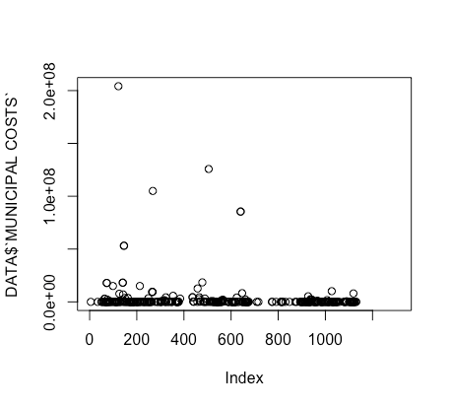

Outlier of Municipal People affected:

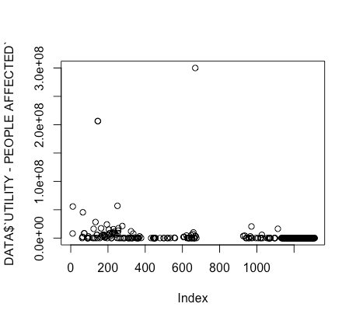

Outlier of OGD Cost:

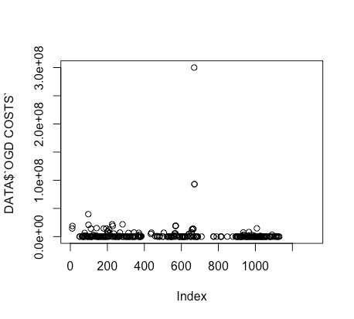

Missing values globally replaced with mean/mode

Final cluster centroids:

Cluster#

Attribute Full Data 0 1 2 3

(1381.0) (294.0) (1021.0) (57.0) (9.0)

================================================================================

utility_people_affected 0 0 0 0 0

municipal_cost 0 0 0 0 0

fatalities 0 2 0 1 3

injured 0 0 0 0 13

Time taken to build model (full training data) : 0 seconds

=== Model and evaluation on training set ===

Clustered Instances

0 294 ( 21%)

1 1021 ( 74%)

2 57 ( 4%)

3 9 ( 1%)

Class attribute: normalized_total_cost

Final cluster centroids:

Cluster#

Attribute Full Data 0 1 2 3

(1381.0) (294.0) (1021.0) (57.0) (9.0)

================================================================================

utility_people_affected 0 0 0 0 0

normalized_total_cost 0 0 0 0 0

municipal_cost 0 0 0 0 0

fatalities 0 2 0 1 3

injured 0 0 0 0 13

Time taken to build model (full training data) : 0 seconds

=== Model and evaluation on training set ===

Clustered Instances

0 294 ( 21%)

1 1021 ( 74%)

2 57 ( 4%)

3 9 ( 1%)

Class attribute: insurance_payements

kMeans

======

Number of iterations: 4

Within cluster sum of squared errors: 1948.0

Initial starting points (random):

Cluster 0: 0,0,2815608.2,0,0,0,43595000,0,0,1,4,200

Cluster 1: 0,0,0,0,0,0,0,0,0,0,0,0

Cluster 2: 0,0,0,0,0,0,0,0,0,0,0,1500

Cluster 3: 0,0,0,0,0,0,0,0,0,1,0,0

Missing values globally replaced with mean/mode

Final cluster centroids:

Cluster#

Attribute Full Data 0 1 2 3

(1381.0) (3.0) (1317.0) (4.0) (57.0)

=====================================================================================

magnitude 0 0 0 0 0

utility_people_affected 0 4828750 0 0 0

normalized_total_cost 0 304647564.1 0 0 0

federal_dfaa_payements 0 665387416 0 0 0

provincal_dfaa_payement 0 60222575 0 0 0

municipal_cost 0 2018484288 0 0 0

insurance_payements 0 1712248000 0 0 0

ogd_cost 0 166306876 0 0 0

ngo_payement 0 13071278 0 0 0

fatalities 0 35 0 0 1

injured 0 945 0 0 0

evacuated 0 17800 0 1500 0

Time taken to build model (full training data) : 0.11 seconds

=== Model and evaluation on training set ===

Clustered Instances

0 3 ( 0%)

1 1317 ( 95%)

2 4 ( 0%)

3 57 ( 4%)

Class attribute: estimated_total_cost

Classes to Clusters:

**Discussion - Machine learning**

J48 is an open source Java implementation of simple C4.5 decision tree algorithm. We saw that when we ran J48 on province(nominal) we got 48% of the results as incorrectly classified, whereas only 51% were correctly classified. Those results are definitely not good. We realize province is not a measure that can be correctly classified based on attributes like disaster_group or disaster subgroup. We also realized running the algorithm on pruned data, gave us better results than reduced error pruning. While running the J48 algorithm on Country gave us amazing results with more than 95% correctly classified instances whereas only 4% of incorrectly classified partly because having the city attribute makes it quite predictive even if disaster subgroup, disaster_group aren’t that good for classifying disasters to country. Data was highly imbalanced too with most of the events in Canada, probably overfitting the data. A very interesting result was for J48 on Canada (y/n) which gave us more than 99% of correctly classified instances well not surprising enough given that our classification attribute was also country which is a clear indicative if the country is Canada or not. To do some realistic classifications we ran J48 for disaster_subgroup since disaster group has some correlation to disaster subgroup, the results were still not the best with 61% correctly classified instances and only 38% of incorrectly classified instances. We realize disaster subgroup is a subset of disaster group and as we’d expect classifying for disaster group when the disaster subgroup is known will give us very accurate results, which it did. Disaster group on J48 gave us more than 98% of correctly classified instances.

While J48 is one of the classification algorithms for accuracy, SMO is a good choice to run some tests on. From the very first test run on SMO for Canada (y/n) we saw how good J48 was compared to SMO. SMO only classified 72% of the instances while 27% of them incorrectly. Comparing to J48 that gave us 99% of correctly classified instances and less than a percent of incorrectly classified instances.

Then we used an ensemble, ADABOOST1, which should do better but surprisingly it does worse than J48. Normally we expect bagging, boosting and ensemble to improve our results. Initially with adaboost for provinces we only got 46% of correctly classified instances but after preprocessing with SMOTE, our results improved to 48% (not a bid difference) which must’ve balanced the data a bit.

NaiveBayes Algorithm works with decision trees, and running it on disaster type gave poor results because decision trees are the not the best at determining disaster subgroup occurs so little it often gets pruned out. Hence we get more than 70% of incorrectly classified instances.Decision trees are neat because they tell you what inputs are the best predictors of the outputs so often decision trees can guide you to find if there is a statistical relationship between a given input to the output and how strong that relationship is.

**Clustering results**

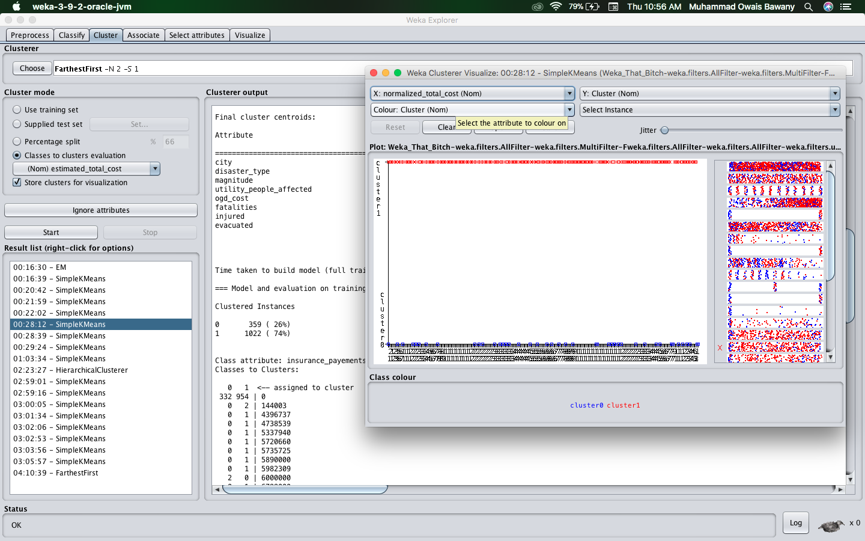

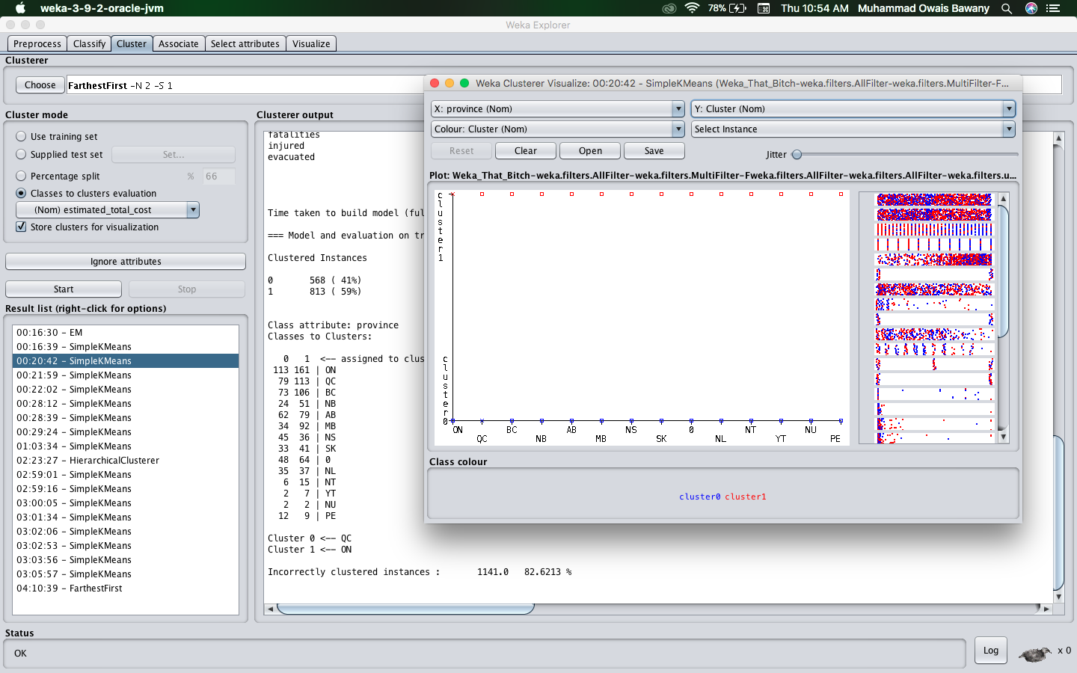

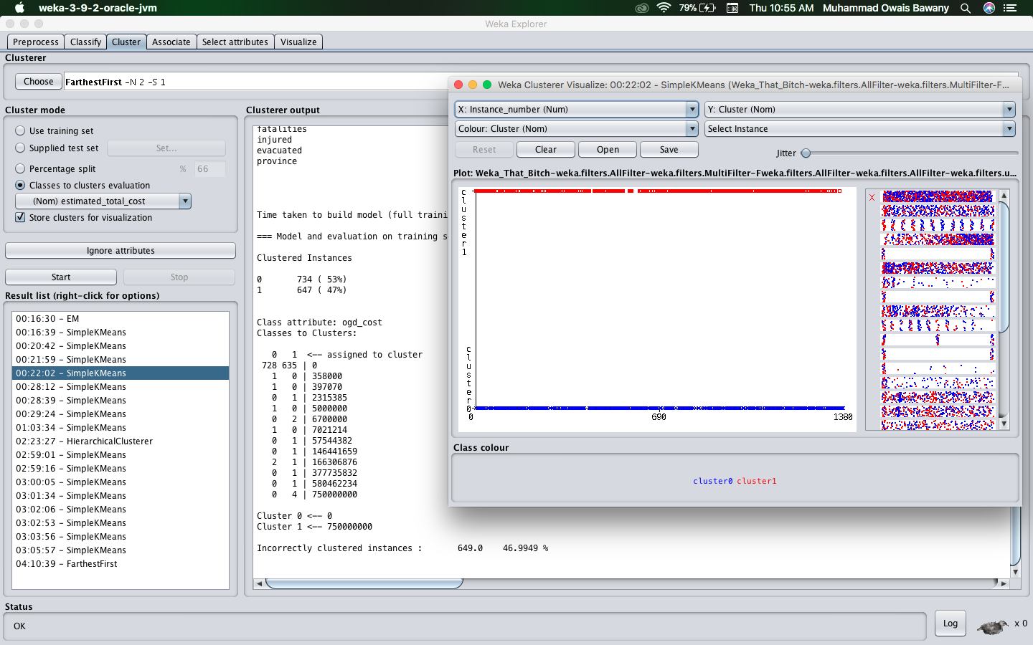

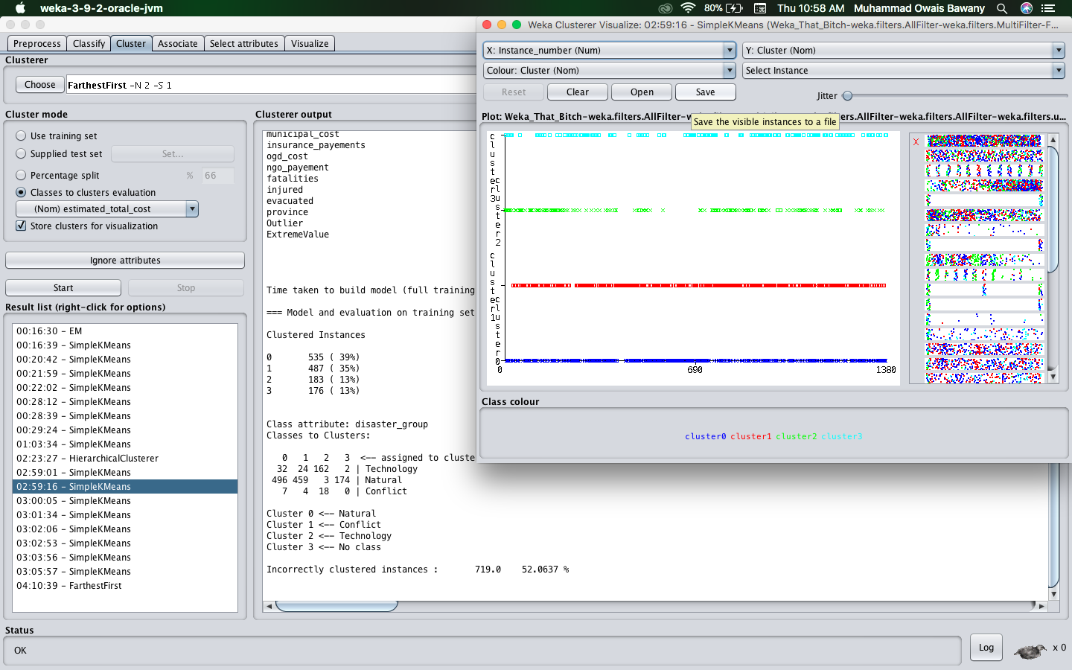

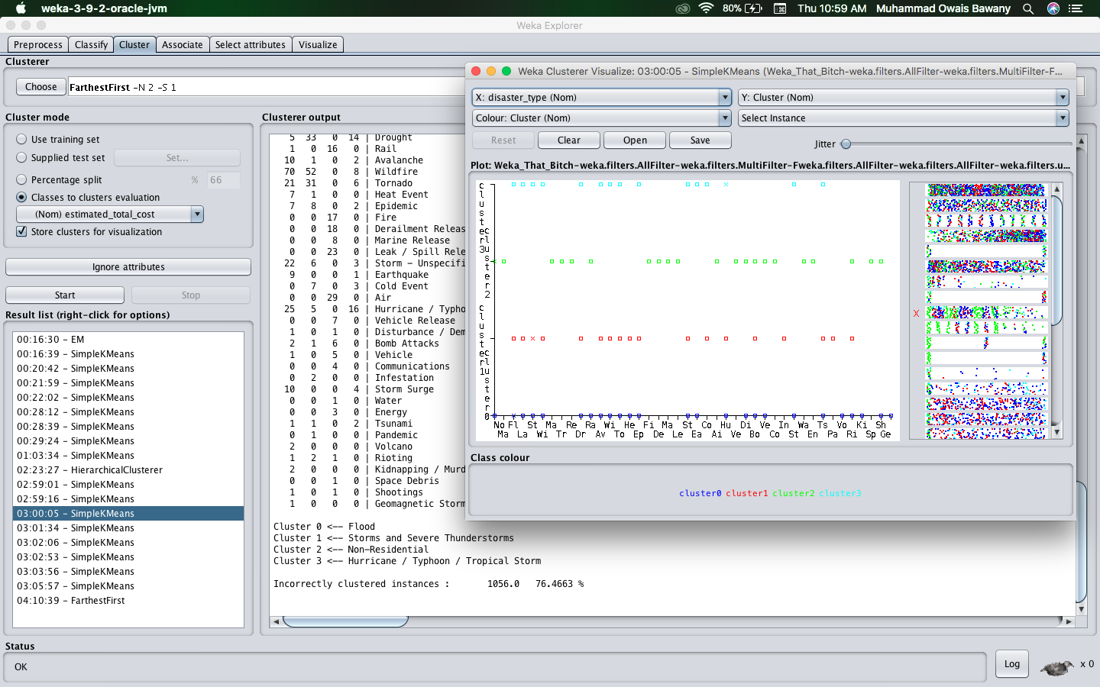

# Appendix

[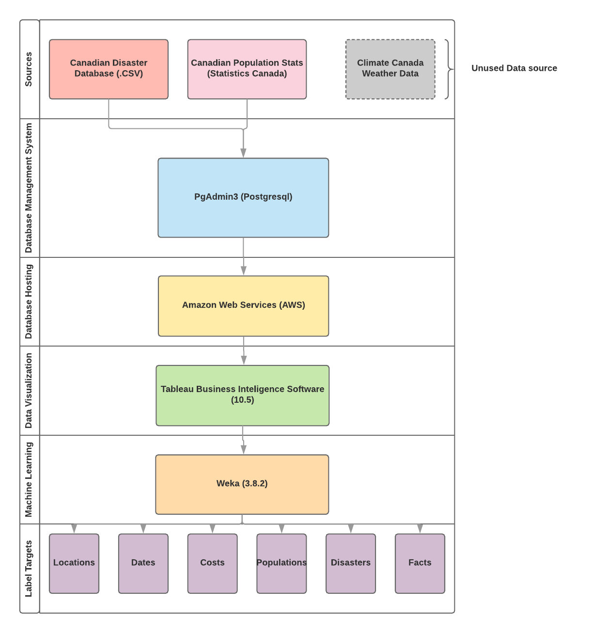](https://www.lucidchart.com/documents/edit/a837e795-9055-4c9f-b418-e89503880337/0?callback=close&name=docs&callback_type=back&v=859&s=612)

Figure 1: High-level schematic

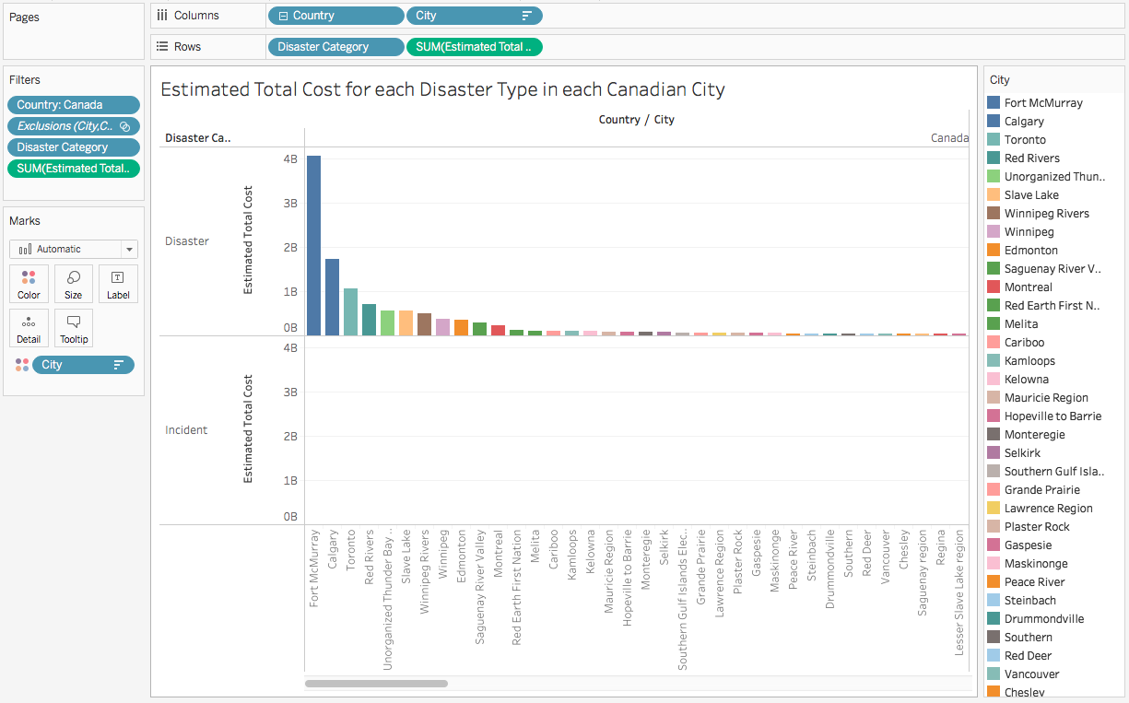

Figure 2: Example of visualizing a roll-up query in Tableau using a simple bar graph. This shows the estimated total cost of both disaster categories. OLAP query: determine total estimated costs of each disaster category IN each canadian city

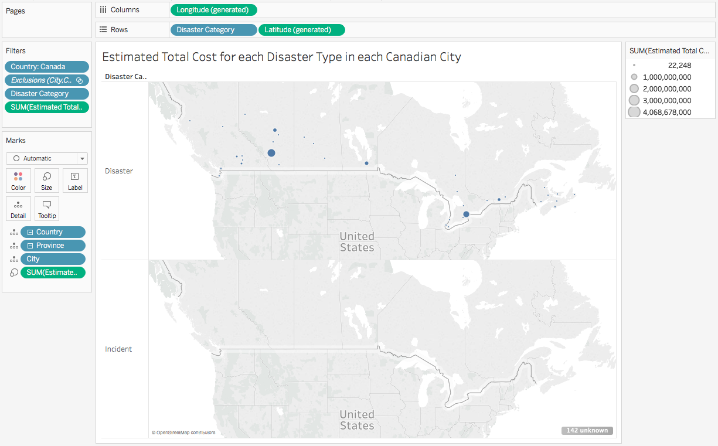

Figure 3: Example of visualizing a roll-up query in Tableau using a geographical representation of each city. This shows the estimated total cost of both disaster categories. OLAP query: determine total estimated costs of each disaster category IN each canadian city

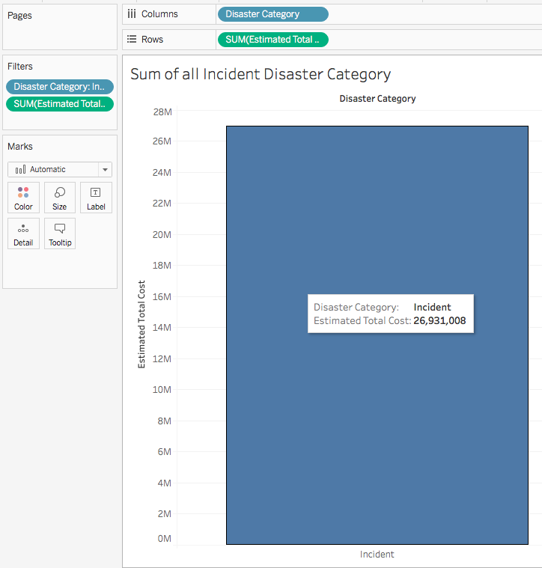

Figure 4: Example of visualizing a slice query in Tableau using a simple bar graph displaying the total estimated cost of incident disasters. OLAP query: determining the estimated total cost of incident disasters IN Canada

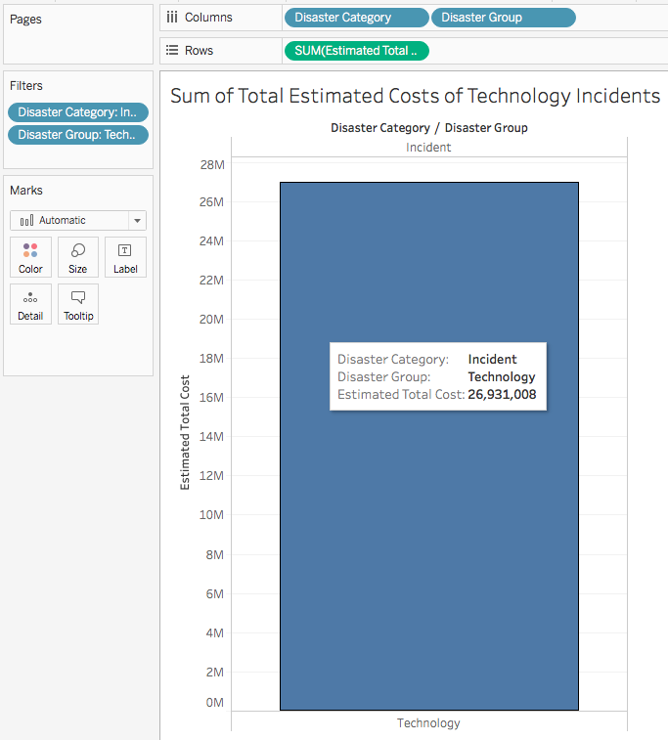

Figure 5: Example of visualizing a dice query in Tableau using a simple bar graph displaying the total estimated cost of incident technology disasters. OLAP query: determining the total cost of Technology related Incidences IN Canada

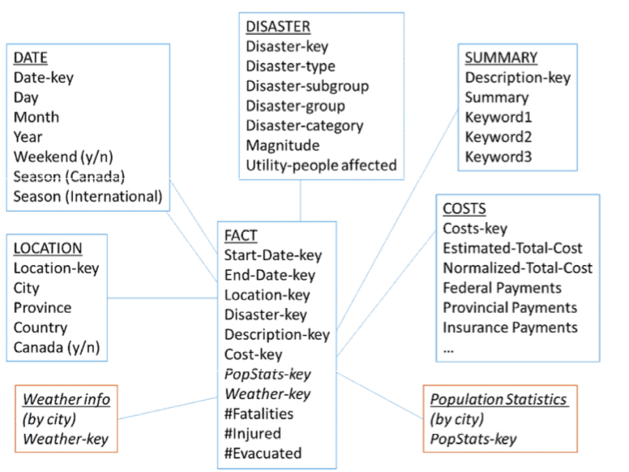

Figure 6: Data mart star schema guideline based on the manual

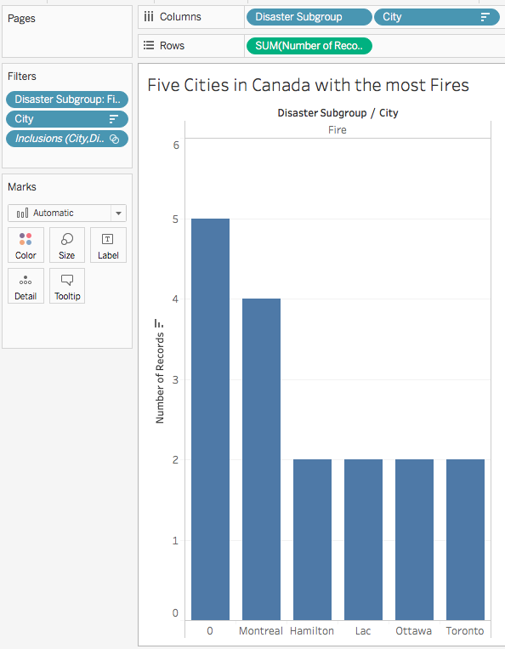

Figure 7: Example of visualizing a dice query in Tableau using a simple bar graph displaying the five cities in Canada with the most fire disasters. OLAP query: determine the 5 cities IN Canada with the most fires

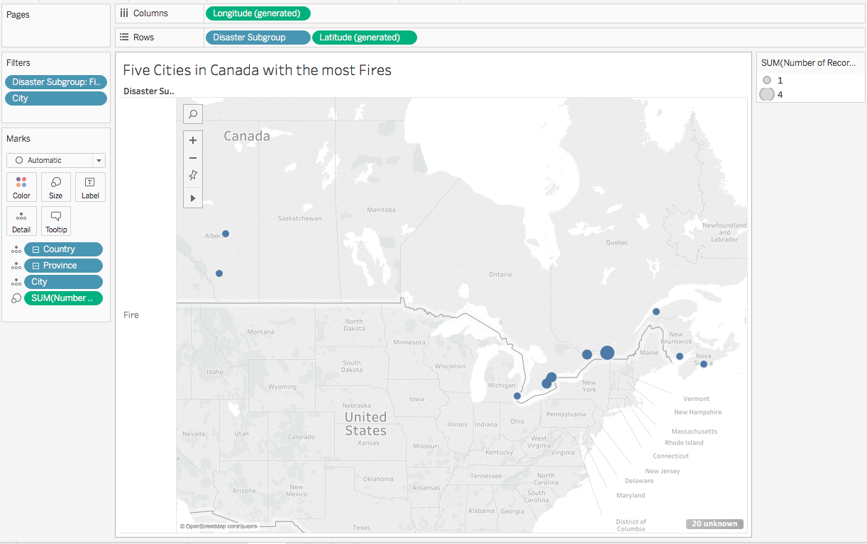

Figure 8: Example of visualizing a dice query in Tableau using a geographical representation of the five cities in Canada with the most fire disasters. OLAP query: determine the 5 cities IN Canada with the most fires

# References

1. "Meteorological Forecast - Open Government - Canada.ca." <https://open.canada.ca/data/en/dataset/4a5ff290-e27d-42f3-9b34-380599546120>. Accessed 22 Mar. 2018.
2. "Historical Climate Data." <http://climate.weather.gc.ca/>. Accessed 22 Mar. 2018.
3. "Population and dwelling counts, for Canada and census subdivisions ...." <http://www12.statcan.gc.ca/census-recensement/2011/dp-pd/hlt-fst/pd-pl/Table-Tableau.cfm?LANG=Eng&T=301&S=3&O=D>. Accessed 24 Mar. 2018.
4. "NLTK's list of english stopwords - GitHub Gist." <https://gist.github.com/sebleier/554280>. Accessed 25 Mar. 2018.
5. "The Canadian Disaster Database." 15 Dec. 2015, <https://www.publicsafety.gc.ca/cnt/rsrcs/cndn-dsstr-dtbs/index-en.aspx>. Accessed 20 Mar. 2018.