NETWORK INTRUSION DETECTION
Snort PCAP Analysis Report
IDS Fundamentals • Technical Case Study
Prepared by Md Obaydur Rahman
Prepared by: Md Obaydur Rahman
Cybersecurity Analyst – Network Security & Intrusion Detection
Snort Intrusion Detection Analysis Report
TryHackMe – IDS Fundamentals | PCAP Investigation

Project | Snort PCAP Analysis
PCAP | Intro_to_IDS.pcap
Focus | SSH detection and Snort rule analysis
Analyst | Md Obaydur Rahman

1. Executive Summary
This case study documents a hands-on network intrusion-detection investigation using the supplied PCAP file. I reviewed the captured traffic, identified the host that initiated the SSH connection attempt, checked for additional activity, and verified the Snort rule responsible for the SSH alert.
The investigation identified 10.11.90.211 as the source of the SSH connection attempt. I also confirmed a separate ping/ICMP detection and verified that the SSH detection rule uses SID 1000002.

2. Scope and Environment
- Operating environment: Ubuntu-based TryHackMe lab machine
- Analysis directory: /etc/snort
- PCAP file: Intro_to_IDS.pcap
- Primary tool: Snort
- Supporting tool: tcpdump / grep

3. Methodology
I started by locating the supplied PCAP in the Snort lab directory. I then focused on TCP port 22 traffic to determine which host initiated the SSH connection. Finally, I searched the Snort rule files to verify the alert message and SID.
Key commands used:
cd /etc/snort
sudo tcpdump -nn -r Intro_to_IDS.pcap 'tcp port 22'
grep -Ri 'SSH Connection Detected' /etc/snort/rules/
grep -Ri 'SSH Connection Detected' /etc/snort/rules/ | grep -o 'sid:[0-9]*'

4. Findings

4.1 SSH Source IP Address
The captured TCP traffic shows communication between 10.10.161.151 on TCP port 22 and 10.11.90.211 using an ephemeral source port (54334). The traffic demonstrates that 10.11.90.211 was the machine initiating the SSH connection toward the subject host.
Finding: SSH source IP address: 10.11.90.211
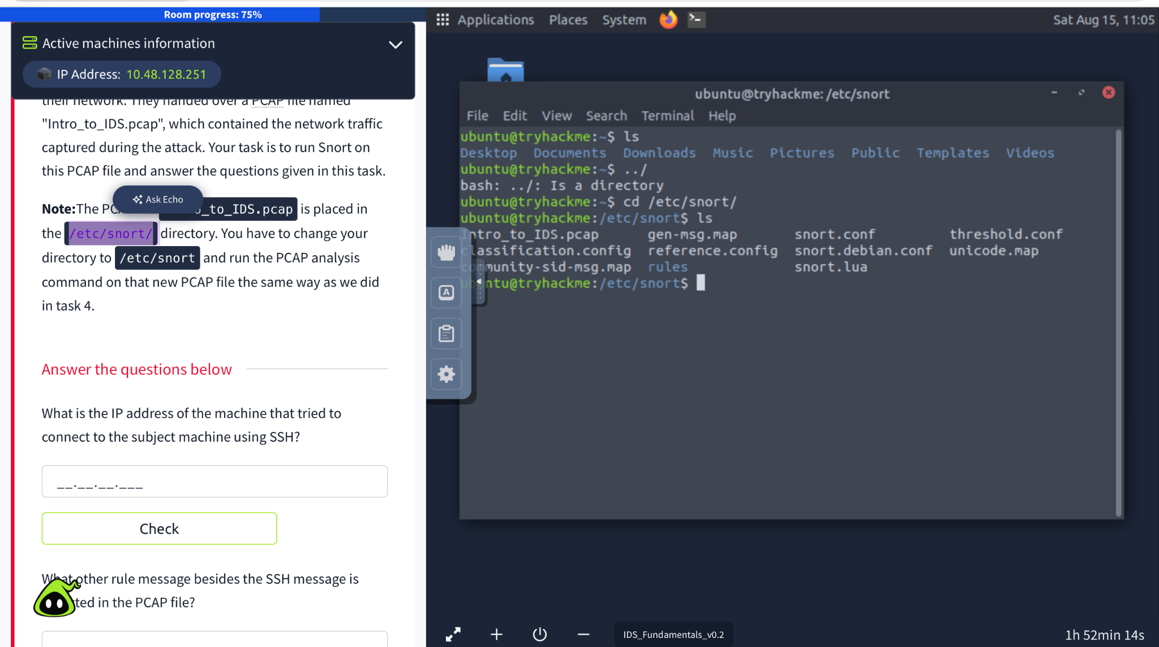
Figure 1. PCAP traffic showing TCP/22 communication involving 10.11.90.211.

4.2 Additional Alert in the PCAP
The PCAP also contains ICMP/ping activity. In the Snort rule set used for the lab, this activity is associated with the alert message “Ping Detected.” This is the additional rule message requested by the exercise, besides the SSH alert.
Finding: Additional rule message: Ping Detected
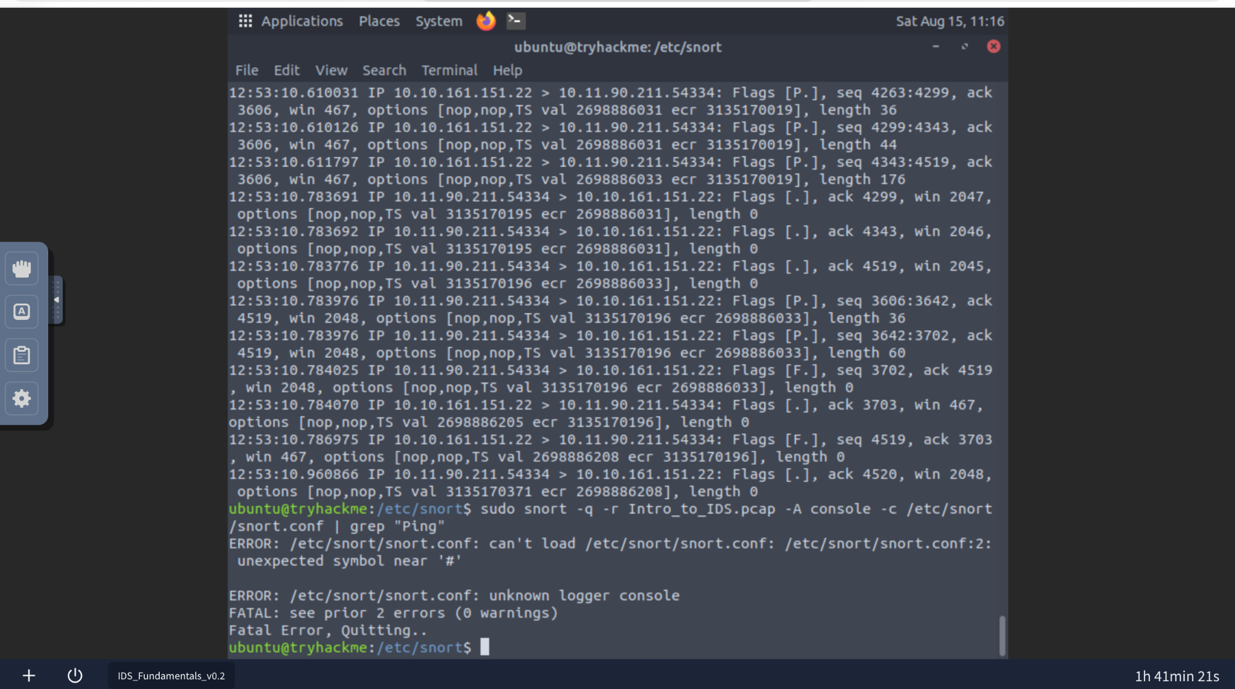
Figure 2. Snort configuration error encountered while attempting to load snort.conf.

4.3 SSH Detection Rule and SID
A direct search of the Snort rule files confirmed the SSH detection rule. The relevant rule contains the message “SSH Connection Detected” and assigns the rule a Snort ID (SID) of 1000002.
Finding: SSH detection SID: 1000002
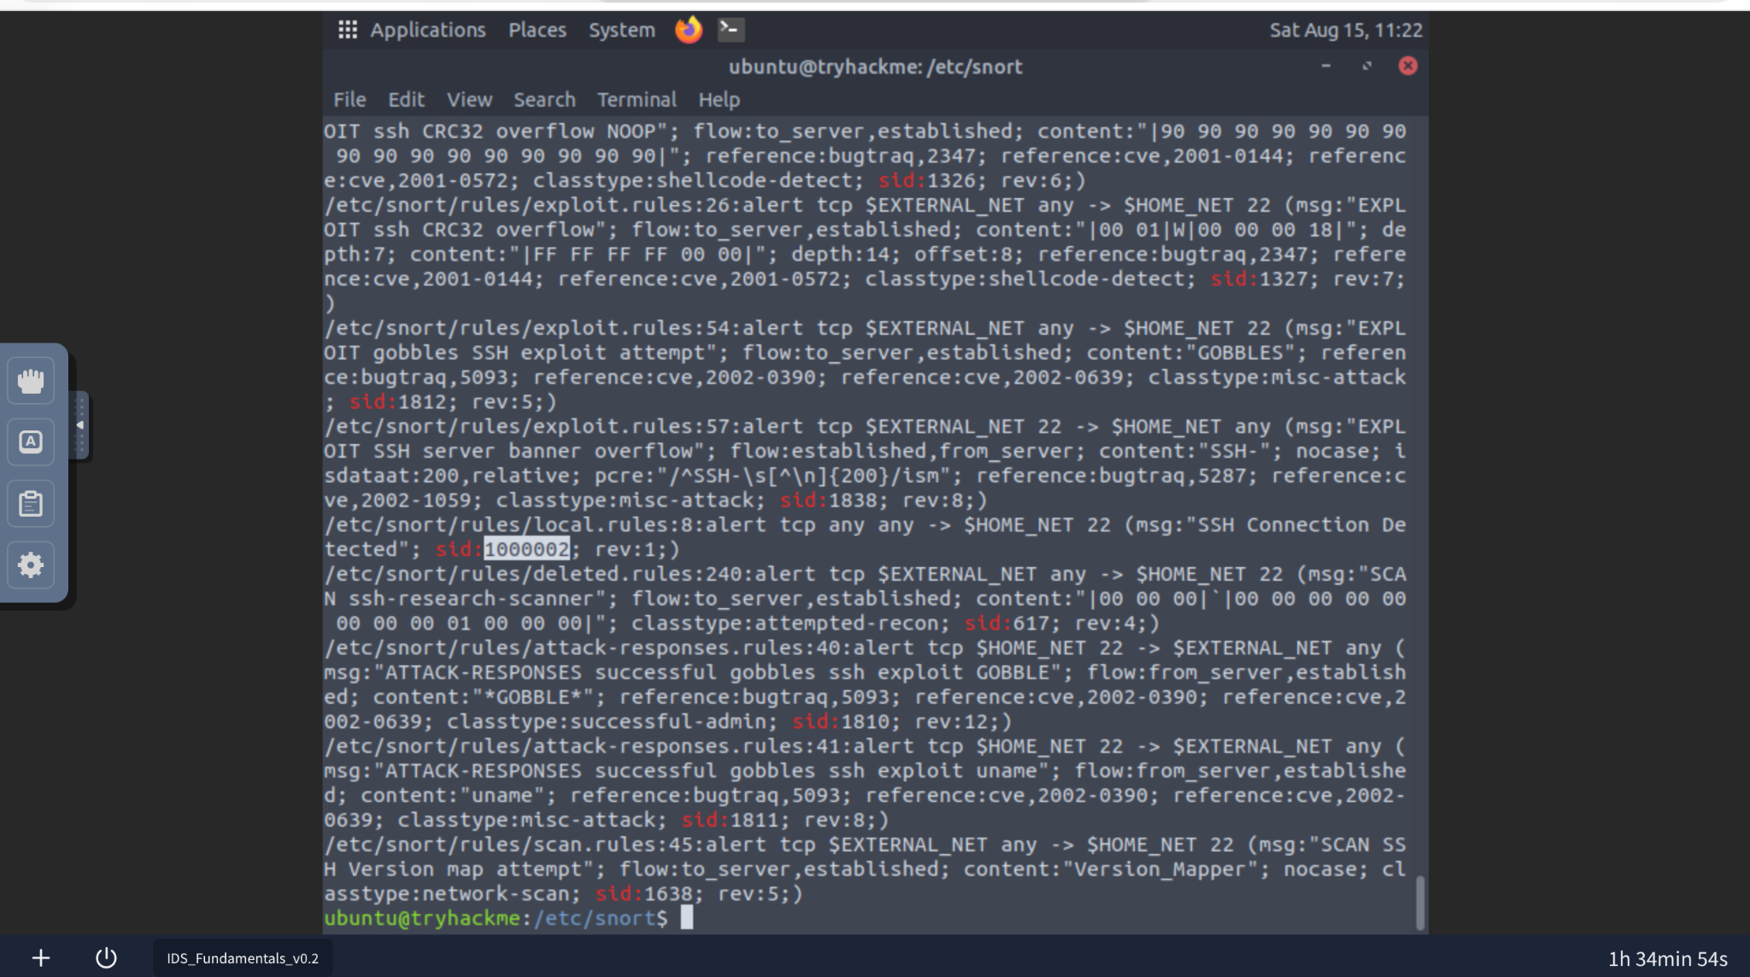
Figure 3. Snort rule search confirming “SSH Connection Detected” with SID 1000002.

5. Analysis Note
One practical issue came up during the investigation: the supplied snort.conf produced a configuration parsing error. Rather than changing the lab configuration, I used direct PCAP inspection and targeted searches of the Snort rule files. This kept the investigation focused on the available evidence and was enough to verify the required findings.

6. Key Findings
Investigation Item | Result
SSH source IP address | 10.11.90.211
Other detected rule message | Ping Detected
SSH rule message | SSH Connection Detected
SSH rule SID | 1000002
PCAP analyzed | Intro_to_IDS.pcap

7. Conclusion
The PCAP investigation successfully identified the host associated with the SSH connection attempt as 10.11.90.211. The analysis also confirmed the presence of ping-related detection activity and verified that the Snort rule responsible for the SSH connection alert uses SID 1000002. These findings provide a concise record of the network indicators and detection rule information observed during the lab.

