MorseAI
An End-to-End Edge AI Workflow on Raspberry Pi 5
A beginner-friendly tutorial for building and deploying neural networks on Arm-based edge hardware

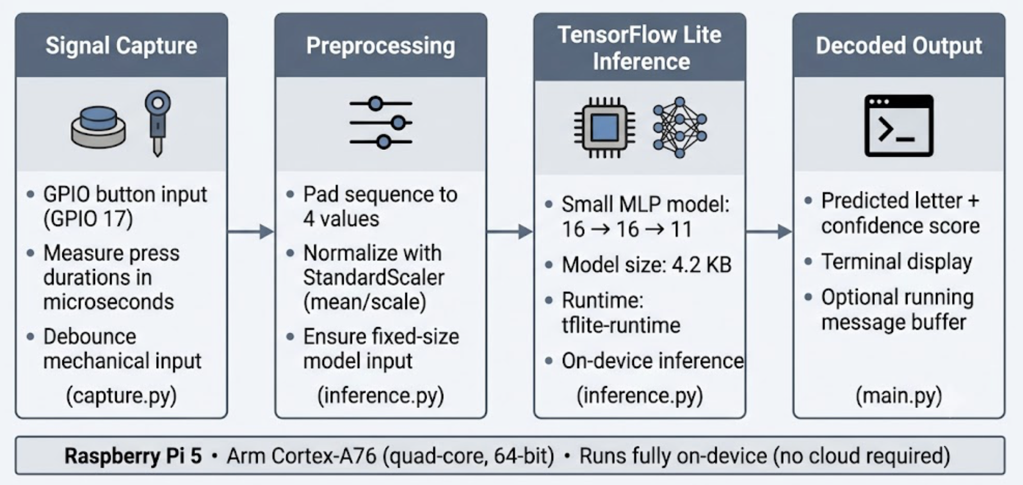

Project | MorseAI: Raspberry Pi 5 port of an Arm STM32 workshop project
Platform | Raspberry Pi 5 (Arm Cortex-A76), 64-bit Raspberry Pi OS
Framework | TensorFlow / TensorFlow Lite (tflite-runtime)
Author | Obed Babington
Status | Tutorial documentation
Date | ______________________

Executive Summary
MorseAI is a compact, complete example of an Edge AI application: a user taps a letter in Morse code on a single push button, and a neural network running entirely on a Raspberry Pi 5 identifies the letter in real time. There is no cloud service and no network round-trip: capture, preprocessing, and inference all happen on the device.
The project began as an Arm workshop on an STM32 microcontroller and was ported to the Raspberry Pi 5 to serve as an accessible teaching platform. Its value is not the Morse problem itself but the workflow it demonstrates: capturing a sensor signal, turning it into features, training a small model off-device, converting it to TensorFlow Lite, and running inference on Arm hardware. That same four-stage pattern underpins practical edge workloads such as sensor classification, vibration-based predictive maintenance, gesture recognition, and anomaly detection.
The deployed model is approximately 4.2 KB and imposes negligible load on the Pi 5, leaving ample headroom to scale up to real sensors and larger models. This document describes the motivation, architecture, implementation decisions, measured resource cost, and the paths from this tutorial to production Edge AI systems, including a comparison with the original microcontroller implementation.

1. Introduction and Motivation
Most introductions to machine learning stop at a notebook: a model is trained, an accuracy number is reported, and the work ends there. The harder and more useful skill is getting a model off the laptop and onto hardware where it has to deal with real, messy input. MorseAI was built to teach exactly that transition, using the smallest honest example we could find.
Morse code is a good first signal to classify because each character is just a handful of button presses that differ only in duration. The data is tiny and human-readable, you can generate your own dataset in minutes, and the problem is genuinely temporal: the same class of concern (timing, noise, sampling) that appears in audio and vibration, but slow enough to debug by hand. It is explicitly a learning example, not an industrial product, and it is framed that way throughout.

2. Why Morse Code Is a Good First Edge AI Problem
- Small, interpretable input. Each character is at most four press durations: four numbers you can read and sanity-check by eye.
- Genuinely temporal. A dot and a dash differ only in duration, which forces real thinking about timing and noise.
- You own the data. A usable dataset is collected by pressing a button, so the learner controls the whole pipeline end to end.
- Instructive failure modes. Ambiguous taps show why a learned model is more forgiving than a hand-tuned threshold, motivating the use of ML in the first place.

3. System Architecture
The system is a four-stage pipeline. Each stage maps to a single source file, which keeps every part independently testable. The training step runs once, off-device; everything in Figure 1 runs on the Pi.

Figure 1. The MorseAI Edge AI pipeline: signal capture → preprocessing → TensorFlow Lite inference → decoded output, running on-device on a Raspberry Pi 5.
Stage | File | Responsibility
Signal capture | capture.py | Time button presses, debounce, detect end-of-character
Preprocessing | inference.py | Pad to four values, apply the training StandardScaler
Inference | inference.py | Run the TFLite interpreter; return top class + confidence
Output | main.py | Wire capture to inference; print results; hold session state

Table 1. Mapping of pipeline stages to source files.

4. Implementation

4.1 Signal Capture
The button is read with the gpiozero library, which fires callbacks on press and release. A monotonic, high-resolution clock (perf_counter_ns) measures each press duration in microseconds. Two implementation details matter more than they appear: a 50 ms debounce filter, so mechanical contact chatter registers as a single press; and a 2-second end-of-character timeout, implemented as a small cancel-and-rearm timer that decides when a character is complete. Each character is stored as up to four durations and zero-padded to a fixed length of four.

4.2 Preprocessing and Feature Representation
Raw press durations span tens to hundreds of thousands of microseconds. A StandardScaler (subtract mean, divide by standard deviation) brings them into a range the network trains on efficiently. Critically, the identical transform must be applied at inference time, so the scaler parameters are exported with the model and reloaded on the device. A normalization mismatch is the most common cause of a model that loads correctly but predicts nonsense.

4.3 Model Design and Training
The classifier is a small feed-forward network: two hidden layers of 16 ReLU units feeding an 11-way softmax (ten letters A–J plus one “unclassified” class). With only four inputs and ten classes, depth is unnecessary and a larger model would simply overfit the 450-sample dataset. The eleventh class is trained on a small fraction of random noise vectors so the model can respond “I don’t know” rather than forcing garbage onto the nearest letter, a small change that makes the deployed system noticeably more robust. Training uses Adam, sparse categorical cross-entropy, and early stopping on validation loss.

4.4 Conversion to TensorFlow Lite
The trained Keras model is converted with the TFLite converter using default optimizations (weight quantization). Conversion produces two artifacts: the model file (4,276 bytes) and a normalization configuration file holding the scaler mean and scale. Shipping the normalization parameters alongside the model is what makes the result reproducible on a different machine.

4.5 On-Device Inference
Inference on the Pi uses tflite-runtime rather than full TensorFlow: it is a few megabytes instead of hundreds, starts quickly, and is sufficient for running (not training) a model. A prediction normalizes the input, sets the input tensor, invokes the interpreter, and takes the argmax of the softmax output, returning the predicted letter with a confidence score and a measured inference time.

5. Performance on Raspberry Pi 5
Edge AI is judged on resource cost. The figures in Table 2 were measured on a Raspberry Pi 5 with python benchmark.py (10,000 iterations, 4 threads, 200 warmup). TFLite loads the XNNPACK CPU delegate automatically.
Metric | Value | How measured
Model size (disk) | 4.18 KB (4,276 bytes) | ls -l of the .tflite file
Input / output | 4 × float32 → 11 × float32 | model signature
Inference latency (median) | 3.0 µs | warm invoke() calls
Inference latency (mean / p95) | 3.1 / 3.1 µs | same run
Inference latency (min / max) | 3.0 / 79.8 µs | same run
Throughput | ~280,400 inferences/s | tight loop, 4 threads
Interpreter memory (RSS Δ) | 2.7 MiB | 39.5 MiB before → 42.2 MiB after load
Process RSS after load | 42.2 MiB | /proc resident set size
CPU during benchmark loop | 100% | process CPU time ÷ wall time

Table 2. Measured resource cost of the MorseAI model on Raspberry Pi 5.
Latency is far below one millisecond. In normal use with main.py, the bottleneck is the 2-second character timeout, not inference. A 4 KB model leaves large headroom for real sensors and bigger networks.
CPU note: the benchmark runs a tight loop with no idle time between calls. 100% means the process kept one core busy for the timed section. It does not mean all four Pi cores were saturated, and it is not typical of CPU use while waiting for button input.
To reproduce: activate the project venv and run python benchmark.py from the repo root.

6. Extending the Pattern to Real-World Workloads
The pipeline does not change when the problem becomes serious. Replace the button with a different sensor, retrain on the new data, and redeploy the same way: capture → preprocess → TFLite inference → act. The following applications reuse the same skeleton.
Application | What changes | What stays the same
Sensor classification | Accelerometer / environmental sensor instead of a button | Fixed-length feature vector, small MLP
Predictive maintenance / vibration | Windowed vibration signal; normal vs. fault label | Time-series in, classification out
Gesture recognition | IMU data from a wearable | Variable-length input → fixed feature trick
Anomaly detection | Learn “normal”; flag drift | The “unclassified” idea, generalised
Other IoT edge workloads | Keyword spotting, occupancy, fault detection | On-device decision, no cloud round-trip

Table 3. The same capture-to-inference pipeline applied to practical Edge AI workloads.
The step up from this tutorial is usually more and better data, a slightly larger model, and windowing a continuous stream rather than discrete presses; none of which change the deployment story.

7. STM32 vs. Raspberry Pi 5: Two Faces of Edge AI
Because the project exists on both an STM32 microcontroller and a Raspberry Pi 5, it offers a clear side-by-side of two points on the Edge AI spectrum. Neither is strictly better; they answer different questions.
Dimension | STM32 (microcontroller) | Raspberry Pi 5 (Linux SBC)
Developer experience | Bare-metal / RTOS, C/C++, flash-and-debug | Full Linux, Python, edit-and-run
Toolchain | TFLite Micro, C compiler, model as C array | TensorFlow → TFLite, tflite-runtime, pip/venv
Deployment workflow | Cross-compile and flash firmware | git pull and run a script
Compute & memory | Hundreds of KB RAM, MHz core, no OS | GBs of RAM, GHz quad Cortex-A76, full OS
Iteration speed | Slow: recompile + reflash | Fast: edit a line, rerun in seconds
Power & cost | Milliwatts; cents to dollars | Watts; tens of dollars
Best for | Always-on, battery, cost-sensitive, real-time | Prototyping, heavier models, learning, gateways

Table 4. Developer-facing comparison of the STM32 and Raspberry Pi 5 implementations.
A realistic workflow uses both: develop and validate the model on the Pi, where the fast edit-run loop keeps attention on the problem, then port the proven model down to the STM32 with TFLite Micro when microwatt power, cents-level unit cost, or hard real-time guarantees are required. The Pi is the workshop; the microcontroller is the finished product.

8. Challenges and Lessons Learned
- The signal is harder than the network. Debounce, the end-of-character timeout, and padding took more effort than the model, typical for Edge AI.
- Normalization is a deployment concern. Shipping the scaler with the model is essential; a mismatch yields confident nonsense.
- An explicit “I don’t know” class pays off. It lets the system degrade gracefully on ambiguous input.
- tflite-runtime vs. TensorFlow is a real choice. The runtime is the right tool for inference-only deployment and shaped the Python setup.
- Threads don’t always help tiny models. Per-call overhead can dominate; benchmark.py makes it easy to compare 1, 2, and 4 threads.

9. Conclusion and Future Work
MorseAI shows that a complete Edge AI workflow, from sensor capture to on-device inference, fits in a few small, readable files on a Raspberry Pi 5. The Morse problem is intentionally simple so that the workflow, which transfers directly to practical sensor and IoT applications, stays in focus. For a beginner, it is a realistic first deployment; for a practitioner, it is a clean template to adapt.
- Grow and balance the dataset; extend coverage to full A–Z and digits.
- Decode whole words using inter-character and inter-word gaps.
- Add an int8-quantized variant and compare accuracy against size.
- Provide TFLite Micro build notes for porting back to the STM32 target.

Appendix A: Hardware Setup and Wiring
Button terminal | Pi physical pin | Pi function | Role
Terminal 1 | Pin 11 | GPIO 17 (BCM) | Signal in
Terminal 2 | Pin 9 | GND | Ground

Table A1. Button wiring. The code enables the internal pull-up, so no external resistor is required.

Appendix B: Reproducing the Results
- Train and convert the model with training/MorseAI_RPi_Notebook.ipynb.
- Deploy on the Pi with setup_pi.sh, then run python main.py.
- Benchmark inference with python benchmark.py (no GPIO required).
- Regenerate the architecture figure with docs/make_diagram.py.

