EXP:3 | 3.PAYSLIP GENERATION

AIM: To develop a java console application to find the gross and net salary using inheritage.

REQUIREMENT:
Develop a java application to create a package payroll and to create the class as
employee with emp_name,emp_id,address,mail_id,mobile_no as data members.
Inherit the classes as programmer,assistantprofessor,associativeprofessor,professor.add
the basic pay as data member for these classes.
create the class calculation to print the DA,HRA,PF,Staff club fund,gross salary and net
salary for the inheritage classes.
ALGORITHM:
1. Declare a package payroll.
2. Declare the class as employee.
3. Declare a constructor and add the data members.
4. Inherit the classes from the super class and add the data members as basic pay.
5. Calculate the gross salary and net salary on the inheritage.
6. Display the result.
CLASS DIAGRAM:
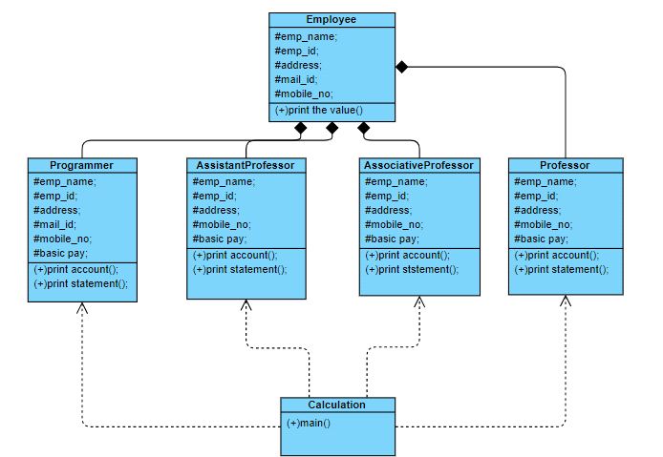

PROGRAMME:
/**
* program to represent employee details
* @author A.mahesh
* maheshraju.9381@gmail.com
*/
package Payroll;
public class Employee {
protected String emp_name;
protected long emp_id;
protected String address;
protected String mail_id;protected long mobile_no;
public Employee()
{
emp_name="name";
emp_id=123123;
address="not given";
mail_id="not given";
mobile_no=91637543;
}
public Employee(String n,long id,String add,String mail,long num)
{
emp_name=n;
emp_id=id;
address=add;
mail_id=mail;
mobile_no=num;
}
public void printaccount()
{
System.out.println("Name of the employee:"+emp_name);
System.out.println("Employee ID:"+emp_id);
System.out.println("Address:"+address);
System.out.println("Mail ID of the employee:"+mail_id);
System.out.println("Mobile number of the employee:"+mobile_no);
}
}
/**program to represent BP of programmer
* @author A.mahesh
* maheshraju.9381@gmail.com
*/
package Payroll;
public class Programmer extends Employee {
private double basicpay;
public Programmer()
{
basicpay=0;
}
public Programmer(String n,long id,String add,String mail,long num,double BP)
{
super(n,id,add,mail,num);
basicpay=BP;
}
public void printAccount()
{
super.printaccount();
System.out.println("Basic pay:"+basicpay);
System.out.println("----------------------------------------------------------
--------------------------------------------------");
}
public void printStatement()
{
double total;
double total1;
double total2;
double total3;double gross;
double net;
printAccount();
total=basicpay*0.97;
total1=basicpay*0.1;
total2=basicpay*0.12;
total3=basicpay*0.001;
gross=total+total1+total2+total3;
net=gross-total2-total3;
System.out.printf("duty allowance(DA):%.2f\n",total);
System.out.printf("HRA:%.2f\n",total1);
System.out.printf("PF:%2f\n",total2);
System.out.printf("staff club fund:%.2f\n",total3);
System.out.printf("gross salary is:%.2f\n",gross);
System.out.printf("net salary is:%.2f\n",net);
}
}
/**
* program to represent BP of Assistant professor
* @author A.mahesh
* maheshraju.9381@gmail.com
*/
package Payroll;
public class AssistantProfessor extends Employee {
private double basicpay;
public AssistantProfessor()
{basicpay=0;
}
public AssistantProfessor(String n,long id,String add,String mail,long num,double BP)
{
super(n,id,add,mail,num);
basicpay=BP;
}
public void printAccount()
{
super.printaccount();
System.out.println("Basic pay:"+basicpay);
}
public void printStatement()
{
double total;
double total1;
double total2;
double total3;
double gross;
double net;
printAccount();
total=basicpay*0.97;
total1=basicpay*0.1;
total2=basicpay*0.12;
total3=basicpay*0.001;
gross=total+total1+total2+total3;
net=gross-total2-total3;
System.out.printf("duty allowance(DA):%.2f\n",total);
System.out.printf("HRA:%.2f\n",total1);
System.out.printf("PF:%2f\n",total2);System.out.printf("staff club fund:%.2f\n",total3);
System.out.printf("gross salary is:%.2f\n",gross);
System.out.printf("net salary is:%.2f\n",net);
System.out.println("----------------------------------------------------------
--------------------------------------------------");
}
}
/**
* program to represent BP of Associative professor
* @A.mahesh
* maheshraju.9381@gmail.com
*/
package Payroll;
public class AssociativeProfessor extends Employee {
private double basicpay;
public AssociativeProfessor()
{
basicpay=0;
}
public AssociativeProfessor(String n,long id,String add,String mail,long num,double
BP)
{
super(n,id,add,mail,num);
basicpay=BP;
}
public void printAccount()
{
super.printaccount();
System.out.println("Basic pay:"+basicpay);}
public void printStatement()
{
double total;
double total1;
double total2;
double total3;
double gross;
double net;
printAccount();
total=basicpay*0.97;
total1=basicpay*0.1;
total2=basicpay*0.12;
total3=basicpay*0.001;
gross=total+total1+total2+total3;
net=gross-total2-total3;
System.out.printf("duty allowance(DA):%.2f\n",total);
System.out.printf("HRA:%.2f\n",total1);
System.out.printf("PF:%2f\n",total2);
System.out.printf("staff club fund:%.2f\n",total3);
System.out.printf("gross salary is:%.2f\n",gross);
System.out.printf("net salary is:%.2f\n",net);
System.out.println("----------------------------------------------------------
--------------------------------------------------");
}
}
/**
* program to represent BP of professor* @author A.mahesh
* maheshraju.9381@gmail.com
*/
package Payroll;
public class Professor extends Employee {
private double basicpay;
public Professor()
{
basicpay=0;
}
public Professor(String n,long id,String add,String mail,long num,double BP)
{
super(n,id,add,mail,num);
basicpay=BP;
}
public void printAccount()
{
super.printaccount();
System.out.println("Basic pay:"+basicpay);
}
public void printStatement()
{
double total;
double total1;
double total2;
double total3;
double gross;
double net;
printAccount();total=basicpay*0.97;
total1=basicpay*0.1;
total2=basicpay*0.12;
total3=basicpay*0.001;
gross=total+total1+total2+total3;
net=gross-total2-total3;
System.out.printf("duty allowance(DA):%.2f\n",total);
System.out.printf("HRA:%.2f\n",total1);
System.out.printf("PF:%2f\n",total2);
System.out.printf("staff club fund:%.2f\n",total3);
System.out.printf("gross salary is:%.2f\n",gross);
System.out.printf("net salary is:%.2f\n",net);
System.out.println("----------------------------------------------------------
--------------------------------------------------");
}
}
CALCULATION:

package Payroll;

public class Calculation {

public static void main(String[] args) {
Programmer pro;
AssistantProfessor Asspro;
AssociativeProfessor Asopro;
Professor prof;
pro=new Programmer("mahesh",250076,"Chennai","account@gmail.com",667457845,786547);

Asspro=new AssistantProfessor("Rohith",698700,"Chennai","account@gmail.com",79857001l,89324);
Asopro=new AssociativeProfessor("Mani",960654,"Chennai","account@gmail.com",958574785,88769);
prof=new Professor("Karthik",900786,"chennai","account@gmail.com",895689561,675675);
pro.printStatement();
Asspro.printStatement();
Asopro.printStatement();
prof.printStatement();
}

}

OUTPUT:
Name of the employee:mahesh
Employee ID:250076
Address:Chennai
Mail ID of the employee:account@gmail.com
Mobile number of the employee:667457845

-------------------------------------------------
Basic pay:786547.0

-------------------------------------------------
duty allowance(DA):762950.59
HRA:78654.70
PF:94385.640000
staff club fund:786.55
gross salary is:936777.48
net salary is:841605.29

-------------------------------------------------

Name of the employee:Rohith
Employee ID:698700
Address:Chennai
Mail ID of the employee:account@gmail.com
Mobile number of the employee:79857001

-------------------------------------------------
Basic pay:89324.0

-------------------------------------------------
duty allowance(DA):86644.28
HRA:8932.40
PF:10718.880000
staff club fund:89.32
gross salary is:106384.88
net salary is:95576.68

-------------------------------------------------

Name of the employee:Mani
Employee ID:960654
Address:Chennai
Mail ID of the employee:account@gmail.com
Mobile number of the employee:958574785

-------------------------------------------------
Basic pay:88769.0

-------------------------------------------------
duty allowance(DA):86105.93
HRA:8876.90
PF:10652.280000
staff club fund:88.77
gross salary is:105723.88
net salary is:94982.83

-------------------------------------------------

Name of the employee:Karthik
Employee ID:900786
Address:chennai
Mail ID of the employee:account@gmail.com
Mobile number of the employee:895689561

-------------------------------------------------
Basic pay:675675.0

-------------------------------------------------
duty allowance(DA):655404.75
HRA:67567.50
PF:81081.000000
staff club fund:675.68
gross salary is:804728.93
net salary is:722972.25

RESULT:
Thus the java application for generation of pay slip is developed by using inheritage classes.

