EX-01 To Generate ElectricityBill

Aim:
To develop a java console application to generate ElectricityBill and to create a package biiling and to create a class ElectricityBill with the following members:customer no,customer name,previous month reading,current month reading,type

Requirements:
Create a class ElectricityBills with the following Data members:custumer no,customer name,previous month reading,current month reading,type
Member function: Read the value,compute the value,print the value

Algorithm:

STEP1:Declare a package Billings
STEP2:Declare a class name ElectricityBill
STEP3:Declare a constructor with initial attribute
STEP4:Declare a data member and a member function
STEP5:Declare a class Calculation1 with static main function
STEP6:Create object of type with customer name,customer no,previous month reading,current month reading,customer tyoe(Domestic or Commercial)
STEP7:Get the input from the user
STEP8:Calculate the total electricity bill
STEP9:Display result

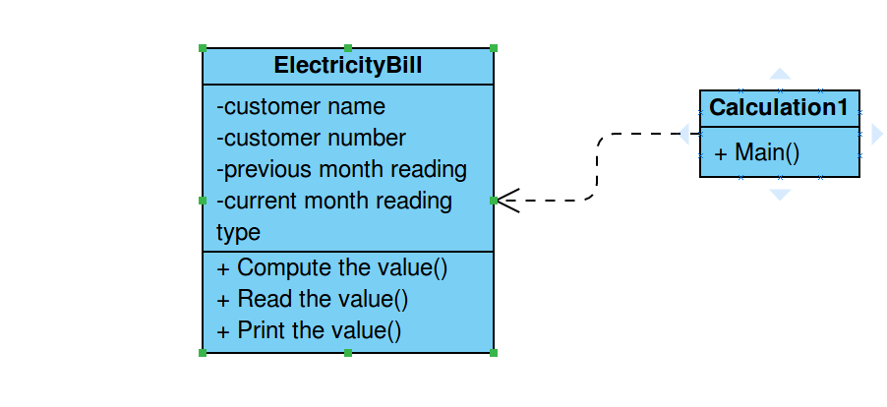

Programme:
ElectricityBill.java

package billings;
import java.util.Scanner;
import java.util.Scanner;
/**
* Electricity bill
* @author maahi
*
*/
public class ElectricityBill {
private long customernumber;
private String customername;
private double previousmonthreading;
private double currentmonthreading;
private String customertype;

/**
* to create electricity bill with initial values
*
*/
public ElectricityBill()
{
this.customernumber=1000;
this.customername="unknown";
this.currentmonthreading=0;
this.previousmonthreading=0;
this.customertype="Domestic";

}
public ElectricityBill(long number,String name,double c_reading,double p_reading,String type)
{
this.customernumber=number;
this.customername=name;
double c_rating;
currentmonthreading=c_reading;
previousmonthreading=p_reading;
customertype=type;

}
/**
* to get bill information from the user
*/
public void getData()
{
Scanner sc=new Scanner(System.in);

System.out.printf("\n%40s","BILLING INFORMATION");
System.out.print("\nEnter the customer number:");
this.customernumber=sc.nextLong();
System.out.print("Enter the customer name:");
customername= sc.next();
System.out.print("Enter the current month reading:");
currentmonthreading=sc.nextDouble();
System.out.print("Enter the previous month reading");
previousmonthreading=sc.nextDouble();
System.out.print("Enter the customer type (Domestic or Commercial):");
customertype=sc.next();

}
/**
* to print the bill details
*/
public void printData()
{
System.out.printf("%-40s%40s\n", "Customer Number:"+customernumber,"CustomerName:"+customername);
System.out.printf("%s%8.2f %s%8.2f %-16s %40s\n", "current month reading:",currentmonthreading,"previous month reading:",previousmonthreading,"CustomerType:",customertype);

}
/***
* to get the total amount
*/
public void computeBillAmount()
{
double totalAmount=-1;
double unitsconsumed;
String divider="---------------------------------------------------------------------------------";

unitsconsumed=currentmonthreading-previousmonthreading;
if(customertype.equals("Domestic"))
{
if((unitsconsumed>=0)&& (unitsconsumed<=100))
{
totalAmount=unitsconsumed*1.0;
}else if((unitsconsumed>=101)&&(unitsconsumed<=200))
{
totalAmount=unitsconsumed*2.50;
}else if((unitsconsumed>=201)&&(unitsconsumed==500))
{
totalAmount=unitsconsumed*4.0;
}else
{
totalAmount=unitsconsumed*6.0;
}
}else if(customertype.equals("Commercial"))
{
if((unitsconsumed>=0)&& (unitsconsumed<=100))
{
totalAmount=unitsconsumed*2.0;
}else if((unitsconsumed>=101)&&(unitsconsumed<=200))
{
totalAmount=unitsconsumed*4.50;
}else if((unitsconsumed>=201)&&(unitsconsumed<=500))
{
totalAmount=unitsconsumed*6.0;
}else
{
totalAmount=unitsconsumed*7.0;
}
}
System.out.print("\n"+divider+"\n");
System.out.printf("%40s", "Electricity BILL");
System.out.print("\n"+divider+"\n");
this.printData();
System.out.printf("%29s%8.2f Rs", "Total Amount:",totalAmount);
System.out.print("\n"+divider+"\n");
}
}

Calculation1.java

package billings;

public class Calculation1 {
public static void main(String[] args) {
ElectricityBill bill1,bill2;

bill1=new ElectricityBill(2001,"Kamal",0,0,"Domestic");
bill1.printData();
bill2=new ElectricityBill();
bill2.getData();
bill1.computeBillAmount();
bill2.computeBillAmount();
}

}

