EX NO: 1 | ELECTRICITY BILL
DATE: 08/08/2019 | ELECTRICITY BILL

AIM:
To develope a java application to generate electtricity bill and consumer number
,consumer name ,previous month reading , current month reading and type of EB connection and display the result

REQUIREMENT:
- Create a class electricity bill with following
- Data members: consumer number , consumer name , previous month reading ,current
month reading and type of EB bill of EB connection
- member functinon: read the value ,compute the value ,print the value
ALGORITHM:
- step1: Declare the class electricity bill with customer name ,customer number previous month reading ,type EB connection ,previous month reading
- step2: delcare the constructor to pass the initial attributes
- step3: declare the constructor to with main function
- step4: create objects consumer name,consumer number ,previous month reading
- step5: get the data
- step6: go for calculation
- step7:display the result
CLASS DIAGRAM:
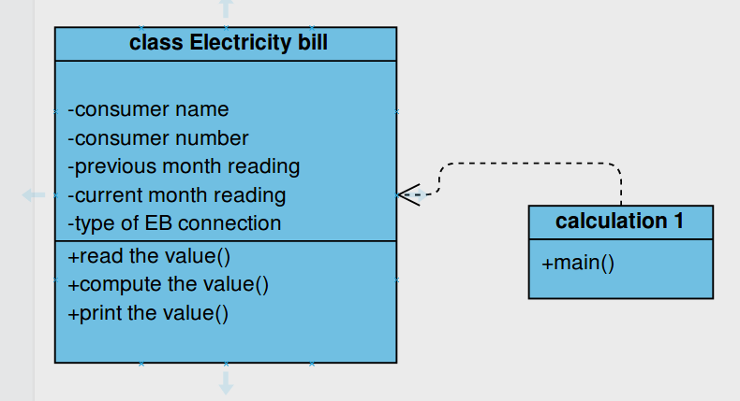

PROGRAM
//CREATED BY
//A SUGUMAR
package electricitybill
import java.util.Scanner;
public class ElectricityBills {
private long customernumber;
private String customername;
private long previousmonthreading;
private long currentmonthreading;
private String customertype;

public ElectricityBills()
{
this.customernumber=1001;
this.customername="unknown";
this.previousmonthreading=100;
this.currentmonthreading=120;
this.customertype="domestic";
}

public ElectricityBills(long number,String name,long reading1,long reading2,String type)
{
this.customernumber=number;
this.customername=name;
previousmonthreading=reading1;
currentmonthreading=reading2;
customertype=type;
}
public void getdata()
{
Scanner sc=new Scanner(System.in);
System.out.printf("\n%40s","BILLING INFORMATION");
System.out.print("\nEnter the customernumber:");
this.customernumber=sc.nextLong();
System.out.print("Enter the customername:");
this.customername= sc.next();
System.out.print("Enter the Previous Month Reading:");
previousmonthreading=sc.nextLong();
System.out.print("Enter the Current Month Reading:");
currentmonthreading=sc.nextLong();
System.out.print("Enter the Customer type (Domestic,Commercial):");
customertype=sc.next();
}
public void printData()
{
System.out.println("CustomerNumber:"+customernumber);
System.out.println("CustomerName:"+customername);
System.out.println("PreviousMonthReading:"+previousmonthreading);
System.out.println("CurrentMonthReading:"+currentmonthreading);
System.out.println("Customertype:"+customertype);
}
public void computeBillamount()
{
long unit=currentmonthreading-previousmonthreading;
double billAmount;
billAmount=0;
String spacing="------------------------------------------------------------------------------------";

if(customertype.equals("Domestic"))
{
if((unit>=0)&& (unit<=100))
{
billAmount=unit*1.0;
}else if((unit>=101)&&(unit<=200))
{
billAmount=unit*2.50;
}else if((unit>=201)&&(unit<=500))
{
billAmount=unit*4.0;
}else
{
billAmount=unit*6.0;
}
}else if(customertype.equals("Commercial"))
{

if((unit>=0)&& (unit<=100))
{
billAmount=unit*2.0;
}else if((unit>=101)&&(unit<=200))
{
billAmount=unit*4.50;
}else if((unit>=201)&&(unit<=500))
{
billAmount=unit*6.0;
}else
{
billAmount=unit*7.0;
}
}
System.out.print("\n"+spacing+"\n");
System.out.printf("%40s", "SALE BILL");
System.out.print("\n"+spacing+"\n");
this.printData();
System.out.printf("%29s%8.2f Rs", "Total Amount:",billAmount);
System.out.print("\n"+spacing+"\n");
}
}

CALCULATION

package electricitybills;

public class Calculationforbillings {

public static void main(String[] args) {
// TODO Auto-generated method stub
ElectricityBills E1,E2;
E1=new ElectricityBills(1001,"Arun",90,110,"Domestic");
E1.printData();
E2=new ElectricityBills();
E2.getdata();
E1.computeBillamount();
E2.computeBillamount();
}

}

OUTPUT
CustomerNumber:1001
CustomerName:Arun
PreviousMonthReading:90
CurrentMonthReading:110
Customertype:Domestic

BILLING INFORMATION
Enter the customernumber:22121
Enter the customername:sugumar
Enter the Previous Month Reading:23322
Enter the Current Month Reading:2322
Enter the Customer type (Domestic,Commercial):
Domestic

------------------------------------------------------------------------------------
SALE BILL
------------------------------------------------------------------------------------
CustomerNumber:1001
CustomerName:Arun
PreviousMonthReading:90
CurrentMonthReading:110
Customertype:Domestic
Total Amount: 20.00 Rs
------------------------------------------------------------------------------------

------------------------------------------------------------------------------------
SALE BILL
------------------------------------------------------------------------------------
CustomerNumber:22121
CustomerName:sugumar
PreviousMonthReading:23322
CurrentMonthReading:2322
Customertype:Domestic
Total Amount:-126000.00 Rs
------------------------------------------------------------------------------------

