EX.NO: | CONVERTER APP
DATE: | CONVERTER APP

AIM:

To develop a java program console application to convert currency with
DOLLAR TO INR, INR TO DOLLAR, INR TO EURO, EURO TO INR, YEN TO INR, INR TO
YEN display the result.

REQUIREMENT:

Create a class currency converter with the following Data member: dollor to INR, INR to dollar, INR to EURO, EURO to INR, YEN to INR, INR to YEN.Member function: Read the value, compute the value, print the value.

ALGORITHM:

STEP-1 Declare the package currency library converter app.
STEP-2 Declare a class name of currency converter.
STEP-3 Declare a constructor with initial attribute.
STEP-4 Declare getdata member and member function.
STEP-5 Declare class calculation with a static main function.
STEP-6 Create object with dollar, inr, euro,yen.
STEP-7 Get the input from user.
STEP-8 Calculate the converter
STEP-9 Display result.

CLASS DIAGRAM:
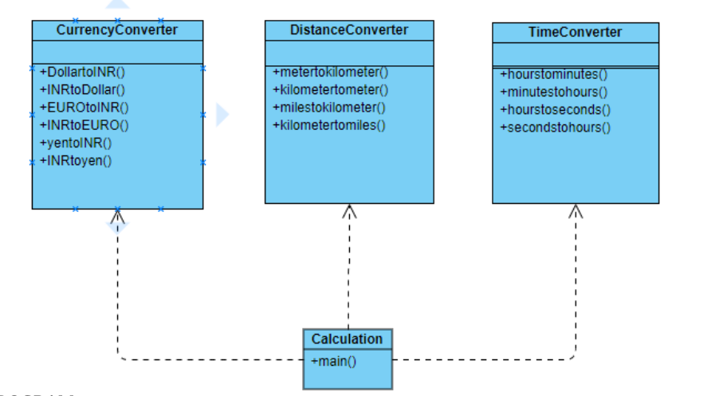

PROGRAM:

* Application for area and length conversion
*
* developed by Mohan Raj c
* cvmohanraj3@gmail.com
*
*
*/
package converterapp;

import java.util.Scanner;
import Converterlibrary.*;
public class Calculation1 {

public static void main(String[] args) {
double value1,value2;
int option;
Scanner sc=new Scanner(System.in);

while(true)
{
System.out.println("1. dollar to INR conversion");
System.out.println("2. INR to dollar conversion");
System.out.println("3. euro to INR conversion");
System.out.println("4. INR to euro conversion");
System.out.println("5. yen to INR conversion");
System.out.println("6. INR to yen conversion");
System.out.println("7. meter to km conversion");
System.out.println("8. km to meter conversion");
System.out.println("9. miles to km conversion");
System.out.println("10. km to miles conversion");
System.out.println("11. hours to mins conversion");
System.out.println("12. mins to hours conversion");
System.out.println("13. hours to sec conversion");
System.out.println("14. sec to hours conversion");
System.out.println("15. Exit");
System.out.print("Enter your choice:");

option=sc.nextInt();
switch(option)
{
case 1:
System.out.print("Enter currency in dollar:");
value1=sc.nextDouble();
value2=CurrencyConverter.dollarToINR(value1);
System.out.printf("%.2f dollor is equal to %.2f INR.\n",
value1,value2);
break;
case 2:
System.out.print("Enter currency in INR:");
value1=sc.nextDouble();
value2=CurrencyConverter.INRTodollar(value1);
System.out.printf("%.2f INR is equal to %.2f dollar.\n", value1,value2);
break;
case 3:
System.out.print("Enter currency in euro:");
value1=sc.nextDouble();
value2=CurrencyConverter.euroToINR(value1);
System.out.printf("%.2f euro is equal to %.2f INR.\n", value1,value2);
break;
case 4:
System.out.print("Enter currency in INR:");
value1=sc.nextDouble();
value2=CurrencyConverter.INRToeuro(value1);
System.out.printf("%.2f INR is equal to %.2f euro.\n", value1,value2);
break;
case 5:
System.out.print("Enter currency in yen:");
value1=sc.nextDouble();
value2=CurrencyConverter.yenToINR(value1);
System.out.printf("%.2f yen is equal to %.2f INR.\n", value1,value2);
break;
case 6:
System.out.print("Enter currency in INR:");
value1=sc.nextDouble();
value2=CurrencyConverter.INRToyen(value1);
System.out.printf("%.2f INR is equal to %.2f yen.\n", value1,value2);
break;
case 7:
System.out.print("Enter distance in meter:");
value1=sc.nextDouble();
value2=DistanceConverter.meterTokm(value1);
System.out.printf("%.2f meter is equal to %.2f km.\n", value1,value2);
break;
case 8:
System.out.print("Enter distance in km:");
value1=sc.nextDouble();
value2=DistanceConverter.kmTometer(value1);
System.out.printf("%.2f km is equal to %.2f meter.\n", value1,value2);
break;
case 9:
System.out.print("Enter distance in mile:");
value1=sc.nextDouble();
value2=DistanceConverter.mileTokm(value1);
System.out.printf("%.2f mile is equal to %.2f km.\n", value1,value2);
break;
case 10:
System.out.print("Enter distance in km:");
value1=sc.nextDouble();
value2=DistanceConverter.kmTomile(value1);
System.out.printf("%.2f km is equal to %.2f mile.\n", value1,value2);
break;
case 11:
System.out.print("Enter time in hours:");
value1=sc.nextDouble();
value2=TimeConverter.hoursTomins(value1);
System.out.printf("%.2f hours is equal to %.2f mins.\n", value1,value2);
break;
case 12:
System.out.print("Enter time in mins:");
value1=sc.nextDouble();
value2=TimeConverter.minsTohours(value1);
System.out.printf("%.2f km is equal to %.2f meter.\n", value1,value2);
break;
case 13:
System.out.print("Enter time in hours:");
value1=sc.nextDouble();
value2=TimeConverter.hoursTosec(value1);
System.out.printf("%.2f hours is equal to %.2f sec.\n", value1,value2);
break;
case 14:
System.out.print("Enter time in sec:");
value1=sc.nextDouble();
value2=TimeConverter.secTohours(value1);
System.out.printf("%.2f sec is equal to %.2f hours.\n", value1,value2);
break;
case 15:
System.out.println("Thankyou for using converter application !!!");
break;
default:
System.out.print("Please enter a valid number !!!");
}

if(option==5)
{
break;
}
}

}

}

CURRENCY CONVERTER

package Converterlibrary;

public class CurrencyConverter {

public static double dollarToINR(double dollar)
{
double INR;
INR=dollar*68.56;
return INR;
}

public static double INRTodollar(double INR)
{
double dollar;
dollar=INR/68.56;
return dollar;
}

public static double euroToINR(double euro)
{
double INR;
INR=euro*77.39;
return INR;
}

public static double INRToeuro(double INR)
{
double dollar;
dollar=INR/77.39;
return dollar;
}
public static double yenToINR(double yen)
{
double INR;
INR=yen*0.62;
return INR;
}

public static double INRToyen(double INR)
{
double yen;
yen=INR/68.56;
return yen;
}
}

DISTANCE CONVERTER

package Converterlibrary;

public class DistanceConverter {

public static double meterTokm(double meter)
{
double km;
km=meter*1000.0;
return km;
}

public static double kmTometer(double km)
{
double meter;
meter=km*2400.0;
return meter;
}
public static double mileTokm(double mile)
{
double km;
km=mile*1.60;
return km;
}

public static double kmTomile(double km)
{
double mile;
mile=km/1.60;
return mile;
}
}

TIME CONVERTER

package Converterlibrary;

public class TimeConverter {

public static double hoursTomins(double hours)
{
double mins;
mins=hours/60.0;
return mins;
}

public static double minsTohours(double mins)
{
double hours;
hours=mins*60.0;
return hours;
}
public static double hoursTosec(double hours)
{
double sec;
sec=hours/3600.0;
return sec;
}

public static double secTohours(double sec)
{
double hours;
hours=sec*3600.0;
return hours;
}
}

OUTPUT

1. dollar to INR conversion
2. INR to dollar conversion
3. euro to INR conversion
4. INR to euro conversion
5. yen to INR conversion
6. INR to yen conversion
7. meter to km conversion
8. km to meter conversion
9. miles to km conversion
10. km to miles conversion
11. hours to mins conversion
12. mins to hours conversion
13. hours to sec conversion
14. sec to hours conversion
15. Exit
Enter your choice:1
Enter currency in dollar:123
123.00 dollor is equal to 8432.88 INR.
1. dollar to INR conversion
2. INR to dollar conversion
3. euro to INR conversion
4. INR to euro conversion
5. yen to INR conversion
6. INR to yen conversion
7. meter to km conversion
8. km to meter conversion
9. miles to km conversion
10. km to miles conversion
11. hours to mins conversion
12. mins to hours conversion
13. hours to sec conversion
14. sec to hours conversion
15. Exit
Enter your choice:

