EX.NO: 08 | MULTI THREADED APPLICATION
DATE: 16-09-19 | MULTI THREADED APPLICATION

AIM: To develop a java program for implementing multithread application.

REQUIREMENTS:
Develop a java program that implements a multithread application that has 3 threads.First generates a random integer for every 1 second and if the value is even,second thread computes the square of the number and prints.If the value is odd,the third thread will print the value of cube of the number.

ALGORITHM:
STEP 1: Declare a package called multithread.
STEP 2: Declare a class name of FirstThread,SecondThread which extends from Thread.
STEP 3: Declare a object in the respective classes.
STEP 4: Create a condition to check the statements.
STEP 5: Print the result.

CLASS DIAGRAM:

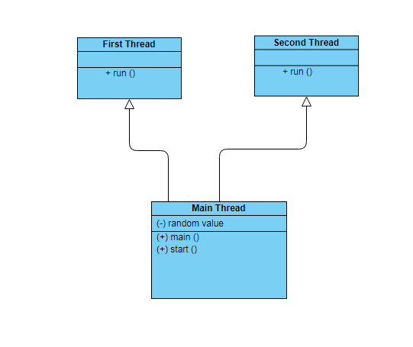

PROGRAM:
MainThread:

package multithread;

/*
* developed by A.sandhiya
* EEE-B
* 212217105052
*
*
*/

import java.util.Random;

public class MainThread {

public static Integer RandomValue;

public static void main(String[] args) {
FirstThread t1;
SecondThread t2;
Random r;

t1=new FirstThread();
t2=new SecondThread();

r=new Random();
RandomValue=-1;

t1.start();
t2.start();

try
{
while(true)
{
synchronized(RandomValue)
{
if(RandomValue==-1)
{
RandomValue=r.nextInt(200);
System.out.println("Placed a new number "+RandomValue);
}
}
Thread.sleep(4000);
}
}catch(InterruptedException ex)
{
System.out.println("Error:"+ex);
}

}

}

FirstThread:

/*
* developed by A.sandhiya
* EEE-B
* 212217105052
*
*
*/

package multithread;

public class FirstThread extends Thread {

public void run()
{

try
{
System.out.println("First thread started...");
while(true)
{
synchronized(MainThread.RandomValue)
{
if(MainThread.RandomValue%2==0&&MainThread.RandomValue!=-1)
{
System.out.println("Value is even");
System.out.println("Answer="+(MainThread.RandomValue*MainThread.RandomValue));
MainThread.RandomValue=-1;
}
}

Thread.sleep(1000);
}
}catch(InterruptedException ex)
{
System.out.println("Error:"+ex);
}

}
}

SecondThread:

/*
* developed by A.sandhiya
* EEE-B
* 212217105052
*
*
*/

package multithread;

public class SecondThread extends Thread {

public void run()
{
try
{
System.out.println("Second thread started...");
while(true)
{
synchronized(MainThread.RandomValue)
{
if(MainThread.RandomValue%2!=0&&MainThread.RandomValue!=-1)
{
System.out.println("Value is odd");
System.out.println("Answer="+(MainThread.RandomValue*MainThread.RandomValue*MainThread.RandomValue));
MainThread.RandomValue=-1;
}
}

Thread.sleep(1000);
}
}catch(InterruptedException ex)
{
System.out.println("Error:"+ex);
}
}
}

RESULT: Thus a java application that performs multithreading is developed.

