System Support Project

PC Solutions Project

By: Obed Cahua, Solution Tech Consultant

Table of Contents

Table of Contents 2
PC Solutions Case Study 3
Student Project Contract 5
Project Scope 8
PC Solutions Feasibility Study 10
PC Solutions Security Plan 13
PC Solutions Timeline and Schedule 17
PC Solutions Database Design 19
User Interface Design 20
PC Solutions Software Selection 32
PC Solutions Implementation Plan 34
PC Solutions Final Recommendations 36

PC Solutions Case Study

PC Solutions started in 2017 as volunteer computer repair service. PC Solutions location is in Winston Salem, NC. PC Solutions services include remote support, malware removal, hard drive replacement, and more. PC Solutions is both a remote and in-person company. Later that year, the company realized their business was becoming successful, so fees were introduced in their computer services. Since PC Solutions started to charge fees in 2018, PC Solutions has served more than 100 customers. PC Solutions only has one location and is planning to expand in the future, for now PC Solutions is only a local based business with 50 employees. In 2019, PC Solutions decided that an online presence was necessary for the company to be promoted, a domain was registered, and a website was created using an online website builder.

Executive Management
Owner: Dr. John Smith P.H.D
Operator: Dr. James Brown
Director, Information Technology: Joshua Williams

Current System:
PC Solutions right now has 50 computers with Windows up to date equipped with the software implemented for the technicians to service customers. The software implemented on the computers used to service customers are Zoho Assist and Google Forms. The website is currently up to date and does not need any upgrades. PC Solutions is equipped to service 1 customer per technician. The platform that is used right now for tickets to be submitted, is Google Forms. Google Forms is a platform with limited resources, as it is not intended to store confidential customer information. Google Forms is mostly designed for personal use, example: teachers creating quizzes for students, users creating an event booking form. The system is also very complex for the technicians in the Information Technology Department to use because it requires the tech’s to go retrieve customer information from the forms, then send out an email saying the ticket has been acknowledged, then in 24 hours send a follow-up email to the customer requesting the setup the support session. Google Forms is not much of a system where everything is in one place. The company has used this system for years and it has served their customers well, but now a recommendation will be made for a more secure and professional looking, and centralized platform. The technicians have also been requesting to bring and work on their own device instead of using a computer from PC Solutions, a recommendation for a BYOD policy will have to be made. PC Solutions right now has no strong corporate security firewall, just the standard consumer router firewall. PC Solutions stores customer information using a paper system and is requesting a platform to be implemented to store the confidential customer information.

Why is a Help Desk system needed?
PC Solutions has decided that a help desk platform either online or as an application should be implemented along with a new platform to store confidential customer information, to better service customers, the help desk platform will be programmed with the customizations required and tested at their location before it is implemented for use. All tickets will now be sent directly to the helpdesk system and acknowledgement of tickets will be sent automatically by the helpdesk platform without the technician having to manually process tickets.
The helpdesk platform, if recommended to be online or as an application will need the appropriate security concerns addressed. Research will be done in the vendor’s documentation to see what security measures are available for the helpdesk platform and recommendations will be made according to the need of the company.
PC Solutions has been operating on a secure but consumer grade firewall since it was founded. A recommendation will be made about what system or software can perform as a corporate grade secure firewall and protect the helpdesk platform and customer data platform from threat actors. These recommendations will ensure PC Solutions systems will be secure for both employees and their customers and will allow for the company’s future expansion.

Student Project Contract

Group Name
Solution Tech Consultants
Group Members
Obed Cahua
Roles Available in Project
Researching Information, Submitting Documents for Review, Taking and Submitting a Timesheet, and Creating Documents.
Role Distribution
Researching Information will be assigned to Obed Cahua.
Submitting Documents will be assigned to Obed Cahua.
Taking and Submitting Timesheets will be assigned to Obed Cahua.
Creating Documents will be Assigned to Obed Cahua.
Project Manager
Instructor
Communications Policy
All group members will stay in contact via email once a week to give updates on the status of their assigned role in this project or to give concerns of any part of the project. Group members will be required to answer any emails sent by other members within 24 hrs. If a group member fails to answer emails sent by other group members within the required timeframe and does not provide a valid explanation to the Group or Project Manager, the Termination Policy shall take effect.

Attendance and Participation Policy
Group members will be expected to attend all scheduled group sessions to discuss the project. If a group member should have a situation that should prevent him/her from attending, a notification via email to the group should be sent. If a member fails to provide a valid explanation for an absence within a week after the event to the Group or the Project Manager, the Termination Policy will take effect. Punctuality and full participation will be required from everyone in the group.
Conflict Management
If a group member faces a conflict in which a member provides advice, and such advice interferes with the project, the group will then listen to both sides of the argument take the ideas into consideration. The conflict will be resolved by a majority vote. If there a stalemate in the vote the Project Manager will be requested to intervene and break the stalemate and the decision will be made. If for any reason the group members that started the conflict are still having issues, the Termination Policy shall take effect.
If someone in the group is not doing their part as required by this contract, the group members will speak to that person and see if they can help the person in any way. If the person is not cooperating with the group and doing their assigned roles, the Termination Policy shall take effect.

Termination Policy
If a group member is not able to complete with their assigned roles or adhering to the polies as set in this contract, the group shall write a detailed written request to the Project Manager to consider that person for termination. The group member that could be considered for termination has a week to appeal to the group, and the group shall by a majority vote decide if a request to terminate that person shall be made or the member shall stay in the group. If there is a stalemate in the vote, the Project Manager will be requested to break the stalemate. Once the vote is completed, if the group decides in favor of termination a detailed request shall be written to the Project Manager to consider the person for termination. If the group voted against termination the person that was considered for termination shall no longer be considered for termination and shall remain in the group and continue meeting the requirements set by this contract. If the same group member after not being considered for termination does not meet the requirements as set forth in this contract, he shall not be granted another opportunity to appeal, and a detailed written to the Project Manager shall be made to consider that person for permanent termination from the group.

I, Obed Cahua, a student from Forsyth Tech, agree to complete the System Support Project with my group with the terms listed in the contract above.

Obed Cahua
Signature
1/27/2021
Date

Project Scope

PROJECT GOAL
To implement a centralized platform and system within one and half months.
PROJECT DESCRIPTION
To implement a centralized platform and system within one and half months. A new system will allow better service for customers of PC Solutions Repair Company. The system will be executed with minimum interruptions to their business activities and with a budget of $90,000 dollars.
DELIEVERABLES
- Fully operational corporate grade firewall for client security.
- Help Desk Platform Application for ease of use and to better service customers.
- Application to store confidential customer information ensuring information security.

OPERATIONAL FUNCTIONS & SOFTWARE REQUIREMENTS
- The Help Desk will have the included feature to receive tickets and send an acknowledgement email back to the PC Solutions customer.
- A Frequently Asked Questions database which is a site within the helpdesk where the technician saves tickets that could serve for future reference for other technicians to work on new tickets will be included.
- Manual Backups for the Help Desk will have to be done by the Information Technology Department.
- Training will be provided for use of the Help Desk platform and Firewall systems to the technicians in the Information Technology Department.
- The technicians will be able to send emails to customers from within the Help Desk application.
- The Corporate Grade Firewall will protect the network clients from threat actors.
- An application with password support to protect customer information will be managed by the Information Technology Department.

COSTS
Implementation | $62,950
Training Costs | $20,000
Total: | $82,950

DEADLINES
- Project Contract January 29th, 2021.
- Project Scope February 12th, 2021.
- Project Feasibility Study February 19th, 2021.
- Security Plans March 5th, 2021.
- Project Timeline and Schedule March 12th, 2021.
- Database Design March 12th ,2021.
- User Interface Design March 26th, 2021.
- Software Selection April 2nd, 2021.
- Platform Testing at PC Solutions Location April ^{4th}, 2021.
- Training Start March 30th, 2021.
- Training Complete April 9th, 2021.
- Implementation Plans Due April 9th, 2021.
- Final Recommendations due April 9th, 2021
- Implementation Started April 13th, 2021.
- Implementation Complete, April 26th, 2021.

PC Solutions Feasibility Study

EXECUTIVE SUMMARY:
This study was written for the PC Solutions Repair Services. The areas of the study cover the following: Technical feasibility and Financial feasibility. The main goal of this document is to give a clear idea about the upgrade of the PC Solutions system. This project brings many long-term advantages for PC Solutions, technical aspects of the helpdesk and networking products, include: ticketing system, firewall, password- protected application etc. More details about this project detailing its technical aspects will be given in the Technical feasibility section of this document.
The ticketing system which allows PC Solutions customers to submit requests directly to PC Solutions servers, and the technicians can without going through the trouble of sending emails and going through paperwork respond through the system. The corporate grade firewall recommended is going to allow the PC Solutions network to be protected from threat actors or people trying to breach its network. The application with password support recommended will allow confidential data to be secure. This project will make business for PC Solutions more organized, and the technicians will be able to take in more customers. Since other local business in the area do not yet operate with this available technology there will be some competition between PC Solutions and local businesses.

TECHNICAL FEASIBILITY:
The Helpdesk platform application Solution Tech Consultants is proposing is an in-house application solution and will be setup as an internal site within the PC Solutions network. The features of the Help desk platform include ticketing system, automatic ticket acknowledgement, frequently asked questions database also known as a knowledge base and an email client to send emails from within the helpdesk. Having Help Desk experience was a job requirement for PC Solutions technicians, since it has been years a system like this has not been used Solution Tech Consultants will be providing training. Once that training is completed the PC Solutions trained personnel should be able to successfully operate the Help desk platform, and in the future train others. The Help desk platform will be setup as an internal site within the PC Solutions network, this configuration does not affect the functions of the help desk platform.
A corporate grade firewall protecting PC Solutions network from threat actors trying breach its network and an application with password support to protect customer information has also been proposed by Solution Tech Consultants. The PC Solutions have no experience with the proposed firewall solution, since this is the case Solution Tech Consultants will provide training. An application with password support to protect confidential customer information has also been proposed by Solution Tech Consultants. The application with password support was a job requirement for the PC Solutions technicians, so knowledge of how to use that application was expected. Once the training is provided to the PC Solutions technicians to operate the firewall the trained personnel will successfully be able to operate the available software. The solutions, Solution Tech Consultants have planned will cover the current needs of PC Solutions Repair Services.
The implementations Solution Tech Consultants is planning for PC Solutions should last the lifetime of their systems if system maintenance and training is provided. From the reasons I have described above this project is technically feasible.

FINANCIAL FEASIBILITY:
The Labor Costs for this Project which will include the Implementation of Help Desk, Hardware Corporate Grade Firewall and Implementation of the Application with password support will be $20,000. The Security costs for this project which will include a Corporate hardware-based firewall will cost $1,600.00. The Application costs for this project include a Help Desk platform application for $34,400 and an application with password support which costs $6,950.00 for 50 computers. The Training Costs for this project include a network trainer for $10,000.00 on a salary and Help desk platform trainer for $10,000.00 also on a salary, training will last 10 days. The final cost of the project is $82,950 and the project is financially feasible.

BUDGET CHART
Labor Costs | $20,000
Help Desk Application | $34,400
Corporate Grade Firewall | $1,600.00
Application with Password Support | $6,950.00
Network Trainer | $10,000
Help Desk Platform Trainer | $10,000
Total: | $82,950

PC Solutions Security Plan

INTRODUCTION:
Security is of utmost importance to PC Solutions Repair Services. Solution Tech Consultants have identified the following needs for this project and will outline them below in this Security Plan.

EMPLOYEE SECURITY:
Need: There is a need for the digital safety of PC Solutions employees. In the past, PC Solutions Employees have not locked their computers when leaving for lunch or break and that has led to an intruder having physical access to their for computer and stealing sensitive data. Also, technicians are downloading software without PC Solutions permission and that software is infecting the computers with viruses.
Risks: Customer or company data will be compromised
Recommendations: Solution Tech Consultants is recommending three policies that should prevent any unauthorized access to employee’s computers.
Policies:
Acceptable Use Policy (AUP):
Individuals must not:
- Leave their password unprotected (for example: writing it down and leaving in the open, saving it on a notepad file on employee’s computer, or storing it on their phone).
- Connect any non-PC Solutions device unless authorized by the BYOP device policy to the PC Solutions Network.
- Leave any account logged in at an unattended and unlocked computer.
- Allow someone else non- PC Solutions employee or an employee to use their computer unless the employee is sent to troubleshoot the computer.
- Leave confidential customer information of their desk, instead they should securely dispose of the information.
- Remove or disable antivirus software.
- Knowingly introduce malicious programs onto PC Solutions network.

Software Policy
Employees may only use software authorized by PC Solutions Repair Service on PC Solutions computers to better service customers any other software is prohibited. Authorized software must be used in accordance with legal and software agreements. All Any software needed to be installed on PC Solutions computers must be approved by management and installed by the PC Solutions IT Department.
The IT department must:
- Ensure configurations are in place for employees to change password every month.
- Ensure configurations are in place for all computers and laptops to automatically lock if no activity is detected in less than 30 seconds, and force login screen for users to login upon return.

Physical Security Policy:
- It is the responsibility of every PC Solutions employee to maintain and preserve a secure work environment.
- Badges will be issued to new employees which will grant the employee the necessary permission to access the appropriate PC Solutions facility the date of hire.
- Employees must have their badges at all time on PC Solutions premises.
- No individual shall be permitted beyond the waiting room without an appropriate badge.
- Badges are not to be left unattended at any time.
- If any door does not work properly notify PC Solutions management immediately.
- Badges should be turned in to management, in upon termination or resignation of PC Solutions employee.
- PC Solutions management must be notified whenever a potential or actual security problem exists including unauthorized entry, theft, or loss.

OFF-SITE DEVICES:
Need: Employees have been complaining about some time that they want to bring their own device to work and use it to instead of PC Solutions computers. An employee brought his device once and connected it to the PC Solutions network and since the device was not configured well, an attacked exploited his device and stole his information.
Risks: Customer or company data will be compromised if BYOD policy is not implemented
Recommendations: Solution Tech Consultants is recommending a Bring Your Own Device Policy for employees to be able to bring their device to work, while the same time security concerns are addressed as well.
Policies:
Bring Your Own Device Policy (BYOD):
Security
- Devices must be protected using a password and other features available on the particular device, a strong password is required to access PC Solutions network.
- PC Solutions password policy is as follows: a minimum 8 characters and combination of upper and lower-letters, numbers, at least one symbol. Passwords will be reset every 15 days and the new password can not be any of the previous passwords.
- The device will lock itself if idle for 30 seconds.
- Laptops and Desktops that are not on the list of supported devices will not be allowed to connect.
- Smartphones will not be allowed to connect to the PC Solutions network.
- The employee’s device may be remotely wiped if:
  - The device is lost or stolen.
  - PC Solutions detects suspicious activity on the device.

Devices and Support
- Windows Desktops (all manufacturers and models acceptable)
- Windows Laptops (all manufacturers and models acceptable)
Devices must be given to the PC Solutions IT department for proper configuration and installation of application required to service customers.

Disclaimers
- PC Solutions reserves the right take disciplinary action up to termination for noncompliance with this policy.
- The PC Solutions employee is expected to use the device in a manner that adheres to PC Solution Acceptable Use Policy.
- The PC Solutions employee assumes fill responsibility for all costs associated by problems caused by loss of company and personal data due to operating system crashes, errors, bugs etc.

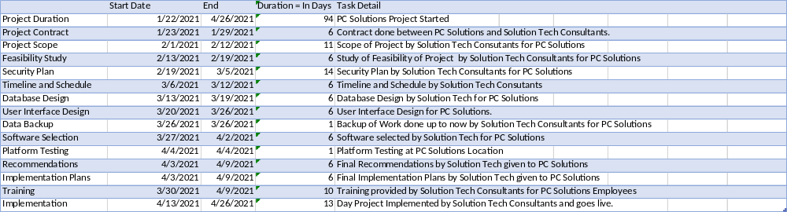
PC Solutions Timeline and Schedule Tasks

PC Solutions Visual Timeline on next page …

PC Solutions Timeline and Schedule Continued

PC Solutions Database Design
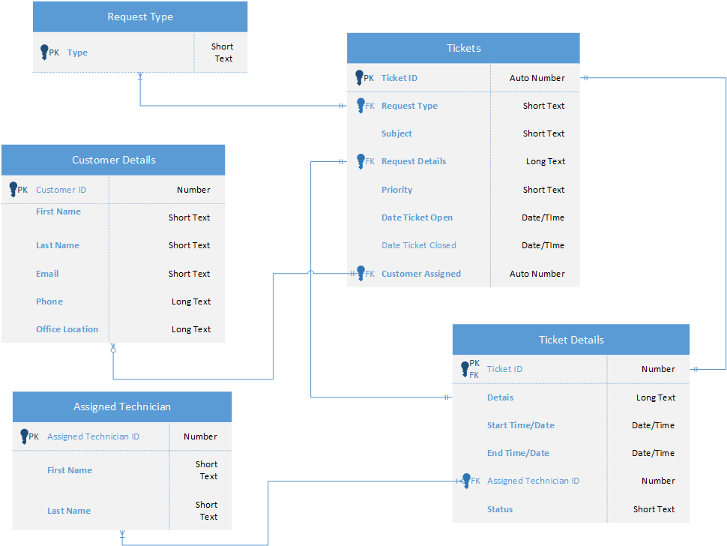

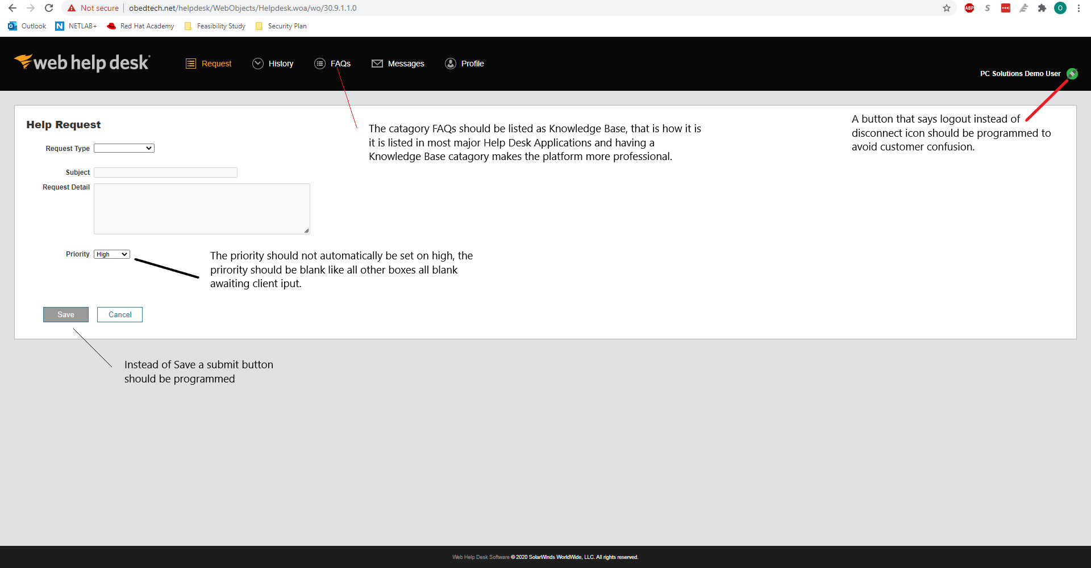
User Interface Design

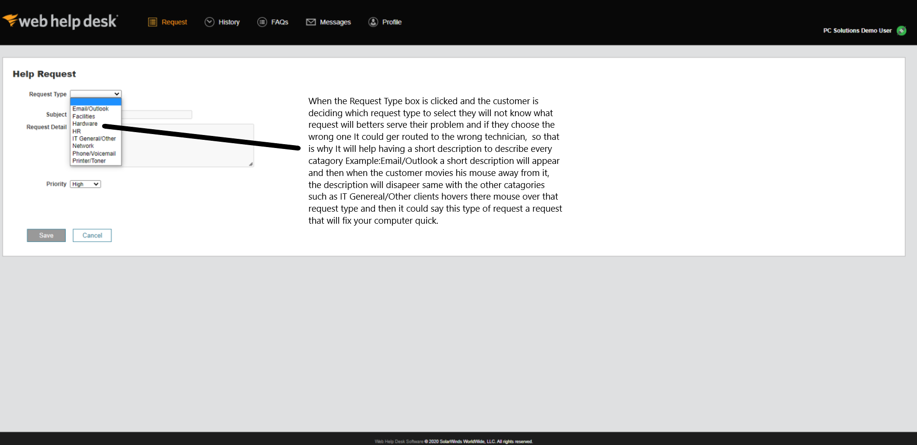

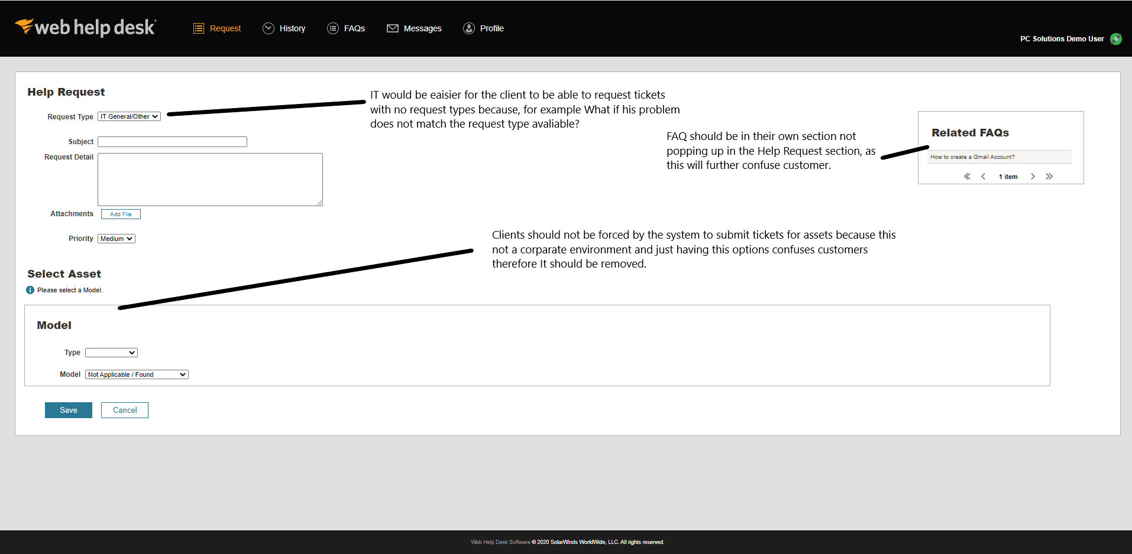

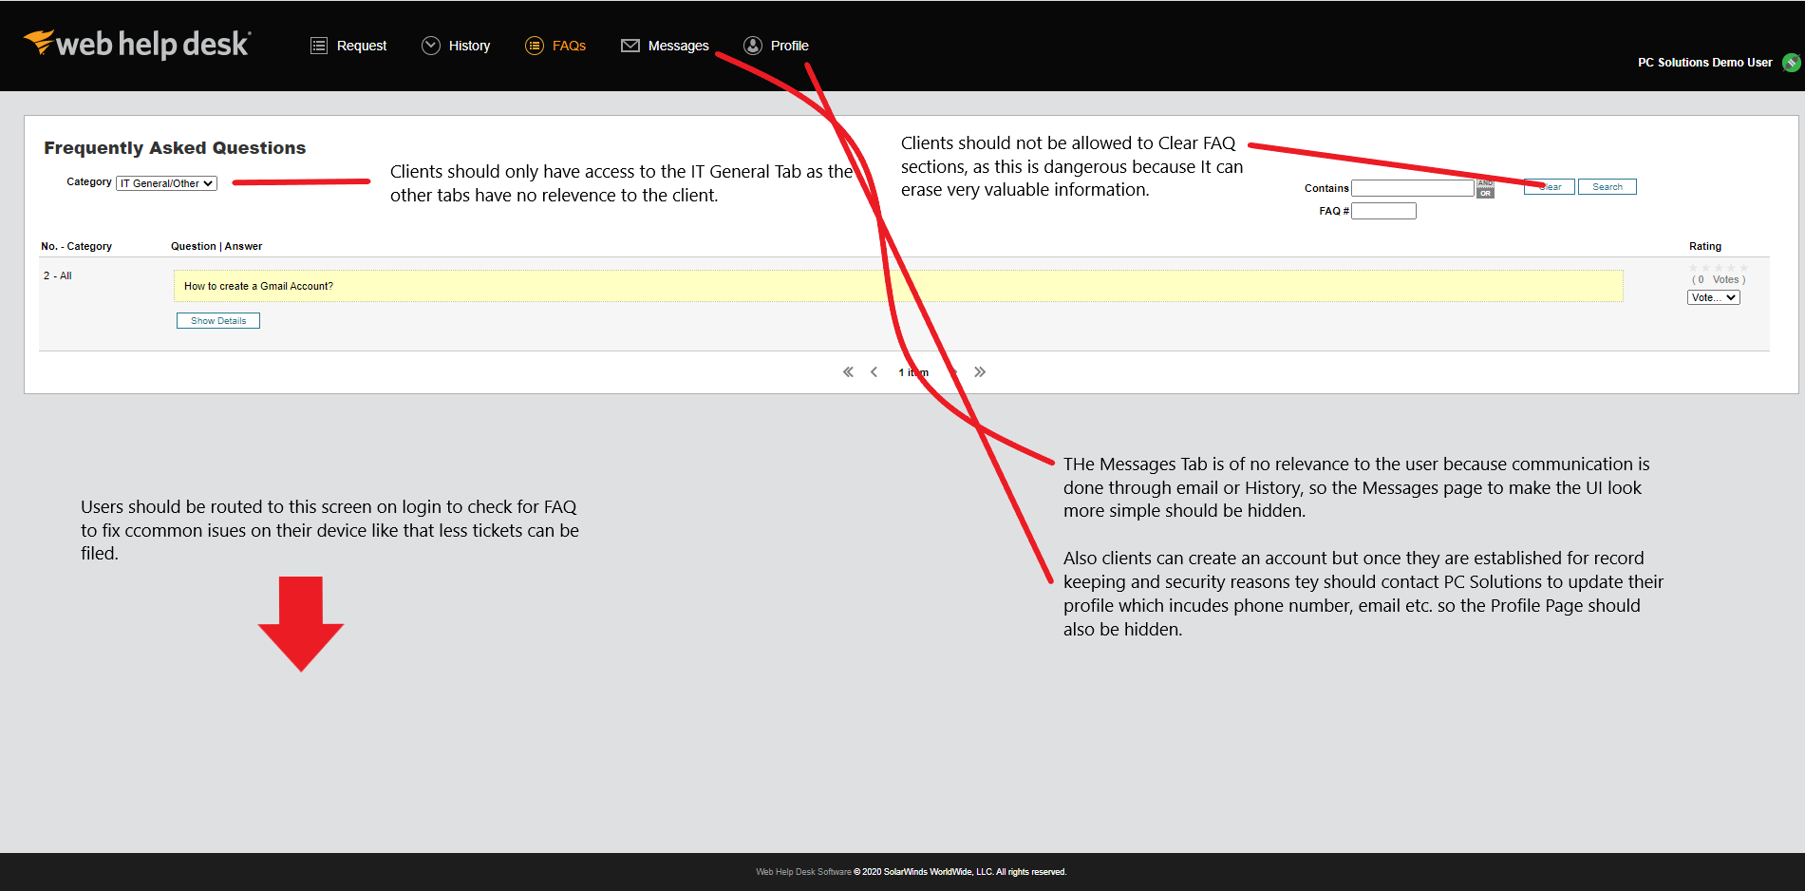

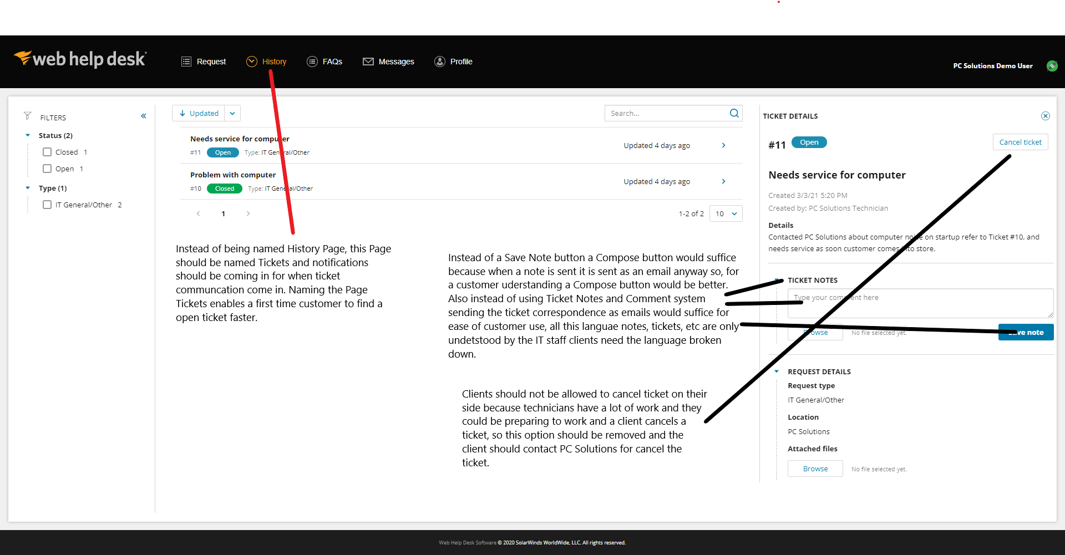

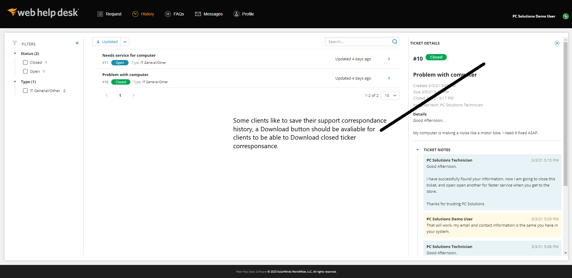

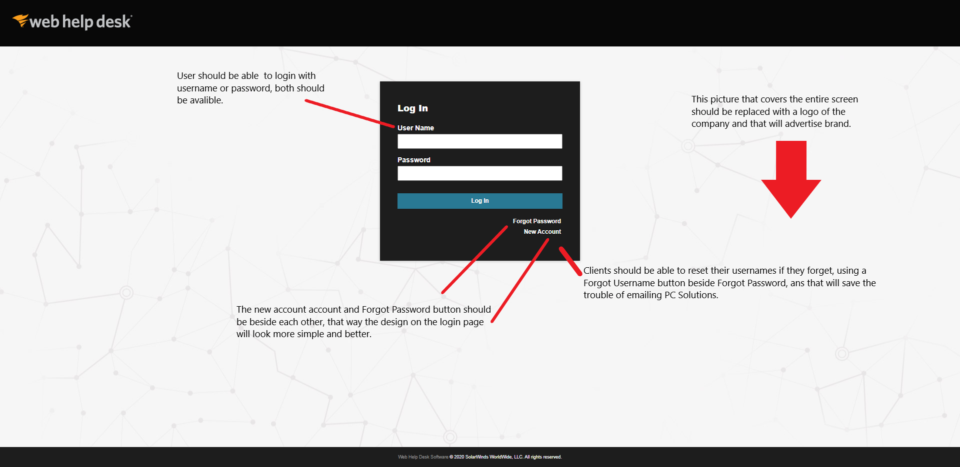
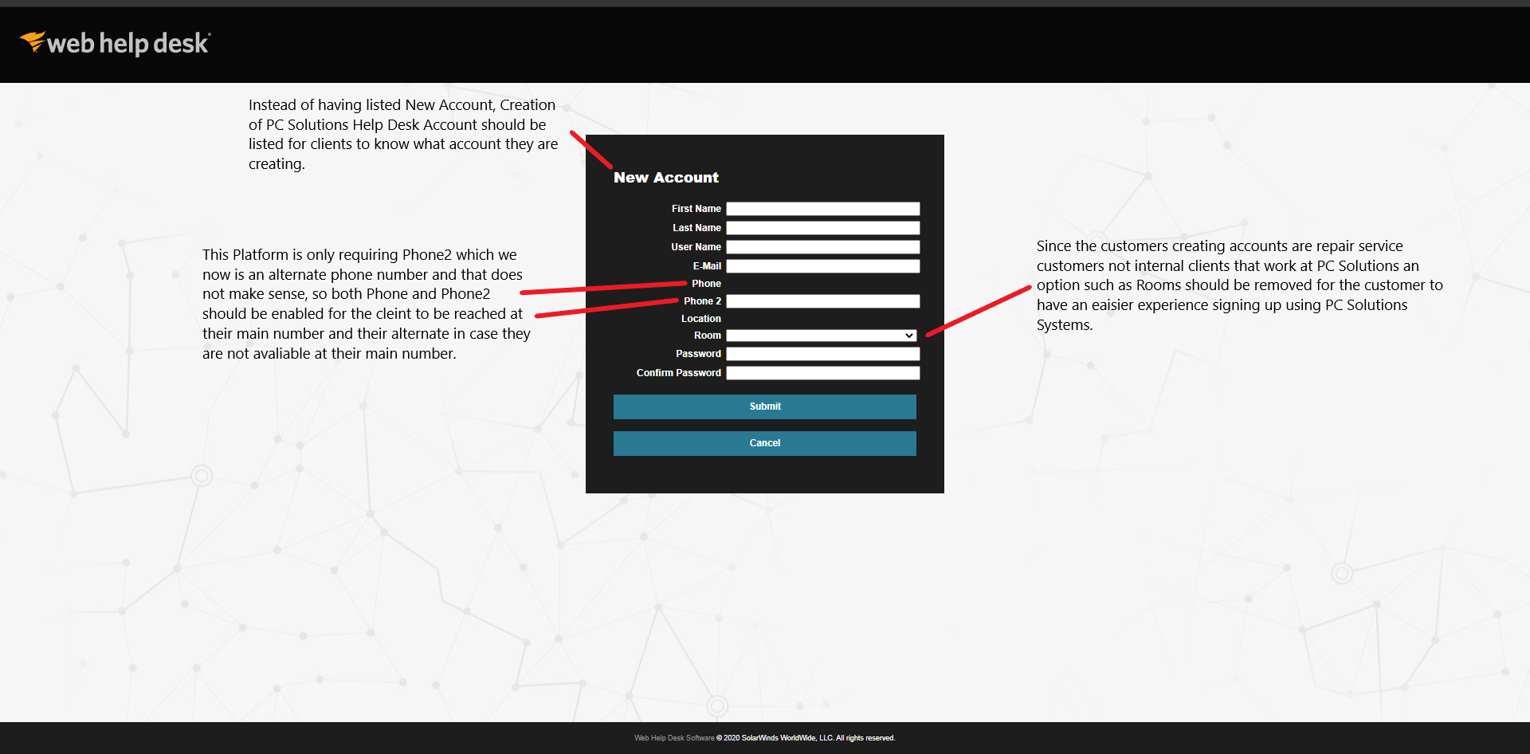

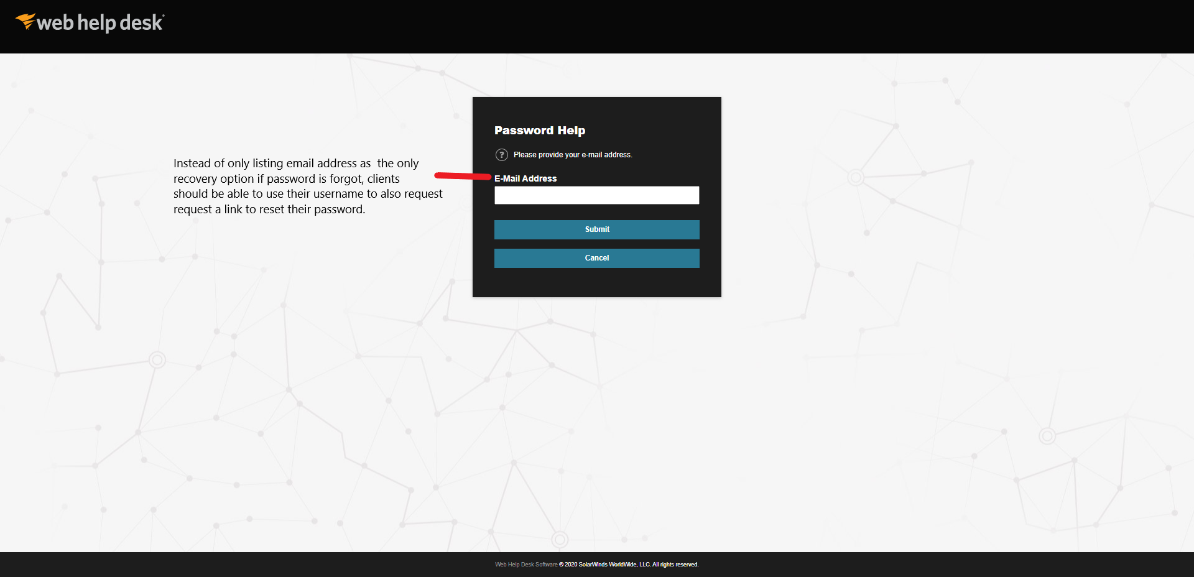

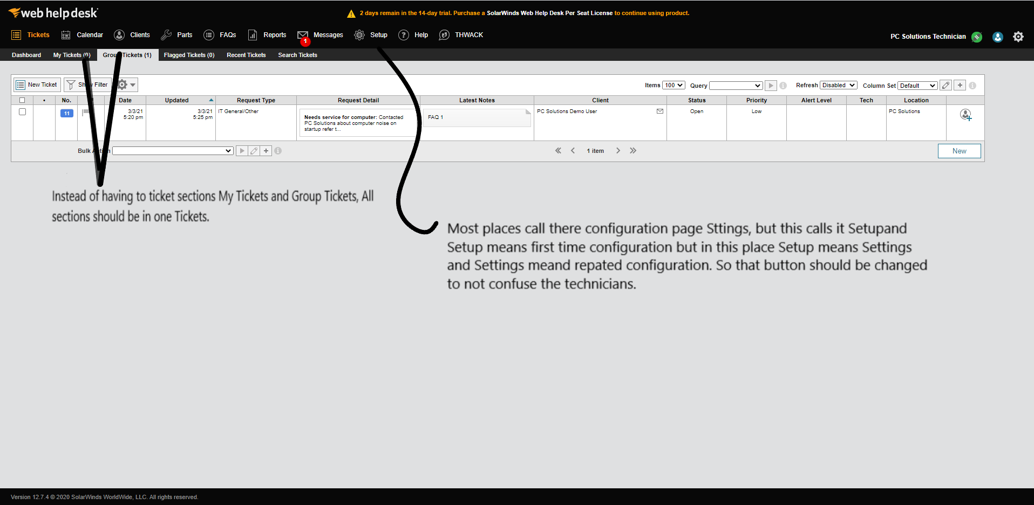

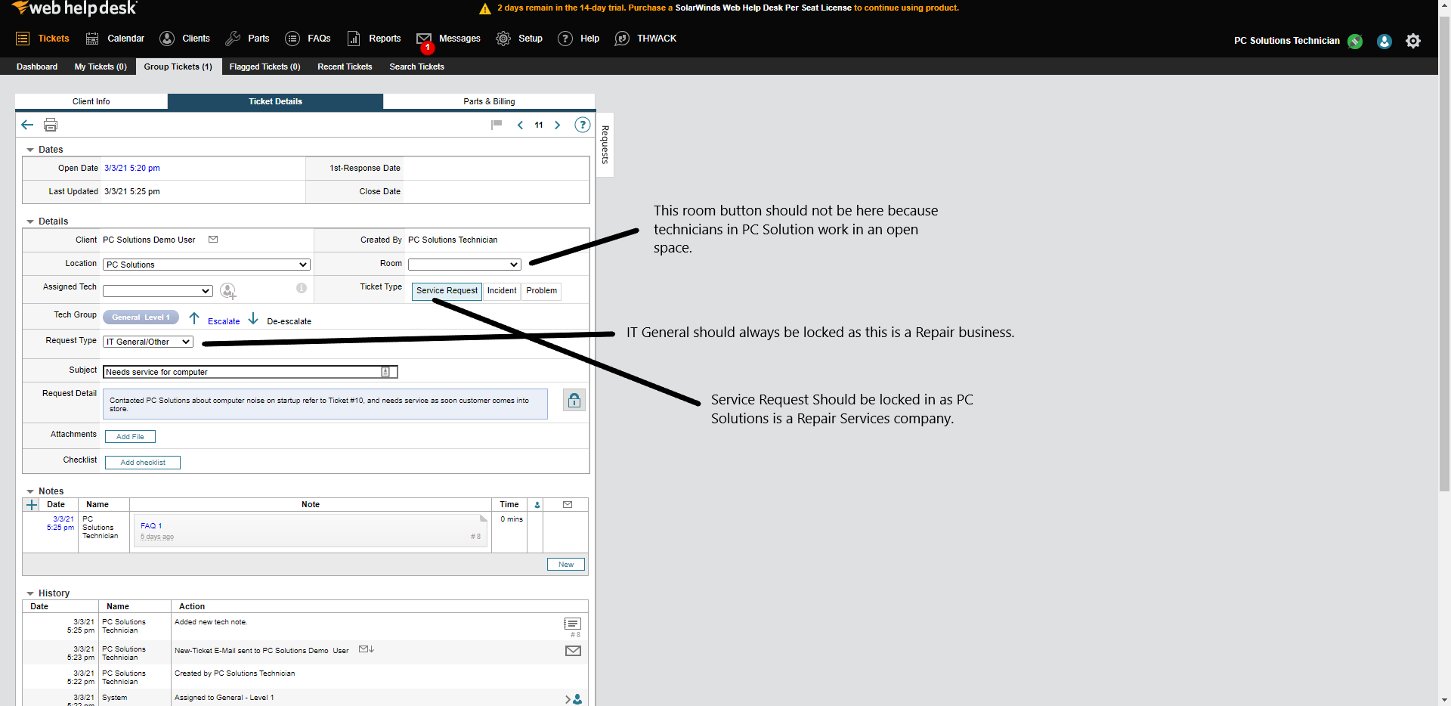

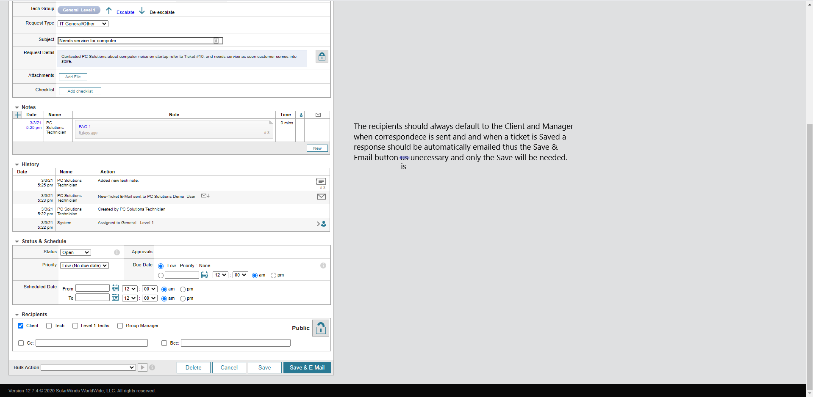

PC Solutions Software Selection

SOFTWARE REQUIREMENTS:
As outlined in the Case Study PC Solutions is requiring a new helpdesk platform and application to store confidential information to better service their customers. The helpdesk platform as outlined in the Project Scope document will require these features: automatic ticket acceptance and acknowledgement, ability for technician to email with helpdesk, and a frequently asked questions database for technicians to save tickets for later reference by other technicians in the future. These are the software requirements for the helpdesk platform.
The password protected application is important as this application is going to be used to store confidential customer information, but its requirements are simple. The requirements for the password protected application are: ability to protect confidential customer information and the ability to enable feature that will lock the application with a password.

SOFTWARE COMPARED:
The software compared for the Help Desk platform by Solution Tech Consultants was the Spiceworks Help Desk and SolarWinds Web Help Desk.
Spiceworks Help Desk was a nice easy to setup platform, it came with all the required features automatic ticket acknowledgement, ticket acceptance, integrated email client and knowledge base. The license cost for this help desk platform was free even for corporate businesses. This platform is highly customizable, and the user interface is very simple, so the technicians can practically use it without training. The user interface was so simple clients when they logged in to view tickets could know how to submit new tickets and view ticket history without assistance.
Solar Winds Web Help Desk was the platform compared; it comes with all the required features also. The user interface with this platform is not simple so on the technicians side it is very easy for the technician to get lost on the page while working on a ticket or configuring the software. This software costs almost $34,000 for 50 technicians, the benefits of implementing this Help desk package are not outweighed by its cost because the user interface is not simple for the technician to use and for a client to submit tickets, the client struggles to find where to follow up on their existing tickets. This platform is not highly customizable except for adding email client settings.

The software compared for the password protected application was My SQL Workbench and Microsoft Excel 2016.
My SQL Workbench is a data entry application based on the SQL language, It is also secure if you know the right configurations. To Enter customer information into this application you must know the language and entering one query can take hours and retrieving it also can.
Microsoft Excel 2016 is spreadsheet-based application mostly used for accounting, managing budgets, etc. This application is a business application so instead of using it for the purposes listed above Excel can be customized and password protection can be enabled, and the software can be used to protect confidential customer information.

DECISION:
Solution Tech Consultants has decided to recommend Microsoft Excel 2016 as the password-protected application. Excel is more convenient because as soon as it has the right customizations technicians will need a password to open the file that way no additional burden of learning another language such as SQL will be put on the technicians.
Solution Tech Consultants has decided to recommend SolarWinds Web Help Desk as the help desk platform for implementation. The software might not have a simple user interface, customization settings and might not be in the interests of PC Solutions but the Project Manager of this project made the decision that it is better to use a paid platform better than a free platform for a business. The helpdesk platform will not be developed in house, but it will be hosted on a PC Solutions server in their location.
A request for proposal (RFP) was not done by Solution Tech Consultants.

PC Solutions Implementation Plan

PURPOSE OF PLAN:
The goal and purpose of this Implementation Plan is to make sure the Project Solution Tech Consultants has been contracted to for PC Solutions is done organized and on time.
PROJECT OVERVIEW:
Solution Tech Consultants will be recommending for implementation a helpdesk platform, application with password support, hardware firewall.
DESCRIPTION OF IMPLEMENTATION:
Testing:
- Solution Tech Consultants will conduct testing at the PC Solutions location on April 4th, 2021.
- The systems Solution Tech Consultants will test that day include helpdesk platform, application with password support, hardware firewall.

Implementation:
- If no errors occur during the testing, Solution Tech Consultants will implement all system from April 13 to April 26, 2021.

Major Tasks:
Training:
- Training will be provided by Solution Tech Consultants from March 30th to April 9th, 2021 to the PC Solutions Information Technology Department.
- Two trainers will be conducting the training, one hardware firewall trainer and one helpdesk trainer.
- The personnel in the Information Technology Department will be trained separately.
- Help desk system personnel will be trained by the help desk trainer
- The security-oriented personnel within the Information Technology Department who will operating the firewall will be trained by the networking trainer.

Implementation Support:
Hardware:
- A hardware firewall will be needed for implementation and a manual will be provided for further assistance.
Software:
- For the helpdesk platform and password protect application online manuals will be provided also for further assistance.

PC Solutions Final Recommendations

OVERVIEW:
In this Recommendations Report Solution Tech Consultants will describe how the recommendations that will be recommended will benefit PC Solutions.

RECOMMENDATIONS:
- Solar Winds Web Help desk platform which comes with automatic ticket acknowledgement and features such as these will simplify the PC Solutions business process.
- Fully Operational corporate grade firewall for security of clients.
- Microsoft Excel with the ability to be password protected and that feature will protect confidential customer information and ensure Information Security.

FINDINGS & RESULTS:
Research has been conducted by Solution Tech Consultants for PC Solutions and the findings and Results will be listed below.
- The SolarWinds Web Help desk platform will simplify the process for the customer submitting requests and technician working on tickets as described in the Project Scope and Feasibility Study Documents.
- The corporate grade firewall protects network clients from threat actors and that will result in a more secure environment for PC Solutions and their customers.
- The Microsoft Excel application with the ability to enable a password lock will ensure information security for confidential customer data and that results in more trust in PC Solutions and a secure environment for PC Solutions and their customers.

FINAL RECCOMENDATIONS:
After all the research Solution Tech Consultants has conducted, Solution Tech Consultants have decided that the corporate grade firewall, Microsoft Excel application with password support and the SolarWinds Web Help desk application, the platform decided by the Project Manager will be recommended to PC Solutions for implementation.

