|  |  |
| --- | --- |
|  | **fUNCTIONAL reQUIREMENTS Specification (FRS)**  **PRODUCT NAME:**  **Mayungano amuka soccer academy(masa)-backend/admin page.** |

**Prepared by: Obeke Godfrey Vicent**

**Date: July 18th, 2022**

Table of Contents

Overview 3

Acronyms, Terms and Definitions 3

Requirements 3

MASA Backend/Admin Panel (Page) 3

Navigating the OSA 4

Login Page 4

Home Page 5

Home Page - The Header/Top Menu bar 5

Home Page - The Side bar/Category block 6

Home Page - Dashboard 7

My Account Page 8

Website Settings 8

Team Player 9

Shop Settings 9

Shop Settings - Size 10

Shop Settings - Country 10

Product Pages 11

Orders Management 11

Slider 12

Service 12

FAQ 13

Customer 13

Pages 14

Social Media 14

Subscriber 15

# Overview

**Mayungano Amuka Soccer Academy (MASA)** is Online Soccer Academy platform (OSA). MASA provides a professional and reliable foundation from which to build a successful online soccer academy. MASA has an extensive number of features that gives you a strong hold over the customization of soccer academy. With MASA's tools, you can help your online soccer activities live up to its fullest potential.

# Acronyms, Terms and Definitions

|  |  |  |
| --- | --- | --- |
| # | Acronyms/Term | Description/Definition |
| 1 | MASA | Mayungano Amuka Soccer Academy |
| 2 | BRS | Business Requirement Specification |
| 3 | FRS | Functional Requirement Specification |
| 4 | RTM | Requirement Traceability Matrix |
| 5 | FAQ | Frequently Asked Questions |
| 6 | OSA | Online Soccer Academy |
| 7 | PHP | Hypertext Preprocessor |
| 8 | SQL | Structured Query Language |

# Requirements

MASA requires certain technical requirements to be met for the soccer academy to operate properly. First, a web server must be created to make the MASA store publicly available on the web. Domain names and hosting services can easily be purchased for an affordable price. When selecting a hosting service, you should check to see that these server requirements are provided and installed on their web servers: These extensions must be enabled for MASA to install properly on the web server.

• PHP 5.4

• jQuery 2.1.1

• JavaScript

• Database (MySQL suggested)

• Web Server (Apache suggested)

# MASA Backend/Admin Panel (Page)

This Document is intended to be used as an introduction to the MASA administration panel. The administration panel reveals how the administrator/staff views and interacts with the OSA.

Navigating the OSA**.**

The OSA helps the administrators/staff members to navigate and do certain operations.

## Login Page

Before accessing the OSA, **the administrator/staff should have the login credentials (valid email address and password).**

There are few steps an administrator/staff can access his/her OSA Account

1. Open the Application URL (https://mayunganoamukasocceracademy.000webhostapp.com/admin)

in any browser.

2. Login credentials for an existing account are required.

3. After step 2 is completed, the administrator may continue with the login process by clicking on the login button.

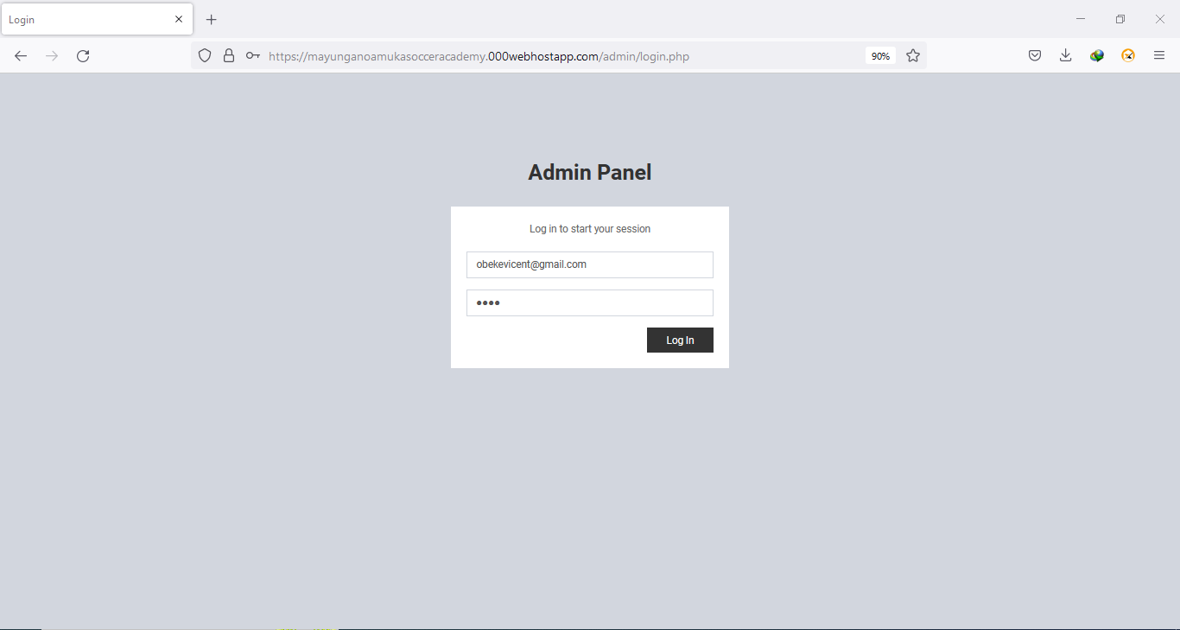

## Home Page

The home page is the most important page in the OSA, in terms of presentation. This will be the first page after successful login/sign in through the login page that administrator interacts with. **The OSA home page should be user-friendly.**

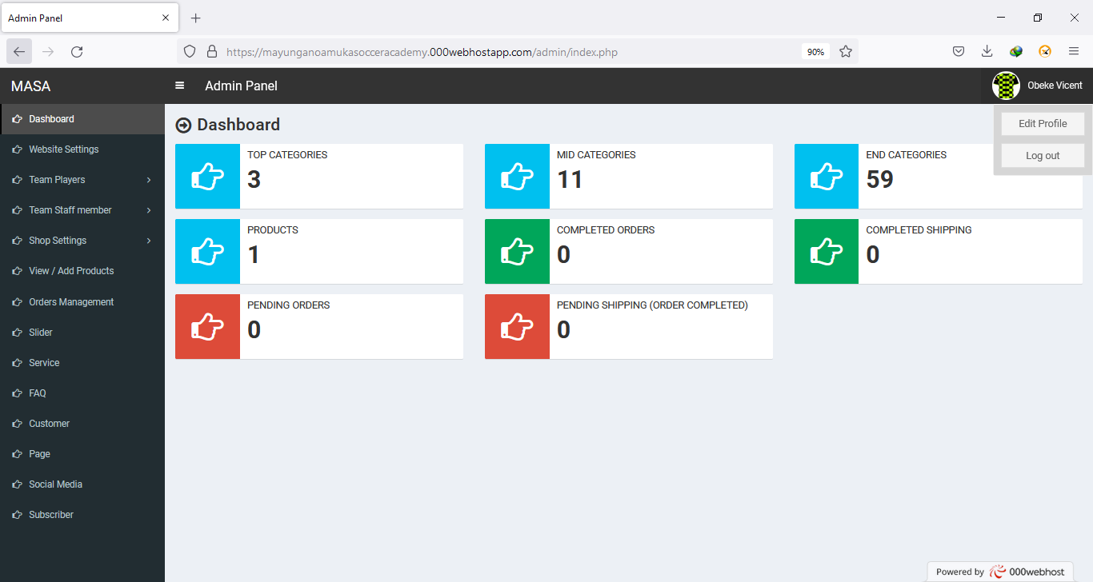

### Home Page - The Header/Top Menu bar

The header will be displayed at the top of the page, on every page of the OSA, not only on the home page



The header has the following navigation options**;**

1. **Menu icon:**

Clicking on this menu icon in the left top corner, the side bar will disappear and appear(display) from/on the OSA.

1. **Site Title:**

Shows the OSA title that is being displayed on the browser.

1. **Administrator Logo and Name:**

Clicking on the administrator logo in the right top corner will show the option for administrator to Edit Profile or Log out. This page gives the administrator an option to edit his/her profile if s/he has already logged into OSA. Clicking on the Log out link/text, the administrator will be taken back to the login page

### Home Page - The Side bar/Category block

The side bar will be displayed at the left side opposite the dashboard, on every page of the OSA, not only on the home page.

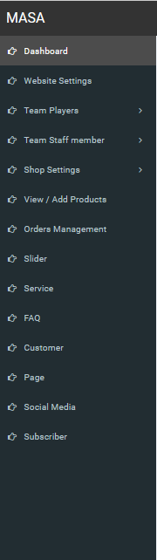

Like the header, the side bar has following navigation options;

1. **Links:**

Links the administrator to the dashboard, website settings, Team Players, Team staff member, shop settings, view/Add products, Orders Management, Slider, Service, FAQ, Customers, Pages, social Media, Subscriber

1. **OSA Name:**

Shows the OSA name (MASA).

### Home Page - Dashboard

The dashboard is the most important section of the home page on the OSA, in terms of presentation because most of the operations clicked on both theHeader/Top Menu bar and Side bar/Category block will be displayed on the dashboard.

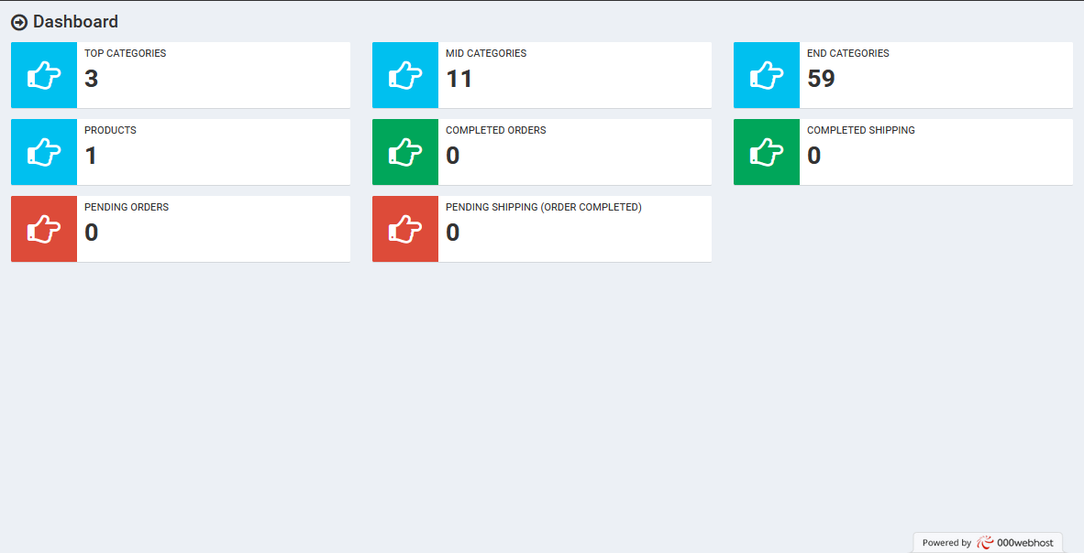

## My Account Page

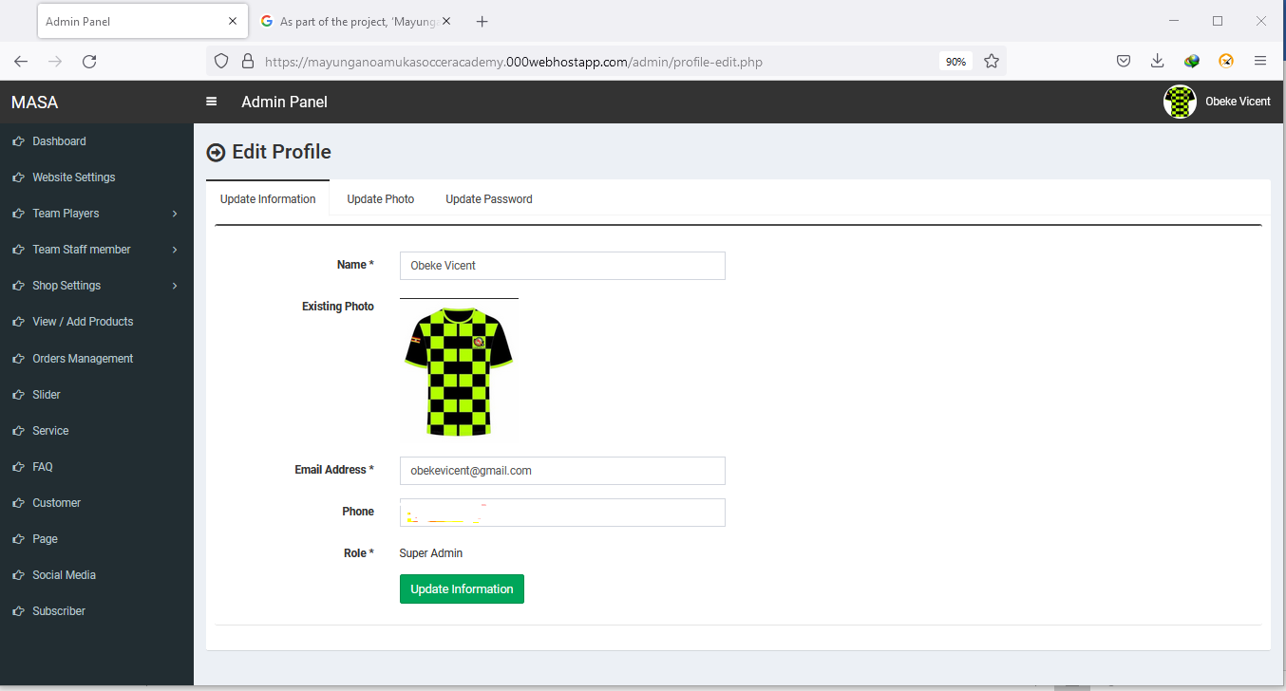

## Website Settings

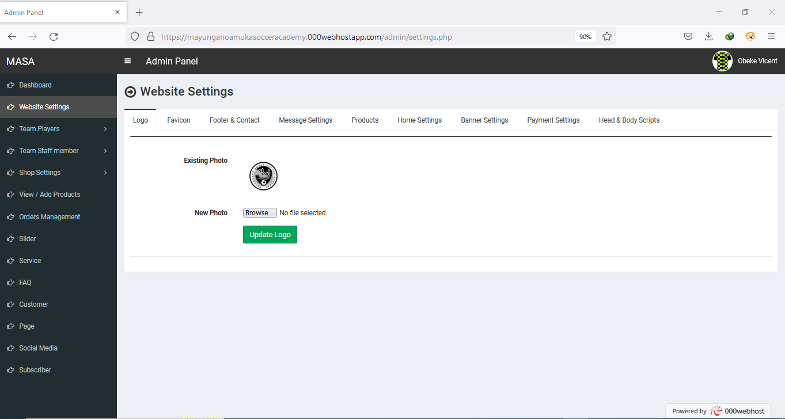

## Team Player

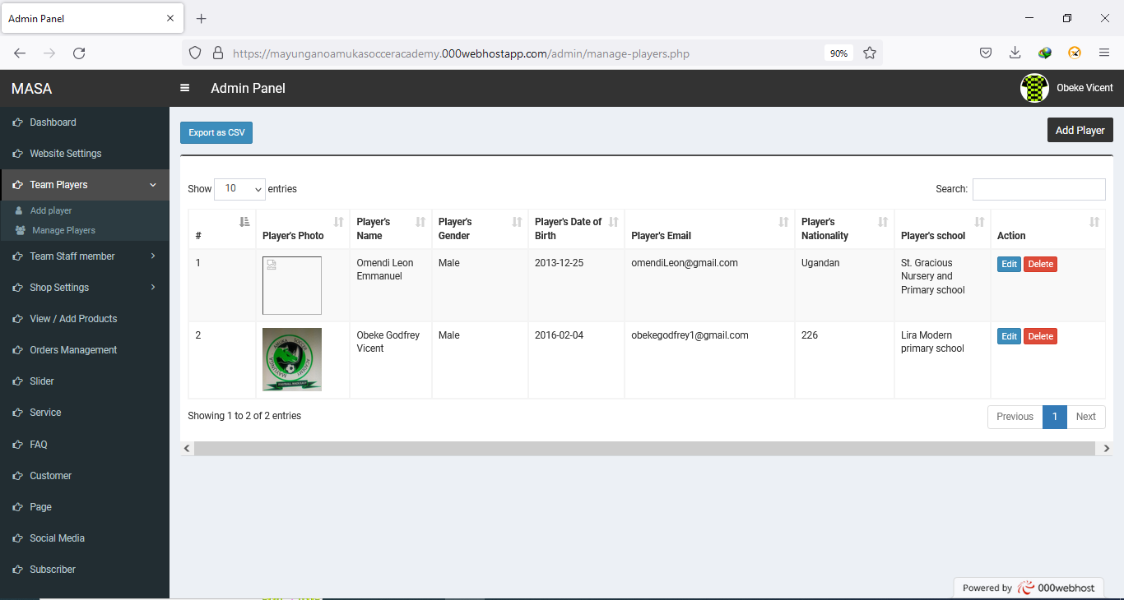

## Shop Settings

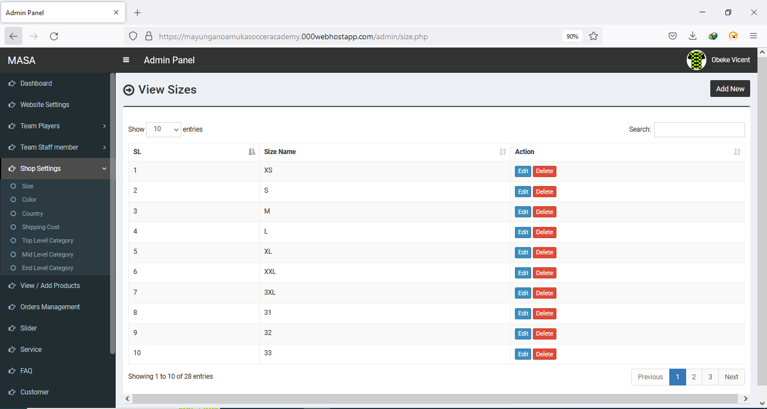

## Shop Settings - Size

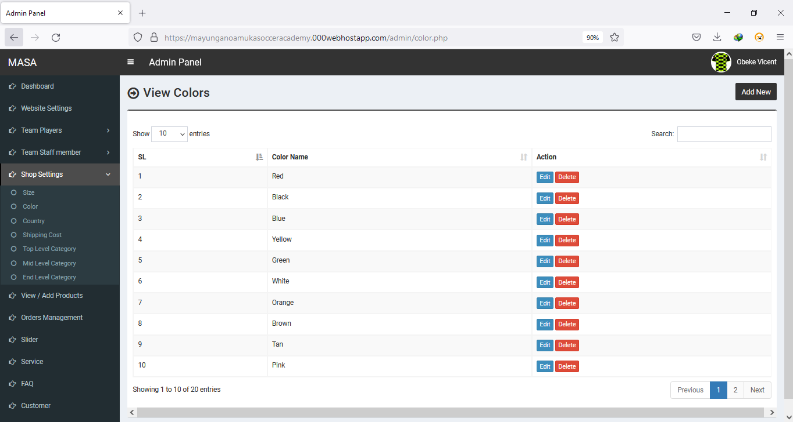

## Shop Settings - Country

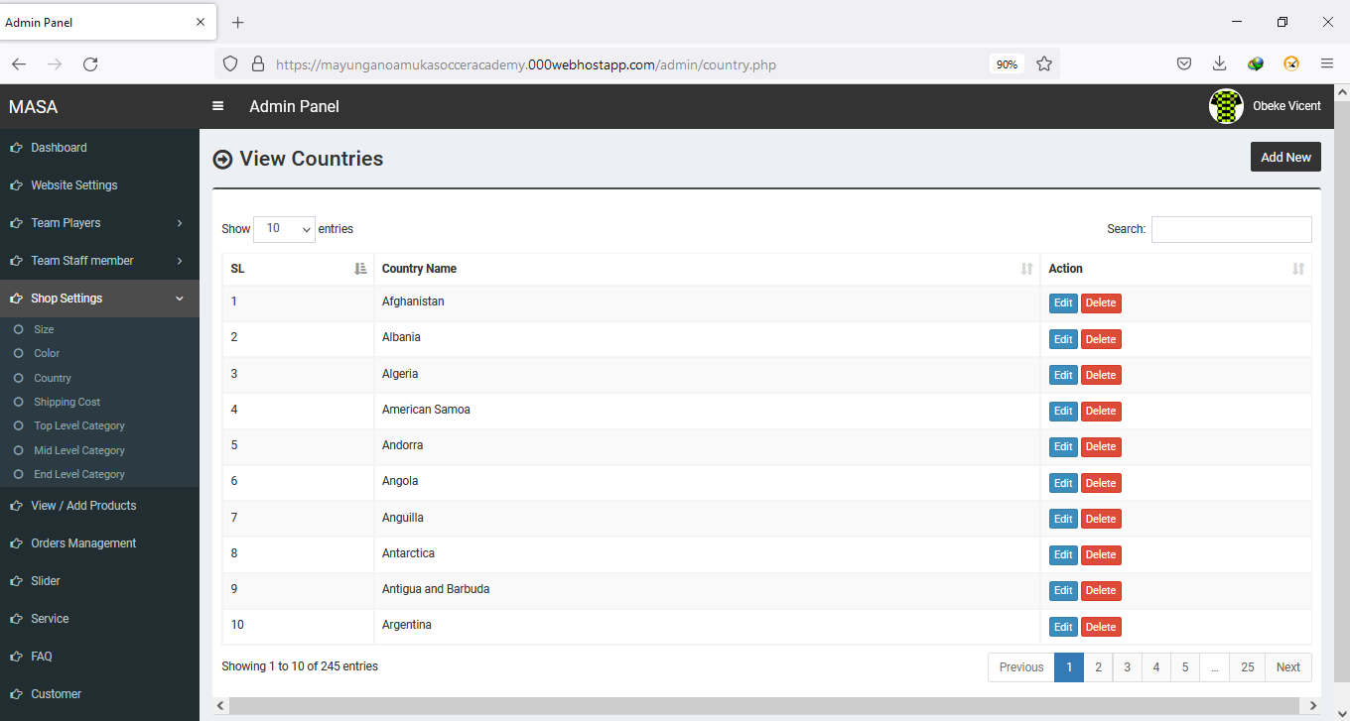

## Product Pages

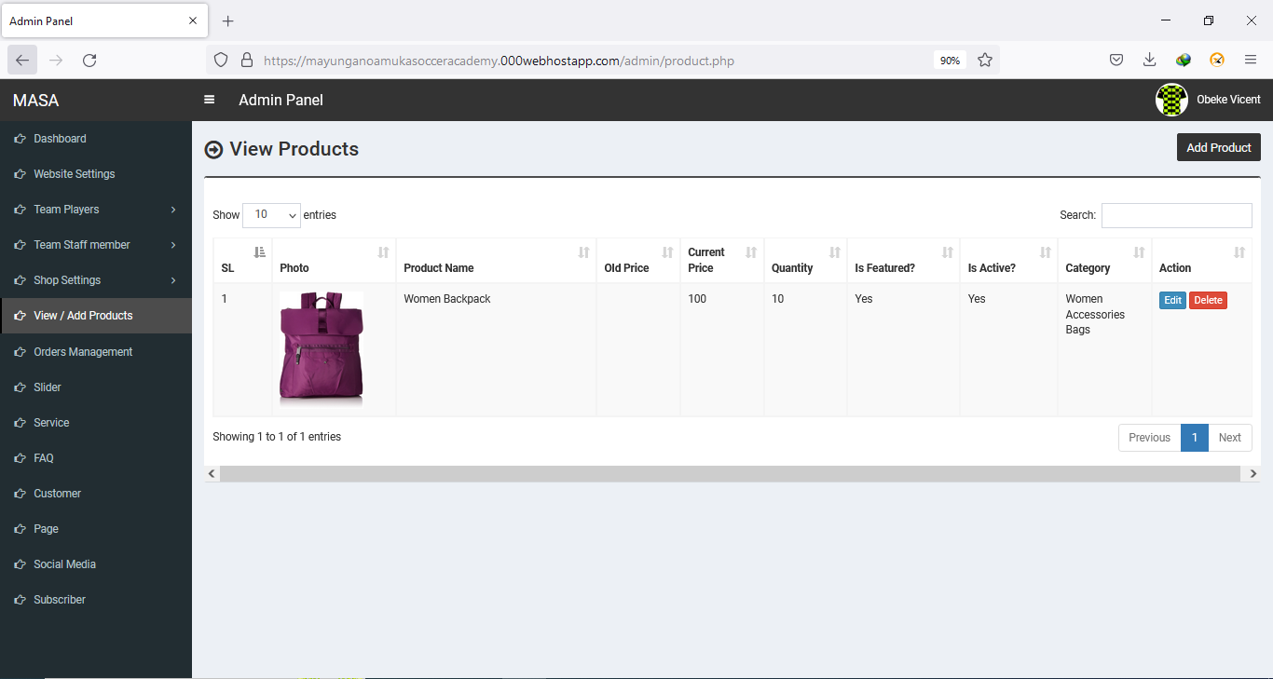

## Orders Management

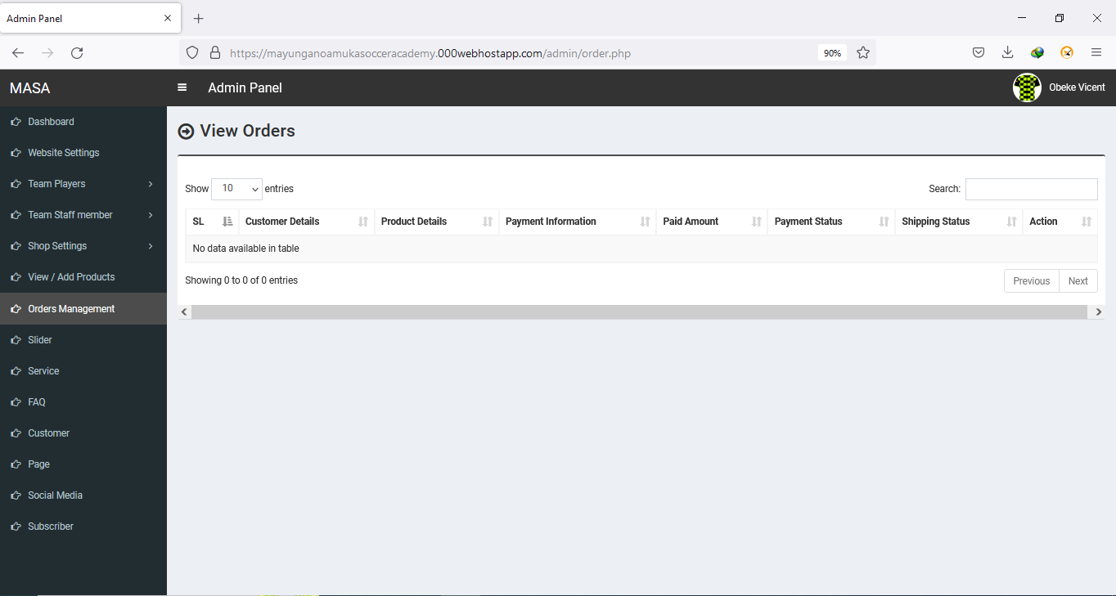

## Slider

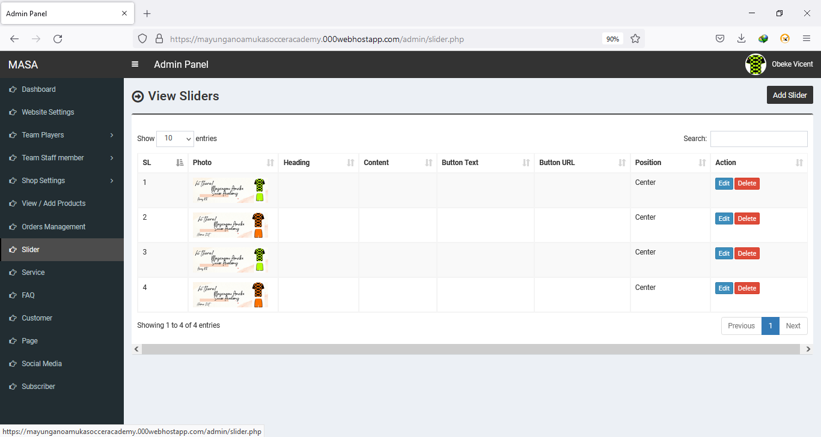

## Service

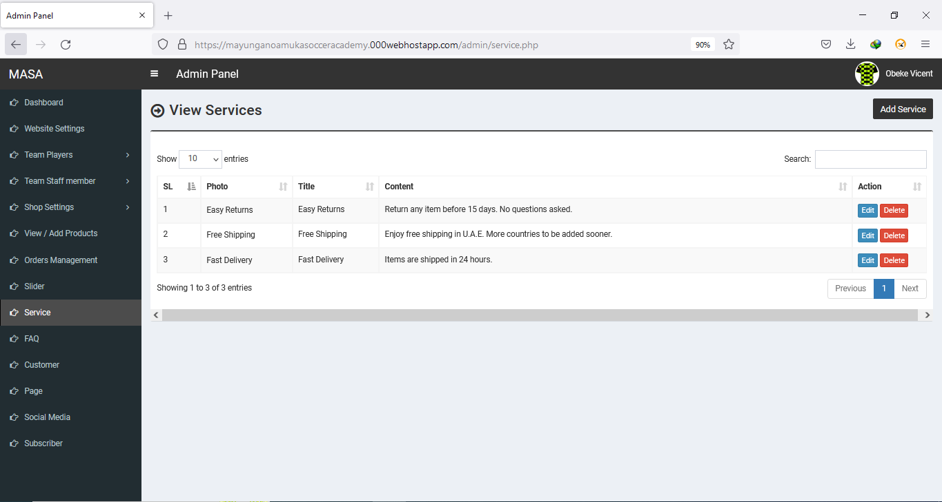

## FAQ

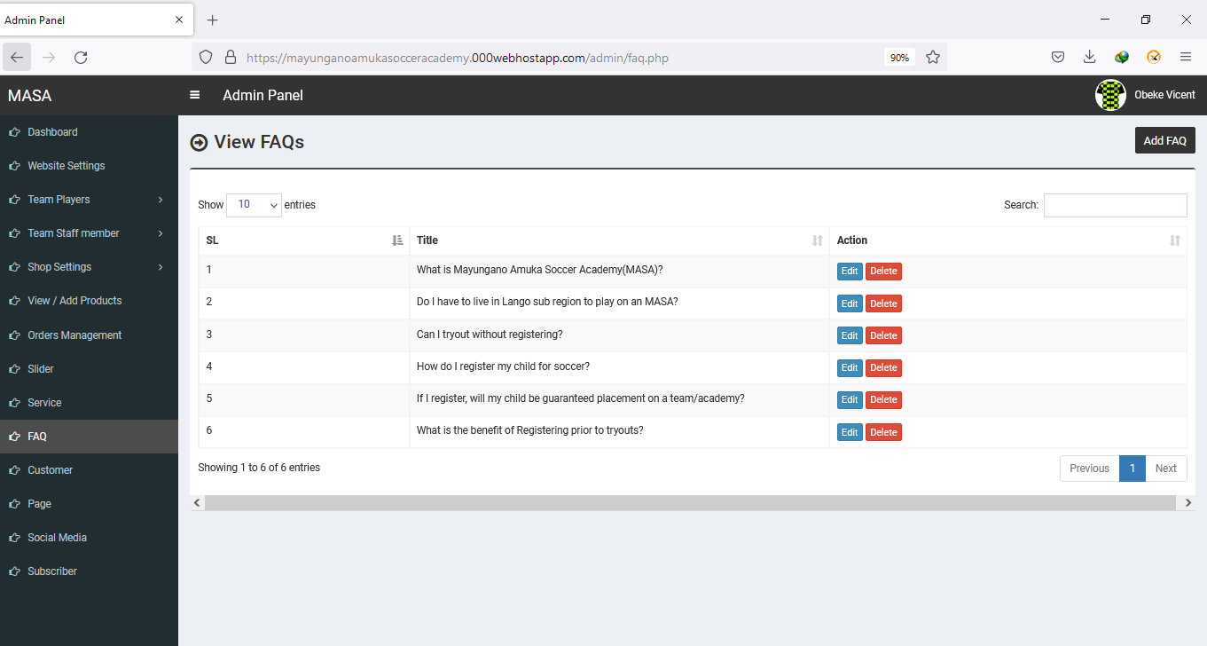

## Customer

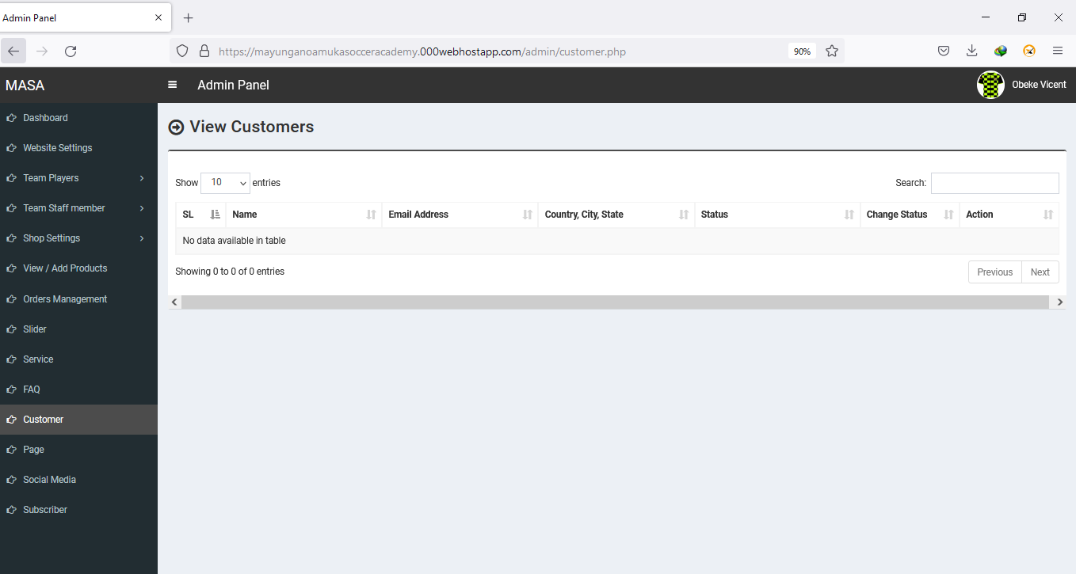

## Pages

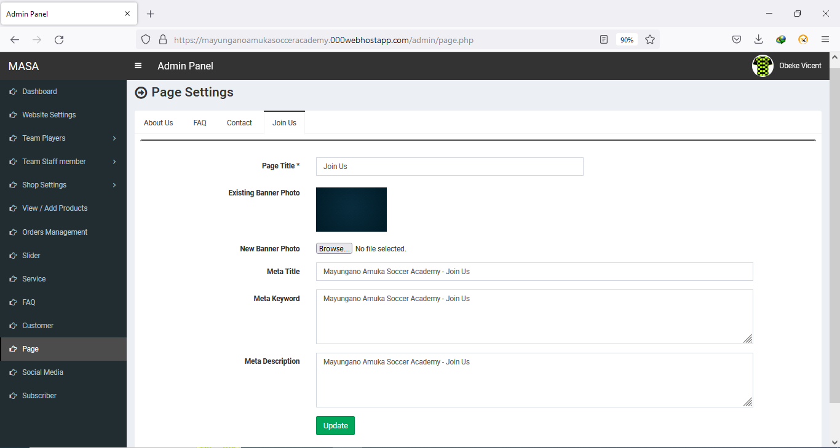

## Social Media

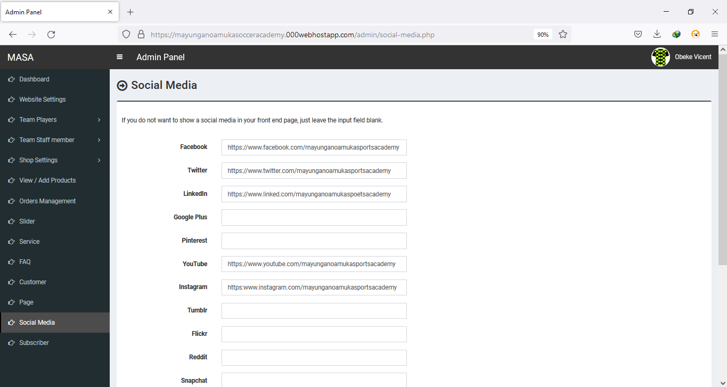

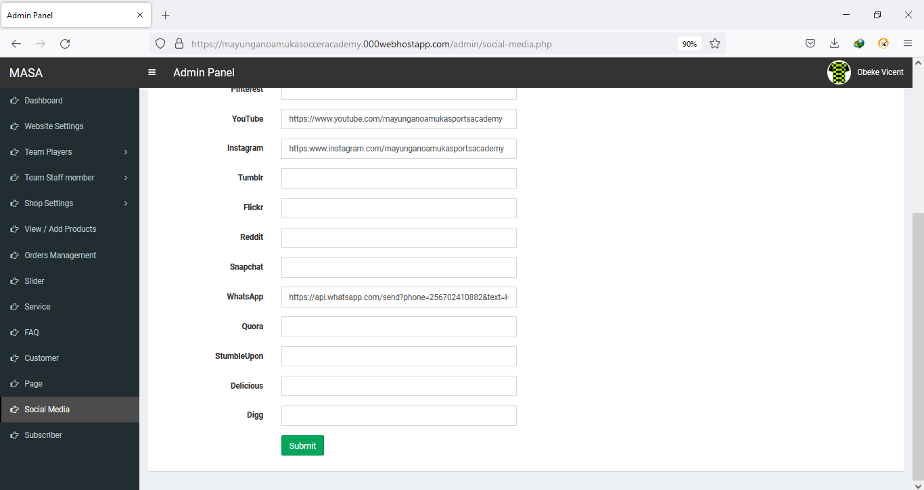

## Subscriber

