19. Storefront User Manual

Document Control

Field | Value
Document Title | ChrisPa Storefront — Customer User Manual
Audience | ChrisPa customers (shoppers)
Version | 1.0
Date | 14 August 2026
Status | Reflects the storefront as actually built — see `00-documentation-index.md`
Related | `docs/SRS.md`, `20-admin-user-manual.md`

Welcome to ChrisPa
ChrisPa Scents and Soaps is a Kampala-based natural wellness brand — candles, sea salts, ghee, honey, and soap bars made from locally-sourced ingredients (goat's milk, honey, herbs, ghee, soywax, beeswax, sea salt, essential oils). This manual walks through everything you can do on the storefront today, from browsing to checkout to getting help.
A quick-reference table of what's live today versus what's still on the way is at the end of this manual (Feature Availability at a Glance) — the rest of the manual focuses on what you can actually do right now.

1. Creating Your Account and Signing In

Sign up
Go to Account in the header (there's no separate "Log In" link — Account is the one entry point, signed in or not) and choose Create an Account, or go directly to /signup. You'll need:
- Full Name
- Email
- Phone (Uganda format, +256XXXXXXXXX)
- Password (at least 8 characters, including at least one number)
- Agreement to the Terms & Privacy Policy
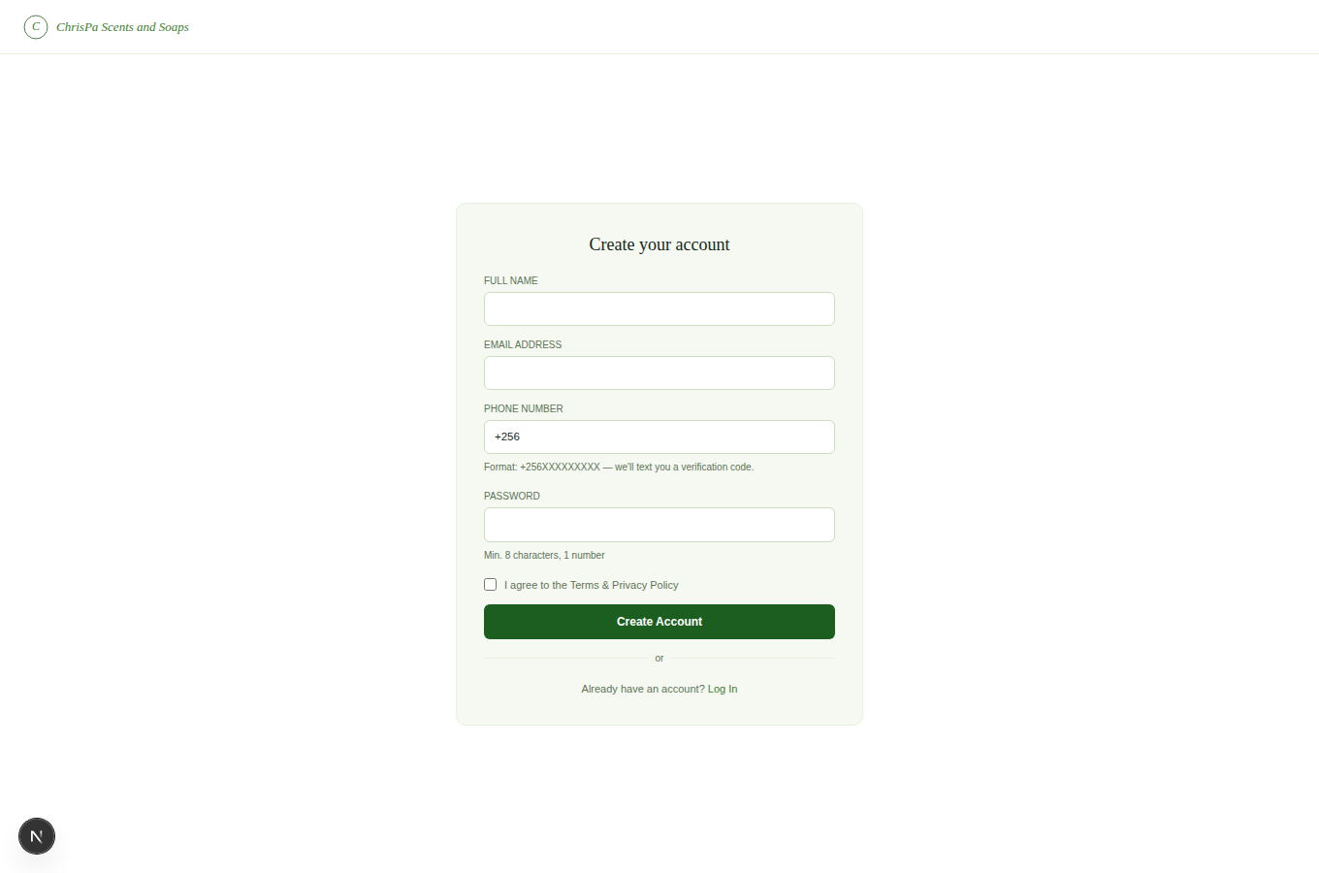
The Sign Up screen — Full Name, Email, Phone, Password, Terms & Privacy, and Continue with Google
After submitting, your account exists but isn't signed in yet — you'll land on a Verify your account step with two boxes, one for a 6-digit code emailed to you and one texted to your phone. Enter both (in either order; "Resend code" is there if one doesn't arrive within a minute or so) and you're signed in automatically the moment the second one's confirmed. Both codes expire after 10 minutes.
Or, skip all of that — click Continue with Google instead of filling in the form. Since Google's already confirmed your email address, this creates (or signs into, if you've used it here before) your account immediately, no password and no verification codes needed.

Log in
Enter your email or phone and password. If you signed up before finishing the email/phone verification above, you'll be sent straight back to that Verify your account step instead of being let in. If your account has Two-Factor Authentication turned on, you'll be asked for a 6-digit code from your authenticator app next.
Continue with Google: if you signed up with Google, or just want to skip typing a password, click Continue with Google and pick your account in the popup.
Biometric Login: if you've registered a passkey/biometric credential (see Settings below), you can skip your password entirely — type your email/phone, then click 🔒 Log In with Biometric and approve it with your device's fingerprint/face unlock or security key.
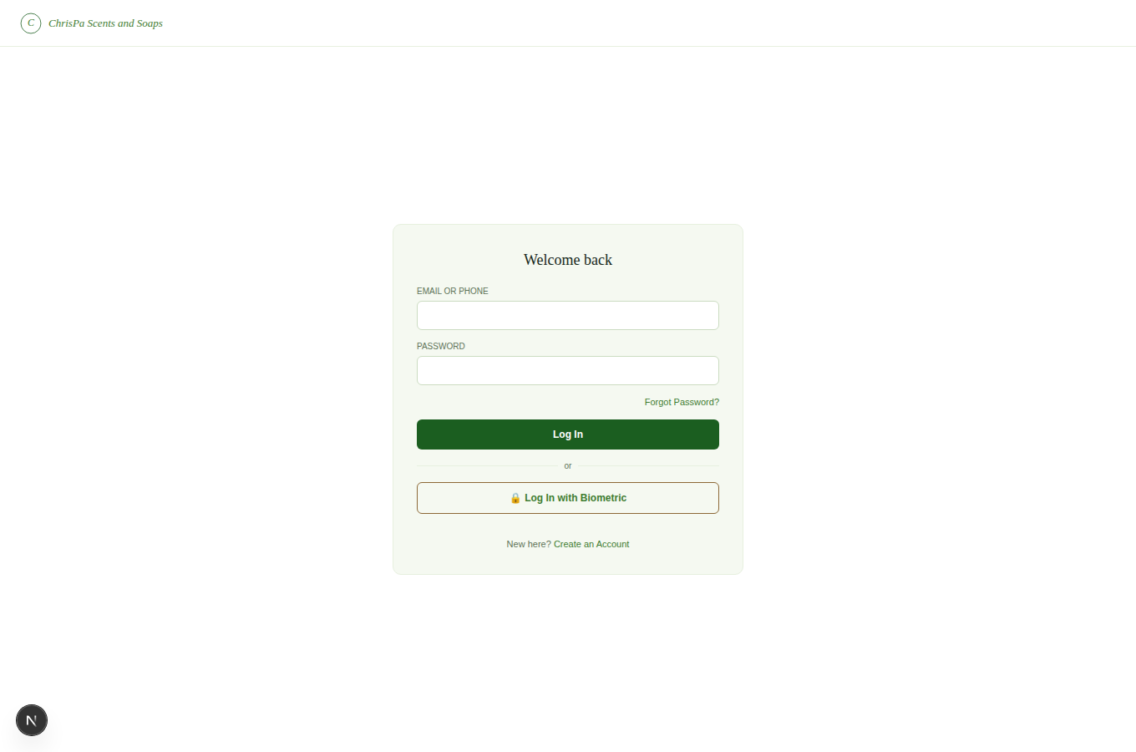
The storefront login screen — Continue with Google, email/phone + password, and Log In with Biometric

Forgotten your password?
The Forgot Password / Reset Password screens are not yet wired up to send a reset link — if you're locked out, contact ChrisPa support to have it resolved manually.
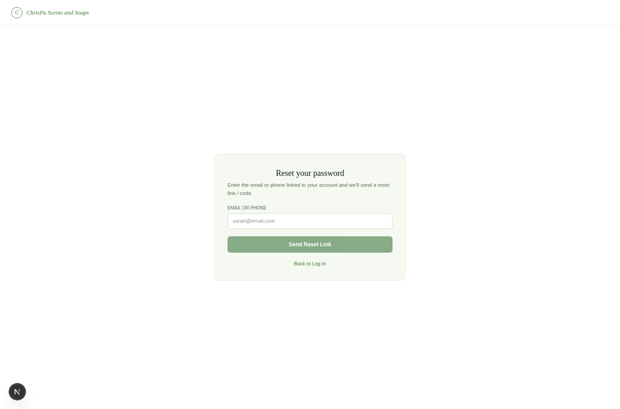
The Forgot Password screen
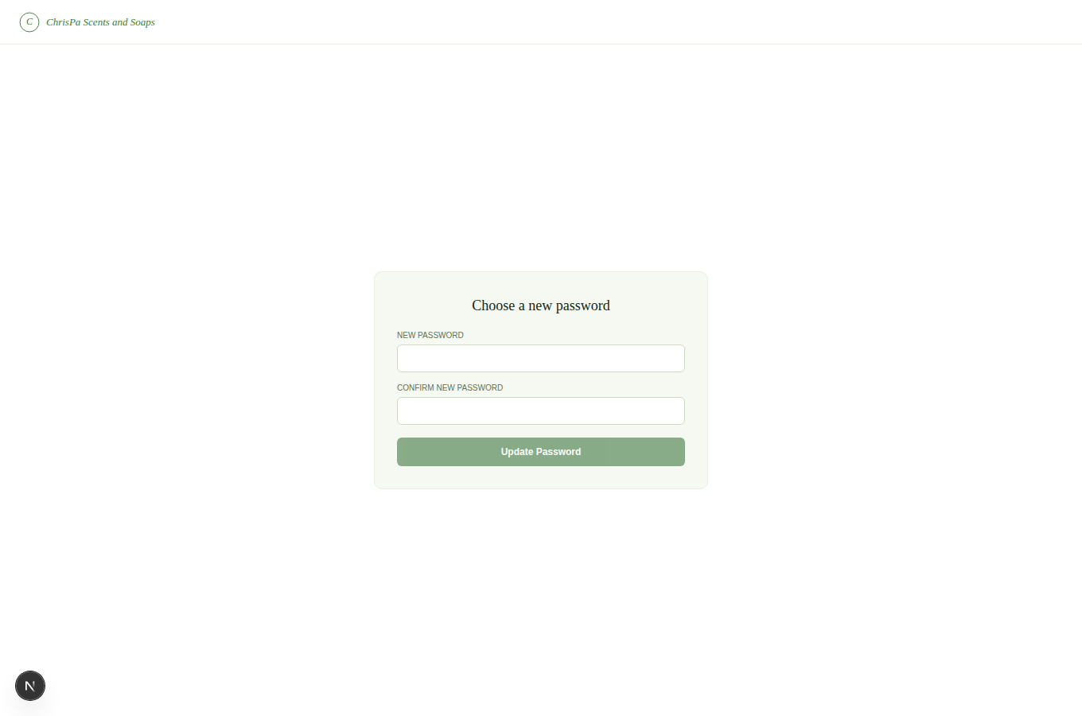
The Reset Password screen

2. Finding What You Need
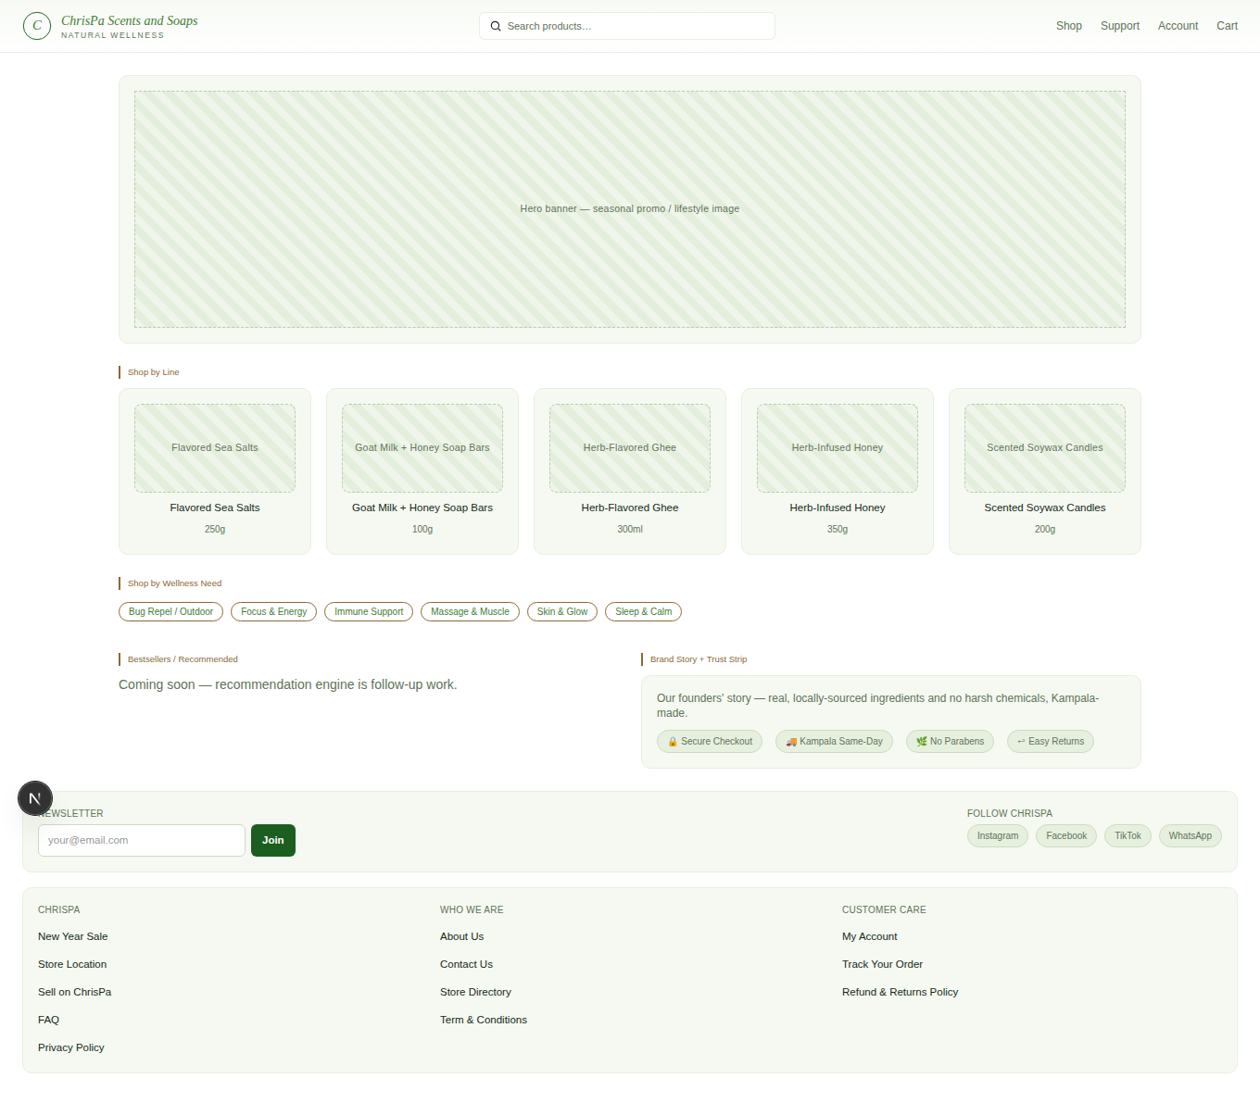
The storefront homepage — hero banner, Shop by Line category tiles, and Shop by Wellness Need chips
- Search: the search box in the header (desktop and mobile) searches product name, scent/flavor notes, and health benefits — type a term like "lavender" or "immune" and press Enter.
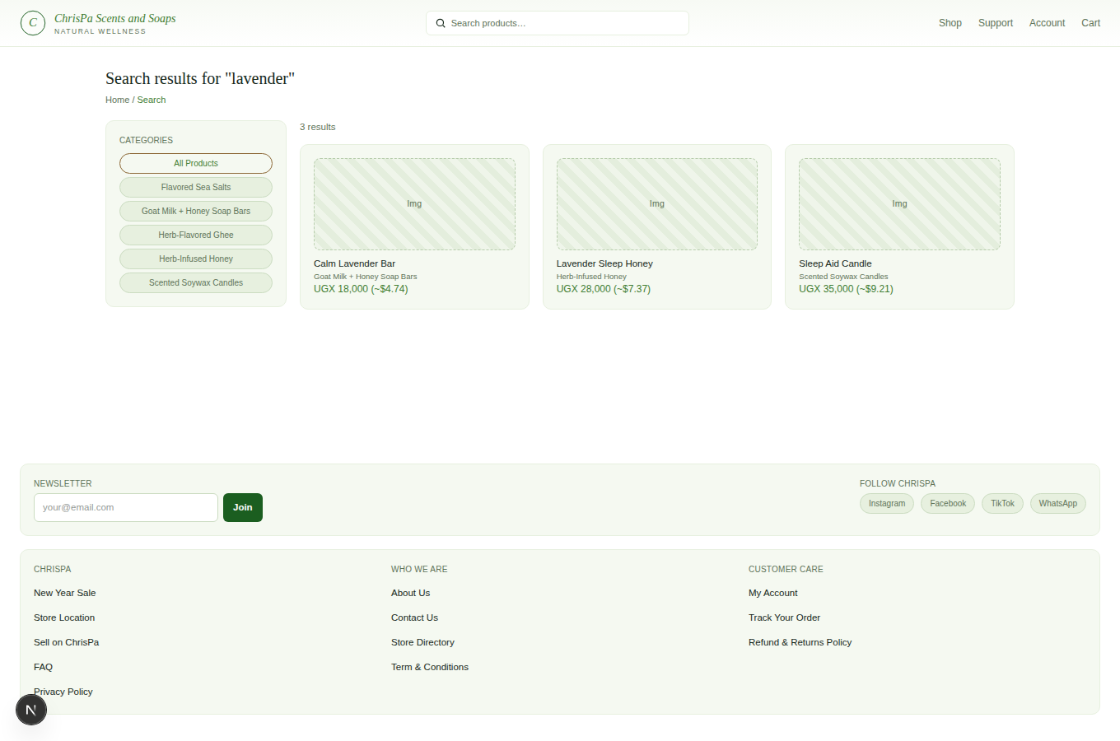
Search results for "lavender"
- Shop by Line: the homepage's category tiles (Candles, Sea Salts, Ghee, Honey, Soap Bars) take you straight to that line's products.
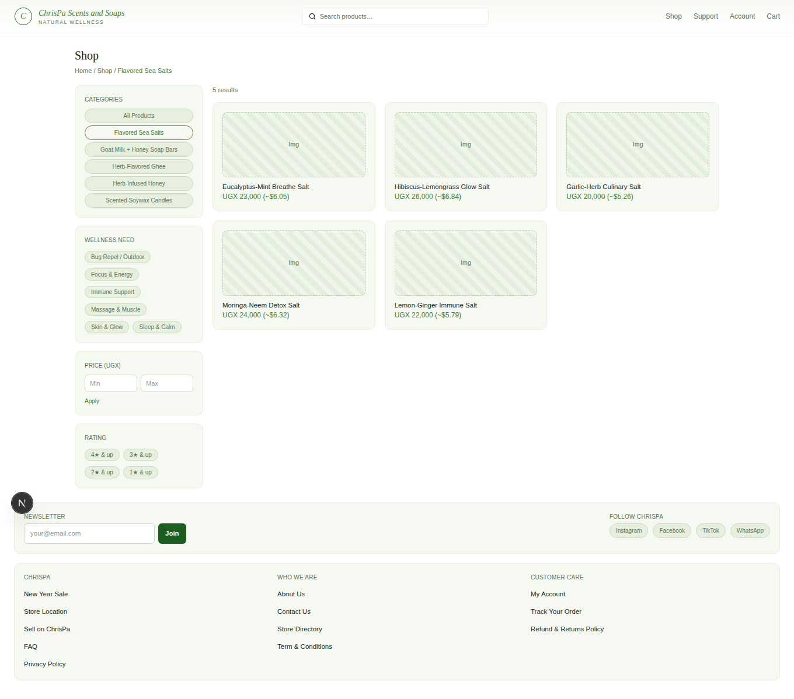
A single product line's page (Sea Salts)
- Shop by Wellness Need: below that, a row of chips (Sleep & Calm, Focus & Energy, Skin & Glow, Immune Support, Bug Repel / Outdoor, Massage & Muscle) — click any one to jump straight to matching products across every product line.
- The Shop page (/shop, or any category page) has a left-hand sidebar with three real filters that all combine together and survive switching category:
- Categories — every product line, plus "All Products."
- Wellness Need — the same tag chips as the homepage.
- Price (UGX) — type a Min and/or Max and click Apply.
- Rating — "4★ & up" through "1★ & up." (ChrisPa doesn't accept product reviews yet, so this filter will currently show no matches — it's ready for when reviews launch.)
Every active filter shows as a removable chip (with a ✕) next to the result count, and a Clear all filters link appears once more than one is active.
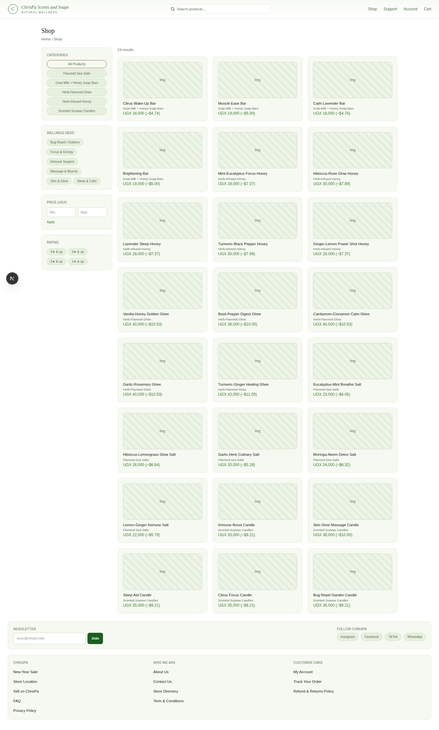
The Shop page — filter sidebar (Categories, Wellness Need, Price, Rating) alongside the product grid

3. Product Pages
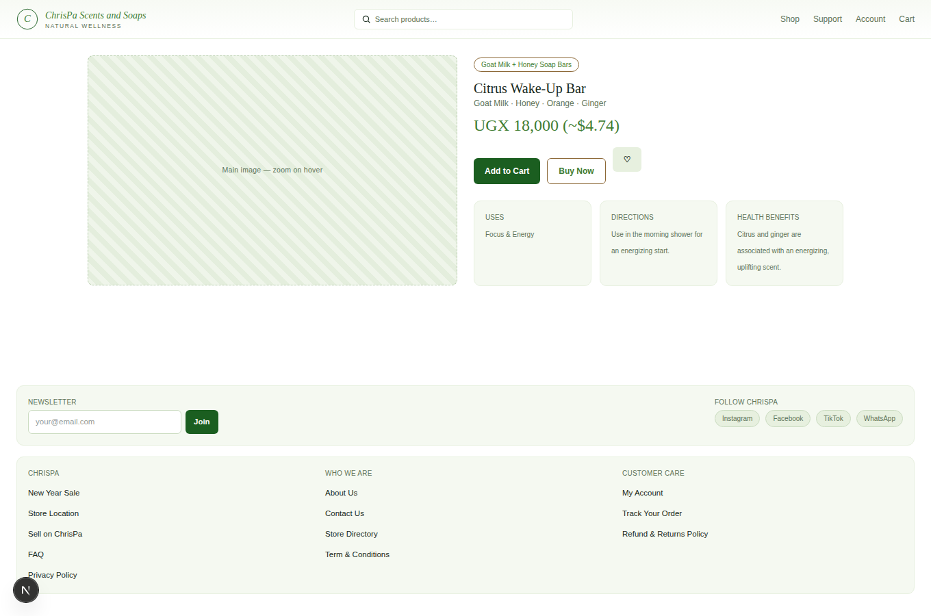
A product detail page — photos, size selector, Uses/Directions/Health Benefits panels, Add to Cart
Every price you see on ChrisPa — here, in the Shop grid, your cart, checkout, order history, wishlist, and your receipt — is shown in both currencies, e.g. UGX 18,000 (~$4.74). UGX is what you're actually charged; the USD figure is an estimate for shoppers thinking in dollars, using a rate ChrisPa updates manually (not a live, minute-to-minute exchange rate).
Each product page shows its photos, a Size selector if the product comes in more than one size, and three info panels specific to ChrisPa's catalog:
- Uses — the wellness needs this product addresses.
- Directions — how to use it.
- Health Benefits — what it's traditionally used for.
Pick a size (if applicable) and click Add to Cart — you'll be taken straight to your cart. Click the ♡ icon to save it to your Wishlist instead (you'll need to be logged in for either).

4. Cart and Checkout

Your cart (/cart)
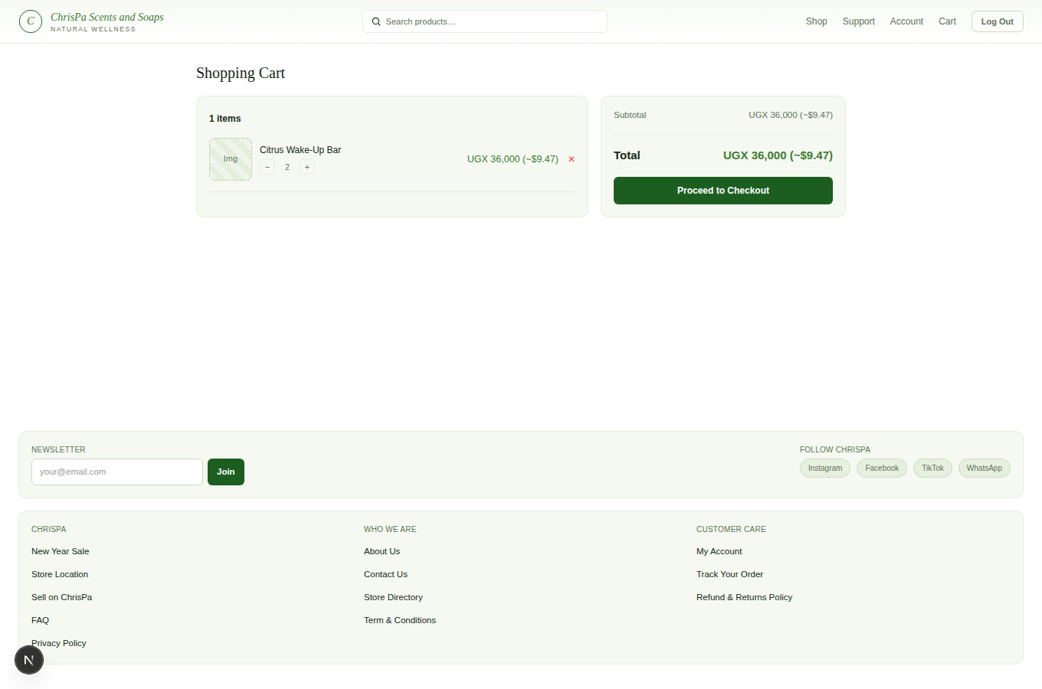
The shopping cart page — line items with quantity steppers, subtotal/total, and Proceed to Checkout
Each line shows the product, a size dropdown (if it has variants), a quantity stepper, and a ✕ to remove it. The summary panel shows your subtotal and total, with a Proceed to Checkout button.

Checkout
You'll need to be logged in. Fill in:
- Shipping details — recipient name, phone, address, city, and any delivery notes.
- Delivery method — Standard (free), Express (UGX 8,000), or Same-day within Kampala (UGX 12,000).
- Promo code (optional) — if you have a coupon, enter it here.
- Payment method — Cash on Delivery is available today. Mobile Money and Card are shown as "coming soon" — ChrisPa hasn't connected a payment gateway for them yet.
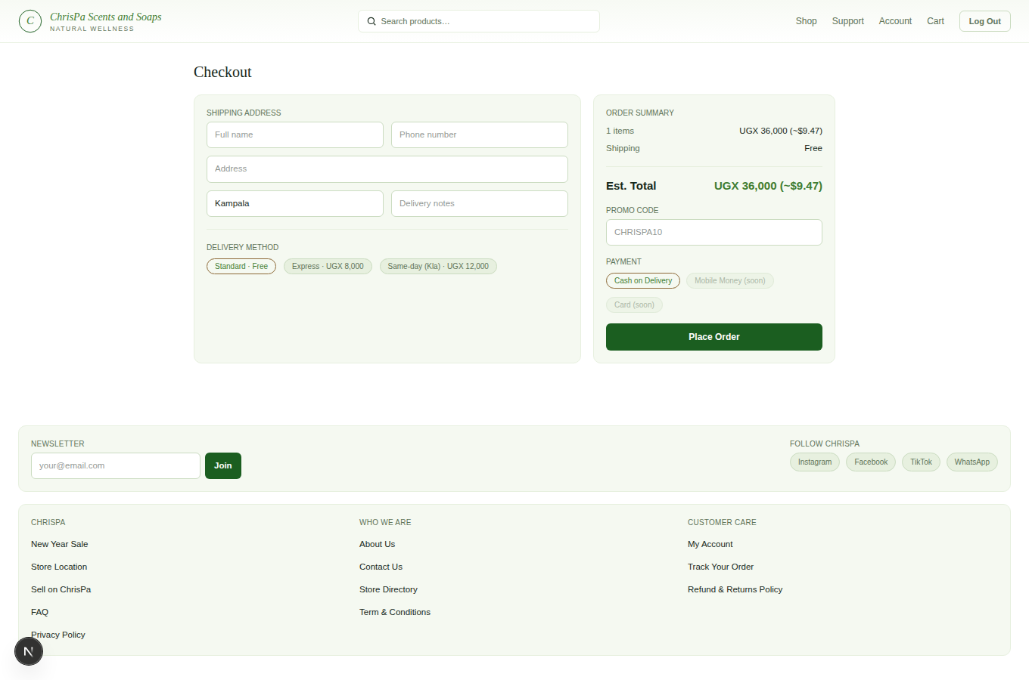
The Checkout page — shipping address, delivery method, promo code, and payment method
Click Place Order. You'll land straight on your new order's tracking page — that page is also your order confirmation.

5. Your Orders

Order Tracking (/orders/[order])
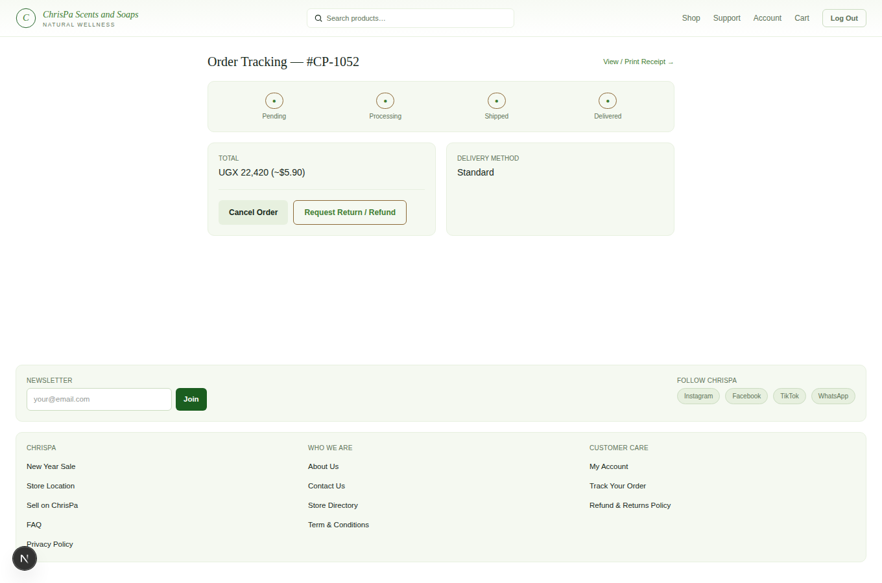
An order tracking page — status pipeline, total, and delivery method
Shows a four-step pipeline — Pending → Processing → Shipped → Delivered — plus your total and delivery method. Once ChrisPa marks your order Delivered, a receipt link appears here.

Getting your receipt
Your printable receipt isn't available the moment an order is marked Delivered — ChrisPa also wants your own confirmation that everything arrived in good shape, so both sides have signed off before the receipt is finalized:
- From the order tracking page, click Confirm Receipt →.
- Click ✓ I received my order in good condition.
- Your receipt unlocks immediately — the link now reads View / Print Receipt →.
Your receipt shows ChrisPa's logo, business contact details, every item you ordered (with quantities and prices), your subtotal/shipping/discount/VAT/total, your payment method, and — since you've just confirmed it — a "Received in Good Condition" stamp with the date you confirmed. Click Print / Save as PDF to print it or save it as a PDF through your browser's print dialog (there's no separate download button — this is the download).
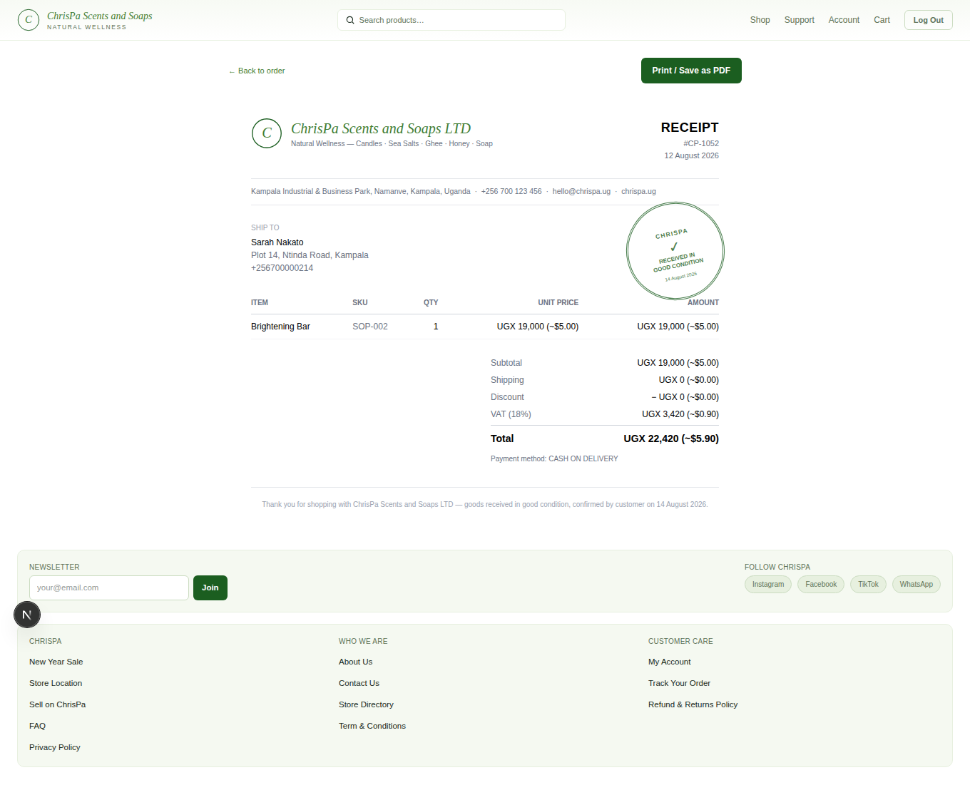
A confirmed receipt — items, totals, payment method, and the Received in Good Condition stamp

6. Your Account
Everything here lives under Account in the header, once you're signed in.
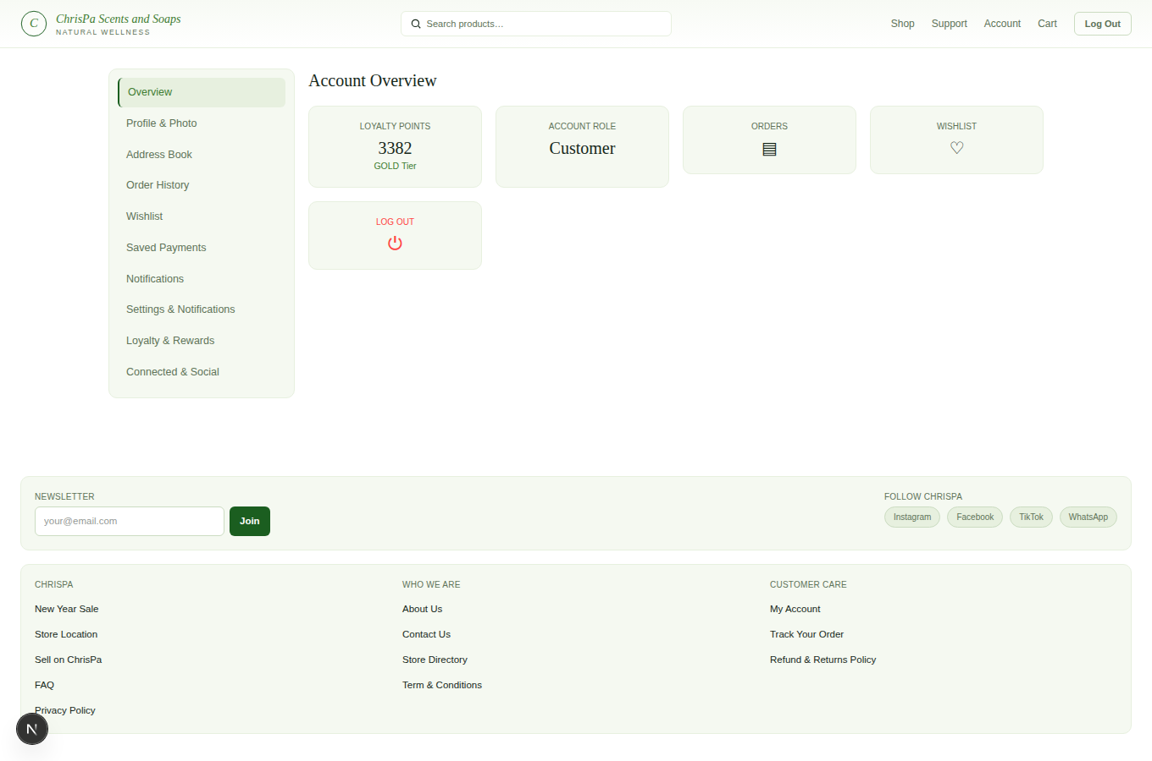
The signed-in Account area — sidebar (Overview, Profile & Photo, Address Book, Order History, Wishlist, Saved Payments, Notifications, Settings & Notifications, Loyalty & Rewards, Connected & Social)

Profile & Photo
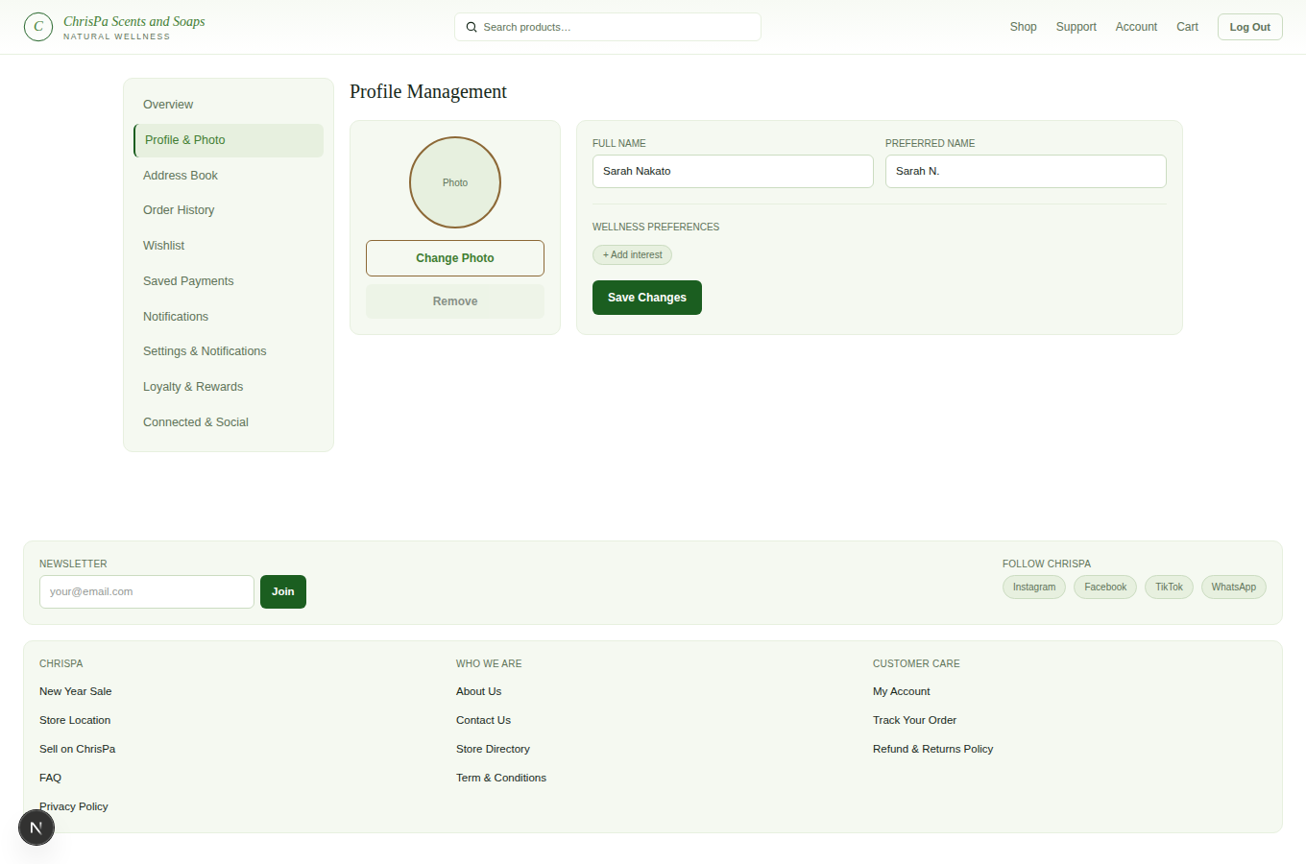
The Profile & Photo page
Edit your name and preferred name, upload or remove a profile photo, and manage a "Wellness Preferences" list of interests (used for future personalization).

Address Book
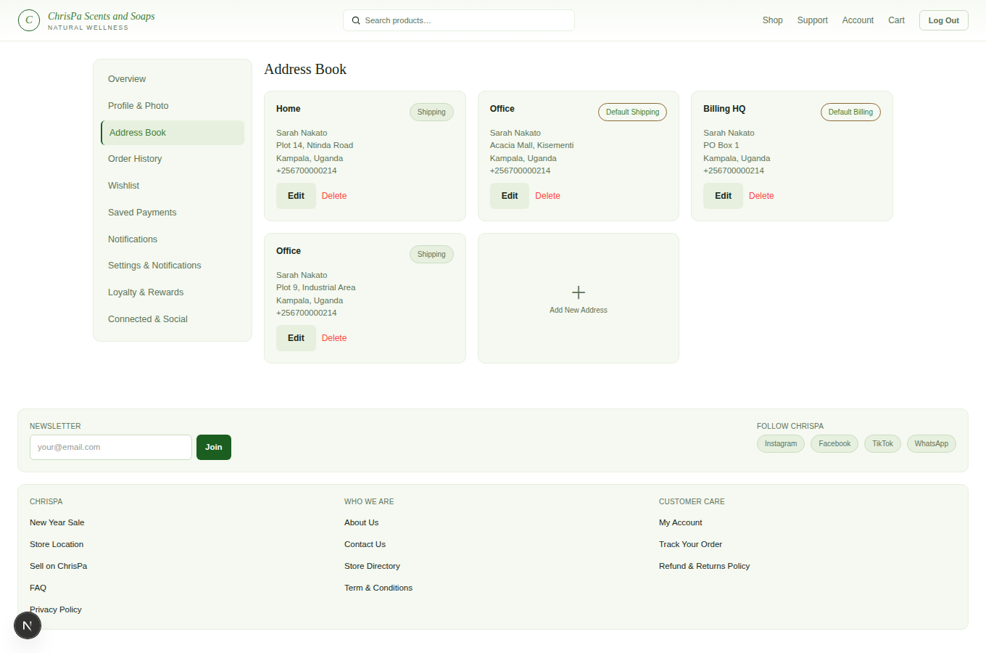
The Address Book page — saved addresses with Shipping/Billing labels
Add, edit, or delete saved addresses — label each one (e.g. "Home," "Office"), mark it Shipping or Billing, and optionally set it as your default for that type.

Order History
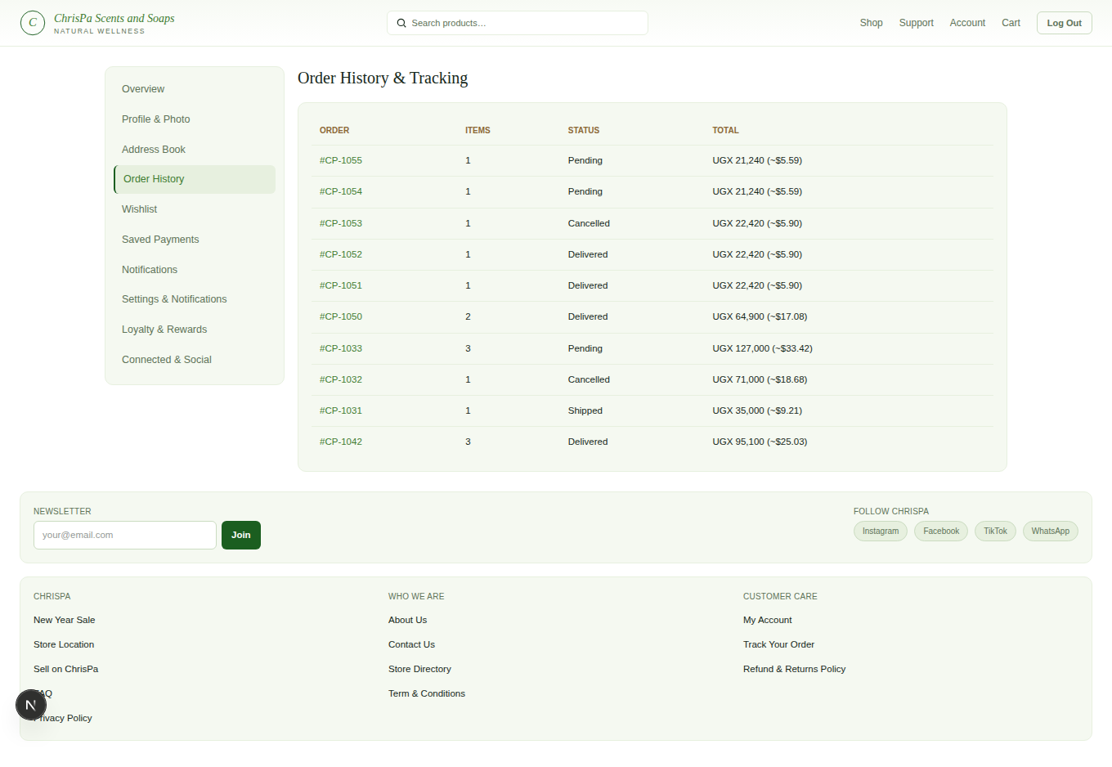
The Order History page — every past order with status and total
A list of every past order with its status and total — click through to any one for full tracking/receipt details.

Wishlist
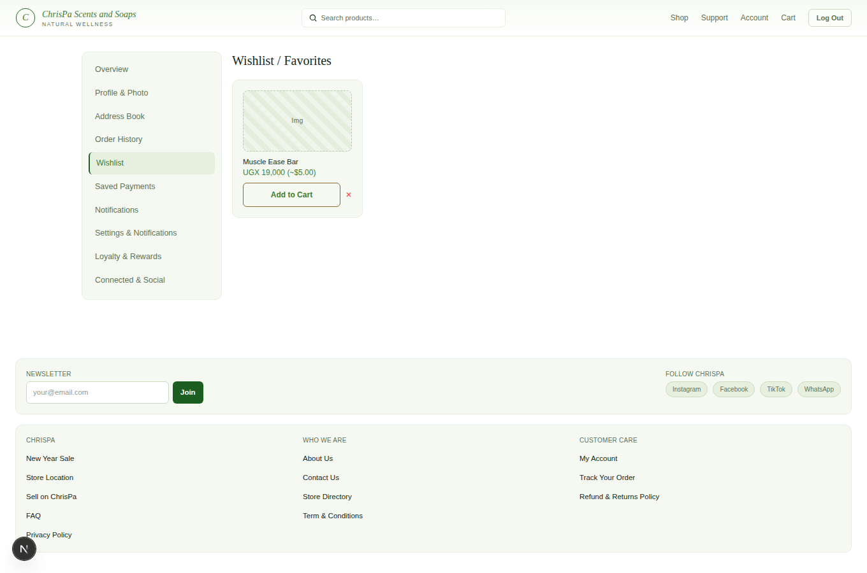
The Wishlist page
Everything you've saved with the ♡ icon. Add straight to cart or remove items from here.

Saved Payment Methods
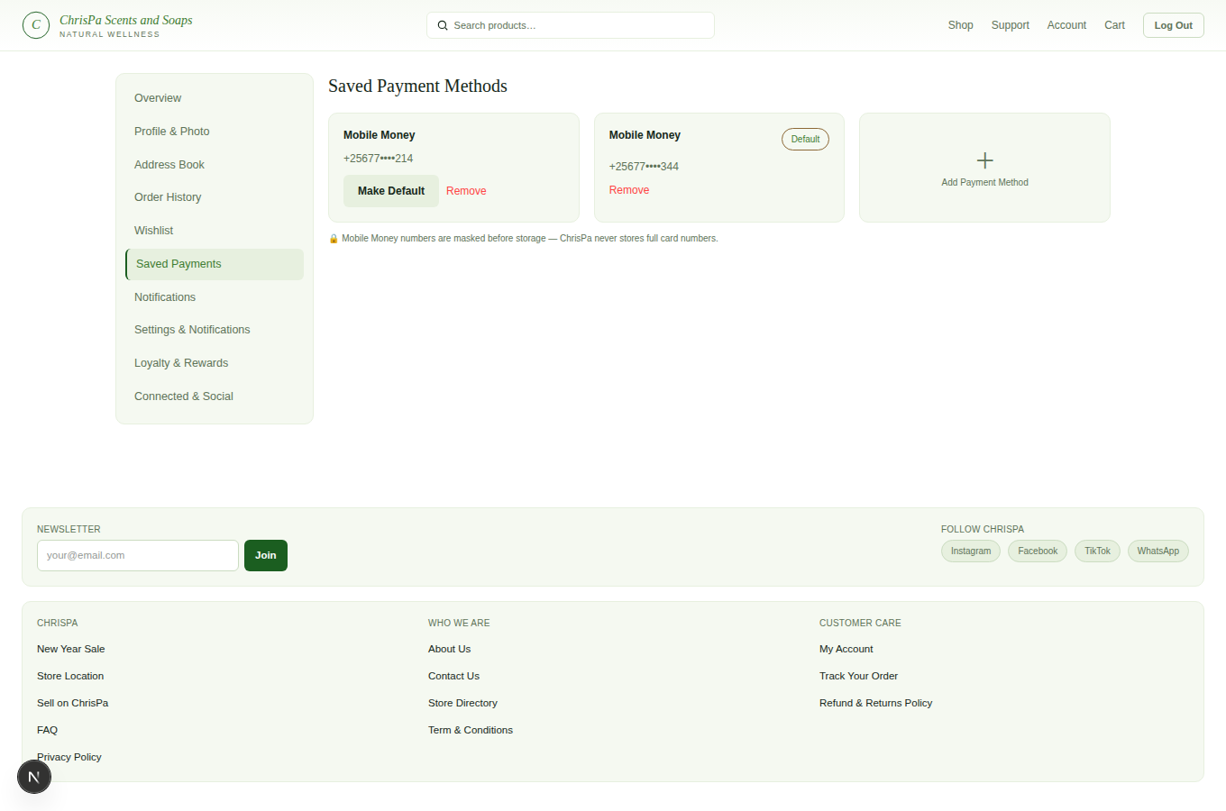
The Saved Payment Methods page
Only Mobile Money numbers can be saved today — enter your number and it's saved (masked) for faster checkout later. Card and PayPal are shown but not yet available (no payment gateway connected for them yet). Set any saved method as your default, or remove it.

Loyalty & Rewards
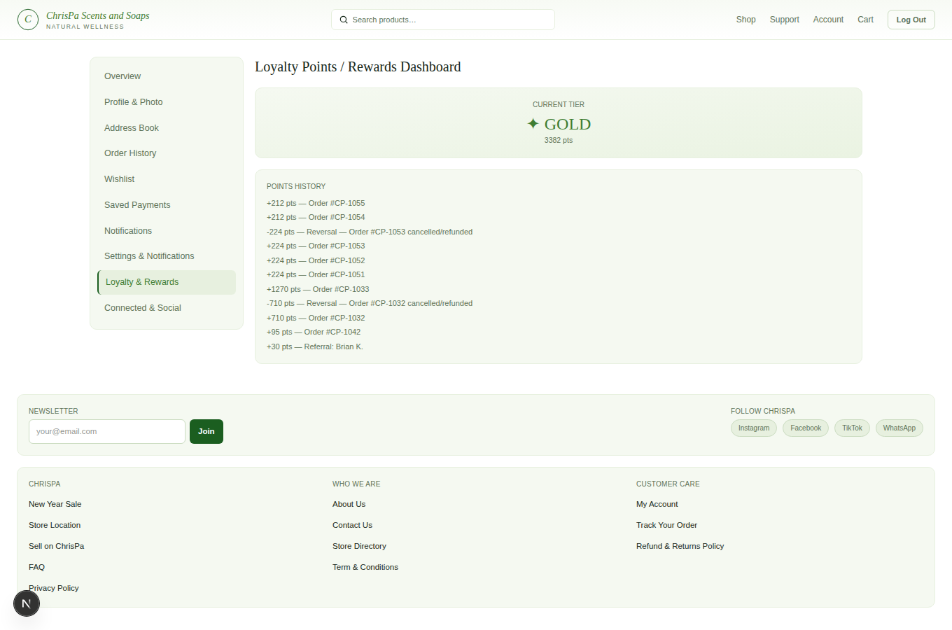
The Loyalty & Rewards page — current tier, points balance, and earning history
Shows your current tier and points balance, plus a history of how you earned them. You earn 10 points for every UGX 1,000 spent, credited automatically as soon as an order is placed. Redeeming points isn't available yet — think of this page as your running rewards statement for now, with redemption coming later.

Settings & Notifications
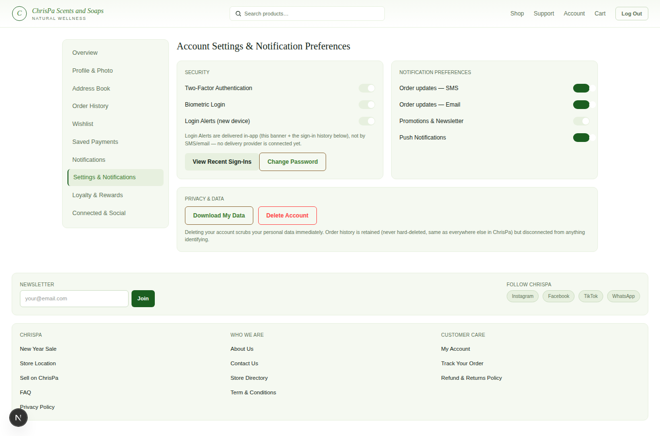
The Settings & Notifications page — security, password, notification preferences, and privacy/data controls
- Two-Factor Authentication: turn on and scan the QR code with your authenticator app (Google Authenticator, Authy, etc.), then confirm with the 6-digit code it shows you.
- Biometric Login: register your device's fingerprint/face unlock or a security key for passwordless sign-in (see Log in above).
- Login Alerts: get notified in-app (right here, plus a "Recent Sign-Ins" history) whenever your account is signed into from a new device — this doesn't currently send an email or SMS, just the in-app alert.
- Change Password: enter your current password and a new one.
- Notification Preferences: toggle Order Updates (SMS), Order Updates (Email), Promotions & Newsletter, and Push Notifications. (These save your preference; nothing sends on any of these toggles today — email and SMS delivery are only wired up for the verification codes you get at signup and for newsletter campaigns (see Notifications below), not for order-update/push triggers yet, and there's no push notification service connected at all.)
- Download My Data: get a JSON file of everything ChrisPa holds about you — profile, addresses, orders, saved payment methods (masked), wishlist, reviews, support tickets, and loyalty history.
- Delete Account: type your password and the word DELETE to confirm. This immediately removes your addresses, saved payment methods, cart, wishlist, and login/biometric data, and signs you out everywhere. Your order history is kept (for receipts, returns, and ChrisPa's own accounting records) but is no longer linked to your personal information. This can't be undone.

Notifications
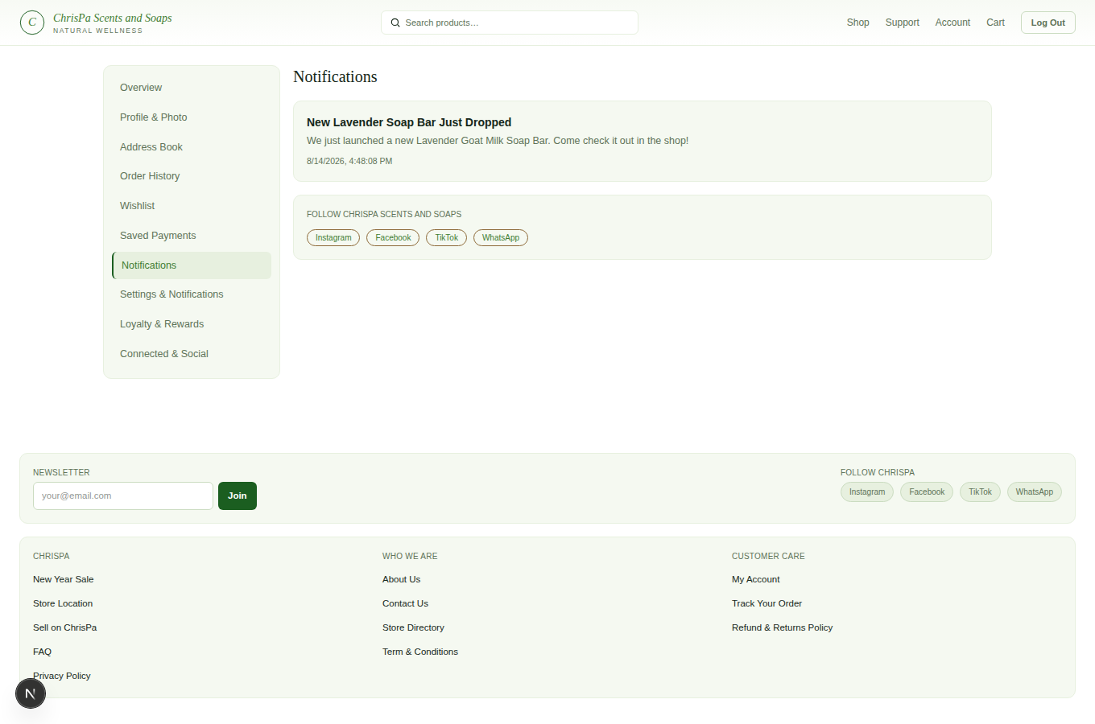
The Notifications inbox — a newsletter entry with a New tag, and the Follow ChrisPa Scents and Soaps card
Your account has a Notifications inbox (its own item in the account sidebar, with a badge showing how many are unread). Today the only thing that lands here is a ChrisPa newsletter — when ChrisPa's team sends one out, you'll see it listed with its subject, message, and a "New" tag until you open it. Click Mark read on one, or Mark all read at the top, to clear the badge. Every newsletter you get here is also emailed to you at the address you signed up with, and the page includes a Follow ChrisPa card linking out to ChrisPa's social accounts, so you can review the update and follow/connect with ChrisPa in the same place. (This inbox is built generically, so other kinds of alerts — order updates, etc. — may start appearing here in the future; right now newsletters are the only kind.)

Connected & Social
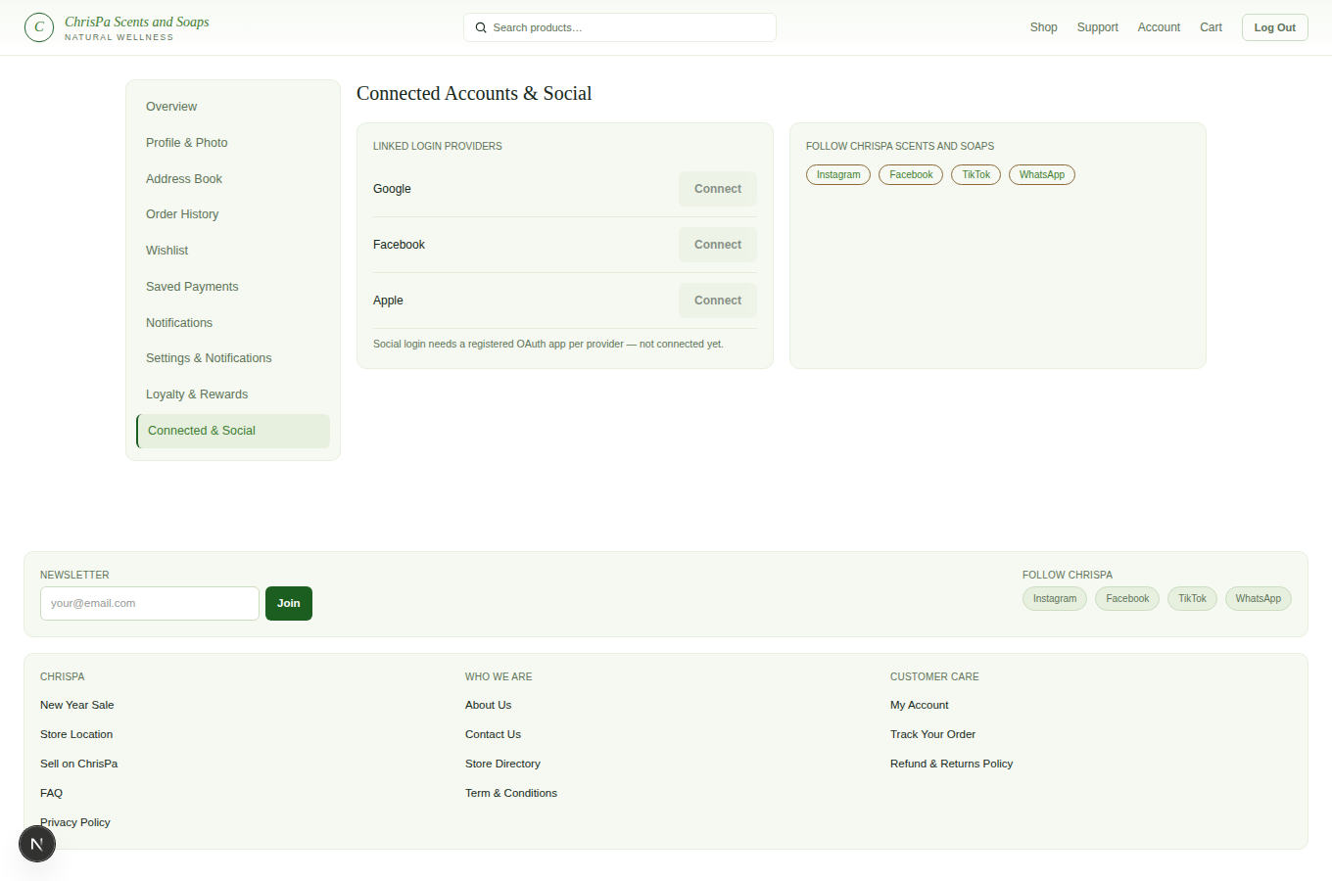
The Connected & Social page — Linked Login Providers and the Follow ChrisPa Scents and Soaps card
Follow ChrisPa — real, clickable links to ChrisPa's social media accounts (Instagram, Facebook, TikTok, WhatsApp, and whatever else ChrisPa adds) appear here, in the footer on every page, and on every newsletter you get (email and in-app — see Notifications above). These are managed by ChrisPa's team, so which accounts show up can change at any time.
Newsletter — the footer on every page (not this Settings page — it's open to anyone, signed in or not) has a working email box and Join button. Enter your email and submit to be added to ChrisPa's mailing list; there's no confirmation email sent, just an inline "Subscribed — thank you!" once it goes through. When ChrisPa's team sends a campaign to that list, you'll get it by email, and — if the email you subscribed with matches your ChrisPa account — as an in-app notification too (see Notifications).
Linked Login Providers: a Connect/Disconnect control here, for adding Google/Facebook/Apple sign-in to an account you already created another way, is reserved for later — not built yet. This is different from signing up or logging in with Google in the first place, which already works (see Creating Your Account and Signing In) — Facebook and Apple aren't available for either use yet.

7. Getting Help
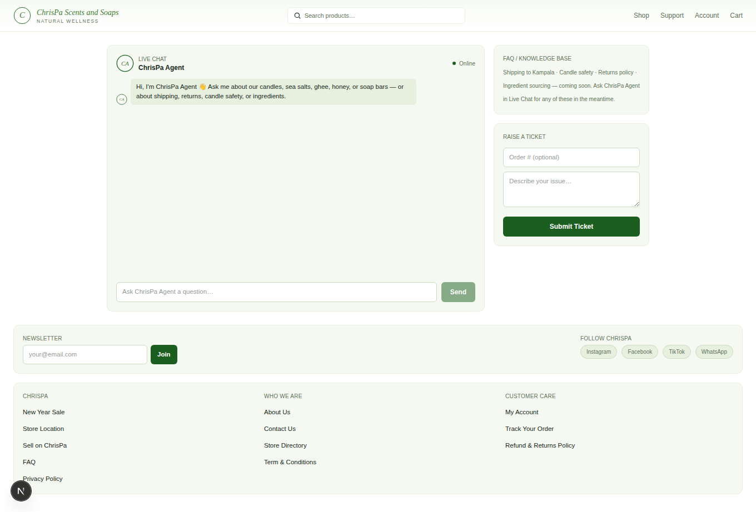
The Support page — ChrisPa Agent chat widget, Raise a Ticket form, and My Tickets list
- Live Chat — the "ChrisPa Agent" widget on the Support page answers common questions about products, candle safety, shipping, returns, and ingredients instantly, any time, no login needed. It's a keyword-matched assistant, not a live human — if it can't help, it'll point you to raising a ticket.
- Raise a Ticket — from the Support page, describe your issue (and your order number, if relevant) and submit. A ChrisPa staff member will respond directly on your ticket.
- Your ticket conversation — every ticket you raise appears in a My Tickets list on the Support page. Open one to see the full back-and-forth with the staff member helping you (their real name, not just "Support"), each message timestamped, and you can reply right there as long as the ticket's still open. A closed ticket is locked — raise a new one if you need more help.
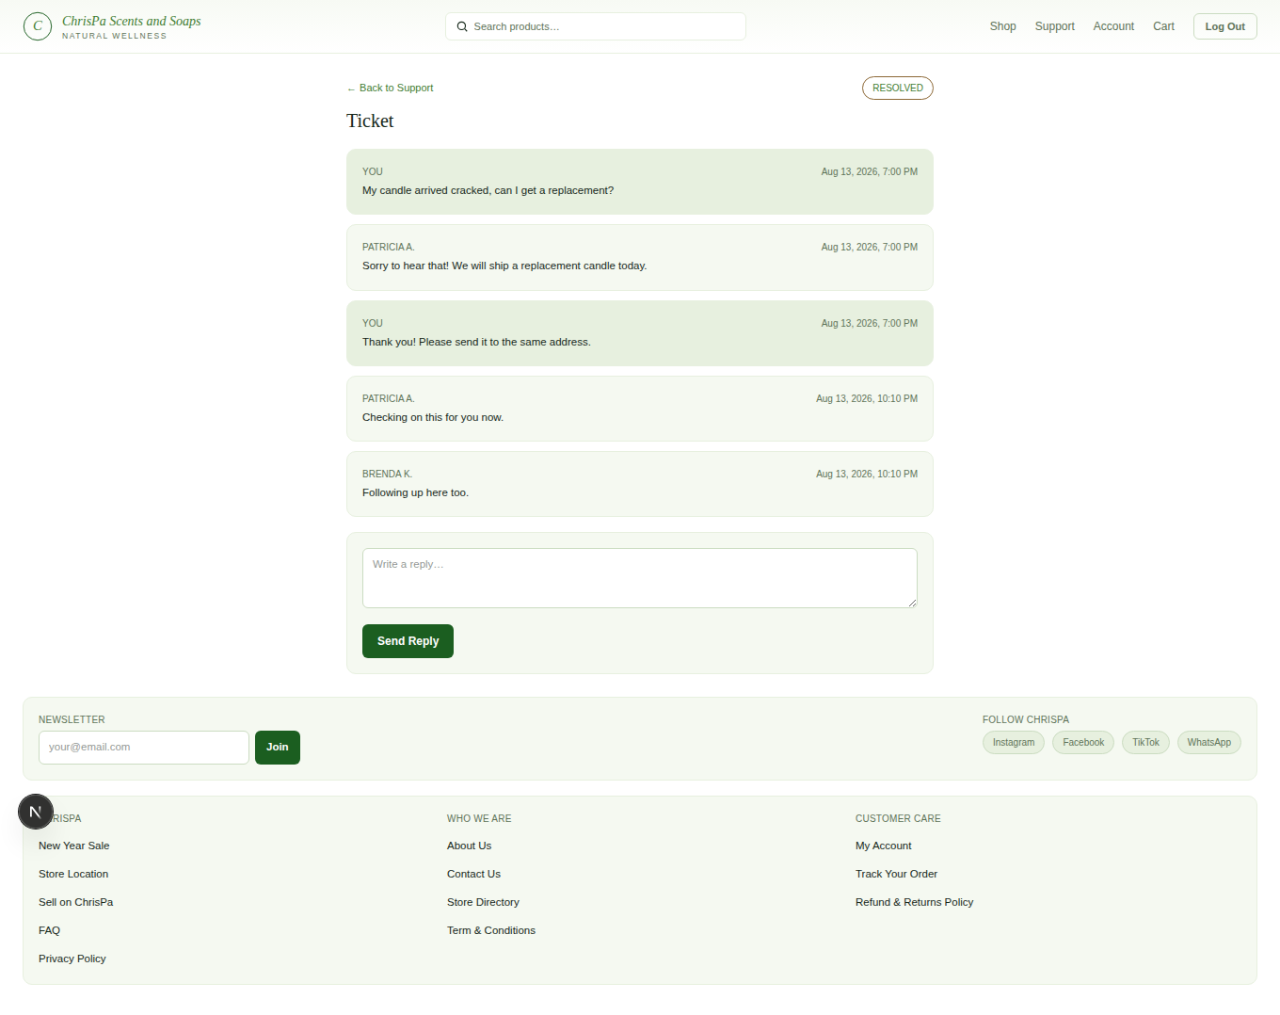
An open ticket conversation — customer message, staff reply, timestamps

The Footer
Every page has a footer with the Newsletter box and Follow ChrisPa links described above, plus a 3-column site map — every link here is real and goes somewhere:
- ChrisPa — New Year Sale, Store Location, Sell on ChrisPa, FAQ (jumps straight to the FAQ card on the Support page), Privacy Policy
- Who We Are — About Us, Contact Us, Store Directory, Term & Conditions
- Customer Care — My Account, Track Your Order (your Order History — there's no separate "enter your order number" lookup), Refund & Returns Policy
Most of these (everything except FAQ, My Account, and Track Your Order) are plain content pages ChrisPa's team publishes — title + text body, no rich formatting — rendered at /pages/[slug].
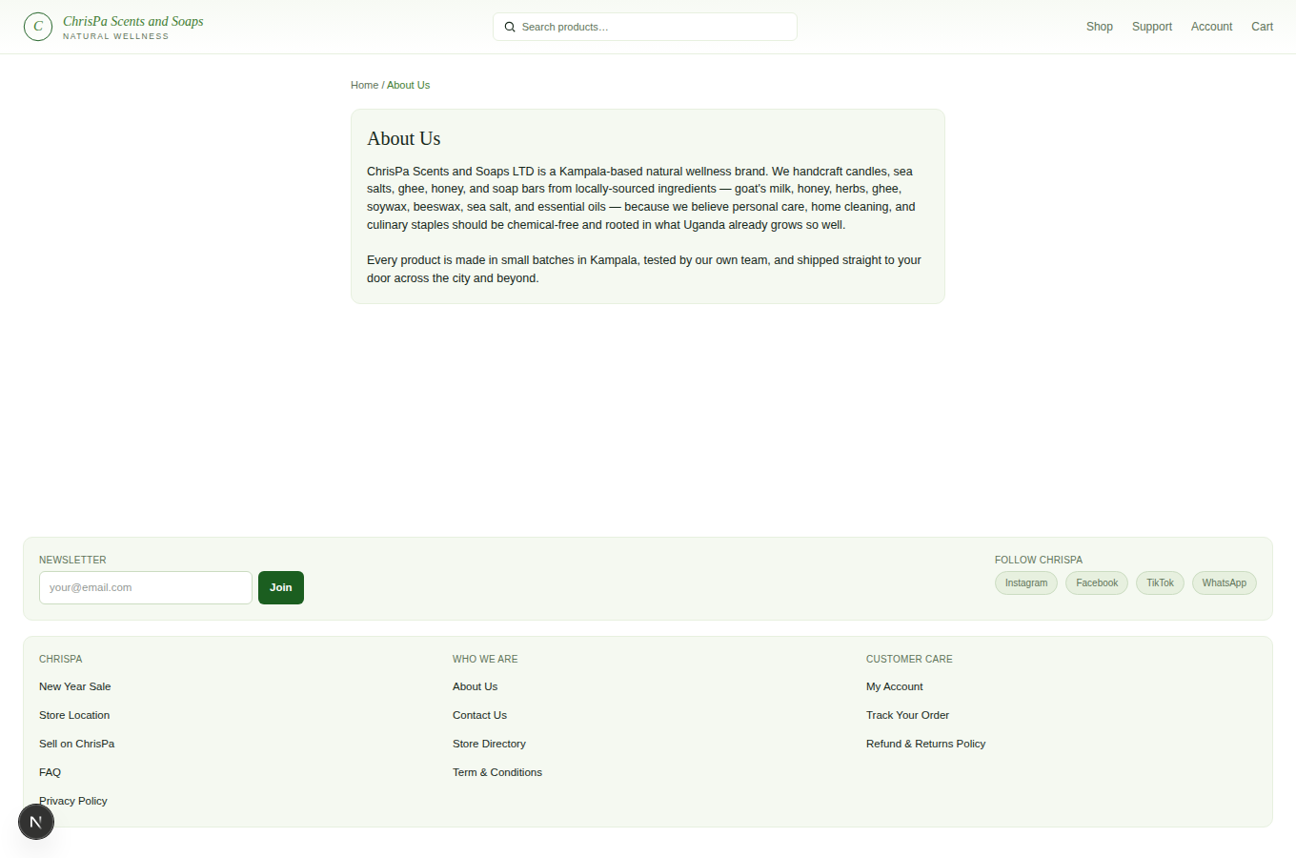
A published static page rendered at /pages/{slug}

Feature Availability at a Glance

Area | Available now | Coming soon
Login | Password, 2FA, biometric/passkey, Google sign-in/sign-up, email+SMS verification at signup | Forgot/reset password, Facebook/Apple sign-in, linking a social login to an existing account
Checkout payment | Cash on Delivery | Mobile Money, Card
Product page | Photos, size selection, Add to Cart, Wishlist | "Buy Now" shortcut, photo zoom/click-to-swap
Order actions | Tracking, receipt (after delivery + your confirmation) | Cancel Order, Request Return/Refund
Loyalty | Earning points, viewing balance/history | Redeeming points, referral/birthday bonuses
Notifications | In-app login alerts, saved preferences, newsletter inbox (email + in-app, with unread badge) | Order-update/push delivery
Reviews | — | Leaving a product review or rating
Social | Following ChrisPa's social accounts (footer + Connected & Social + every newsletter), footer newsletter signup, real newsletter campaigns (email + in-app) | Linking your own Google/Facebook/Apple login

