20. Administrator User Manual

Document Control

Field | Value
Document Title | ChrisPa Admin Console — Administrator & Staff User Manual
Audience | ChrisPa staff — Owner, Store Manager, Fulfillment, HR Manager, Support Agent
Version | 1.0
Date | 14 August 2026
Status | Reflects the admin console as actually built — see `00-documentation-index.md`
Related | `docs/SRS.md`, `19-storefront-user-manual.md`

Who This Manual Is For
The admin console has five staff roles, and what you see depends on which one you are:

Role | Sees
Owner | Everything — every section below, no restrictions
Store Manager | Admin/Backend (all of it except Users & Settings and Activity Log) + My HR
Fulfillment | Admin/Backend (same as Store Manager, minus Support Tickets too) + My HR
HR Manager | Human Resources + My HR only — no Admin/Backend, no Financial & Accounting
Support Agent | Support Tickets only, + My HR
Everyone with a linked employee record — regardless of role — gets My HR, the self-service section for your own attendance, leave, shifts, performance, payslips, and salary advances.
A quick-reference table of what's fully built versus still follow-up work is at the end of this manual (Feature Availability at a Glance).

1. Getting Started

Logging in
Go to the admin console's login screen with your email/phone and password (plus a 2FA code, if your account has it enabled — same as the storefront, and biometric login is available here too). The console's default page redirects straight to the login screen if you're not signed in — you can't land on the dashboard or any other page without logging in first.
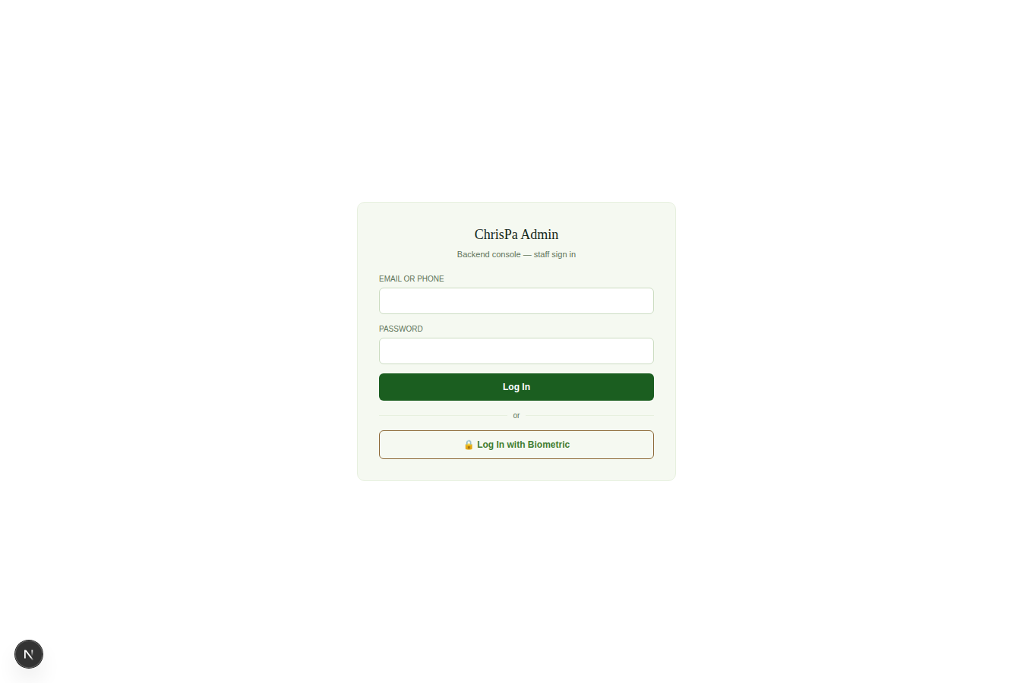
The ChrisPa Admin login screen — email/phone + password, and Log In with Biometric

Your first login (temporary password)
If HR or the Owner just created your login, you were given a one-time temporary password. On first login you'll be forced straight to Set a New Password before you can do anything else:
- Enter the Temporary Password you were given.
- Choose a New Password (at least 8 characters) and confirm it.
- Click Set Password & Continue.
You're then taken straight to the dashboard, fully signed in with your own password.

Finding your way around
The sidebar is grouped into up to four collapsible sections (only the ones your role can see appear at all): Admin / Backend, Human Resources, My HR, and Financial & Accounting. Your session automatically signs you out after 5 minutes of inactivity.
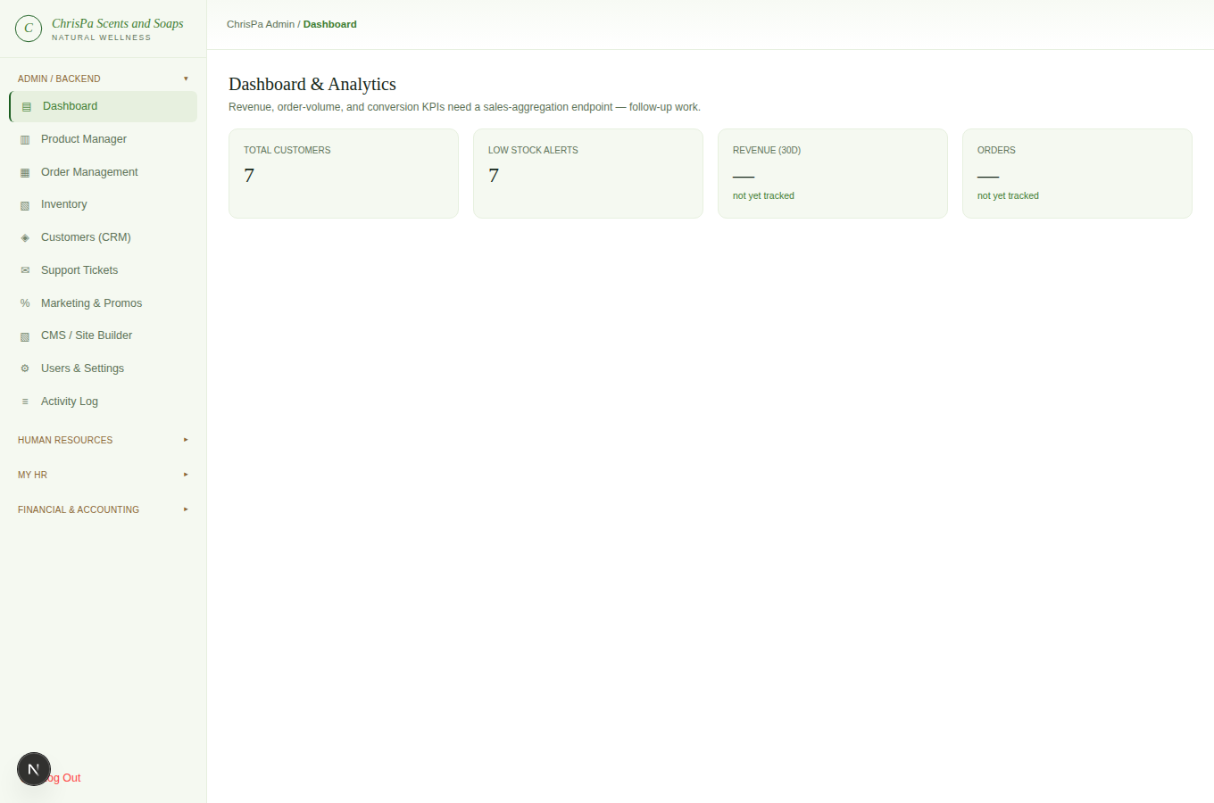
The admin Dashboard — sidebar navigation and top-line KPI tiles

2. Product Manager
Owner, Store Manager.
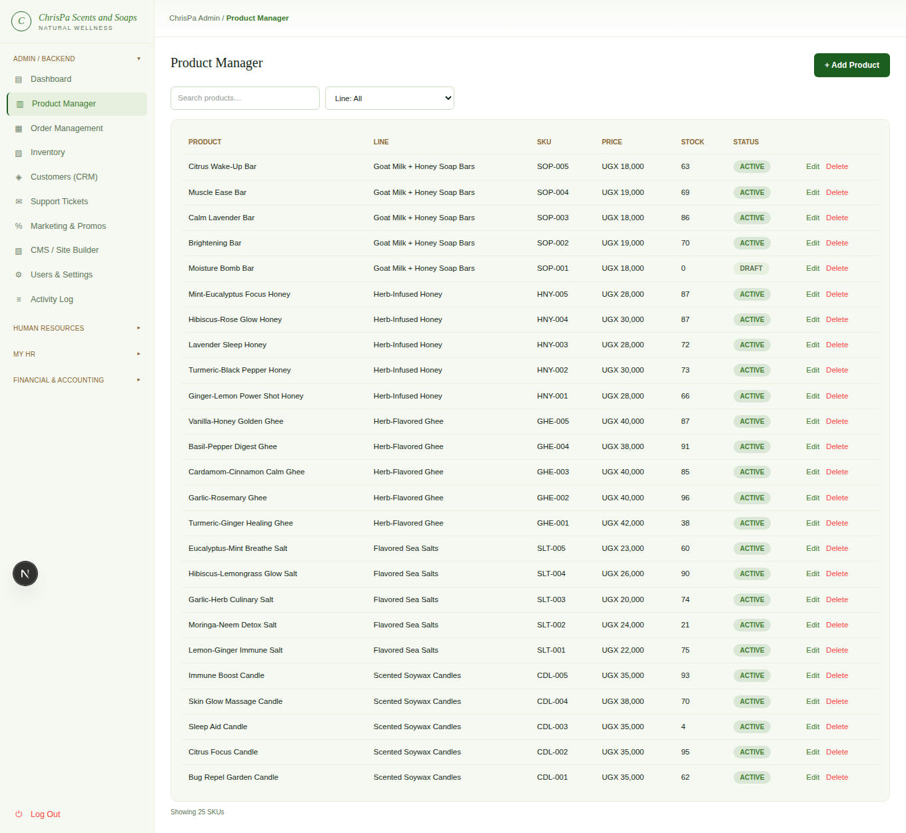
The Product Manager list, filterable by product line, with Edit/Delete per row
The product list (Admin → Product Manager) is searchable and filterable by product line. Click + Add Product, or Edit an existing one, to open the product form:
- Name, SKU, Product Line (required)
- Scent/Flavor Notes, Uses (comma-separated — rendered live as wellness-tag chips as you type), Directions, Health Benefits
- Price (UGX), Stock Qty
- Vendor — leave as "ChrisPa (no vendor)" for ChrisPa's own products, or assign a marketplace vendor
- Cost (UGX) — used for cost-of-goods-sold accounting, not shown to customers
- SEO — slug (auto-fills from the name if left blank), title, meta description
- Status — Draft, Active, or Archived
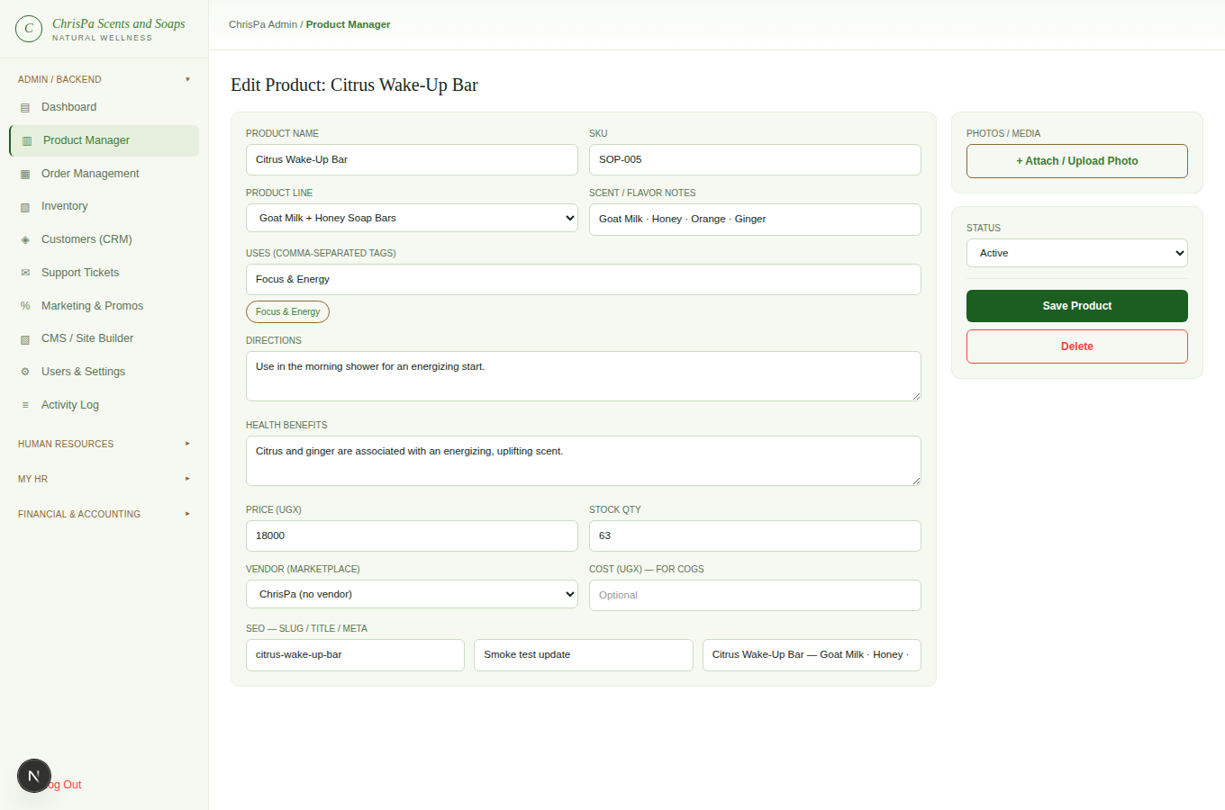
The Edit Product form — required fields, wellness-tag chips, pricing, SEO, and photo thumbnails
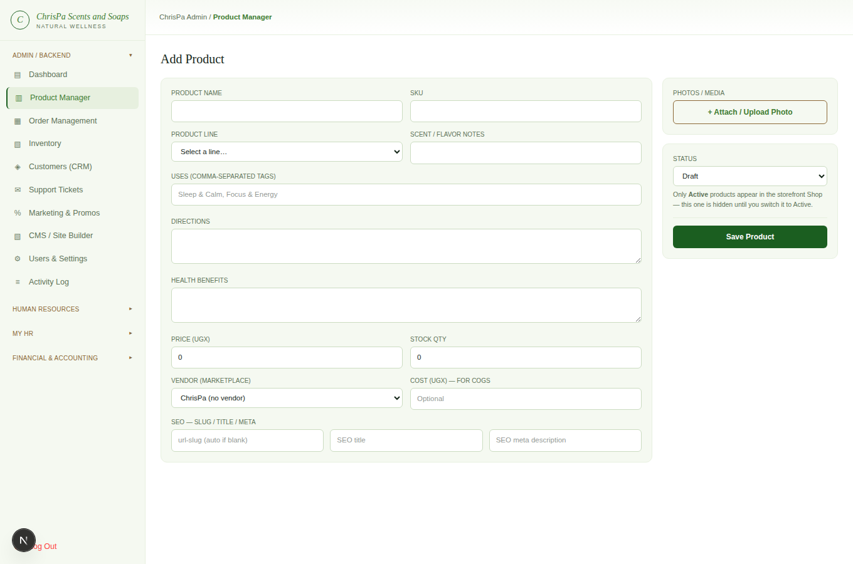
The Add Product form (+ Add Product), blank
Photos: click + Attach / Upload Photo to pick one or more image files (JPEG/PNG/WEBP/GIF) — each uploads immediately and appears as a thumbnail; click the ✕ on any thumbnail to remove it before saving.
Only Active products appear on the storefront. New products default to Draft on purpose (review before publish) — the form reminds you inline whenever Status isn't Active.
Deleting: click Delete. If the product has real order history, ChrisPa automatically archives it instead of deleting it — order history is never allowed to break.

3. Order Management
Owner, Store Manager, Fulfillment.
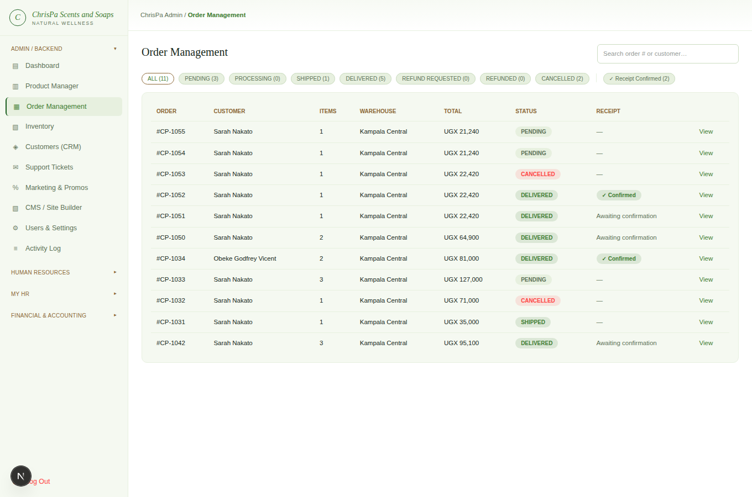
Order Management — status tabs with live counts and the order table
The order list (Admin → Order Management) has a tab per status (with live counts) and a search box for order number or customer name. Open any order to see its full detail and a Move to row of status chips — click the next status to transition it. Valid next steps only:
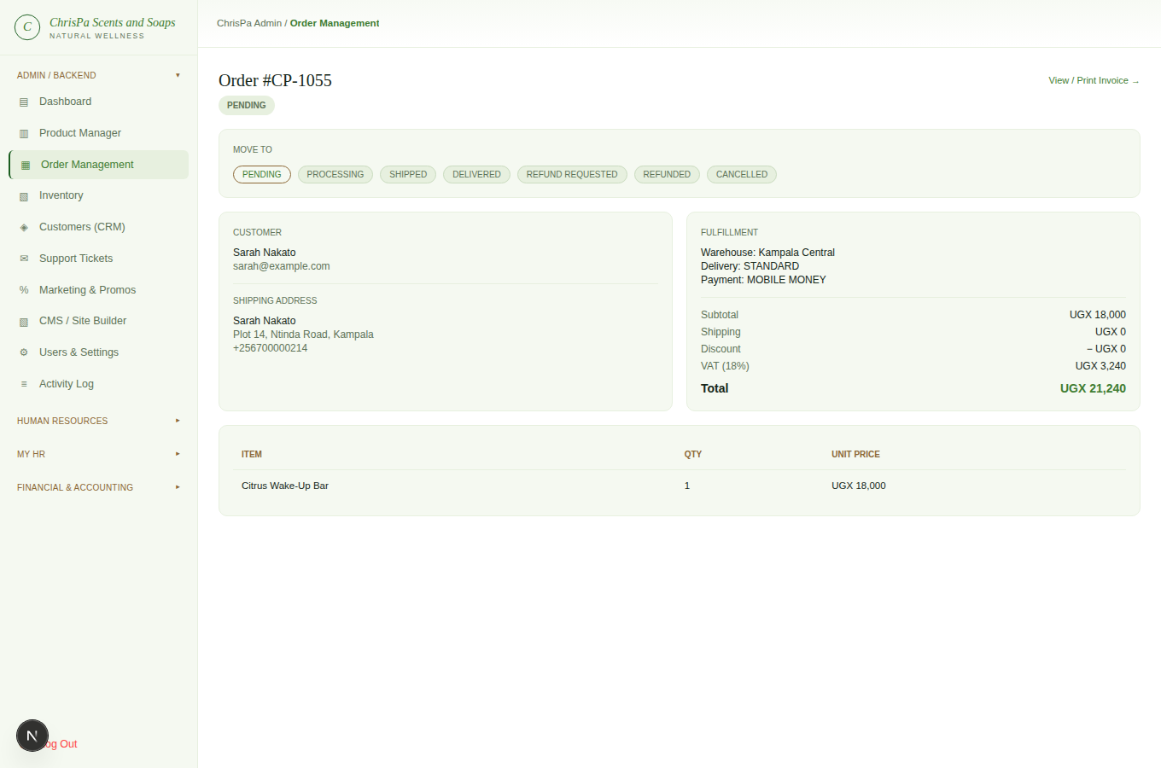
An order's detail page — status pipeline chips and order/customer info
PENDING → PROCESSING → SHIPPED → DELIVERED → REFUND_REQUESTED → REFUNDED (or back to DELIVERED to reject a refund request); CANCELLED is reachable from PENDING/PROCESSING. Cancelling or refunding an order automatically restocks inventory and reverses any loyalty points it earned.
Click View / Print Receipt on any order for a printable copy with ChrisPa's logo, full company details, and every line item — it's the same document the customer sees (same "Receipt" heading, same dual-currency UGX/USD figures, same layout), not a separate admin-only version. Once the customer has confirmed their own receipt (see the storefront manual), your copy shows the same "Received in Good Condition" stamp they see; if they haven't yet, it says so plainly instead.
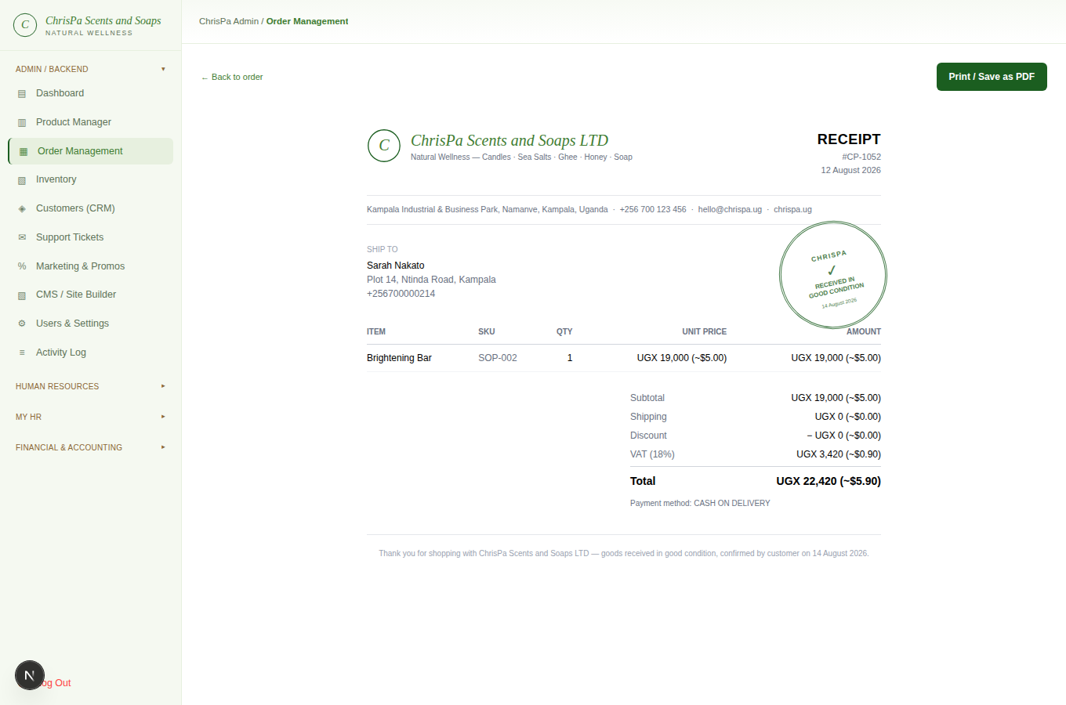
An order's printable receipt, from the admin side
Finding confirmed receipts at a glance: you don't have to open every order to check — the order list has a Receipt column ("✓ Confirmed," "Awaiting confirmation," or a dash), and a "✓ Receipt Confirmed" filter chip next to the status tabs shows only the orders whose customers have confirmed. Opening an order also shows the same confirmation status right next to its status badge.
Editing items/address/pricing, internal notes, split shipment, packing slips, and shipping labels aren't built yet.

4. Inventory
All Admin/Backend roles — read-only.
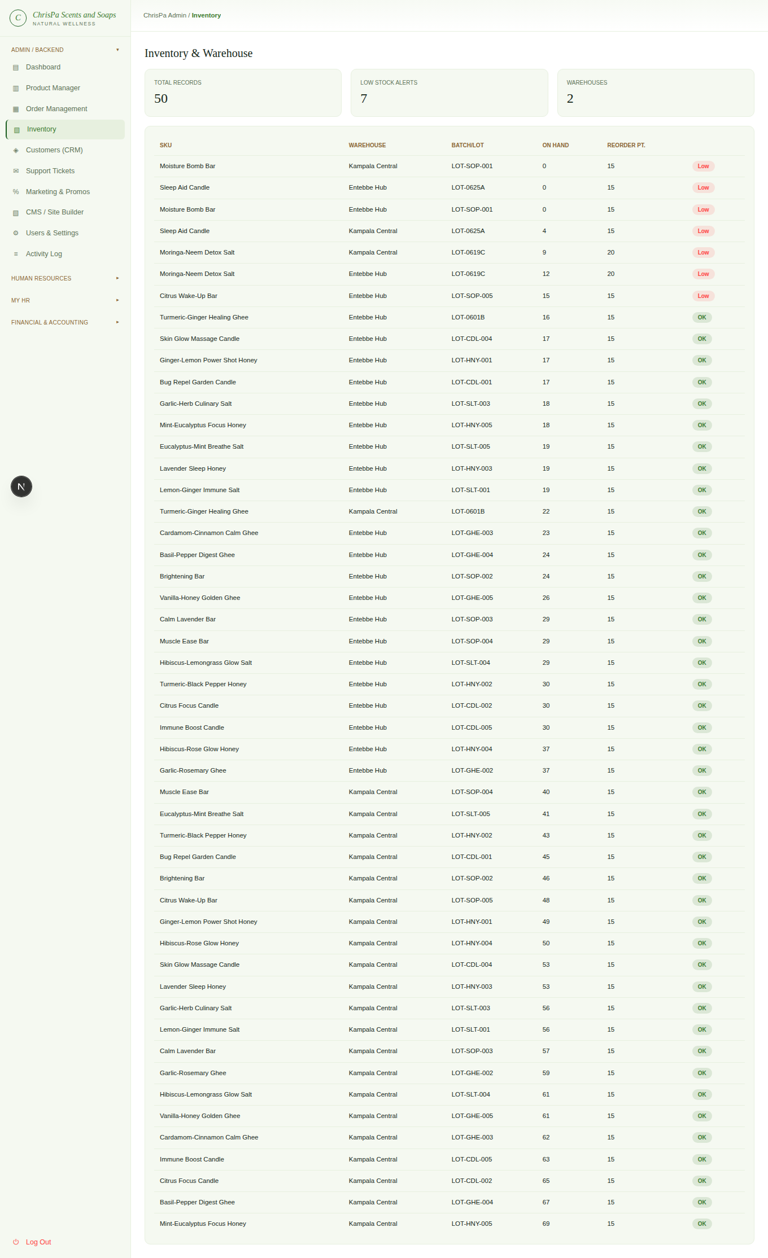
The Inventory page — per-SKU/warehouse stock table with Low/OK status chips
Admin → Inventory shows Total Records, Low Stock Alerts, and Warehouse count at a glance, then every inventory record (SKU, warehouse, batch/lot, quantity on hand, reorder point) with a red Low or green OK status chip. This is a live view — there's nothing to edit here yet (no purchase orders, transfers, or cycle counts).

5. Customers (CRM)
All Admin/Backend roles — read-only.
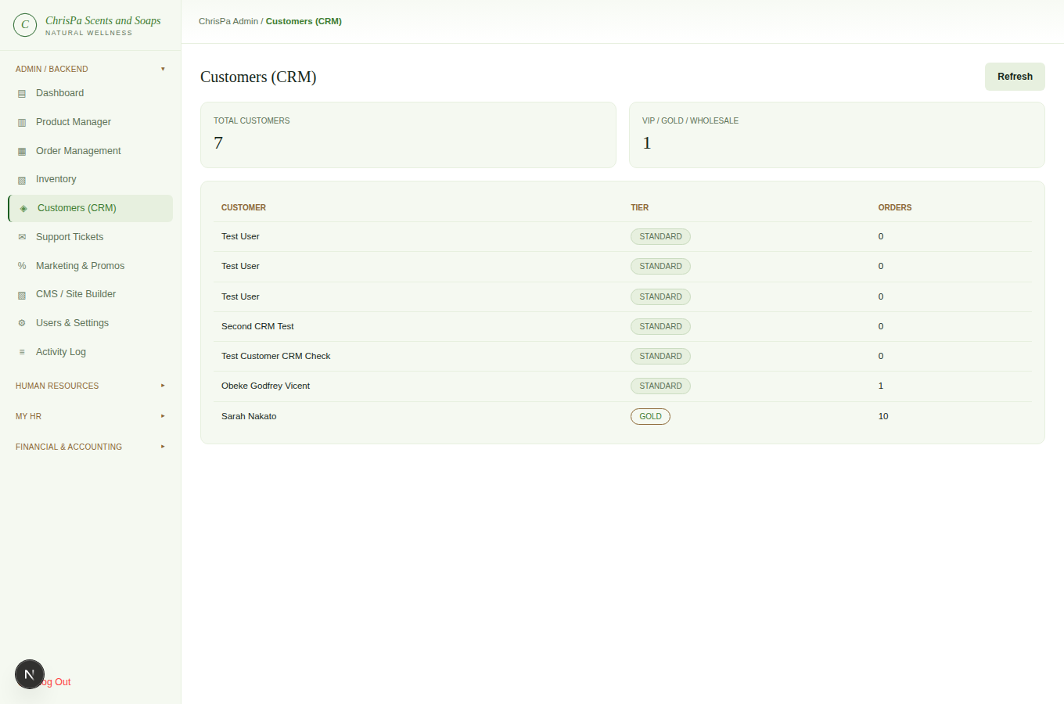
The Customers (CRM) page — customer list with loyalty tier and order count
Admin → Customers lists every customer with their loyalty tier and order count, plus totals for your whole customer base and how many are Gold/Wholesale-tier. There's no per-customer detail drill-down or notes/tags yet — for a specific customer's activity, check the Activity Log (Owner only) or their orders.

6. Marketing & Promos
Coupons/bundles/subscriber list are read-only for all Admin/Backend roles. Sending a newsletter is Owner/Store Manager only.
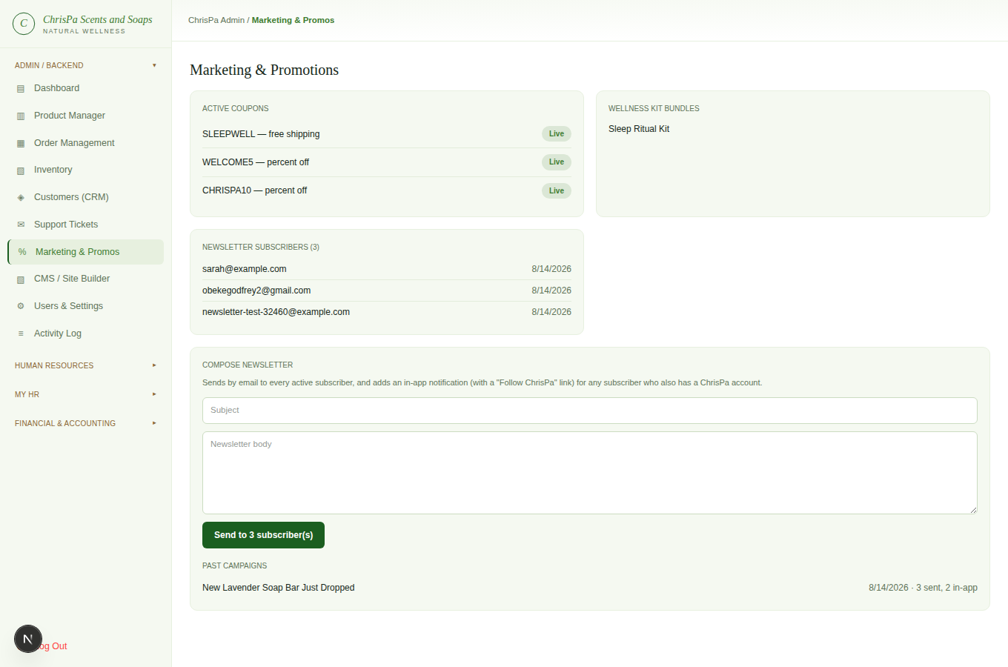
Marketing & Promos — coupons, bundles, newsletter subscribers, and the Compose Newsletter form with Past Campaigns
Admin → Marketing & Promos shows your active coupon codes, wellness-kit bundles, a Newsletter Subscribers card — every email address currently signed up through the storefront footer's newsletter box, newest first, with a running count in the card header — and a Compose Newsletter form. Creating/editing coupons and bundles isn't built yet.
Compose Newsletter: type a subject and a message, then send — it goes out immediately, there's no draft/scheduling step. Every active subscriber is emailed, and any subscriber whose email matches a real ChrisPa account also gets an in-app notification (their Account → Notifications inbox) with the same content — both the email and the in-app notification include a "Follow ChrisPa" block linking to whatever social accounts are active under CMS → Social Media Accounts, so customers reviewing the update can follow/connect right from it. The button reports back how many subscribers were emailed and how many got the in-app notification, and every send is logged below as a Past Campaigns entry (subject, date, recipient counts) and in the Activity Log. There's no unsubscribe-link-in-email flow, per-recipient delivery receipts, or audience segmentation yet — every active subscriber gets every campaign.

7. CMS / Site Builder
All Admin/Backend roles can view; Owner and Store Manager can also manage Pages, Banners, and Social Media Accounts.
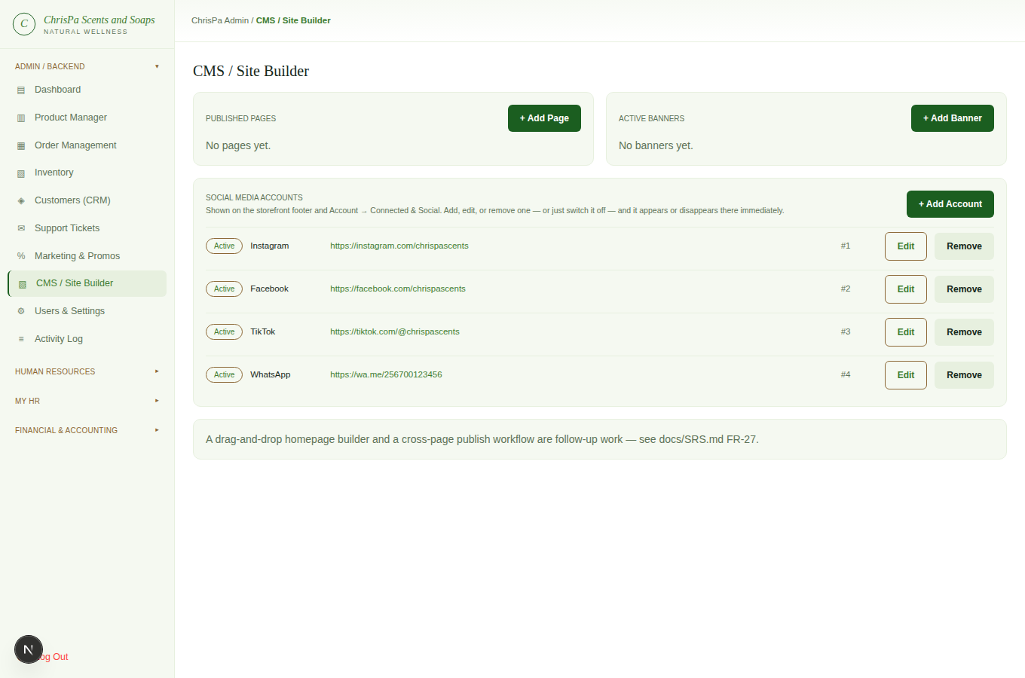
CMS / Site Builder — Published Pages, Active Banners, and Social Media Accounts panels
Admin → CMS has three editable panels — Blog Posts is the one area of this page still a read-only status view (a drag-and-drop homepage builder and a cross-page publish workflow aren't built yet either). Nothing in the three panels below needs a separate "publish" step — the storefront always shows whatever's currently Active/Published.
Published Pages — real standalone pages, live at /pages/[slug] the moment they're saved Published.
- + Add Page — a Title (the slug auto-generates from it, or type your own), page content, and a Draft/Published status.
- Click the Draft/Published chip on any row to flip it directly.
- Edit to change anything; Delete removes it (the storefront URL then 404s).
Active Banners — the lowest-Order Active banner becomes the storefront homepage's hero image (previously a static placeholder). Not a multi-slide carousel — one banner shows at a time.
- + Add Banner — Upload Image (a real upload, same as product photos — JPEG/PNG/WEBP/GIF, 5MB max), an optional Link URL, and a display Order.
- Click Active/Hidden to pull a banner without deleting it; Edit to replace the image or change its link/order; Remove to delete it.
Social Media Accounts drives both the storefront footer's "Follow ChrisPa" links and the Account → Connected & Social page — one list, two places it shows up.
- + Add Account — a platform name (anything: Instagram, Facebook, TikTok, WhatsApp, X, YouTube...) and its full URL.
- Click Active/Hidden to show or hide it without deleting it; Edit to change the platform, URL, or display order; Remove to delete it outright (confirms first).

8. Support Tickets
Owner, Store Manager, Support Agent. (Not Fulfillment.)
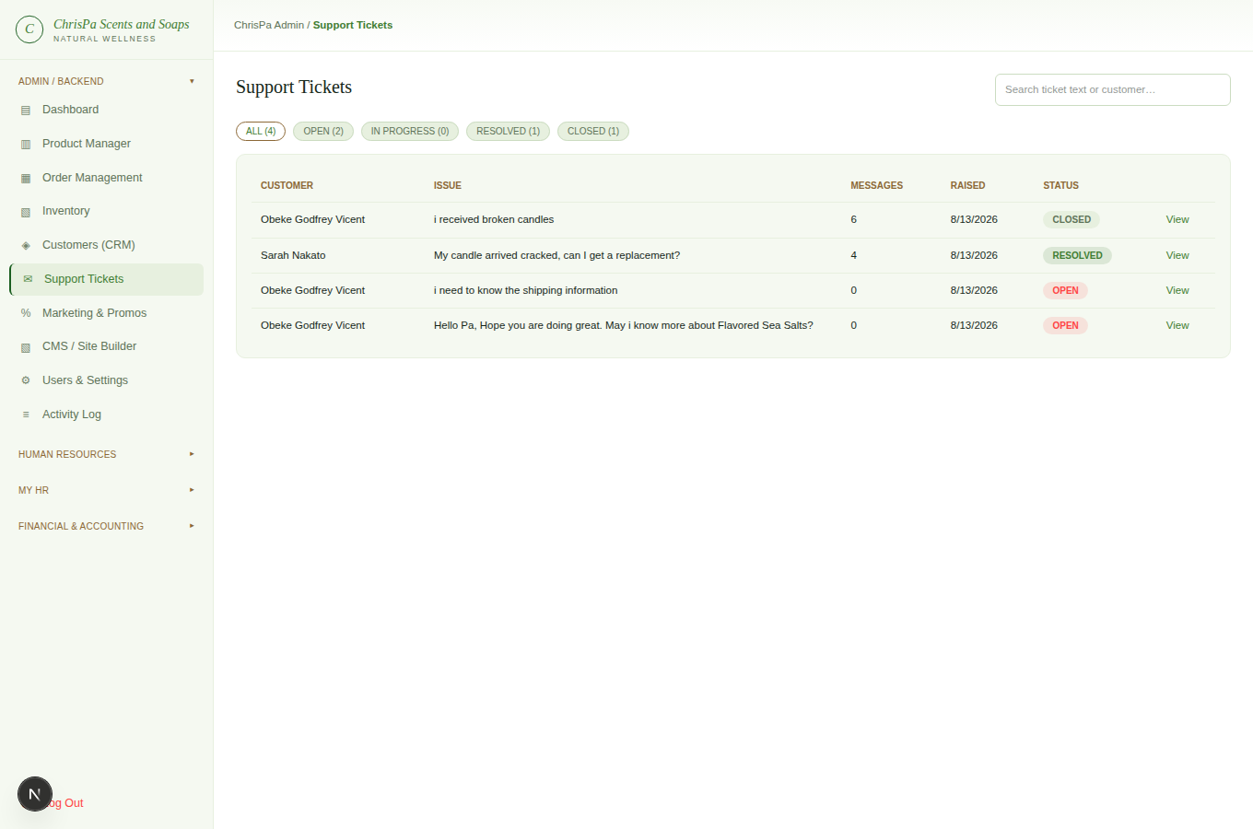
Support Tickets — status tabs and the ticket list
Admin → Support Tickets mirrors Order Management's layout — status tabs (Open/In Progress/Resolved/ Closed) with counts, and a search box. Open a ticket to see the customer's original issue, their contact details, any related order, and the full conversation.
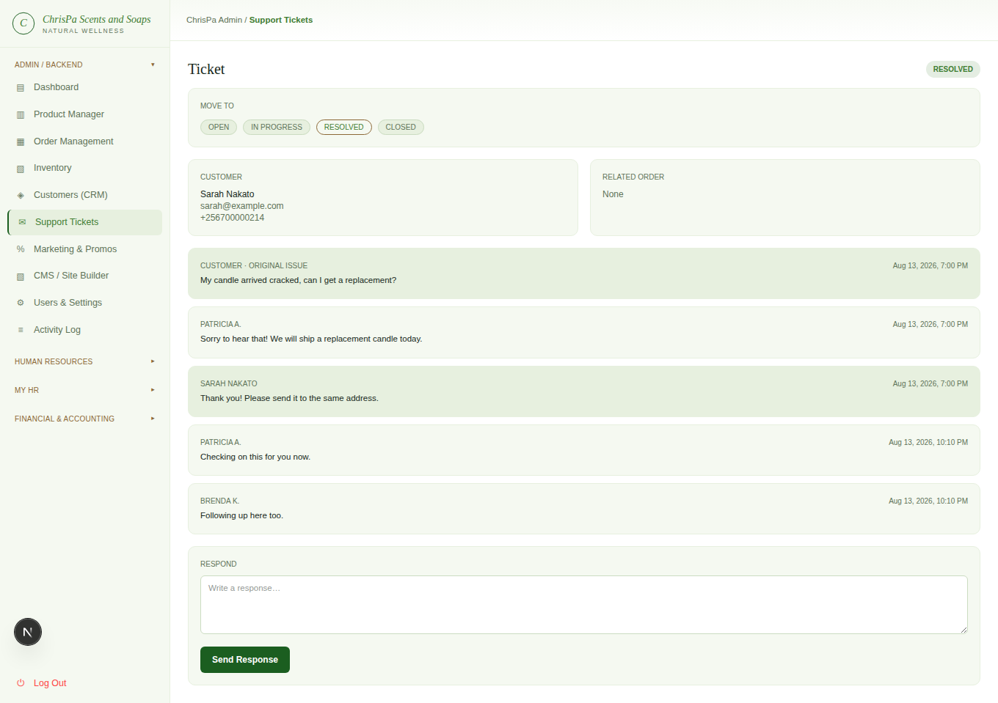
An open ticket's detail page — the full conversation and a reply box
- Responding posts your reply immediately to the customer's own ticket page — a real back-and-forth, not a one-shot answer. Replying to an Open ticket automatically moves it to In Progress — there's no separate "claim" step.
- Status is otherwise your free choice (Open/In Progress/Resolved/Closed) via the Move to row.
- Closed is a hard stop — neither you nor the customer can post further until you move it to a different status first.

9. Users & Settings / Activity Log
Owner only.
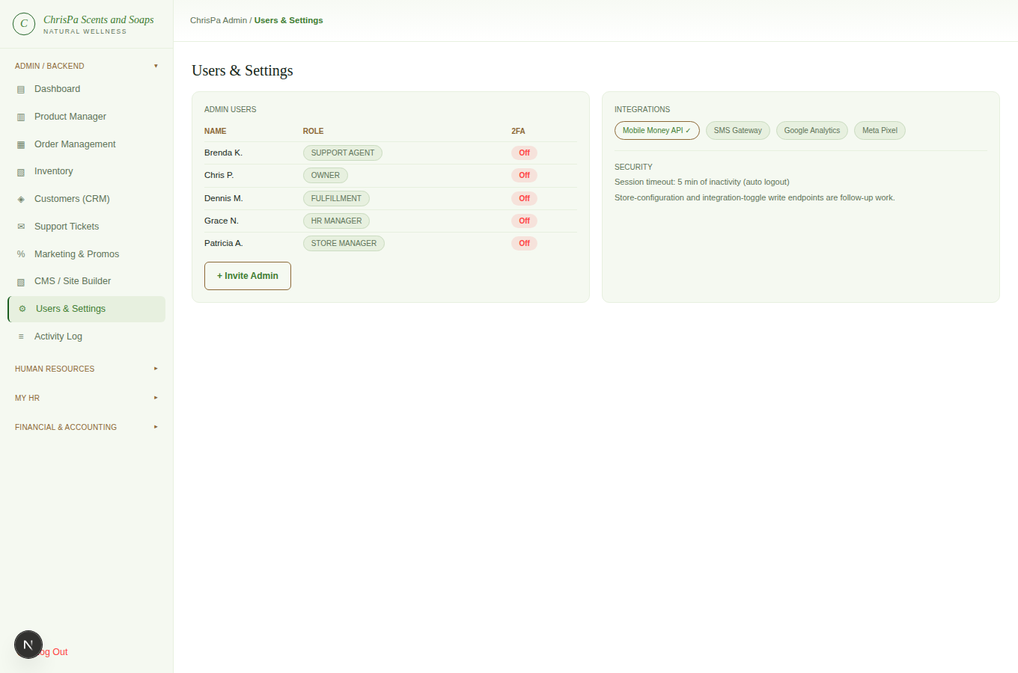
Users & Settings — admin user list, Invite Admin, and Integrations/Security panels
Admin → Users & Settings lists every admin-console user with their role and whether 2FA is on. ("+ Invite Admin" and the Integrations/Security panels here are informational displays — they don't yet have working write actions behind them; grant a new login through HR → Employees instead, see below.)
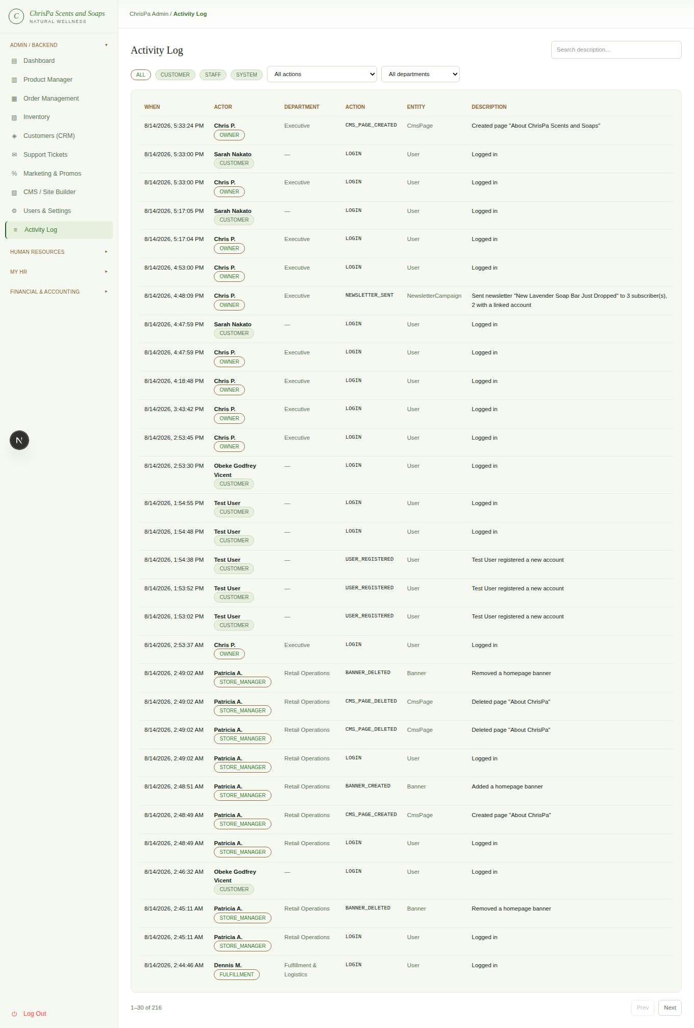
The Activity Log — unified, filterable feed of customer and staff actions
Admin → Activity Log is a unified, searchable feed of both customer and staff actions across the whole platform — logins, orders placed, product/order/employee edits, tickets responded to, and more — each row showing who did it (their real name and department, where known), filterable by actor type, action, and department, plus free-text search and pagination. This is your audit trail; it doesn't cover literally every mutation in the system, just the representative write paths that matter most.

10. Human Resources
Owner, HR Manager.

HR Dashboard
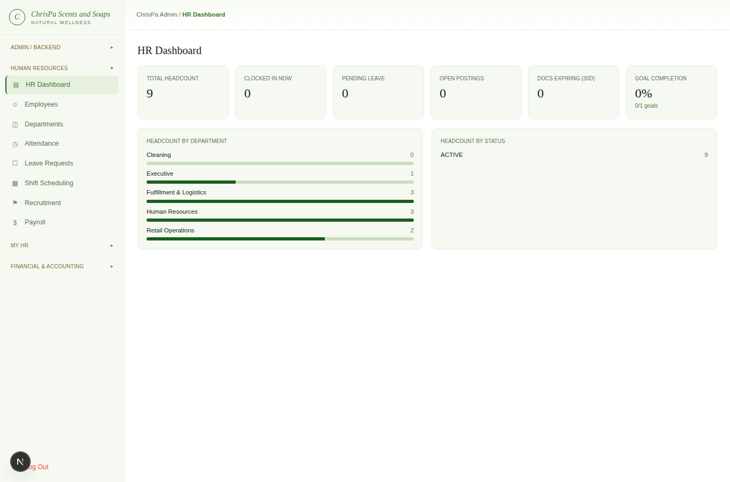
The HR Dashboard — headcount, pending leave, open postings, and other live-computed KPIs
Headcount by department/status, pending leave requests, open job postings, who's currently clocked in, documents expiring within 30 days, and goal-completion rate — all computed live, nothing to configure.

Employees
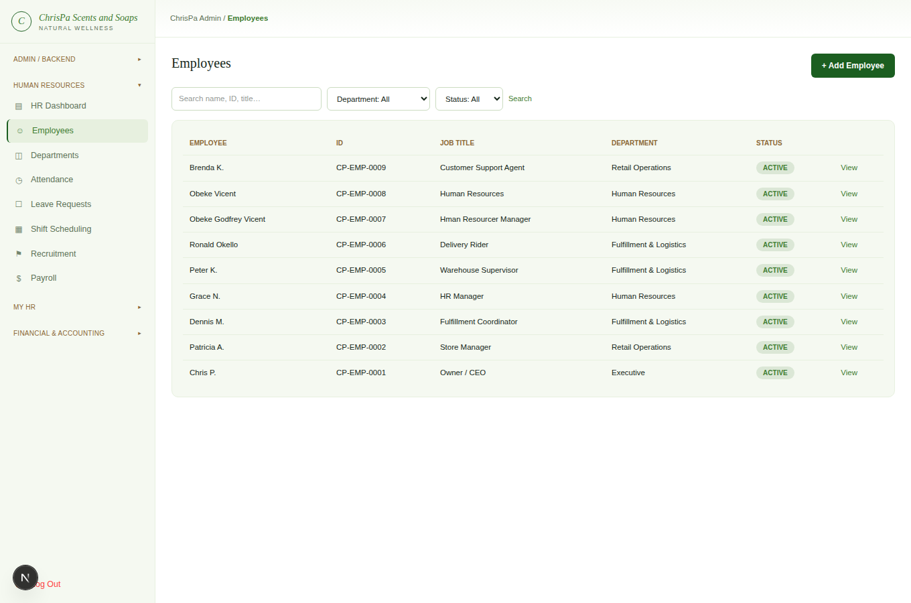
The Employees list — searchable, filterable by department and status
The employee list is searchable and filterable by department and status. Each employee's detail page is a full workbench:
- Profile — personal details, department, job title, employment type, hire date, base salary, NSSF/TIN numbers — all editable.
- Employment History — an automatic, read-only log of every job-title/department/salary/status change.
- Documents — attach type/title/file URL/expiry, or remove one.
- Allowances — recurring housing/transport/lunch/medical/hardship/other allowances, each flagged taxable or not; activate, deactivate, or remove.
- Salary Advances — record a principal + monthly installment (auto-recovered from future payslips), with a note; cancel if needed.
- Performance — set Goals, log Feedback, and create/submit Reviews.
- Status — Active / On Leave / Suspended, or Terminate Employment (a deliberate, separate danger action — employee records are never deleted, only marked terminated).
- System Login — grant a login by choosing an email and role; you'll get a one-time temporary password to hand to them securely (it's shown only once, right here — write it down or copy it now).
- Staff ID Card — a printable ID card (browser print, credit-card sized).
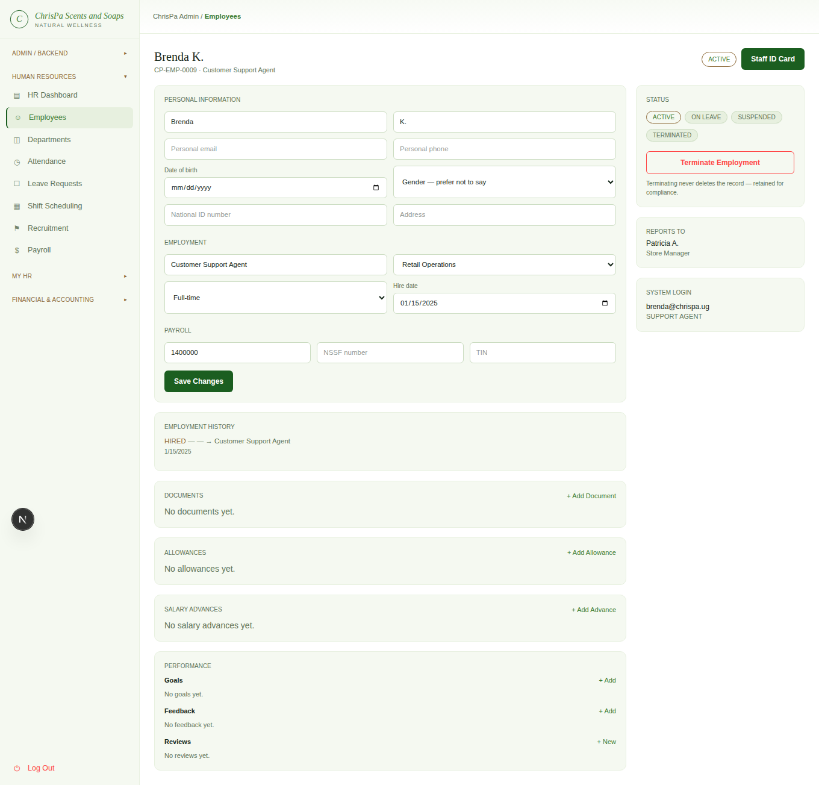
An employee's full detail workbench — profile, employment history, documents, allowances, performance
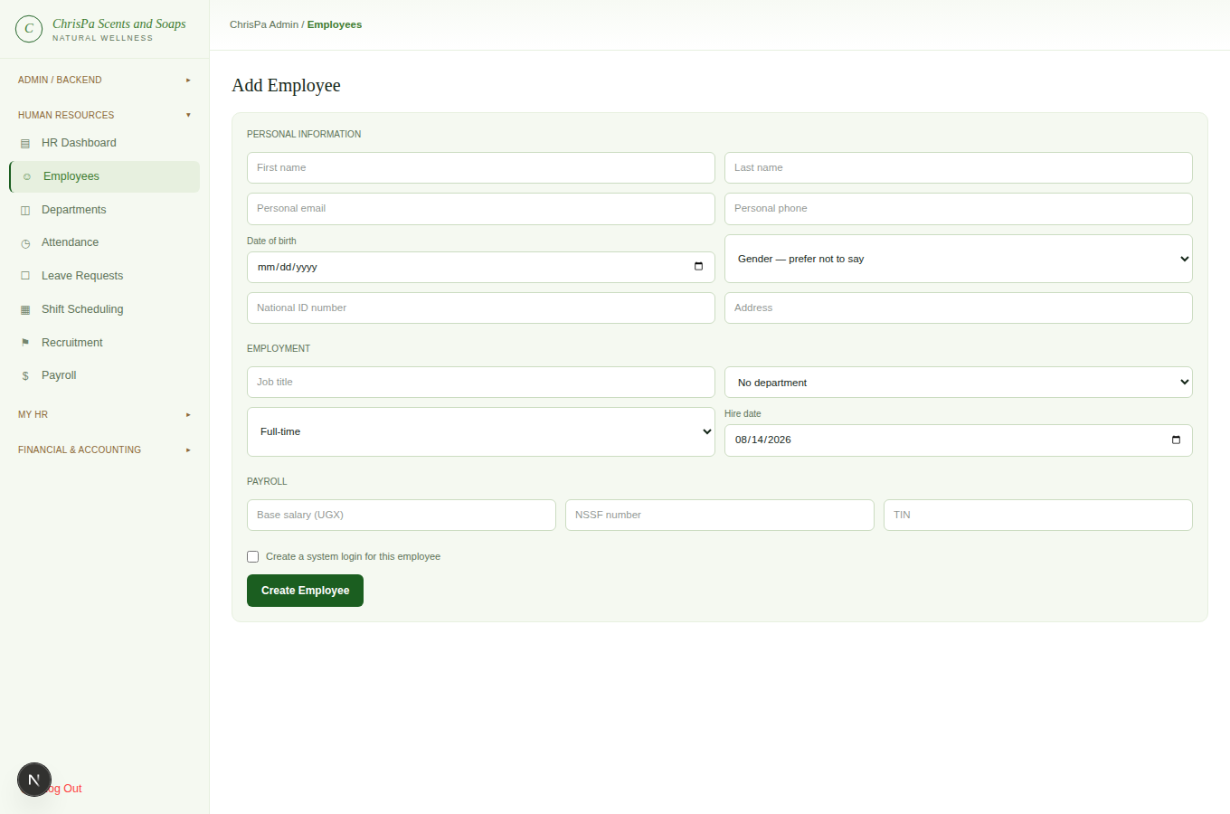
+ Add Employee — the blank new-employee form
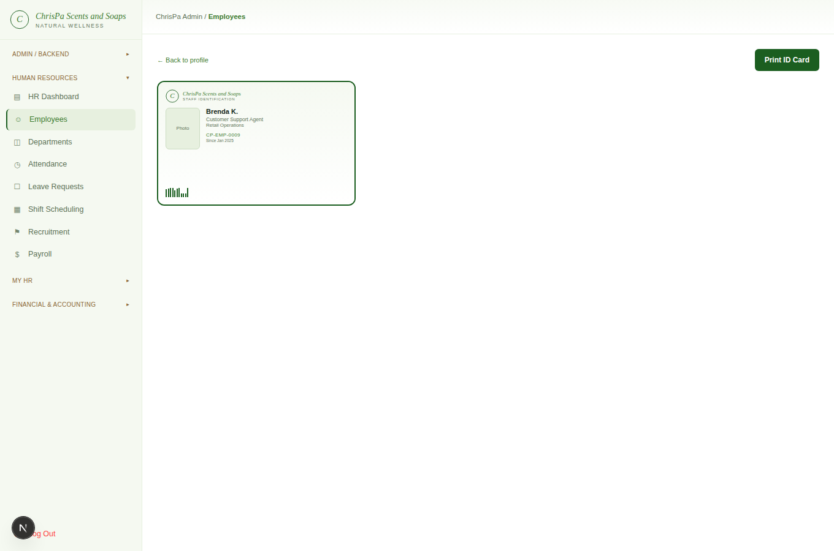
The printable Staff ID Card view

Departments
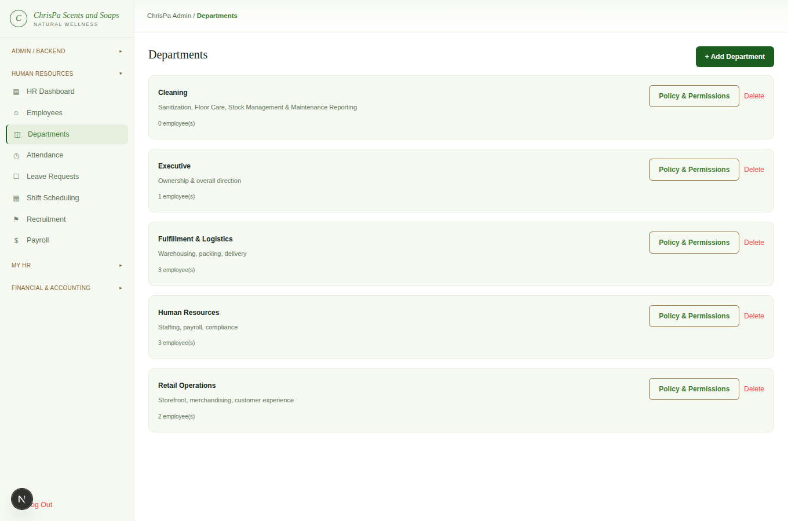
The Departments page — department list and Policy & Permissions matrix
Add or remove departments, and set each one's Policy & Permissions — a matrix of View/Create/Update/ Delete/Execute per admin area, for documentation purposes. This matrix records intended policy; it does not itself control what anyone can actually do — that's still governed by each person's role (Owner/Store Manager/Fulfillment/HR Manager/Support Agent), same as everywhere else in this console.

Attendance
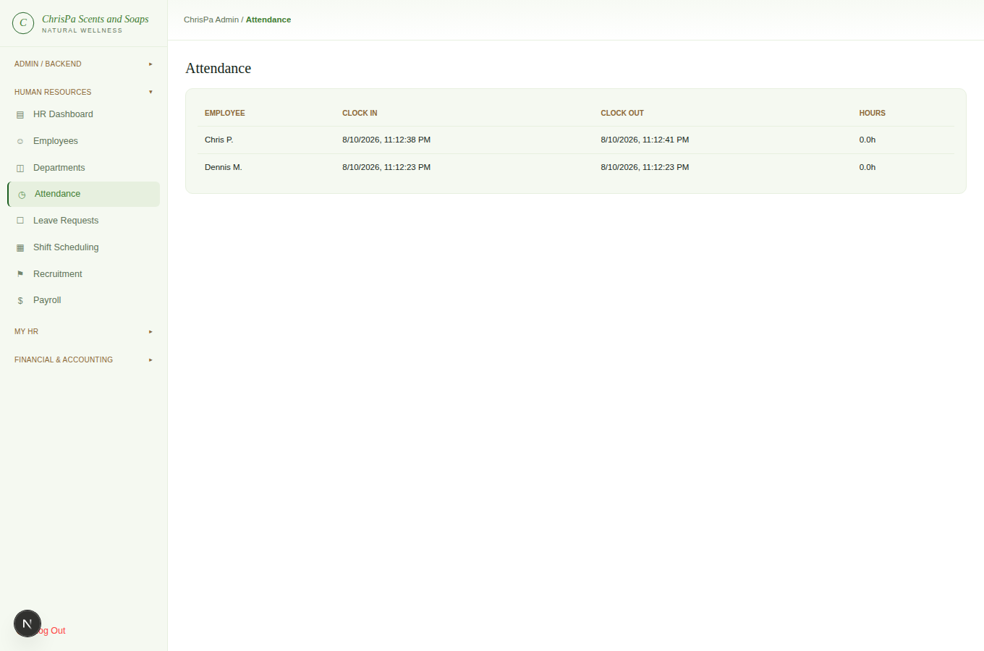
The Attendance oversight table — every employee's clock-in/out times and computed hours
A read-only oversight table of every employee's clock-in/clock-out times and computed hours — see My HR below for how employees clock in themselves. There's no manual correction tool here yet.

Leave Requests
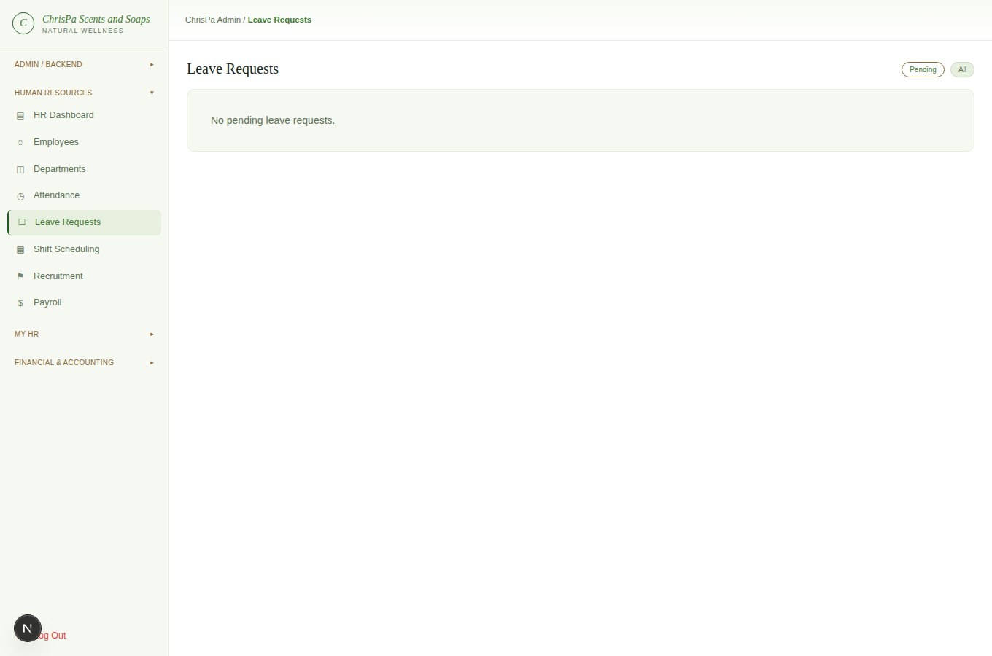
The Leave Requests approval queue
An approval queue — Pending and All tabs. Approve or Reject each request; rejecting lets you add an optional reason.

Shift Scheduling
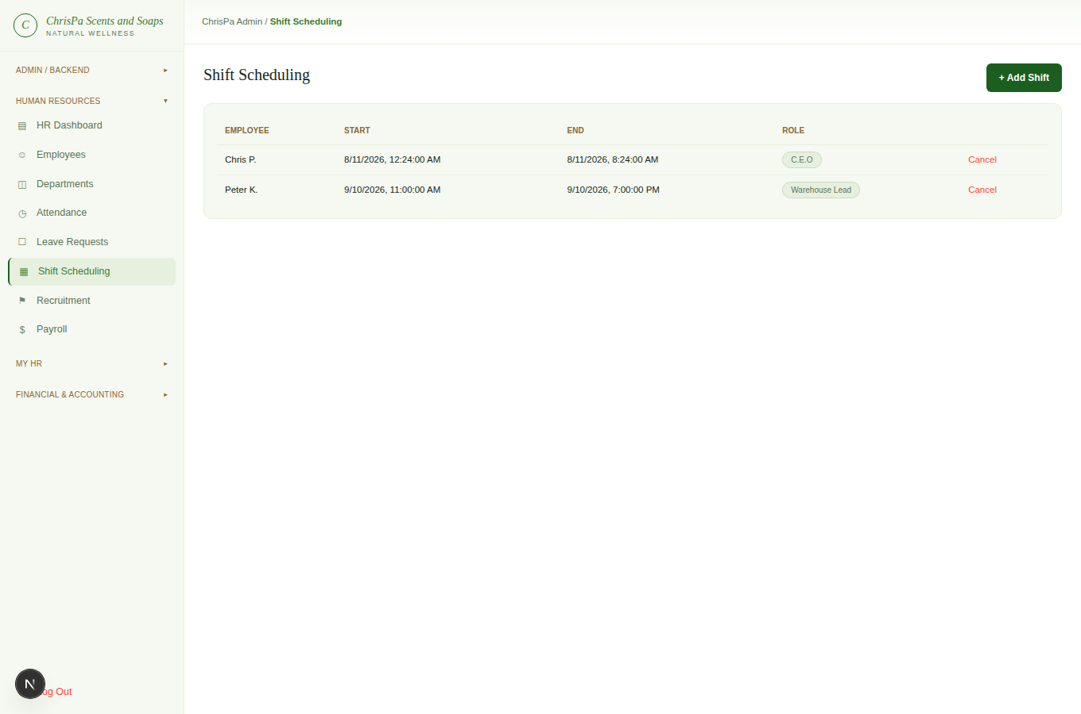
Shift Scheduling — assigned shifts and the Pending Swap Requests panel
+ Add Shift to assign an employee a role and time slot; Cancel to remove one. A separate Pending Swap Requests panel lets you Approve or Reject when one employee asks another to cover their shift — approving actually reassigns the shift to the covering employee.

Recruitment
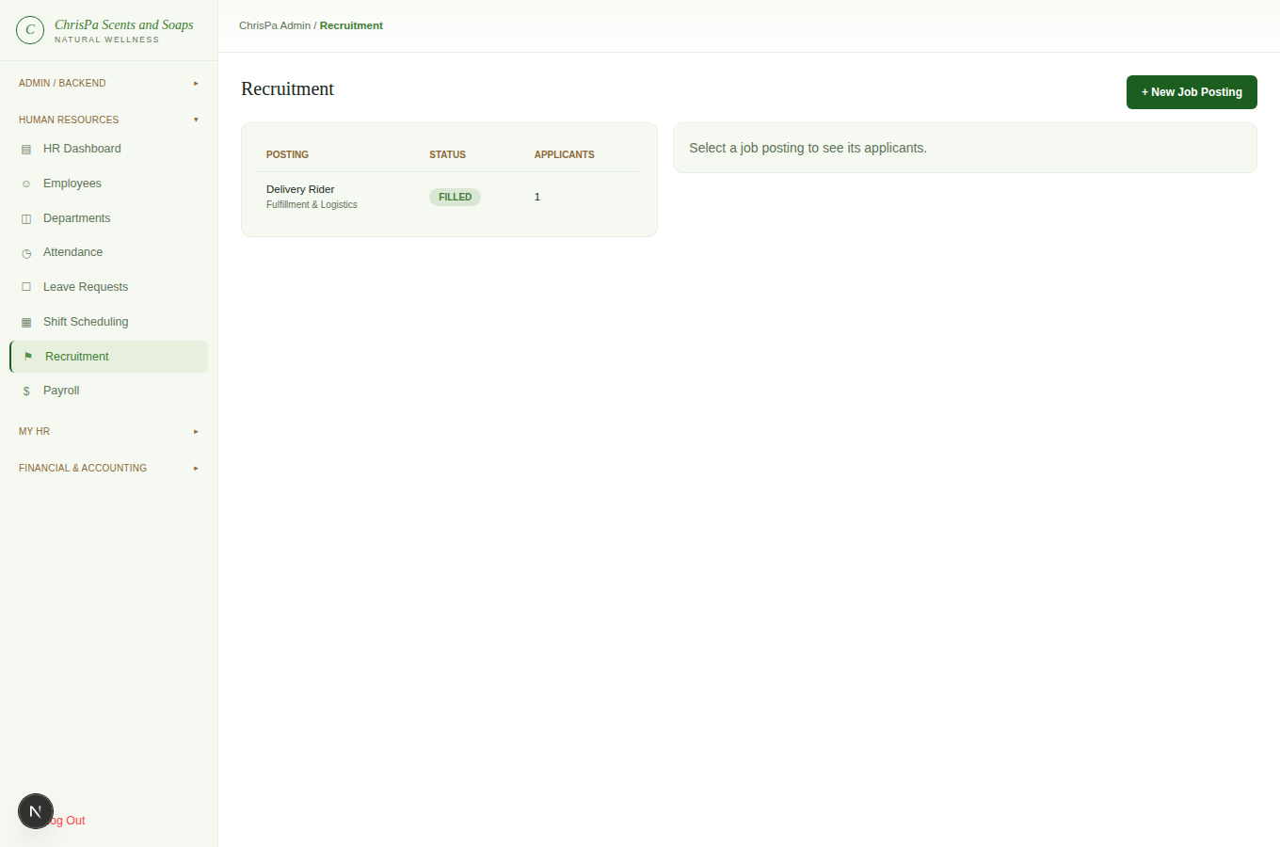
Recruitment — Job Postings and the Applicant pipeline
Create Job Postings per department (they start as Draft — move them through Draft → Open → Closed → Filled yourself). Log Applicants against a posting and move them through the pipeline (Applied → Screening → Interview → Offer → Hired/Rejected) with a stage dropdown. Convert to Employee on a hired applicant creates a real employee record in one click and marks the posting Filled.

Payroll
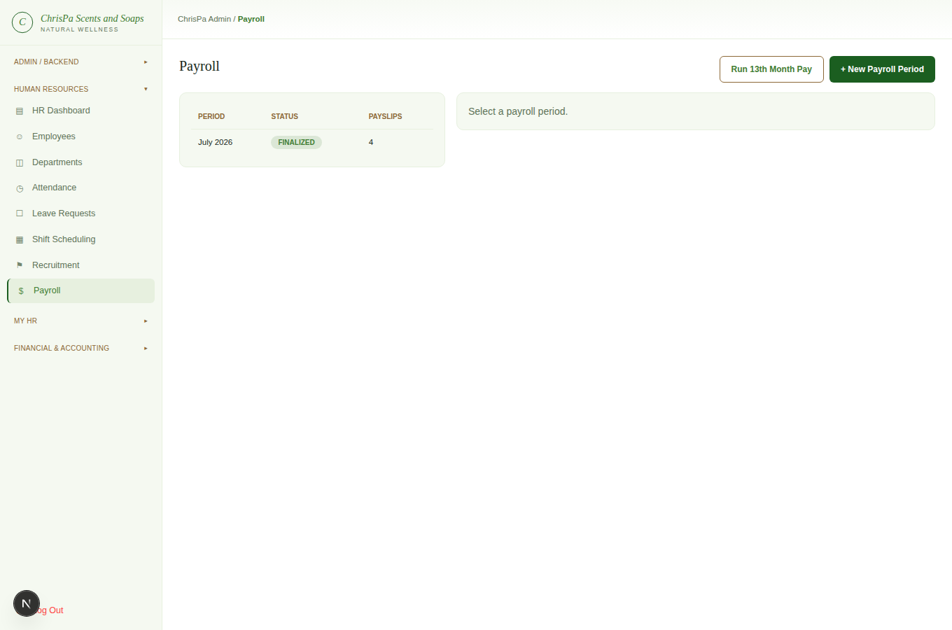
Payroll — periods, Run Payroll, Adjustments, and Finalize
Create a Payroll Period for a given month (or Run 13th Month Pay for a discretionary year-end bonus). Within a period:
- Run Payroll computes a payslip for every active employee with a base salary set — safe to re-run as many times as you like before finalizing.
- Adjustments — add Bonus/Penalty/Overtime/Other Earning/Other Deduction items per employee. The overtime comparison tool shows computed hours from clock-in/out data next to a confirmable amount — nothing is paid until you review and confirm it.
- Finalize locks the period permanently — payslips are snapshotted and can no longer change. This can't be undone, so the button confirms before proceeding.
Every payslip is expandable to show its full breakdown: basic pay, allowances (taxable/non-taxable), overtime, bonus, PAYE, employer NSSF, penalties, and advance repayments — all computed against Uganda's real, current tax bands.

11. My HR — Self-Service
Any staff member with a linked employee record, regardless of role.
- My Profile — edit your own personal email, phone, address, date of birth, and gender. (Job title, department, and salary are HR-controlled and can't be changed here.)
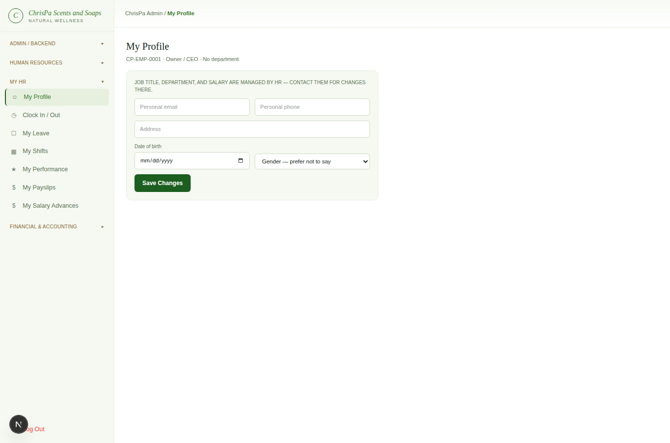
My Profile
- Clock In / Out — one button that toggles based on whether you're currently clocked in, plus your recent history with computed hours.
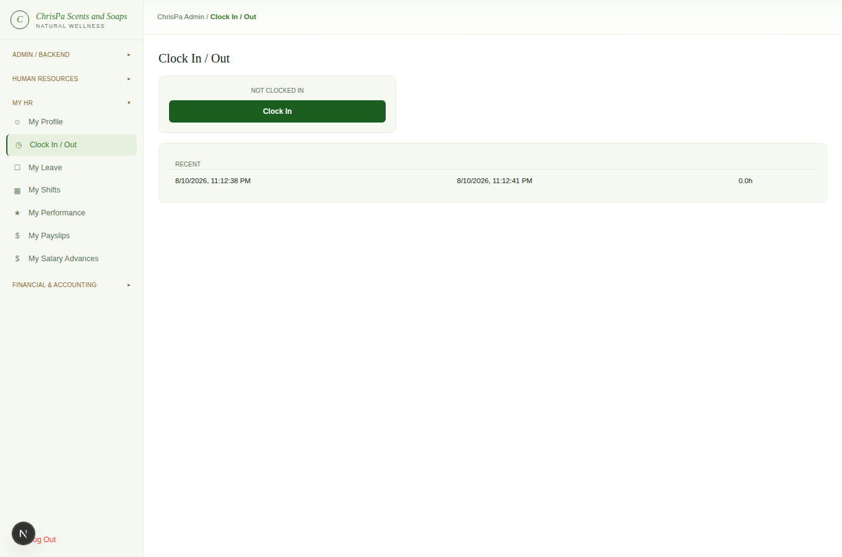
Clock In / Out
- My Leave — see your annual leave balance (allocated/used/remaining), request new leave (type + dates + reason), and cancel your own pending requests.
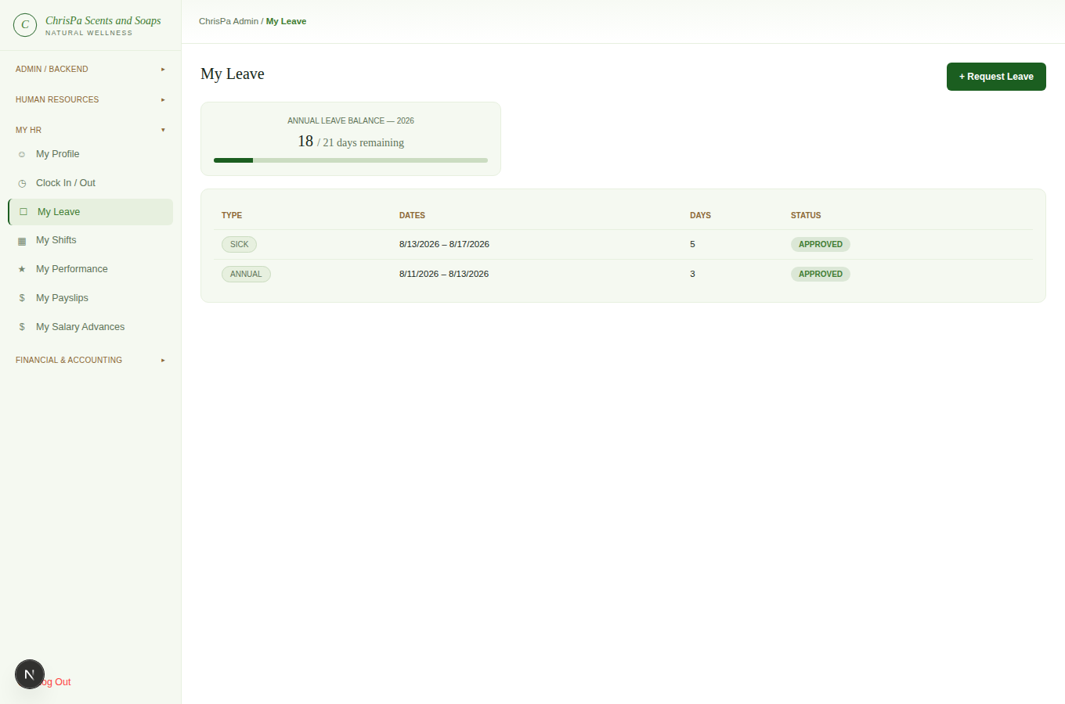
My Leave
- My Shifts — view your schedule and request a swap with a named colleague; cancel your own pending swap requests.
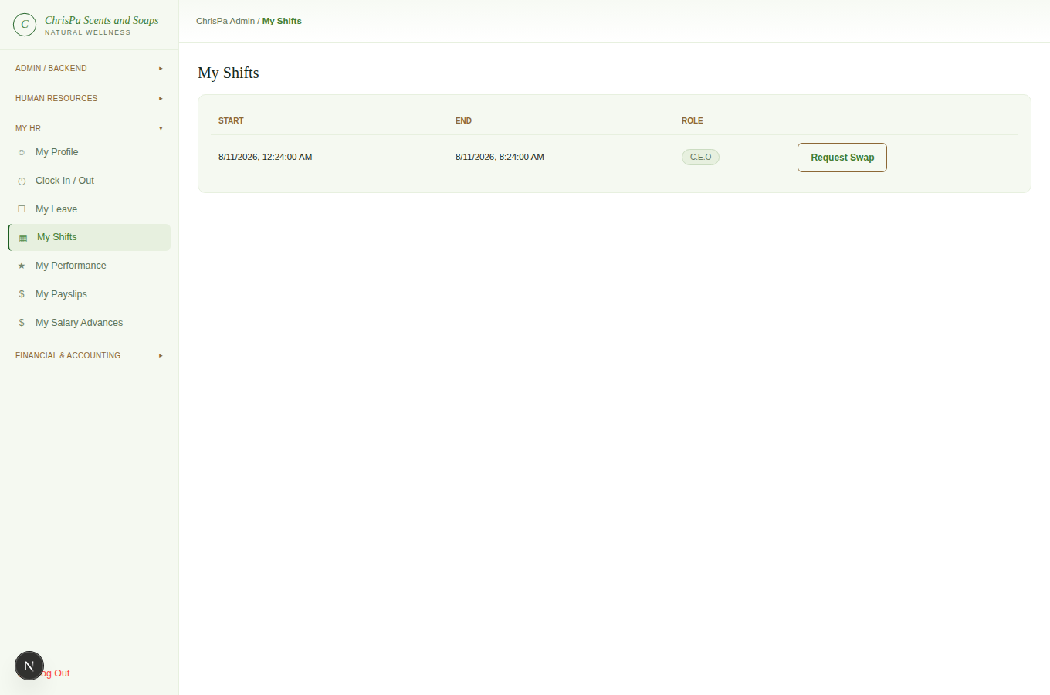
My Shifts
- My Performance — view your Goals (with progress), Feedback, and Reviews; Acknowledge any review that's been submitted to you (the one action available here).
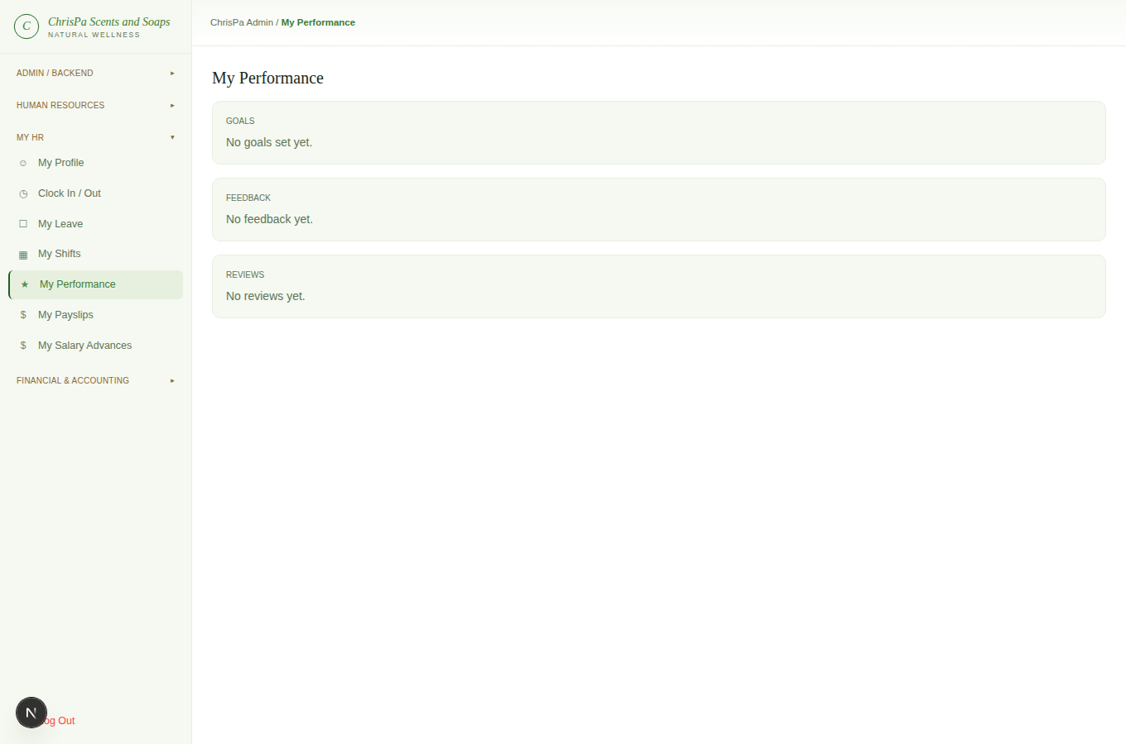
My Performance
- My Payslips — read-only, same detailed breakdown HR sees for your payslips.
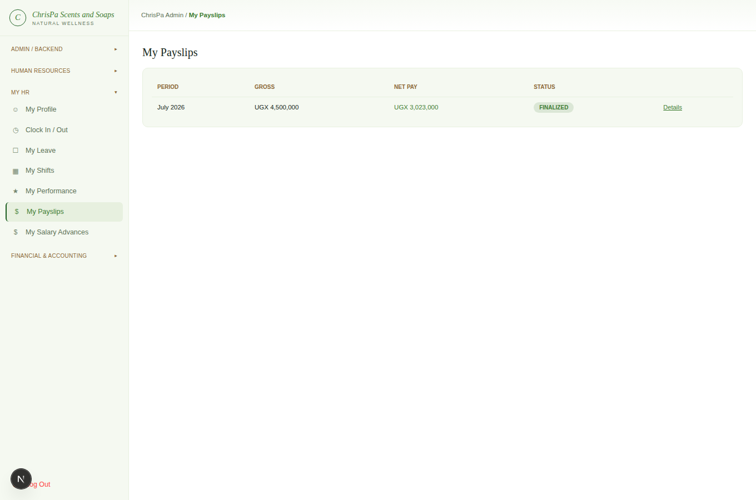
My Payslips
- My Salary Advances — read-only; HR creates and manages these, with each installment automatically recovered from your future payslips.
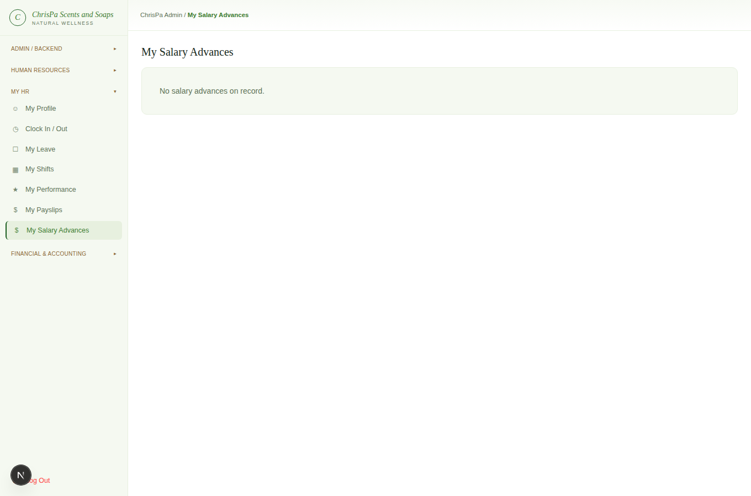
My Salary Advances

12. Financial & Accounting
Owner only.
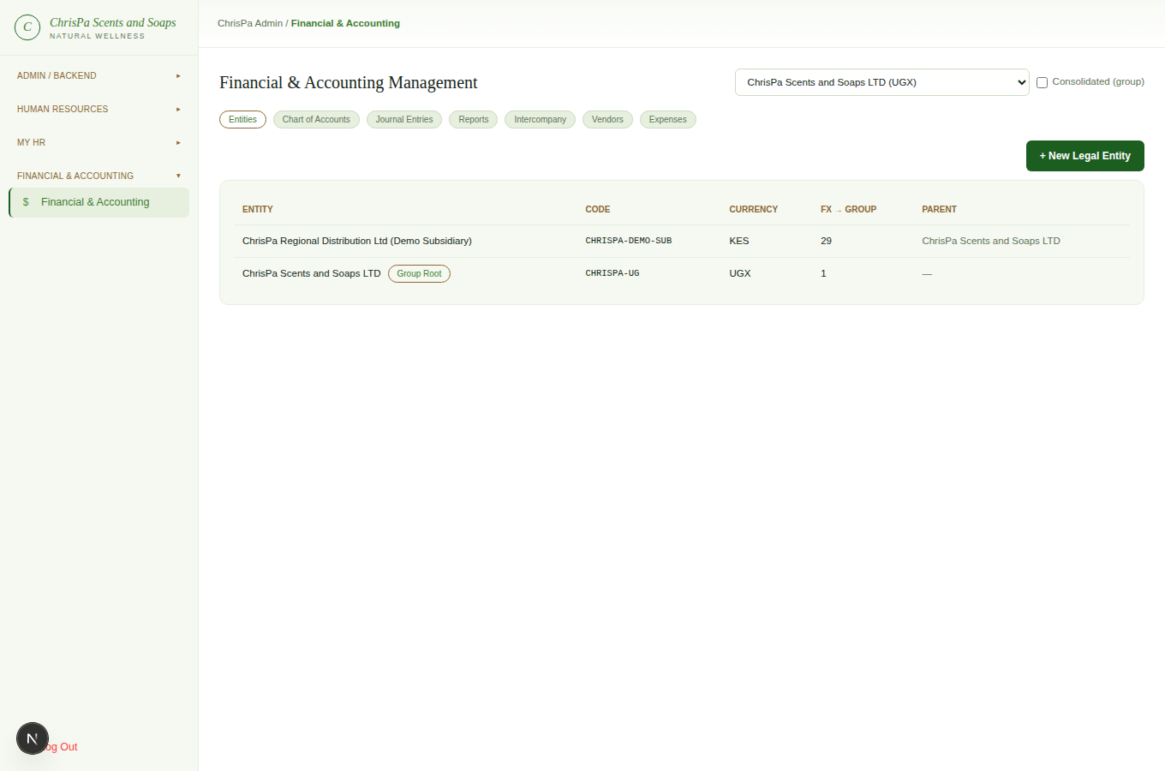
Financial & Accounting — entity selector and tabs (Entities, Chart of Accounts, Journal Entries, Reports, Intercompany, Vendors, Expenses)
Its own top-level sidebar section, with a global entity selector and a "Consolidated (group)" option at the top, and seven tabs:
- Entities — ChrisPa's legal-entity tree (a parent company with any subsidiaries); + New Legal Entity to add one, with its own functional currency and FX rate to the group's reporting currency.
- Chart of Accounts — the selected entity's accounts (read-only view).
- Journal Entries — the entity's posted entries, and a form to post a new one — add debit/credit lines against real accounts; the Post Entry button only enables once your lines balance exactly.
- Reports — Balance Sheet, Income Statement, and Cash Flow Statement, for one entity or the whole group consolidated, over any date range — each with a live balanced/reconciled indicator.
- Intercompany — allocate a management fee from the group parent to a subsidiary in one step (posts both sides of the transaction together), and see each entity's due-to/due-from balances.
- Vendors — your marketplace vendor directory; + New Vendor to add one (name, contact, Mobile Money payout number, commission %); Compute Vendor Payout tallies up a vendor's delivered, not-yet-paid sales for a date range, and Mark Paid records that you've paid them (outside the system — there's no automatic Mobile Money disbursement).
- Expenses — record a one-off operating expense (server/hosting, software, marketing, etc.) against an entity and a "paid from" account.

13. Quick Reference: Common Tasks

Task | Where | Who
Create/edit/archive a product | Product Manager | Owner, Store Manager
Move an order to the next status | Order Management → an order | Owner, Store Manager, Fulfillment
Print an order's receipt | Order Management → an order → View / Print Receipt | Owner, Store Manager, Fulfillment
Respond to / close a support ticket | Support Tickets → a ticket | Owner, Store Manager, Support Agent
Add/edit/publish/remove a page, banner, or social media account | CMS / Site Builder | Owner, Store Manager
Compose and send a newsletter (email + in-app) | Marketing & Promos → Compose Newsletter | Owner, Store Manager
Grant a staff login | HR → Employees → an employee → System Login | Owner, HR Manager
Approve/reject leave | HR → Leave Requests | Owner, HR Manager
Run and finalize payroll | HR → Payroll | Owner, HR Manager
Edit a department's policy matrix | HR → Departments | Owner, HR Manager
Clock in/out, request leave (yourself) | My HR | Any linked staff member
Post a journal entry / view financial statements | Financial & Accounting | Owner
Compute and mark a vendor payout | Financial & Accounting → Vendors | Owner
Review the platform-wide activity feed | Activity Log | Owner

Feature Availability at a Glance

Area | Available now | Coming soon
Product Manager | Full CRUD, photo upload, wellness tags | —
Order Management | Status pipeline, invoice printing | Editing items/address, split shipment, packing slips
Inventory | Live read view with low-stock flagging | Purchase orders, transfers, cycle counts
Customers (CRM) | Tier & order-count list | Per-customer detail, notes/tags, campaign export
Marketing & Promos | View coupons/bundles, newsletter subscriber list, compose &amp; send newsletter (email + in-app, with follow-us links) | Creating/editing coupons and bundles, audience segmentation, scheduling/drafts
CMS / Site Builder | Full CRUD on Pages, Banners, Social Media Accounts | Blog Posts write access, drag-and-drop builder, cross-page publish workflow, multi-slide hero carousel
Support Tickets | Full review & response workflow | —
Users & Settings | Admin user list | Inviting a new admin, integration toggles
Activity Log | Full audit feed | —
HR (all phases) | Employees, Departments, Attendance, Leave, Shifts, Recruitment, Payroll | Biometric clock-in hardware
Department Policy & Permissions | Editable, documented matrix | Does not itself enforce access (roles do)
Financial & Accounting | Full multi-entity ledger, reports, intercompany | Period-close workflow, live FX rates
Marketplace Vendors | Directory, payout computation | Automatic Mobile Money disbursement

