FreeCAD ‘Modern’ Icon Design guidelines

Icon document setup:
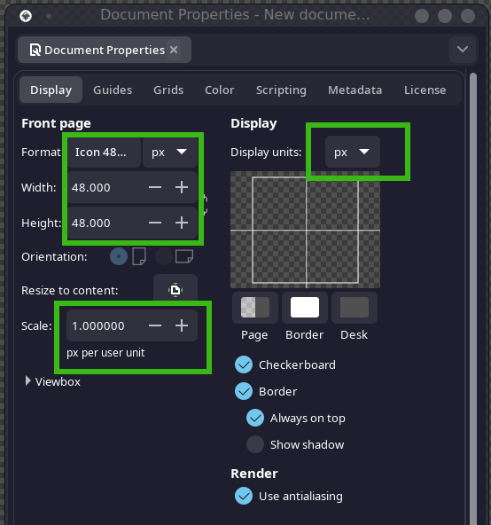

All Icons should be centered and sized to maximize space utilization and sizing consistency with a 2px padded area surrounding the icon. Protrusion of minor icon features into the padded area is acceptable but should be minimized wherever possible. Setting up guides at the precise area with snapping enabled can assist with this.

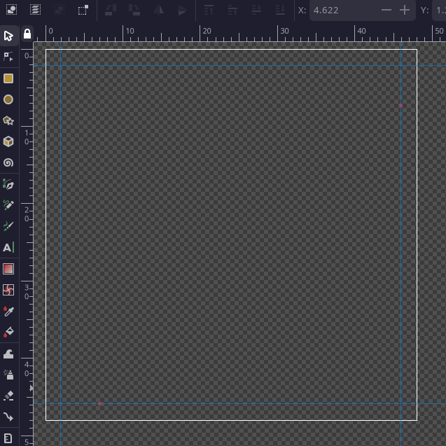

Icon color palette is based on the Open Color UI palette:
https://yeun.github.io/open-color/

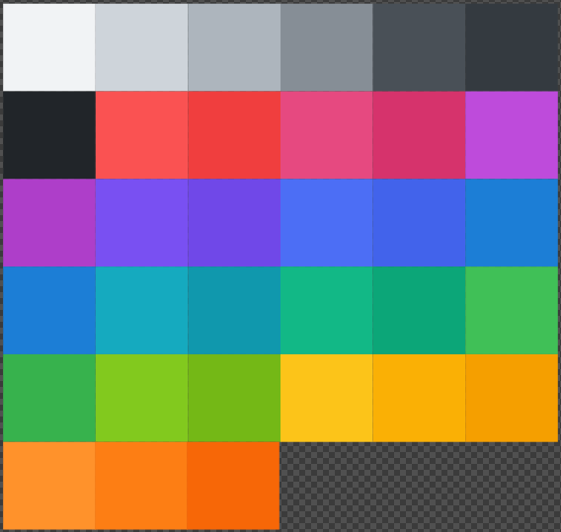

Icons should easily scale to 24px in size without any considerable loss of visual detail as they will scale even smaller when shown in menus and on lower resolution displays.


General rules for design should incorporate a 3px stroke for external borders and 1.5px stroke for internal line details on more complex icons
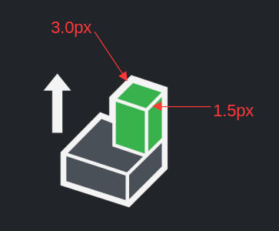

If scaling objects in Inkscape, ensure you have the following toggle off, to avoid scaling of your stroke weight:
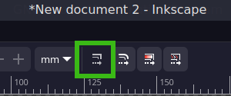

Every Attempt should be made, to ensure the icon conveys its purpose as clearly as is possible. (This is often difficult to do as design can often be subjective)

When indicating a point or vertex in your icon the default visual language should use a circle with 3px stroke with a 12px height and width. Lone points can be upscaled to 14px for better representation when no other elements are in the icon
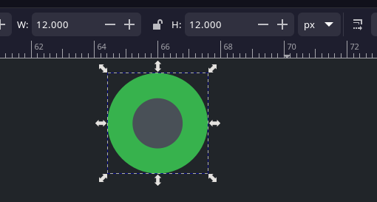

Lines should favor stroked paths with round ends over boxes/shapes

Dashed or partial lines should use the following pattern settings of 0.01 2px:
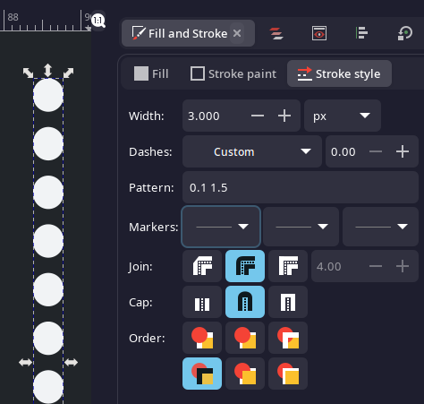

Where dotted/dashed lines are impractical a contrasting greytone should be used (ie polygon icons where the dashed lines do not render sufficient detail)

Use of color to provide shading should be avoided in most circumstances in favor of detail lines. Gradients are not to be used at all. If jagged edges appear, applying minimal blur settings to objects is acceptable in order to address the issue.
The general goal is to provide flat appearing icons. Rare cases for use of mulitple colors exist in order to represent 3d primitives and viewport render settings.

Use of differing color schemes should be used to enhance representation of functions but shall not be the sole differentiator wherever possible to ensure those with limited color-vision can identify functions. (This may not be 100% avoidable, but every effort should be made to do so)

